# Purpose

* To learn how to measure currents with a resistor.
* To make an application of a series circuit also known as a voltage divider.
* To model circuits with Ohm’s Law.
* To apply analog output techniques on a microcontroller.

# Introduction

When using digital acquisition systems such as a microcontroller, one does not have access to an ammeter (current measurement). It is possible to use a series circuit with a resistor of known value to calculate the current from Ohm’s Law. A series resistor circuit is shown below.

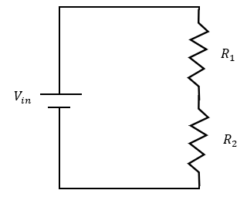

Figure 1

We found in a previous experiment that the resistances add together and that the input voltage is divided between the two resistors. These concepts can be written mathematically as:

$R_{tot}=R_{1}+R_{2} \left(1\right)$

$V_{in}=V_{R1}+V_{R2} \left(2\right)$

One way to think about this is that the amount of electric potential (voltage) varies depending on the resistance. In a series circuit, more of the electrical energy must be consumed pushing charges through the larger resistance. This unequal division ensures a constant current through the single pathway. Rewriting the second equation above for Ohm’s Law we have:

$$V_{in}=IR_{1}+IR_{2}=I\left(R_{1}+R_{2} \right) (3)$$

Suppose we insert a known value resistor for $R_{2}$.Since the current is the same for both resistors, we can measure the voltage across the known resistor and calculate the current:

$$V_{2}=IR_{2}$$

Then, using equations (2) and (3), we can calculate the voltage, $V_{1}$ , and resistance, $R_{1}$ , respectively. This allows us to evaluate an unknown resistor.

This week, we will do experiments to verify these measurements are possible with a microcontroller and determine how the value of $R_{2}$  affects our circuit. This will allow us to develop a resistive sensing apparatus in our next experiment.

# Experiment

You will set up a microcontroller circuit like the one shown below in Figure 2.

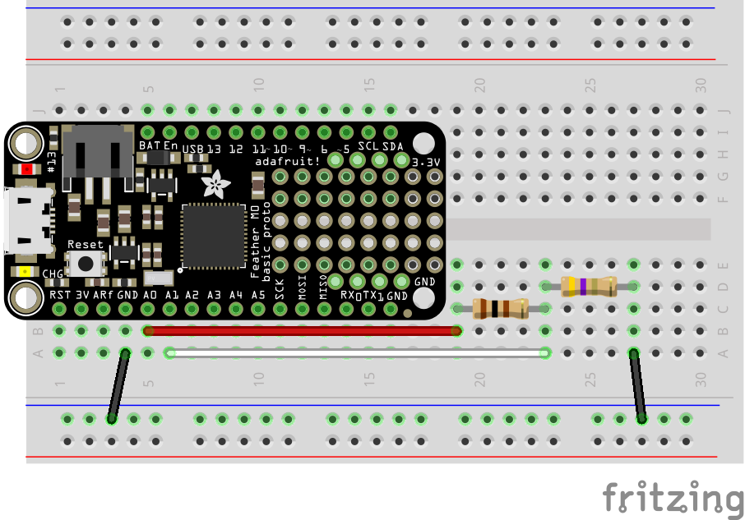

Figure 2

In this experiment, you know the value of both resistors, but in the next experiment, you will only know the value of one of the resistors. Suppose your desired circuit is a single resistor circuit like Figure 3, where $R_{1}=100 Ω$ . You wish to measure the current in this circuit without significantly affecting the circuit. To do this, you propose to make the series circuit of Figures 1 and 2.

**Questions to Consider:**

* **Should the value of $R_{2}$ be large or small?**
  + **“Large” or “small” is relative in this case. How should $R_{2}$ compare to $R_{1}$? Explain and use Ohm’s Law in your rationale.**
* **Describe a method of using Ohm’s Law to determine $R_{1}$ by using $R_{2}$ to measure the current. HINT: You want to use the linear relationship in Ohm’s Law ( *V = IR* ) to determine $R_{1}$ while assuming $R_{2}$ as a means to measure current does not significantly affect value of the circuit resistance.**
* **Choose three values $R_{2}$ to test and tell your instructor or TA your plan so they can provide these resistors (or ones close in value).**

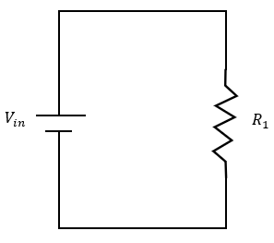

Figure 3

## Programming the Microcontroller

We will use the analog input/output techniques we saw in a previous experiments programming a buzzer and potentiometer. To begin, we will set the voltage manually to verify that the experiment is functioning correctly. Recall that these analog values are 16-bit ranging from 0 to 65535, corresponding to 0 to 3.3 Volts. This means a voltage of 2 V in integer is:

$$2V=65535*2/3.3$$

The code to operate the analog output voltage on analog pin A0 and read the analog voltage on A1 is:

import time #keep track of time and make delays

import board #identify the microcontroller

import analogio #do analog I/O

Vin = analogio.AnalogOut(board.A0) #apply analog output on A0

V2 = analogio.AnalogIn(board.A1) #read analog input on A1

while True:

Vin.value = int(65535 * 0.5/3.3) #adjust the input voltage

print(V2.value)

print(V2.value*3.3/65535)

time.sleep(1.0)

Use this code to verify your experiment is working. Change the voltage Vin to the values in Table 1 and record your measurements of V2 (digital integer, conversion of integer to voltage, calculation of current). Compare your measurements to calculations of Ohm’s Law for the single resistor circuit.

### Table 1. Manually run experimental results of a series resistor circuit using a resistor to measure current.

|  |  |  |  |  |
| --- | --- | --- | --- | --- |
| Vin (Volts) | V2 (digital integer) | V2  (Volts) | I(A) | Ohm’s Law Current (A) |
| 0.5 |  |  |  |  |
| 1.0 |  |  |  |  |
| 1.5 |  |  |  |  |
| 2.0 |  |  |  |  |
| 2.5 |  |  |  |  |
| 3.0 |  |  |  |  |

We can use CircuitPython to calculate the voltages V1,V2 and the current I

* Write the calculations symbolically using Vin,V2, and R2.
* There are three calculations.
  + - * Convert V2 from digital integer to voltage.
      * Calculate the current from V2 and R2.
      * Calculate V1 from Vin and V2.
* Write a method of conversion between Vin in volts to digital integer.

Next, we will program the microcontroller to scan the input voltage while measuring V2 and incorporate the conversion calculations you determined.  Here is the skeleton code. You will need to edit four lines in the for loop.

import time #keep track of time and make delays

import board #identify the microcontroller

import analogio #do analog I/O

import array #make lists of numbers

Vin = analogio.AnalogOut(board.A0) #apply analog output on A0

V2 = analogio.AnalogIn(board.A1) #read analog input on A1

V1_arr = array.array("d")#create an array of V1

I_arr = array.array("d") #create an array of current

Vin_list = [0.5, 1.0, 1.5, 2.0, 2.5, 3.0] #list of Vin

for i in Vin_list: #loop to scan input voltage

#Students edit four lines below

Vin.value = int()#conversion to integer using i in place of Vin

time.sleep(0.2)

V2Volts = #conversion of V2 from integer to volts using V2.value

V1_arr.append() # calculation of V1 using i as Vin and V2Volts

I_arr.append() # conversion of V2 to current using R2 and V2Volts

time.sleep(0.1)

#print the results

print("V1")

print(V1_arr)

print("I")

print(I_arr)

The program should print a list of V1 and I values. The analysis will be performed using Python in Trinket. Open the Lab 6 Trinket. It has code like the following.

import numpy as np

import matplotlib.pyplot as plt

from scipy.optimize import curve_fit

#create a function that returns a line

def line_fit(x, m, b):

return m * x + b

#testing with a 2.2 ohm current resistor (paste your values in the square brackets)

#You can copy and paste all of the code below for each resistor.

#Change the arrays and the colors and labels on the graphs.

V1 = np.array([-0.0112795, 0.3931698, 0.7960077, 1.1988476, 1.6065135, 2.0093554, 2.4138086])

Current = np.array([0.00512705, 0.00878918, 0.01318377, 0.01757836, 0.01977568, 0.02417027, 0.02783245])

#Do the linear fit and print the results

fitp, fitc = curve_fit(line_fit, Current, V1)

slope = fitp[0]

slope_unc = np.sqrt(fitc[0,0])

intercept = fitp[1]

intercept_unc = np.sqrt(fitc[1,1])

print("R2 = 2.2 ohms")

print("m = ", '{:.2f}'.format(slope), "+/-", '{:.2f}'.format(slope_unc))

print("b = ", '{:.2f}'.format(intercept), "+/-", '{:.2f}'.format(intercept_unc))

#Graph the results

plt.plot(Current, V1, 'or', label='2.2 ohm') #graph the data

plt.plot(Current, !!!!, '-r') #graph the fit

plt.xlabel("I (Amps)") #label y axis

plt.ylabel(r"$V_1$ (Volts)") #label x axis

plt.legend() #create a legend

plt.show()

This code will determine a best-fit line to your data and report the slope and intercept with uncertainty. You will need to

1. Paste your data into V1 and Current.
2. Change the resistance value in the print statement and the plot label.
3. Insert the formula for calculating a line from the fit values slope and intercept. Keep in mind that the x-values are Current. You will insert this formula in place of !!!!.
4. Copy the appropriate portion of the code to repeat the analysis for all of your resistor values.
5. Plotting all three datasets may work best if the last two lines of the plotting are only included for the last resistor.

5a. That is, delete plt.legend() and plt.show() for all but the last resistor.

# Conclusions

* Describe the resistance values you obtained for R1 from the slopes of your graphs.
  + Do these values agree with the theoretical value given by the colored bands on the resistor? Explain in detail.
  + Use the uncertainty from the linear fit to explain this agreement.
  + Do you notice a trend in the value of slope as your R2 value increases?
  + Can you draw conclusions about the ratio of R2/R1 that will provide the best result for R1 in terms of accuracy and uncertainty? Explain in detail.
  + Can you prescribe an upper and lower limit to R2 that will give the best results in terms of accuracy and uncertainty? Explain in detail.