User Manual

Requirements: All of the software has been tested on Mac OS 10.6 (Snow Leopard). However, these instructions are for Windows XP or 7.

Downloading Software onto PC

1. Downloading Python onto your PC
   1. http://www.python.org/download/
   2. Click on: Python 2.7.1 Windows Installer
   3. Save the file in c:\program files and download the program
   4. Open the program files via the start menu
   5. Under Python right click IDLE (python GUI)
   6. Create shortcut and drag that shortcut onto the desktop
2. Downloading the Arduino zip file onto a Windows PC
   1. http://arduino.cc/en/Main/Software
   2. Under download, click the Windows hyperlink
   3. Save the file Arduino-XXXX.zip (XXXX is a version number, e.g., 0024)
3. Saving the Arduino and Python programs onto your PC
   1. Download the files from http://www.centenary.edu/neuroscience/tailflick into a folder that you will remember and is easily accessible. The program will automatically save your collected data into a file and place that file in the same folder that the program is in.

Getting Started

1. Connecting the Platform
   1. Plug the USB cord into one of the PC’s USB ports
      1. If done correctly you should hear a few clicks coming from the platform; this is just powering the platform.
      2. It is recommended but not required that all other USB ports are empty.
   2. Plug the lamp into a nearby power strip
      1. If you have plugged the platform into the PC the light should be off at this point. If you have reversed the order and plugged the lamp in before the platform the light will flicker on and then off, and should remain off.
2. Installing the Arduino code
   1. Open the Arduino executable (arduino.exe) that is in the Arduino-XXXX folder.
   2. Click Tools → Board → Arduino Uno (or whichever type of Arduino you are using).
   3. Click Tools → Serial Port → COM #
      1. Linux and Unix (Apple) computers will have ports labeled with “tty”
      2. The # will depend on your PC and what is plugged into USB ports. You can check which port the Arduino is assigned in your hardware profiles or you can use trial and error.
   4. Click File → Open → tailflick.pde → Open
   5. Click File → Upload to I/O Board (Ctrl + U)
      1. If you have selected the correct port, there will be no errors, and there will be a message at the bottom left that reads “Done uploading.”
3. Opening the Python program
   1. Double click IDLE (python GUI) to open Python (usually in C:\Python27
      1. What pops up is known as the python shell
   2. Click: file → open → tail_flick_project_v0.2 → open
      1. If done correctly you should see a lot of code now in the Python window.
4. Setting up the program
   1. Click: run → run program (F5)
      1. This could take a few moments to run depending on computer speed and other files open at the time.
      2. If done correctly the lamp should flicker on and then off and you should see a user interface pop up.
   2. In first entry insert the file name that you would like the program to save your data into. This is for future reference as a data collector. Make sure to put your filename and one of the below two file extensions.
      1. .csv = excel document
      2. .txt = word document
   3. In the second entry insert the name or ID of the mouse that is being tested, so the program can differentiate mice. This feature lets you change mice and not have to restart the program in between each test.
      1. If you do not enter anything into these two boxes there is a default program and mouse name that will be saved into the folder that the program is in. The data will all be saved, so there is no need to worry if you forget or get lazy.
   4. The third box will be your running timer, no entry is needed. This will display the time as the mouse is put through the test. At the end of the test it will display the time it took for the mouse to flick its tail.
5. Placing the mouse
   1. With the mouse in its holder with tail coming out (see figure below), then place the mouse on the platform with its tail running along the grove in the platform. MAKE SURE that the mouse’s tail is covering the hole made on the top of the device, if it is not the platform will not work properly.

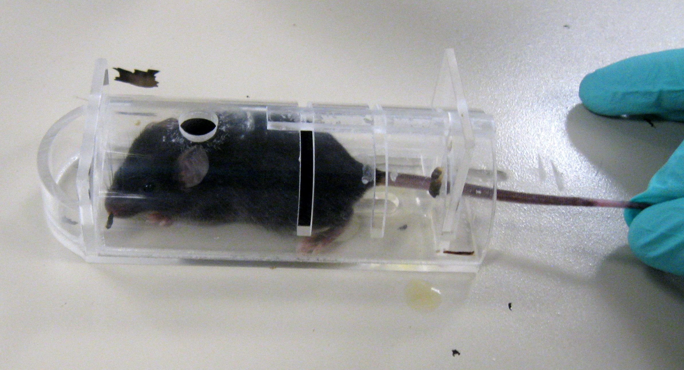

* 1. Place the provided housing (red box in figure below) over the mouse careful so as to not crush its tail. The tail should be down in the groove and not being touched by the housing if done correctly.

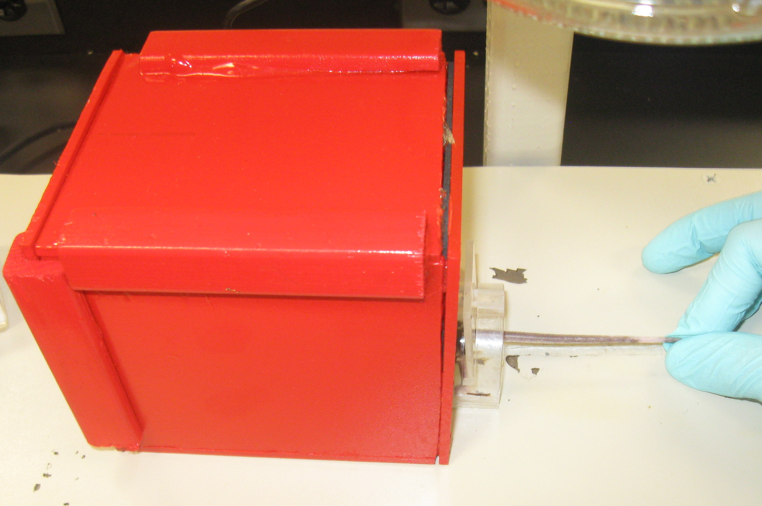

Running the Program

1. Start
   1. Click OK or press ENTER on the keyboard
      1. If done correctly the lamp should turn on over the mouse’s tail and the running timer should begin to count.
      2. At this point the program is running and doing its job, so do not interfere with the platform or the mouse until the mouse has flicked its tail and the light has shut off.
   2. If you are continuing with more mice or the same mouse move to step 2. If you want to collect your data move to 3.
2. Continuing the experiment
   1. The same mouse
      1. If you are done and want to collect your data, move on to Recovering Data. If you are running another trial with the same mouse all you have to do is keep the mouse in its box, reposition its tail over the hole once more and then press okay in the box just like step one.
   2. Different mouse
      1. If you are using a different mouse, you will need to identify him some way different than the first mouse. To do this, insert a new name for the mouse in the given box just as before. Do not change the file name unless you would like to start with an entirely new file. In this case it is okay to change the name of the file, but all new information will now be saved to the new file.

Recovering Data

1. Using this platform there is no need to write your data down in a notebook, the program has saved all your mice names and times down in a folder that you have created. This way you can print the information out, save it in a database, or email the file.
   1. To recover this file, go to the directory where you saved the python program. Your file or files will be saved there. You can now save this file to a different directory or do what you please with the information.

Trouble Shooting

1. The light is staying on when you plug in the platform and the light
   1. Move the platform to a new USB port on your PC, keeping switching until you find the one that will turn the light off.
   2. If a does not work, look under the platform, most likely the white wire is disconnected from one of its two sides. It will need to be plugged back into the ground on the Arduino, the chip under the platform.
2. Error messages in the python shell
   1. Close the entry box then in the shell push ctrl+c
   2. Remember that every time you run the program there can only be one entry box opened. The program does close the entry box on its own; this is so that you can test many different mice multiple times. If you happened to accidentally run the program from python again without closing the entry box you will get an error in the python shell. You must close the first entry box then run the program again to get another dialog box. If you get the error message do the above step.
3. The program clock does not start and light doesn’t turn on.
   1. Close the entry box and in the shell push ctrl+c. Then run the program once again.
   2. If that does not work pull the USB out of the port and wait 10 second then plug it back in. This resets the Arduino, the board running the platform.
4. Any other error
   1. ctrl+c in the shell then start the program, if that does not work move on.
   2. Close all open windows
   3. Unplug the USB and lamp
   4. Open python
   5. Plug the USB and lamp back in
   6. Open the file and start the program