Tic-Tac-Toe Project

User Stories

1. As a user, I want to login with email and password, so that my ID is authenticated.
2. As a user, I want to change my password, so that it can be more meaningful.
3. As a user, I want logout capability, so that game session will be closed.
4. As a user, I want player active status, so that current player is known
5. As a user, I want invalid cell choices disabled, so that cheating is prohibited
6. As a user, I want game status displayed, so that win tie, or game in progress is known
7. As a user, I want current game disabled upon win or tie, so that cheating is prohibited
8. As a user, I want to select a new game, so that game playing can continue
9. As a user, I want clearly defined graphics, so that game is visually appealing.

Wirefr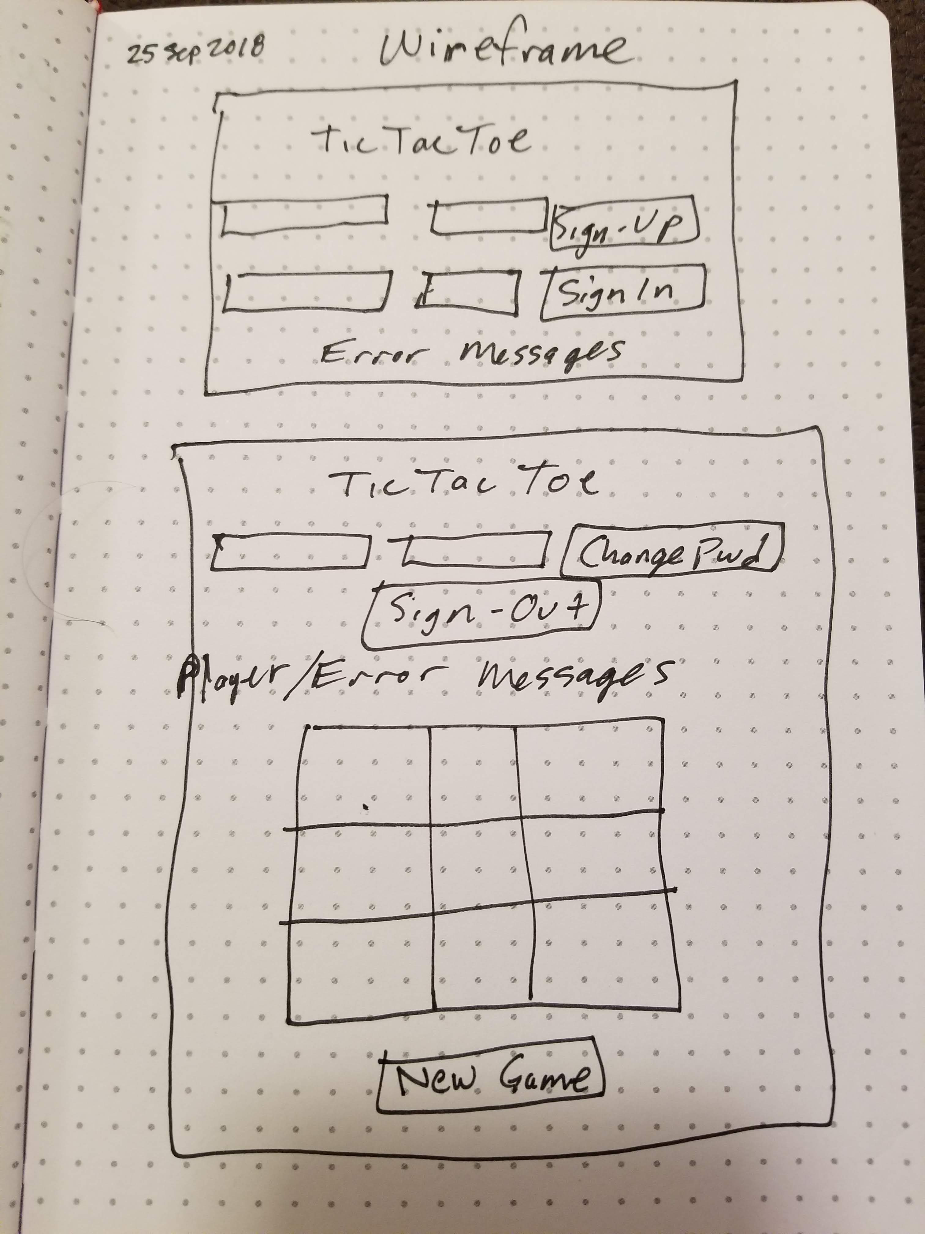ame

Schedule

**Tuesday, September 25th**

Planning

1. Review [game-project-scope-study](https://git.generalassemb.ly/ga-wdi-boston/game-project-scope-study)
2. User Stories
3. Review [project-planning-wireframes-practice](https://git.generalassemb.ly/ga-wdi-boston/project-planning-wireframes-practice)
4. Wire Frames

Set Up

1. [Download Browser Template](https://git.generalassemb.ly/ga-wdi-boston/browser-template)
2. Create a Github Repository
3. [Deploy to Github Pages](https://git.generalassemb.ly/ga-wdi-boston/gh-pages-deployment-guide)

**Wednesday, September 26th**

Game Engine

1. Create Empty Board in JS
2. Create Current Player
3. Add Current Player to Board
   * Current Player rotates between x and o
   * Can not choose already occupied spots
4. Check Board for Winner

**Thursday, September 27th**

Game UI

1. Design a game board
2. Add a click handler for when a space on the game board is clicked
3. If the user clicks on a valid space then add their X or O
4. Do not allow users to add an X or O to an invalid space
5. Do not allow users to add an X or O to any spaces after the game is over
6. Update the game engine when the game board is updated
7. Add messaging for the user when the turn changes
8. Add messaging for the user when the user clicks on an invalid space
9. Add messaging for the user when the game is over (win or draw)

**Friday, September 28th**

Authentication

1. Review [api-token-auth](https://git.generalassemb.ly/ga-wdi-boston/api-token-auth)
2. Sign Up (curl then web app)
3. Sign In (curl then web app)
4. Change Password (curl then web app)
5. Sign Out (curl then web page)
6. All API calls have success or failure messages

Game API

1. Review [query-ajax-post](https://github.com/ga-wdi-boston/jquery-ajax-post)
2. Create Game, start new game (curl then web app)
3. Update Game, play the game (curl then web app)
4. Get Games (curl then web app)

**Saturday-Monday, September 29th-October 1st**

Final Touches

1. README
2. Troubleshoot/Debug
3. Style

**Tuesday, October 2nd**

Project Presentation