

COMP.5212
Programming

Assessment | Type of Assessment | Due Date & Time | Marks | Weighting
Assign #1,  Part A | Programming assignment | 7th Sept 2018,  Before 4pm | 109 | 60%
Learning outcomes assessed:
- Use procedural and Object Oriented programming.
- Write applications using design patterns.

MARK ALLOCATION:
Question | Marks  Allocated | Marks  Awarded
1. | 30
2. | 8
3. | 8
4. | 29
5. | 22
TOTAL | 97

Reminder

The assignment must be a product of your own work, except for the use of resources supplied with the course, discussions conducted with the lecturers, and other assistance shown as acceptable in the section Assistance to Other Students below.

Assistance to other students

Students themselves can be excellent resources to assist the learning of fellow students, but there are issues that arise in assessments that relate to the type and amount of assistance given by students to other students. It is important to recognise what types of assistance are beneficial to another’s learning and also what types of assistance are acceptable in an assessment.

Beneficial Assistance (this assignment)
- Study Groups
- Discussion
- Sharing reading material

Unacceptable Assistance
- Working together on one copy of the assessment and submitting it as your own work
- Giving another student your work
- Copying someone else’s work
- Changing or correcting another student’s work
- Copying from books, the Internet etc. and submitting it as your own work

Question 1 (30 marks)

Create a new console application which includes the Car class, with its attributes and operations as shown in the UML class diagram below:

Car
- colour: string
- make: string
- gearbox: string
+ GetColour(): string
+ SetColour(col: string)
+ GetMake(): string
+ SetMake(mk: string)
+ GetGearbox(): string
+ SetColour(gbox: string)

Your program should create a new car object, obtain the colour, make and gearbox from the user, which are then assigned to the object’s fields by way of the Set methods. The program should then display the car information as shown in the sample below, by calling the appropriate methods.

Program sample:

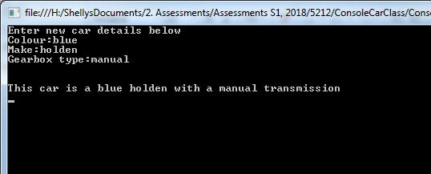

Question 2 (8 marks)

Redesign the UML class diagram for the Car Class (in question 1) replacing all of the Get and Set methods with; three auto-implemented properties.
This is to be completed in a Microsoft Word document and submitted in the zip file along with all of your Visual Studio projects.

Question 3 (8 marks)

Create a completely new console application which also includes a Car class that matches the updated UML class diagram created above in question 2. (DO NOT change your question 1 application).

This new application should still run as per the program sample given in question 1.

Question 4 (23 marks)

Create a new console application which includes the Person class, with its attributes and operations as shown in the UML class diagram below:

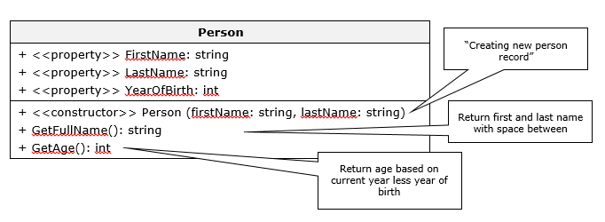

Your program should obtain the first and last name from the user in order to create a record for a single person. You will also prompt the user to enter the year they were born. Then using the appropriate method(s) display the person’s full name and age back to the screen as shown in the sample below:

NOTE: For this question; the Program.cs file must only contain the Main Method and the Person class must contained in a Person.cs file

Program sample:
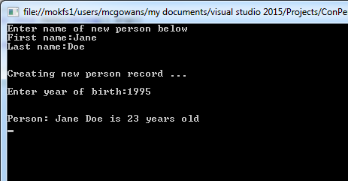
Question 4 extension (6 marks)

Extend the Console application in the previous question (Question 4) as follows (DO NOT create a new Console application):

- Ask the user if they want to add another person (y/n are their options)
- If they enter in ‘y’ - the user should then be able to enter in the data for a new person record and then have the correct information displayed back to them.
- If they enter in ‘n’ – the program will display exit message, then exit.

- The Person class MUST NOT be changed for this extension.

Program sample:
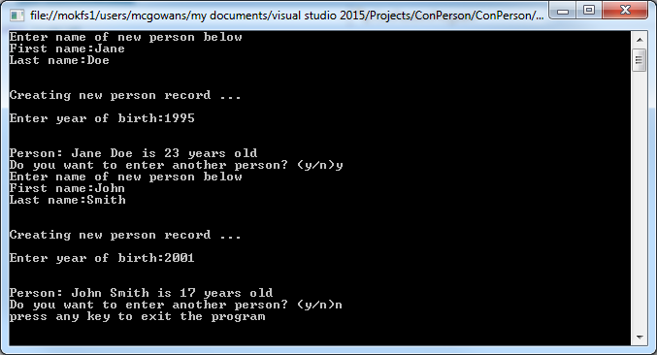

Question 5 (22 marks)

Create a completely new Console application that also uses the same Person class (person.cs file) created in question 4. Extend this new application more by adding a second class called Student (which is a derived class of Person) as shown in the UML class diagram below:
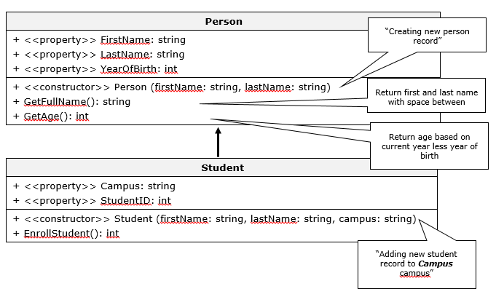
The EnrollStudent method should generate a StudentID number made up of a 4 digit random integer.

Your program should run as shown in the program sample given below:

Program sample:
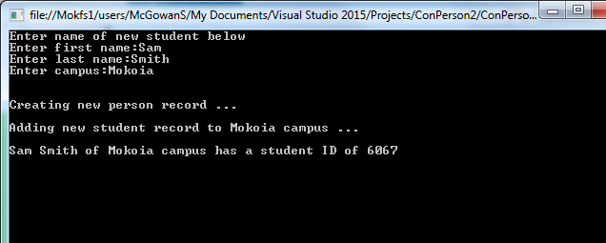

END OF ASSIGNMENT

DELIVERABLES

You will need to upload a repository link containg the following files:
- All 4 MS Visual Studio project folders for all questions
NOTE: Each project folder must contain the solution file and all of the files necessary to open the project.
- The UML Class diagram created for question 2 (MS Word document).
This repository link is to be uploaded to Moodle by selecting the Assignment Part A upload link.

