**CHAPTER I**

**Problem and its Background**

**Introduction**

Nowadays there’s so many reports and incident involving a motorcycle. Therefore, researchers of Bulacan State University Sarmiento Campus (BSU-SC) conduct specific question and answer providing proofs for this project to be successful. The project will be the Motorcycle Alarm system with Short Message Service (SMS) the researchers conducts this project because of the multi incident involving motorcycle. It contains about how to provide the owner the security he/she needs for his/her motorcycle, this project can benefit not only for the researchers but also the future researchers.

**Statement of the Problem**

The statistic of the motorcycle theft is in the second rank of the general theft (Criminal statistic of interest, throughout the kingdom of Thailand). During 2001-2009, the average rate of the stolen motorcycle is 18,886 units per year. The lost trend is still high. What is the way to reduce lost? The evolution of anti-theft device began after the motorcycle is produced in 1886 by Gottlieb Daimler. In 1924, the mechanical lock or pad lock of motorcycle for security has occurred. Since then, the wireless remote controler for motorcycle in security system was developed. Until now, research and development of device has developed to two-way communication between owner and motorcycle.

**General Problem**

The general problem is that motorcycle lacks the security it needs to keep thieves away. So the general objective of this study is to provide security alarm system to keep your motorcycle safe from thieves and to warn owners.

**SPECIFI PROBLEM**

The problem of owners of the motorcycle that it lack the security it need to be protected the case is motorcycle are most likely to be stolen and police and owners struggle to find the thief.

1. How can they be sure that it is effective and reliable to use in the parking lot?
2. It is accessible to all motorcycle owners were looking an immediate solutions?
3. What type of hardware and software that is being used in this study to give the best performance?

**SIGNIFICANTS OF THE STUDY**

This study will benefit the student of (BSUSC) Bulacan State University Sarmiento Campus for the safety of their motorcycle. This study is significant to what motorcycle owner needs? It is to provide the security they need for their motorcycle.

This will benefit the security of the Bulacan State University Sarmiento Campus Guard to help them guard motorcycles with ease. because of the alarm system of the motorcycle it helps the guard to act quickly and responsibly.

The project will help the future researchers to create more trustworthy alarm system that can help not only the guards and the owner of the motorcycle maybe other people who own vehicles.

**Scope and Delimitation of the study**

The scope and limitation of Motorcycle Alarm System with Short Message Service Notification for the Bulacan State University on what device can provide uses and its limitation.

**Scope**

The purpose of this Motorcycle Alarm System with (SMS) Short MessageService is to develop hardware for the security purpose of a motorcycle inside the Bulacan State University Sarmiento Campus (BSUSC) parking lot. One of the researchers motorcycle will be use to test the project. This device can warn the owner even if he or she is far from their motorcycle after the thief triggers the alarm it will automatically send ah text message the alarm will warn nearby people and the text message will be used to warn the owner.

**Limitation**

The main problem of this project is if the simcard of the device has no load balance the device will not send a notification to the owner of motorcycle. And if the phone of the owner doesn’t have a signal the message will be delayed, and if the battery of the device was depleted and the weather is bad, and if the motorcycle does not have a compartment the alarm system cannot be installed. Only motorcycle with compartment can use this project.

**CHAPTER II**

**RELEVANT THEORIES**

**Short Message Service**

Theory of using the SMS reminders may be more effective in warning people. Because most of the people nowadays use android phone in their every day work and for their amusement so theory suggest that it can be included in the security system to help people in their intrusion problems.

The home light automation activated by sending short message service (SMS). The owner send a text message to the device, the light must be turn on or off this will program by GSM module. An activated light automation this will help power reduce consumption on houses and its convenience to the owner to activate the light.

In case of smoke detection the device will send a text message to notify the owner that there’s a possibility of smoke leak. Short message service will be capable to notify the person in case of emergency.

Weather forecast sending a text message. If the device detected a bad weather this will send a text message to notify all people in that area that there’s a heavy rainfall or floods.

Door lock system with text massage, when the owner send a text message to device the door will automatic lock or unlock. This will help the owner when he forgot to lock the door.

School attendance system with SMS. When a student goes to school and he will log in on student attendance system, the device will send a text message to the parents or guardian that her child is attending on a class.

**Alarm System Theories of Fire Alarm System**

This theory is relevant to the researcher study of the alarm system that they are developing for the safety of an intrusion. The fire alarm system is setup to give early to warning so occupants may evacuate the building and notify the fire department and or security soon enough that they have time to react. There are different types of fire alarm system building alarm system may be local with based alarm system connections. They may be coded or noncoded and may operate either on line-voltage or low-voltage electric power.

Alarm intrusion system of car, when system detect a motion or touched created by man the device will create a loud noise to notify the owner or people around the area.

Burglar alarm system, when a malicious presence of person in the house, alarm system will activated to notify the owner that a person trespassing on the house and take all things. This device will secure the houses

Fire alarm system when a device detected a presence of fire in that specific area. The device will make an alarm to notify the bearue of fire protection or people in that particular area.

Flood alarm system this theory that when flood comes the alarm system will make information and send to flood control. It will help to identify where the flood in the area is and give an instruction to create a rescue team when a people is in danger.

Metal detection alarm system in mall. When a person carrying a weapon, The detection of device will create information that there’s a metal weapon that place in bag. The device will notify the security personnel that the person is dangerous

**Foreign Literature**

Somboon Phongphu and Panya Srichandr (July 16, 2011) This paper reports the design and development of an innovative anti-theft alarm system with text message for motorcycles. The design concept is based in two-way communication strategy between the vehicle and owner. Radio frequenc link technology is employ to achieve two-way communication. Details of subsystems, their functions, and operating steps are describin a prototype of the alarm is developed and tested. The result shows that the prototype alarm performed well with the distance of 100 meters in open space and 10 meters in crowded areas. When fully developed, it is expected that this innovative alarm system with text message could prevent the motorcycles from being stolen effectively although it can never achieve 100 % thief-proofs. Currently motorcycle thefts happened very often and tend to be more increasing intense. Although the Thai Police is trying to trace criminal gangs and arrests them.

The thieves have many techniques how to steal and spend short time. It also smuggled out to neighboring countries for sale through several routes. It is difficult to track the criminal and be difficult to track down the stolen motorcycle to send back to the owner. One way to helped preventing the problem is providing useful information for the owners to be careful about their vehicles so that it would not be stolened easily. The statistic of the motorcycle theft is in the second ranked of the general theft (Criminal statistic of interest, throughout the kingdom of Thailand) during 2001-2009, the average rate of the stolen motorcycle is 18,886 units per year. The lost trend is still high.

**Local Literature**

According to John Nicohlus R. Cañeba (August 2011) said that in Mapua Institute of Technology The GSM-Based Home Intrusion Detection Device is a security device that sends a text message to the owner’s mobile number in case of home intrusion. This is to warned and notify the owner of an impending attack. It is useful when the owner is outside the house, or even when asleep. It is programmed to stored the owner’s mobile number in which the device would send a text message notifying the receiver of an intrusion.

The device uses a GSM modem which required a SIM card to send text messages. The devices is to be placed adjacent to possible entries of intrusion, such as doors and windows. The device is activated once the door or window is opened and it automatically sends a text message which is also pre-programmed. In 2008, the Social Weather Stations (SWS) conducted a survey on common crime victimization. It was found out that 7.8% of family’s lost property to pickpockets, burglars or car nap, and 1.6% suffered physical violence. The survey found 3.6% of families were victimized by burglary. Comparing these data with the previous (SWS) survey of 2013, families victimized by pickpocket and carnapping declined from 8.6% and 1.9%, respectively, but families victimized by burglary and physical violence from 3.0% and 1.4%. As in most SWS survey, Metro Manila was found to have the highest rates of victimization by property crimes.

Families who suffered break-ins most areas. It went up from 3.0% to 4.0% in Metro Manila, from 1.9% to 3.6% in the visayas, and from 2.3% to 4.0% in Mindanao. It went from 3.3% to 2.3% in Luzon.

**Conceptual Framework**

**Input**  **Process** **Output**

**Knowledge Requirements**

*Arduino sketch

**Hardware Requirements**

*GSM Shield

*Guizdino 4.1

**Software**

*Arduino IDE

**Motorcycle Alarm System with Notification Short Message**

**Service**

*Planning

*Analization

*Design

*Testing

**CHAPTER III**

**REASEARCH METHODOLOGY**

This chapter contains the methods and techniques and developing of the proposed project that the researchers use with the study. This includes the development –cost , method and technique and population and sampling which help the researchers in conducting the study for the proposed project

**Project Development**

This study will develop a device to secure a motorcycle inside or outside campus to help student concern about their motorcycles safety and it can even help students and other people to lessen the incident of motorcycle being stolen. The researchers will develop this kind of device because of a high price of motorcycle security device and other student cannot afford motorcycle security device. This development will see the structure of the device, materials, specification and costing.

The cost and quality of the device, specifications of each material and its function to be applied will also be presented in this Chapter. The flowchart will also show how the device works.

**Methods and Techniques**

First the researchers disassemble the parts of the motorcycle then, the researcher check the wirings to combine it with the two arduino hardware with their specific modules that the researchers programmed in the computer after they combine the parts of the hardware module. Researchers combine the hardware module to the software arduino codes.

**Online Searching**

Using of the interne,t it is the component of how the researcher gather information and data that they need for the study

**Library Research**

Theresearcher required this tool to gather data from previous study

**Interview**

A tool in research used in field of survey, conducting interview in which person gives an information and opinion to different related study

**Evaluation form**

Another way is to gathered data in procedural form from the respondent compairing the proposed device to the existing device

**Instrument of the study**

The instrument is use to conduct a survey is creating evaluation form for the student and faculty members of the Bulacan State University. Thirty persons subject for gathering data for the survey conducted. This will help to developed the device better functionality, performance, usability and accurate.

**Population and Sampling**

This survey was conducted in Bulacan State University Sarmiento Campus (BSUSC) the researcher gave 1 survey papers with 20 question according to criteria for different student who own a motorcycle including guards and BSU professor.

The survey was conducted to learn how the project of the researchers affect the security of the Bulacan State University Sarmiento Campus and how will it benefit the guards, the student and university professors.

**Development Method**

The researcher programmed two Arduino modules one is for the Short Message Service (SMS) Arduino with the short message service module to provide texting ability for the system and, programmed the alarm arduino module for the alarm system of the device.

**Development Cost**

|  |  |
| --- | --- |
| **Materials** | **Cost** |
| 1 Switch On/Off | Php 10.00 |
| 1 Sim Card | Php 45.00 |
| 1 Speaker | Php 35.00 |
| 1 meter Wire | Php 20.00 |
| Guizdino | Php 900.00 |
| 2pcs. Capacitor | Php 30.00 |
| 2pcs. Capacitor | Php 20.00 |
| 3pcs. 1UF | Php 75.00 |
| GSM module | Php 1,200.00 |
| 1 Diode | Php 1.00 |
| Lead wire | Php 50.00 |
| **Total Cost** | Php 2,386.00 |

This table shows the details of materials and costing of the device. The researchers will develop an affordable device for the readers and the future researchers. It also shows the highest and lowest cost of materials needed to create an alarm system device for the motorcycle. The most expensive material is the arduino because it can be used in a programmable device that will help the researchers to create software. The lowest cost is switch, the most common material to develop a device used to activate device.

**System Specification**

* Operating System Windows 7, XP, 8
* Ram 2 GB, 1GB
* Hard disk
* Processor Intel i3 4th generation, Core2Duo, Core2Quad

**Recommended Hardware**

* Guizdino4.1
* Guizdino GSM Shield

**Requirements**

1. Arduino
2. Alarm System
3. Sim Card
4. Wirings
5. GSM module
6. Battery

**Recommended Software**

* Arduino IDE

**Requirements**

The arduino Integrated Development Environments or Arduino Software (IDE) o contains a text editor for writing code, a message area, a text console, a toolbar with buttons for common function and a series of menus. It connects to the Arduino IDE and Genuino hardware to updated program and communicates with them. Patched for Gizduino with recommended drivers.

**Evaluation Strategies**

This device will be implanted to a motorcycle. This device can detect a person, touch on your motorcycle and it will send a (SMS) Short Message Service to your mobile phone and trigger the alarm system that creates a loud noise.

**CHAPTER IV**

**PRESENTATION, ANALYSIS, AND INTERPRETATION**

This section contains the analysis, presentation of the gathered data and interpretation of the result of the evaluation, survey that conducted in Bulacan State University

**Evaluation of the system**

This section is containing the list of the survey trough self-observation. Here the respondent can show an idea to improve the project for the future use which is necessary for the student.

This survey wherein by thirty people are subjected, five faculty member of Bulacan State University Sarmiento Campus, twenty five students, each respondent about this study as well the conclusion, finding, recommendation like so on.

**Name:________________________________ Date:_____________________**

**Position: _______________________________ Course:___________________**

**Direction:** Please evaluate the proposed project and place a ( ) mark in the column that represents best of your answer. Kindly use the rating scale shown below.S

**RATING SCALE:**

5- Excellent 4- Very Good 3- Good 2- Fair 1- Poor

|  |  |  |  |  |  |  |  |
| --- | --- | --- | --- | --- | --- | --- | --- |
| **Security** | **5** | **4** | **3** | **2** | **1** | **Mean** | **Total** |
| **1.** The project helps many people. |  |  |  |  |  |  |  |
| **2.** The project increasing the security. |  |  |  |  |  |  |  |
| **3.** The project shows the security using SMS notification. |  |  |  |  |  |  |  |
| **4.** The project shows the maximum security. |  |  |  |  |  |  |  |

|  |  |  |  |  |  |  |  |
| --- | --- | --- | --- | --- | --- | --- | --- |
| **Efficiency** | **5** | **4** | **3** | **2** | **1** | **Mean** |  |
| **1.** The projects function correctly. |  |  |  |  |  |  |  |
| **2.** The project meets the purpose of embedded system. |  |  |  |  |  |  |  |
| **3.** The project informed the user about the use of GSM module and Gizduino. |  |  |  |  |  |  |  |
| **4.** The projects illustrate the concept of the alarm system with SMS notification. |  |  |  |  |  |  |  |

|  |  |  |  |  |  |  |  |
| --- | --- | --- | --- | --- | --- | --- | --- |
| **Performance** | **5** | **4** | **3** | **2** | **1** | **Mean** |  |
| **1.** The project functions faster. |  |  |  |  |  |  |  |
| **2.** The project requires less time. |  |  |  |  |  |  |  |
| **3.** The project performs well. |  |  |  |  |  |  |  |
| **4.** The project is safe from short circuits. |  |  |  |  |  |  |  |

|  |  |  |  |  |  |  |  |
| --- | --- | --- | --- | --- | --- | --- | --- |
| **Effectiveness** | **5** | **4** | **3** | **2** | **1** | **Mean** | **Total** |
| **1.** The project is reliable. |  |  |  |  |  |  |  |
| **2.** The project can learn without any difficulty. |  |  |  |  |  |  |  |
| **3.** The project informed the user about the use of Gizduino and GSM module. |  |  |  |  |  |  |  |
| **4.** The project is very effective. |  |  |  |  |  |  |  |

Signature over printed name:

**Table1.0Evaluation Form**

The evaluation form shows the criteria and question that will heilp the device work properly and shows how responsive the dvice interms of performance, accurate and secure.

|  |  |  |
| --- | --- | --- |
| **RESPONDENT** | **FREQUENCY** | **PERCENTAGE** |
| **FACULTY** | **5** | **25%** |
| **STUDENT** | **25** | **75 %** |
| **TOTAL** | **30** | **100%** |

**Table 1.1 Frequency Distribution of Respondents**

This table shows distribution of the respondents. All respondent give a equal percentage in criteria for the evaluation form.

**Result ofthe Evaluation**

The evaluation is containing of the list survey conducted by the developers, and design this project to be evaluated in terms of capability of the project and respondents evaluate the project using the following scale: Pass or Fail. This result of the evaluation will be presented in different for each criterion.

|  |  |
| --- | --- |
| **5** | **Excellent** |
| **4** | **Very Good** |
| **3** | **Good** |
| **2** | **Fair** |
| **1** | **Poor** |

**Table 1.2 Legend used for 5 rating scale**

The table illustrate the numerical scale for the evaluation form of the project and its equivalent. This will result of pass or fail in each criteria.

|  |  |  |
| --- | --- | --- |
| **Security** | **MEAN** | **EXCELLENT** |
| **1.** The project helps many people. | 4.7 | **Excellent** |
| **2.** The project increasing the security. | 4.7 | **Excellent** |
| **3.** The project shows the security using SMS notification. | 4.7 | **Excellent** |
| **4.** The project shows the maximum security. | 4.3 | **Excellent** |
| **Composite Mean** | 4.6 | **Excellent** |

**Table 1.3 Result of the Respondent’s Table Evaluation of the Project in terms of Security**

The result shows in table 1.3 the percentage of every question that will past the criteria. The highest mean express in terms of security will be excellent. the respondent rates the highest mean of 4.7. the security that will provide of device is more helpful in the owner of motorcycle. The lowest mean of 4.5 represent how the maximum security will provide the device.

|  |  |  |
| --- | --- | --- |
| **Efficiency** | **MEAN** | **EXCELLENT** |
| **1.** The projects function correctly. | 4.8 | **Excellent** |
| **2.** The project meets the purpose of embedded system. | 4.8 | **Excellent** |
| **3.** The project informed the user about the use of GSM module and Gizduino. | 4.7 | **Excellent** |
| **4.** The projects illustrate the concept of the alarm system with SMS notification. | 4.8 | **Excellent** |
| **Composite Mean** | 4.8 | **Excellent** |

**Table 1.4 Result of the Respondent’s Table Evaluation of the Project in terms of Efficiency**

The result shows in figure 1.4 the percentage of every question that will past the criteria. The highest mean express in terms of security will be excellent. The respondent rates the highest mean of 4.8 illustrate the device worked properly and meets the purpose of embedded system. The lowest mean 4.7 represent if the user know how to use arduino and gsm module.

|  |  |  |
| --- | --- | --- |
| **Performance** | **MEAN** | **EXCELLENT** |
| **1.** The project functions faster. | 4.6 | **Excellent** |
| **2.** The project requires less time. | 4.3 | **Excellent** |
| **3.** The project performs well. | 4.9 | **Excellent** |
| **4.** The project is safe from short circuits. | 4.6 | **Excellent** |
| **Composite Mean** | 4.6 | **Excellent** |

**Table 1.5 Result of the Respondent’s Table Evaluation of the Project in terms of Performance**

The result shows in figure 1.5 the percentage of every question that will past the criteria. The highest mean express in terms of security will be excellent. The respondent rates the highest mean of 4.9. The performance of the device was stable in terms of functioning of arduino and GSM module that can send a text message properly. The lowest mean 4.3 represent the time of sending a text message.

|  |  |  |
| --- | --- | --- |
| **Effectiveness** | **MEAN** | **EXCELLENT** |
| **1.** The project is reliable. | 4.6 | **Excellent** |
| **2.** The project can learn without any difficulty. | 4.7 | **Excellent** |
| **3.** The project informed the user about the use of Gizduino and GSM module. | 4.6 | **Excellent** |
| **4.** The project is very effective. | 4.7 | **Excellent** |
| **Composite Mean** | 4.7 | **Excellent** |

**Table 1.6 Result of the Respondent’s Table Evaluation of the Project in terms of Effectiveness**

The result shows in figure 1.6 the mean of every question that will past the criteria. The highest mean express in terms of security will be excellent. the respondent rates the highest mean of 4.7: The device more effective in performance, can send a text a message and simultaneously activate the alarm system. The lowest mean 4.6 represent that a user have a knowledge in arduino codes.

**CHAPTER V**

**SUMMARRY OF FINDINGS, CONCLUSION, AND RECOMMENDATION**

This chapter includes the findings and recommendation for the improvement of the project. The evaluator will list down the recommendation about the project. The proponents must indicate the conclusion also. Therefore the proponents must be well known about the project. In this chapter the evaluator should list down the entire findings about this project. According to the proponents, self-thought and observation.

**Summary Findings**

When it comes should be consisted with the findings of the proponents according to self-observation, opinion and idea. Having the security of Bulacan State University Sarmiento Campus, the proponents come up with an idea using a Motorcycle Alarm System with SMS (Short Message Service) Notification.

This observation, examination and gathering of information and data the proponents can have self-idea on how to conclude the project will become much better.

**Conclusions**

The evaluator may share a good or better idea about this device will function better. Base on the survey that was conducted, mean that the proponents can say bad thing only for providing better security in motorcycle. But this project help the student for secure there motorcyle so there‘s no reason for proponents to have a disapproval comments suggestion.

**Recommendation**

Based on the finding and conclusions the following recommendations were derived.

* This project will be useful for the Faculty members, Students, Guard and it may become necessary for the other school to have this project.
* The project can be developing by future use for security.
* The future proponents will continue and developing another device alarm system with short message service.
* Future studies that can developed and adding more security.

**APPENDICES**

**APPENDIX A:**

**System Structure**

**PROJECT DESIGN FLOWCHART**

**If**

**Touched or Moved?**

Yes

No

**The owner will receive a text message after the device alarm.**

**Will the owner receive a text message?**

Yes

No

**SAMPLE CODES**

#include <SoftwareSerial.h>

SoftwareSerial GPRS(9, 10);

boolean state, lastState;

void setup()

{

pinMode(2, INPUT_PULLOUT);

state = digitalRead(1);

lastState = state;

GPRS.begin(9600);

Serial.begin(9600);

GPRS.println("AT");

delay(300);

}

void loop()

{

while(GPRS.available()) {

Serial.write(GPRS.read());

}

lastState = state;

state = digitalRead(2);

if ( state != lastState ) {

sendSMS();

}

delay(300);

pinMode(10, OUTPUT);

}

void sendSMS() {

Serial.print(" ");

Serial.println(state ? "SENDING2" : "SENDING1!");

GPRS.println("AT+CMGF=1");

delay(300);

GPRS.println("AT+CMGS=\"+639358112272\"");

delay(300);

GPRS.print(" ");

GPRS.println(state ? "SUCCESS" : "SEND BY PROJECT!");

GPRS.write( 0x1a );// ctrl+Z character

GPRS.println("AT+CMGF=1");

delay(300);

digitalWrite(80, HIGH); // turn the LED on (HIGH is the voltage level)

delay(200); // wait for a second

digitalWrite(10, LOW); // turn the LED off by making the voltage LOW

delay(200);

}

**APPENDIX B:**

**Device Diagram and**

**Manual Guide**

**Block Diagram**

**POWER CONVERTER**

**GIZDUINO**

**GSM MODULE**

**SUPPLY**

**CELL PHONE**

**ALARM SYSTEM**

**BATTERY**

**SPEAKER**

**Schematic Diagram**

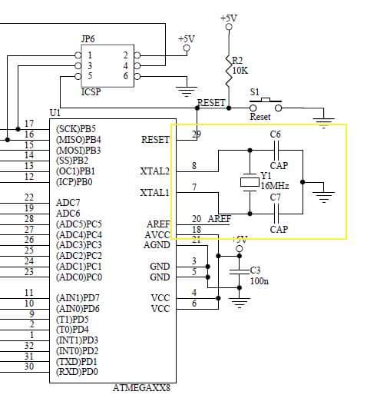**GSM Module Shield**

**Schematic Diagram**

**Alarm System**

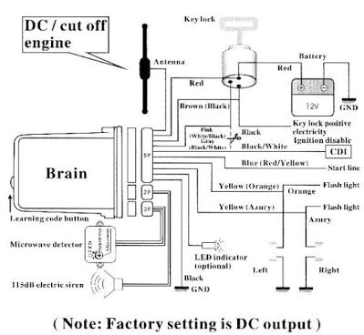

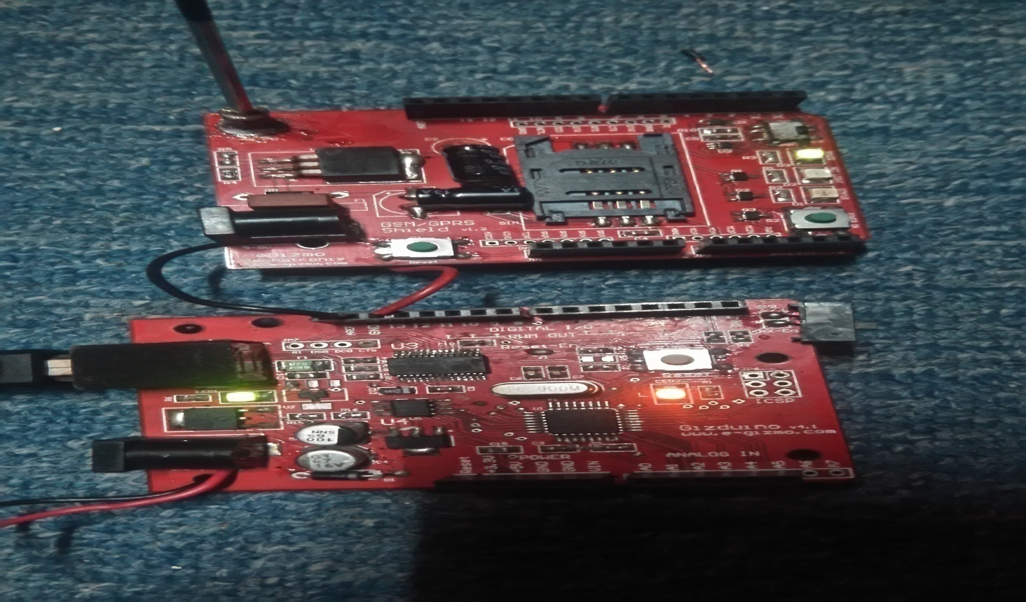**GSM MODULE AND GIZDUINO**

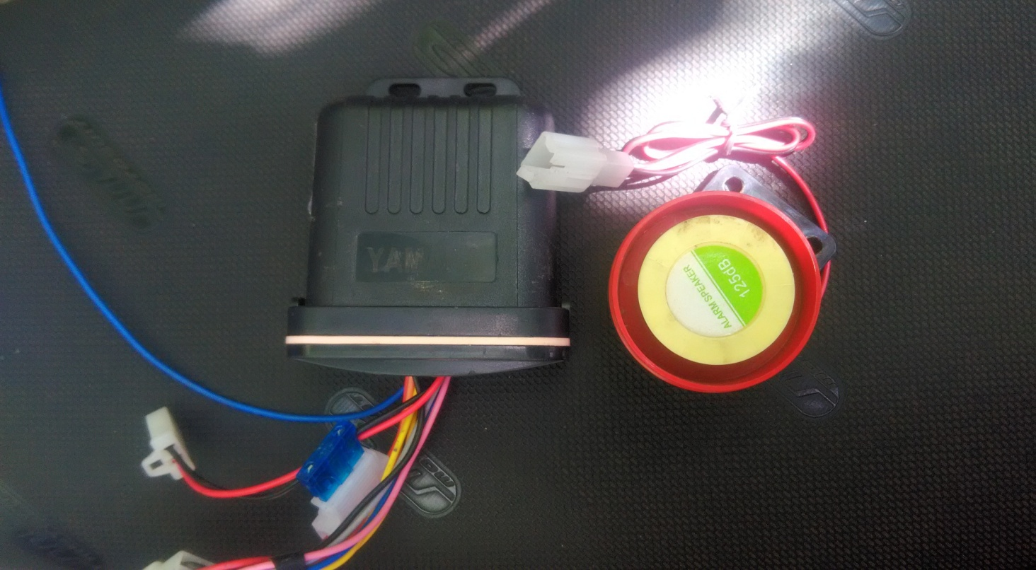**ALARM SYSTEM**

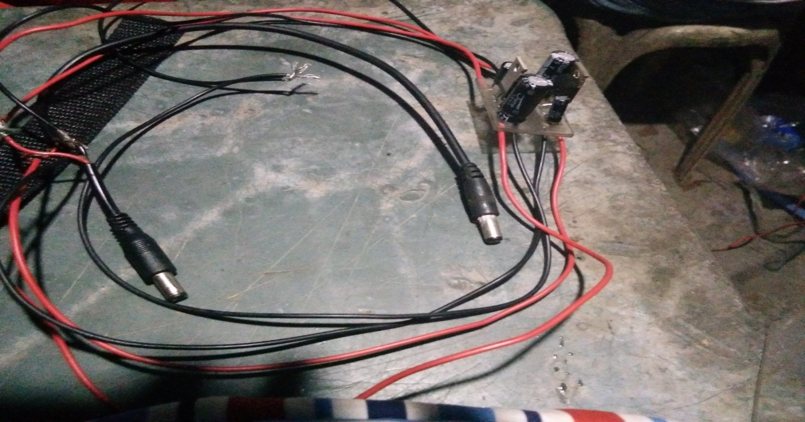**CONVERTER**

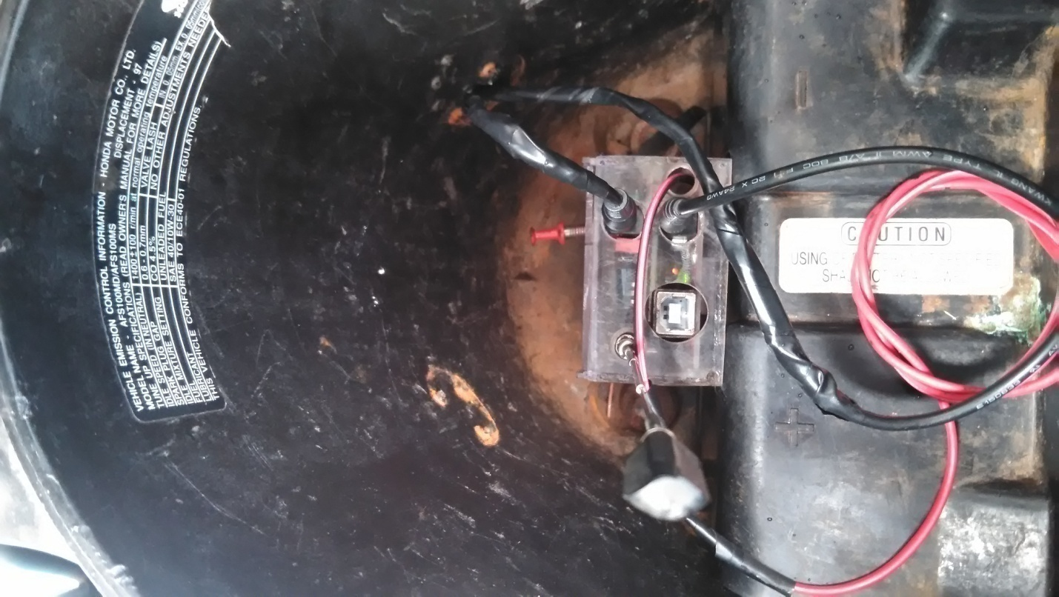

**WORKING GSM-MODULE AND GIZDUINO**

**APPENDIX C:**

**Evaluation Form**

**APPENDIX D:**

**Curriculum Vitae**