Step 1 - Equipment Setup

1. Remove the camera stand from it's bag and set it up to its full height in front of the first pew directly in the middle of the bench.
2. Open the camera case and attach the camera to the top of the stand and aim the camera in the direction of the pulpit.
3. Attach the ethernet adapter cable to the camera.
4. Attach the a CAT5 ethernet cable to the ethernet adapter. Run the other end of the CAT5 ethernet cable to the ethernet port in your chapel.
5. Connect the power plug and cable to the ethernet adapter and plug in the power cable.

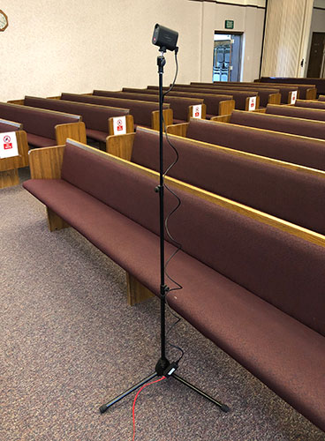

Step 2 - Connect to the Internet

 Wi-Fi service in meetinghouses (Liahona) is disabled during church sacrament meeting hours to allow broadcasts complete access to the bandwidth in the building. Therefore, a direct connection to the meethinghouse Meraki switch will give the Mevo camera the power and connectivity to the internet.

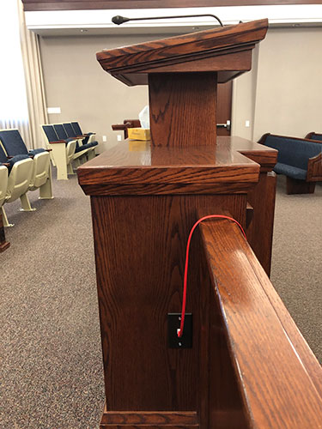

Step 3 - Download Mevo App (Skip if already done)

1. Using your phone or tablet, go to the Apple App Store or Google Play Store and download and install the free Mevo app.

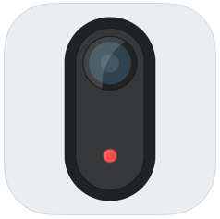

Step 4 - Connect Mevo App to Camera

1. Turn On the Mevo camera by pressing and holding the top button at the back of the camera for 3 seconds.
2. Open up the Mevo app on your device. It will automatically begin looking for the camera.
3. When the app opens up, ensure the "**Ethernet**" connection is stated at the bottom.
4. Click the blue "Connect" button.

If your connection is successful, you should now see what the camera is pointed at.

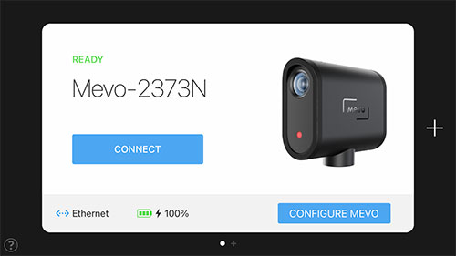

Step 5 - Recommended Camera Settings

The following settings have been tested and shown to deliver the best broadcast experience.

1. Tap the red record button on the bottom right of the Mevo app.
2. At the top of the app you will see a default quality setting of 1080p. Tap that and select 720p. This will ensure HD quality at a lower bitrate. Encoding at the higher bitrate (1080p) is not recommended.
3. In the audio settings, be sure to turn the "Auto Gain Control" off.

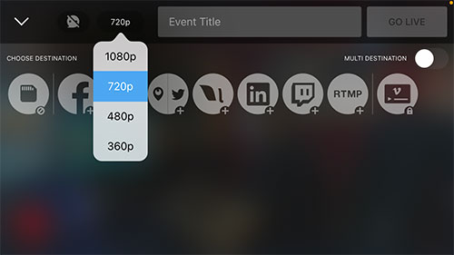

Select 720p for best results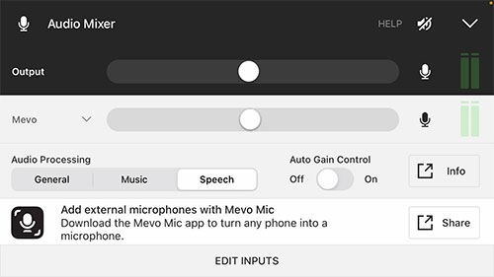

Turn off Auto Gain Control

Step 6 - Set RTMP Settings

This step only needs to be done once each Sunday by the first ward who sets up the equipment.

1. Tap the red record button. Then tap the RTMP icon.
2. Tap the "Configure" button at the bottom of the app.
3. Select your building (below), copy and paste the RTMP Url and Stream Key into the Mevo App.
4. Tap the "Save" button at the top right corner of the app.

Top of Form

Submit

If you don't know the code, please [contact support](https://highlandutahstake.avantsg.net/tech/broadcast/faq).

Bottom of Form

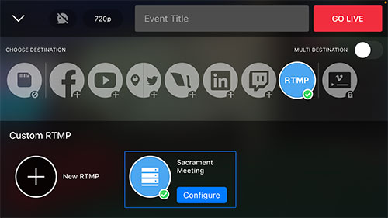

Setup RTMP settings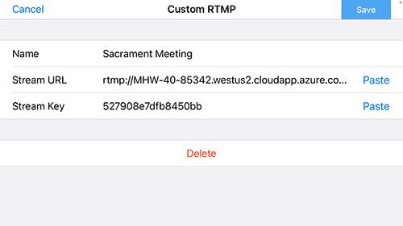

Copy and paste RTMP information here.

Step 7 - Start/Run Broadcast

1. To start streaming your meeting, tap the red "GO LIVE" button at the top of the app.



Start streaming with the GO LIVE button

Step 8 - Viewing A Broadcast

1. Send the following url to your ward members:

Top of Form

Viewing URL:



 Copy[View](http://mywebcast.churchofjesuschrist.org/highlandutahstake)

Bottom of Form

1. The viewer will see a list of broadcasts for our stake. They simply click the blue "View" button for their building to begin watching.
2. It is the responsibility of each ward to provide viewer support.

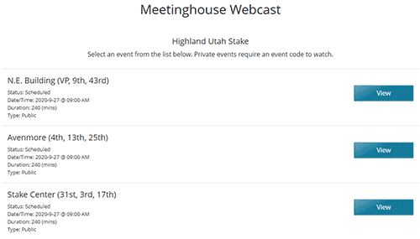

Step 9 - End Broadcast

1. Slide the red button at the bottom of the app to the right and click "OK".
2. Turn off the camera by pushing and holding the button on the back of it for 2 seconds.
3. If you are the last ward in your meetinghouse, disconnect all the cables carefully and return the camera, ethernet adaptor, red CAT7 cable and stand back in the broadcast bin.

