**PokeRun**

**Intro**

The game is called PokeRun

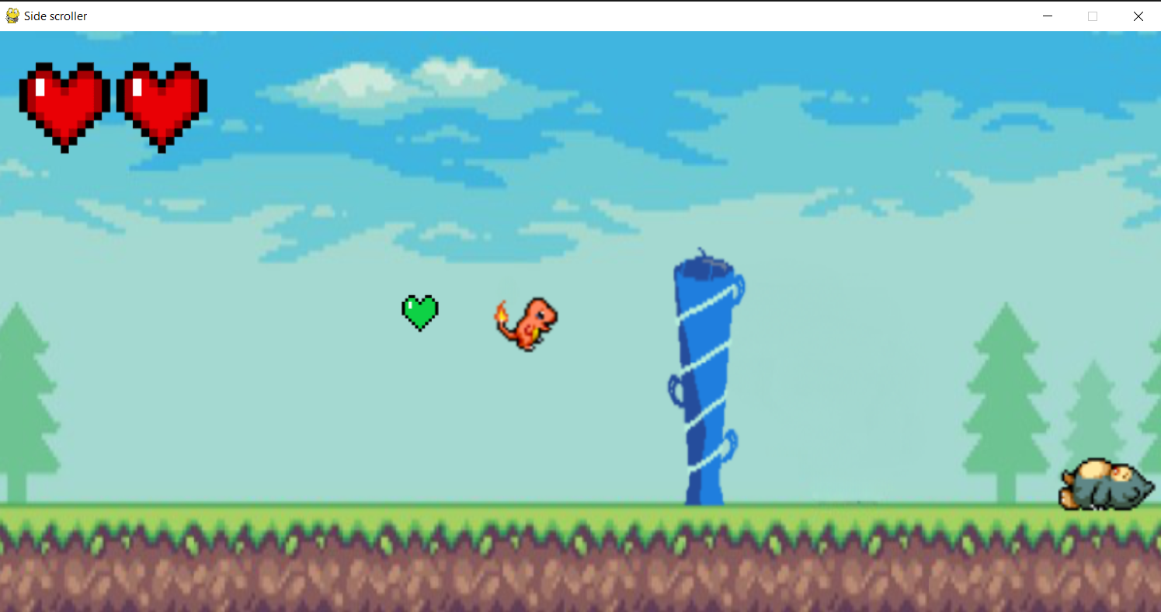

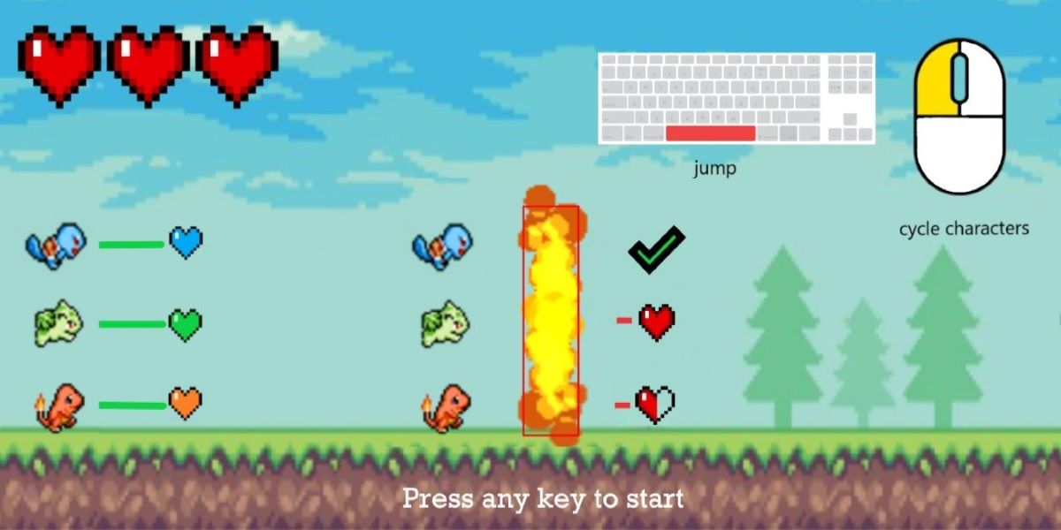

There is a start screen that summarizes how to play the game visually. It’s mostly self explanatory. How much damage you take from an obstacle will depend on which pokemon you use to run through it. Also health can only be picked up by the pokemon of the same type.

**To play the game:**

- git clone <https://github.com/trp02/pokeRun.git>

- have pygame installed

- run **main.py**

- versions used: **python 3.9.13**, **pygame 2.1.3**, should work on Windows and MacOS. Didn’t work on clemson SoC virtual desktop due to “no audio device” error. Primary way I ran it was on VSCode with pygame installed.

- **Controls** : Left click to cycle character and space to jump

**Game Design**

The game is an infinite side scroller. The player will have to cycle through characters and dodge obstacles that spawn randomly. As the game goes on it will become faster until it hits a cap and from there the goal is to last as long as possible. The gimmick is that there are obstacles that you can’t jump over. Rather you have to pick which character to cycle to in order to not take damage. And if you mess up the player will take damage based on how effective the obstacle type is compared to the pokemon running through it. Most other side scroller games from my experience have power ups that you can pick up for temporary boosts but in my game the “power up” is already there, you just have to learn when to pull it out.

There is no real story, just **survive**.

The primary emotion I want the player to feel is frustration. The game is simple on the surface but as the pace picks up the player will have less and less time to react to their surroundings and once they accidentally mess up once and lose health it’ll rattle them and lose concentration leading them to die soon after. The biggest challenge will be to find a rhythm and figure out a pattern for switching characters. So they’ll think something like: “Ok I need to switch to charmander to pick up this fire health pack and immediately after left click twice to change to bulbasaur to run through the water wall”. They will also need cold hands because if they accidentally click one too many times there might not be enough time to cycle back, essentially crippling any plan they had. The player will have to react quickly and more importantly, stay calm.

The aim is to get the high score and nothing else will be recorded because if you’re not first you’re last.

**Game Design Changes**

**Original Concept:**

At the base level the game will run in a familiar way. The player will be controlling a character and the goal is to keep them alive. As the game progresses it will become faster and it will be important to execute moves with precision and speed. The player will be able to switch between three characters which will be cycled in a set order. The player will have the freedom to switch as many times as they want. Each character will have a unique nature indicated by their color: fire, water and grass. If the player chooses the wrong character or gets hit by a neutral object they will die.

**Changes**:

Overall the gameplay itself is very similar to what was originally proposed. Most of the changes were visually. For most of the early development I was planning on the game having a much smoother style of graphics - not pixelated. But over time I realized in order to accomplish that I would need to create the art myself because it’s hard to find assets that mesh well together. For that reason I switched to pixel style.

Mechanics and gimmick are identical to what was originally envisioned.

**Development/Documentation**

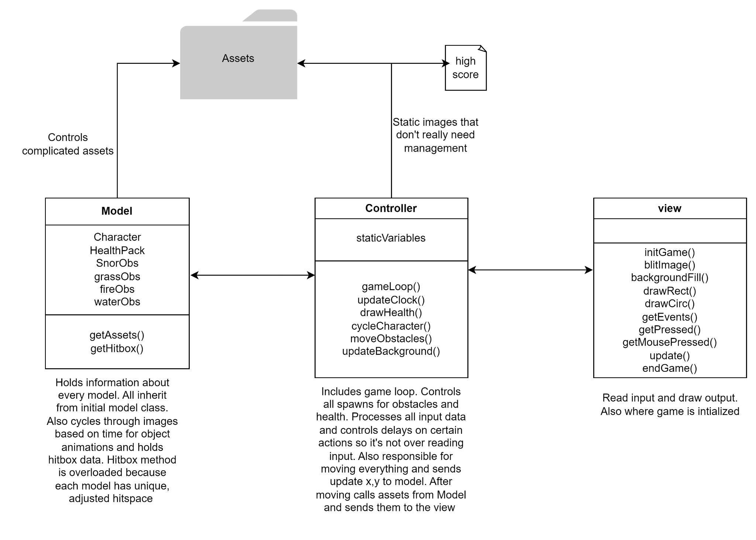

**Bugs**:

Game spawn works with real time so if you are playing the game and click on top to drag the window, obstacles spawning will screw up and clump together.

Also there has been a range of performance issues. From personal experience the game runs perfectly fine on my Windows desktop(as seen in video) but on my Macbook I’ve consistently encountered screen tearing. Possibly due to hardware and code optimization.

**Roles, Tasks, Performance**

Tirth- 100%

Obstacle system, animations, asset/hitbox adjustment, collisions, health system, input mechanics, interaction adjustment, game time, bug fixes, game movement, game docs, asset search, etc.

Milestone 1: Added rudimentary obstacle system, one character animations/movement, basic collision detection

Milestone 2: Added assets/animation for remaining characters, game pacing, remaining obstacles, game input/controls, adjusted hitboxes

Final: Health system, individual interaction finalized, eliminated bugs, highscore system and loading screens

Assets: <https://sprites.pmdcollab.org>, itch.io and other websites who I’m pretty sure just stole the art.

**DEMO:**

<https://www.youtube.com/watch?v=H4QhCFWzs68>