**Explained variance ratio for each component of PCA**

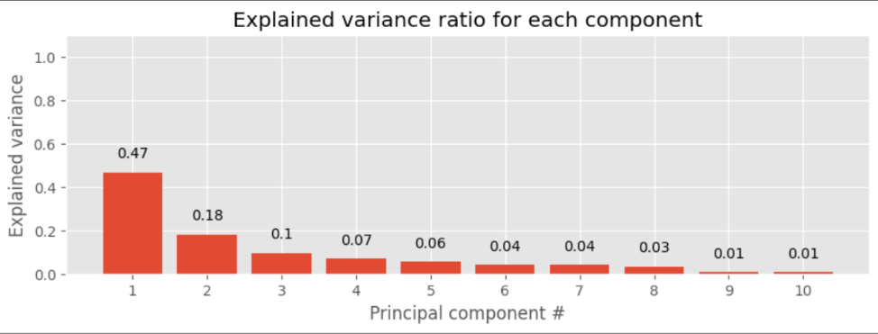

**Cumulative explained variance of PCA**

