TRPA
Cumulative Accounting Dashboards
Content review — track changes copy
Prepared for Ken Kasman + Dan Segan
2026-05-12
How to use this document
This document captures the visible copy of all 8 active TRPA cumulative-accounting dashboards plus a screenshot of each.
Mark edits using Word Track Changes (Review → Track Changes → All Markup). Add comments via Review → New Comment. Send the marked-up file back to Mason for integration.
Numerical values shown in the screenshots are live-as-of the screenshot timestamp; copy review focuses on labels, descriptions, and narrative text rather than the data values themselves.
Active dashboards in this review
1. Allocation Tracking · Track 1 (Allocation tracking) · Staff · daily ops
2. Pool Balance Cards · Track 1 (Allocation tracking) · Staff · per-pool drilldown
3. Residential Allocation Availability · Track 1 (Allocation tracking) · Public
4. Residential Additions by Source · Track 2 (Source of rights) · Leadership · public
5. Regional Plan Capacity Dial · Track 4 (Total development tracking) · Executive · board
6. Development History — Buildings · Companion view · Planners · analysts
7. Development History — Residential Units · Companion view · Housing analysts
8. QA Change Rationale Audit Trail · QA / audit · Ken · Dan · QA leads

1. Allocation Tracking
Track: Track 1 (Allocation tracking) Audience: Staff · daily ops File: allocation-tracking.html
Live URL: https://trpa-agency.github.io/Reporting/html/allocation-tracking.html
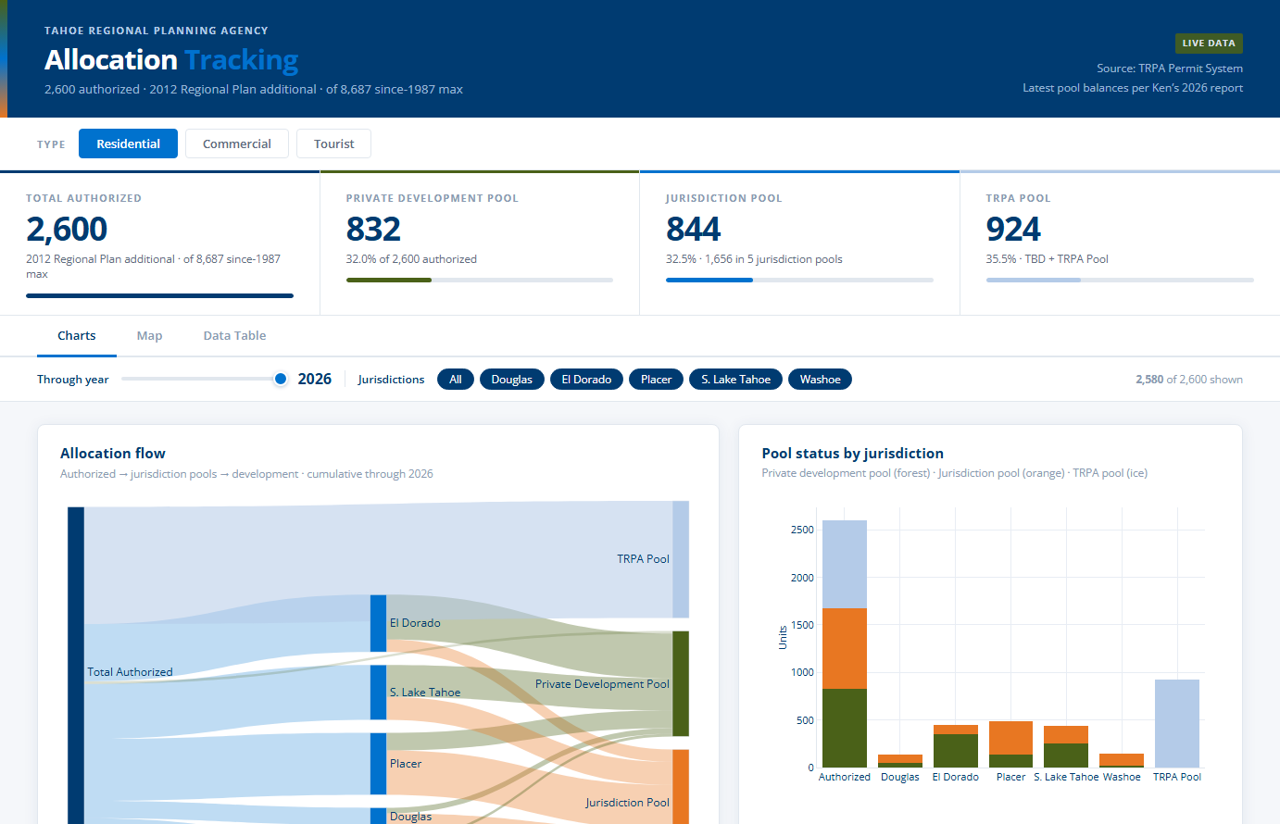

Header copy
Element | Text
Eyebrow | Tahoe Regional Planning Agency
Title | Allocation Tracking
Subtitle / tagline | 2,600 authorized · 2012 Regional Plan additional · of 8,687 since-1987 max
Header meta (top right) | Live Data

KPI cards
Label | Sub-text
Total authorized | 2012 Regional Plan additional · of 8,687 since-1987 max
Private development pool | loading…
Jurisdiction pool | loading…
TRPA pool | loading…

Section headings
Heading | Description
Allocation flow | Authorized → jurisdiction pools → development · cumulative through 2025
Pool status by jurisdiction | Private development pool (forest) · Jurisdiction pool (orange) · TRPA pool (ice)
Pool summary by jurisdiction | Total authorized units per pool, allocation status, and utilization rate
Loading allocation data… | (no description)

Control labels (buttons / toggles)
Residential · Commercial · Tourist

2. Pool Balance Cards
Track: Track 1 (Allocation tracking) Audience: Staff · per-pool drilldown File: pool-balance-cards.html
Live URL: https://trpa-agency.github.io/Reporting/html/pool-balance-cards.html
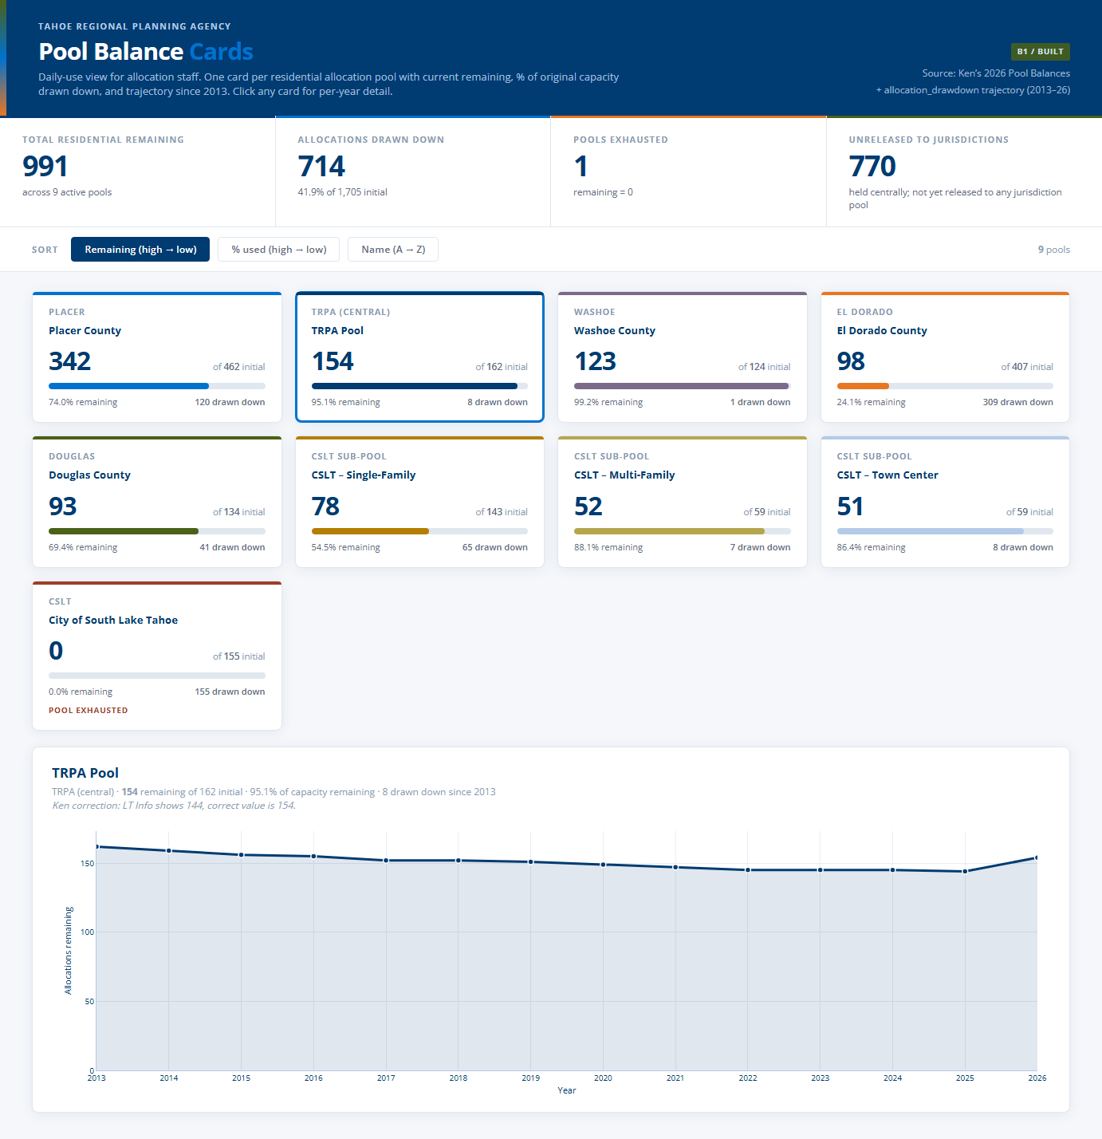

Header copy
Element | Text
Eyebrow | Tahoe Regional Planning Agency
Title | Pool Balance Cards
Subtitle / tagline | Daily-use view for allocation staff. One card per residential allocation pool with current remaining, % of original capacity drawn down, and trajectory since 2013. Click any card for per-year detail.
Header meta (top right) | B1 / Built

KPI cards
Label | Sub-text
Total residential remaining
Allocations drawn down
Pools exhausted
Unreleased to jurisdictions

Section headings
Heading | Description
Pool detail | (no description)

Control labels (buttons / toggles)
Remaining (high → low) · % used (high → low) · Name (A → Z)

Footnote / data attribution
Data: remaining counts inlined from from_ken/Additional Development as of April2026.xlsx — LT Info Pools Balances sheet (with Ken’s correction note: TRPA Pool is 154, LT Info shows 144 incorrectly). Per-year trajectory inlined from html/allocation_drawdown.html’s embedded series. Eventually backed by PoolDrawdownYearly (see dashboards_to_schema_trace.md Trace 2 / G2.1). Cluster B1 in proposed_dashboards.md.

3. Residential Allocation Availability
Track: Track 1 (Allocation tracking) Audience: Public File: public-allocation-availability.html
Live URL: https://trpa-agency.github.io/Reporting/html/public-allocation-availability.html
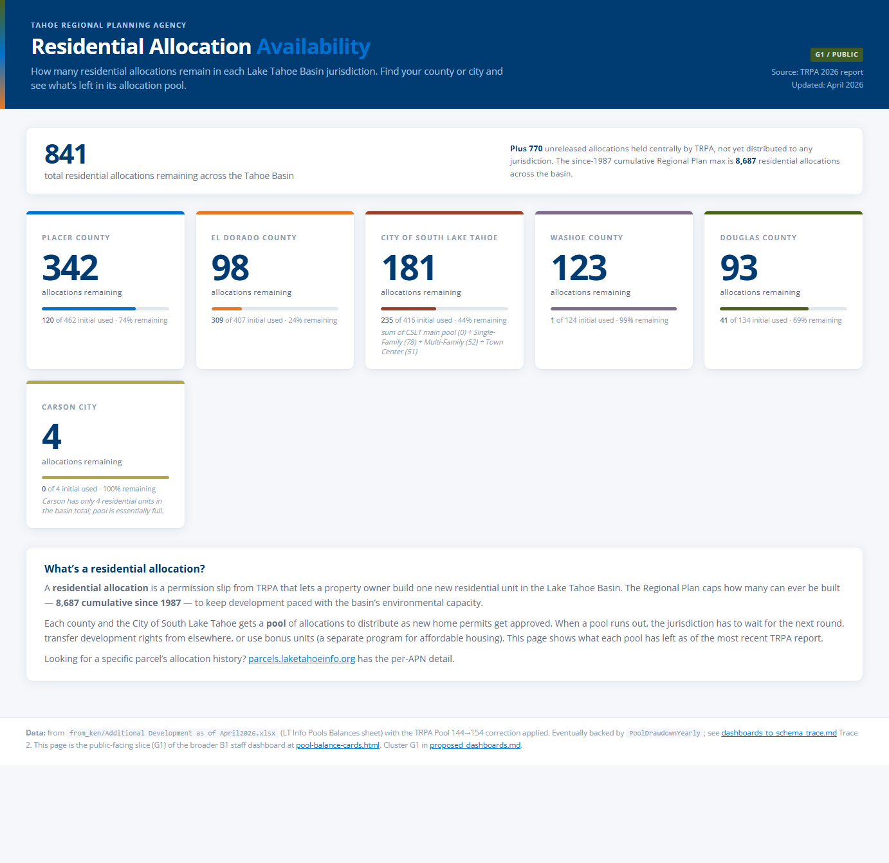

Header copy
Element | Text
Eyebrow | Tahoe Regional Planning Agency
Title | Residential Allocation Availability
Subtitle / tagline | How many residential allocations remain in each Lake Tahoe Basin jurisdiction. Find your county or city and see what’s left in its allocation pool.
Header meta (top right) | G1 / Public

Section headings
Heading | Description
What’s a residential allocation? | (no description)

Footnote / data attribution
Data: from from_ken/Additional Development as of April2026.xlsx (LT Info Pools Balances sheet) with the TRPA Pool 144→154 correction applied. Eventually backed by PoolDrawdownYearly; see dashboards_to_schema_trace.md Trace 2. This page is the public-facing slice (G1) of the broader B1 staff dashboard at pool-balance-cards.html. Cluster G1 in proposed_dashboards.md.

4. Residential Additions by Source
Track: Track 2 (Source of rights) Audience: Leadership · public File: residential-additions-by-source.html
Live URL: https://trpa-agency.github.io/Reporting/html/residential-additions-by-source.html
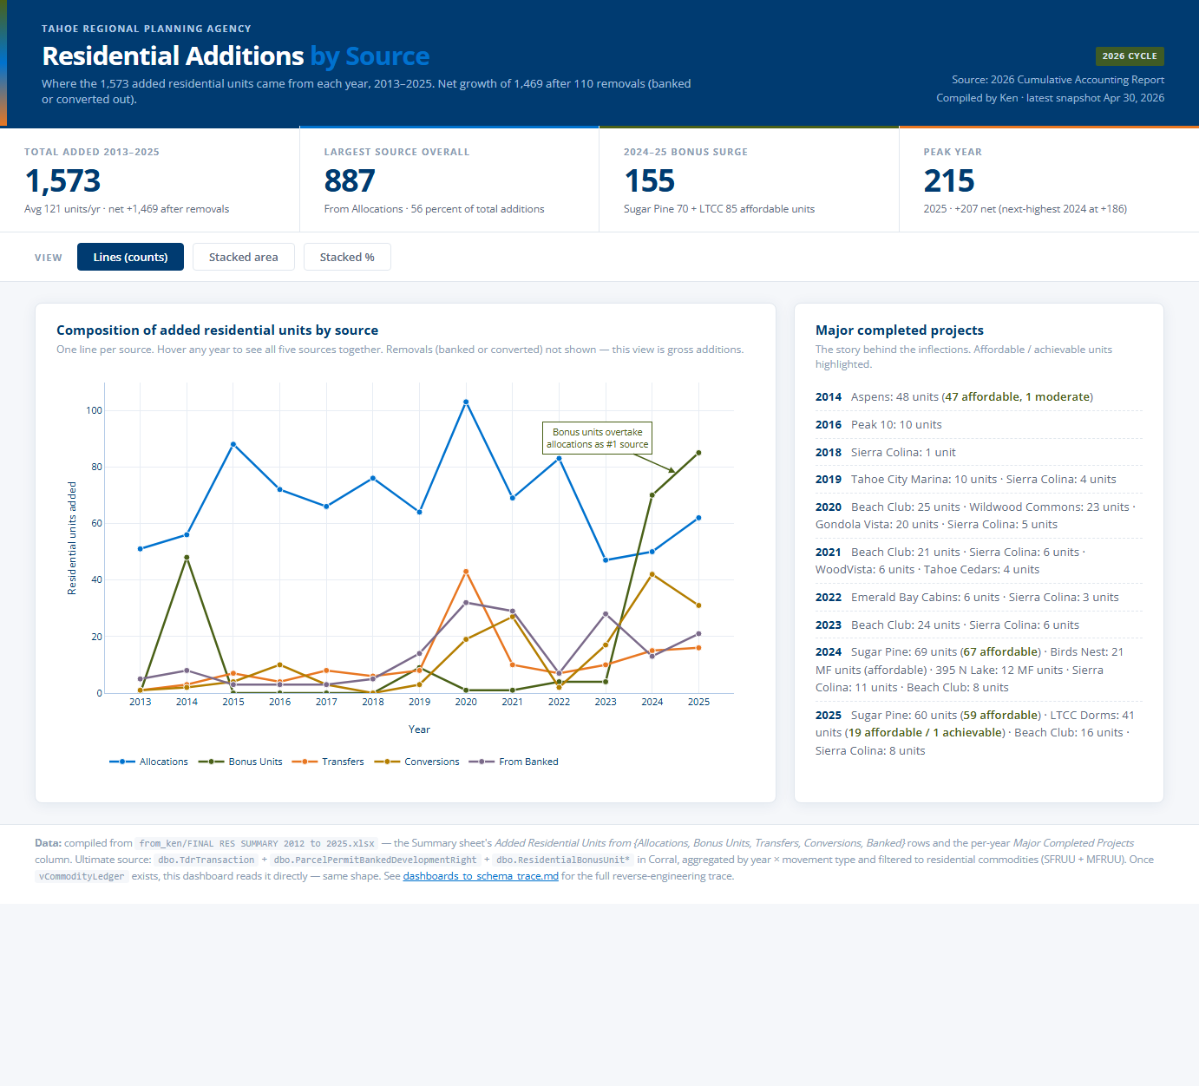

Header copy
Element | Text
Eyebrow | Tahoe Regional Planning Agency
Title | Residential Additions by Source
Subtitle / tagline | Where the 1,573 added residential units came from each year, 2013–2025. Net growth of 1,469 after 110 removals (banked or converted out).
Header meta (top right) | 2026 Cycle

KPI cards
Label | Sub-text
Total added 2013–2025
Largest source overall
2024–25 bonus surge
Peak year

Section headings
Heading | Description
Composition of added residential units by source | One line per source. Hover any year to see all five sources together. Removals (banked or converted) not shown — this view is gross additions.
Major completed projects | The story behind the inflections. Affordable / achievable units highlighted.

Control labels (buttons / toggles)
Lines (counts) · Stacked area · Stacked %

Footnote / data attribution
Data: compiled from from_ken/FINAL RES SUMMARY 2012 to 2025.xlsx — the Summary sheet's Added Residential Units from {Allocations, Bonus Units, Transfers, Conversions, Banked} rows and the per-year Major Completed Projects column. Ultimate source: dbo.TdrTransaction + dbo.ParcelPermitBankedDevelopmentRight + dbo.ResidentialBonusUnit* in Corral, aggregated by year × movement type and filtered to residential commodities (SFRUU + MFRUU). Once vCommodityLedger exists, this dashboard reads it directly — same shape. See dashboards_to_schema_trace.md for the full reverse-engineering trace.

5. Regional Plan Capacity Dial
Track: Track 4 (Total development tracking) Audience: Executive · board File: regional-capacity-dial.html
Live URL: https://trpa-agency.github.io/Reporting/html/regional-capacity-dial.html
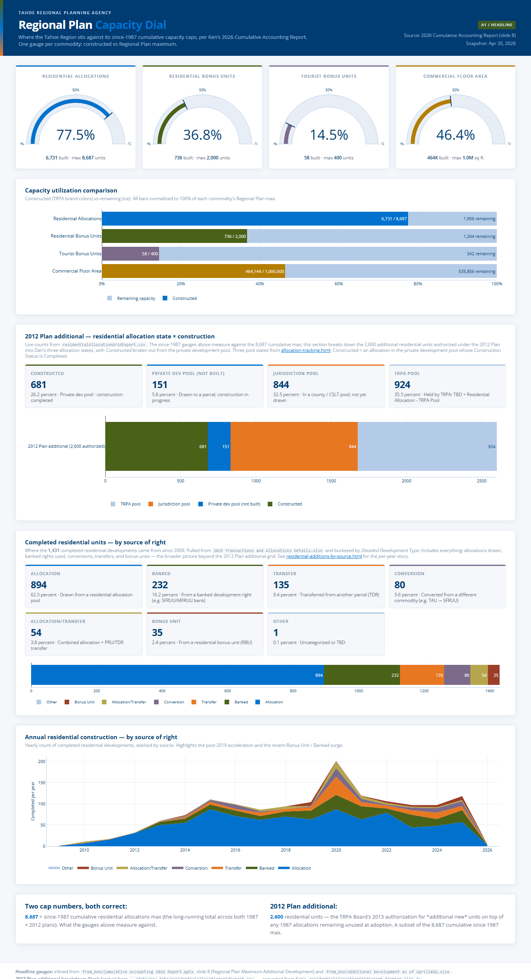

Header copy
Element | Text
Eyebrow | Tahoe Regional Planning Agency
Title | Regional Plan Capacity Dial
Subtitle / tagline | Where the Tahoe Region sits against its since-1987 cumulative capacity caps, per Ken’s 2026 Cumulative Accounting Report. One gauge per commodity: constructed vs Regional Plan maximum.
Header meta (top right) | A1 / Headline

Section headings
Heading | Description
2012 Plan additional — residential allocation state × construction | Live counts from residentialAllocationGridExport.csv. The since-1987 gauges above measure against the 8,687 cumulative max; this section breaks down the 2,600 additional residential units authorized under the 2012 Plan into Dan’s three allocation states, with Constructed broken out from the private development pool. Three pool states from allocation-tracking.html; Constructed = an allocation in the private development pool whose Construction Status is Completed.
Completed residential units — by source of right | Where the — completed residential developments came from since 2009. Pulled from 2025 Transactions and Allocations Details.xlsx and bucketed by Detailed Development Type. Includes everything: allocations drawn, banked rights used, conversions, transfers, and bonus units — the broader picture beyond the 2012 Plan additional grid. See residential-additions-by-source.html for the per-year story.
Annual residential construction — by source of right | Yearly count of completed residential developments, stacked by source. Highlights the post-2019 acceleration and the recent Bonus Unit / Banked surge.
Capacity utilization comparison | (no description)

Footnote / data attribution
Headline gauges: inlined from from_ken/Cumulative Accounting 2026 Report.pptx slide 8 (Regional Plan Maximum Additional Development) and from_ken/Additional Development as of April2026.xlsx. 2012 Plan additional breakdown (live): fetched from ../data/raw_data/residentialAllocationGridExport.csv — converted from Ken’s residentialAllocationGridExport_fromKen.xlsx by parcel_development_history_etl/scripts/convert_allocation_grid.py. Buckets follow Dan’s 5/11/2026 framing: Constructed = Allocated & Construction Status = Completed, Private dev pool (not built) = Allocated & Not Completed, Jurisdiction pool = Unallocated in a county/CSLT pool, TRPA pool = Unallocated in “Residential Allocation - TRPA Pool” + Unreleased (TBD). Eventually backed by CumulativeAccountingSnapshot aggregated to Regional totals — see dashboards_to_schema_trace.md Trace 1. Cluster A1 in proposed_dashboards.md.

6. Development History — Buildings
Track: Companion view Audience: Planners · analysts File: development_history.html
Live URL: https://trpa-agency.github.io/Reporting/html/development_history.html
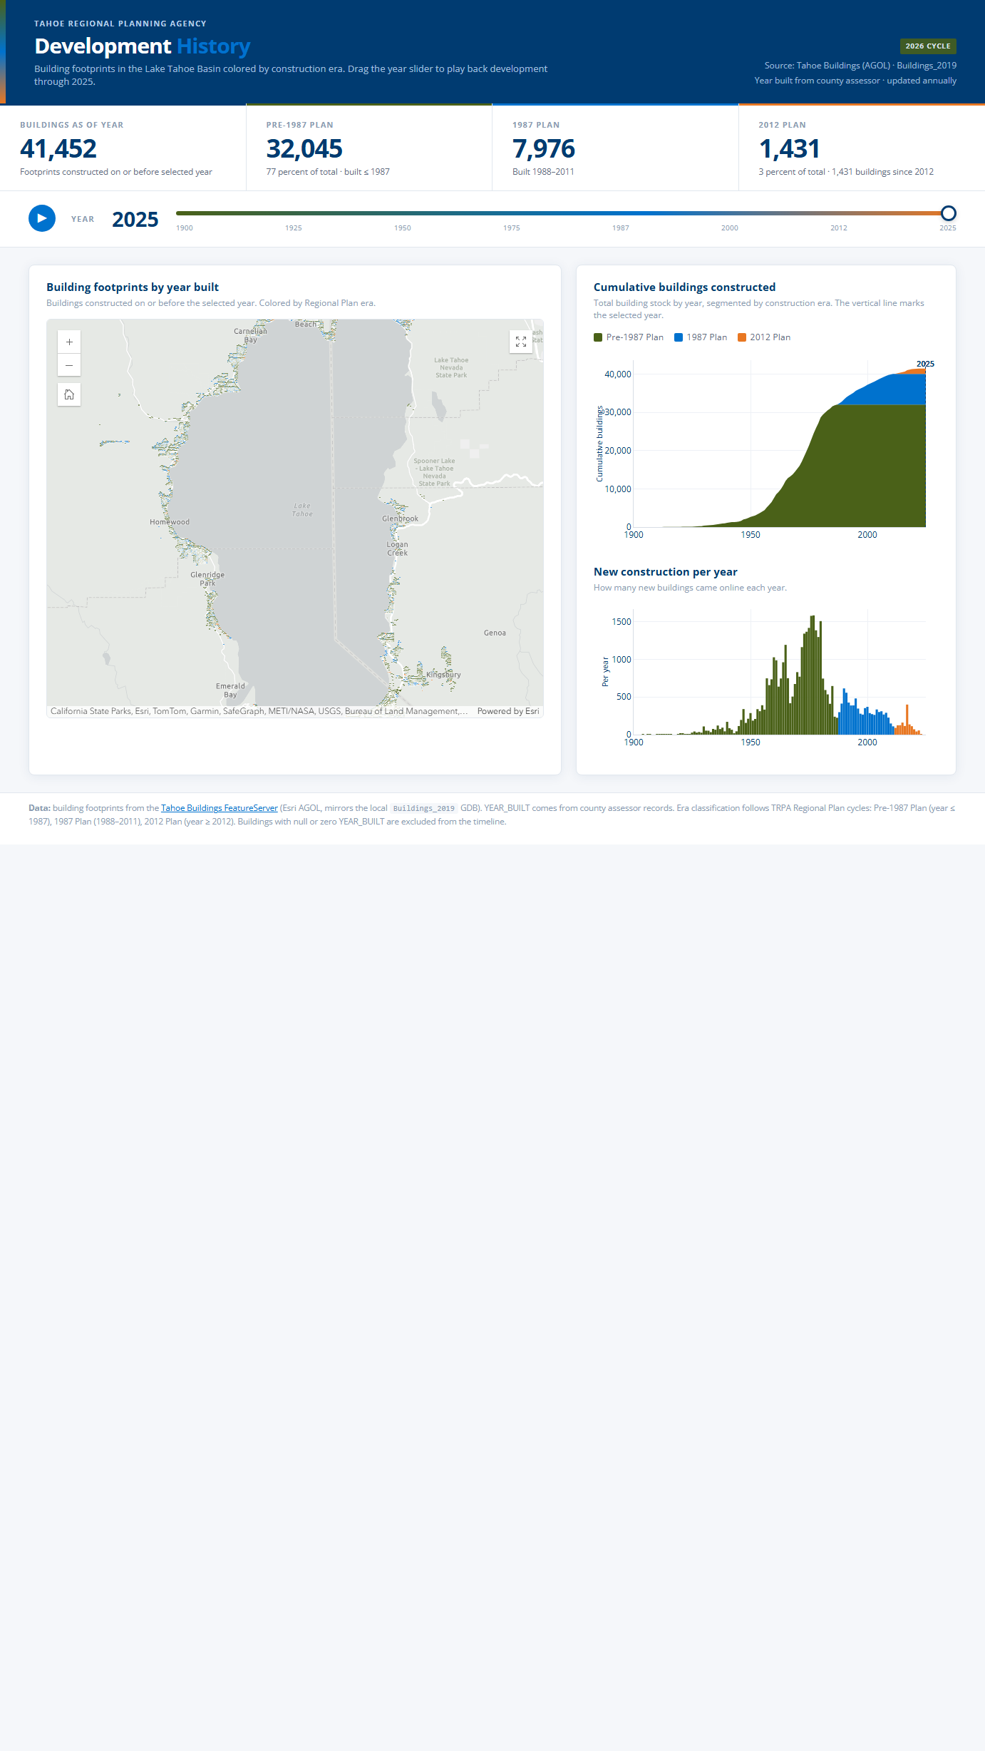

Header copy
Element | Text
Eyebrow | Tahoe Regional Planning Agency
Title | Development History
Subtitle / tagline | Building footprints in the Lake Tahoe Basin colored by construction era. Drag the year slider to play back development through 2025.
Header meta (top right) | 2026 Cycle

KPI cards
Label | Sub-text
Buildings as of year
Pre-1987 Plan
1987 Plan
2012 Plan

Section headings
Heading | Description
Building footprints by year built | Buildings constructed on or before the selected year. Colored by Regional Plan era.
Cumulative buildings constructed | Total building stock by year, segmented by construction era. The vertical line marks the selected year.
New construction per year | (no description)

Footnote / data attribution
Data: building footprints from the Tahoe Buildings FeatureServer (Esri AGOL, mirrors the local Buildings_2019 GDB). YEAR_BUILT comes from county assessor records. Era classification follows TRPA Regional Plan cycles: Pre-1987 Plan (year ≤ 1987), 1987 Plan (1988–2011), 2012 Plan (year ≥ 2012). Buildings with null or zero YEAR_BUILT are excluded from the timeline.

7. Development History — Residential Units
Track: Companion view Audience: Housing analysts File: development_history_units.html
Live URL: https://trpa-agency.github.io/Reporting/html/development_history_units.html
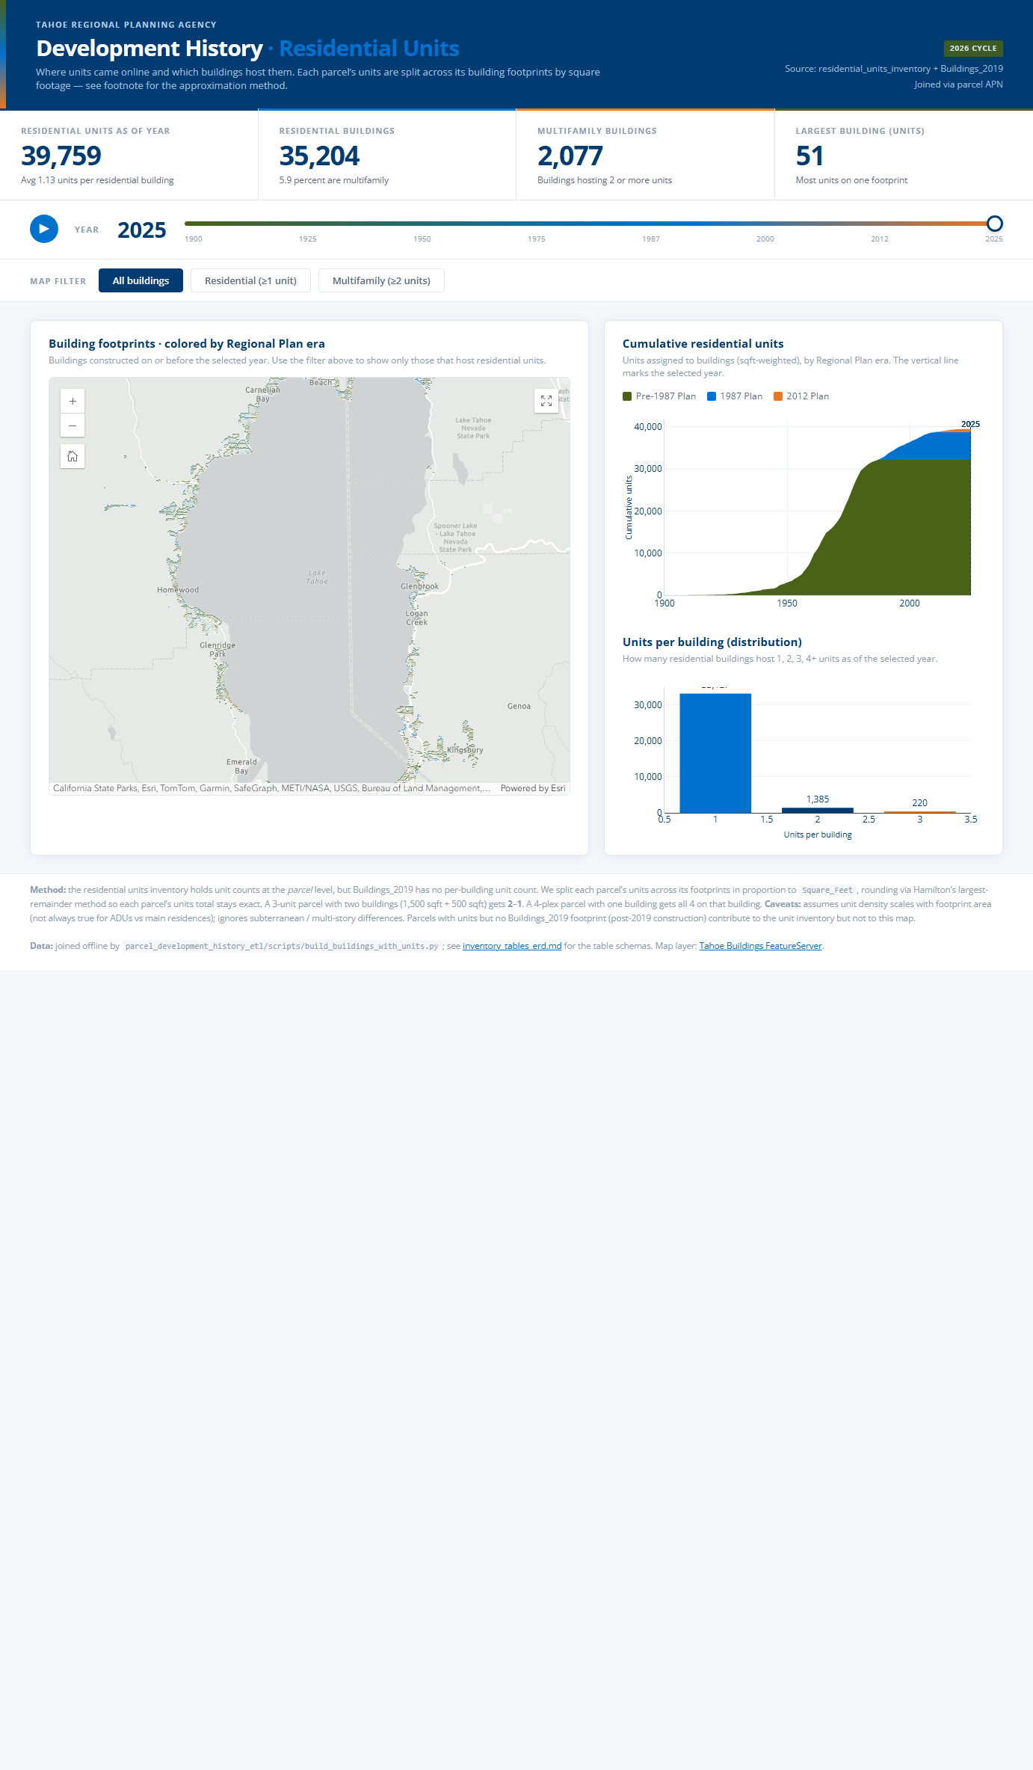

Header copy
Element | Text
Eyebrow | Tahoe Regional Planning Agency
Title | Development History · Residential Units
Subtitle / tagline | Where units came online and which buildings host them. Each parcel’s units are split across its building footprints by square footage — see footnote for the approximation method.
Header meta (top right) | 2026 Cycle

KPI cards
Label | Sub-text
Residential units as of year
Residential buildings
Multifamily buildings
Largest building (units)

Section headings
Heading | Description
Building footprints · colored by Regional Plan era | Buildings constructed on or before the selected year. Use the filter above to show only those that host residential units.
Cumulative residential units | Units assigned to buildings (sqft-weighted), by Regional Plan era. The vertical line marks the selected year.
Units per building (distribution) | (no description)

Control labels (buttons / toggles)
All buildings · Residential (≥1 unit) · Multifamily (≥2 units)

Footnote / data attribution
Method: the residential units inventory holds unit counts at the parcel level, but Buildings_2019 has no per-building unit count. We split each parcel’s units across its footprints in proportion to Square_Feet, rounding via Hamilton’s largest-remainder method so each parcel’s units total stays exact. A 3-unit parcel with two buildings (1,500 sqft + 500 sqft) gets 2–1. A 4-plex parcel with one building gets all 4 on that building. Caveats: assumes unit density scales with footprint area (not always true for ADUs vs main residences); ignores subterranean / multi-story differences. Parcels with units but no Buildings_2019 footprint (post-2019 construction) contribute to the unit inventory but not to this map. Data: joined offline by parcel_development_history_etl/scripts/build_buildings_with_units.py; see inventory_tables_erd.md for the table schemas. Map layer: Tahoe Buildings FeatureServer.

8. QA Change Rationale Audit Trail
Track: QA / audit Audience: Ken · Dan · QA leads File: qa-change-rationale.html
Live URL: https://trpa-agency.github.io/Reporting/html/qa-change-rationale.html
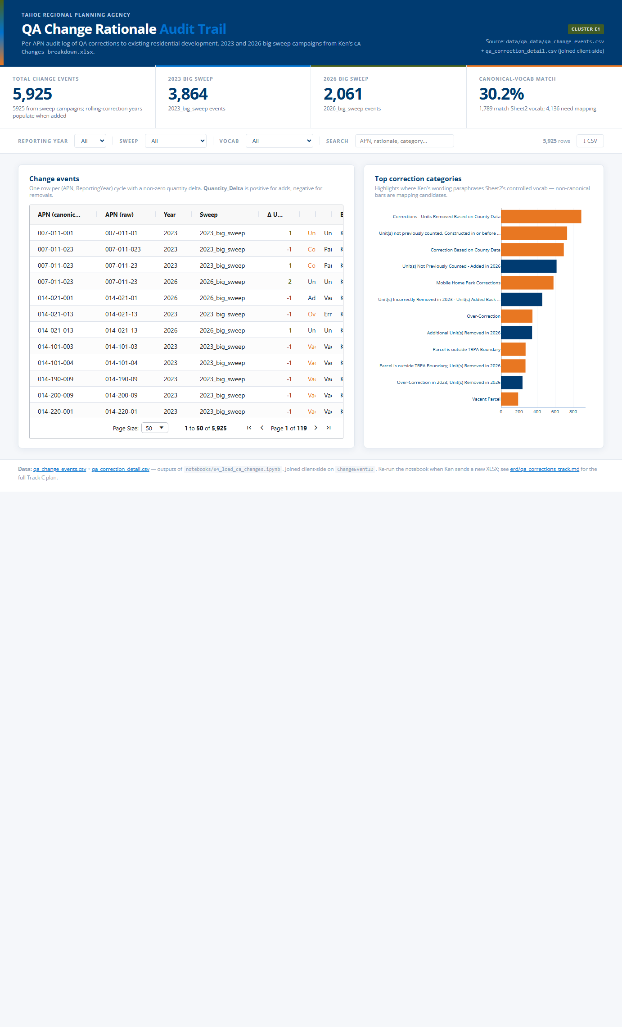

Header copy
Element | Text
Eyebrow | Tahoe Regional Planning Agency
Title | QA Change Rationale Audit Trail
Subtitle / tagline | Per-APN audit log of QA corrections to existing residential development. 2023 and 2026 big-sweep campaigns from Ken’s CA Changes breakdown.xlsx.
Header meta (top right) | Cluster E1

KPI cards
Label | Sub-text
Total change events
2023 big sweep
2026 big sweep
Canonical-vocab match

Section headings
Heading | Description
Change events | One row per (APN, ReportingYear) cycle with a non-zero quantity delta. Quantity_Delta is positive for adds, negative for removals.
Top correction categories | Highlights where Ken's wording paraphrases Sheet2’s controlled vocab — non-canonical bars are mapping candidates.
Loading QA change events… | (no description)

Footnote / data attribution
Data: qa_change_events.csv + qa_correction_detail.csv — outputs of notebooks/04_load_ca_changes.ipynb. Joined client-side on ChangeEventID. Re-run the notebook when Ken sends a new XLSX; see erd/qa_corrections_track.md for the full Track C plan.

Notes & open questions for the team
Use this section to capture any cross-cutting questions, vocabulary suggestions, or items that touch more than one dashboard.
Cross-dashboard reconciliation (verified after Ken's April 2026 update):
- Allocation Tracking KPIs sum to 2,600 (Private dev pool 832 + Jurisdiction pool 844 + TRPA pool 924).
- Regional Plan Capacity Dial 2012 Plan additional cards sum to 2,600 (Constructed 681 + Private dev pool not built 151 + Jurisdiction pool 844 + TRPA pool 924).
- Pool Balance Cards staff total 991 = 154 TRPA + 837 jurisdictions (matches Ken's xlsx exactly).
- Public Allocation Availability totals 841 = 837 jurisdictions + 4 Carson (Ken's table excludes Carson; we keep it for completeness).

Ken's review focus suggestions:
- Pool / state vocabulary — does 'TRPA pool', 'Jurisdiction pool', 'Private development pool' read correctly to a developer or board member?
- Source-of-rights labels — 'Allocation / Banked / Transfer / Conversion / Bonus Unit' — any of these confusing or duplicative?
- Era cutoff labels — 'Pre-1987 Plan', '1987 Plan', '2012 Plan' — preferred phrasing for non-staff audience?
- Footnote attribution language — do data sources need to be more / less prominent on the public-facing pages?

