**Project Name**

Project Integrity

**Team Member Names**

Christine Zheng

Haotian Xu

Michelle Ching

Nathan Pham

**User Need**

How might we make different political opinions and/or news more readily accessible to people who don’t want to deviate from their current routine?

**Iconic Image**

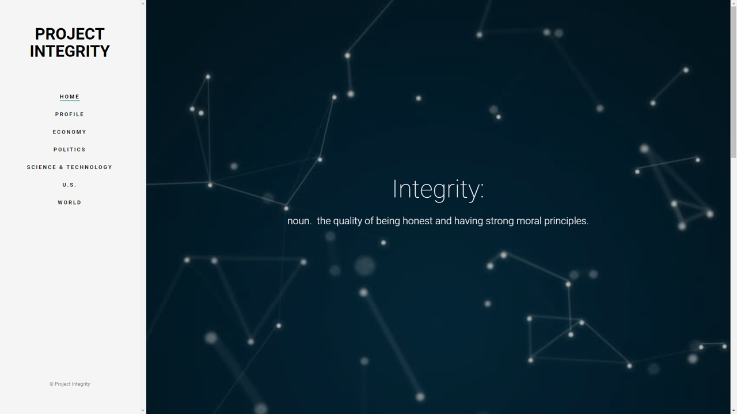

**Submitted Materials**

P1 https://drive.google.com/open?id=1s_Sf4gNAN7COlG0ucwIOBlBKN5-xtmp71gOIzKQEUJM

P2 https://drive.google.com/open?id=115AOAqXIIdtUFUC4Hx2-u5UOg-CwmOao5PmYK1jUr-8

P3 https://drive.google.com/open?id=1REPs3D4_rJjPqb_nVm0iAQrYU74pyLoPk32JkEd9xck

P4 https://drive.google.com/open?id=1ukQL_kXnc0Jx9t75QfdfOWctrcygz7NGlDhMo87R6jc

P5 https://drive.google.com/open?id=1V9wMmLsVZvXzvZ9AZmoOV7cILsi2YGoHdETCGZcXKys

P6-A https://drive.google.com/open?id=1rQPMnp9XKjt9KdML2TWdYeKxdjBOdDjO3HFE_a9etaU

P6-B https://drive.google.com/open?id=1z9WZFfthfEFnDZ6dgkhBPE8Jojl8cyuaJIhV3QhkkHg

https://drive.google.com/open?id=1SNUokjCFMNFxRjCn5DN7Tg3neifnqag6iM3avg6tCH8

P7-A https://drive.google.com/open?id=1VkXtJxlVs03sPqwTr1h52Qr0oRN28HCvrUJDEvvvRdc

https://drive.google.com/open?id=1a8f1OGqzCFO_p2g9oWdVhrNBX3hUkqESUKDefPdKYXM

P7-B https://drive.google.com/open?id=1UmAotUZCDYXXl97IK0hhBD9tdavZsTFX

https://drive.google.com/open?id=1VocZftMvMO-6LbufRkknZhf2n5XzzIOy

https://drive.google.com/open?id=17icAQ6cSBpqqDs-smKE_CmXVGvLxaUfq

**Video Demo**

https://photos.app.goo.gl/B7SKeXkkJWCUxMaf1