Hospital Database Project Report
Group: Team Omega
Date: May 20, 2025
Overview: This report details the redesigned hospital database schema and presents the SQL query results with embedded screenshots.

Part I – Design

ER Diagram
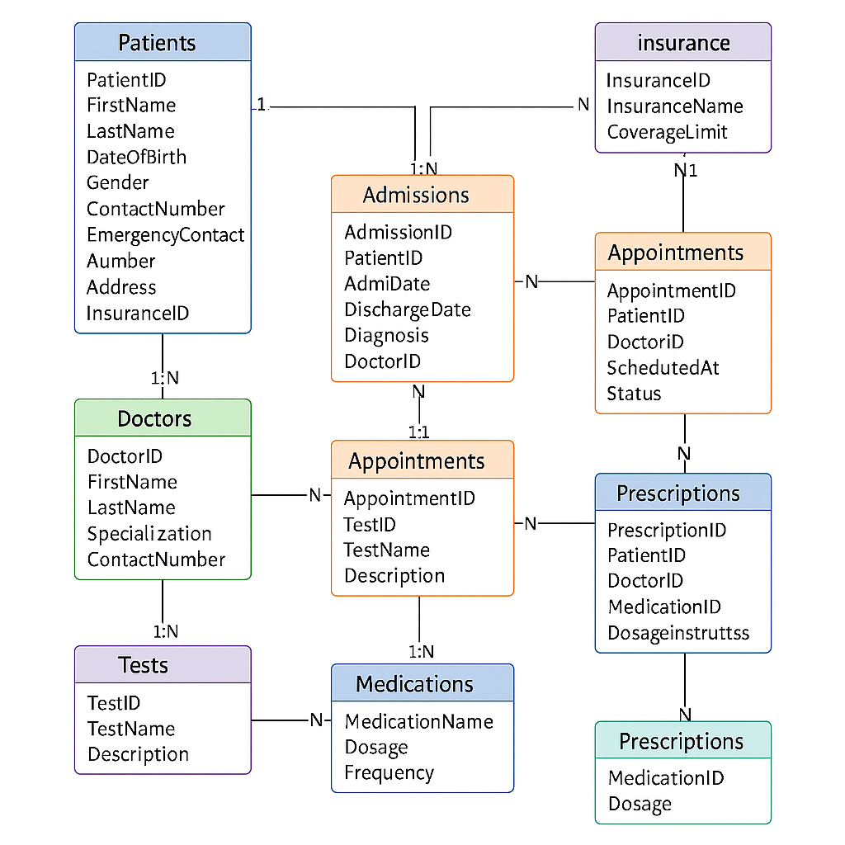
Figure 1: Entity-Relationship diagram depicting the alternate schema with colored entities and cardinalities.

Relational Model
Table | Primary Key | Foreign Keys
COVERAGES | CoverageID | —
CLIENTS | ClientID | CoverageID → COVERAGES.CoverageID
DOCTORS | DoctorID | —
CAREGIVERS | CaregiverID | —
HOSPITALIZATIONS | HospID | ClientID → CLIENTS; AttendingDoc → DOCTORS
SCHEDULES | ScheduleID | ClientID → CLIENTS; DoctorID → DOCTORS
DIAGNOSTICS | TestCode | —
DIAG_RESULTS | ResultCode | TestCode → DIAGNOSTICS; ClientID → CLIENTS
DRUGS | DrugCode | —
PRESCRIPTIONS | RXID | ClientID → CLIENTS; DoctorID → DOCTORS; DrugCode → DRUGS
This relational layout shows tables, primary keys, and foreign key linkages ensuring data integrity.

Part II – Query Result Screenshots

Conclusion
In conclusion, the alternate schema provides a robust framework for managing hospital data. The ER diagram and relational model ensure comprehensive data integrity, and the SQL query results validate the system's ability to handle critical reporting scenarios. This report demonstrates both design and functionality in a cohesive document.

