Moein Almasi

almasimm@myumanitoba.ca

unit testing in android studio

This is step by step guide on creating basic project and implement a local unit test using Junit. Either you can follow the steps or you can directly pull the application from:

<https://github.com/moeinalmasi/UnitTest>

First we go ahead and create the simple project using android studio using following steps:

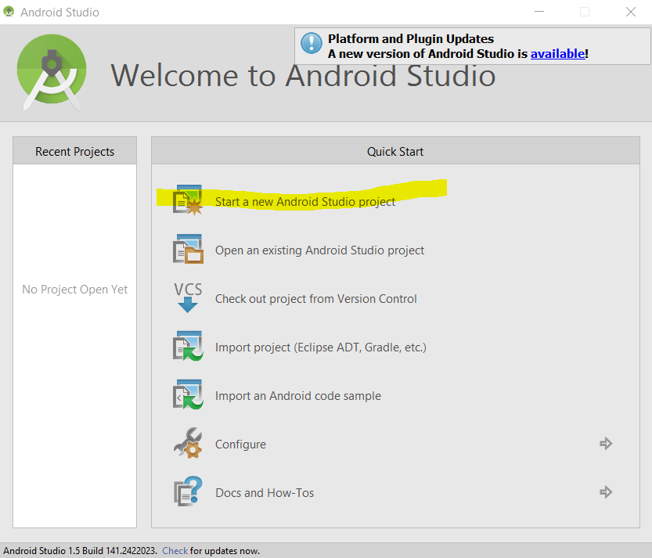

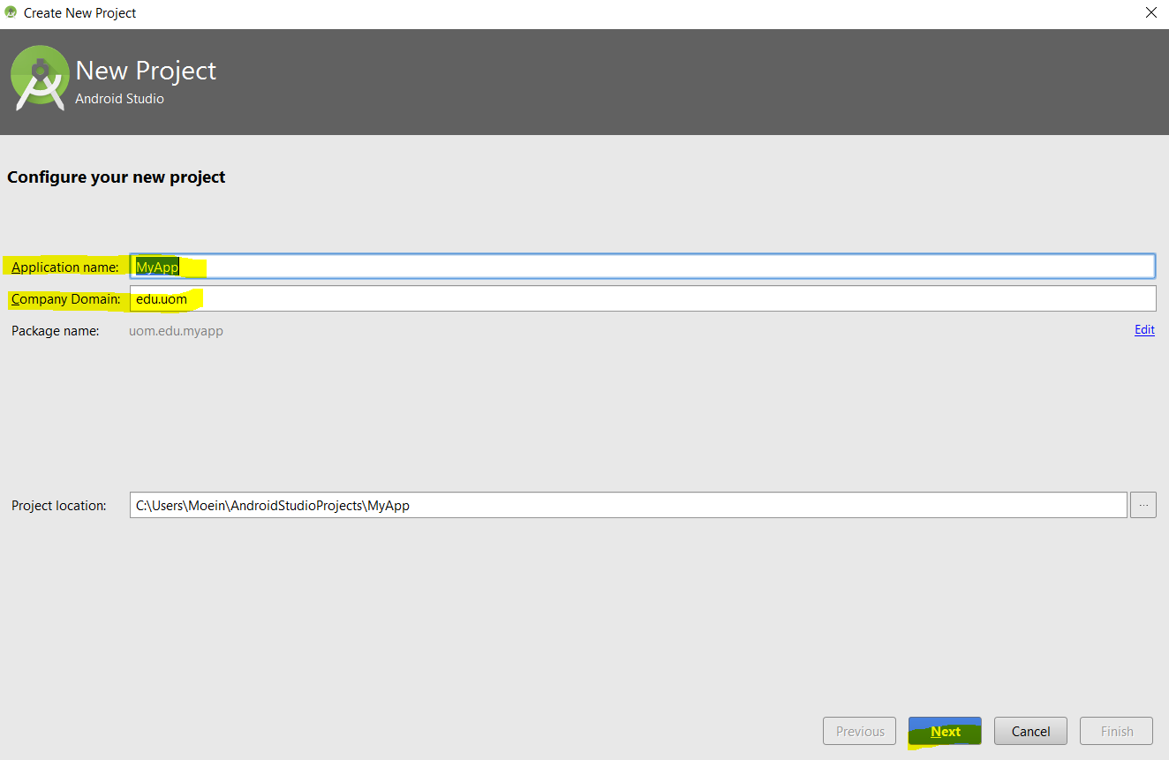

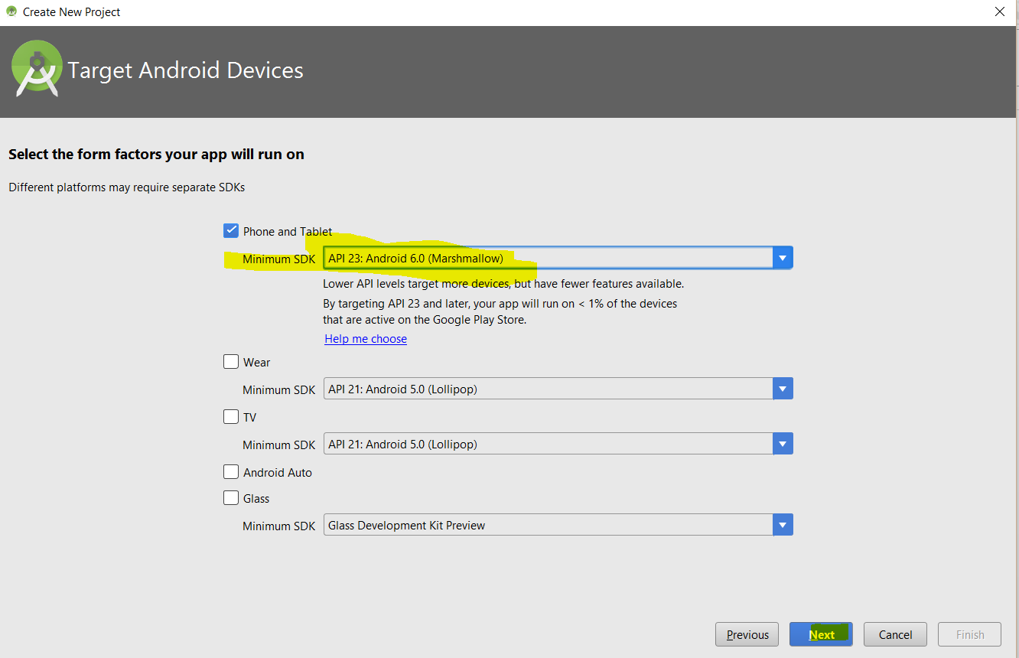

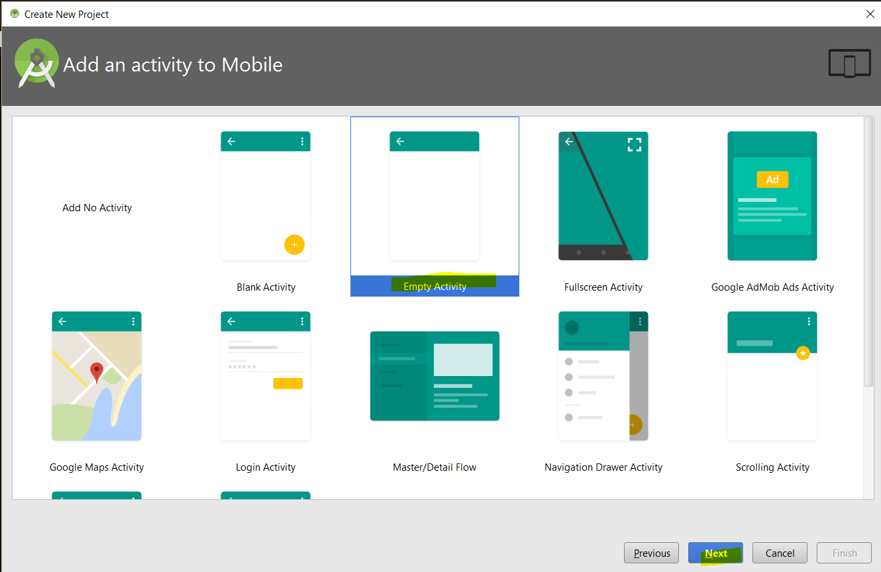

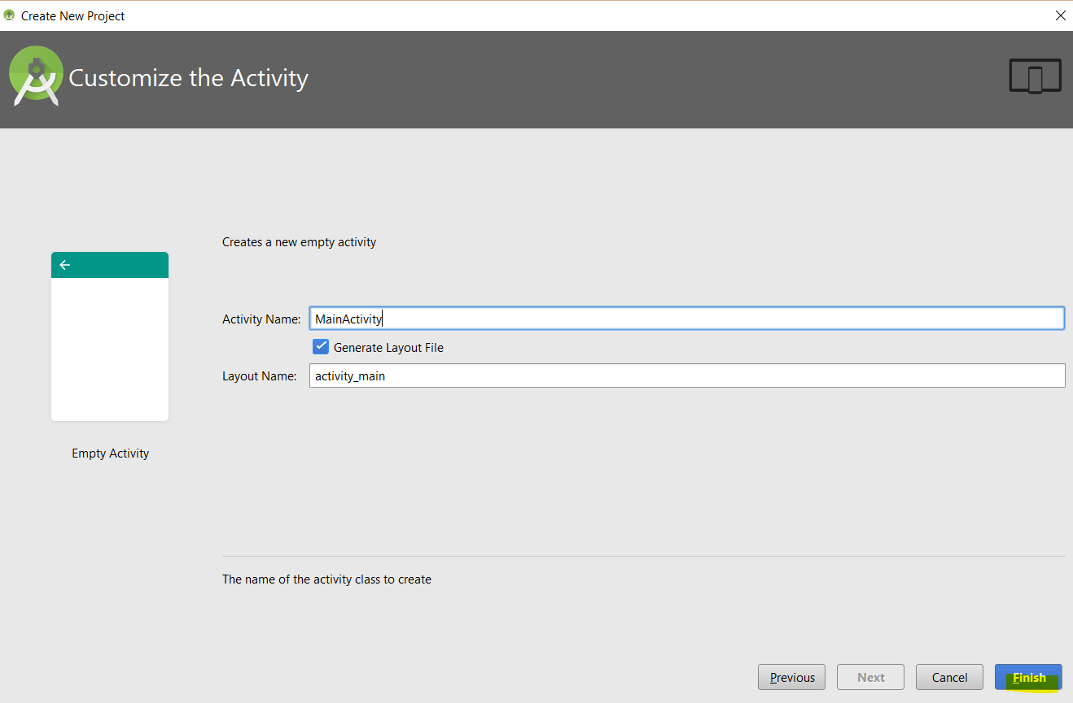

We are only interested in testing local unit test, meaning testing business domain regardless of device context information, therefore, we have to set our test artifact in our build variant to unit tests as per below:

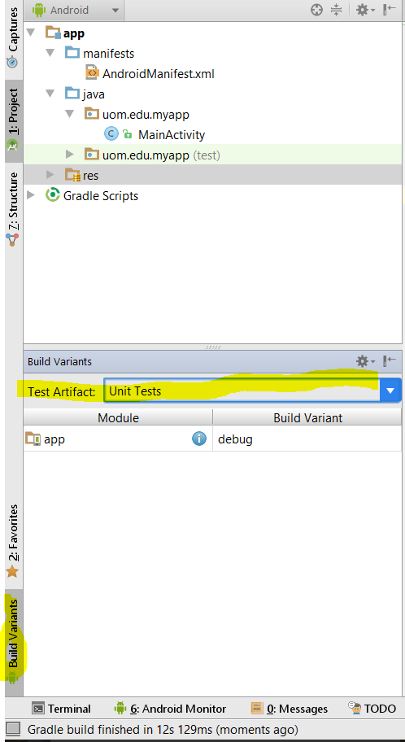

Also we have to ensure that in our gradle build dependencies we have Junit dependencies, by the default the dependency will be added:

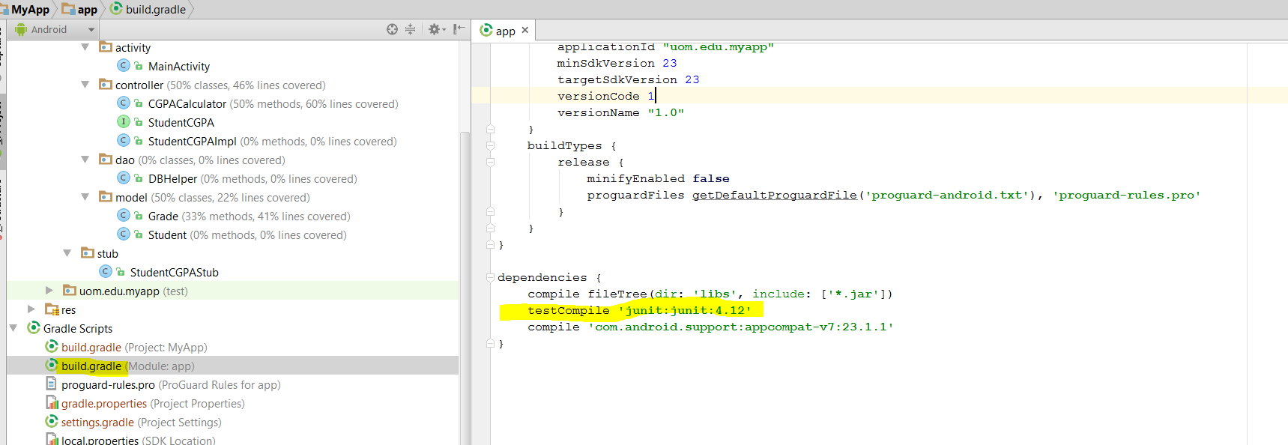

Once you change build variant and also ensure that dependencies are in place we go ahead and test if our unit testing setup is working:

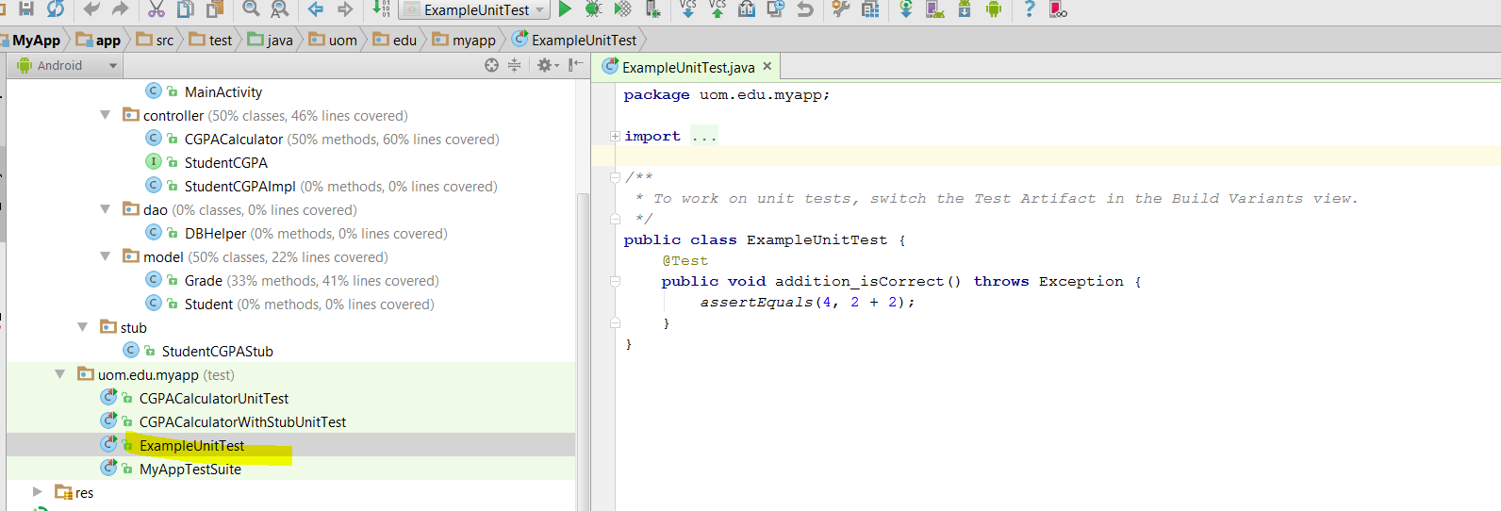

Right click middle of above class and select Run as ‘ExampleUnitTest’

We should be getting something like following screen:

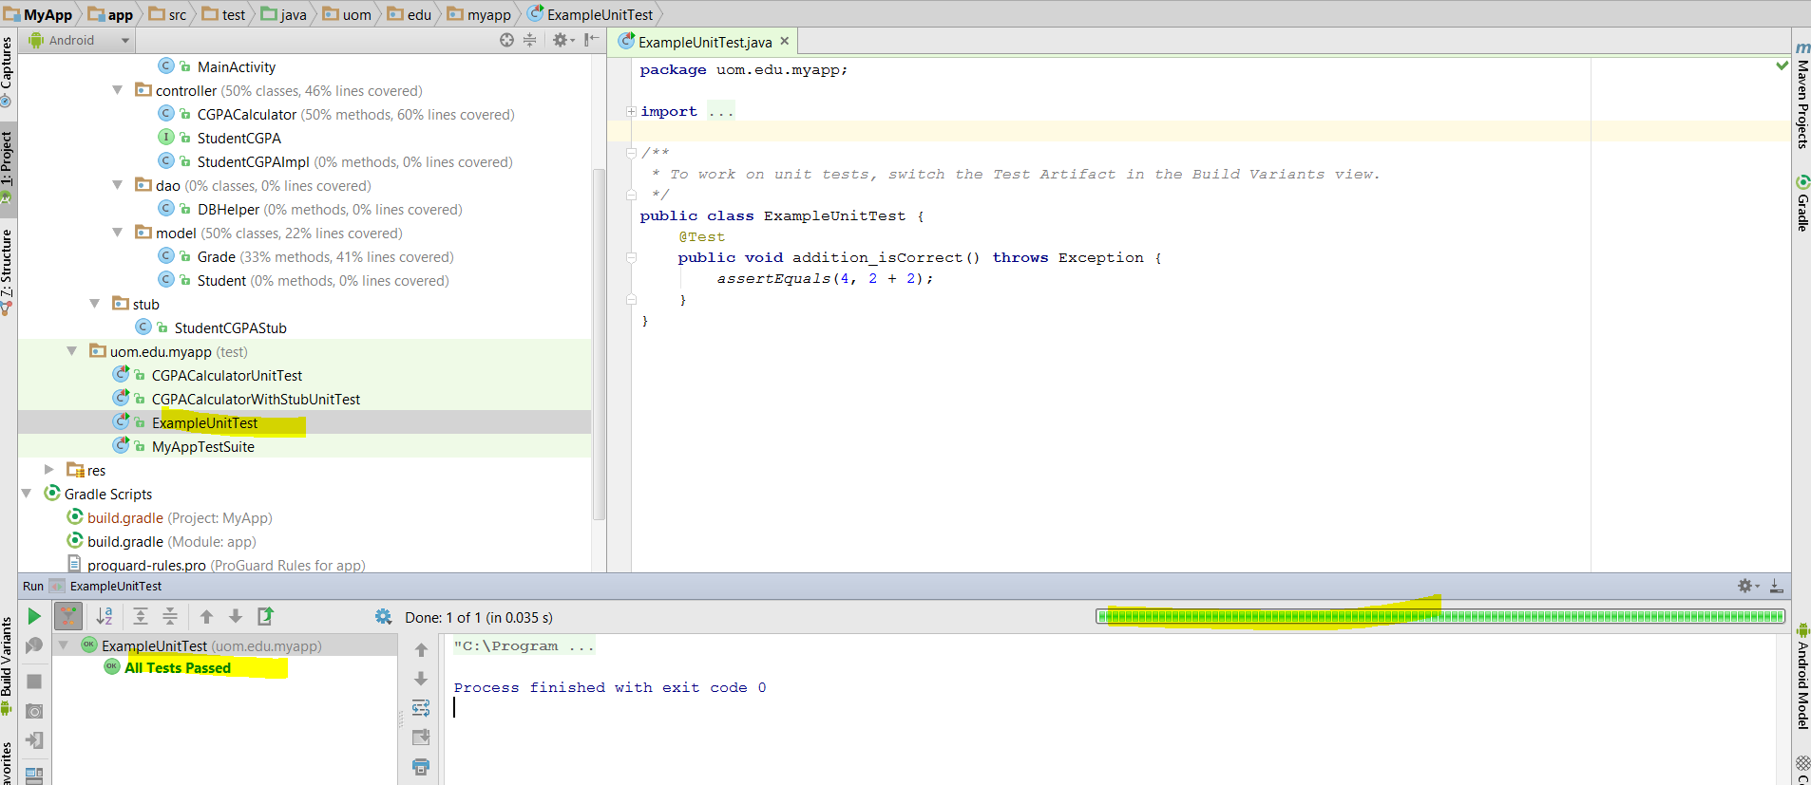

Now that we are all set, we go ahead and create two basic model classes as below: (Student and Grade classes) 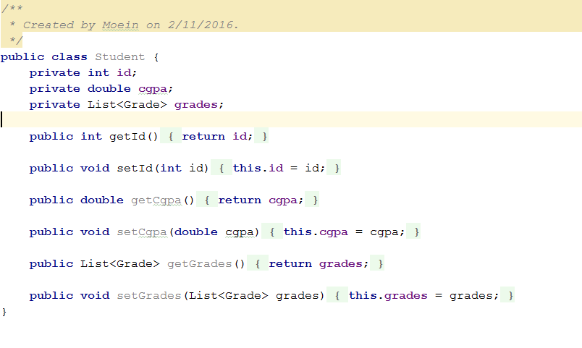

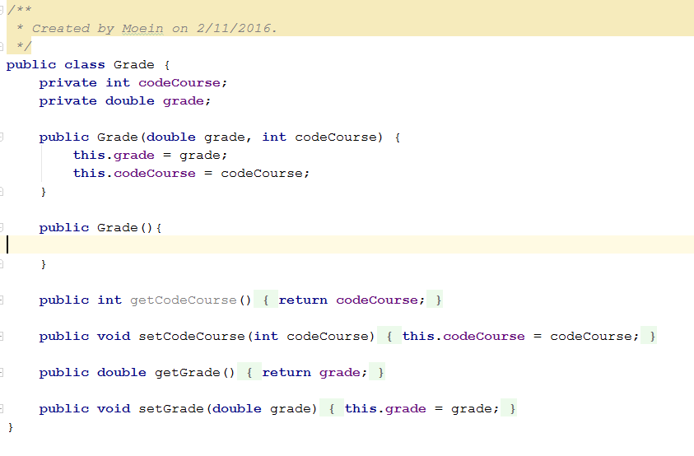

Create both above class under uom.edu.myapp.model package. Let’s create following simple function calculate CGPA under uom.edu.myapp.controller package

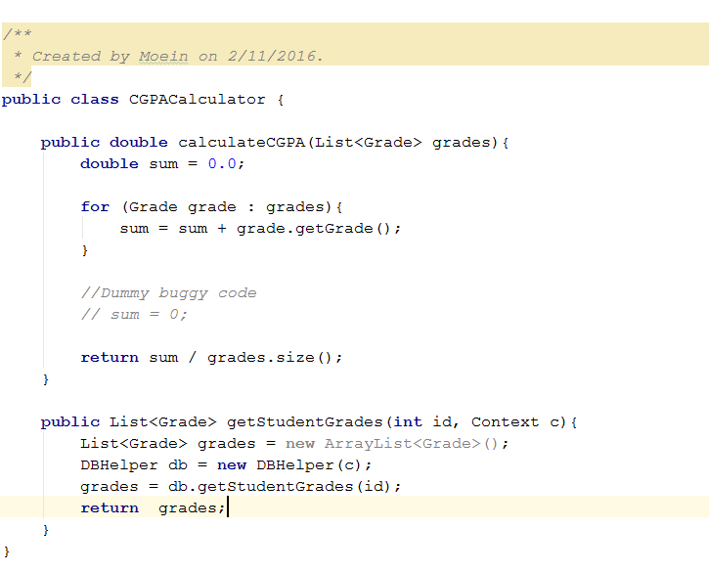

Let’s create simple unit test for calculateCGPA method, we need to create CGPACalculatorUnitTest class under test package as per below:

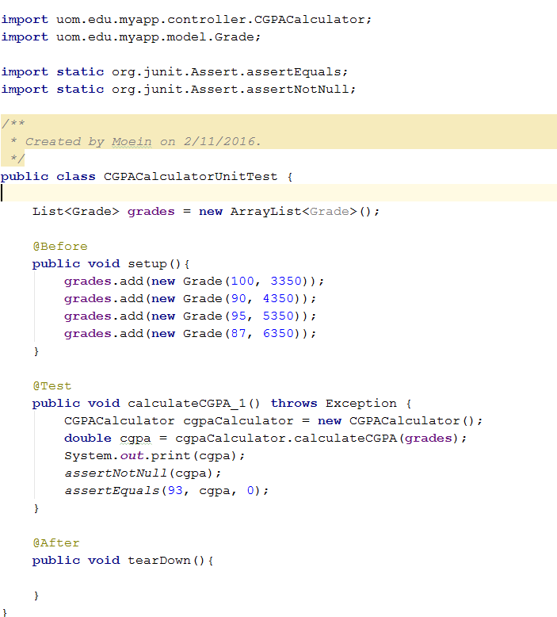

At setup function we set grades of student into Grade object and make a list of grades, then we pass the grade list to caclculateCGPA function during test case execution to test the function, at the end we set some assertion to check if response has value and it is not NULL plus check if expected and actual values are same.

Next we try to extend CGPA calculation function to more abstract interface that get student id and returns student’s CGPA:

Create StudentCGPA interface under controller package

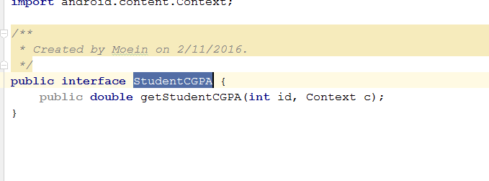

Add its implementation as per below in the same package: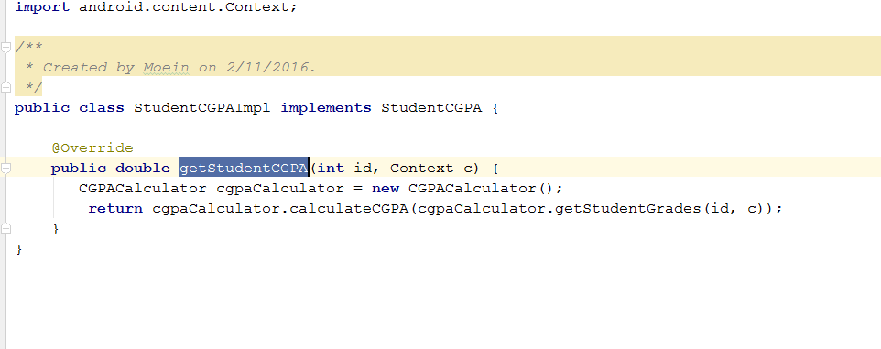

As you noticed calcualteCGPA function call another function which is getStudentsGrades that connect to database and get the student data from in-memory SQL DB which requires device context. In order for us to be able to test this function without device we need to create STUB class that implement StudentCGPA but return static response.

Let’s create StudentCGPAStubs under Stubs package

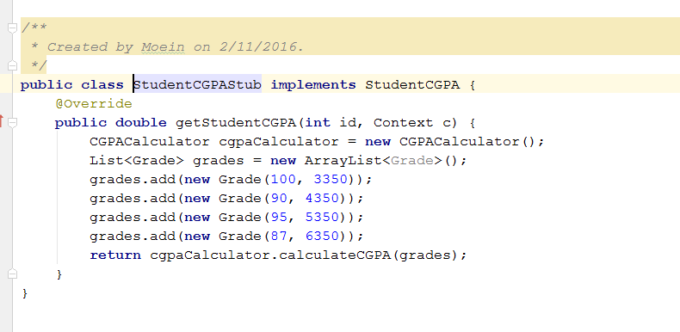

Above class will return calculateCGPA function output based on static set of input without a need of device in-memory database.

Let’s create new unit test and call it CGPACalculateWIthStubUnitTest, notice that upon creation of StudentCGPA Interface with are calling its Stub implementation rather that its actual implementation:

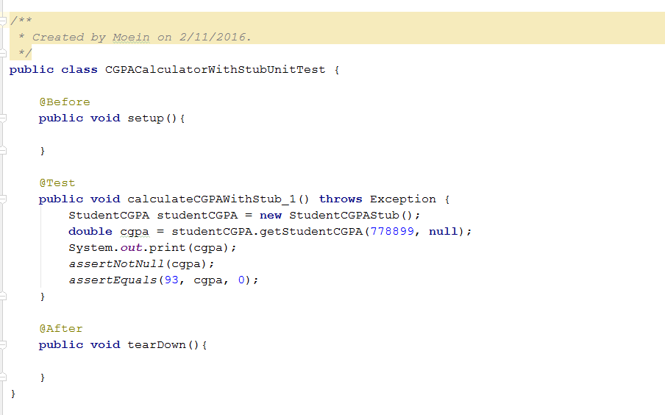

**Overall Project Structure**

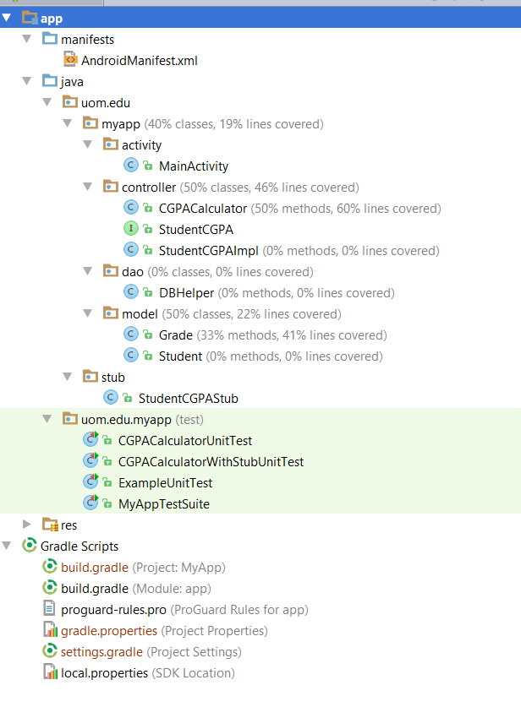

**More Examples and Useful Links**

<https://github.com/moeinalmasi/Android-CleanArchitecture>

<http://developer.android.com/training/testing/unit-testing/index.html>

<https://github.com/googlesamples/android-testing>