<Task Manager>

Use Case Model

Usage note: There is procedural guidance within this template that appears in a style named InfoBlue. This style has a hidden font attribute allowing you to toggle whether it is visible or hidden in this template. Use the Word menu Tools🡪Options🡪View🡪Hidden Text checkbox to toggle this setting. A similar option exists for printing Tools🡪Options🡪Print.

# Introduction

This project is an exercise for the discipline of Software Engineering II, on the Faculdade Senac Porto Alegre, second semester of 2015, based on a system for task management.

# Overview

This is a software for task management and control.

# Use-Case Diagram

Image 1 – system requirements

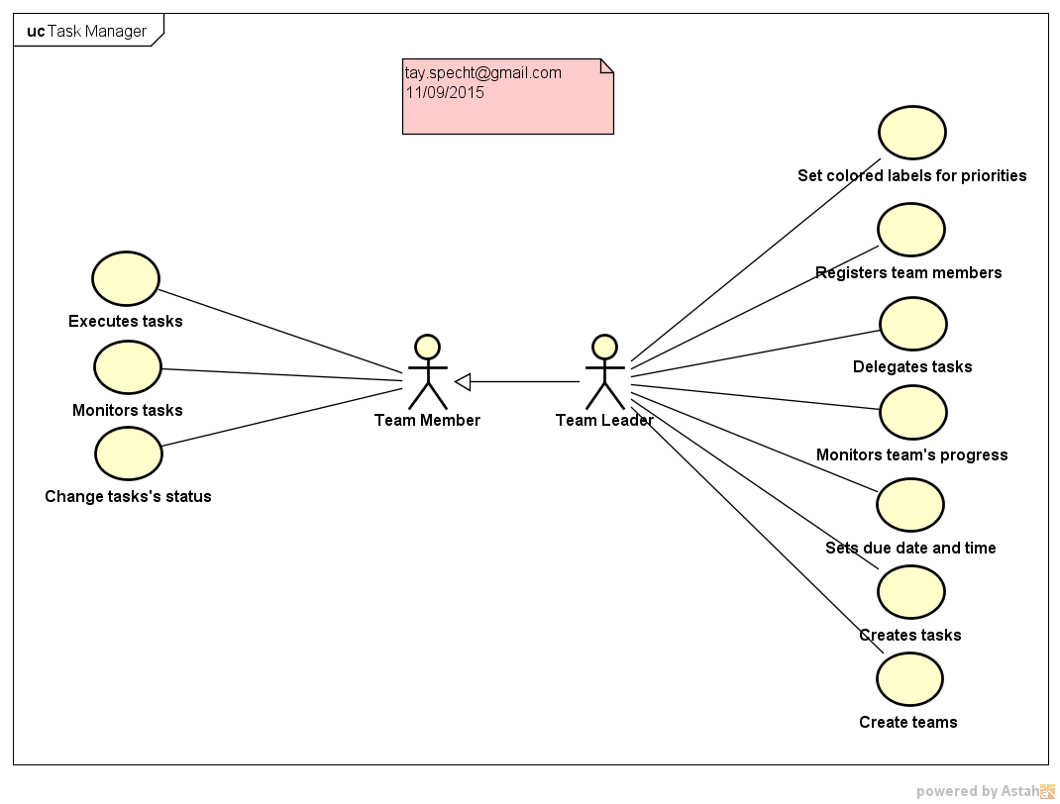

# Actors

In this use case diagram, we have two main actors, the team member and the team leader. The team leader inherits, beyond its own use cases, the use cases from the team members.

# Use Cases

## Use Case 1 – Execute tasks

In this use case, the team member will execute the task that was previously attributed to him. For example, write a piece of code for a specific feature.

## Use Case 2 – Monitor tasks

In this use case, the team member will be able to monitor the tasks that were attributed to him, check due dates and times, and keep up with his own progress.

## Use Case 3 – Change tasks’s status

In this use case, the team member will be able to change the status of his task. For example, change from “Doing” to “Done”, or “Impediment”.

## Use Case 4 – Set colored labels for priorities

In this use case, the team leader can flag a priority by coloring it in a scale that is as follows:

* red – high priority;
* yellow – medium priority;
* green – low priority.

Note that the low priority does not mean it’s not important and/or doesn’t have to be done, but shows that it can be done last.

## Use Case 5 – Register team members

In this use case, the team leader will register which members belong to which task team.

## Use Case 6 – Delegate tasks

In this use case, the team leader will attribute specific tasks to specific team members (himself included).

## Use Case 7 – Monitor team’s progress

In this use case, the team leader will be able to monitor if tasks are being done or if they have been in the same status for too long, enabling the leader to deal with the situation if necessary.

## Use Case 8 – Set due date and time

In this use case, the team leader will be able set a due date and time to help him monitor the progress of each task. This date and time will be given according to the leader’s own experience, and it might be changed afterwards.

## Use Case 9 – Create tasks

In this use case, the team leader will be able to create specific tasks, determined by the team’s final objective.

## Use Case 10 – Create teams

In this use case, the team leader will be able to create teams for specific tasks.