Course information

Your Name

Assignment: ????

Title of project

Version <1.0>

Table Of Contents

Time Log 3

Introduction 4

Purpose 4

Definitions, acronyms, and abbreviations 4

Overall Description 4

Story Board 5

Assignment requirements 6

Specific requirements 7

|  |  |  |  |
| --- | --- | --- | --- |
| Time Log | | | |
| Estimated time to complete assignment => | | | Hours |
| Date | Time Spent  (in hours) | Description | Author |
| 08/19/14 | 2.0 | First Version of Software Requirements | Robert Erickson |
|  |  |  |  |
|  |  |  |  |
|  |  |  |  |
|  |  |  |  |
|  |  |  |  |
|  |  |  |  |
|  |  |  |  |
|  |  |  |  |
|  |  |  |  |
|  |  |  |  |
|  |  |  |  |
|  |  |  |  |
|  |  |  |  |
|  |  |  |  |
|  |  |  |  |
|  |  |  |  |
|  |  |  |  |
|  |  |  |  |
|  |  |  |  |
|  |  |  |  |
|  | Mark me wrong if not updated | <=Total Time Spent |  |
|  |  |  |  |

# Introduction

### Purpose

The purpose of this document is to describe the requirement specification for the web site “_____________________________”.

The intended audience for this document is ________

*First it is the contract between you and the client. Second it is for the developer of the site. Two primary goals are:*

1. *Client gets a very good understanding of what you will be delivering.*
2. *Developer has a very good understanding of what they are going to create.*

### Definitions, acronyms, and abbreviations

*Sample for the client:*

HTML – Hypertext markup language – used to define your content.

PHP – Personal Home Page – language that helps to customize html.

CSS – Cascading Style Sheets – used to define the look of a web site.

W3 Validation – refers to both Html and CSS validation tool provided by the W3c.org. the html validator is located at:

<http://validator.w3.org/>

with the CSS validator located at:

<http://jigsaw.w3.org/css-validator/>

# Overall Description

A short paragraph describing the site

# Story Board

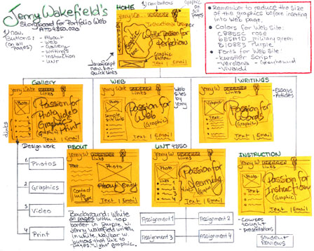

# Specific requirements

1. *You fill out* – This is where you would put the exact detail of what you want for the project. For example:
2. *Title for main page*: *What is the title, shows up as a link in a search result.*
3. *Meta Description*: *what is the description for the above link.*
4. *Meta Character set*: UTF - 8
5. *Logo*: *pick a logo to be used on the site.*
6. *Main page photo*: *pick a photo of you.*
7. *Content can be found here*:
8. I hope you get the idea. The goal would be the developer would be able to make the entire site based on this document and the client would see you have included everything.