5)
Abstract:-
The paper proposed by Maksimovic et. al describes Raspberry Pi, fully customizable and programmable small computer board. Comparative analysis of its key elements and performances with some of current existing IoT prototype platforms have shown that despite few disadvantages, the Raspberry Pi remains an inexpensive computer with its very successfully usage in diverse range of research applications in IoT vision.Based on performed analysis, it can be stated that Udoo has
the best performances among considered IoT hardware platforms, but at the same time its price is quite high. On the other side the detail analyses of Raspberry Pi have shown that as ultra-cheap-yet-serviceable computer board, with support for a large number of input and output peripherals, and network communication is the perfect platform for interfacing with many different devices and using in wide range of
applications.

Citation:-
Maksimovic, Mirjana & Vujovic, Vladimir & Davidović, Nikola & Milosevic, Vladimir & Perisic, Branko. (2014). Raspberry Pi as Internet of Things hardware: Performances and Constraints.

6)
This paper proposed by C. Rahmad et. al makes a comparison between VJ and HOG for detecting the face. V-J method calculate Integral Image through Haar-like feature with AdaBoost process to make a robust cascade classifier,HOG compute the classifier for each image in and scale of the image, applied the sliding windows, extracted HOG descriptor at each window and applied the classifier, if the classifier detected an object with enough probability that resembles a face, the classifier
recording the bounding box of the window and applied non-maximum suppression to make the accuracy increased. The experimental results show that the system successfully detected face based on the determined algorithm.Based on the experiment the system can classify and detect the face in many cases and conditions.With six types of condition and five times of trial, obtain the accuracy by 75,33% by using V-J and 80,22% by using HOG.V-J algorithm can detect frontal face very well in images, regarding of their scale, pose, makeup, expression, and illumination, but rather difficult to detect the face who have
occlusions like using helm, eyeglass, and mask.The V-J algorithm can perform in real-time on many applications and hardware.

Citation:-
C Rahmad et al 2020 IOP Conf. Ser.: Mater. Sci. Eng. 732 012038

7)
In this paper proposed by Adrian Kliks et. al an example of exercise for the microprocessor or wireless communications laboratory is presented. The idea of the exercise is to use the AT commands to control the mobile phone or GSM/GPRS modem.The paper describes the exercise in every detail including the explanation of formulating the AT commands and
their use for SMS messaging. Two modes of SMS messaging are presented: the text mode and PDU mode. Message formulation rules are explained for the PDU mode including data encoding. Finally, a detailed description of the exercise is given including examples of the commands and responses obtained through the experiment. The proposed exercise gives opportunity to familiarize the student with mobile phone’s
features, that are unavailable when using the Graphical User Interface (GUI).

Citation:-
No, L & Kliks, Adrian & Sroka, Pawel. (2021). ON THE USE OF AT COMMANDS FOR CONTROLING THE MOBILE PHONE WITH
MICROCONTROLLER – LABORATORY EXERCISE.

----------------------------------------------------------------------------------
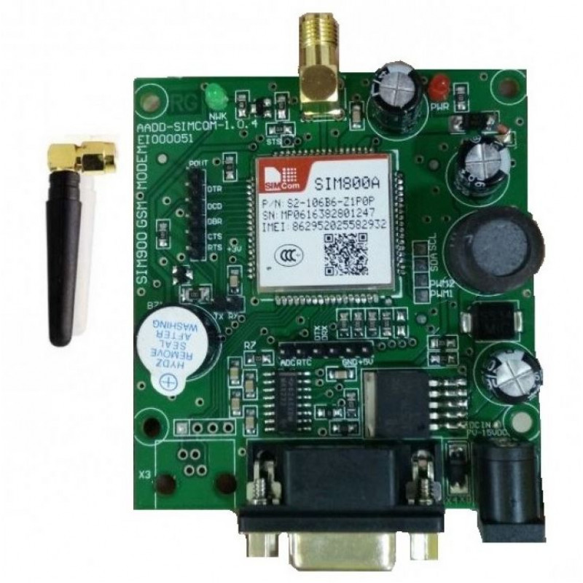

GSM Module-SIM800a

The SIM800A Quad-Band GSM/GPRS Module with RS232 Interface is a complete Quad-band GSM/GPRS solution in an LGA(Land grid array) type which can be embedded in the customer applications. SIM800A support Quad-band 850/900/1800/1900 MHz, it can transmit Voice, SMS and data information with low power consumption.

With a tiny size, it can fit into slim and compact demands of custom design. Featuring and Embedded AT, it allows total cost savings and fast time-to-market for customer applications.
There are two types of UART available on the Raspberry Pi – PL011 and mini UART. One UART is selected to be present on GPIO 14 (transmit) and 15 (receive) - this is the primary UART.
Interfacing GSM module with raspberry pi:-
The logic levels of PI are at 3.3 volts & it is risky to connect directly with a 5v level GSM pin.
The Tx pin (pin 8 , GPIO14) of PI can be directly connected to Rx of GSM. As GSM accepts 3.3volt level as high , this connection is straight without level shifting.
However the Rx pin (pin 10, GPIO 15) of PI cannot be connected directly to Tx of GSM.
A simple level shifter using a signal diode 1N4148 & a 10k resistor is used

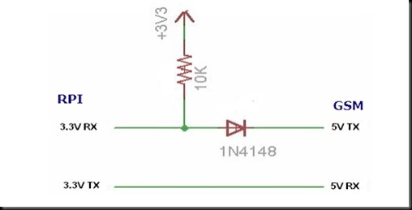

LOGIC LEVEL SHIFTER

When the level at GSM Tx is LOW , the diode is forward biased & the Rx of PI gets LOW.
When the level at GSM Tx is HIGH ,the diode is Reverse biased & the 3.3v is available at Rx of PI through the resistor.
A separate power source 12v 1 amp is required for GSM , and the GND pins of PI & GSM are made common.

