Round 3A content: Payday Portfolio
KTQT FTUers · Future Business Analyst Season 6 · DNSE Securities
Content for team review before slide design (Phase 3), 17 October 2026
Main slides 1 to 15, then Appendix A to I and References. On-slide text and speaker notes are in English; designer notes are in Vietnamese.

Round 3A deck content: Payday Portfolio (bản 2)
Bản 1 (16/10/2026) đã được user duyệt câu chuyện ở checkpoint 3.1. Bản 2 (17/10/2026): đủ hình, mọi bảng sinh từ CSV, appendix và references nằm ở `deck_appendix.md`.
Đọc file này thế nào
- Mỗi slide theo đúng khung của prompt: action title, on-slide text, bảng, hình, designer notes, speaker notes, sources.
- Chữ trên slide và speaker notes viết bằng tiếng Anh, cho giám khảo đóng vai Board. Designer notes viết bằng tiếng Việt, cho người dựng slide.
- Bảng không sửa trực tiếp ở đây. Mỗi bảng nằm giữa hai dòng <!-- table: ... --> và được ghi từ CSV bằng python src/round3/deck_tables.py. Muốn đổi chữ thì sửa CSV mẫu trong data/round3/deck_tables/; số thì lấy từ mô hình.
- Hình nằm trong outputs/round3/figures/, vẽ bằng figures_round3.py và diagrams_round3.py; dữ liệu của từng hình ghi ở dòng "Data".
- Số lấy từ outputs/round3/tables/ (kịch bản base, trừ khi ghi khác) và từ các nguồn trong data/round3/sources_round3.csv.
- Kiểm bằng python src/round3/check_deck_content.py:
- action title ≤15 từ; chữ trên slide ≤60 từ; Executive Summary ≤150 từ;
- bảng ≤6 dòng × 5 cột; speaker notes khoảng 120 từ;
- mỗi bảng khớp CSV của nó.
Quy ước làm tròn trên slide (số gốc nằm trong CSV):
- Trần CAC VND 128,000 (127,512); trần khi miễn phí VA VND 199,000 (198,876).
- Ngưỡng phí VA VND 6,200 (6,191); ngưỡng mức góp VND 717,000 (716,502).
- Chi phí ròng/TK mới ≥10 triệu: "about VND 1.3 million" trong câu, 1.29 trong bảng.
- Tỷ lệ từ review đọc tay làm tròn đến số nguyên (83%, 45%, 17%).

Câu chuyện của deck
Một câu (thay cho câu ở `plan_payday.md` §1):
DNSE has won accounts; Payday Portfolio sets out to win balances. It turns part of each salary into a goal-based plan the customer controls, and asks the Board for VND 6.6 billion it can stop at month 6.
Mạch 15 slide:
- Vấn đề (slide 2–5):
- DNSE có tài khoản nhưng không có tiền.
- Năm 2026 tiền rời CTCK và đối thủ đã vào cuộc đua tích lũy.
- Mỗi insight dẫn tới một lựa chọn thiết kế.
- Những gì đã đổi so với Round 2.
- Giải pháp (slide 6–10): cho ai; sản phẩm là gì; khách thấy gì; phía sau vận hành ra sao; đứng ở đâu so với đối thủ.
- Kế hoạch (slide 11–15):
- Business case trung thực: base không tự hoàn vốn, nên mua TK có tiền với giá khoảng 1,3 triệu.
- GTM năm 1, lộ trình 5 phase, cổng quyết định có số.
- Rủi ro và đề nghị cụ thể với Board.
Ba điều giám khảo cần nhớ:
- VND 6,6 tỷ, dừng được ở tháng 6.
- +14.871 TK mới ≥10 triệu ở tháng 36 (base).
- Khoảng 1,3 triệu đồng cho mỗi TK có tiền.

Slide 1: Executive summary
Action title: Approve VND 6.6 billion to test whether payday plans can fund DNSE's accounts
On-slide text:
Problem. DNSE opens one in five new accounts in Vietnam, yet only 1.8% of its 1.51 million accounts hold VND 10 million or more, and brokerage has lost money for 16 quarters.
Solution. Payday Portfolio is a goal-based monthly plan from VND 500,000. A standing order from the salary bank funds a personal virtual account. The customer confirms an adviser-signed plan of bank bonds, funds and an ETF. No platform fee; delivery metrics published monthly.
Business case. Base case: no payback within five years (NPV −VND 25 billion). Upside: payback in month 44.
Ask. Fund build and a 45,000-account pilot; stop or scale at month 6.
Table:
Key figure | What it means
VND 6.6 billion | Board ask for months 1 to 6
+14,871 | New accounts above VND 10 million by month 36 (base)
VND 1.3 million | Net cost per new funded account (base)

CSV: outputs/round3/tables/slide01_key_figures.csv (sinh bằng src/round3/deck_tables.py từ data/round3/deck_tables/ và output của mô hình; sửa CSV mẫu, không sửa bảng ở đây).
Source: authors' cohort model; DNSE Securities (2026c).
Figure: không có (3 con số lớn thay cho hình).
Designer notes (tiếng Việt):
Cỡ chữ 14–15 theo booklet. Ba con số đặt thành 3 ô lớn ở hàng trên, màu RED; bốn đoạn Problem / Solution / Business case / Ask ở dưới, mỗi đoạn một dòng nhãn đậm.
Tổng số từ của slide (kể cả 3 ô số) phải ≤150; script kiểm đã tính cả bảng.
Không thêm hình, logo hay câu nào khác vào slide này.
Speaker notes:
Good afternoon. DNSE has done the hard part of growth: it opens one in five new securities accounts in Vietnam. But accounts are not money. Only 1.8 per cent of its 1.5 million accounts hold ten million dong or more, and the free-trading model has not paid for itself. Payday Portfolio is our answer: a monthly plan, set up once, that moves part of each salary towards a goal the customer chooses, through bank bonds, funds and an ETF. We will be direct about the economics. In the base case Payday is not a profit centre; it buys funded accounts at about 1.3 million dong each. So we ask for only 6.6 billion dong now, with a clear stop-or-scale decision at month six.
Sources: DNSE Securities (2026c); authors' cohort model.

Slide 2: Problem recap: accounts, not money
Action title: DNSE has 12.3% of Vietnam's accounts but only 2.3% of investor cash
On-slide text:
- Only 1.8% of DNSE's 1.51 million accounts held VND 10 million or more (December 2025).
- The closer to money, the smaller DNSE gets: 1.4% of margin loans, 0.6% of profit.
- Brokerage revenue trailed its direct cost for 16 straight quarters (−VND 190 billion).
- The platform costs VND 7.3 million a year per funded account.
Figure: outputs/figures/fig04_market_position.png (dùng lại Figure 4 của Round 2).
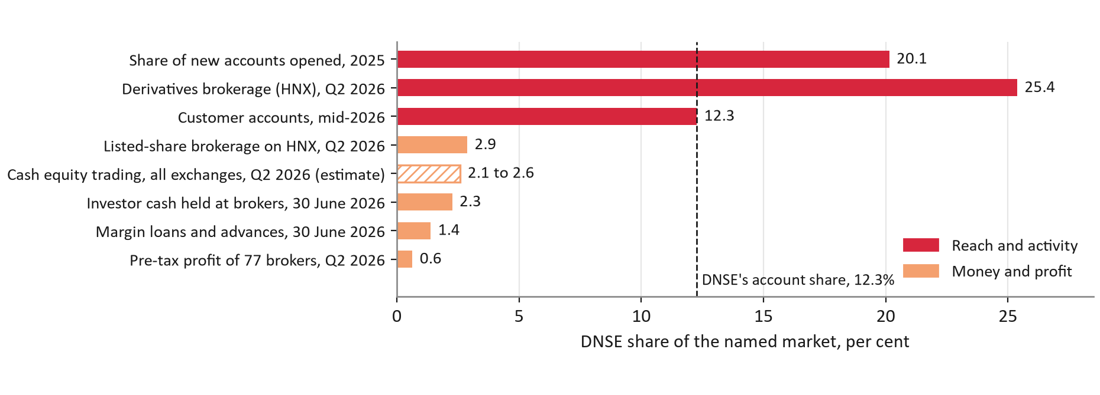
Caption: DNSE's share of each market, per cent; the dashed line is its 12.3% share of accounts.
Source: VnExpress (2026a); DNSE Securities (2026c); Vietstock (2026b); CafeF (2026); VnEconomy (2026); Hanoi Stock Exchange (2026); DNSE filings; authors' calculations (Round 2, Figure 4).
Designer notes (tiếng Việt):
Hình Figure 4 chiếm 2/3 slide, bên trái; 4 ý ở cột phải.
Nhấn mạnh hai thanh "Customer accounts 12.3" và "Investor cash 2.3" (đã có màu khác nhau trong hình).
Ghi nhỏ ở góc: "Round 2 finding, unchanged".
Nếu cần chỗ, bỏ ý thứ 4 lên speaker notes.
Speaker notes:
In Round 2 we showed one fact that frames everything today. DNSE is very good at opening accounts: one in five new accounts in Vietnam last year, and 12.3 per cent of all accounts by mid-2026. But the closer a measure sits to money, the smaller DNSE becomes: 2.3 per cent of investor cash, 1.4 per cent of margin loans and 0.6 per cent of industry profit. Only 1.8 per cent of DNSE's accounts hold ten million dong or more. This matters because free trading does not pay for itself: brokerage revenue has been below its direct cost for sixteen quarters in a row. Every funded account also carries about 7.3 million dong a year of platform cost. Funding the accounts DNSE already has is the cheapest fix.
Sources: DNSE Securities (2026a, 2026c); Hanoi Stock Exchange (2026); VnEconomy (2026); Vietstock (2026b); CafeF (2026); VnExpress (2026a); Vietcap Securities (2026).

Slide 3: Why now
Action title: The 2026 accumulation race has started, and DNSE has no entry yet
On-slide text:
- Investor cash at brokers fell 38% in three quarters, to VND 86.6 trillion (June 2026).
- Banks pay 5.9% for 12 months; certificates of deposit pay 7.4%.
- SSI, TCBS, VPS and VPBank launched recurring or goal-based plans in 2026.
- Banks must open their APIs by 1 March 2027.
- DNSE made about 20% of its 2026 profit target in H1.
Figure: outputs/round3/figures/why_now_timeline.png.
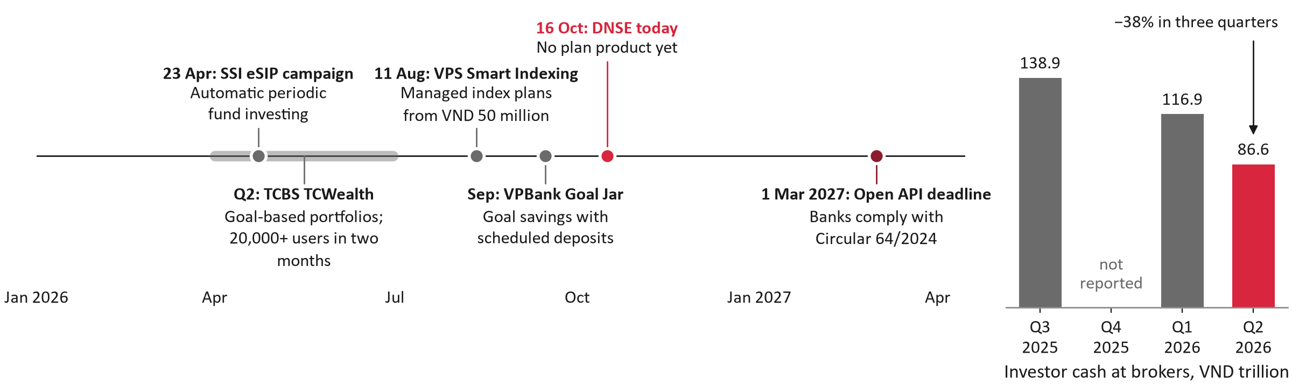
Caption: Left, 2026 launches of recurring and goal-based plans and the banks' Open API deadline. Right, investor cash at Vietnamese brokers, VND trillion (Q4 2025 not reported).
Source: SSI Securities (2026); TCBS (2026); Tin nhanh Chung khoan (2026); Tuoi Tre (2026); VPBank (2026); State Bank of Vietnam (2024); VnEconomy (2026).
Data: outputs/round3/tables/why_now_events.csv, why_now_investor_cash.csv.
Designer notes (tiếng Việt):
Hình đã gồm cả timeline và cột tiền NĐT, đặt nửa trên slide, toàn chiều ngang. Mốc đối thủ màu xám; "DNSE today" màu RED; mốc Open API màu DARK_RED.
5 ý chữ đặt nửa dưới, chia 2 cột: "Money is leaving" (ý 1–2) và "Rivals are moving" (ý 3–5).
Q4/2025 không có số liệu công bố nên để trống trong hình; không nối cột.
Speaker notes:
Why act now? Three things changed this year. First, money is leaving brokers. Investor cash at Vietnamese brokers fell 38 per cent in three quarters, while banks pay 5.9 per cent for twelve months and certificates of deposit 7.4. Second, competitors have started an accumulation race. SSI ran a recurring-fund campaign from April, TCBS turned TCWealth into goal-based portfolios, VPS launched Smart Indexing in August and VPBank launched goal jars in September. DNSE has no entry. Third, banks must open their APIs by March 2027, which makes salary-linked investing easier for whoever has a product ready. Meanwhile DNSE made only about a fifth of its 2026 profit target in the first half. A product that builds balances is now urgent.
Sources: VnEconomy (2026); Thi truong Tai chinh Tien te (2026b); SSI Securities (2026); TCBS (2026); Tin nhanh Chung khoan (2026); VPBank (2026); State Bank of Vietnam (2024); Vietstock (2026a); DNSE Securities (2026a).

Slide 4: Insight, design decision, impact
Action title: Every design choice traces to evidence and to one KPI the pilot measures
On-slide text:
- Round 2's root causes still hold; 2026 data adds reliability as the first barrier.
- Each KPI has a stop line in the pilot (slide 14).
Table:
Insight | Evidence | Design decision | KPI it moves
Accounts are opened but not funded | 98% of accounts hold under VND 10 million | A monthly plan funded by a standing order from the salary bank | New accounts above VND 10 million: +14,871 by month 36
Intention stalls without a plan | 77% of investors find managing a portfolio hard | A plan by goal horizon, signed by a licensed adviser and confirmed by the customer | Three contributions in a row: 81% (stop below 60%)
Conditional rewards broke trust | Trust themes: 55% of negative Google Play reviews, H1 2025 | No cash rewards; all terms on one screen; free withdrawal | Trust themes below 10% of Payday reviews
2026 update: reliability now dominates | 83% of 2026 negative reviews describe something that broke | Payday scheduler kept apart from the pre-trade check; 99.5% launch gate | 99.5% credited on the same banking day
Small tickets carry heavy unit costs | A VND 1 million contribution pays a VND 3,300 bank fee and earns VND 368 a month | Gate 0: collection fee target VND 0 | CAC ceiling rises from VND 128,000 to 199,000

CSV: outputs/round3/tables/slide04_insight_design.csv (sinh bằng src/round3/deck_tables.py từ data/round3/deck_tables/ và output của mô hình; sửa CSV mẫu, không sửa bảng ở đây).
Source: DNSE Securities (2026c); Nhan Dan (2025); Google Play and App Store reviews, authors' coding; VPBank (2024); authors' cohort model.
Figure: outputs/round3/figures/reviews_2026_causes.png (nửa slide, tùy chọn; có thể chuyển xuống appendix D nếu chật).
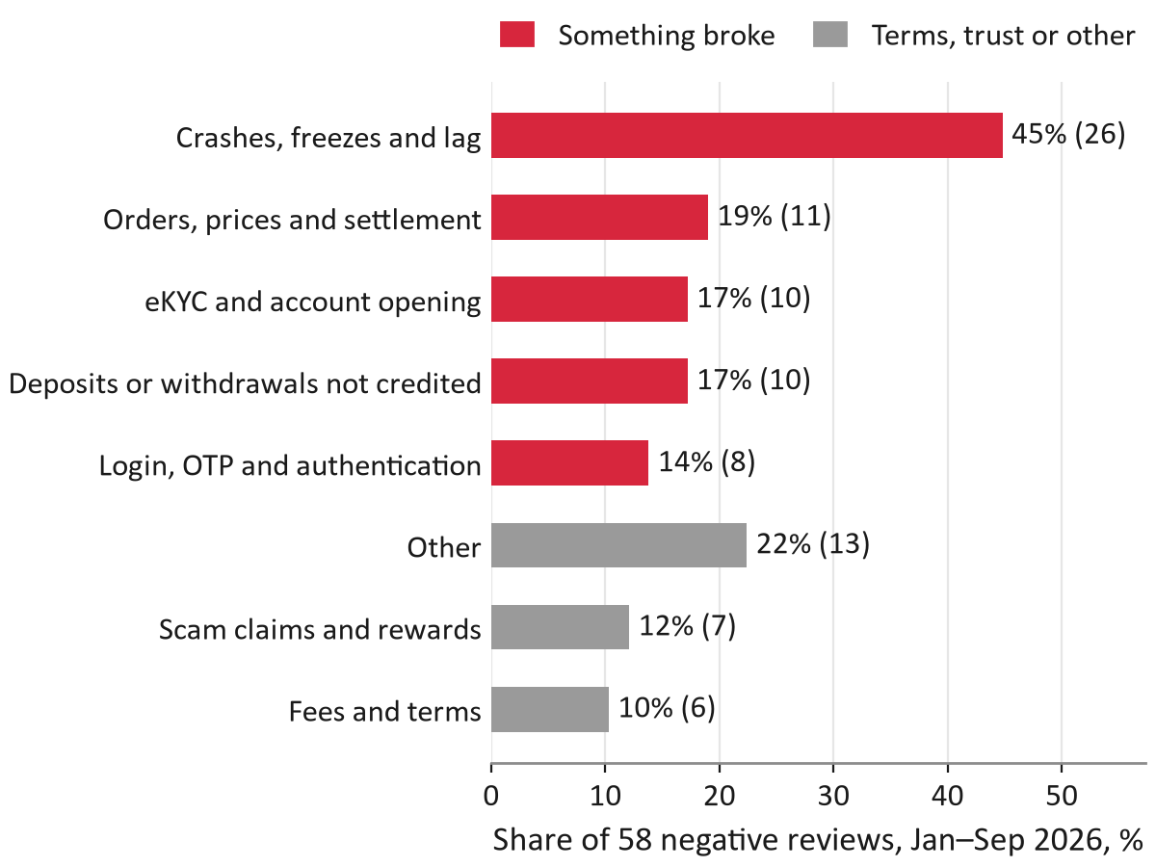
Caption: Causes in 58 negative reviews of DNSE's app, January to September 2026; a review can carry several causes.
Source: Google Play; App Store; authors' coding of each review.
Designer notes (tiếng Việt):
Đây là slide ăn điểm "evidence-to-solution linkage" (25 điểm). Bảng 5 dòng là trung tâm, có mũi tên giữa các cột Insight → Decision → KPI.
Dòng "2026 update" tô nền LIGHT_RED để thấy đây là cập nhật mới.
Nếu đặt hình nguyên nhân review: thu nhỏ ở góc phải, nối bằng đường mảnh tới dòng 4.
Speaker notes:
This slide links each insight to a design choice and to the KPI that tests it. Accounts are opened but not funded, so a standing order from the salary bank funds the plan; we count new accounts above ten million dong. Intention stalls without a plan: 77 per cent of investors find portfolios hard, so a licensed adviser signs a plan by goal horizon and the customer confirms it. Conditional rewards broke trust in 2025, so there is no cash reward and every term sits on one screen. The 2026 update is reliability: 83 per cent of this year's negative reviews describe something that broke. So the payday scheduler runs apart from the trading check, and 99.5 per cent on-time crediting is a launch gate.
Sources: DNSE Securities (2026c); Nhan Dan (2025); Google Play and App Store reviews (authors' coding); VPBank (2024); authors' cohort model.

Slide 5: What changed since Round 2
Action title: We kept the mechanism and rebuilt the numbers, rewards and positioning
On-slide text:
- Kept: the dormant salaried target, personal virtual account, adviser-signed plan the customer confirms, rebalancing with new money, SSC notice and a randomised pilot.
Table:
Area | Round 2 | Round 3A, and why
Main barrier | Trust | Reliability: 83% of 2026 negative reviews describe a failure; trust 19%
Business case | Static: 150,000 savers for 18 months; target of 85,000 accounts above VND 10 million | Monthly cohorts over 60 months: about 42,000 accounts above VND 10 million by month 36 (27,100 + 14,871), because a saver needs 11 contributions to pass VND 10 million
Pilot | 20,000 accounts; go ahead at 15% enrolment | 45,000 accounts; scale at 1.5%, stop below 1.0% (break-even 1.0%)
Rewards | Cash tiers, including a 4.3% idle-cash rate | Non-cash persistence package; cash tiers would cost 41% of revenue per saver
Bond core | Golden Egg, which also holds DNSE's own bonds | Bank-issued bonds only, to avoid a conflict of interest
Differentiator | The salary-day trigger | Recurring transfers are standard (VinaSIP since 2021); we compete on asset range and published delivery metrics

CSV: outputs/round3/tables/slide05_what_changed.csv (sinh bằng src/round3/deck_tables.py từ data/round3/deck_tables/ và output của mô hình; sửa CSV mẫu, không sửa bảng ở đây).
Source: KTQT FTUers (2026); authors' cohort model; Thi truong Tai chinh Tien te (2021); DNSE Securities (2026c).
Figure: không có (bảng là nội dung chính).
Designer notes (tiếng Việt):
Bảng 3 cột; cột "Round 2" chữ xám, cột "Round 3A" chữ đen, phần "why" in nghiêng.
Dòng "Kept" đặt trên cùng thành dải màu nhạt có dấu ✓. Rubric khen việc giải thích vì sao giữ.
Nếu ban tổ chức gửi feedback Round 2, thêm cột "Feedback" (plan_payday.md §2).
Speaker notes:
What changed since Round 2, and why. We kept the core: the target segment, the personal virtual account, the adviser-signed plan the customer confirms, rebalancing with new money, the regulator notice and a randomised pilot. Five things changed. Our Round 2 model assumed every saver contributed for eighteen months. With monthly cohorts and sourced costs, the base case reaches about 42,000 accounts above ten million dong by month 36, against a Round 2 target of 85,000 in eighteen months. The pilot grows to 45,000 accounts so it can detect a ten-point effect, with thresholds derived from unit economics. Cash tiers would cost 41 per cent of revenue, so rewards are non-cash. DNSE's own bonds leave the default plan. And recurring transfers are now standard, so we compete on asset range and proof.
Sources: KTQT FTUers (2026); authors' cohort model; Thi truong Tai chinh Tien te (2021); DNSE Securities (2026c).

Slide 6: Target users and sizing
Action title: Launch with dormant salaried accounts; most savers later arrive at account opening
On-slide text:
- Salaried dormant holders test the offer first: 45,000 accounts in the pilot.
- By month 36, 60% of the 31,133 savers come from the account-opening step.
- Employers are tested from Q4 and pay back only above 39% participation.
Table:
 | P1 Salaried dormant holder (launch) | P2 Active trader adding a core | P3 New account holder
Size | 1.43 million accounts used no product in December 2025 | 85,739 active customers | About 31,180 new accounts a month (H1 2026)
Job to be done (hypothesis) | "Invest part of my salary without deciding each month" | "Grow a long-term core while I trade" | "Start small and see it work"
Barrier (evidence) | Procrastination; distrust after the 2025 rewards | Plan money drifting back to trading | Reward-seeking; eKYC failures (17% of 2026 negative reviews)
Model input (assumption) | 25% salaried and reachable; 2% enrol | 4% enrol over 12 months | 2% set up within 60 days
Savers by month 36 (base) | 6,836 | 3,430 | 18,708

CSV: outputs/round3/tables/slide06_personas.csv (sinh bằng src/round3/deck_tables.py từ data/round3/deck_tables/ và output của mô hình; sửa CSV mẫu, không sửa bảng ở đây).
Source: DNSE Securities (2026c); VnExpress (2026a); authors' cohort model.
Figure: outputs/round3/figures/sizing_funnel.png.
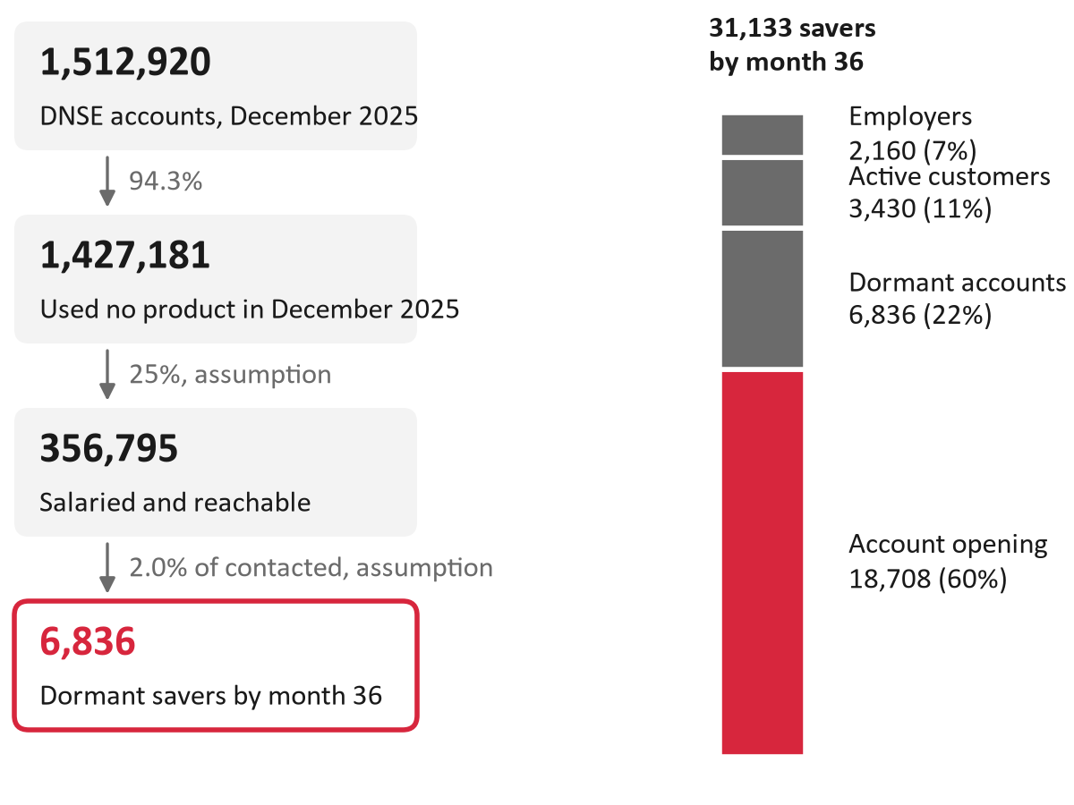
Caption: Left, from DNSE's 1.51 million accounts to dormant savers by month 36. Right, all 31,133 savers by month 36, by channel (base case).
Source: DNSE Securities (2026c); authors' cohort model (assumptions labelled).
Data: outputs/round3/tables/sizing_funnel.csv, savers_by_channel.csv.
Designer notes (tiếng Việt):
Trái: hình funnel và thanh saver theo kênh (nửa slide). Phải: bảng persona (P1 viền RED vì là khách ra mắt).
Mỗi persona ghi rõ "assumption" ở dòng thông số mô hình. Không thêm ảnh người, tên hay tuổi cụ thể: persona dựng từ data, không bịa đời tư.
Phần account opening (60%) đã tô RED trong hình để khớp với ý thứ hai.
Speaker notes:
Who is it for? We launch with salaried holders of dormant accounts: 1.43 million DNSE accounts used no product in December 2025, and nearly half of working adults in Vietnam are paid into an account. We assume a quarter of dormant accounts are salaried and reachable, and that two per cent of those contacted enrol; the pilot will measure both. Active traders are a second group: they want a long-term core next to trading. The third group matters most for scale. About 31,000 accounts are opened each month, and a plan step at opening brings in 60 per cent of all savers by month 36. Employers come later and pay back only if at least 39 per cent of staff join.
Sources: DNSE Securities (2026c); World Bank (2025); VnExpress (2026a); authors' cohort model.

Slide 7: The solution
Action title: A goal-based monthly plan from VND 500,000 that the customer always controls
On-slide text:
- Customer: one plan per goal; cash waits in the Never-Sleeping Account (Tài khoản Không Ngủ); withdraw free in one tap.
- DNSE: funded accounts, on payment rails that also tackle deposit-crediting failures.
- No platform fee; fund fees of 0.8–1.95% a year sit inside fund prices.
- Excluded: margin, single stocks, derivatives, DNSE's own bonds, sign-up cash.
Table:
Goal horizon | Golden Egg (Trứng Vàng), bank bonds | Bond funds | Equity funds | VN30 ETF
Under 1 year | 100% | – | – | –
1 to 3 years | 50% | 50% | – | –
3 years or more | 30% | 30% | 20% | 20%
Last 12 months before the goal | New money only, into Golden Egg | Nothing sold | Nothing sold | Nothing sold

CSV: outputs/round3/tables/slide07_glide_path.csv (sinh bằng src/round3/deck_tables.py từ data/round3/deck_tables/ và output của mô hình; sửa CSV mẫu, không sửa bảng ở đây).
Source: authors' design; fund fees from SSI Asset Management (2026), VCBF (2026) and fund prospectuses.
Figure: outputs/round3/figures/solution_overview.png.
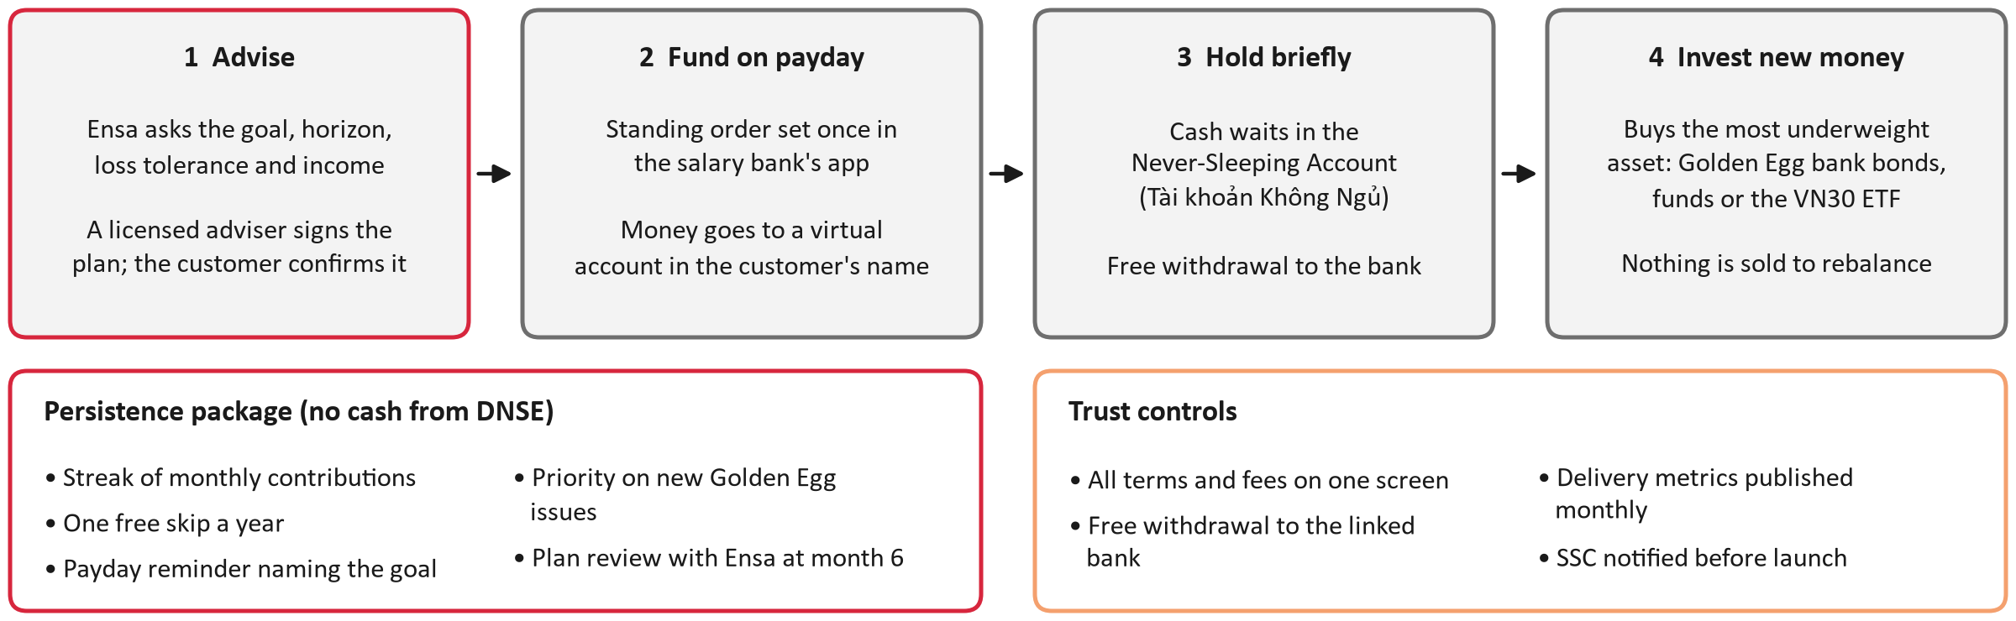
Caption: How Payday works: advise, fund on payday, hold briefly, invest new money; with the persistence package and the trust controls.
Source: authors' design (redraws Round 2 Figure 7 without cash tiers).
Data: data/round3/solution_overview.json.
Designer notes (tiếng Việt):
Nửa trên: sơ đồ 4 bước. Nửa dưới trái: bảng glide path. Nửa dưới phải: 4 ý chữ.
Dòng "Excluded" có biểu tượng gạch chéo, màu xám đậm, để Board thấy rõ những gì cố ý loại.
Lần đầu xuất hiện thuật ngữ tiếng Việt phải có bản dịch: "Trứng Vàng (Golden Egg)", "Tài khoản Không Ngủ (Never-Sleeping Account)".
Speaker notes:
The product in one line: a goal-based monthly plan from 500,000 dong that the customer controls. The customer sets a goal, answers three suitability questions and confirms a plan signed by a licensed adviser. The salary bank sends a standing order to a virtual account in the customer's name. Cash waits in the Never-Sleeping Account and is invested, usually the next business day, into the most underweight asset. The mix follows the goal horizon: short goals stay in bank bonds through Golden Egg; long goals add funds and a VN30 ETF, with equities capped at 40 per cent. There is no platform fee. We deliberately leave out margin, single stocks, derivatives, DNSE's own bonds and sign-up cash.
Sources: DNSE Securities (n.d.-b); SSI Asset Management (2026); VCBF (2026); Ministry of Finance (2020); Karlan et al. (2016).

Slide 8: Customer journey
Action title: Six screens take a saver from a goal to the 90-day milestone
On-slide text:
- Each screen answers the question the customer has at that step.
- Failure screens are designed in advance: transfer late, salary late, skip a month, withdraw (Appendix G).
Figure: outputs/round3/figures/wireframes_journey.png.
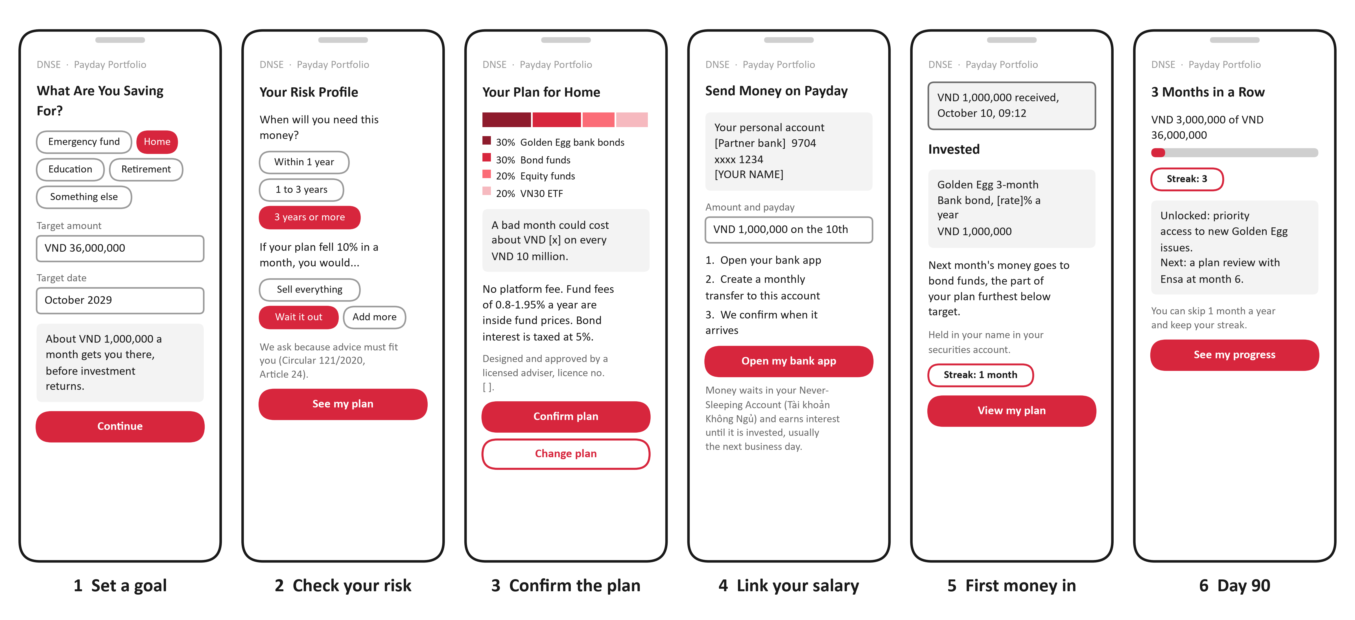
Caption: Low-fidelity wireframes of the six main screens; values in brackets are filled in by the live app.
Source: authors' design.
Table:
Moment of truth | What the customer sees | Measure we publish
First money in | "Received" within minutes; invested the next business day | Contributions credited on the same banking day: ≥99.5%
First money out | Arrival time and cost in VND before confirming; free to the linked bank | Median time from request to the bank
First failure | Streak kept; one clear next step: send now or skip | Incident note within 5 business days

CSV: outputs/round3/tables/slide08_moments_of_truth.csv (sinh bằng src/round3/deck_tables.py từ data/round3/deck_tables/ và output của mô hình; sửa CSV mẫu, không sửa bảng ở đây).
Source: authors' design.
Designer notes (tiếng Việt):
6 điện thoại xếp ngang chiếm 2/3 slide; bảng 3 dòng ở dưới.
Hình hiện tại là low-fi bằng matplotlib. Thay bằng bản Figma nếu team kịp vẽ; giữ nguyên chữ trong data/round3/wireframe_copy.json.
Đánh số 1–6 khớp với caption. Đánh dấu màn hình 5 (tiền vào lần đầu) bằng viền RED.
Speaker notes:
Here is the experience on six screens. A saver picks a goal, say a home, 36 million dong by October 2029, and sees the monthly amount. A short suitability check sets the risk profile, with the legal reason shown. The plan screen shows the mix, a bad month in dong and every fee. The fourth screen gives a personal account number and opens the bank app. On payday the customer sees the money received and invested. At day 90 the streak unlocks priority access to new Golden Egg issues. Three moments decide trust: the first money in, the first money out and the first failure. We designed the failure screens in advance, so a late transfer keeps the streak and offers one clear next step.
Sources: authors' design; Ministry of Finance (2020).

Slide 9: Service blueprint
Action title: Every payday step has an owner and a fallback when something fails
On-slide text:
- New build: personal virtual accounts and a scheduler kept apart from the pre-trade check that failed on 4 March 2026.
- Reused: Ensa, Golden Egg, the Never-Sleeping Account and ETF trading.
Figure: outputs/round3/figures/service_blueprint.png.
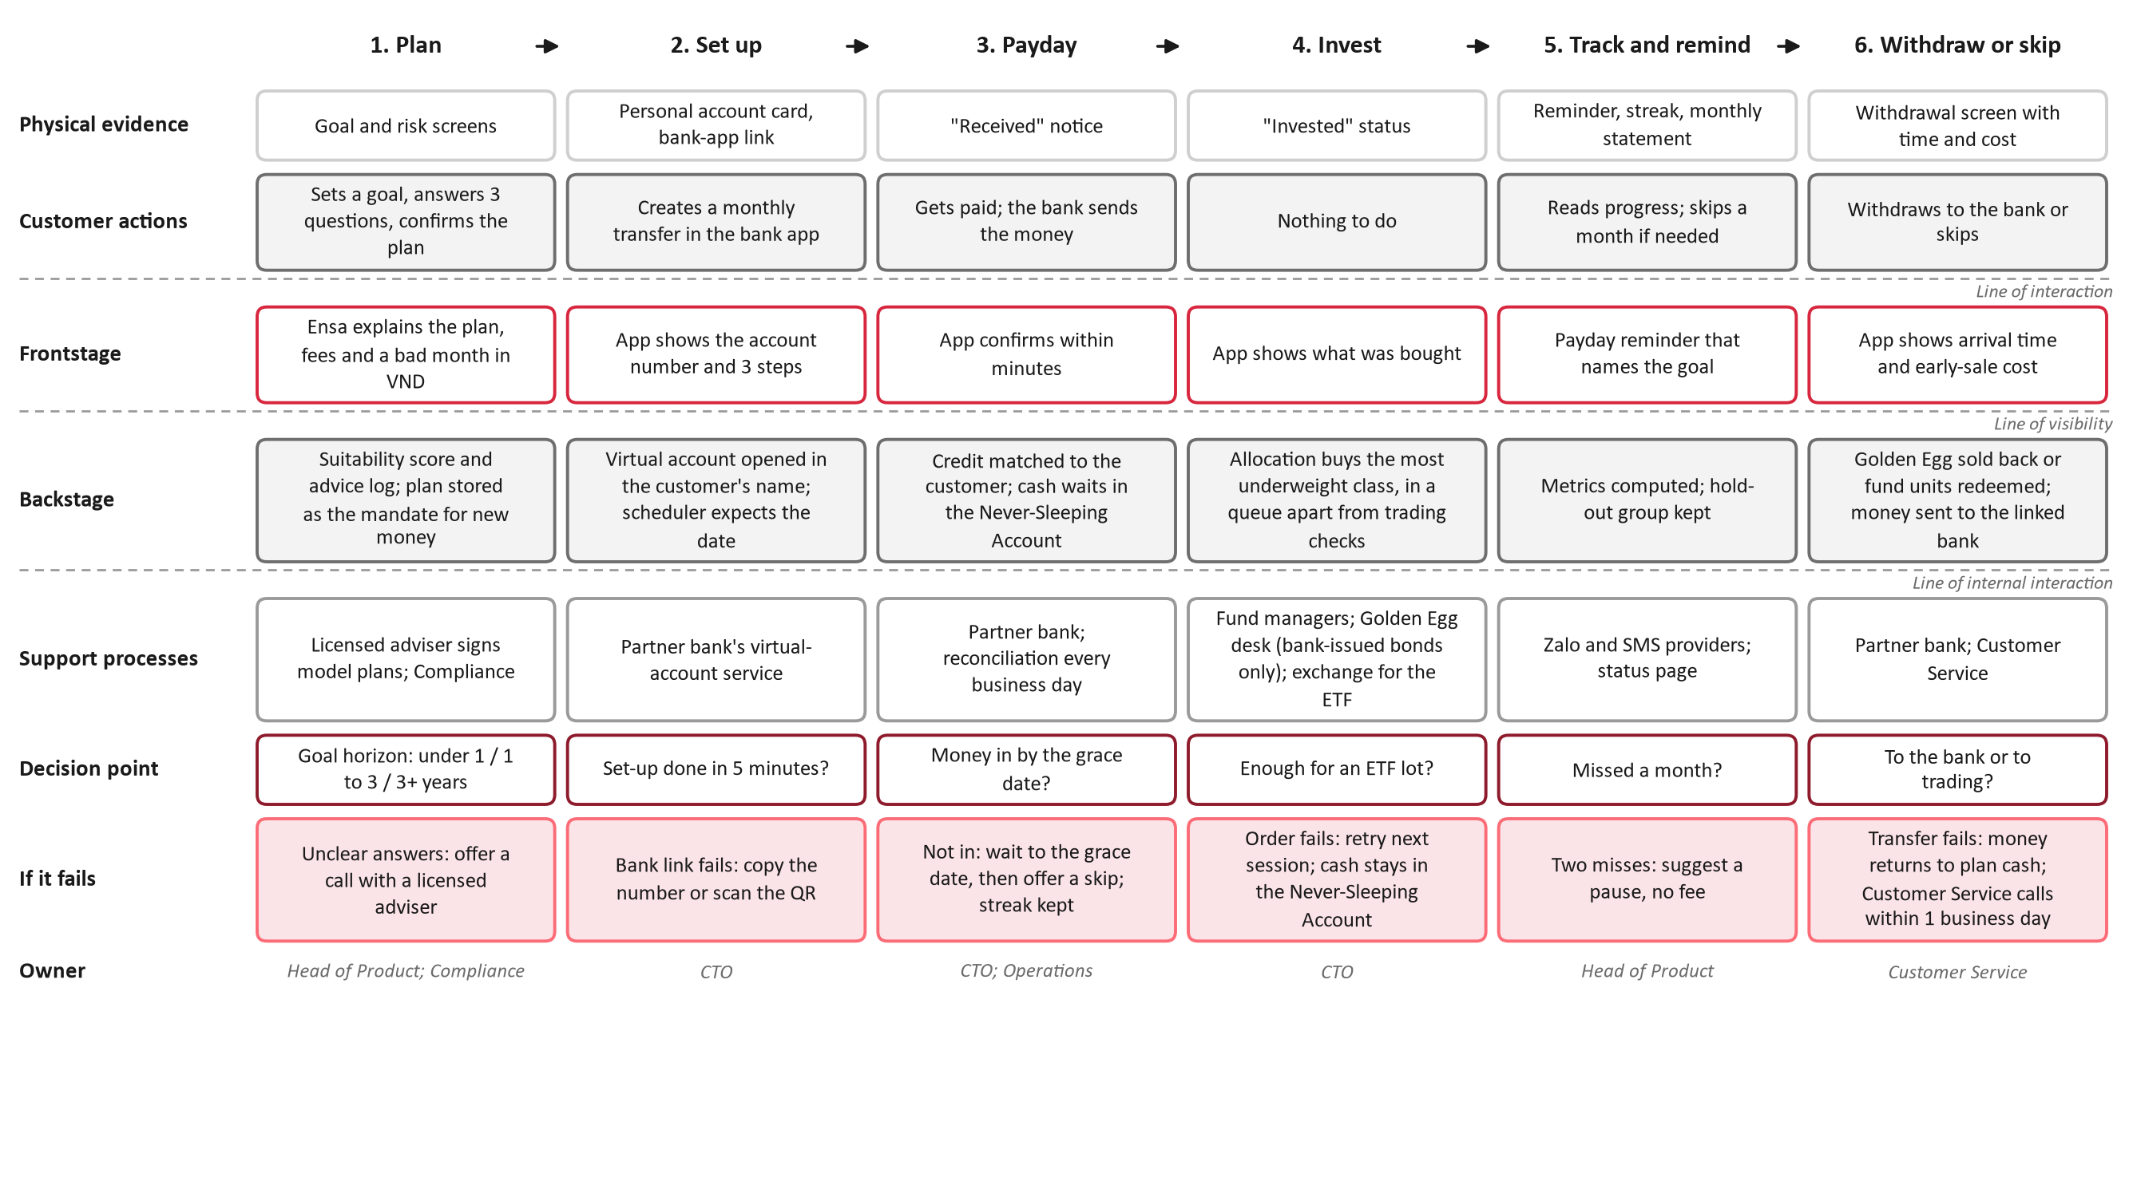
Caption: Service blueprint of one payday cycle: customer, frontstage, backstage and support, with decision points, failure handling and owners.
Source: authors' design; DNSE Securities (2026e).
Table:
When this fails | What happens | Owner
Money not in by the grace date (the 15th) | Suggest skipping the month; streak kept | CTO; Operations
An order fails | Retried next session; cash keeps earning in the Never-Sleeping Account | CTO
Two months missed | Suggest a pause, not a cancellation | Head of Product
Transfer to the bank fails | Money returns to plan cash; a call within 1 business day | Customer Service

CSV: outputs/round3/tables/slide09_failure_handling.csv (sinh bằng src/round3/deck_tables.py từ data/round3/deck_tables/ và output của mô hình; sửa CSV mẫu, không sửa bảng ở đây).
Source: authors' design.
Designer notes (tiếng Việt):
Blueprint đầy đủ khá dày chữ (khoảng 9,6pt ở khổ toàn slide). Trên slide có thể chỉ giữ 4 làn: khách hàng, frontstage, backstage, xử lý lỗi. Bản đầy đủ đưa xuống appendix G.
Ba đường (interaction, visibility, internal interaction) phải thấy rõ; nét đứt.
Bảng 4 dòng đặt dưới cùng, màu chữ RED cho cột "When this fails".
Speaker notes:
Behind the screens, this blueprint shows who does what. Above the line of visibility, the customer sees notices and statements. Below it, the scheduler expects each payday, the virtual account credits the customer automatically and the order engine buys funds or Golden Egg. Two decisions are automatic: whether the money arrived by the grace date, and whether there is enough for an ETF lot. Every failure has a fallback and an owner. If money is late, we wait until the fifteenth, then suggest skipping, and the streak is kept. If an order fails, it is retried next session while cash keeps earning. On 4 March 2026 DNSE's pre-trade check stopped orders for two hours, so the Payday scheduler runs apart from it.
Sources: DNSE Securities (2026e); authors' design.

Slide 10: Competitive positioning
Action title: Recurring plans are now standard; Payday competes on asset range and published proof
On-slide text:
- Of 20 rival products we reviewed, several offer goal-based or multi-fund investing.
- None we found combines bank bonds, funds and an ETF in one customer-confirmed plan from VND 500,000.
- None we found publishes its transfer-success rate or withdrawal times.
- Based on public information as of 16 October 2026.
Table:
Product | Assets | Minimum | Who decides | Fee
VPS Smart Indexing (Aug 2026) | Shares, direct indexing | VND 50 million, then 10 million a month | VPS (discretionary) | 0.5% a year
SSI eSIP (Apr 2026) | SSIAM and Dragon Capital funds | Not found | Customer | No subscription fee on SSIBF
TCBS TCWealth (Q2 2026) | Goal-based portfolios | Not found | Not stated | Not found
VNDIRECT Tích sản hưu trí (Retirement accumulation) | Bond and equity funds, 80/20 | VND 1 million | Customer | 0.1% a year
VCB Digibank SIP (VCBF) | VCBF funds | VND 100,000 a period | Customer | Lower SIP redemption fee
Payday Portfolio (proposed) | Bank bonds, bond and equity funds, VN30 ETF | VND 500,000 a month | Customer confirms an adviser-signed plan | No platform fee

CSV: outputs/round3/tables/slide10_competitors.csv (sinh bằng src/round3/deck_tables.py từ data/round3/deck_tables/ và output của mô hình; sửa CSV mẫu, không sửa bảng ở đây).
Source: Tuoi Tre (2026); Tin nhanh Chung khoan (2026); SSI Securities (2026); Bao Phap Luat (2026); SSI Asset Management (2026); TCBS (2026); VNDIRECT (n.d.); VCBF (n.d.); authors' review, 16 October 2026.
Figure: outputs/round3/figures/positioning_map.png.
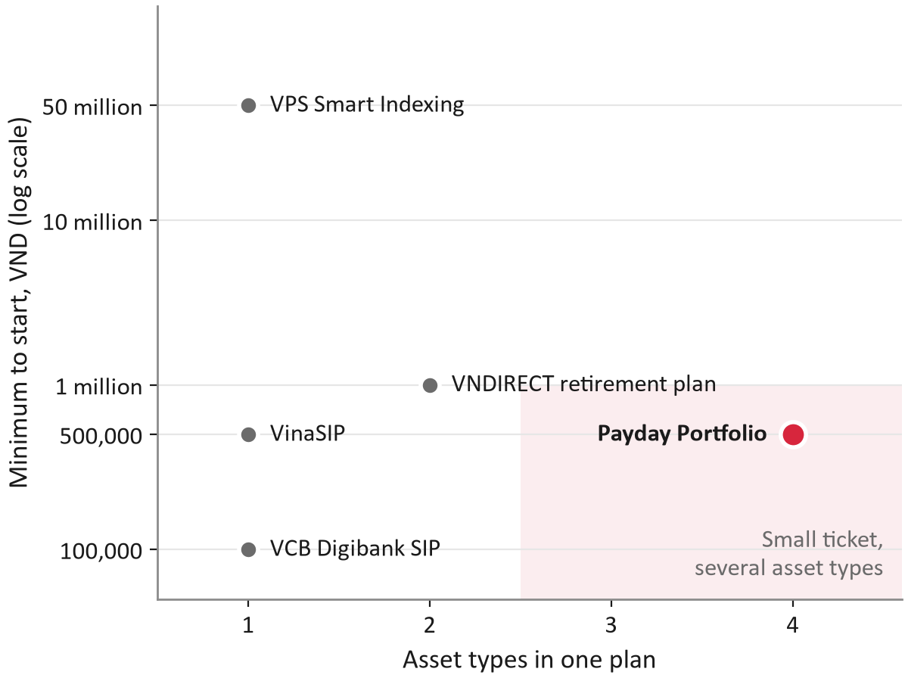
Caption: Minimum to start against the number of asset types in one plan. Only products with a verified minimum are plotted; we found no published minimum for SSI eSIP, TCBS TCWealth or VPBank Goal Jar.
Source: Tuoi Tre (2026); VNDIRECT (n.d.); VCBF (n.d.); Thi truong Tai chinh Tien te (2021); authors' design.
Data: outputs/round3/tables/positioning_map.csv.
Designer notes (tiếng Việt):
Trái: bảng 6 dòng. Phải: bản đồ định vị (nửa slide); ô "small ticket, several asset types" đã tô nhạt, Payday là chấm RED duy nhất.
Không viết "the only" ở bất kỳ đâu. Dòng "Based on public information as of 16 October 2026" bắt buộc phải có.
Appendix C: 9 sản phẩm tác giả đã tự kiểm và 11 sản phẩm tra cứu tại bàn, tổng 20 sản phẩm đối thủ.
Speaker notes:
Where does Payday sit? We reviewed twenty rival products from brokers, banks and fintech apps. Recurring transfers are standard: VinaCapital has offered them since 2021, and Vietcombank customers can invest from 100,000 dong a period. Goal-based plans exist too, such as TCBS TCWealth and VNDIRECT's retirement plan. So we do not claim to be first. VPS Smart Indexing targets wealthier investors, from 50 million dong with a 0.5 per cent fee, and VPS decides for the customer. Payday sits in the empty middle: 500,000 dong a month, bank bonds, funds and an ETF in one plan, and the customer confirms every change. Its lasting edge is reach into 1.5 million accounts DNSE already holds, plus delivery metrics we publish monthly.
Sources: Tuoi Tre (2026); Tin nhanh Chung khoan (2026); SSI Securities (2026); Bao Phap Luat (2026); SSI Asset Management (2026); TCBS (2026); VNDIRECT (n.d.); VCBF (n.d.); Thi truong Tai chinh Tien te (2021).

Slide 11: Business case
Action title: Payday buys funded accounts for about VND 1.3 million each, not fee income
On-slide text:
- The Board risks VND 6.6 billion before the month-6 gate.
- Fixed cost decides the case: build and running cost move month-60 cash by VND 17.5 billion.
- Levers: waive the bank fee, run a lean team, negotiate fund and bond margins.
- Not counted: month-36 balances equal 18% of DNSE's investor cash.
Table:
 | Downside | Base | Upside
Cash need, Phase 0–1, with 15% contingency | VND 8.7 billion | VND 6.6 billion | VND 4.8 billion
New accounts above VND 10 million, month 36 | 2,911 | 14,871 | 51,445
NPV over 60 months at 12% | −VND 35.1 billion | −VND 25.0 billion | +VND 11.0 billion
Payback month | None | None | 44
Net cost per new funded account, month 60 | VND 10.02 million | VND 1.29 million | 0

CSV: outputs/round3/tables/slide11_scenarios.csv (sinh bằng src/round3/deck_tables.py từ data/round3/deck_tables/ và output của mô hình; sửa CSV mẫu, không sửa bảng ở đây).
Source: authors' cohort model (assumptions in Appendix H).
Figure: outputs/round3/figures/payday_jcurve.png và outputs/round3/figures/payday_tornado.png (hai hình nửa slide).
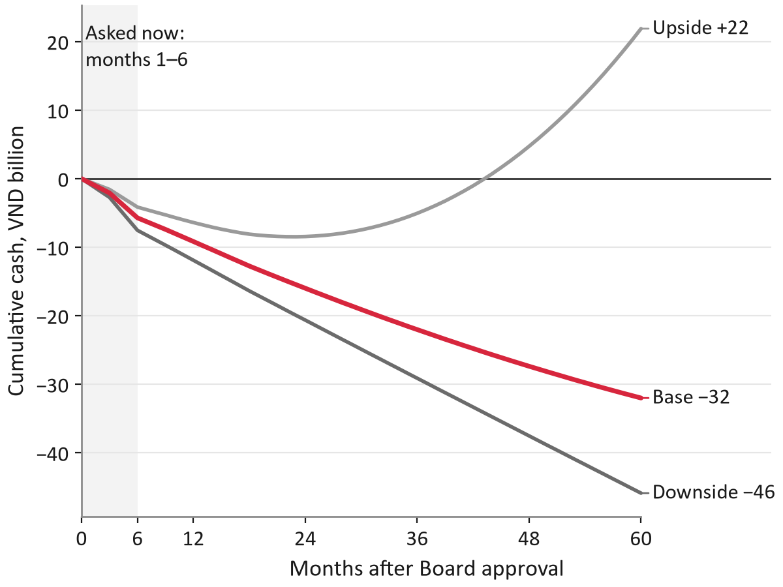 | 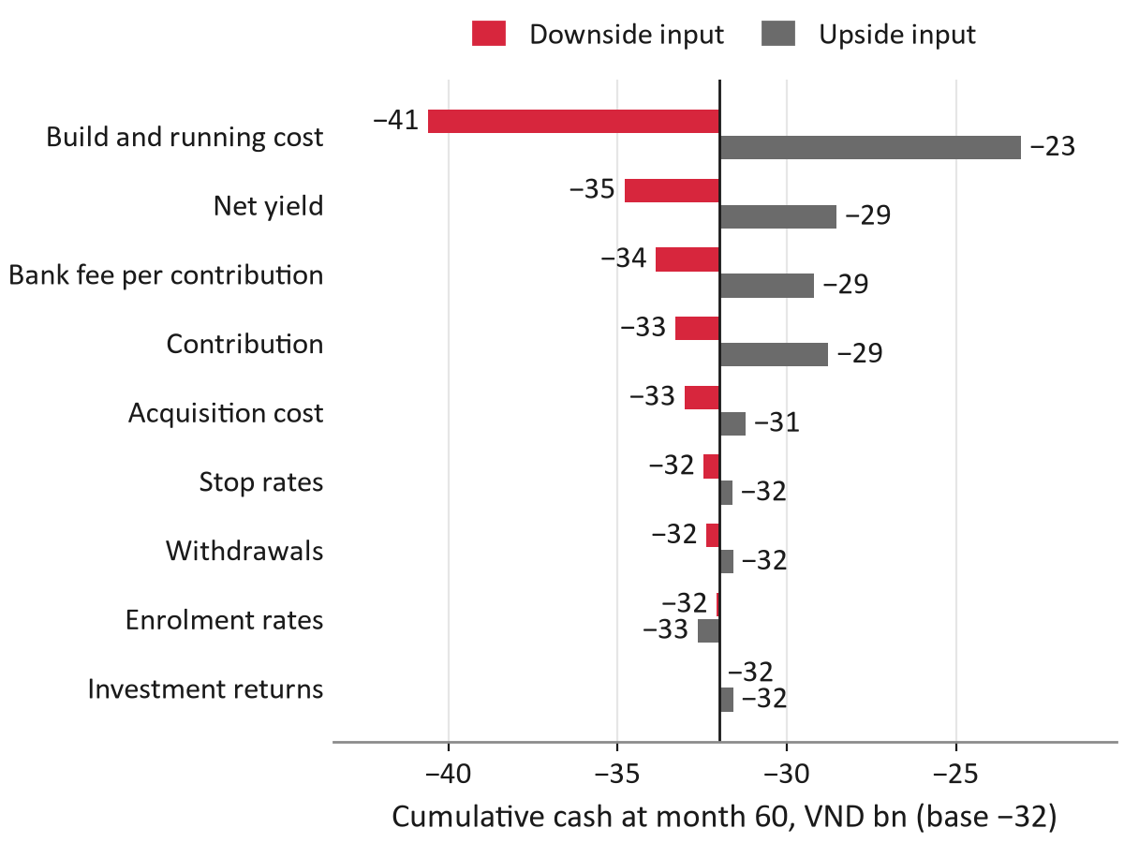

Caption: Left, cumulative cash over 60 months in three scenarios. Right, month-60 cash when one group of inputs moves to its downside or upside value.
Source: authors' cohort model.
Designer notes (tiếng Việt):
Hàng trên: J-curve (trái) và tornado (phải), mỗi hình nửa slide. Hàng dưới: bảng 5 dòng; 4 ý chữ đặt dọc bên phải bảng hoặc chuyển 1–2 ý vào speaker notes nếu chật.
Cột "Base" in đậm. Không tô xanh lá cho số dương: dùng màu xám cho downside/upside, RED cho base, như trong hình.
Ghi chú nhỏ dưới tornado: "Enrolling more savers lowers the cost per funded account (VND 0.68 million at upside enrolment)".
Speaker notes:
Now the CFO's question. We modelled monthly cohorts over sixty months with sourced costs. In the base case Payday does not pay back within five years: cumulative cash reaches minus 32 billion dong at month 60, an NPV of minus 25 billion. It is better read as buying funded accounts at about 1.3 million dong each, and that is the yardstick we ask the Board to accept. The tornado shows fixed cost is the swing factor, far more than yields or enrolment, so a lean team and reused components matter most. Waiving the bank fee is the cheapest lever. The upside pays back in month 44. Either way, the Board's exposure before the first stop decision is 6.6 billion dong.
Sources: authors' cohort model; ITviec (2025); VPBank (2024); SSI Asset Management (2026); VCBF (2026); DNSE Securities (2026c).

Slide 12: Go-to-market, year 1
Action title: Year one: build, test with 45,000 accounts, then scale inside DNSE's base
On-slide text:
- Year-one spend (base): VND 9.2 billion, released gate by gate; the Board approves VND 6.6 billion now.
- Outreach and marketing: VND 1.2 billion of the total.
- No sign-up cash, no "free money" influencers, at most three messages per account.
Table:
Quarter | Who and where | Message | Gate | End of quarter, base: funded savers; balances; spend
Q1: build | DNSE staff, internal beta | – | Gate 0: partner terms; 99.5% shadow runs; SSC notice | 0; 0; VND 2.1 bn
Q2: pilot | 45,000 dormant accounts in 3 arms; Zalo, SMS, push, Ensa | "Your account is ready. Let payday do the investing." | Gate 1: enrolment ≥1.5%, stop below 1.0% | 162; VND 1.1 bn; VND 3.6 bn
Q3: roll out | Dormant accounts; in-app for traders; plan step at account opening | "Keep a core that grows while you trade." | Monthly: acquisition cost per funded saver ≤VND 128,000 | 1,620; VND 10.5 bn; VND 1.7 bn
Q4: first employers | 3 to 5 employers through HR sessions | "An employee benefit that invests your salary." | Gate 2: funded ≥3,962; balances ≥VND 24.1 billion | 4,953; VND 30.1 bn; VND 1.8 bn

CSV: outputs/round3/tables/slide12_gtm.csv (sinh bằng src/round3/deck_tables.py từ data/round3/deck_tables/ và output của mô hình; sửa CSV mẫu, không sửa bảng ở đây).
Source: authors' design; numbers from the authors' cohort model.
Figure: outputs/round3/figures/gtm_timeline.png.
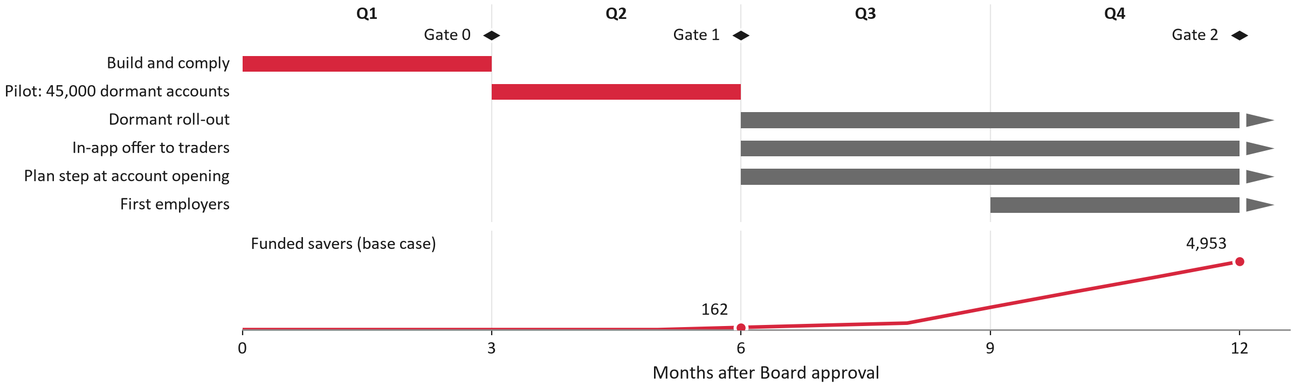
Caption: Year-one activities by month with Gates 0 to 2 (top) and funded savers by month (bottom), base case. Red marks the months the Board approves now; arrows mark channels that continue into year two.
Source: authors' cohort model.
Data: outputs/round3/tables/gtm_year1.csv, payday_monthly_base.csv.
Designer notes (tiếng Việt):
Timeline trên cùng, bảng 4 dòng ở dưới.
Ba thông điệp để nguyên tiếng Anh trong ngoặc kép, in nghiêng.
Ô "Gate" màu RED nhạt để nối với slide 14.
Speaker notes:
Year one has four steps. In quarter one we build, sign partners and run the plan with staff money; nothing launches before Gate zero. In quarter two a randomised pilot reaches 45,000 dormant accounts in three arms, with at most three messages each and no sign-up reward. If enrolment clears 1.5 per cent, quarter three rolls out to the remaining eligible dormant accounts, adds an in-app offer for active traders and a plan step at account opening. In quarter four we test the first three to five employers through HR sessions with a licensed adviser. By month twelve the base case has 9,414 savers enrolled, 4,953 funded and 30 billion dong in plans, for 9.2 billion dong of spending.
Sources: authors' cohort model; Zalo Business Solutions (n.d.); MobiFone (n.d.).

Slide 13: Strategic roadmap
Action title: Five gated phases move DNSE from trading-first to balance-first
On-slide text:
- Shared rails serve the whole app: virtual accounts, scheduler, suitability engine, transparency dashboard.
- Ecosystem: fix the base (months 0–6), keep money in (6–12), grow on balances (12–24).
- Not in the base case: ETF-secured lending, reviewed only at Gate 3.
Table:
Phase | Months | Objective | Key initiatives | Gate and result (base)
0. Build and comply | 1–3 | A safe, legal MVP | Virtual accounts (fee target VND 0); fund contracts; adviser-signed plans; SSC notice | Gate 0; −VND 2.1 billion cumulative
1. Pilot | 4–6 | Measure enrolment, persistence, new money | Randomised pilot, 45,000 accounts, 3 arms | Gate 1; 600 savers
2. Scale in the base | 7–12 | Controlled scale | Dormant roll-out; in-app; account opening; first employers | Gate 2; 4,953 funded
3. Outside channels | 13–24 | Channels that create a default | Employers; salary percentage via Open API from March 2027; step-up with pay rises | Gate 3; 7,714 new accounts above VND 10 million
4. Optimise | 25–36 | Better economics, a managed option | Partner or DNSE-owned fund manager; Golden Egg with more bank partners | Quarterly review; 14,871 new accounts above VND 10 million

CSV: outputs/round3/tables/slide13_roadmap.csv (sinh bằng src/round3/deck_tables.py từ data/round3/deck_tables/ và output của mô hình; sửa CSV mẫu, không sửa bảng ở đây).
Source: authors' design; numbers from the authors' cohort model; DNSE Securities (2026f); State Bank of Vietnam (2024).
Figure: outputs/round3/figures/roadmap.png.
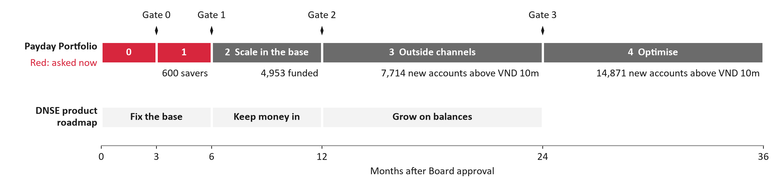
Caption: Payday's five gated phases with base-case results (top), above DNSE's balance-first product roadmap (bottom).
Source: authors' design; authors' cohort model.
Data: outputs/round3/tables/roadmap_phases.csv, ecosystem_roadmap.csv.
Designer notes (tiếng Việt):
Hình roadmap chiếm nửa trên; bảng 5 dòng nửa dưới (có thể bỏ cột "Months" nếu hình đã thể hiện).
Dòng "Not in the base case" màu xám, nhỏ hơn.
Speaker notes:
Beyond year one, the roadmap has five gated phases. Phases zero to two build, test and scale inside DNSE's base. Phase three, from month thirteen, adds channels that create a default: employers, and salary-percentage contributions through bank open APIs once banks comply in March 2027. Phase four looks at a fully managed version through a partner or DNSE-owned fund manager, and wider Golden Egg supply through DNSE's planned bank partnerships. Payday also anchors DNSE's shift from trading-first to balance-first: the virtual accounts, scheduler, suitability engine and transparency dashboard serve deposits, margin and Golden Egg as well. ETF-secured lending is not in our numbers; it would be reviewed only at Gate three.
Sources: authors' cohort model; State Bank of Vietnam (2024); DNSE Securities (2026f).

Slide 14: Validation and KPIs
Action title: Each phase has a number that scales, adjusts or stops the plan
On-slide text:
- Pilot: 45,000 dormant accounts in three arms of 15,000: control, Payday, Payday with the persistence package.
- Enough to detect a 10-point gain in six-month persistence.
- North Star: new accounts above VND 10 million. Leading signs: funded savers, new money, on-time rate.
Table:
Gate (month) | Measure | Scale if | Stop if | Owner
0 (3) | Shadow payday runs credited on time | ≥99.5% | Below 99.5%: delay the pilot | CTO
0 (3) | Bank fee per contribution | VND 0 target, ≤3,300 | Above VND 6,200 | CFO
1 (6) | Enrolment of treated dormant accounts | ≥1.5% | Below 1.0% | Head of Product
1 (6) | Projected net cost per new funded account | ≤VND 1.6 million | Above VND 2.6 million | CFO
2 (12) | Funded savers | ≥3,962 | Below 2,476 for two quarters | Head of Product
3 (24) | New accounts above VND 10 million; employer participation | ≥6,171; ≥39% | Below 1,140; below 20% | CEO

CSV: outputs/round3/tables/slide14_gates.csv (sinh bằng src/round3/deck_tables.py từ data/round3/deck_tables/ và output của mô hình; sửa CSV mẫu, không sửa bảng ở đây).
Source: authors' cohort model; thresholds derived from unit economics.
Figure: outputs/round3/figures/decision_tree.png.
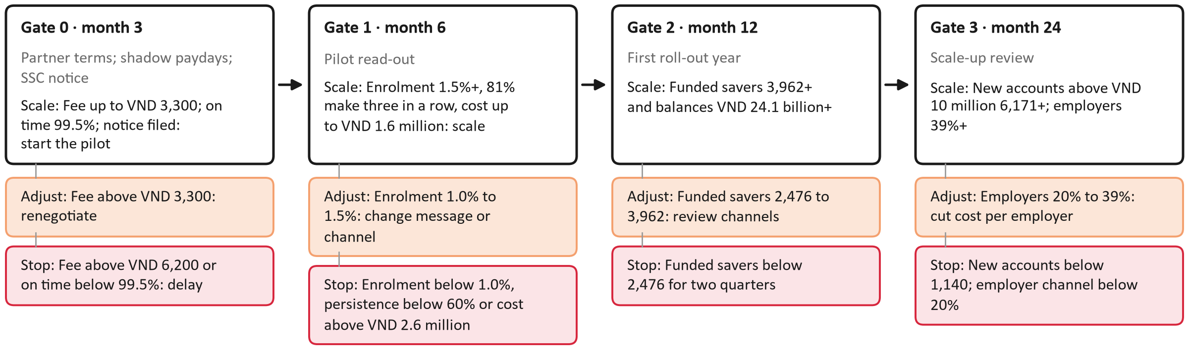
Caption: Scale, adjust and stop branches at Gates 0 to 3, with thresholds from the cohort model.
Source: authors' cohort model.
Data: outputs/round3/tables/decision_tree.csv.
Designer notes (tiếng Việt):
Cây quyết định nằm ngang chiếm nửa trên: mỗi cổng là một nút có ba nhánh (xanh xám = scale, PEACH = adjust, RED = stop).
Bảng 6 dòng ở dưới. Đây là slide của tiêu chí 30 điểm: phải đọc được ở cỡ slide.
Speaker notes:
How will the Board know whether to continue? Every phase ends with numbers that scale, adjust or stop the plan. Gate zero, at month three, checks partner terms, a 99.5 per cent on-time rate in shadow paydays and written compliance. Gate one, at month six, reads the pilot. We scale if at least 1.5 per cent of treated accounts enrol and stop below one per cent. We also stop if fewer than 60 per cent make three contributions, or if the projected cost per new funded account exceeds 2.6 million dong. The pilot has three arms of 15,000 accounts, enough to detect a ten-point gain in persistence. Gates two and three test funded savers, new funded accounts and the employer channel.
Sources: authors' cohort model.

Slide 15: Risks and Board ask
Action title: Approve VND 6.6 billion and five decisions; we report back at month 6
On-slide text:
- Highest risks: a payday failure (20 of 25), low enrolment (16), and a regulator objection to Golden Egg's role (15).
- Each risk has an owner and an early-warning trigger (Appendix B).
Table:
Ask | Detail
Budget | VND 6.6 billion for months 1 to 6 (5.7 plus 15% contingency)
Decision 1 | Choose the virtual-account bank; collection fee target VND 0
Decision 2 | Sign 1 to 2 fund managers
Decision 3 | File the SSC notice; pre-consult on Golden Egg's role
Decision 4 | Have a licensed adviser sign the model plans
Decision 5 | Accept about VND 1.3 million per new funded account as the gate yardstick

CSV: outputs/round3/tables/slide15_board_ask.csv (sinh bằng src/round3/deck_tables.py từ data/round3/deck_tables/ và output của mô hình; sửa CSV mẫu, không sửa bảng ở đây).
Source: authors' cohort model.
Figure: outputs/round3/figures/risk_heatmap.png.
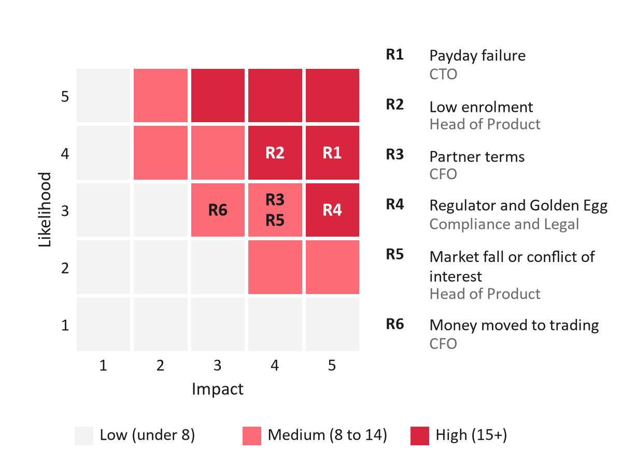
Caption: Six risks by likelihood and impact on a 1 to 5 scale, with owners; cell colours follow the score bands of the risk register.
Source: authors' assessment.
Data: outputs/round3/tables/risk_register.csv.
Designer notes (tiếng Việt):
Trái: heat map 5×5 (ô càng đỏ càng nặng), mỗi rủi ro là một nhãn R1–R6. Phải: khung "Board ask" viền RED.
Đây là slide cuối, kết bằng câu hỏi xin duyệt. Không thêm "Thank you" trên cùng slide.
Speaker notes:
Three risks matter most. A payday failure scores highest, and the 4 March outage shows it can happen, so shadow runs, a separate scheduler and a release freeze come before launch. Low enrolment comes second, which is why we stop below one per cent. Third, the regulator may object to Golden Egg's role or to the advice flow. New Golden Egg openings were paused at the regulator's request in December 2023, so we notify the SSC early and keep bond funds as a fallback core. Our ask is specific: 6.6 billion dong for months one to six, and five decisions, starting with a virtual-account bank that waives the collection fee. We will come back at month six with measured numbers.
Sources: authors' assessment; DNSE Securities (2023, 2026e); Market Times (2026).

Appendix và references
Appendix A–I (nội dung đầy đủ, có bảng sinh từ CSV) và danh mục references APA 7 nằm ở `docs/doc_round3/deck_appendix.md`.

Round 3A deck appendix and references: Payday Portfolio
Lập ngày 17/10/2026, đi cùng `deck_content.md`. Appendix không tính vào 15 slide chính. Thứ tự trong deck: 15 slide chính → appendix A–I → references.
Đọc file này thế nào
- Mỗi mục "###" là một slide appendix (bảng dài có thể tách thành 2 slide khi thiết kế).
- Bảng nằm giữa hai dòng <!-- table: ... --> và được ghi từ CSV bằng python src/round3/deck_tables.py. Không sửa bảng trực tiếp ở đây.
- Chữ trên slide bằng tiếng Anh; ghi chú cho người dựng slide bằng tiếng Việt.

Appendix A: Data and methods

A1. Data behind the deck
Title: Every number comes from DNSE's filings, public sources or the cohort model
Text:
- Assumptions are labelled as such; the pilot measures them before any scale-up.
Table:
Data | Source | Used for
Accounts, active customers and funded accounts, December 2025 | DNSE Annual Report 2025 (DNSE Securities 2026c) | Problem, sizing, model inputs
DNSE financial statements, Q1 2018 to Q2 2026 | DNSE filings via Vietcap Securities (2026) | Brokerage loss, platform cost per funded account
Market shares of accounts, investor cash, margin loans and profit | HNX, VSDC and press reports, reconciled in Round 2 | Slide 2
App reviews of DNSE, VPS and FPTS, 2021 to 2026 | Google Play and App Store; Round 2 cleaning; 58 negative 2026 reviews coded by hand | Slides 4 and 5; Appendices D and F
Rates, fees and product terms, October 2026 | 44 web sources with access dates (sources_round3.csv) | Model inputs; slides 3, 7 and 10
Wages paid into an account | World Bank (2025) Global Findex | Share of salaried dormant holders

CSV: outputs/round3/tables/appA1_data_sources.csv.
Source: authors.

A2. Methods and checks
Title: The model reproduces the Round 2 worked example before it is used
Text:
- Every table and figure is generated by code from the data files and can be rerun in about ten seconds.
Table:
Method | What it does | How it was checked
Monthly cohort model | Follows each month's new savers: stop rates, contributions, withdrawals and who passes VND 10 million | 35 tests pass, including the worked example of the Round 2 plan
Calendar engine | Runs the same cohorts in calendar time, so a shock hits every cohort at once | Matches the cohort engine exactly when there is no shock
Unit economics | CAC ceiling = present value of net revenue per saver over 60 months at 12% | Break-even enrolment = reach cost ÷ CAC ceiling
Decision gates | Stop and scale lines solved from the model by bisection | Programme test: net cost per new funded account
Review coding | 58 negative 2026 reviews read one by one; 8 cause codes, several allowed per review | 95% Wilson intervals; compared with the Round 2 keyword rule

CSV: outputs/round3/tables/appA2_methods.csv.
Source: authors.

Appendix B: Cohort model, sensitivity and implementation detail

B1. Unit economics by scenario
Title: A saver needs 11 contributions to pass VND 10 million in the base case
Table:
Measure | Downside | Base | Upside
Net yield on plan balances, a year | 0.25% | 0.44% | 0.68%
Revenue a year on VND 10 million of balance | VND 25,000 | VND 44,150 | VND 67,900
Still contributing after 3 contributions | 72.2% | 81.0% | 88.4%
Still contributing after 6 contributions | 63.9% | 75.1% | 84.4%
Still contributing after 12 contributions | 50.0% | 64.5% | 77.1%
Contributions in a row to pass VND 10 million | 14 | 11 | 7
CAC ceiling: PV of net revenue per saver, 60 months | −VND 44,938 | VND 127,512 | VND 728,075
Acquisition cost per dormant saver | VND 220,000 | VND 65,000 | VND 27,500
Reach cost per dormant account contacted | VND 2,200 | VND 1,300 | VND 1,100
Break-even enrolment of contacted accounts | not reached | 1.02% | 0.15%

CSV: outputs/round3/tables/appB1_unit_economics.csv.
Source: authors' cohort model (assumptions in Appendix H).

B2. Budget by phase and the path of balances
Title: Most of the spend is the team, not marketing
Table (VND billion, base case):
Phase | Months | Cost | of which build | Revenue | Cumulative cash at end
Phase 0: build and comply | 1–3 | 2.09 | 2.09 | 0.00 | −2.09
Phase 1: pilot | 4–6 | 3.63 | 2.09 | 0.00 | −5.72
Phase 2: scale in the base | 7–12 | 3.49 | 0.00 | 0.03 | −9.17
Phase 3: outside channels | 13–24 | 7.28 | 0.00 | 0.46 | −15.99
Phase 4: optimise | 25–36 | 7.23 | 0.00 | 1.20 | −22.02
Years 4 and 5 | 37–60 | 14.73 | 0.00 | 4.76 | −32.00

CSV: outputs/round3/tables/appB2_phase_budget.csv.
Figure: outputs/round3/figures/payday_balance_accounts.png.
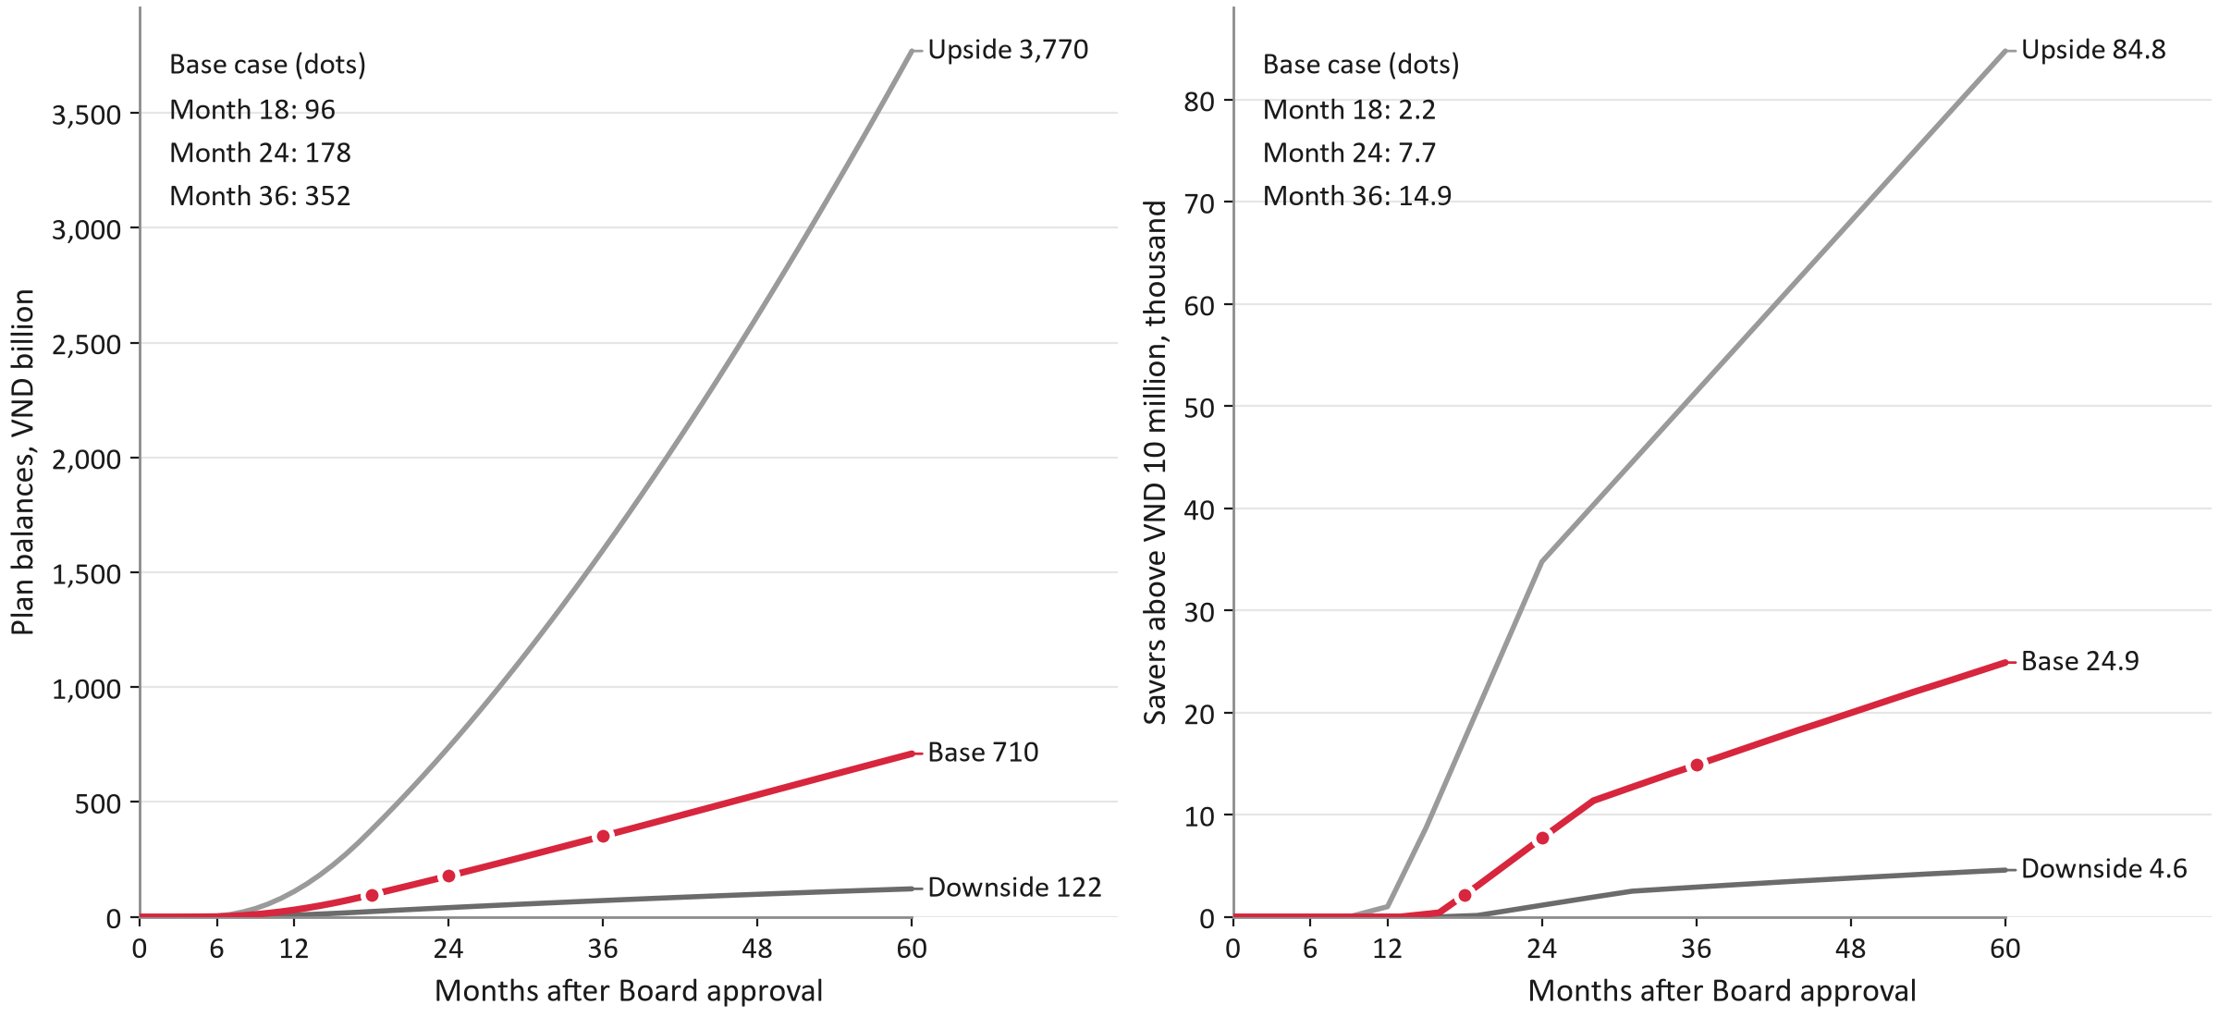
Caption: Plan balances (left) and new accounts above VND 10 million (right) by month, in three scenarios.
Source: authors' cohort model.

B3. Levers on the cost per funded account
Title: A lean team is the biggest lever; waiving the bank fee is the cheapest
Table:
Case | Net cost per new funded account, month 60 (VND million) | Cumulative cash, month 60 (VND billion) | NPV (VND billion) | Break-even month
Base case | 1.29 | −32.0 | −25.0 | none
Partner bank waives the collection fee | 1.17 | −29.2 | −23.0 | none
Lean team: 4 IT staff, lower overheads | 0.85 | −21.2 | −16.8 | none
Upside yields: Golden Egg margin 1.5%, 40% of fund fees | 1.15 | −28.5 | −22.7 | none
Upside enrolment in every channel | 0.68 | −30.8 | −24.5 | none
Fee waived and lean team | 0.74 | −18.4 | −14.8 | none
Fee waived, lean team, upside yields | 0.60 | −14.9 | −12.6 | 58
Fee waived, lean team, upside yields and enrolment | 0.18 | −8.2 | −8.3 | 39
All inputs at upside (upside scenario) | 0.00 | 21.9 | 11.0 | 24
DNSE's own bonds in the Golden Egg core (margin about 1.2 points; rejected, decision D7) | 1.13 | −28.1 | −22.4 | none
Half of the team cost treated as shared platform spending (incremental view) | 0.86 | −21.4 | −16.8 | none

CSV: outputs/round3/tables/appB3_levers.csv.
Source: authors' cohort model.

B4. Stress tests
Title: Shocks hit the KPI far more than the cash
Table:
Case | New accounts above VND 10 million, month 36 | Change | Change in month-60 cash (VND billion)
Base case, no shock | 14,871 | 0.0% | 0.00
Market fall in year 2: stop and withdrawal rates three times normal in months 13 to 15 | 13,043 | −12.3% | −0.35
Failed payday run in month 9: 15% of contributing savers stop; enrolment 30% lower in months 9 to 11 | 13,725 | −7.7% | −0.21
Both shocks | 12,118 | −18.5% | −0.51

CSV: outputs/round3/tables/appB4_stress.csv.
Source: authors' cohort model (calendar engine).

B5. Cash tiers and pilot size
Title: Cash tiers pay only if the bank fee is waived and persistence rises
Text:
- A 45,000-account pilot can detect a 9.9-point gain in the six-contribution rate; 20,000 accounts could not.
Table:
Bank fee | Reward design | Reward cost, % of revenue | CAC ceiling | 12-contribution rate needed
Base bank fee | Round 2 tiers made small: 10k / 20k / 50k gifts, 0.1-point fee rebate from 6, Golden Egg +0.2 points from 12 | 41.2% | VND 36,712 | not reachable
Base bank fee | Tested option: 30k gift at 12, 0.1-point fee rebate from 6 | 14.2% | VND 96,158 | not reachable
Base bank fee | MVP (decision D1): non-cash features only | 0.0% | VND 127,512 | 64.5%
Bank fee waived | Round 2 tiers made small: 10k / 20k / 50k gifts, 0.1-point fee rebate from 6, Golden Egg +0.2 points from 12 | 41.2% | VND 108,077 | not reachable
Bank fee waived | Tested option: 30k gift at 12, 0.1-point fee rebate from 6 | 14.2% | VND 167,523 | 73.3%
Bank fee waived | MVP (decision D1): non-cash features only | 0.0% | VND 198,876 | 64.5%

CSV: outputs/round3/tables/appB5_tiers.csv.
Table:
Pilot accounts | Savers per treated arm | Enrolment, 95% interval | Smallest detectable gain (points) | Outreach cost (VND million)
20,000 | 133 | 1.76–2.24% | 14.8 | 17.3
30,000 | 200 | 1.81–2.19% | 12.1 | 26.0
45,000 | 300 | 1.84–2.16% | 9.9 | 39.0
60,000 | 400 | 1.86–2.14% | 8.6 | 52.0

CSV: outputs/round3/tables/appB6_pilot_power.csv.
Source: authors' cohort model.

B6. All decision gates
Title: Seventeen measures across four gates, each with an owner
Table:
Gate | Measure | Scale if | Adjust if | Stop if | Owner
Gate 0: before the pilot | Partner terms signed: bank fee per contribution; share of fund fees paid to DNSE; DNSE's margin on bank bonds in Golden Egg | Fee ≤ VND 3,300; fund share ≥ 30%; margin ≥ 0.6 points | Worse on any term: re-run the model and renegotiate before the pilot | Fund or bank partner not signed (launch dependency) | CFO
Gate 0: before the pilot | Bank fee per contribution (virtual-account collection), VND | 0 (partner bank keeps the deposits) | 1 to 3,300 (list price) | > 6,191: a dormant saver no longer pays back | CFO
Gate 0: before the pilot | Shadow payday runs with staff accounts: transfers credited on time | ≥ 99.5% | - | < 99.5%: delay the pilot | CTO
Gate 1: pilot read-out | Projected net cost per new account above VND 10 million by month 60 (model re-run with the pilot's measured values and the signed terms), VND million | ≤ 1.6 (1.25 x plan) | 1.6 to 2.6 | > 2.6 (2 x plan) | CFO
Gate 1: pilot read-out | Enrolment rate of treated dormant accounts (set-up and first contribution within 60 days) | ≥ 1.5% | 1.0% to 1.5% | < 1.0% | Head of Product
Gate 1: pilot read-out | Savers making three contributions in a row | ≥ 81.0% | 60.0% to 81.0% | < 60.0% | Head of Product
Gate 1: pilot read-out | Average monthly contribution, VND | ≥ 1,000,000 | 716,502 to 1,000,000 | < 716,502 | CFO
Gate 1: pilot read-out | Share of plan inflows that is new money (tagged by source) | ≥ 80% | 60% to 80% | < 60% | CFO
Gate 1: pilot read-out | Scheduled transfers credited on time | ≥ 99.5% | - | < 99.5% (launch gate) | CTO
Gate 1: pilot read-out | Compliance: SSC notice filed; model portfolios signed off by a licensed adviser | Written confirmation | - | Missing (launch gate) | Compliance
Gate 2: first roll-out year | Funded savers (three or more contributions in a row) | ≥ 3,962 (80% of plan) | 2,476 to 3,962 | < 2,476 for two quarters | Head of Product
Gate 2: first roll-out year | Plan balances, VND billion | ≥ 24.1 (80% of plan) | 15.1 to 24.1 | < 15.1 for two quarters | CFO
Gate 2: first roll-out year | Acquisition cost per funded saver, VND | ≤ 127,512 (CAC ceiling) | - | > 127,512 for two quarters | CFO
Gate 3: scale-up review | Monthly plan revenue against monthly running cost | ≥ 16% (plan) | - | < 2% (downside path): review the revenue model | CFO
Gate 3: scale-up review | New accounts above VND 10 million from the plan | ≥ 6,171 (80% of plan) | - | < 1,140 (downside path) | CEO
Gate 3: scale-up review | Employer channel: share of employees who enrol after the HR session | ≥ 39% | 20% to 39%: lower the cost per employer | < 20%: stop the channel | Head of Product
Gate 3: scale-up review | Net cost per new account above VND 10 million to date, VND million | ≤ 2.6 (1.25 x plan) | 2.6 to 4.1 | > 4.1: fold into the core app team or stop | CFO

CSV: outputs/round3/tables/appB7_gates.csv.
Source: authors' cohort model.
Ghi chú cho người dựng slide: bảng dài, tách thành 2 slide (Gate 0–1 và Gate 2–3).

B7. Risk register
Title: Six risks, each with an early warning and an owner
Table:
ID | Risk | Likelihood × impact | Mitigation | Early warning | Owner
R1 | A payday transfer or the app fails on a payday | 4 × 5 = 20 | Shadow payday runs before launch; contribution scheduler kept apart from the pre-trade buying-power check; no app release in the days before peak contribution dates; staged releases; status page and post-incident note | Contributions credited on time below 99.5% in any month | CTO
R2 | Too few dormant accounts enrol | 4 × 4 = 16 | Randomised pilot with 45,000 accounts before any roll-out; Gate 1 stop line at 1.0%; plan step at account opening; message tests across arms | Enrolment of treated accounts below 1.0% at month 6 | Head of Product
R4 | The regulator objects to Golden Egg's role or to the advice flow | 3 × 5 = 15 | SSC notice and pre-consultation before launch; model plans signed by a licensed adviser; bond funds ready as the alternative safe core | Written query or objection from the SSC | Compliance and Legal
R3 | Partner terms leave too little per saver (bank fee, fund-fee share, bond margin) | 3 × 4 = 12 | Gate 0 terms: collection fee target VND 0 (the bank keeps the deposits), fund-fee share >= 30%, bond margin >= 0.6 points; re-run the model before the pilot | Signed fee above VND 6,191 per contribution | CFO
R5 | A market fall or a conflict of interest damages trust | 3 × 4 = 12 | Plans follow the goal horizon (no equities for goals under 3 years); no DNSE-issued bonds in the default plan; bad-month cost shown in VND before confirming | Trust themes above 10% of Payday-related negative reviews | Head of Product
R6 | Plan money is moved to trading or comes from existing balances | 3 × 3 = 9 | Inflows tagged by source; withdrawals go to the linked bank by default; a separate step with a goal reminder before moving money to buying power | New money below 80% of inflows, or more than 10% of withdrawals moved to buying power | CFO

CSV: outputs/round3/tables/appB8_risks.csv.
Source: authors' assessment; DNSE Securities (2023, 2026e); Market Times (2026); VnExpress (2026b).

B8. Responsibilities (RACI)
Title: One accountable owner for every activity
Table:
Activity | CEO | CFO | CTO | Head of Product | Compliance and Legal | Marketing and CRM | Customer Service | Licensed adviser
Gate decisions (months 3; 6; 12; 24) | A | R | C | R | C | I | I | I
Partner terms: virtual-account bank, fund managers, bond supply | I | A/R | C | C | C | - | - | -
SSC notice, legal opinions, review of promotions | I | I | I | C | A/R | C | - | C
Model plans and suitability rules | I | - | I | C | A | - | - | R
MVP build: scheduler, virtual accounts, allocation, dashboard | I | I | A/R | C | C | - | I | -
Shadow payday runs and the 99.5% reliability gate | I | I | A/R | C | I | - | I | -
Randomised pilot: design and read-out | I | C | C | A/R | C | C | I | C
Outreach and messages | I | I | I | A | C | R | I | -
Complaints, withdrawals and recovery after failures | I | I | C | A | C | I | R | -
Monthly service metrics published | I | I | R | A | C | C | C | -

CSV: outputs/round3/tables/appB9_raci.csv.
Source: authors' design. R = responsible, A = accountable, C = consulted, I = informed.

Appendix C: Competitor products

C1. Products checked by the authors
Title: Recurring plans are common; none we found mixes bank bonds, funds and an ETF
Text:
- Checked by the authors on 16 October 2026 against the sources listed.
- Also reviewed from desk research, not re-checked: TCBS iTracker, Fundmart and iSave; VNDIRECT VNDGO; VPBankS NEO Invest and Tích sản cổ phiếu (Share accumulation); MBS Mobile; Techcombank iFund; MoMo Túi Thần Tài (God of Wealth pocket); Tikop; Finhay with DFVN.
Table:
Product | Assets | Minimum | Recurring | Who decides | Fees and rewards | Source
VPS Smart Indexing (11 Aug 2026) | Shares, direct indexing | VND 50 million, then 10 million a month | Yes | VPS (discretionary) | 0.5% a year | Tuoi Tre (2026); Tin nhanh Chung khoan (2026)
SSI eSIP (campaign from 23 Apr 2026) | SSIAM and Dragon Capital funds | Not published | Yes | Customer | VND 50,000 voucher for new customers buying VND 1 million through eSIP | SSI Securities (2026); Bao Phap Luat (2026)
TCBS TCWealth (Q2 2026) | Goal-based portfolios | Not found | Not stated | Not stated | Not found | TCBS (2026)
TCBS iPower | Idle cash | VND 5 million | Automatic | – | Up to 6% a year (2025 comparison) | DNSE Securities (2025)
VNDIRECT Tích sản hưu trí (Retirement accumulation) | Bond and equity funds, 80/20 for 10 years | VND 1 million | Yes | Customer | 0.1% a year (free to December 2025) | VNDIRECT (n.d.)
VinaCapital VinaSIP (Jun 2021) | One VinaCapital fund per plan | VND 500,000 a month | Yes, standing order from the bank | Customer | – | Thi truong Tai chinh Tien te (2021)
VCB Digibank SIP (VCBF) | VCBF funds | VND 100,000 a period | Yes | Customer | Preferential redemption fee for SIP | VCBF (n.d.)
VPBank Hũ Mục Tiêu (Goal Jar; Sep 2026) | Deposits | Not found | Yes, by day, week or month | Customer | – | VPBank (2026)
KBSV periodic investment | Shares | – | Yes | Customer | VND 50,000 voucher a month, capped at VND 600,000 (Apr 2025 to Mar 2026) | KBSV (n.d.)
DNSE today | Never-Sleeping Account (1.8–4.3% on idle cash); Golden Egg bonds (6.20–7.60%) | Golden Egg from VND 100,000 | No plan product | Customer | No fee on share trades | DNSE Securities (2026b, 2026d, n.d.-b)
Payday Portfolio (proposed) | Bank bonds, bond and equity funds, VN30 ETF | VND 500,000 a month | Yes, standing order to a personal virtual account | Customer confirms an adviser-signed plan | No platform fee | Authors' design

CSV: outputs/round3/tables/appC1_competitors.csv.
Source: as listed in the table; based on public product information as of 16 October 2026.

Appendix D: Reviews of DNSE's app, 2026

D1. Causes
Title: Something broke in 83% of DNSE's negative reviews in 2026
Text:
- 58 negative reviews (34 Google Play, 24 App Store), 1 January to 21 September 2026, read one by one; a review can carry several causes.
Table:
Cause | Google Play | App Store | Both stores | 95% interval
Login, OTP and authentication | 3 (9%) | 5 (21%) | 8 (14%) | 7.2–24.9%
Deposits or withdrawals not credited | 4 (12%) | 6 (25%) | 10 (17%) | 9.6–28.9%
Orders, prices and settlement | 6 (18%) | 5 (21%) | 11 (19%) | 10.9–30.9%
Crashes, freezes and lag | 15 (44%) | 11 (46%) | 26 (45%) | 32.7–57.5%
eKYC and account opening | 5 (15%) | 5 (21%) | 10 (17%) | 9.6–28.9%
Fees and terms (closure, auto-renewal) | 3 (9%) | 3 (12%) | 6 (10%) | 4.8–20.8%
Scam claims and rewards | 4 (12%) | 3 (12%) | 7 (12%) | 6.0–22.9%
Other (service, interface, Ensa, no reason) | 6 (18%) | 7 (29%) | 13 (22%) | 13.6–34.7%
Something broke (any of the first five causes) | 28 (82%) | 20 (83%) | 48 (83%) | 71.1–90.4%
Fees, terms, scam claims or rewards | 6 (18%) | 5 (21%) | 11 (19%) | 10.9–30.9%
Login/OTP failures or money not credited | 7 (21%) | 10 (42%) | 17 (29%) | 19.2–42.0%
Posted 4-5 March 2026, after the outage DNSE disclosed for 4 March | 4 (12%) | 5 (21%) | 9 (16%) | 8.4–26.9%
Blames an app update | 2 (6%) | 3 (12%) | 5 (9%) | 3.7–18.6%
Negative reviews coded | 34 | 24 | 58

CSV: outputs/round3/tables/appD1_review_causes.csv.
Figure: outputs/round3/figures/reviews_2026_causes.png.
Caption: Causes in 58 negative reviews of DNSE's app, January to September 2026.
Source: Google Play; App Store; authors' coding of each review.

D2. Timing and the 2025 comparison
Title: March 2026 holds 17 of the 58 reviews, after the 4 March outage
Text:
- 9 reviews were posted on 4–5 March, after the outage DNSE disclosed; 7 App Store reviews name version 2.113.28.
- By the Round 2 keyword rule, trust themes fell from 55% of negative Google Play reviews in H1 2025 to 15% in 2026.
Table:
Month | Negative reviews | Something broke | Posted 4–5 March
2026-01 | 7 | 5 | 0
2026-02 | 5 | 5 | 0
2026-03 | 17 | 17 | 9
2026-04 | 7 | 4 | 0
2026-05 | 5 | 3 | 0
2026-06 | 5 | 4 | 0
2026-07 | 5 | 3 | 0
2026-08 | 5 | 5 | 0
2026-09 | 2 | 2 | 0

CSV: outputs/round3/tables/appD2_reviews_by_month.csv.
Source: Google Play; App Store; authors' coding; DNSE Securities (2026e).

D3. In customers' words
Title: Customers describe failures at the moments that decide trust
Table:
What the customer wrote (authors' translation) | Review
Today, 4 March 2026, the app froze and I could not place a single buy or sell order all afternoon, on a day the market was red from start to finish. When prices recovered near the close, it would not let me buy to lower my average cost. It would not let me withdraw my money either. | App Store review, 1 star, 2026-03-04, version 2.113.28
I deposited money and the bank said the transfer was successful, but the app showed nothing credited. The money still has not reached my account. | Google Play review, 1 star, 2026-03-02
I cannot transfer money out to my bank. The OTP confirmation never arrives; the timer counts down again and again and I still cannot withdraw. | App Store review, 1 star, 2026-03-30, version 2.114.3
A finance app that updates four or five times a week. Every update brings new bugs, and afterwards it wipes my login details and settings. | App Store review, 1 star, 2026-08-17, version 3.4.18
I never pressed renew, but it renewed automatically, so I lost money. | Google Play review, 1 star, 2026-01-05
The advance fee is quoted at 13.5 per cent a year, but in practice it is 27 per cent a year. Hidden fees, wrong fees. | App Store review, 1 star, 2026-03-26, version 2.114.2

CSV: outputs/round3/tables/appD3_quotes.csv.
Source: Google Play and App Store reviews; authors' translation.

Appendix E: Legal and regulatory map

E1. Rules and how the design meets them
Title: The design stays inside advisory rules: the customer confirms every change
Table:
Requirement | Rule | Design response | Status
Advice must fit the client | Circular 121/2020/TT-BTC, Article 24 (client information for investment advice) | Ensa records goal, horizon, income and loss tolerance; a licensed adviser designs and signs the model plans; advice is logged | Adopt
No investing on a client's behalf without a mandate | Circular 121/2020/TT-BTC, Article 4 | The customer confirms the plan and every change; the system only invests new money as the confirmed plan says | Adopt
Lending only for margin and defined purposes | Circular 121/2020/TT-BTC, Article 27 | No credit line on savings; margin is not a reward | Exclude
Portfolio management is not a securities-company business | Law on Securities 2019, Article 72 | No discretionary service; a fully managed version only through a licensed fund manager | Exclude (Phase 4 via a fund manager)
Bank Open API | Circular 64/2024/TT-NHNN: banks must comply by 1 March 2027; customer consent lasts at most 180 days | Phase 1 uses standing orders the customer sets in the bank app; salary-linked percentage contributions only after bank agreements (Phase 3) | Later phase
New services must be reported | Decision 461/QD-XPHC (17 August 2026): VND 275 million of the VND 802.5 million fine was for services not reported to the SSC | Notify the SSC before launch; written confirmation is a Gate 0 condition | Launch gate
Golden Egg's regulatory history | New Golden Egg openings were paused at the regulator's request from 25 December 2023 (DNSE notice) | Pre-consult the SSC on Golden Egg's role in Payday; keep bond funds ready as the alternative core | Pre-consult
Fund distribution | DNSE registered as a fund-certificate distribution agent (15 December 2021) but is not on the distributor lists of SSIAM, Dragon Capital or VCBF | Sign distribution agreements with 1 to 2 managers in Phase 0; launch with Golden Egg and an ETF if they are late | Phase 0 dependency

CSV: outputs/round3/tables/appE1_legal.csv.
Source: Ministry of Finance (2020); National Assembly (2019); State Bank of Vietnam (2024); Market Times (2026); DNSE Securities (2023, n.d.-b).

Appendix F: Feedback evidence

F1. What surveys, the market and reviews tell us
Title: Reviews support the design choices, though no one asked for a recurring plan
Text:
- Published surveys: 77% of investors find managing a portfolio hard and 81% want professional advice (Nhan Dan, 2025; VnEconomy, 2025).
- Market behaviour: SSI, TCBS, VPS and VPBank all launched accumulation products in 2026.
- Limit: reviews are mostly complaints; we found none asking for a recurring plan.
Table:
Design choice | What customers wrote (authors' translation) | Review
Personal virtual account with instant credit | "DNSE should work with BIDV to create an account identifier for transfers; otherwise deposits keep failing and people will leave the app" | Google Play, DNSE, 5 stars, 10 helpful votes, January 2022
Personal virtual account with instant credit | "When I deposit outside trading hours, the bank takes the money but my securities account does not receive it" | Google Play, DNSE, 2 stars, 18 votes, June 2025
Never-Sleeping Account as the waiting place | "The Never-Sleeping Account is the best; watching the interest tick up is a treat" | Google Play, DNSE, 5 stars, 13 votes, May 2026
Golden Egg core with a ladder of terms | "Just add 6-month and 1-year Golden Egg terms and it is OK" | App Store, DNSE, 5 stars, February 2025
Show the cost of selling early | "Bought a 1-month Golden Egg and lost 4% of the money" | App Store, DNSE, 1 star, January 2025
No platform fee | "A VND 33,000 charge every month is too high, not worth it for a long-term investor" | Google Play, VPS, 1 star, 9 votes, May 2026

CSV: outputs/round3/tables/appF1_feedback.csv.
Source: Google Play and App Store reviews of DNSE and VPS; authors' translation.

Appendix G: Customer journey, error screens and service blueprint

G1. Error and edge-case screens
Title: Every failure screen keeps the streak and offers one next step
Figure: outputs/round3/figures/wireframes_errors.png.
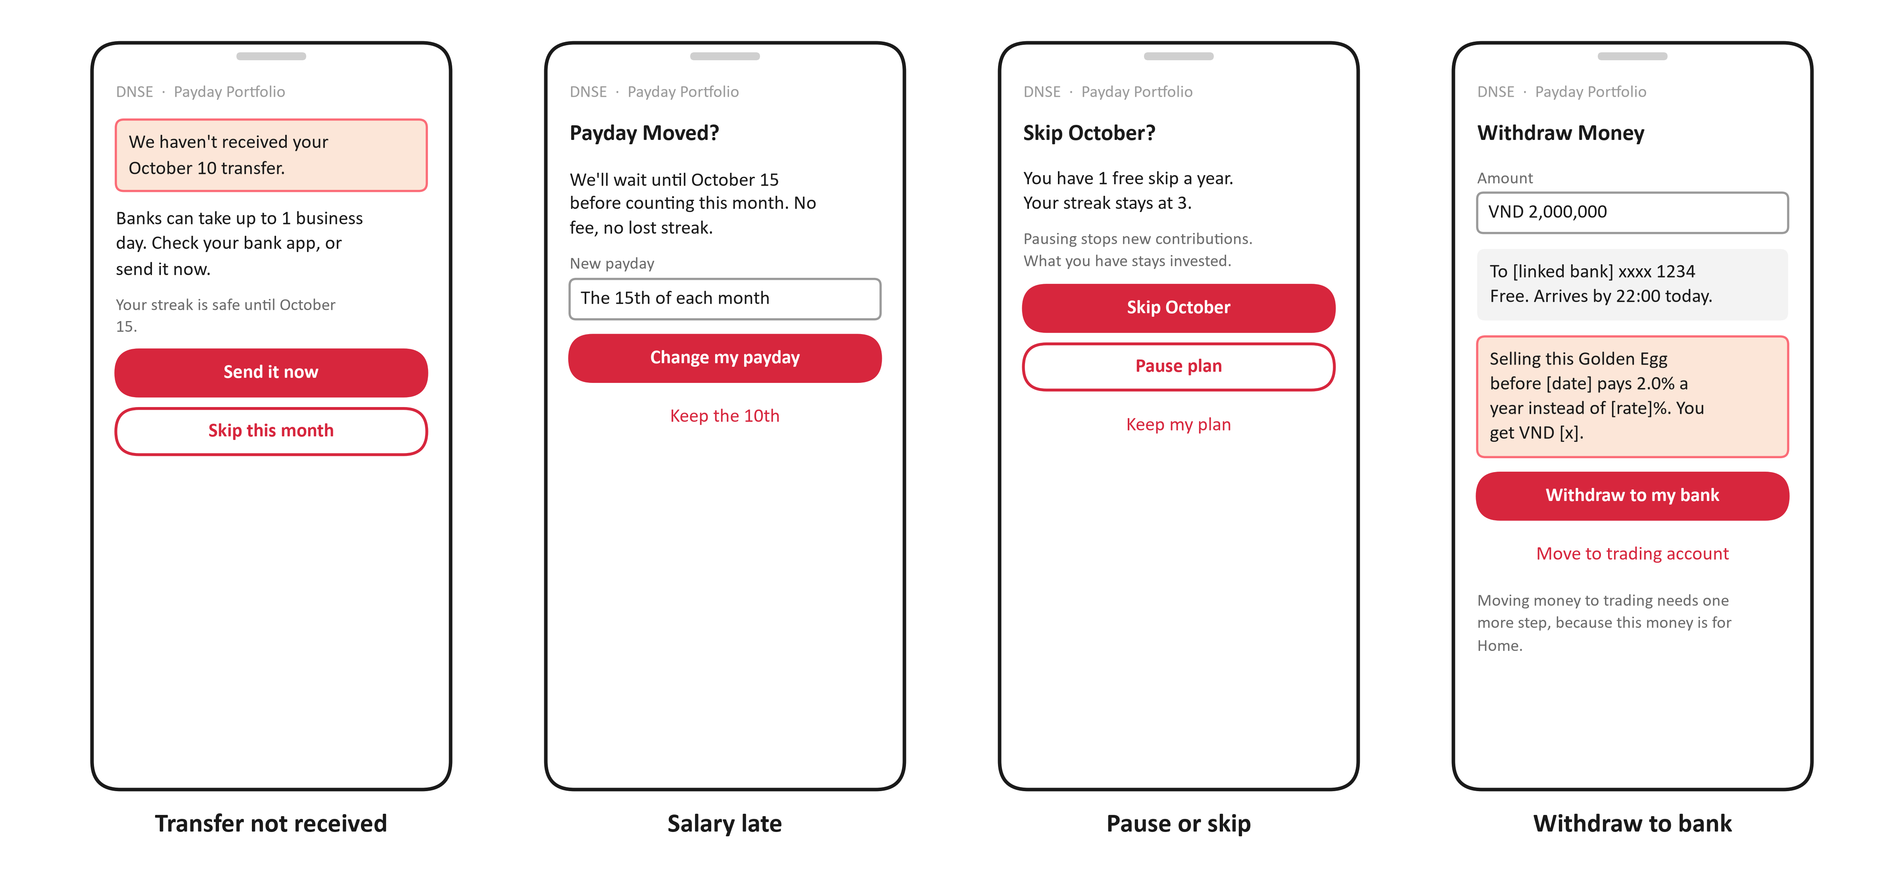
Caption: Low-fidelity wireframes of four error and edge-case screens: transfer not received, salary late, skip or pause, withdraw to the bank.
Source: authors' design; DNSE Securities (n.d.-a) for the early-sale rule.

G2. Journey map (persona P1)
Title: Three moments decide trust: first money in, first money out, first failure
Table:
 | 1. Notice the offer | 2. Make a plan | 3. Set up the money | 4. First payday | 5. Build the habit (to day 90) | 6. Withdraw or keep going
Goal | Decide whether this is worth a look | Know what to put in and why | Make saving automatic | See the first money arrive and get invested | Keep going without thinking about it | Get money out when needed
Actions | Opens a Zalo message or app banner | Sets a goal, answers 3 questions, confirms the plan | Creates a monthly transfer in the salary bank's app | Gets paid; the bank sends the transfer | Reads the payday reminder; skips a month if needed | Withdraws to the bank or skips a month
Touchpoints | Zalo template message, SMS, push, banner | Ensa, plan screen, fee screen | Personal account card, bank app link, QR | "Received" and "Invested" notices | Reminder naming the goal; streak; statement | Withdrawal screen
Thinking | "Is this another reward with conditions?" | "What am I buying, and what can I lose?" | "Will my bank transfer actually reach DNSE?" | "Did it arrive? Where is my money now?" | "Is it still worth it this month?" | "How fast, and what does it cost to take it out?"
Feeling (to test in the pilot) | Sceptical | Unsure | Impatient | Anxious then relieved | Motivated or forgetful | Wary
Pain points today (evidence) | Distrusting offers after the 2025 sign-up reward (trust themes 55% of negative Google Play reviews in H1 2025) | Finding portfolio choices hard (77% of investors find managing a portfolio difficult) | Leaving the app to set up a transfer; failing eKYC and account steps (17% of 2026 negative reviews) | Waiting for deposits the bank says were sent (17% of 2026 negative reviews) | Postponing each month; apps that crash, freeze or lag (45% of 2026 negative reviews) | Losing money on a 1-month Golden Egg without seeing why (2025 review) or on an auto-renewal the customer did not want (2026 review, product not named); withdrawals blocked when the bank-account name does not match (2026 review)
Design response | Remove sign-up rewards; say in one line what the plan is and who approves it | Ask 3 questions; set the plan by goal horizon; show a bad month in VND | Give a personal account number with a bank-app link and QR; aim for 5 minutes and no more steps than VCB Digibank SIP | Credit to a personal virtual account automatically; confirm within minutes; publish the on-time rate | Send a reminder that names the goal; keep a streak; allow one skip a year | Show arrival time and cost in VND before confirming; withdraw to the linked bank free; add a step before moving money to trading
Metric | Open and tap-through rates | Plans confirmed after the suitability check | Set-up completion and time | Contributions credited on the same banking day (>= 99.5%) | Savers making 3 contributions in a row | Median withdrawal time; share moved to buying power
Owner | Marketing and CRM | Head of Product; licensed adviser | CTO; partner bank | CTO; Operations | Head of Product | Customer Service
Moment of truth | - | - | - | Yes: first money in | - | Yes: first money out

CSV: outputs/round3/tables/appG2_journey.csv.
Source: authors' design; evidence from Appendix D, Nhan Dan (2025) and the review data. Feelings are hypotheses for the pilot to test.

G3. Service metrics DNSE would publish
Title: Seven commitments, each with a number published on a schedule
Table:
Commitment | Customer sees | Published metric | Target | Cadence | Owner
Money arrives when we say | A "received" notice within minutes of the bank credit | Share of scheduled contributions credited on the same banking day | >= 99.5% (launch gate) | Monthly | CTO
Money is invested quickly | An "invested" status with the asset bought | Median time from credit to invested | <= 1 business day | Monthly | CTO
Withdrawals are fast and free | "Arrives by 22:00 today" for Golden Egg sales placed 09:00-14:30 (DNSE FAQ: about 21:00-22:00 on the sale day); the fund settlement date before confirming | Median time from request to money in the linked bank | Same day for Golden Egg sales | Monthly | Head of Product
Leaving is easy | Pause, skip or cancel in one tap | Share of cancellations completed in the app without a call | 100% | Monthly | Head of Product
No hidden costs | One screen with every fee and tax in VND before confirming | Plans confirmed with the fee screen shown (audit) | 100% | Quarterly | Compliance and Legal
Problems are owned, not hidden | Status page and a post-incident note | Incidents affecting contributions with a note published within 5 business days | 100% | Per incident | CTO
Complaints are counted | - | Trust themes in Payday-related negative reviews | < 10% | Quarterly | Customer Service

CSV: outputs/round3/tables/appG3_trust_metrics.csv.
Source: authors' design; DNSE Securities (n.d.-a) for Golden Egg sale timing.

G4. Full service blueprint
Title: The full blueprint behind slide 9
Figure: outputs/round3/figures/service_blueprint.png.
Caption: Service blueprint of one payday cycle across six steps and eight lanes.
Source: authors' design; DNSE Securities (2026e).

Appendix H: Assumptions of the cohort model

H1. Key assumptions, three scenarios
Title: Twenty-six inputs drive the model; the pilot measures the uncertain ones
Text:
- Downside and upside are the low and high cases of the model. "Assumption" means the pilot measures it; the full list of 60 inputs is in the model file.
Table:
Assumption | Downside | Base | Upside | Type | Basis
Dormant accounts (used no product, Dec 2025) | 1,427,181 | 1,427,181 | 1,427,181 | derived | DNSE Securities (2026c)
Share of dormant accounts salaried and reachable | 15% | 25% | 35% | assumption | World Bank (2025); pilot survey
Pilot accounts (three arms) | 45,000 | 45,000 | 45,000 | assumption | Decision D4
Enrolment of contacted dormant accounts | 1% | 2% | 4% | assumption | Never-Sleeping Account reached 0.8% of accounts; TCBS (2026)
Enrolment of active customers over 12 months | 2% | 4% | 6% | assumption | Never-Sleeping Account sign-ups equal 14% of active customers
New accounts a month | 20,000 | 31,180 | 43,210 | derived | DNSE Securities (2026c); VnExpress (2026a)
Set-up within 60 days of opening | 1% | 2% | 3% | assumption | Assumption
Employers signed a quarter | 2 | 4 | 8 | assumption | Go-to-market plan
Employees who enrol after an HR session | 10% | 20% | 28% | assumption | Ashraf et al. (2006) as upper bound
Monthly contribution | VND 800,000 | VND 1,000,000 | VND 1,500,000 | assumption | About 11% of the VND 9.0 million average income (National Statistics Office, 2026)
Stop rate, 2nd and 3rd contributions (a month) | 15.0% | 10.0% | 6.0% | assumption | Assumption; pilot measures it
Stop rate after the 3rd contribution (a month) | 4.0% | 2.5% | 1.5% | assumption | Assumption; pilot measures it
Balances withdrawn a year | 15% | 10% | 5% | assumption | Assumption; inflows tagged
DNSE margin on bank bonds in Golden Egg | 0.30% | 0.60% | 1.00% | assumption | Thi truong Tai chinh Tien te (2026a); DNSE Securities (n.d.-b)
Distributor share of bond-fund fees | 0.22% | 0.33% | 0.44% | assumption | SSI Asset Management (2026); VCBF (2026); fund prospectuses
Distributor share of equity-fund fees | 0.38% | 0.56% | 0.75% | assumption | Fund prospectuses and factsheets, 2026
Build team, months 1 to 6 | VND 3.97 billion | VND 3.18 billion | VND 2.54 billion | derived | ITviec (2025) salary medians
Integration, security tests, legal opinions | VND 1.50 billion | VND 1.00 billion | VND 0.60 billion | assumption | VPBank (2024); assumption
Running team, a year | VND 4.72 billion | VND 3.78 billion | VND 2.52 billion | derived | ITviec (2025) salary medians
Operations, compliance and cloud, a year | VND 1.80 billion | VND 1.20 billion | VND 0.80 billion | assumption | Assumption
Content and promotion review, a year | VND 1.50 billion | VND 1.00 billion | VND 0.60 billion | assumption | Assumption
Reach cost per dormant account contacted | VND 2,200 | VND 1,300 | VND 1,100 | derived | Zalo Business Solutions (n.d.); MobiFone (n.d.)
Bank fee per contribution | VND 5,500 | VND 3,300 | VND 0 | assumption | VPBank (2024) list price
Service cost per active saver a month | VND 2,000 | VND 1,000 | VND 500 | assumption | Zalo confirmation, statements
Discount rate | 12% | 12% | 12% | assumption | Hurdle rate
Asset mix: Golden Egg / bond funds / equity funds / ETF | same | 45/35/10/10 | same | assumption | Design: glide path by goal horizon

CSV: outputs/round3/tables/appH1_assumptions.csv (from data/round3/payday_assumptions.csv).
Source: as listed in the table.

Appendix I: Backup answers for Q&A

I1. Questions the Board is likely to ask
Title: Short answers, each with the number behind it
Table:
Question | Short answer | Evidence
Why not just a bank deposit? | Golden Egg pays 6.20–7.60% against 5.9% for a Big Four 12-month deposit, but bond coupons are taxed 5% and deposits are not. We compete on short terms, automation, a goal and published proof, not on the rate. | DNSE Securities (n.d.-a, n.d.-b); Thi truong Tai chinh Tien te (2026b)
Is VPS Smart Indexing the same thing? | No. VPS decides for the customer, holds shares only, starts at VND 50 million plus 10 million a month and charges 0.5% a year. Payday is customer-confirmed, holds four asset types and starts at VND 500,000. | Tuoi Tre (2026); Tin nhanh Chung khoan (2026)
Who is liable if Ensa's advice is wrong? | Ensa only collects the facts. A licensed adviser signs the model plans, every recommendation is logged, and nothing is invested without the customer's confirmation. | Ministry of Finance (2020), Articles 4 and 24; National Assembly (2019), Article 72
What happens in a market fall? | Goals under a year hold only bank bonds. In the stress test, a fall in year 2 cuts new funded accounts at month 36 by 12.3% and month-60 cash by VND 0.35 billion. | Authors' cohort model; VnExpress (2026b)
Why not use DNSE's own bonds? | They would improve month-60 cash by about VND 3.9 billion, but they create a conflict of interest in an advised product. New Golden Egg openings were paused at the regulator's request in December 2023. | Authors' cohort model; DNSE Securities (2023)
Why not lend against the plan's ETFs? | Base NPV would improve only from −VND 25.0 billion to −VND 20.9 billion. It would also cut against the savings purpose and the 2026 margin findings, so we review it only at Gate 3. | Authors' cohort model; Market Times (2026)
What if the bank charges its list fee? | At VND 3,300 per contribution the CAC ceiling falls from VND 199,000 to VND 128,000; above VND 6,200 the dormant channel stops paying back. Gate 0 targets VND 0. | VPBank (2024); authors' cohort model
What if only 1% of dormant accounts enrol? | That is the break-even rate, so we would not scale: we scale at 1.5% and stop below 1.0%. The downside path costs about VND 10.0 million per new funded account and is stopped at month 6. | Authors' cohort model
Is Open API a threat or an opportunity? | Banks must comply by 1 March 2027 and customer consent lasts up to 180 days. Our virtual-account bank is the natural first Open API partner for salary-percentage contributions in Phase 3. | State Bank of Vietnam (2024)

CSV: outputs/round3/tables/appI1_qa.csv.
Source: as listed in the table.

References
APA 7, theo cách trình bày của report Round 2. URL chỉ ghi dạng chữ, không gắn hyperlink.
- Ashraf, N., Karlan, D., & Yin, W. (2006). Tying Odysseus to the mast: Evidence from a commitment savings product in the Philippines. The Quarterly Journal of Economics, 121(2), 635–672. https://doi.org/10.1162/qjec.2006.121.2.635
- Bao Phap Luat. (2026, June 30). Thêm quỹ Dragon Capital, SSI iBoard mở rộng sản phẩm đầu tư trên nền tảng số [SSI iBoard adds Dragon Capital funds to its digital platform]. https://baophapluat.vn/them-quy-dragon-capital-ssi-iboard-mo-rong-san-pham-dau-tu-tren-nen-tang-so.html
- CafeF. (2026, July 22). Soi số lợi nhuận 15.200 tỷ của ngành chứng khoán trong quý 2 [The securities industry's VND 15,200 billion profit in Q2]. https://cafef.vn/soi-so-loi-nhuan-15200-ty-cua-nganh-chung-khoan-trong-quy-2-mot-cuoc-doi-ngoi-dang-am-tham-dien-ra-188260722020054991.chn
- DNSE Securities. (2023, December 24). Thông báo tạm dừng mở mới Egg X và Gift X [Notice pausing new Golden Egg (Egg X) and Gift X openings]. https://www.dnse.com.vn/tin-tuc/tb-tam-dung-eggx-va-giftx-25-12-2023
- DNSE Securities. (2025). So sánh các chương trình "sinh lời tự động" từ tiền nhàn rỗi 2025 [Comparison of automatic-earning programmes for idle cash, 2025]. https://www.dnse.com.vn/hoc/chuong-trinh-sinh-loi-tu-dong
- DNSE Securities. (2026a). Financial statements and investor relations releases, 2019 to the second quarter of 2026. https://ir.dnse.com.vn/vi/ctype-finance_report
- DNSE Securities. (2026b). Tài khoản Không Ngủ [Never-Sleeping Account, product page]. Retrieved September 24, 2026, from https://www.dnse.com.vn/san-pham/tai-khoan-khong-ngu
- DNSE Securities. (2026c). Báo cáo thường niên 2025 [Annual report 2025]. https://cdn.dnse.com.vn/dnse-assets/CBTT/DSE%20-%20BCTN%202025.pdf
- DNSE Securities. (2026d). Lightspeed API [Product page]. Retrieved September 27, 2026, from https://www.dnse.com.vn/lightspeed-api
- DNSE Securities. (2026e, March 4). Công bố thông tin về sự cố công nghệ thông tin [Disclosure of an IT incident]. https://ir.dnse.com.vn/vi/post/cong-bo-thong-tin-ve-su-co-cong-nghe-thong-tin-717.htm
- DNSE Securities. (2026f). Tài liệu họp Đại hội đồng cổ đông thường niên 2026 [2026 annual general meeting documents]. https://mobiv2.fireant.vn/News/NewsAttachedFile/1863037
- DNSE Securities. (n.d.-a). FAQ Trứng Vàng giao dịch trái phiếu [Golden Egg bond trading FAQ]. Retrieved October 16, 2026, from https://hdsd.dnse.com.vn/san-pham-dich-vu/sp-trung-vang/trung-vang-qua-giao-dich-trai-phieu-v2/faq-trung-vang-giao-dich-trai-phieu
- DNSE Securities. (n.d.-b). Trứng Vàng [Golden Egg, product page]. Retrieved October 16, 2026, from https://www.dnse.com.vn/san-pham/trung-vang
- Hanoi Stock Exchange. (2026). Quarterly announcements of the ten securities companies with the largest brokerage market share, Q4 2017 to Q2 2026 [Data set]. Retrieved September 25, 2026, from https://www.hnx.vn
- ITviec. (2025). Vietnam IT salary and recruitment market report 2025–2026. https://itviec.com/report/vietnam-it-salary-and-recruitment-market
- Karlan, D., McConnell, M., Mullainathan, S., & Zinman, J. (2016). Getting to the top of mind: How reminders increase saving. Management Science, 62(12), 3393–3411. https://doi.org/10.1287/mnsc.2015.2296
- KBSV. (n.d.). Periodic investment: Accumulate as desired. Retrieved October 16, 2026, from https://kbsec.com.vn/en/periodic-investment-accumulate-as-desired.htm
- KTQT FTUers. (2026). DNSE Securities Joint Stock Company: Round 2 business analytics report [Unpublished competition report]. Future Business Analyst Season 6, RMIT Business and Finance Club Hanoi.
- Market Times. (2026, August 17). Chứng khoán DNSE (DSE) của Chủ tịch Nguyễn Hoàng Giang bị phạt hơn 800 triệu đồng vì loạt vi phạm trong hoạt động chứng khoán [DNSE fined more than VND 800 million for securities violations]. https://markettimes.vn/chung-khoan-dnse-dse-cua-chu-tich-nguyen-hoang-giang-bi-phat-128642.html
- Ministry of Finance. (2020). Circular No. 121/2020/TT-BTC on the operation of securities companies. https://thuvienphapluat.vn/van-ban/Doanh-nghiep/Thong-tu-121-2020-TT-BTC-huong-dan-hoat-dong-cua-cong-ty-chung-khoan-453690.aspx
- MobiFone. (n.d.). SMS Brandname. Retrieved October 16, 2026, from https://www.mobifone.vn/doanh-nghiep/cong-nghe-thong-tin/chi-tiet/24
- National Assembly of Vietnam. (2019). Law on Securities No. 54/2019/QH14. https://thuvienphapluat.vn/van-ban/Chung-khoan/Luat-Chung-khoan-nam-2019-399763.aspx
- National Statistics Office. (2026, July). Một số nét chính tình hình kinh tế – xã hội quý II và 6 tháng đầu năm 2026 [Socio-economic situation in the second quarter and first half of 2026]. https://www.nso.gov.vn/tin-tuc-thong-ke/2026/07/mot-so-net-chinh-tinh-hinh-kinh-te-xa-hoi-quy-ii-va-6-thang-dau-nam-2026/
- Nhan Dan. (2025, July 8). Công bố khảo sát 2025 về nhu cầu quản lý tài sản và đầu tư của người Việt [2025 survey of Vietnamese wealth management and investment needs]. https://nhandan.vn/cong-bo-khao-sat-2025-ve-nhu-cau-quan-ly-tai-san-va-dau-tu-cua-nguoi-viet-post892406.html
- SSI Asset Management. (2026). Thông tin chung quỹ SSIBF [SSIBF fund information]. Retrieved October 16, 2026, from https://ssiam.com.vn/thong-tin-chung-quy-ssibf
- SSI Securities. (2026, April 23). Tích sản thảnh thơi cùng tính năng đầu tư chứng chỉ quỹ tự động tại SSI [Easy accumulation with automatic fund investing at SSI]. https://www.ssi.com.vn/tin-tuc/tin-tuc-chung/tich-san-thanh-thoi-cung-tinh-nang-dau-tu-chung-chi-quy-tu-dong-tai-ssi
- State Bank of Vietnam. (2024). Circular No. 64/2024/TT-NHNN on the implementation of open application programming interfaces in the banking sector.
- TCBS. (2026, July). Thông cáo báo chí kết quả kinh doanh quý 2/2026 [Press release on second-quarter 2026 results]. https://www.tcbs.com.vn/wp-content/uploads/2026/07/Press-Release_2Q2026_VN_FINAL.pdf
- Thi truong Tai chinh Tien te. (2021, June 23). VinaCapital ra mắt chương trình đầu tư định kỳ thông minh VinaSIP [VinaCapital launches the VinaSIP systematic investment plan]. https://thitruongtaichinhtiente.vn/vinacapital-ra-mat-chuong-trinh-dau-tu-dinh-ky-thong-minh-vinasip-36072.html
- Thi truong Tai chinh Tien te. (2026a). Agribank chào bán 15.000 tỷ đồng trái phiếu ra công chúng năm 2026 [Agribank offers VND 15,000 billion of public bonds in 2026]. https://thitruongtaichinhtiente.vn/agribank-chao-ban-15-000-ty-dong-trai-phieu-ra-cong-chung-2026-84152.html
- Thi truong Tai chinh Tien te. (2026b, October 1). Lãi suất đầu tháng 10/2026: Tiết kiệm giữ nhịp ổn định, chứng chỉ tiền gửi hút khách [Interest rates in early October 2026]. https://thitruongtaichinhtiente.vn/lai-suat-dau-thang-10-2026-tiet-kiem-giu-nhip-on-dinh-chung-chi-tien-gui-hut-khach-85944.html
- Tin nhanh Chung khoan. (2026, August 11). VPS chính thức ra mắt sản phẩm VPS Smart Indexing [VPS launches VPS Smart Indexing]. https://www.tinnhanhchungkhoan.vn/vps-chinh-thuc-ra-mat-san-pham-vps-smart-indexing-post395704.html
- Tuoi Tre. (2026, September 25). VPS triển khai đầu tư theo danh mục, vốn từ 50 triệu đồng [VPS offers portfolio investing from VND 50 million]. https://tuoitre.vn/vps-trien-khai-dau-tu-theo-danh-muc-von-tu-50-trieu-dong-100260925082458764.htm
- VCBF. (2026). VCBF Fixed Income Fund (VCBF-FIF) factsheet, September 2026. https://www.vcbf.com/images/2026/vcbf_fixed_income_fund_vcbf-fif_092026.pdf
- VCBF. (n.d.). About SIP. Retrieved October 16, 2026, from https://www.vcbf.com/en/open-ended-funds/systematic-investment-plan-sip/about-sip/
- Vietcap Securities. (2026). Financial statements of DSE and other securities companies, Q1 2018 to Q2 2026 [Data set]. Vietcap IQ. Retrieved September 24, 2026, from https://iq.vietcap.com.vn
- Vietstock. (2026a, March 26). Những nội dung đáng chú ý ở ĐHĐCĐ thường niên DNSE 2026 [Highlights of DNSE's 2026 AGM]. https://vietstock.vn/2026/03/nhung-noi-dung-dang-chu-y-o-dhdcd-thuong-nien-dnse-2026-737-1415846.htm
- Vietstock. (2026b, July 21). Dư nợ margin lập kỷ lục 454 ngàn tỷ đồng, cuộc đua có sự phân hóa [Margin lending reaches a record VND 454 trillion]. https://vietstock.vn/2026/07/du-no-margin-lap-ky-luc-454-ngan-ty-dong-cuoc-dua-co-su-phan-hoa-830-1468883.htm
- VnEconomy. (2025, July 8). Lời giải nào cho nghịch lý giữa kỳ vọng sinh lời và tâm lý e ngại của nhà đầu tư Việt? [Resolving the paradox between Vietnamese investors' return expectations and caution]. https://vneconomy.vn/loi-giai-nao-cho-nghich-ly-giua-ky-vong-sinh-loi-va-tam-ly-e-ngai-cua-nha-dau-tu-viet.htm
- VnEconomy. (2026, July 22). Lãi suất cao khiến số dư tiền gửi của nhà đầu tư tại công ty chứng khoán giảm về mức thấp nhất 1 năm? [High interest rates push investor deposits at brokers to a one-year low]. https://vneconomy.vn/lai-suat-cao-khien-so-du-tien-gui-cua-nha-dau-tu-tai-cong-ty-chung-khoan-giam-ve-muc-thap-nhat-1-nam.htm
- VNDIRECT. (n.d.). Tích sản hưu trí [Retirement accumulation plan]. Retrieved October 16, 2026, from https://dautu.vndirect.com.vn/san-pham/tich-san-huu-tri/
- VnExpress. (2026a, September 10). Người Việt mở thêm 2 triệu tài khoản chứng khoán sau 8 tháng [Vietnamese open 2 million more securities accounts in eight months]. https://vnexpress.net/nguoi-viet-mo-them-2-trieu-tai-khoan-chung-khoan-sau-8-thang-5118477.html
- VnExpress. (2026b, March 9). VN-Index giảm mạnh nhất lịch sử [The VN-Index's largest one-day fall]. https://vnexpress.net/vn-index-mat-hon-90-diem-5048146.html
- VPBank. (2024). Biểu phí quản lý tiền tệ dành cho khách hàng doanh nghiệp [Cash management fee schedule for corporate customers]. https://www.vpbank.com.vn/-/media/vpbank-latest/tai-lieu-bieu-mau/bieu-phi/kh-dn/2024/bieu-phi-quan-ly-tien-te-danh-cho-khach-hang-doanh-nghiep.pdf
- VPBank. (2026). VPBank chính thức ra mắt "Hũ Mục Tiêu" [VPBank launches Goal Jar]. https://www.vpbank.com.vn/tin-tuc/tin-vpbank/2026/vpbank-chinh-thuc-ra-mat-hu-muc-tieu-tiet-kiem-cung-hoi-cham-dich-cung-vui
- World Bank. (2025). Global Financial Inclusion (Global Findex) database 2025, Vietnam [Data set]. World Bank Open Data. Retrieved September 20, 2026, from https://api.worldbank.org/v2/sources/28/country/VNM/series/all/data?format=json
- Zalo Business Solutions. (n.d.). Bảng giá và hướng dẫn tính giá ZBS Template Message [ZBS template message pricing]. Retrieved October 16, 2026, from https://zalo.solutions/zns/pricing

