FUTURE BUSINESS ANALYST SEASON 6
ROUND 2 BUSINESS ANALYTICS REPORT
From accounts to assets
A balance-first growth strategy for DNSE Securities and the Vietnamese customers who should fund it
Selected organisation: DNSE Securities Joint Stock Company (HOSE: DSE)
Category: wealthtech and technology-enabled financial institution
Prepared for the senior management team of DNSE
Team: [Team name]
September 2026

Executive summary
DNSE Securities has been one of the fastest-growing Vietnamese brokers by customer numbers. It opened one in five of the country's new securities accounts in 2025, passed 1.7 million customers by mid-2026, equal to about one in eight securities accounts in Vietnam, and handled a quarter of all derivatives brokerage in the second quarter of 2026. Zero-fee trading on the Entrade X app, no branch network and fast technology made this possible at low cost.
The money has not followed the accounts. Measured on 30 June 2026, DNSE held 2.3 per cent of the cash that investors keep at Vietnamese brokers, 1.4 per cent of the industry's margin lending and 0.6 per cent of the industry's pre-tax profit. An average DNSE account held VND 1.15 million in cash, less than one fifth of the market average of VND 6.25 million, and borrowed VND 3.7 million against a market average of VND 32.8 million. Only 85,739 customers, 5.7 per cent of accounts, were active in 2025. Customer assets per account fell 9 per cent during 2025, a year in which the VN-Index rose 41 per cent. VPBankS and TCBS each serve fewer accounts than DNSE and lend eight to twelve times more per account.
The income statement shows the consequence. Operating revenue rose 3.2 times between 2022 and 2025, while pre-tax profit excluding proprietary trading stayed between VND 128 and 221 billion a year. In the first half of 2026 revenue grew by VND 315 billion and pre-tax profit fell by VND 46 billion, so each extra VND 100 of revenue came with VND 115 of extra cost. Direct brokerage costs have exceeded brokerage revenue for 16 consecutive quarters. At the half-year DNSE had delivered 20 per cent of its 2026 profit target of VND 550 billion.
Vietnam's current conditions make the gap more expensive. Credit has grown faster than deposits since 2025, and banks raised 12-month deposit rates by about 2.5 percentage points during 2026. Household bank deposits reached a record VND 11 quadrillion in June 2026, while the cash investors held at brokers fell by a quarter in the second quarter. DNSE pays a base rate of 1.8 per cent on idle cash. TCBS pays a base rate of 4.5 per cent, and a 12-month deposit at the four largest state banks pays 6.8 per cent. Brokers owned by banks took 62 per cent of the industry's growth in margin lending in the same quarter.
Customer and population evidence explains where the gap comes from and where money can be found. Among 670 cleaned Google Play reviews, complaints about deception, sign-up bonus terms and the account closure fee make up 24 per cent of negative reviews and attract 43 per cent of the helpful votes those reviews receive. The idle-cash product that could hold customer money appears in three reviews. World Bank Global Findex data for Vietnam show that working, secondary-educated adults in the upper 60 per cent of the income distribution hold most of the formally saved surplus and already receive wages into accounts. The richest 60 per cent and adults in the labour force rank first and second under four different weighting schemes, and secondary-educated adults third or fourth. Adults aged 15 to 24, the cohort at the centre of DNSE's marketing, rank seventh to ninth.
A wider scan of the firm points the same way. The stock market values DNSE at 1.7 times its book equity while the firm earns an annualised 3.8 per cent on that equity, so the share price already assumes that the account base will be turned into income. Short-term loans supply 86 per cent of DNSE's borrowing, and an August 2026 penalty stopped three derivatives financing services and found lending to insiders.
The priority problem is therefore the balance gap, defined as accounts that are opened but never funded with meaningful savings. It ranks first of seven candidate problems on scale, urgency, strategic relevance, strength of evidence and DNSE's control over the outcome. Its scale is visible in DNSE's own targets. Reaching the 2026 profit plan from core business would need a margin loan book 2.3 times the current one, backed by about 2.5 times the customer assets DNSE held at the end of 2025.
Comparable firms abroad solved the same problem by gathering assets. Robinhood's growth after 2021 came from net deposits, which reached USD 68 billion in 2025, and net interest supplied a third of its revenue. Trade Republic passed the full central bank rate to customers and built free savings plans, reaching more than EUR 150 billion of assets. Groww entered India's market through monthly mutual fund plans and proved more resilient than derivatives-heavy rivals when the regulator tightened derivatives trading in 2024. Vietnam offers neither payment for order flow nor a tax-advantaged investment account, so balances matter even more for DNSE than for these peers.
The recommended direction is Payday Portfolio, a salary-linked savings-to-investing layer for salaried mass-affluent adults, starting with DNSE's existing customers aged 25 and over. It combines a market-linked cash yield delivered through a bank sweep or a licensed money market fund, automatic transfers from salary accounts on payday through bank open application programming interfaces and ZaloPay, a ladder into bond funds, the existing Trứng Vàng bond product and VN30 exchange-traded funds, and opt-in use of the resulting portfolio as margin collateral. A trust package runs across every step. It removes the closure fee, pays rewards on funding instead of sign-up, and reports the product to the State Securities Commission before launch. In the base case, 150,000 savers contributing VND 2.5 million a month would add about VND 3.2 trillion of net new money a year, 1.6 times DNSE's entire investor cash today.
Round 3 should test seven assumptions before commitment, led by the internal distribution of balances, customers' price sensitivity to the cash yield, the legal structure of the cash layer and the enrolment rate in a 20,000-customer payday pilot. The proposed success measures are the funded-account rate, net new money, assets per funded customer, the share of contributions retained after 90 days and the share of negative reviews that concern trust.
Table of contents
Executive summary 2
1. Introduction 7
1.1 DNSE and its business model 7
1.2 Market context 8
1.3 Business area and question 8
2. Findings of observations 9
2.1 Evidence base and data preparation 9
2.2 Analytical approach 10
2.3 Finding 1. Customer acquisition works 11
2.4 Finding 2. The money does not follow the accounts 12
2.5 Finding 3. Peers with fewer accounts hold far more money 15
2.6 Finding 4. Revenue grows while core profit stands still 16
2.7 Finding 5. An expensive balance sheet with spare lending capacity 18
2.8 Finding 6. What customers say 20
2.9 Finding 7. Where Vietnamese investable money sits 22
2.10 Summary of findings 25
3. Discussion and main analysis 26
3.1 A three-layer diagnosis 26
3.2 Root cause analysis 28
3.3 Macroeconomic conditions and household savings 29
3.4 Banking trends and competition 31
3.5 Customer behaviour 33
3.6 Lessons from comparable business models abroad 33
3.7 A wider view of DNSE 36
3.8 Target market and scope 39
3.9 Problem prioritisation and problem statement 40
3.10 Strategic alternatives and trade-offs 42
4. Recommendations 44
4.1 The preliminary recommendation 44
4.2 How the design follows from the evidence 45
4.3 Value logic and expected outcomes 46
4.4 Feasibility, risks and trade-offs 48
4.5 Validation direction 48
5. Conclusion 51
Appendices 52
Appendix A. DNSE financial data 52
Appendix B. Market and industry data 54
Appendix C. Customer review analysis 55
Appendix D. Findex segment analysis 57
Appendix E. Methods, assumptions and limitations 59
Appendix F. Data sources and access 62
References 63
List of figures
Figure 1. DNSE customer accounts and derivatives brokerage share 12
Figure 2. DNSE's share of eight Vietnamese markets 12
Figure 3. Value of an average DNSE account relative to the average Vietnamese securities account 13
Figure 4. DNSE investor cash, margin lending and customer assets per account 14
Figure 5. Where value is lost between an account and a profit 14
Figure 6. Lending and profit per customer account, DNSE against VPBankS and TCBS 15
Figure 7. Operating revenue and pre-tax profit split into core business and proprietary trading 16
Figure 8. Composition of DNSE operating revenue 17
Figure 9. Brokerage revenue against direct brokerage cost, by quarter 17
Figure 10. Where each VND 100 of operating revenue goes 18
Figure 11. Yield on margin loans and on deposits and bonds held to maturity, against the estimated cost of funding 19
Figure 12. Composition of DNSE total assets 19
Figure 13. Mean rating of DNSE reviews by year, and the share of one-word reviews 20
Figure 14. Themes in DNSE's negative reviews, by count and by helpful votes 21
Figure 15. DNSE reviews per month, positive above the axis and negative below 21
Figure 16. Mean rating of cleaned reviews on the two stores, 2025 and 2026 22
Figure 17. Account ownership, digital payments, formal saving, wage receipt and formal borrowing among Vietnamese adults 22
Figure 18. Vietnamese adult segments by digital habit and formally held investable surplus 23
Figure 19. Payday and saving behaviour by segment pair 24
Figure 20. Layer 1 indicators of financial health 26
Figure 21. Returns available to a Vietnamese saver's idle cash, September 2026 30
Figure 22. Investor cash held at brokers, indexed to the third quarter of 2025 30
Figure 23. Revenue mix of selected zero or low-commission brokers 35
Figure 24. What the 2026 profit plan implies for loans, equity and customer assets 42
Figure 25. How Payday Portfolio works 44
Figure 26. Layer assets and annual net new money under three scenarios 47
Figure 27. Validation roadmap for Round 3 50
List of tables
Table 1. DNSE at a glance 7
Table 2. Evidence base 9
Table 3. Review cleaning log 10
Table 4. What the 2025 cohort of accounts brought, under different assumptions about existing customers 14
Table 5. DNSE against two named peers with similar account bases 15
Table 6. Summary of findings and their business implications 25
Table 7. Layer 2. Evidence on the customer lifecycle and the gaps to close in Round 3 27
Table 8. Five-whys analysis of the balance gap 28
Table 9. Macroeconomic and banking indicators relevant to household savings, 2025 and 2026 29
Table 10. Where Vietnamese savers keep money, mid-2026 31
Table 11. Competitive map of Vietnamese retail brokerage business models 32
Table 12. Comparable business models abroad and their lessons for DNSE 34
Table 13. Transferability of foreign designs to Vietnam 35
Table 14. DNSE seen from twelve angles 36
Table 15. Competitive forces in Vietnamese retail brokerage 37
Table 16. SWOT analysis of DNSE 38
Table 17. Stakeholders affected by the balance gap 38
Table 18. Scoring of candidate target markets 39
Table 19. Scope of the business problem for Round 3 40
Table 20. Prioritisation of candidate business problems 41
Table 21. Business problem statement 42
Table 22. Strategic alternatives assessed against the balance gap 43
Table 23. The first 90 days of a new DNSE customer, today and under Payday Portfolio 45
Table 24. Evidence behind each design choice 46
Table 25. Illustrative outcomes of Payday Portfolio 18 months after launch 47
Table 26. Feasibility conditions for Payday Portfolio 48
Table 27. Assumptions, tests and measures for Round 3 49
Table A1. DNSE income statement summary, 2021 to the first half of 2026 (VND billion) 52
Table A2. DNSE balance sheet and key ratios, 2021 to 30 June 2026 52
Table A3. DNSE quarterly indicators, first quarter of 2024 to second quarter of 2026 53
Table B1. DNSE's position on eight measures, 2025 to mid-2026 54
Table B2. Securities industry cross-section, second quarter of 2026 54
Table C1. DNSE Google Play reviews by year after cleaning 55
Table C2. Themes in DNSE's negative Google Play reviews 55
Table C3. Three applications compared on both stores 56
Table C4. Selected DNSE reviews, translated from Vietnamese 56
Table D1. Indicators in the two Findex indices 57
Table D2. Findex segment indicators for Vietnam, 2024 fieldwork 57
Table D3. Segment ranks under four weighting schemes 58
Table E1. Definitions of calculated measures 59
Table E2. Register of assumptions behind the main results 60
Table E3. Limitations of the evidence 60
Table F1. Data sources, access and dates 62

1. Introduction

1.1 DNSE and its business model
DNSE Securities Joint Stock Company began in 2007 as Dai Nam Securities with charter capital of VND 38 billion. At the end of 2020 Encapital, a financial technology group, acquired more than 98 per cent of its shares and repositioned it as a technology-led broker (CafeF, 2024c). Its charter capital stood at VND 4,282.5 billion after a rights issue completed in March 2026 (CafeF, 2026a), and its total assets were VND 15.2 trillion at 30 June 2026 (DNSE, 2026a). Its shares listed on the Ho Chi Minh Stock Exchange (HOSE) on 1 July 2024 under the code DSE, after the only initial public offering on the Vietnamese market in 2024 (CafeF, 2024c; VnExpress, 2024).
DNSE distributes only through its Entrade X application and website, without branches. It was one of the first Vietnamese brokers to offer lifetime zero-fee trading in listed shares (CafeF, 2024b). Revenue therefore comes from four other sources. The largest is interest on margin loans. Since December 2022 DNSE has managed leverage deal by deal through Margin Deal (Dân trí, 2022), which charges a transaction fee of 0.045 to 0.085 per cent on financed trades (DNSE, 2026c). The second is derivatives brokerage through Future X. The third is interest on term deposits and bonds held to maturity, and the fourth is proprietary trading. Table 1 summarises the firm.
Table 1. DNSE at a glance
Item | Detail
Legal name and listing | DNSE Securities Joint Stock Company, HOSE code DSE, listed 1 July 2024
Scale | Charter capital VND 4,282.5 billion; total assets VND 15,208 billion; equity VND 5,440 billion
Ownership | Encapital group and its chairman about 49.7 per cent; Capella Group 9.8 per cent (March 2026)
Customers | More than 1.7 million accounts (mid-2026); 518,514 accounts opened in 2025; 85,739 active users in 2025
Distribution | Entrade X app and web only; no branches; account opening by electronic identity check; ZaloPay partnership since 2023
Pricing | Zero fees on cash equity trades without borrowing; 0.045 to 0.085 per cent on Margin Deal trades; derivatives margin deposit, withdrawal and management fees paid by DNSE since May 2025
Products | Entrade X (shares), Future X (derivatives), Margin Deal (deal-by-deal lending), Tài khoản không ngủ (idle-cash account paying 1.8 to 4.3 per cent), Trứng Vàng (bonds from VND 1 million), Ensa (artificial intelligence assistant), Lightspeed API (algorithmic trading)
Market position, Q2 2026 | Second in derivatives brokerage (25.38 per cent); eighth in listed-share brokerage on HNX (2.88 per cent); outside the HOSE top ten (below 2.94 per cent)
2026 plan | Revenue VND 1,736 billion; pre-tax profit VND 550 billion; VND 3,500 billion bond programme; securities subsidiary at the International Financial Centre
Regulatory record | Fined VND 802.5 million on 17 August 2026 and ordered to stop three derivatives financing services offered without prior notice to the State Securities Commission
Source: DNSE filings retrieved from Vietcap's data service; DNSE investor relations and product pages; Vietstock (2026a, 2026b, 2026f); CafeF (2026c); Market Times (2026). Figures at 30 June 2026 unless stated.
Under this model trading is free, and DNSE earns money when customers borrow, trade derivatives or leave cash with the firm. Each of these revenue sources depends on customers holding money on the platform. Free trading attracts customers, and customer balances generate the income that pays for it.

1.2 Market context
Vietnam's retail investor base has grown at a pace few markets have matched. Domestic individual securities accounts rose from about 7.2 million at the end of 2023 to 11.8 million at the end of 2025 (Nhân Dân, 2026). By the end of August 2026 the market held nearly 13.9 million accounts, equal to 13.6 per cent of the population (VnExpress, 2026b). Individual investors supply more than 90 per cent of trading value (Dân trí, 2026b). The VN-Index rose 40.9 per cent in 2025 to 1,784 points (Thanh Niên, 2025) and closed at 1,799.67 on 21 September 2026, the day FTSE Russell's reclassification of Vietnam to secondary emerging market status took effect (VTV, 2026).
Commissions no longer separate one broker from another. TCBS, MBS, Pinetree and DNSE offer zero-fee trading, and others waive fees for new customers (CafeF, 2024b). The industry's profit comes from lending. In the second quarter of 2026 securities firms earned VND 12.2 trillion from lending, more than three times the VND 3.7 trillion they earned from brokerage (Vietstock, 2026h), and they lent a record VND 453.8 trillion at 30 June 2026, including advances against sale proceeds (Vietstock, 2026g). Profit is concentrated. Six firms earned more than VND 1,000 billion each in the second quarter of 2026 and together took about 62 per cent of the industry's VND 15,200 billion (CafeF, 2026d).

1.3 Business area and question
This report examines how DNSE converts customer acquisition into income, and which Vietnamese customers it should prioritise to do so. Because trading is free, account numbers measure reach. Income arises only when customers fund their accounts, hold assets and borrow or trade against them. The business question for this report is how DNSE can turn a large, young, low-balance account base into funded customer relationships, and which segment of Vietnamese savers it should target first.
Three sub-questions structure the analysis. The first asks where in the customer journey value is lost, measured against the market and named peers. The second asks why, drawing on financial statements, customer reviews, population survey data, Vietnam's macroeconomic and banking conditions and a wider scan of the firm's ownership, risks, regulation and valuation. The third asks which response creates the most value within DNSE's capabilities, funding and regulatory limits. Investment banking, proprietary trading strategy and the planned International Financial Centre subsidiary are outside the scope.

2. Findings of observations

2.1 Evidence base and data preparation
The analysis combines eight datasets. Four are drawn from primary disclosures and official statistics, two were collected and cleaned for this study, and two are compiled from company publications and the press. Table 2 lists them with their coverage and treatment.
Table 2. Evidence base
Dataset | Content and coverage | Main preparation step
DNSE filed statements | 395 line items of the income statement, balance sheet, cash flow and notes, first quarter of 2018 to second quarter of 2026 | Pulled line by line from Vietcap's data service and reconciled to the half-year statements reviewed by KPMG
DNSE company indicators | Accounts, new-account shares, active users, customer assets, derivatives share, 2026 plan, product terms and fee schedules | Taken from investor relations releases and product pages; each figure dated and cross-checked with a second report where possible
Exchange and industry data | HOSE and HNX brokerage shares; industry margin lending, investor cash at brokers and pre-tax profit; trading value; account statistics | Each share kept with its own exchange; competing industry totals recorded and one chosen per measure
Named peers | VPBankS and TCBS accounts, lending, profit and customer cash | Company releases and financial press; account dates differ and are stated
Google Play reviews | 867 DNSE reviews (October 2020 to September 2026) and 1,377 reviews of VPS SmartOne and FPTS EzTrade | Collected on 23 September 2026 and cleaned with one rule set for all three apps
App Store reviews | 1,055 written reviews of the same three apps and Apple's star-rating counts | Collected on 24 September 2026; used as a cross-check for 2025 and 2026
World Bank Global Findex | 51 indicators for Vietnam across 13 demographic segments (2024 fieldwork) and five survey waves from 2011 | Retrieved from the World Bank open data interface; segment population shares recovered from the survey itself
Macro, banking and international | GDP, inflation, credit, deposits and rates (NSO, SBV, bank rate sheets); reference reports listed by the organisers; annual results of Robinhood, Futu and Indian and Japanese market data | Dated at source; forecasts and projections labelled as such
Source: compiled by the authors. Access dates between 20 and 24 September 2026. Full addresses in Appendix F.
Four preparation decisions shape the results. The first concerns the company's figures. The quarterly statement of 20 July 2026 reported second-quarter pre-tax profit of VND 98.9 billion. The half-year statement reviewed by KPMG implies VND 97.4 billion once the first quarter is deducted (DNSE, 2026a), and this report uses the reviewed figure. Operating revenue for 2025 is VND 1,457.9 billion in the filings. The press figure of VND 1,467 billion adds financial income (Vietstock, 2026a), so the two are consistent under different definitions. Template line 24 of the securities company statements combines loan-loss provisions with the borrowing cost of the loan book. Funding cost is therefore estimated as interest expense plus line 24, less the rise in the balance-sheet allowance for loan losses.
The second decision concerns denominators. HOSE and HNX define market share as a share of traded value on their own exchange, so a share on one exchange is never compared with a share on another. Industry totals differ by definition and source. Margin lending at 30 June 2026 appears as VND 453.8 trillion when advances against sale proceeds are included and about VND 435 to 446 trillion without them (Vietstock, 2026g; VnEconomy, 2026b). Investor cash at brokers appears as VND 86.6 trillion in the VnEconomy tally and about VND 82 trillion in the CafeF tally of the largest firms (CafeF, 2026e). The report uses the broader figure in each case and states where the choice matters.
The third decision concerns accounts. DNSE reports customer accounts. The depository (VSDC) reports accounts across all brokers, and one person may hold several. Both sides of every per-account comparison therefore count accounts, and the market average includes inactive accounts in the same way DNSE's figure does.
The fourth decision concerns reviews, which required the most work. Vietnamese app stores carry heavy spam from unlicensed lending sites and from users farming referral codes. Much of it hides behind mathematical Unicode characters that defeat keyword filters. Every text was normalised before filtering, with Unicode compatibility composition, removal of diacritics and conversion to lower case. Two rules then flagged loan advertising and referral farming. The referral rule fires only where a referral phrase sits next to a code or a reward amount, so that complaints about one-time passwords are kept. An audit of the code on 23 September 2026 corrected four earlier errors, and the rule now passes 37 test cases. Copy-and-paste duplicates of 20 characters or more were removed, while identical short reviews by different people were kept. Reviews of a single word were flagged as generic so that a burst of one-word praise cannot be read as satisfaction.
Table 3. Review cleaning log
Stage | DNSE, Play | VPS, Play | FPTS, Play | DNSE, iOS | VPS, iOS | FPTS, iOS
Reviews retrieved | 867 | 1,200 | 177 | 332 | 518 | 205
Loan advertising removed | 127 | 23 | 0 | 0 | 0 | 0
Referral farming removed | 70 | 3 | 0 | 73 | 6 | 0
Duplicates removed | 0 | 3 | 0 | 0 | 0 | 0
Reviews retained | 670 | 1,171 | 177 | 259 | 512 | 205
Mean rating before cleaning | 3.29 | 2.60 | 2.18 | 3.37 | 1.57 | 2.31
Mean rating after cleaning | 3.22 | 2.58 | 2.18 | 2.94 | 1.53 | 2.31
Source: Google Play and Apple App Store public listings; authors' cleaning code. VPS is its 1,200 most recent Google Play reviews, from 27 March 2023.
Cleaning changed the conclusions. In 2022 and 2023, 46 and 54 per cent of DNSE's Google Play reviews were spam, so an uncleaned series for those years measures spam campaigns. The removed material was rated higher than the genuine reviews left behind (3.53 against 3.22), so cleaning lowers DNSE's average rating.
Findings are labelled by the strength of their evidence. Measured figures come directly from filings, exchanges or datasets. Derived figures are calculations from measured inputs, such as per-account values. External estimates are published by third parties. Hypotheses are claims the data suggest without establishing, and each one reappears in the validation plan in Section 4.5.

2.2 Analytical approach
The analysis runs in two directions and meets in the middle. The top-down direction starts from DNSE's stated goals (the 2026 plan, the five-year ambition set at the listing and management's intention to extend its derivatives model to the share market) and from the Vietnamese context, including the competition for deposits, the tightening of identity and biometric rules and the segments that banks and brokers serve poorly. The bottom-up direction explores the data for breaks and anomalies through share comparisons, per-account and cohort calculations, segmentation of the Findex population and monthly analysis of reviews. Where a symptom appears in the data, a five-whys analysis traces it to customer behaviour and to DNSE's own product and incentive policies. A wider scan of ownership, valuation, risk, regulation, technology and new ventures (Section 3.7) checks that the chosen problem does not depend on the lenses applied. A problem is treated as a business problem only when the analysis can say where, and by how much, it costs DNSE money, raises its risk or narrows its growth.
Five methods serve this design. Share comparison places DNSE's share of one market against its share of another, from accounts through trading, cash and lending to profit. Dividing each share by the account share gives the value of an average DNSE account relative to an average market account, which locates the point where value is lost. Unit economics and profit decomposition separate the income statement into brokerage, lending, balance-sheet and proprietary results, and trace yields against the estimated cost of funding. Thematic coding assigns each cleaned review one or more labels, weights the themes by the helpful votes other users gave them and tracks them by month to date spikes. Segment scoring builds two indices from Findex, one for formally held investable surplus and one for digital habit, and ranks segments on six normalised criteria under four weighting schemes so that no ranking depends on one choice of weights. Prioritisation and option appraisal use explicit criteria and weights, report the result under equal weights as a check, and set the scale of each problem against DNSE's own targets.
These methods describe associations. They can show that DNSE's accounts hold less money than the market's, and when complaints rose, but they cannot prove why an individual customer did not fund an account. App store reviews over-represent dissatisfied customers, and Findex reports one demographic dimension at a time from 1,000 interviews. DNSE does not publish customer-level data, so funnel stages such as identity verification, first funding and dormancy after 30 to 90 days can only be inferred. The report treats the combination of independent measures pointing the same way as the main source of confidence, and it lists the measures that must come from DNSE's internal data in Round 3.

2.3 Finding 1. Customer acquisition works
DNSE has grown its customer base faster than the market in every period for which data exist. It opened more than 434,000 accounts in 2024, 21.6 per cent of all new accounts in Vietnam (Bnews, 2025), and 518,514 in 2025, or 20 per cent (Vietstock, 2026a). Its share of new accounts reached 33 per cent in the first quarter of 2025 (Vietstock, 2025a) and was 18 per cent in the first quarter of 2026 (Vietstock, 2026c). The customer base tripled from about 0.55 million at the end of 2023 to 1.7 million by mid-2026 (Figure 1).
Figure 1. DNSE customer accounts and derivatives brokerage share
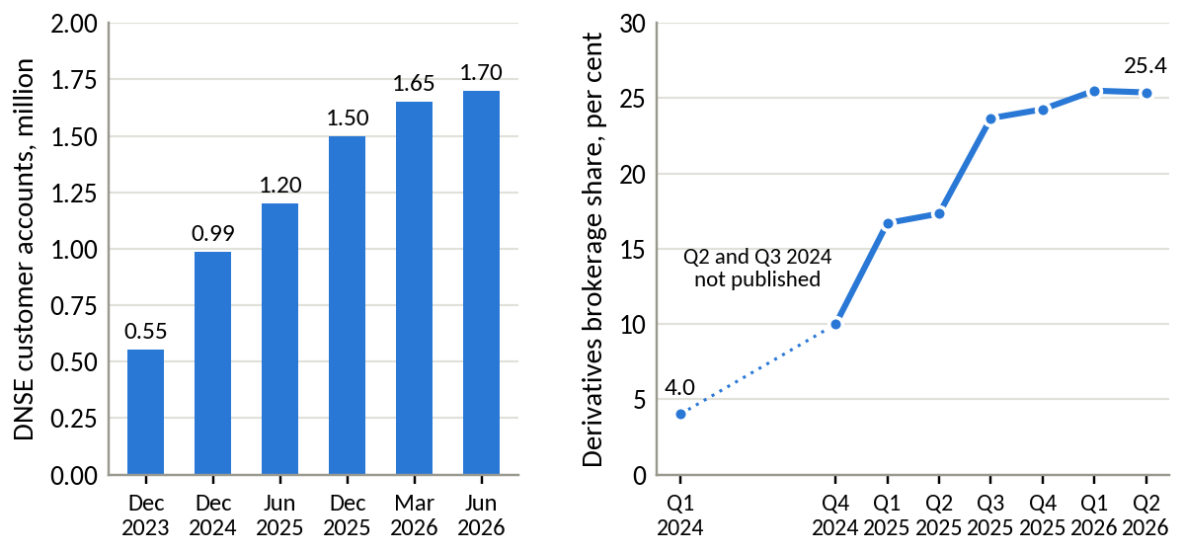
Source: DNSE investor relations releases; HNX quarterly announcements. The account figure for December 2023 is derived from the 2024 opening count. HNX did not publish DNSE's derivatives share for the second and third quarters of 2024.
Derivatives followed the same path. DNSE held 4.01 per cent of derivatives brokerage in the first quarter of 2024 and 25.38 per cent in the second quarter of 2026, second only to VPS for seven consecutive quarters (Vietstock, 2026f). DNSE's acquisition model delivers reach, together with trading activity in the product that needs the least capital from the broker.

2.4 Finding 2. The money does not follow the accounts
The same firm looks very different when money replaces registration as the measure. Figure 2 places DNSE's share of eight markets side by side. DNSE holds 12.3 per cent of securities accounts and 25.4 per cent of derivatives brokerage. It intermediates 2.9 per cent of listed-share trading on HNX, holds 2.3 per cent of the cash investors keep at brokers, 1.4 per cent of margin lending and 0.6 per cent of the industry's pre-tax profit. The further a measure sits from registration and the closer it sits to money, the smaller DNSE becomes.
Figure 2. DNSE's share of eight Vietnamese markets
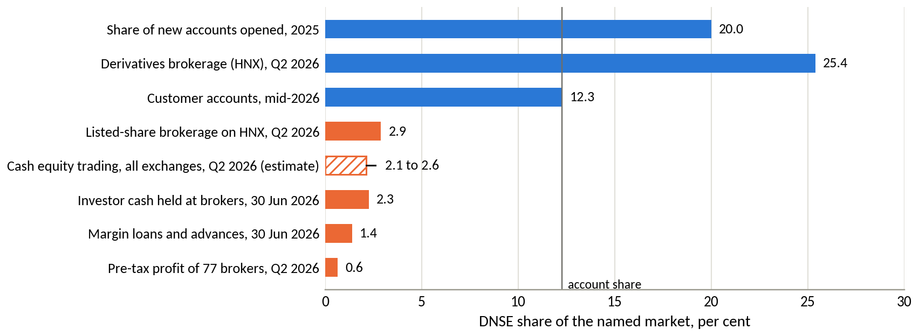
Source: VSDC; HNX; DNSE filings; VnEconomy (investor cash, 22 July 2026); Vietstock (lending, July 2026); CafeF (profit of 77 brokers, 22 July 2026); authors' calculations. Each bar is a share of its own market. The hatched bar is an estimate from DNSE's disclosed trading value of shares for customers, divided by twice the value traded on HOSE plus an allowance of 7 per cent for HNX and UPCoM. It ranges from 2.1 to 2.6 per cent depending on whether negotiated block trades are counted.
One new measure confirms the gap directly. The notes to DNSE's statements disclose the value of shares its customers traded, VND 62.9 trillion in the second quarter of 2026 across both sides of each trade. Set against the value traded on Vietnam's exchanges, this puts DNSE's share of cash equity trading between 2.1 and 2.6 per cent. The estimate agrees with the published HNX share of 2.88 per cent (CafeF, 2026c) and with DNSE's absence from the HOSE top ten, where tenth place held 2.94 per cent (CafeF, 2026b).
Dividing each share by the account share gives the value of an average DNSE account relative to an average market account (Figure 3). A DNSE account trades derivatives at twice the market rate. It trades shares at about a fifth of the market rate, holds 0.18 of the market's cash per account, borrows 0.11 of the market's loan per account and generates 0.05 of the market's profit per account. Measured on 30 June 2026, the average DNSE account held VND 1.15 million in cash against VND 6.25 million across the market, and borrowed VND 3.7 million against VND 32.8 million.
Figure 3. Value of an average DNSE account relative to the average Vietnamese securities account
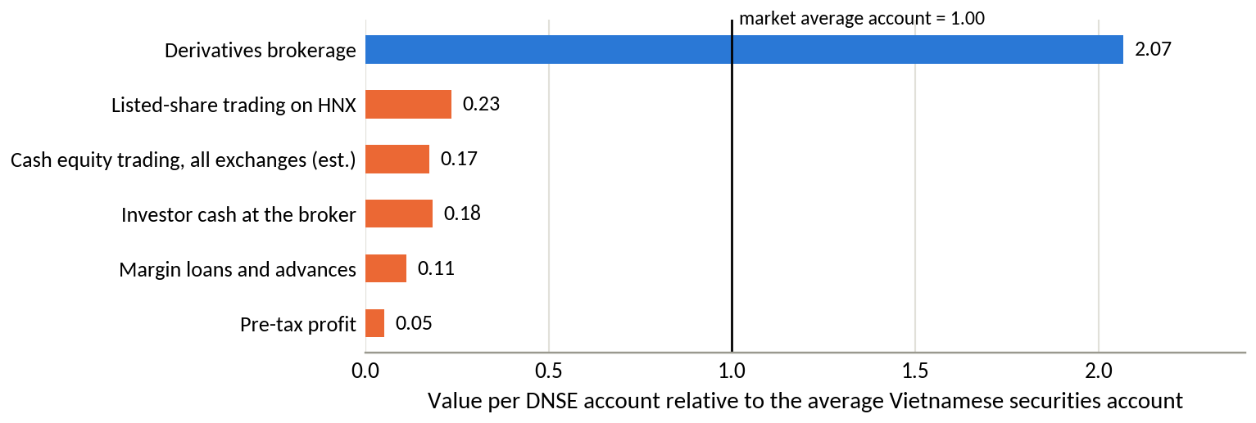
Source: as for Figure 2. Values are DNSE's market share divided by its account share of 12.27 per cent (1.7 million of 13.85 million accounts).
The time series shows the gap widening as the base grows (Figure 4). Margin lending per account fell from VND 4.5 million at the end of 2023 to VND 3.7 million in June 2026. Cash per account rose with the 2025 rally and then fell to VND 1.15 million, the lowest point in the series. The clearest signal comes from customer assets. DNSE reported customer assets of VND 38,854 billion at the end of 2024 and VND 53,471 billion at the end of 2025, a rise of 37.6 per cent (Bnews, 2025; Vietstock, 2026a). Accounts grew 52 per cent over the same year, so assets per account fell 9.4 per cent to VND 35.6 million in a year when the VN-Index rose 40.9 per cent. Most of the 518,514 accounts opened in 2025 appear to have brought little money with them. A simple cohort decomposition makes the point (Table 4). If the assets that existing customers held at the end of 2024 had not grown at all during 2025, the new accounts would have brought VND 28 million each. If those assets had risen by a fifth, half the index's gain, the new accounts would have brought VND 13 million each, and at the index's full gain they would have brought nothing. The decomposition cannot separate deposits by new customers from withdrawals by existing ones, so it measures the combined net inflow. Under any plausible market effect that net inflow was small. Company-reported active users confirm the pattern, at 85,739 in 2025, or 5.7 per cent of accounts (Vietstock, 2026a).
Table 4. What the 2025 cohort of accounts brought, under different assumptions about existing customers
Assumed change in existing customers' assets during 2025 | Existing customers' assets, end-2025, VND billion | Implied assets of accounts opened in 2025, VND billion | Implied assets per new account, VND million
No change | 38,854 | 14,617 | 28.2
+10 per cent | 42,739 | 10,732 | 20.7
+20 per cent | 46,625 | 6,846 | 13.2
+30 per cent | 50,510 | 2,961 | 5.7
+40.9 per cent, the VN-Index's gain | 54,734 | minus 1,263 | below zero
Source: DNSE releases (customer assets of VND 38,854 billion at the end of 2024 and VND 53,471 billion at the end of 2025; 518,514 accounts opened in 2025); authors' calculations. The VN-Index rose 40.9 per cent in 2025.
For comparison, the average account held VND 39.4 million of assets at the end of 2024.
Figure 4. DNSE investor cash, margin lending and customer assets per account
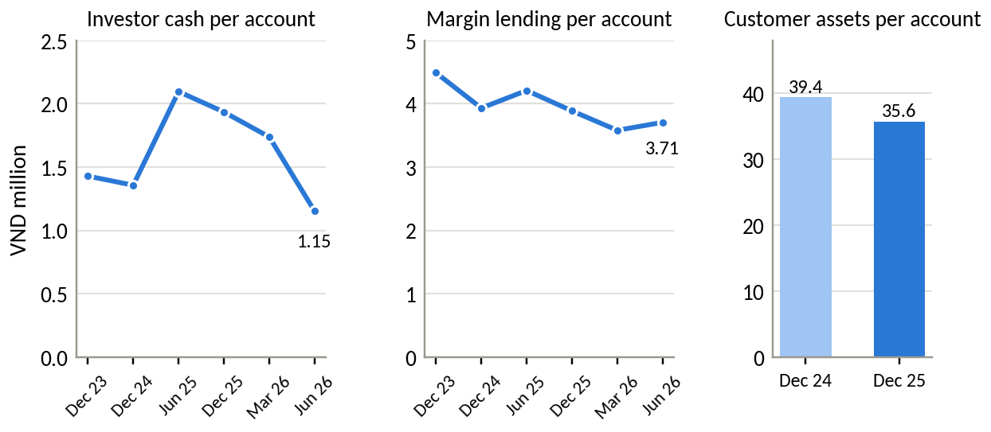
Source: DNSE filings (off-balance-sheet investor cash, loans); DNSE releases (accounts, customer assets); authors' calculations. Account counts for December 2023 and 2024 are derived from reported openings and growth rates.
Figure 5 assembles these measures into the sequence of steps that turns an account into profit. DNSE is strong at the first step and weak at every step after it.
Figure 5. Where value is lost between an account and a profit
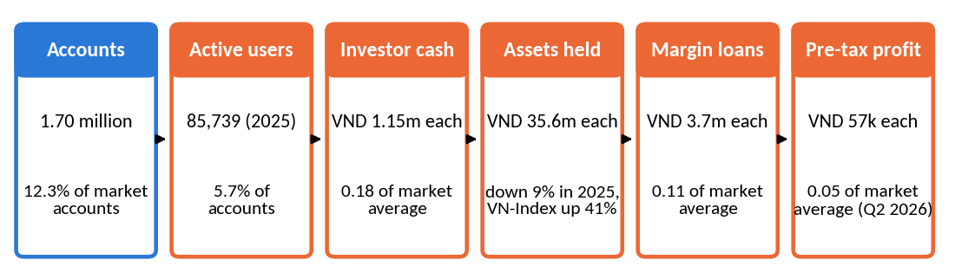
Source: as for Figure 2 and Figure 4. Active users are company-reported and the definition is not disclosed.

2.5 Finding 3. Peers with fewer accounts hold far more money
One possible objection is that all brokers count dormant accounts, so the gap could reflect the market as a whole. Two named peers disclose account numbers and allow a like-for-like test (Table 5, Figure 6). VPBankS reported 1.3 million accounts in May 2026 (Vietstock, 2026d) and TCBS more than 1.2 million at the end of 2025 (Thị trường Tài chính Tiền tệ, 2026a). Both serve fewer accounts than DNSE. At 30 June 2026 VPBankS lent VND 38.2 trillion and TCBS VND 51.5 trillion, against DNSE's VND 6.3 trillion (Vietstock, 2026g). Per account, VPBankS lends VND 29.4 million and TCBS VND 42.9 million, eight and twelve times DNSE's VND 3.7 million. Second-quarter pre-tax profit per account was about VND 1.7 million at both peers and VND 57,000 at DNSE.
Table 5. DNSE against two named peers with similar account bases
Indicator | DNSE | VPBankS | TCBS
Customer accounts, million | 1.70 | 1.30 | 1.20
Margin lending, 30 June 2026, VND billion | 6,303 | 38,200 | 51,500
Lending per account, VND million | 3.7 | 29.4 | 42.9
Pre-tax profit, Q2 2026, VND billion | 97.4 | 2,159 | 2,097
Profit growth, Q2 2026 on Q2 2025 | +7% | about 4 times | +21%
Pre-tax profit per account, Q2 2026, VND thousand | 57 | 1,661 | 1,748
HOSE brokerage share, Q2 2026 | below 2.94% | 3.57% | 9.36%
Investor cash per account, VND million | 1.15 | not disclosed | about 7.5
Parent bank | none | VPBank | Techcombank
Source: company releases and quarterly statements; Vietstock (lending); CafeF (customer cash); authors' calculations. Account figures are dated May 2026 (VPBankS), end-2025 (TCBS) and mid-2026 (DNSE). TCBS customer cash is the end-June figure reported for the largest brokers.
Figure 6. Lending and profit per customer account, DNSE against VPBankS and TCBS
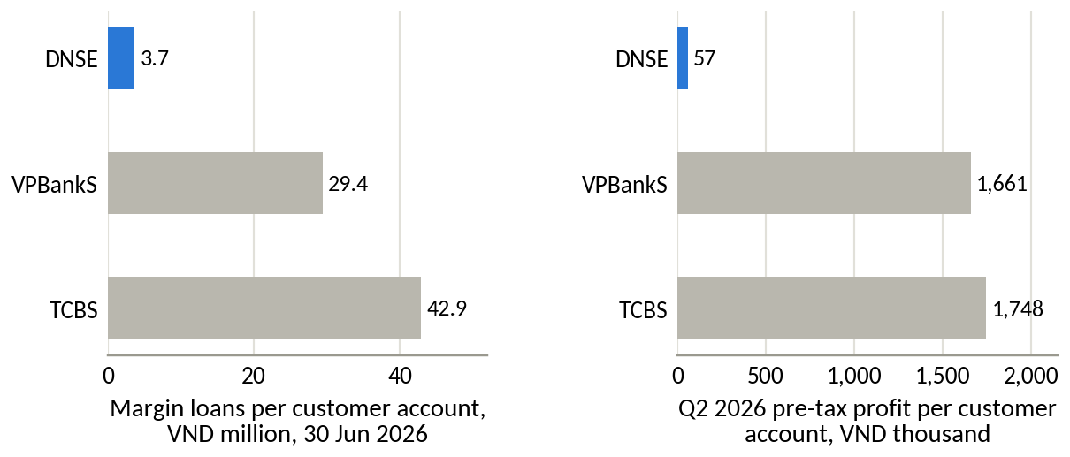
Source: as for Table 5.
The comparison does not depend on the market average. With comparable account bases, the two bank-affiliated brokers carry balances and earnings an order of magnitude larger. The industry also grew faster. Pre-tax profit across 77 brokers rose 51 per cent in the second quarter of 2026 compared with a year earlier (CafeF, 2026d), while DNSE's rose 7 per cent.

2.6 Finding 4. Revenue grows while core profit stands still
DNSE's revenue has grown quickly. Operating revenue rose from VND 180.7 billion in 2021 to VND 1,457.9 billion in 2025, a compound rate of 69 per cent a year, and reached VND 848.2 billion in the first half of 2026, up 59 per cent. Profit has not kept pace. Separating the net result of proprietary trading from everything else shows that pre-tax profit from the core business was VND 156 billion in 2022, VND 128 billion in 2023, VND 221 billion in 2024 and VND 194 billion in 2025 (Figure 7). The two years of strong reported growth, 2023 and 2025, relied on trading gains of VND 158 billion and VND 146 billion. Proprietary trading supplied 43 per cent of pre-tax profit in 2025.
Figure 7. Operating revenue and pre-tax profit split into core business and proprietary trading
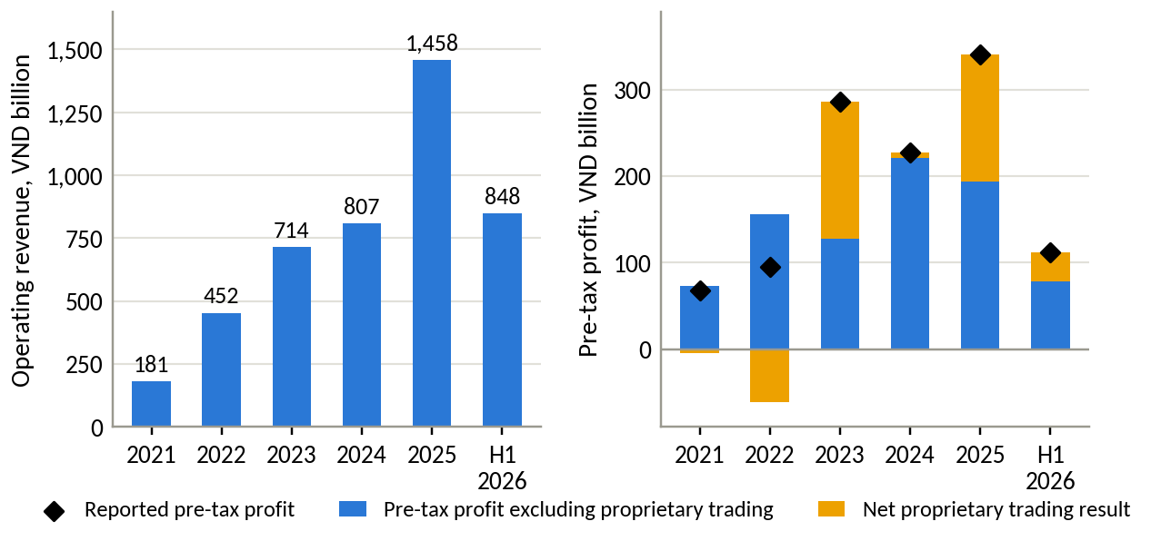
Source: DNSE filings, authors' calculations. The proprietary result is gains less losses on financial assets at fair value through profit or loss. H1 2026 is not annualised.
The first half of 2026 made the pattern plain. Revenue rose by VND 314.6 billion compared with the first half of 2025, and costs rose by VND 360.5 billion. Pre-tax profit fell by VND 45.9 billion, or 29 per cent, and core profit fell from VND 82.4 billion to VND 77.7 billion. Every extra VND 100 of revenue came with VND 115 of extra cost. The pre-tax margin fell from 23.3 per cent in 2025 to 13.2 per cent, and was 2.7 and 3.6 per cent in the two quarters to March 2026.
The composition of revenue explains part of the exposure (Figure 8). Interest on margin loans supplied 40 per cent of revenue in the first half of 2026 and interest on term deposits and bonds held to maturity 23 per cent. Brokerage fees supplied 26 per cent and proprietary gains 9 per cent. About 71 per cent of revenue therefore depends on the size of the balance sheet or the direction of the market. The recovery of brokerage revenue since 2024 comes from derivatives and from fees on financed trades, since unfinanced share trades are free.
Figure 8. Composition of DNSE operating revenue
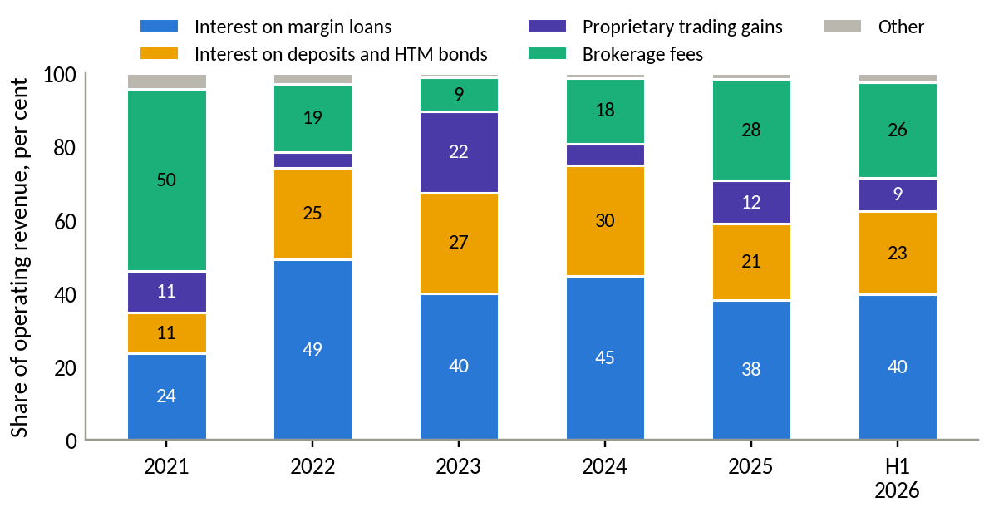
Source: DNSE filings, authors' calculations.
Brokerage itself loses money before overheads (Figure 9). In 2021 brokerage revenue covered its direct cost 1.75 times. Direct costs have exceeded brokerage revenue in every quarter since the third quarter of 2022, a run of 16 quarters with a cumulative shortfall of VND 190 billion. Revenue covered 87 per cent of direct cost in 2025 and 83 per cent in the first half of 2026. The notes combine brokerage and custody costs without further detail, so the shares of exchange fees, partner commissions and absorbed customer fees cannot be separated. DNSE has paid derivatives margin deposit, withdrawal and management fees on behalf of customers since May 2025 (Vietstock, 2025b), and it pays exchange fees on free share trades.
Figure 9. Brokerage revenue against direct brokerage cost, by quarter
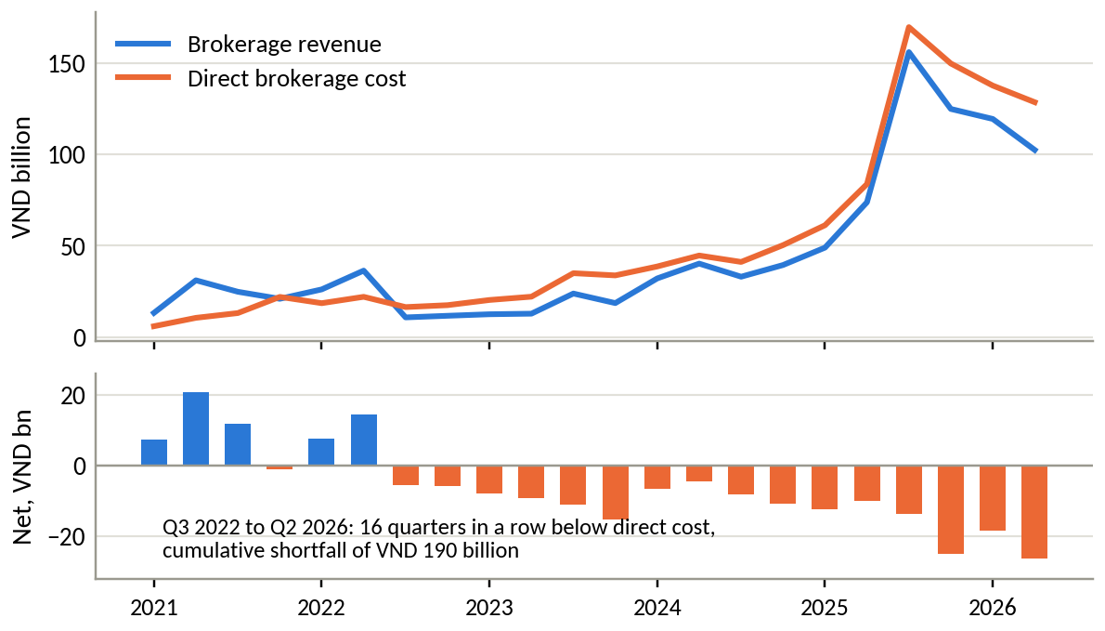
Source: DNSE filings, authors' calculations.
Figure 10 traces each VND 100 of revenue. In 2021, VND 38 became pre-tax profit. In the first half of 2026 the figure was VND 13, because direct brokerage cost rose to VND 31 and funding cost with provisions to VND 38.
Figure 10. Where each VND 100 of operating revenue goes
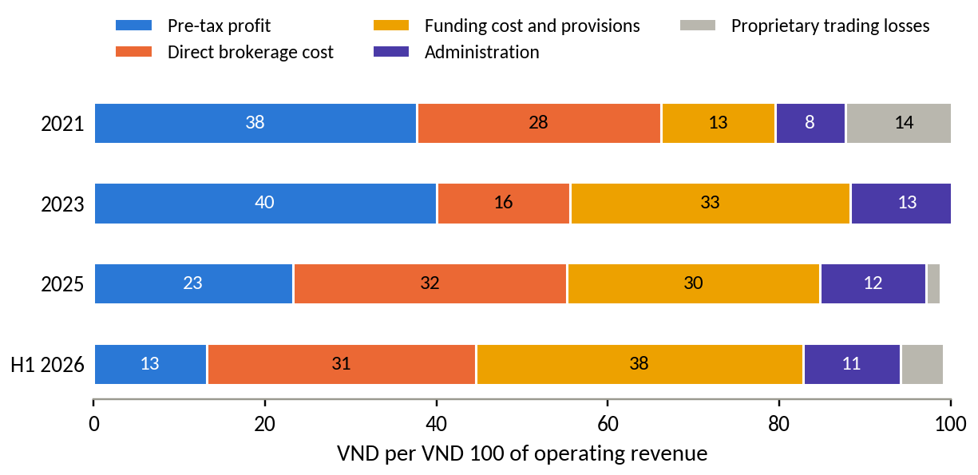
Source: DNSE filings, authors' calculations. Funding cost and provisions combine interest expense and template line 24.
The 2026 plan now looks out of reach from core business. DNSE targeted revenue of VND 1,736 billion and pre-tax profit of VND 550 billion (Vietstock, 2026b). At the half-year it had delivered 48.9 per cent of the revenue target and 20.3 per cent of the profit target. The second half would need VND 438 billion of pre-tax profit, or VND 219 billion a quarter, which is 28 per cent more than DNSE's best quarter on record (VND 171 billion in the third quarter of 2025). Return on equity has ranged between 3.7 and 8.9 per cent since 2021 and was 3.8 per cent annualised in the first half of 2026, below the 6.8 per cent a saver earns on a 12-month deposit at a state bank (VietnamNet, 2026).

2.7 Finding 5. An expensive balance sheet with spare lending capacity
Lending is the only business line with a wide margin. The yield on margin loans has stayed between 9.7 and 13.1 per cent since 2022, while the estimated cost of funding rose from 3.6 per cent in mid-2024 to 6.5 per cent in the second quarter of 2026 (Figure 11). The net spread on lending was 4.9 percentage points in the first half of 2026. Each additional VND 1,000 billion of lending therefore adds about VND 49 billion of pre-tax profit a year before credit losses.
Figure 11. Yield on margin loans and on deposits and bonds held to maturity, against the estimated cost of funding
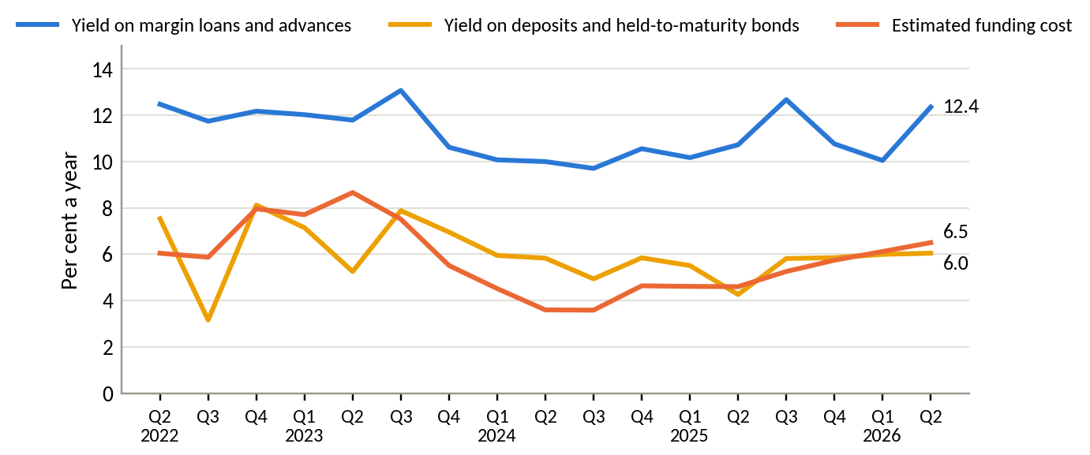
Source: DNSE filings, authors' calculations. Yields are annualised quarterly income over the average of opening and closing balances.
The rest of the balance sheet earns little. From 2022 to 2024 term deposits and bonds held to maturity made up 44 to 48 per cent of total assets, more than margin loans (Figure 12). According to note 8(b) of the reviewed half-year statements, about 93 per cent of these deposits and bonds were pledged as collateral for bank borrowing at 30 June 2026. They yield about 6 per cent, roughly the cost of the funds that finance them. They add about a fifth of revenue and almost no profit. This structure is consistent with a lender that must post cash collateral to obtain credit lines. Short-term loans supplied 86 per cent of its VND 9.4 trillion of borrowings at 30 June 2026, and bonds the rest, so the funding must be rolled over within the year. Bank-affiliated brokers probably avoid this cost through their parents, a hypothesis that the notes on borrowing terms could confirm.
Figure 12. Composition of DNSE total assets
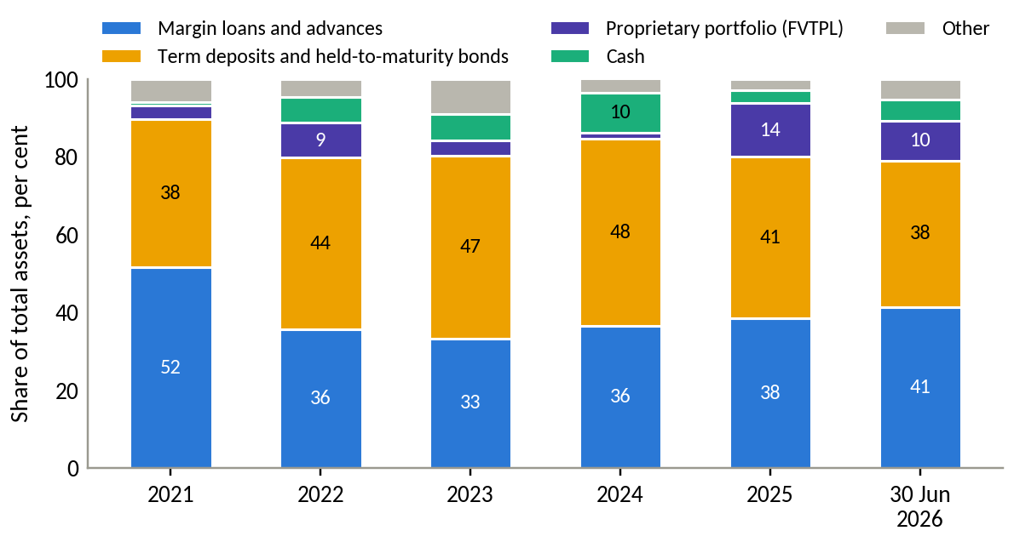
Source: DNSE filings, authors' calculations.
Capital is not the constraint on lending. Loans were 116 per cent of equity at 30 June 2026 against a regulatory ceiling of 200 per cent, which leaves room for about VND 4,600 billion more lending before new capital is needed. The 2026 annual general meeting also approved a bond programme of VND 3,500 billion (Vietstock, 2026b). DNSE lends little because its customers hold little to borrow against and few of them trade actively.

2.8 Finding 6. What customers say
After cleaning, DNSE averages 3.22 stars on Google Play across 670 reviews, ahead of VPS at 2.58 and FPTS at 2.18. The direction of travel matters more than the level. Substantive reviews, meaning those that carry a content theme, averaged 4.15 stars in 2024 and 2.38 in 2025 (Figure 13). The 2024 peak rests on the year with the most one-word reviews, 34 per cent of retained reviews against 12 per cent in 2025. The fall holds under stricter definitions. Treating reviews of up to four words as generic, the substantive mean still falls from 3.74 to 2.01.
Figure 13. Mean rating of DNSE reviews by year, and the share of one-word reviews
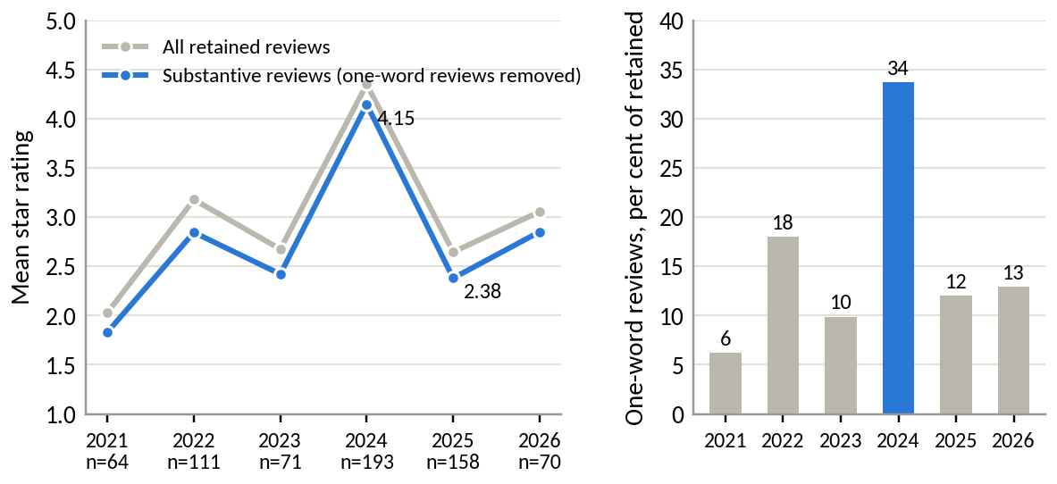
Source: Google Play, pulled 23 September 2026; authors' cleaning and coding. 2020, with three reviews, is omitted.
Among 278 negative reviews (one or two stars), crashes and login failures appear in 27.3 per cent, account opening and identity checks in 21.2 per cent and explicit accusations of deception in 17.6 per cent. Weighting by the helpful votes that other users gave each review changes the order (Figure 14). Accusations of deception attract 28.2 per cent of the votes, sign-up bonus terms 17.8 per cent and complaints about closing an account 11.3 per cent. Taken together, reviews on deception, bonus terms or closure make up 24.1 per cent of negative reviews and 42.9 per cent of their helpful votes. Product complaints about stability and onboarding make up 42.4 per cent of negative reviews and 34.1 per cent of votes. Other customers endorse trust complaints most strongly.
Figure 14. Themes in DNSE's negative reviews, by count and by helpful votes
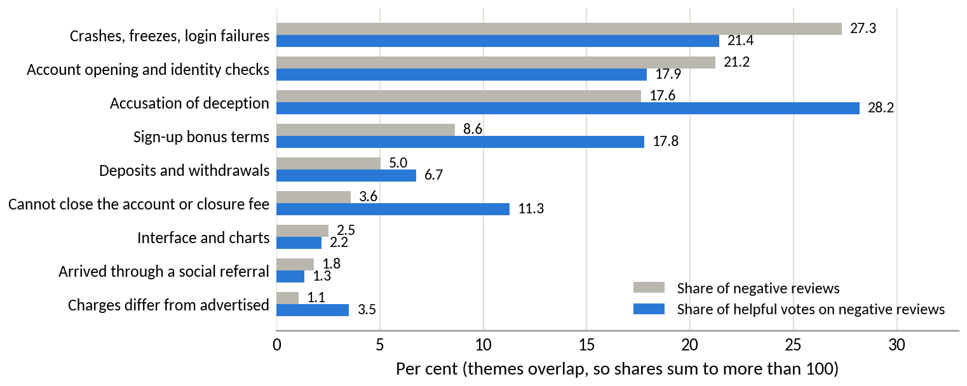
Source: as for Figure 13. 278 negative reviews carrying 1,794 helpful votes.
The monthly series dates the problem (Figure 15). October and November 2024 produced 91 retained reviews, 44 per cent of them a single word, and one of them cited a VND 200,000 gift for opening an account. June 2025 produced 29 negative reviews, the highest monthly count in the data. The most-voted of them say that a VND 100,000 sign-up reward required a deposit of at least VND 2 million, and that closing an account cost VND 100,000. Promotional waves thus appear twice in the data, first as a burst of short praise and then as a burst of accusations. From March 2023, when the VPS sample begins, 5.6 per cent of DNSE's retained reviews concern sign-up bonuses or rewards, against 0.7 per cent of VPS reviews. None of the 177 FPTS reviews, all written in 2025 and 2026, raise the subject.
Figure 15. DNSE reviews per month, positive above the axis and negative below
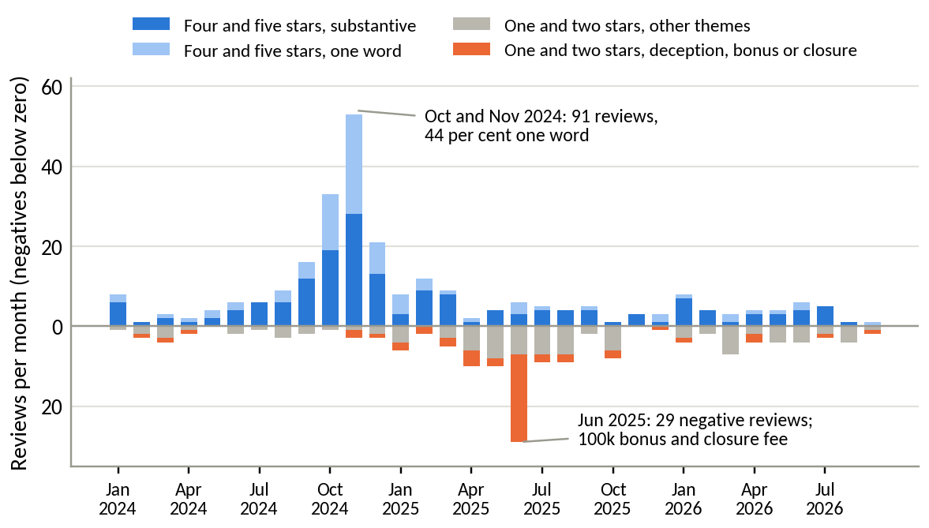
Source: as for Figure 13.
The idle-cash product, Tài khoản không ngủ, appears in three reviews, all positive. The feature that could hold customer money has almost no presence in what customers write. The App Store, whose iPhone users probably sit higher in the income distribution, gives a cross-check for 2025 and 2026 (Figure 16). App Store reviewers rate DNSE lower, at 2.25 against 2.77 on Google Play, and slightly below FPTS. They complain more about the product than the promotions. Crashes, login and onboarding appear in 51 per cent of their negative reviews against 38 per cent on Google Play, while deception and bonus terms appear in 15 per cent against 34 per cent.
Figure 16. Mean rating of cleaned reviews on the two stores, 2025 and 2026
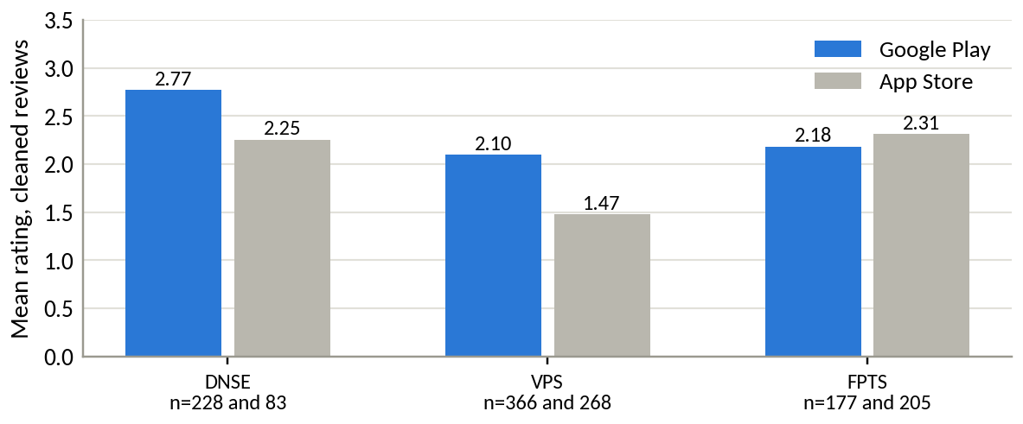
Source: Google Play and Apple App Store; authors' cleaning. Written reviews are harsher than star ratings as a whole. Apple reports an average of 4.04 stars from 1,490 ratings for DNSE, most given without text.

2.9 Finding 7. Where Vietnamese investable money sits
Vietnamese households have entered the formal financial system quickly (World Bank, 2025a; Figure 17). Account ownership rose from 21 per cent of adults in 2011 to 71 per cent in 2024, and the share receiving wages into an account from 8 per cent in 2014 to 37 per cent. The share saving at a financial institution rose from 20 per cent in 2022 to 43 per cent in 2024, while borrowing from formal institutions fell from 22 per cent in 2017 to 8 per cent. Households are accumulating, and they keep their savings in banks. The two-year jump in saving may partly reflect changes in the survey, and the Findex documentation should be checked before the trend is treated as behavioural.
Figure 17. Account ownership, digital payments, formal saving, wage receipt and formal borrowing among Vietnamese adults
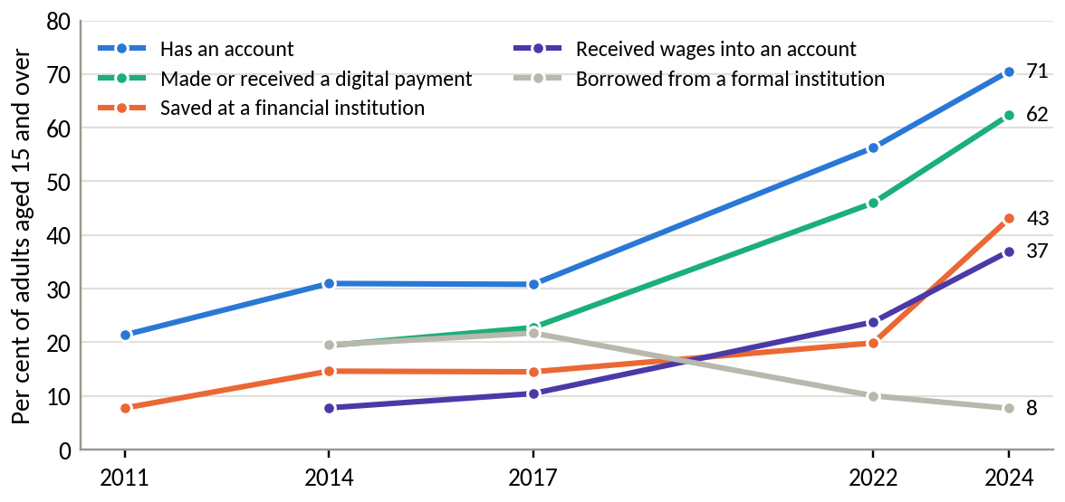
Source: World Bank Global Findex, Vietnam, waves 2011 to 2024 (the 2024 wave is published as Global Findex 2025).
Two indices summarise where investable money sits and how reachable it is digitally (Figure 18). Index A averages six indicators of formally held surplus, namely saving at an institution, monthly saving into an account, storing money in an account, receiving interest, saving for old age and the ability to cover two months without income. Index B averages six indicators of digital habit, namely a digitally enabled account, daily internet use, smartphone ownership, weekly in-store card or mobile payment, checking a balance by phone and receiving wages into an account. Adults in the richest 60 per cent of the income distribution, those in the labour force and those with secondary education or more combine the highest investable surplus with high digital habit. Each of these segments contains between 15 and 20 million adults who hold an account and do not yet save at a financial institution.
Figure 18. Vietnamese adult segments by digital habit and formally held investable surplus
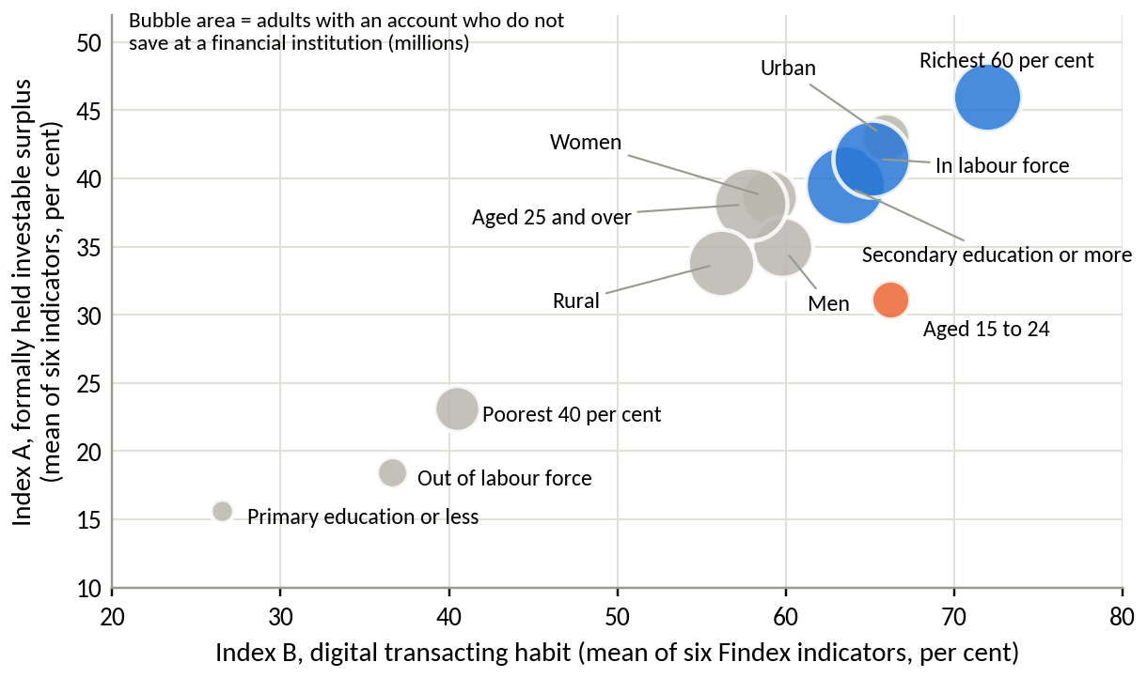
Source: World Bank Global Findex 2024 fieldwork; authors' indices. The two indices average different indicators, so segments are compared within each axis.
Adults aged 15 to 24 are the exception. They show the highest digital habit of any age group and the lowest investable surplus of any large segment, with the widest gap between holding an account and saving at an institution (33.6 points). The detail matters for strategy (Figure 19). Young adults receive wages into an account as often as older adults (37 per cent each) and save into an account every month as often (20 per cent each). They differ in horizon. Only 8 per cent of young adults saved for old age, against 23 per cent of adults aged 25 and over. The data suggest that young customers already have income and a monthly habit, and lack a reason and a product for keeping money invested.
Figure 19. Payday and saving behaviour by segment pair
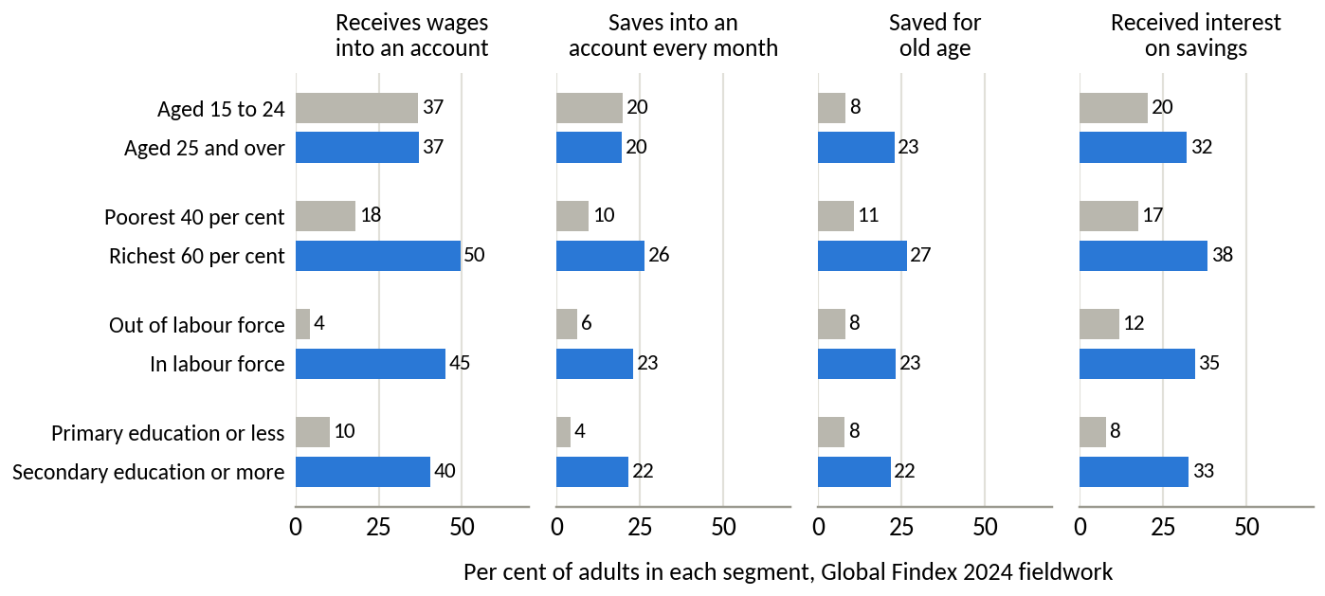
Source: World Bank Global Findex 2024 fieldwork.
A ranking of the twelve segments on six normalised criteria (both indices, the activation gap, the size of the unconverted pool, wage receipt into an account and saving for old age) gives the same top two under all four weighting schemes and the same top three under three of them. The richest 60 per cent ranks first and adults in the labour force second in every scheme. Adults with secondary education or more rank third in three schemes and fourth when value is weighted most heavily. Adults aged 15 to 24 rank between seventh and ninth. The ranking is stable because the leading segments score well on every criterion. Appendix D reports the full table.

2.10 Summary of findings
Table 6. Summary of findings and their business implications
Finding | Main evidence | Evidence type | Implication
Acquisition works | 20% of new accounts in 2025; 1.7 million customers; 25.4% of derivatives brokerage | Measured | DNSE does not need more reach to grow
Money does not follow | 2.3% of investor cash, 1.4% of lending, 0.6% of profit against 12.3% of accounts; 5.7% active; assets per account down 9% in 2025 | Measured and derived | Value is lost after the account is opened
Peers hold more per account | VPBankS and TCBS lend 8 to 12 times more per account with fewer accounts | Measured and derived | The gap is specific to DNSE's model
Revenue without profit | Core profit flat at VND 128 to 221 billion while revenue tripled; brokerage below direct cost for 16 quarters | Measured | Growth in activity does not create value on its own
Costly balance sheet | Funding cost 6.5%; deposits and bonds held to maturity are 38% of assets, mostly pledged, and earn about the cost of funds; 86% of borrowing is short term; lending at 116% of equity | Measured and estimated | Capital is available and balances are missing
Trust deficit | Trust themes take 43% of helpful votes on negative reviews; June 2025 promotion complaints; idle-cash product nearly invisible | Measured, self-selected sample | Customers hesitate to leave money with DNSE
Money sits with working adults | The richest 60% and adults in the labour force rank first and second under four weightings; young adults save monthly, yet few save for old age | External survey, derived | Target salaried mass-affluent adults and give young customers a long-term product
Source: Sections 2.3 to 2.9.

3. Discussion and main analysis

3.1 A three-layer diagnosis
Marketing claims about a digital broker, such as speed, zero fees or customer numbers, say little about where it gains or loses money. The findings are therefore read through three layers where the data meet the business model. The first is financial health and the structure of earnings. The second is the customer lifecycle from sign-up to a retained, funded account. The third is the depth of each customer's relationship across products.
Layer 1. Financial health and the structure of earnings. For a bank, the warning signs of expensive growth are a falling share of cheap current-account deposits (CASA), a rising cost of funds, a narrowing net interest margin and fee income that does not cover its cost. A broker's closest equivalent to CASA is the idle cash that clients keep on the platform, which measures whether money flows stay with the firm. All four signs are present at DNSE (Figure 20). Idle client cash peaked at VND 3,192 billion in the third quarter of 2025 and fell to VND 1,961 billion by June 2026. The estimated cost of funds rose from 3.6 per cent in mid-2024 to 6.5 per cent. The net interest margin on loans and deposits held fell from 5.0 per cent in 2024 to 4.2 per cent in 2025 and 3.5 per cent in the first half of 2026. Fee and commission income rose from 10 per cent of revenue in 2023 to 29 per cent in 2025, yet brokerage stayed below its direct cost in every quarter. DNSE is paying to generate activity and revenue while the money that would make them profitable leaves.
Figure 20. Layer 1 indicators of financial health
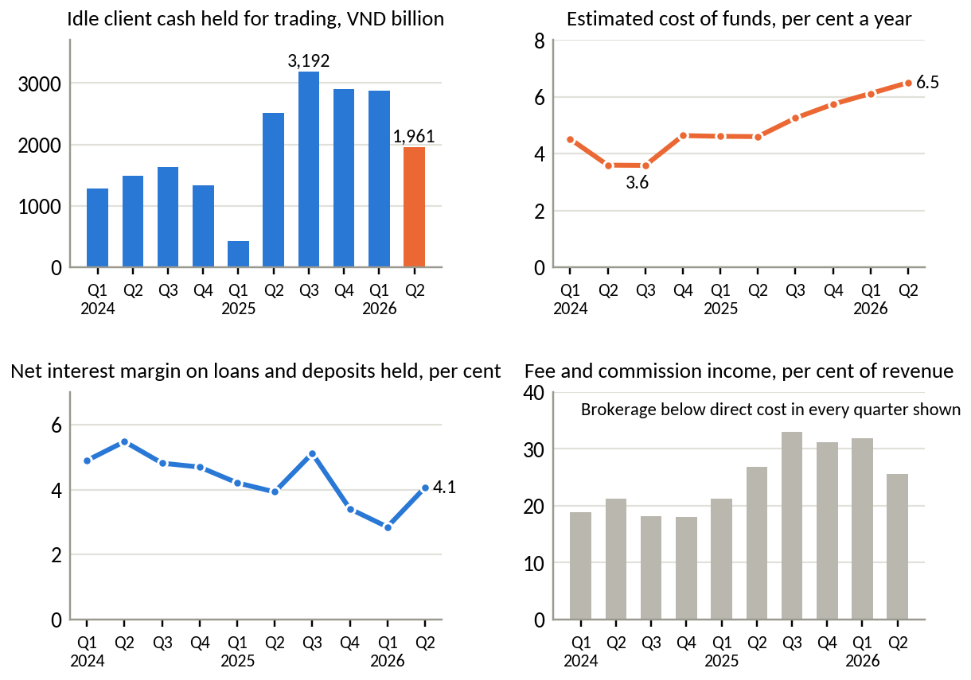
Source: DNSE filings; authors' calculations. Net interest margin is interest on loans and on deposits and bonds held to maturity, less the estimated cost of funds, over average interest-earning assets. Fee income is operating revenue excluding interest and proprietary trading. The fall in idle cash in the first quarter of 2025 appears in the filings and was reversed the next quarter; it may reflect the timing of settlement.
Layer 2. The customer lifecycle. DNSE does not publish funnel data, so Table 7 assembles the available evidence stage by stage and names what must be measured internally. The pattern is consistent. Sign-up is strong, identity verification generates a fifth of all complaints, and the conversion from an opened account to a funded, active one is where most value is lost. The 2025 cohort brought little money, only 5.7 per cent of accounts were active, and the bursts of complaints follow reward campaigns whose conditions surfaced at the first deposit. A draft circular of the Ministry of Finance, published for comment in May 2026, would require biometric matching for withdrawals and transfers of VND 10 million or more and facial authentication at the first trade of each login session (Dân trí, 2026a). If adopted, it will add friction at exactly these stages unless onboarding and authentication are linked to the national VNeID platform, which the draft accepts as a reference for biometric data.
Table 7. Layer 2. Evidence on the customer lifecycle and the gaps to close in Round 3
Stage | Available evidence | What it shows | Measure needed from internal data
Sign-up | 518,514 accounts in 2025; 18 to 33% of new accounts in the market | Acquisition works | Cost per account by channel and campaign
Identity verification (eKYC) | 21% of negative reviews on onboarding (NFC chip reading, one-time passwords, photo checks); peaks in 2021, 2022 and 2025 | Recurring friction | Completion rate and time to verify, by device and channel
First funding | Implied assets of the 2025 cohort of VND 0 to 13 million per account under plausible market effects; June 2025 complaints that a reward required a VND 2 million deposit | The weakest stage | Share of new accounts funded within 30 days, and amount
First trade and activity | 85,739 active users in 2025, 5.7% of accounts | Most accounts stay idle | First-trade rate; active rate by cohort month
Retention at 30 to 90 days | Cash per account fell 32% in the second quarter of 2026, in line with the industry | Money leaves when rates rise | Dormancy at 30, 60 and 90 days; balance retention
Second product | Idle-cash product in 3 of 670 reviews; Ensa used by 73,000 customers | Depth is thin | Products held per funded customer
Source: DNSE releases; Sections 2.4 and 2.8; Dân trí (2026a) on the draft circular.
Layer 3. Product depth and cross-selling. The third layer asks whether customers treat DNSE as a place to keep and grow money or as a trading tool. The evidence points to the second. Margin lending is concentrated among the active few, with about VND 68 million of loans per active user in 2025 against VND 3.9 million per account. Distribution of bonds and funds, which earned TCBS VND 964 billion in the second quarter of 2026 (TCBS, 2026b), contributed almost nothing to DNSE's revenue, with financial advisory and underwriting together at VND 7.7 billion in the first half of 2026. The idle-cash product is priced for large balances and rarely mentioned by customers, and no product helps customers save regularly. At TCBS, by contrast, 11,500 customers invest through the Fundmart fund platform each month and more than 20,000 tried its upgraded wealth platform within two months (TCBS, 2026b; TheLEADER, 2026). Robinhood reports that more than 15 per cent of its funded customers pay for its premium tier, which carries a higher yield on cash (Robinhood Markets, 2026).
The three layers point to the same stage. The business loses most value between the opened account and the funded, retained account, in the first weeks after sign-up and at each payday afterwards when customers decide where their money goes. The shallow product range explains why conversion fails at this stage, and Layer 1 shows the cost.

3.2 Root cause analysis
A five-whys analysis traces the central symptom to its cause in DNSE's own policies (Table 8). Each step is supported by evidence from this report, and the last step identifies the policy that Round 3 must change.
Table 8. Five-whys analysis of the balance gap
Step | Question and answer | Evidence
Symptom | Accounts opened in 2025 brought between nothing and VND 13 million each, and only 5.7% of accounts were active | Cohort decomposition; company-reported active users
Why 1 | Why do new accounts stay small? Many customers open an account for a reward and deposit only what the reward requires | June 2025 complaints about a VND 100,000 reward that required a VND 2 million deposit; DNSE reviews raise bonus terms about eight times as often as VPS reviews
Why 2 | Why do reward seekers dominate the intake? Incentives pay for opening an account and a minimum deposit, and marketing targets young first-time investors | Reward waves in the review series (late 2024, June 2025); Gen Z price board, trading contests and social media content
Why 3 | Why does money not stay after the reward? The product gives no competitive reason to keep cash on the platform | Idle cash earns 2.1 to 2.3% for a typical customer against 6.8% on a 12-month state bank deposit; no automatic saving; trading-first design
Why 4 | Why has the product not been built? DNSE's goals and public measures centre on accounts, market share and speed | Published indicators are accounts, new-account share, derivatives share, active users and order speed of 3.9 milliseconds; balances appear only as total customer assets, without per-account or funded-account figures
Root cause | DNSE earns through lending and trading, which need customer balances, but it measures and rewards acquisition. Its incentives and product roadmap are aligned with the wrong outcome | Core profit flat since 2022 while accounts tripled from the end of 2023; lending per account falling
Source: authors' analysis of Sections 2 and 3.1.
Four further mechanisms reinforce the root cause. The first is selection by price. Zero commissions appeal most to customers who choose a broker on price, typically young and first-time investors with small portfolios. Gen Z accounts made up 31.5 per cent of DNSE's 1.2 million accounts in mid-2025 (VnExpress, 2025), and in May 2025 the firm launched a price board designed for Gen Z (Vietstock, 2025c). Investors with larger portfolios are likely to weigh margin rates, research and service more heavily. The second is the product mix. Derivatives produce market share from a small pool of capital, because each investor posts their own margin at the clearing house and DNSE lends nothing. The August 2026 penalty also ordered DNSE to stop three services that advanced money to derivatives customers (Phụ nữ Việt Nam, 2026), so the franchise will now tie up even less customer money with the firm. The third is the price of the cash product. DNSE's idle-cash account pays a fixed 1.8 per cent, plus up to 1.5 points for balances of VND 10 billion or more and up to 1.0 point for large trading values (DNSE, 2026b). A customer with less than VND 500 million earns 2.1 to 2.3 per cent. The fourth is reliability. For a firm without branches, the application is the whole service, and crashes, login failures and failed identity checks account for 42 per cent of negative reviews. Customers who doubt that they can withdraw cash quickly, close an account freely or receive an advertised reward will hesitate to leave savings with the firm.
Four alternative explanations were tested and rejected. The first holds that the gap reflects the market cycle. It does not explain 2025, when the VN-Index rose 41 per cent and DNSE's assets per account fell. DNSE's cash fell in the second quarter of 2026 by the same proportion as the industry's, so the cycle moves both sides and leaves the gap intact. The second holds that DNSE lacks capital to lend. Lending stood at 116 per cent of equity against a ceiling of 200 per cent. The third holds that DNSE deliberately acquires young customers now to monetise them later. The strategy is plausible, but per-account lending has fallen for two and a half years, and the Findex data show that young adults save monthly without saving for the long term. Without a product that keeps their growing income on the platform, later monetisation depends on customers who can move to another free broker at no cost. The fourth holds that DNSE counts inactive accounts. So does every broker, and the comparison with VPBankS and TCBS holds with similar counts.

3.3 Macroeconomic conditions and household savings
Vietnam's macroeconomic conditions in 2026 change how the findings should be read. Growth is strong. GDP grew 8.18 per cent in the first half of 2026 and 8.39 per cent in the second quarter (Chinhphu.vn, 2026). Average consumer price inflation was 4.45 per cent in the first eight months, with core inflation at 4.24 per cent (Báo Đấu thầu, 2026). The binding constraint in the financial system is funding. Credit grew 19.0 per cent in 2025 against deposit growth of 11.4 per cent (FiinRatings, 2026), and in the first quarter of 2026 credit grew almost five times as fast as deposits, at 2.15 against 0.44 per cent (Thị trường Tài chính Tiền tệ, 2026b). By 28 August 2026 credit had grown 10.24 per cent for the year (Diễn đàn Doanh nghiệp, 2026). Banks responded by competing for deposits, and FiinRatings (2026) expects considerable liquidity pressure throughout 2026 (Table 9).
Table 9. Macroeconomic and banking indicators relevant to household savings, 2025 and 2026
Indicator | Value | Period
GDP growth | 8.18% (Q2 8.39%) | First half of 2026
Consumer price inflation, average | 4.45% (core 4.24%) | January to August 2026
Gold price index, average change on a year earlier | +47.0% | January to August 2026
Credit growth against deposit growth | 19.0% against 11.4% | 2025
Credit growth, year to date | 10.24%, about VND 20.5 quadrillion outstanding | To 28 August 2026
Sector net interest margin | 2.9% (3.5% in 2024) | 2025
Household deposits at banks | Above VND 11 quadrillion, +7.1% in six months | June 2026
Individual payment account balances | About VND 1.22 quadrillion in 256.7 million accounts, against about VND 1.35 quadrillion a year earlier | June 2026
12-month deposit rate, Big Four state banks | 6.8% | September 2026
Highest listed 12-month rate for deposits below VND 1 billion | 7.9% | September 2026
Change in 12-month deposit rates at large banks since January | About +2.5 percentage points | January to July 2026
Households with income above USD 5,000 a year | 68.2% projected | 2028
Source: National Statistics Office via Chinhphu.vn (2026) and Báo Đấu thầu (2026); State Bank of Vietnam via Diễn đàn Doanh nghiệp (2026), Thị trường Tài chính Tiền tệ (2026b), Vietstock (2026i) and VietnamPlus (2026); FiinRatings (2026); VnEconomy (2026b); VietnamNet (2026); VnExpress (2026c); KPMG Vietnam (2025).
Three consequences follow for DNSE. First, idle cash has become expensive to hold anywhere that pays little. Payment account balances, on which interest is capped at 0.5 per cent, fell by more than VND 120 trillion in a year while household deposits reached a record (VietnamPlus, 2026; Vietstock, 2026i). Savers are moving money to where it earns. DNSE's typical idle-cash rate of about 2.3 per cent sits below inflation, below the base rate of its closest competing product and far below bank deposits (Figure 21).
Figure 21. Returns available to a Vietnamese saver's idle cash, September 2026
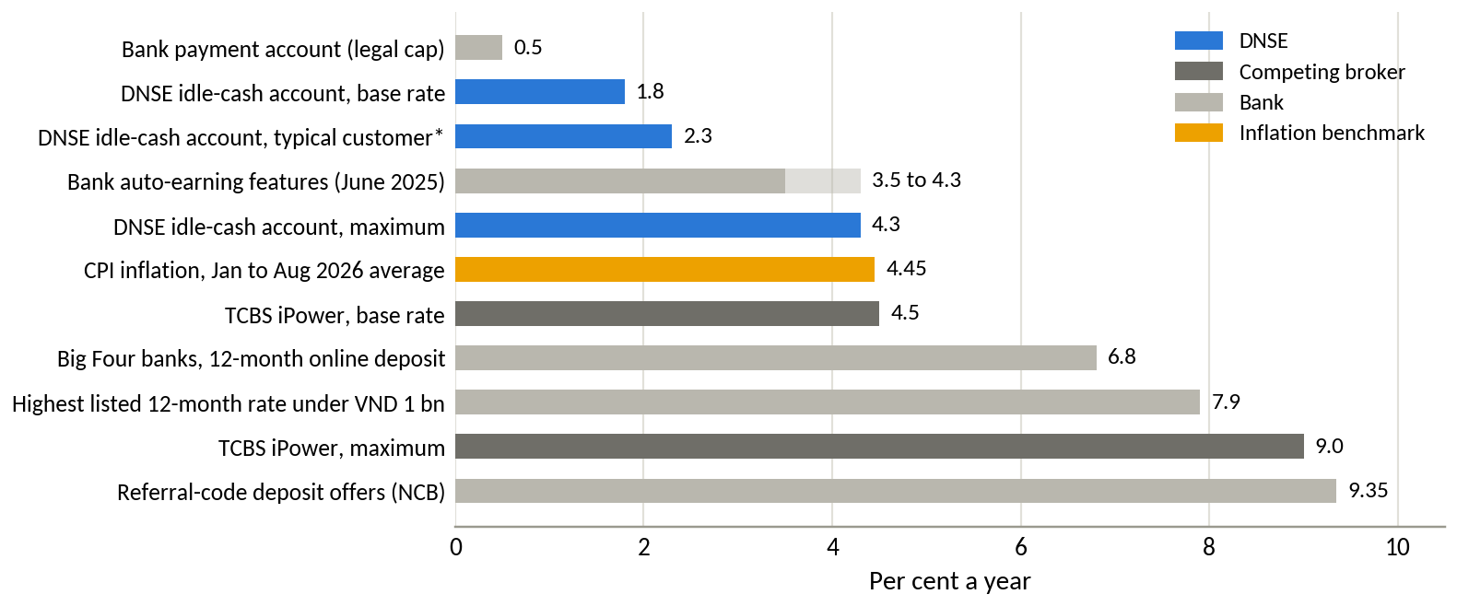
Source: DNSE (2026b) and TCBS (2026a) product pages, accessed 24 September 2026; DNSE (2025) comparison of bank auto-earning products; VietnamNet (2026) and VnExpress (2026c) bank rate surveys; Báo Đấu thầu (2026). * A customer holding VND 1 million to 500 million with trading value in the same band.
Second, the fall in investor cash is market-wide, and DNSE's share of it has held. Cash held at brokers fell from VND 138.9 trillion in the third quarter of 2025 to VND 86.6 trillion in the second quarter of 2026 (VnEconomy, 2026b). DNSE's fell by about the same proportion, from VND 3,192 billion to VND 1,961 billion (Figure 22). VnEconomy links the outflow to higher deposit rates. The balance gap is structural, and the rate cycle has made it larger in absolute terms.
Figure 22. Investor cash held at brokers, indexed to the third quarter of 2025
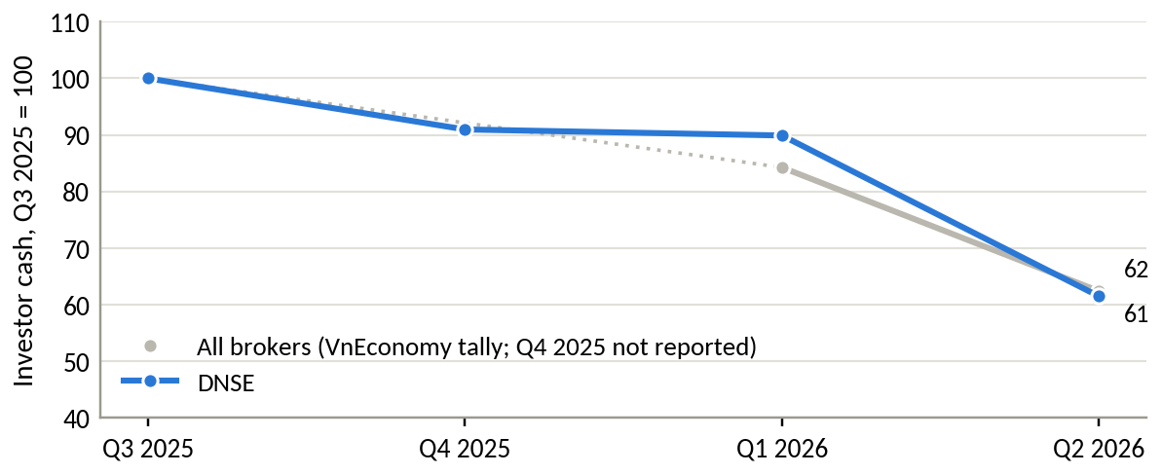
Source: VnEconomy (2026b) tally of investor deposits at securities firms; DNSE filings. The industry figure for the fourth quarter of 2025 was not reported.
Third, the pool of money DNSE is failing to attract is very large. Table 10 sets DNSE's investor cash against the places where Vietnamese households keep money. A shift of one tenth of one per cent of household bank deposits into DNSE would be worth VND 11 trillion, 5.6 times DNSE's investor cash today. The macro environment therefore raises both the cost of inaction and the size of the opportunity. Gold, whose price index rose 47 per cent on average in the first eight months of 2026, competes for the same savings.
Table 10. Where Vietnamese savers keep money, mid-2026
Pool | Value, VND trillion | Multiple of DNSE investor cash
Household deposits at banks (June 2026) | above 11,000 | about 5,600
Individual payment accounts at banks (June 2026) | about 1,220 | about 620
Investor cash at all securities firms (June 2026) | 86.6 | 44
DNSE customer assets (December 2025) | 53.5 | 27
DNSE investor cash (June 2026) | 1.96 | 1
Source: Vietstock (2026i); VietnamPlus (2026); VnEconomy (2026b); DNSE filings and releases.
The FTSE Russell reclassification helps over the medium term, with limited direct benefit to DNSE. It took effect on 21 September 2026 with 27 Vietnamese stocks in the FTSE All-Cap index, and Vietcap estimates passive inflows of about USD 1.5 billion at full inclusion (The Investor, 2026). The money will flow into large-capitalisation shares through institutional brokers, where DNSE's share is smallest. Its indirect value for DNSE lies in higher market confidence and a larger pool of domestic savers willing to hold equities for longer. DNSE's chief executive expects same-day trading to make share trading resemble derivatives trading and to draw active derivatives traders into shares (Báo Đầu tư, 2026). The chairman of the depository expects same-day trading more likely in the second half of 2027 or in 2028 (Người Quan sát, 2026).

3.4 Banking trends and competition
Four banking trends shape the market in which DNSE competes. The first is the rise of brokers owned by banks. Their share of industry margin lending rose from 19 per cent in 2022 to 30 per cent in 2024 (Vietstock, 2026e). In the second quarter of 2026, nine bank-backed firms among the top twenty supplied VND 18.7 trillion of the industry's VND 30 trillion increase in lending (Vietstock, 2026g). Bank-affiliated brokers earn a return on average assets of about 5.5 per cent against 3.5 per cent for the industry, and large brokers earn a return on equity of 14.3 per cent against 7.8 per cent for small ones (Vietstock, 2026e). Their advantages are funding, capital and customers. VPBankS raised VND 12.7 trillion in its 2025 listing and drew USD 200 million of foreign loans arranged by its strategic partner SMBC in early 2026 (Vietstock, 2026d, 2026e). TCBS draws customers from Techcombank, although 60 per cent of its new accounts in 2025 came to it directly (Thị trường Tài chính Tiền tệ, 2026a).
The second trend is the collapse of commission as a source of profit. TCBS earned VND 69 billion from brokerage and custody in the second quarter of 2026, against VND 1,380 billion from margin lending and VND 964 billion from capital sourcing and bond distribution (TCBS, 2026b). Across the industry, brokerage revenue fell to VND 3.7 trillion in the same quarter while lending revenue reached VND 12.2 trillion (Vietstock, 2026h). Zero-fee trading is now standard across the market.
The third trend is the migration of banking into the phone, together with stricter identity rules. Individuals held 256.7 million payment accounts in June 2026 (VietnamPlus, 2026), and the number of non-cash transactions grew 34 per cent in the first half of the year (Tiền Phong, 2026). Banks now compete with automatic interest on idle balances (DNSE, 2025). The State Bank's Circular 64/2024 sets open application programming interface standards that banks must meet by 1 March 2027 (State Bank of Vietnam, 2024), and Decree 94/2025 opened a regulatory sandbox for lending, open interfaces and credit scoring from July 2025 (Government of Vietnam, 2025). Linking a salary account to an investment account will become cheaper and more standard. Biometric rules, applied to bank transfers since 2024 and proposed for securities trading in 2026 (Dân trí, 2026a), raise the bar for smooth digital onboarding.
The fourth trend is regulatory scrutiny of retail brokerage. Decision 461 of the securities inspectorate, issued on 17 August 2026, fined DNSE VND 802.5 million for offering derivatives financing services without prior notice to the regulator, lending to insiders and related persons, and allowing purchases beyond available funds (Market Times, 2026; Phụ nữ Việt Nam, 2026). The Personal Data Protection Law, in force since 1 January 2026, gives customers the right to have their data deleted (National Assembly of Vietnam, 2025), which raises the cost of a slow and paid account closure.
Outside capital adds a further constraint. Global fintech investment reached USD 116 billion in 2025, but the number of deals fell to an eight-year low, Asia-Pacific investment fell to USD 9.3 billion, its lowest level in more than a decade, and investment in wealth technology fell from USD 4.9 billion to USD 1.4 billion (KPMG, 2026). Deal numbers kept falling in the first quarter of 2026 (CB Insights, 2026). In ASEAN, fintech funding fell 36 per cent in the first nine months of 2025 to about USD 835 million, of which Singapore took 87 per cent and Vietnam, Malaysia and Thailand together less than 10 per cent (UOB et al., 2025). Venture funding for Vietnamese financial services fell 61 per cent in 2024 to USD 58 million (Do Ventures, 2025). Investors now favour firms with proven and profitable business models. DNSE must therefore finance growth from earnings, listed equity and bonds, and each of these depends on showing that its customer base can produce income.
Table 11 maps the main business models against these trends.
Table 11. Competitive map of Vietnamese retail brokerage business models
Model | Examples | How it earns | Strength | Weakness
Bank-affiliated balance-sheet brokers | TCBS, VPBankS, MBS, SHS | Margin lending, bond distribution, investment banking | Cheap funding, capital, bank customers | Less focus on first-time and young investors
Independent full-service brokers | SSI, HSC, Vietcap, VNDirect | Margin, institutional brokerage, advisory | Research, institutional clients, brand | Higher cost to serve retail
Retail trading platforms | VPS | Retail brokerage, derivatives, margin | Largest retail and derivatives share | HOSE share fell to 12.61% in Q2 2026, lowest in 22 quarters
Digital zero-fee challengers | DNSE, Pinetree | Margin and derivatives | Low cost, fast technology, young customers | Small balances, no bank parent, trust gaps
Banks' own savings features | Techcombank, VPBank, VIB | Deposit spread | Salary accounts, trust, 3.5 to 4.3% auto-earning (2025) | Limited investment choice
Source: company releases and statements; Vietstock (2026e); CafeF (2026b); DNSE (2025); authors' assessment.
The market gap sits between the first and last rows. Banks own the salary account and the saver's trust but offer little beyond deposits. Bank-affiliated brokers offer investment and high-yield cash products mainly to customers inside their parents' networks. TCBS's iPower, for example, requires at least VND 5 million to earn interest (TCBS, 2026a). Digital challengers attract young and first-time investors but give them nowhere competitive to keep money. No independent digital broker yet offers a salaried saver a trusted, market-rate place to hold a monthly surplus with a direct path into bonds, funds and shares. DNSE has the customers, the technology and the brand among young investors to fill that gap. It lacks the product and the trust.

3.5 Customer behaviour
Vietnamese consumers are digital and still conservative with savings. DataReportal counts 85.6 million internet users at the end of 2025, 84.2 per cent of the population, with Zalo reaching 78.3 million monthly users and TikTok 76.1 million adults (Kemp, 2026). Visa's consumer payment study found that 56 per cent of Vietnamese respondents carried less cash than a year earlier and that at least four in five used mobile wallets (Visa, 2024). Reach is cheap, and DNSE's acquisition model exploits it well.
Savings behaviour lags behind digital habit. A 2025 survey by Thien Viet Asset Management found that 75 per cent of individual investors use only two or three channels, mostly traditional ones such as real estate, gold and bank savings, and that 88 per cent expect returns above 7 per cent a year. Seventy-seven per cent find it difficult to manage their own portfolios and 81 per cent want professional advice (Nhân Dân, 2025). Only 16 per cent had used a digital wealth platform, although 36 per cent knew of one. Among those who knew, 34 per cent worried about non-transparent fees and 30 per cent about security (VnEconomy, 2025), the same two concerns that dominate DNSE's reviews.
Findex adds three points (World Bank, 2025a). About half of adults could cover more than two months without income, and one in six names money for old age as their top financial worry, so latent demand for longer-term saving exists. Young adults are less resilient than older adults. Twenty-eight per cent say emergency funds would be very difficult to find, against 14 per cent of adults aged 25 and over, and 18 per cent earn money through apps or websites, against 10 per cent. Income earned through apps is usually irregular, which argues for flexible contributions. Finally, 8.3 per cent of adults received a call or message asking for money in the past year, and Acclime Vietnam and UOB Vietnam (n.d.) count about 13,900 cyberattacks on Vietnamese systems in 2023. Customers who meet fraud attempts regularly will judge a new savings product first on whether they can trust it.
The evidence points to an unmet customer need for a transparent and safe way to move money from a salary account into investments, at a return that beats a bank deposit on a comparable basis.

3.6 Lessons from comparable business models abroad
Zero-fee and low-fee brokers in other markets met the same problem earlier, and their solutions offer tested designs. The shift toward gathering assets is already visible in Southeast Asia. Assets on digital wealth platforms in six markets of the region, Vietnam among them, grew 24 per cent in 2025 to about USD 90 billion, faster than digital lending or digital payments (Google et al., 2025). Table 12 compares five foreign models with DNSE.
Table 12. Comparable business models abroad and their lessons for DNSE
Firm and market | How it grew | How it earns money | Lesson for DNSE
Robinhood, United States | Zero commissions since its 2015 launch; 27.0 million funded customers in 2025 | Trading 59%, net interest 34%, subscriptions and other 7% of USD 4.5 billion revenue in 2025 | Growth after 2021 came from assets. Net deposits reached USD 68 billion in 2025 (35% of opening assets), helped by retirement accounts, a paid tier with a higher cash yield and a bank account with direct deposit. A USD 70 million FINRA penalty in 2021 for outages and misleading information preceded the shift
Trade Republic, Germany and Europe | EUR 1 trades and free ETF savings plans | Interest on cash and trading | Passing the full central bank rate on uninvested cash and automating savings plans took customer assets past EUR 150 billion by October 2025; EUR 2.5 billion of interest was passed to customers from 2023
Zerodha and Groww, India | Flat or zero fees; Groww began as a mutual fund platform in 2016 | Zerodha earned 70 to 90% of its income from futures and options | After the regulator tightened derivatives trading in late 2024, derivatives turnover fell 29% and Zerodha's revenue fell from INR 10,000 crore to 8,500 crore. Groww, with monthly fund plans at its base, raised profit 12% in the quarter when peers fell. Monthly SIP inflows reached INR 29,529 crore in October 2025
SBI and Rakuten Securities, Japan | Zero commissions on domestic shares from October 2023, plus the tax-free NISA account from 2024 | Balances, fund distribution and group banking | NISA accounts reached 26.96 million and cumulative purchases JPY 63 trillion by June 2025. Rakuten's automatic sweep between its bank and broker passed 7 million accounts in August 2026 and pays a preferential deposit rate
Futu, Hong Kong | Low commissions and a strong community | Brokerage 46%, interest 46% of revenue in 2025 | Only 3.37 million of 29.2 million users are funded (11.5%), yet client assets reached HKD 1.23 trillion, with HKD 180 billion in wealth management products
DNSE, Vietnam | Zero fees on shares; 1.7 million accounts | Lending 40%, own-account investments 32%, brokerage 26% of revenue in H1 2026 | Has the reach and the technology; lacks a competitive cash product, automated saving and asset-based incentives
Source: Robinhood Markets (2026); FINRA (2021); Trade Republic (2025); Inc42 (2025); AMFI (2025); Financial Services Agency (2026); Rakuten Group (2026); Futu Holdings (2026).
Figure 23 shows where the money comes from. Firms that succeeded with free trading earn a large share of revenue from client balances, either as interest or as distribution and wealth fees. TCBS, the most profitable Vietnamese example, earns 2 per cent of net revenue from trading and the rest from lending, distribution, investment banking and other activities (TCBS, 2026b). DNSE earns a third of its revenue from its own investments, which yield little above their funding cost, and almost nothing from distribution.
Figure 23. Revenue mix of selected zero or low-commission brokers
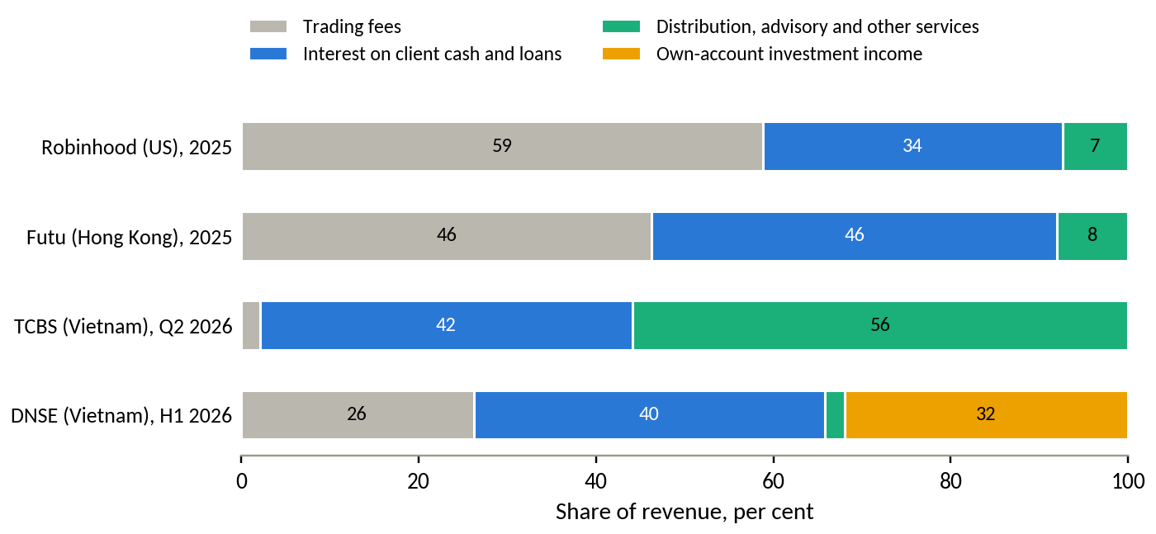
Source: as for Table 12; TCBS (2026b), shares of net revenue by segment in the second quarter of 2026; DNSE filings. Robinhood's trading revenue includes payment for order flow and cryptocurrency trading. DNSE's own-account income is interest on term deposits and bonds held to maturity plus proprietary trading gains.
Not every lesson transfers to Vietnam (Table 13). Vietnam's exchanges match orders centrally, so there is no payment for order flow, which supplied much of Robinhood's trading revenue. There is no tax-advantaged retail investment account comparable to NISA or an American retirement account. A securities company cannot hold deposits or receive wages directly. These gaps make customer balances even more important for DNSE than for its foreign peers, and they mean that DNSE has to reach salaries through partners.
Table 13. Transferability of foreign designs to Vietnam
Design | Transferable | Condition in Vietnam
Market-rate yield on uninvested cash | Yes | Deliver through a bank sweep or a licensed money market fund; legal structure to be confirmed with the SSC
Automatic monthly investment plans | Yes | Periodic fund subscriptions and bond products from VND 1 million already exist
Salary-linked transfers | Partly | Wages arrive at banks; a pull on payday requires bank open interfaces (standard by March 2027) or ZaloPay
Asset-based rewards | Yes | Pay rewards on funding, saving and transferred portfolios instead of sign-ups
Paid subscription tier | Later | Useful once a funded base exists
Payment for order flow | No | Order-driven exchanges
Tax-advantaged accounts | No, for now | Requires policy change; DNSE can support industry proposals
Bank account with direct deposit | No | Securities firms cannot take deposits; partner banks can
Source: authors' assessment based on Section 3.6 and the Vietnamese regulation cited in Section 3.4.

3.7 A wider view of DNSE
The diagnosis so far looks at DNSE through its customers and its income. A board would also ask how the firm looks to its owners, lenders, regulators and competitors, and whether any of these views reveals a larger problem. Table 14 scans the firm from twelve angles and records what each adds.
Table 14. DNSE seen from twelve angles
Angle | Evidence | What it adds
Strategy and business model | Free trading funded by lending, derivatives and balance-sheet income; 71% of H1 2026 revenue depends on balance-sheet size or market direction | Every revenue line needs balances, and no fee income works without them
Customers and brand | 20% of new accounts in 2025; Gen Z 31.5% of accounts in mid-2025; 5.7% of accounts active; strongest brand among young and first-time investors | Reach is an asset; the base is young, price-driven and mostly idle
Products and technology | Order processing in about 4 milliseconds; Lightspeed API; Ensa assistant used by 73,000 customers; a new data centre planned for 2026 to serve high-frequency traders; crashes and login failures in 27% of negative reviews | Investment favours speed for active traders, while reliability and saving tools lag
Capital and shareholder returns | Equity VND 5.4 trillion after a VND 1.3 trillion rights issue, 86% of it earmarked for margin lending and advances; ROE 3.8% annualised in H1 2026; cash dividends of 7% of par for four consecutive years | New capital is raised for lending that customer balances do not yet support
Funding and liquidity | Borrowings of VND 9.4 trillion, 86% of them short-term loans, equal to 1.7 times equity; 93% of deposits and bonds held pledged; VND 3.5 trillion bond programme | Funding is short, collateralised and more expensive than at bank-owned rivals
Credit and market risk | Loan-loss allowance of 1.0% of loans; financial assets held for trading of VND 1.5 trillion, 28% of equity, which produced 43% of 2025 pre-tax profit | A market fall would hit profit through trading losses before lending losses
Regulation and conduct | Decision 461 of August 2026 imposed a VND 802.5 million fine, stopped three derivatives financing services and found lending to insiders from January 2024 to June 2026 and purchases beyond available funds | Controls lag growth, and new products need prior reporting and stronger compliance
People and operations | No branches; administrative expenses 11 to 12% of revenue; staff costs VND 99 billion in 2025, 6.8% of revenue; the largest cost is direct brokerage cost at 31% of revenue | The cost base is lean, so the gap must be closed through revenue per account
Partners and ecosystem | ZaloPay partnership since 2023; banks supply credit lines against pledged deposits; no fund manager of its own; part of the Encapital group | Partners supply reach and funding, and a salary link will need a bank or wallet partner
Ownership and governance | Encapital group and chairman about 49.7%; Capella Group, a co-founding investor of Encapital, 9.8% since March 2026 | A stable controlling group can take a multi-year view; minority investors watch conduct
Market valuation | Share price VND 22,000 on 24 September 2026 against the IPO price of VND 30,000; market value about VND 9.4 trillion, 1.7 times book equity and about 39 times trailing earnings | The price assumes that the account base will be monetised
New ventures | 1% stake (about VND 10 billion) in Sun Group's digital-asset company; planned IFC securities subsidiary; plan to establish or acquire a fund manager, delayed by high valuations; plan to join carbon-credit exchanges | Options for later growth that compete with the core problem for management attention
Source: Sections 2 and 3; DNSE filings; CafeF (2026a); Kinh tế Chứng khoán (2026); Bnews (2026); Simplize (2026); Mekong ASEAN (2024); VnExpress (2026a); Thời báo Tài chính Việt Nam (2026); Doanh nhân (2026); VietnamBiz (2025); Market Times (2026); authors' calculations.
The valuation angle is the most telling. Investors pay 1.7 times book value for a firm that earns 3.8 per cent on equity, below the 6.8 per cent a saver earns on a state bank deposit. The premium rests on expectations that the account base will produce income. Those expectations have already weakened. The share price is 27 per cent below the IPO price, and the market value of about VND 9.4 trillion is below the valuation of about VND 10 trillion at listing in July 2024 (VnExpress, 2024), even though shareholders have since added VND 1.3 trillion of new capital (Simplize, 2026; CafeF, 2026a). Converting accounts into balances is therefore also the most direct way to raise shareholder value.
The competitive forces explain why acquisition alone cannot sustain profit (Table 15). Customers hold several free accounts and switch at no cost, substitutes for their savings pay more than DNSE, and the brokers with the cheapest funding are gaining share in lending.
Table 15. Competitive forces in Vietnamese retail brokerage
Force | Strength | Evidence and implication for DNSE
Rivalry among brokers | High | 77 firms reported second-quarter results; zero fees are standard; the HOSE top ten hold 65% of trading; bank-affiliated brokers took 62% of lending growth in Q2 2026
Bargaining power of customers | High | Accounts are free and investors hold accounts at several brokers; switching costs are low, so rewards win sign-ups that last only as long as the reward
Threat of substitutes for savings | High | Bank deposits at 6.8 to 7.9%, banks' auto-earning accounts, gold (price index up 47% in 2026) and real estate compete for the same surplus
Threat of new entrants | Medium | Licences and capital rules limit entry, but bank groups and foreign investors enter by recapitalising existing brokers; the digital-asset pilot and the IFC create new venues
Bargaining power of suppliers | Medium to high | Banks supply short-term credit against pledged deposits; exchanges and the depository set fees that DNSE absorbs on free trades; biometric and data rules add compliance costs
Source: Sections 1.2, 3.3 and 3.4; authors' assessment.
Table 16 brings the internal and external evidence together.
Table 16. SWOT analysis of DNSE
Strengths | Weaknesses
Low-cost digital acquisition (20% of new accounts); fast order technology; second in derivatives brokerage; strongest brand among young investors; spare lending capacity (116% of equity against a 200% ceiling); controlling shareholders willing to add capital | Low balances and activity per account; brokerage below direct cost for 16 quarters; profit reliant on proprietary trading; short, costly and collateralised funding; weak cash product; app reliability and trust complaints; control gaps shown by the 2026 penalty
Opportunities | Threats
Record VND 11 quadrillion of household deposits; 37% of adults receive wages into accounts; open banking interfaces by March 2027; digital wealth assets in Southeast Asia up 24% in 2025; FTSE upgrade; same-day trading from 2027 or 2028 | Bank-affiliated brokers with cheaper funding; rising deposit rates drawing cash from brokers; tighter rules on derivatives and biometric checks; zero fees everywhere; a market fall hitting proprietary results and margin loans; scarce outside capital for fintech
Source: Sections 2 and 3; authors' assessment.
Reading the quadrants together gives four strategic implications. Pairing strengths with opportunities, DNSE's low-cost acquisition and technology can reach salary flows as open banking arrives, which is the logic of the recommendation in Section 4. Pairing weaknesses with opportunities, a competitive cash yield delivered with a partner bank or fund can turn the weak cash product into the main way of collecting savings. Pairing strengths with threats, DNSE should compete where bank-affiliated brokers are weakest, among digitally active savers outside their parents' networks, and avoid a price war on margin rates, where cheaper funding decides the outcome. Pairing weaknesses with threats, controls and trust must be repaired before new products or ventures, since a second penalty or a failed payday transfer would deepen the trust deficit.
The balance gap also touches every stakeholder group (Table 17).
Table 17. Stakeholders affected by the balance gap
Stakeholder | Interest | How the balance gap affects them
Customers | Low-cost trading, a safe place for savings, fair terms | Idle cash earns less than inflation; reward terms and closure fees erode trust
Shareholders | Return on equity above the cost of capital; growth in profit per share | ROE of 3.8% annualised; share price below the IPO price; new capital without matching profit
Lenders and bondholders | Repayment and collateral quality | Short-term credit lines rolled over against pledged deposits; the bond programme needs a credible earnings base
Regulators (SSC, SBV, Ministry of Finance) | Investor protection, orderly margin lending, data protection | Reward-driven sign-ups and derivatives financing drew a penalty; new savings products need prior reporting
Management and employees | Growth targets, incentives, reputation | Targets built on accounts and speed; the 2026 profit plan is out of reach
Partners (banks, ZaloPay, fund managers) | Fee income and access to customers | Few balances to distribute products to; partners gain if a salary link succeeds
Source: authors' assessment based on Sections 2 and 3.
The wider view adds one candidate problem to the diagnosis, the control and conduct weaknesses exposed by the August 2026 penalty, which would matter for any new product. It also confirms where the centre of the problem lies. Owners, lenders, regulators and the market price all depend on converting accounts into funded relationships.

3.8 Target market and scope
The Findex ranking identifies where money sits in the population. Choosing DNSE's target market also requires judgement about fit, competition and risk. Five candidate markets were scored on six criteria (Table 18). The scores are the authors' judgements, and each rests on evidence cited in Sections 2 and 3.
Table 18. Scoring of candidate target markets
Candidate market | Wallet per customer (25%) | Reachable scale (20%) | Fit with balance-based revenue (20%) | DNSE's right to win (15%) | Low competitive intensity (10%) | Low conduct and regulatory risk (10%) | Weighted | Equal
Salaried mass-affluent adults (employed, secondary-educated, upper 60% income) | 4 | 5 | 5 | 3 | 3 | 4 | 4.15 | 4.00
Affluent and high-net-worth investors | 5 | 1 | 4 | 1 | 1 | 4 | 2.90 | 2.67
Household businesses | 3 | 4 | 2 | 1 | 2 | 3 | 2.60 | 2.50
Young first-time investors (15 to 24) | 1 | 3 | 2 | 5 | 2 | 2 | 2.40 | 2.50
Active derivatives traders | 2 | 1 | 2 | 5 | 2 | 1 | 2.15 | 2.17
Source: authors' assessment. Scores from 1 (weak) to 5 (strong). The weighted total uses the weights shown; the equal-weight total is a robustness check.
Salaried mass-affluent adults score highest under both weightings. They hold the formally saved surplus (Index A of 40 to 46 against 31 for young adults), 40 to 50 per cent of them receive wages into an account, and each defining segment holds 15 to 20 million adults with an account and no formal saving. They fit a revenue model built on balances, because their savings arrive every month. DNSE's right to win is moderate. Part of this segment is already in its base, the zero-fee brand is known, and the missing pieces are a savings product and trust. Competition is real, since banks and bank-affiliated brokers target the same salaries, but few offer a direct path from salary to investment.
Affluent investors bring the largest wallets, but they are few and well served by private banking and bank-affiliated brokers, and DNSE has no advisory force. Household businesses are numerous, at about 5.3 million in the 2026 economic census (VnEconomy, 2026a), but their needs are payments and credit, which belong to banks. Young first-time investors are DNSE's strongest franchise and its weakest source of money. Young adults with irregular income from apps and gig work form part of this group, and their volatile cash flows make them a poor first target for a balance-building product. Active derivatives traders are loyal and add market share, yet the business loses money after direct costs and carries the highest regulatory risk after the August 2026 penalty and India's experience.
The scope of the problem is narrowed along three dimensions (Table 19), so that Round 3 develops one concept in depth.
Table 19. Scope of the business problem for Round 3
Dimension | In scope | Out of scope for now
Customer segment | Salaried adults, roughly 22 to 40, in the upper 60% of the income distribution. The first wave comes from DNSE's own unfunded or low-balance accounts held by working customers, including Gen Z customers who have started work | Students without income, affluent advisory clients, institutional clients, household businesses
Journey stage | The first 90 days after an account is opened, from identity verification to first funding and the third payday, and the matching restart journey for dormant accounts | Brand marketing, trading features, derivatives, after-sales service beyond balance retention
Solution depth | Mechanism, value logic, main assumptions and measures of success | Detailed feature design, screens, pricing tables and budgets, which Round 3 will develop
Source: authors' assessment.
Findex cannot measure the intersection of the defining segments directly. Its bounds are wide, between 29 and 60 per cent of adults, and measuring it with the survey microdata is one of the first validation tasks. Young customers remain important within this scope. As they enter salaried work, the same product should carry their savings from their first pay cheque.

3.9 Problem prioritisation and problem statement
Seven candidate problems emerged from the diagnosis and the wider scan. Table 20 compares them on five consistent criteria, namely the scale of the effect, urgency, strategic relevance to DNSE's stated goals, the strength of data support and DNSE's control over the outcome. Quantitative anchors are given where the data allow.
Table 20. Prioritisation of candidate business problems
Candidate problem | Scale anchor | Scale (25%) | Urgency (15%) | Strategic relevance (20%) | Data support (20%) | Control (20%) | Weighted | Equal
Balance gap (accounts not converted into funded, retained relationships) | 2026 plan gap of VND 395 billion; VND 83 billion a year per extra VND 1 million lent per account | 5 | 4 | 5 | 5 | 4 | 4.65 | 4.60
Trust and reliability deficit | Indirect; blocks conversion of the base | 3 | 4 | 4 | 4 | 5 | 3.95 | 4.00
Loss-making brokerage | About VND 89 billion a year below direct cost | 3 | 3 | 3 | 5 | 4 | 3.60 | 3.60
Derivatives concentration and regulatory exposure | Three services stopped in August 2026; Indian turnover fell 29% after new rules | 3 | 4 | 4 | 4 | 2 | 3.35 | 3.40
Control and conduct weaknesses | Fine of VND 802.5 million; insider lending over 30 months; reputational cost not measurable | 2 | 4 | 3 | 3 | 5 | 3.30 | 3.40
Earnings dependent on proprietary trading | Swings of about VND 150 billion a year | 4 | 2 | 2 | 5 | 3 | 3.30 | 3.20
Rising funding cost and pledged deposits | About VND 130 billion a year from a 1.4-point rise in the cost of funds | 4 | 4 | 3 | 3 | 2 | 3.20 | 3.20
Source: authors' assessment based on Sections 2 and 3. Scores from 1 (weak) to 5 (strong). Scale anchors are annual pre-tax profit effects estimated from DNSE filings where possible.
The balance gap ranks first under both weightings. It governs lending, trading and fee income at the same time, it is tied directly to DNSE's plan and its five-year ambition, it rests on independent measures from filings, industry data, peers, reviews and population data, and it sits within DNSE's control through product, pricing, incentives and targeting. Several other problems are its symptoms. Brokerage loses money because free and derivatives trading generate costs without balances to monetise. Earnings lean on proprietary trading because core income from customers has stalled. The trust deficit ranks second and is treated as a precondition within the solution, since a savings product cannot succeed while customers doubt the firm. Control and conduct weaknesses are cheap to fix and fully within DNSE's control, so they belong in the solution's trust layer without competing with the balance gap for priority. The confidence in the ranking is moderate. The scores are judgements, the scale of the trust deficit cannot be measured from public data, and a different reading of urgency would bring the funding problem closer to the top.
The scale of the balance gap is clearest in DNSE's own targets (Figure 24). Pre-tax profit from core business ran at about VND 155 billion a year in the first half of 2026. Reaching VND 550 billion from lending at the current net spread of 4.9 points would need VND 8.1 trillion of additional loans, a book 2.3 times today's. That book would exceed the 200 per cent lending ceiling at current equity and would need about VND 132 trillion of customer assets at DNSE's current ratio of loans to assets, 2.5 times the level at the end of 2025. The listing roadshow in January 2024 set an ambition of about 5 million customers and VND 2,400 billion of annual profit within five years (CafeF, 2024a). At DNSE's 2025 profit per account of about VND 274,000, 5 million customers would generate about VND 1,370 billion. The ambition therefore requires profit per account to rise by about three quarters, which only larger balances can deliver.
Figure 24. What the 2026 profit plan implies for loans, equity and customer assets
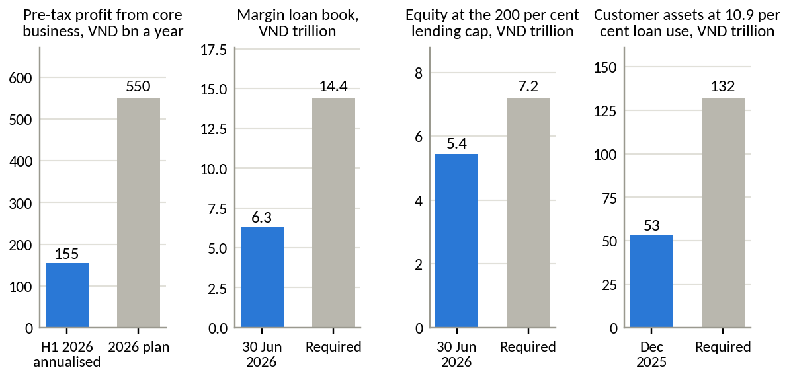
Source: DNSE filings and 2026 plan; authors' calculations. The calculation assumes that all additional profit comes from lending at the first-half 2026 net spread of 4.88 points, with no change in other lines. It is an order-of-magnitude illustration.
Table 21. Business problem statement
Element | Statement
Context | DNSE opened one in five of Vietnam's new securities accounts in 2025 and serves 1.7 million customers. Its income comes from lending, trading and its balance sheet, all of which depend on customer money held on the platform
Quantified gap | DNSE holds 12.3% of accounts but 2.3% of investor cash, 1.4% of margin lending and 0.6% of industry profit. An average account holds VND 1.15 million in cash against VND 6.25 million across the market; 5.7% of accounts were active in 2025; assets per account fell 9% in 2025
Economic impact | Core pre-tax profit has stayed between VND 128 and 221 billion a year since 2022 while revenue tripled. Each additional VND 1 million lent per account is worth about VND 83 billion of pre-tax profit a year. The 2026 plan implies a loan book 2.3 times the current one
Strategic urgency | Deposit rates have risen about 2.5 points in 2026 and cash is leaving brokers; bank-affiliated brokers took 62% of margin growth in the second quarter; open banking interfaces become standard by March 2027, after which every competitor can link salary accounts; the share price already trades below the IPO price
Problem | DNSE converts sign-ups into funded, retained relationships at a low rate, above all in the first 90 days, because its incentives reward opening accounts and its products give salaried customers no competitive, trusted reason to keep money on the platform
Source: Sections 2 and 3.

3.10 Strategic alternatives and trade-offs
Six responses to the balance gap were assessed against the same six criteria (Table 22). Each is a distinct strategy with a different use of DNSE's money and management attention.
Table 22. Strategic alternatives assessed against the balance gap
Alternative | Impact on funded balances (30%) | Profit potential by 2028 (20%) | Low capital and cost need (15%) | Low execution and regulatory risk (15%) | Fit with DNSE capabilities (10%) | Evidence support (10%) | Weighted | Equal
B. Payday Portfolio, a salary-linked savings-to-investing layer | 5 | 3 | 3 | 3 | 4 | 5 | 3.90 | 3.83
D. Upmarket advisory tier for affluent investors | 4 | 4 | 2 | 3 | 1 | 3 | 3.15 | 2.83
E. Distribution alliance with a bank or e-wallet | 3 | 3 | 4 | 2 | 3 | 3 | 3.00 | 3.00
C. Derivatives-to-shares bridge for traders on same-day trading | 2 | 3 | 4 | 1 | 5 | 2 | 2.65 | 2.83
F. Reintroduce trading fees | 1 | 3 | 5 | 2 | 1 | 2 | 2.25 | 2.33
A. Continue acquisition-led growth | 1 | 1 | 3 | 4 | 5 | 1 | 2.15 | 2.50
Source: authors' assessment. Scores from 1 (weak) to 5 (strong); for cost and risk, a higher score means lower cost or lower risk.
Each option gives something up. Continuing acquisition-led growth (A) protects the new-account share and the brand among young investors, but it adds accounts from the segment with the least money and raises a cost base that already absorbs more than all incremental revenue. Building a derivatives-to-shares bridge (C) plays to DNSE's strongest capability, but it waits for same-day trading that may not arrive before 2028. It also deepens exposure to the activity the regulator has just penalised, and India shows how quickly rules can cut derivatives income. An upmarket advisory tier (D) raises revenue per customer directly, but it requires advisers and a relationship model that DNSE deliberately avoided and in which bank-affiliated firms are entrenched. An alliance with a bank or e-wallet (E) would bring salary flows and possibly cheaper funding, but DNSE would share its economics and customer relationship with a partner. It works better as a channel inside another strategy than as the strategy itself. Reintroducing fees (F) would raise revenue quickly and break the lifetime promise that brought 1.7 million customers, in a market where zero fees are standard.
Payday Portfolio (B) ranks first under both weightings. It acts directly on the balance gap at the stage where the gap opens, it builds on products DNSE already runs (the idle-cash account, Trứng Vàng, Margin Deal, the Lightspeed interface and the ZaloPay partnership), and it follows the pattern that worked abroad. What it sacrifices is speed. Balances accumulate month by month, so the option contributes little to the 2026 plan, and it needs a yield on cash high enough to compete with banks, a partner or licence for funds, and prior reporting to the regulator. The ranking holds because the alternatives either leave the balance gap untouched or trade it for a larger risk. Elements of E and D can be added later as channels and tiers once a funded base exists.

4. Recommendations

4.1 The preliminary recommendation
DNSE should build Payday Portfolio, a salary-linked savings-to-investing layer that turns a customer's monthly surplus into a growing balance on the platform. It is aimed at salaried adults of roughly 22 to 40 in the upper income segments, starting with DNSE's own unfunded or low-balance accounts held by working customers. It acts on the first 90 days after an account is opened, the stage where the balance gap opens, and offers the same journey to dormant accounts as a restart.
Figure 25 shows the mechanism. Money moves in four steps, and a trust layer governs all of them.
Figure 25. How Payday Portfolio works
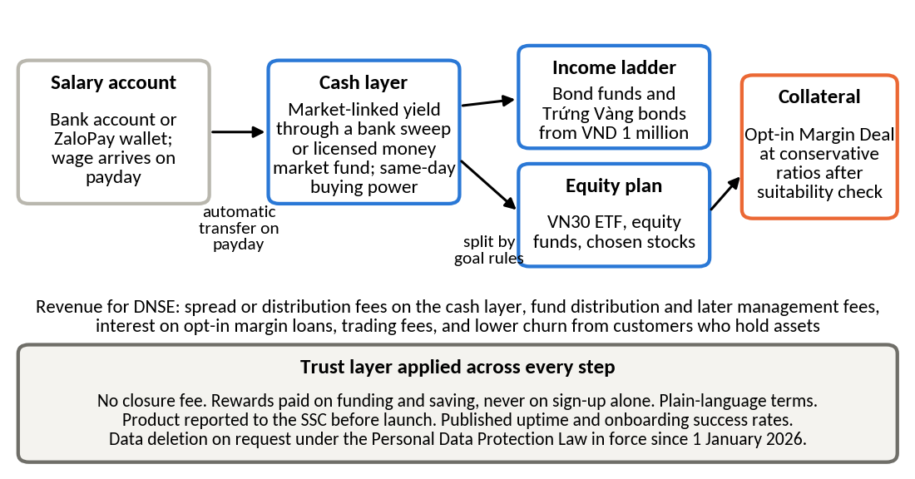
Source: authors' design, drawing on Sections 3.1 to 3.7.
The first step is the salary link. On payday, a fixed amount chosen by the customer moves automatically from a bank account or ZaloPay wallet to DNSE. The link is set up once, with the biometric confirmation that bank rules already require, and later through the open interfaces that banks must support by March 2027. ZaloPay, a DNSE partner since 2023 (Thanh Niên, 2023), provides a channel in the meantime.
The second step is the cash layer. Money arrives in a cash position that earns a market-linked return, delivered either through a sweep into deposits at a partner bank or through units of a licensed money market fund, and that remains available as buying power on the same day. The yield should be comparable with bank savings on a like-for-like basis, a large step up from the current 2.1 to 2.3 per cent for typical customers, and it should not depend on trading volume.
The third step is the ladder. Goal rules chosen at sign-up (an emergency fund, a home deposit, retirement) split the balance between an income ladder of bond funds and the existing Trứng Vàng bonds, which start at VND 1 million, and an equity plan in VN30 exchange-traded funds, equity funds or selected shares. Contributions can pause or change in months when income falls.
The fourth step is optional collateral. Customers who pass a suitability check may use part of their portfolio as collateral for Margin Deal at conservative loan ratios. The product never offers leverage by default.
The trust layer changes DNSE's incentives and terms. It removes the account closure fee and makes cancellation immediate. It pays rewards only on funding and saving, for example a yield bonus on the first six months of contributions, and stops cash rewards for opening an account. It publishes terms in plain language, reports the product to the State Securities Commission before launch, publishes uptime and onboarding success rates, and deletes data on request as the Personal Data Protection Law requires. Onboarding moves to the VNeID national identity platform to cut failed identity checks. Internal controls on lending to related persons and on purchases beyond available funds are strengthened before launch, since the August 2026 penalty found failures in both.
Table 23 shows how the first 90 days change for a new customer.
Table 23. The first 90 days of a new DNSE customer, today and under Payday Portfolio
Moment | Today | Under Payday Portfolio
Day 0, sign-up | Account opened, often in response to a cash reward; identity checks by chip reading and photos | Account opened through VNeID; the first screen asks for a savings goal and a payday amount
First funding | Deposit set by the reward condition (for example VND 2 million); no reason to add more | First transfer on the next payday; reward paid only on money that stays
Idle cash | Earns 2.1 to 2.3% unless the balance exceeds VND 500 million | Earns a market-linked return with same-day buying power
Paydays 2 and 3 | No prompt; cash drifts back to banks as deposit rates rise | Automatic transfer; ladder allocation by goal; progress shown against the goal
Day 90 | Most accounts inactive (5.7% of accounts were active in 2025) | Review of goal and allocation; invitation to the equity plan; margin offered only after a suitability check
Closure | VND 100,000 fee reported by customers; slow cancellation | Free and immediate; data deleted on request
Source: authors' design; current journey reconstructed from DNSE product pages and customer reviews.

4.2 How the design follows from the evidence
Each element of the concept answers a specific finding, and most have been tested in another market (Table 24).
Table 24. Evidence behind each design choice
Design choice | Evidence in Vietnam | Lesson abroad
Target salaried adults and start with DNSE's own accounts | The three leading Findex segments rank first to fourth under four weightings; 40 to 50% receive wages into an account; 94% of DNSE accounts inactive | Groww built its base on monthly fund plans before trading
Act in the first 90 days | Cohort decomposition shows new accounts bring little money; complaints cluster at identity checks and first deposits | Robinhood tracks funded customers and net deposits, the measures that open and close this stage
Market-linked cash yield without trading conditions | DNSE pays 2.1 to 2.3% to typical customers against 4.5% base at TCBS and 6.8% at state banks; cash at brokers fell 38% in three quarters | Trade Republic passed the full central bank rate on cash and gathered EUR 150 billion; Rakuten's bank sweep passed 7 million accounts
Automatic payday transfers | Wages arrive in bank accounts; open banking standards by March 2027; ZaloPay link already live | Robinhood's direct deposit; India's SIPs of INR 29.5 thousand crore a month
Ladder into bonds and funds | TCBS earns most non-lending income from distribution; 75% of investors use only traditional channels and 81% want guidance | Futu holds HKD 180 billion in wealth products; Trade Republic added bond ETFs from EUR 1
Collateral only by opt-in | Lending is DNSE's widest margin; the August 2026 penalty and derivatives risk argue for prudence | India's derivatives curbs cut broker revenue sharply
Trust layer | Trust complaints attract 43% of helpful votes on negative reviews; 34% of investors fear hidden fees; new data protection law | Robinhood's 2021 penalty for outages and misleading information preceded its shift to savings products
Source: Sections 2 and 3.

4.3 Value logic and expected outcomes
The concept creates value through four channels, in order of certainty. The first is retention of money that is already leaving. DNSE's investor cash fell by VND 1.2 trillion between the third quarter of 2025 and the second quarter of 2026, and a competitive cash layer is the direct response. The second is income from balances, through distribution and later management fees on funds and bonds and, if the bank sweep structure allows, a spread on the cash layer. The third is lending. Balances that reach the equity plan become collateral, and each VND 1,000 billion of additional lending adds about VND 49 billion of pre-tax profit a year at the current spread. The fourth is a lower cost of growth, because the first wave comes from accounts DNSE has already paid to acquire and because rewards are paid only on money that stays.
Table 25 and Figure 26 show the scale under three sets of assumptions, each of which Round 3 must test. The base case assumes 150,000 savers, about one in eleven of today's accounts and 1.75 times the number of active users in 2025, contributing VND 2.5 million a month and keeping 70 per cent of contributions on the platform.
Table 25. Illustrative outcomes of Payday Portfolio 18 months after launch
Assumption or outcome | Conservative | Base | Upside
Savers enrolled | 60,000 | 150,000 | 300,000
Average monthly contribution, VND million | 1.5 | 2.5 | 3.5
Share of contributions kept on the platform | 60% | 70% | 80%
Assets per saver after 18 months, VND million | 16.2 | 31.5 | 50.4
Layer assets, VND trillion | 1.0 | 4.7 | 15.1
Net new money a year at full enrolment, VND trillion | 0.6 | 3.2 | 10.1
Revenue yield on layer assets | 0.5% | 0.8% | 1.0%
Annual revenue from layer assets, VND billion | 5 | 38 | 151
Layer assets as a multiple of DNSE investor cash in June 2026 | 0.5 | 2.4 | 7.7
Source: authors' projections. All inputs are assumptions to be validated in Round 3. Revenue yield covers fund distribution fees, any cash-layer spread and interest on opt-in margin loans, net of rewards.
Figure 26. Layer assets and annual net new money under three scenarios
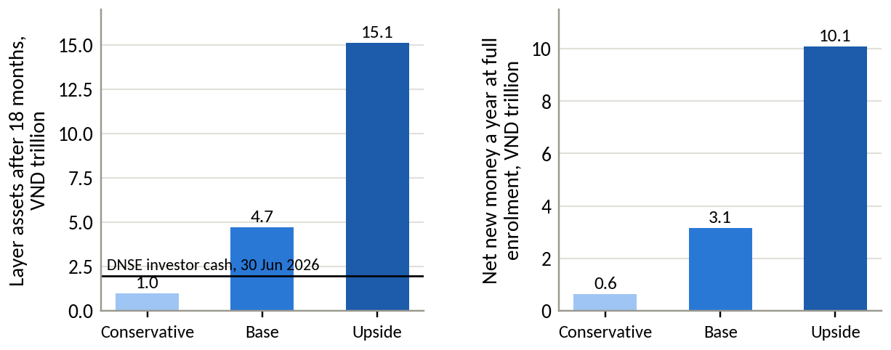
Source: as for Table 25.
Three conclusions follow, and they are stated with their limits. The concept changes the balance sheet of the customer base much faster than it changes the income statement. In the base case the layer would hold 2.4 times DNSE's current investor cash within 18 months, while its direct revenue of about VND 38 billion a year would be under 3 per cent of 2025 revenue. The concept will not rescue the 2026 plan, which is out of reach from core business under any option assessed here. Its purpose is to rebuild the base on which DNSE's lending and fee income depend in 2027 and 2028. The upside case shows that the concept becomes material once enrolment and contributions rise together, and the most sensitive assumptions are the enrolment rate and the size of the monthly contribution.
A salaried customer who deposits VND 2.5 million a month and keeps 70 per cent of it on the platform holds about VND 21 million after a year, 18 times DNSE's current cash per account. Doubling DNSE's total investor cash would need only about 93,000 such customers, 5.5 per cent of today's accounts. The concept therefore does not require a mass change in customer behaviour. It requires a meaningful change among a minority of working customers.

4.4 Feasibility, risks and trade-offs
The main building blocks exist (Table 26). The gaps are a licensed structure for the cash layer and funds, the salary link at scale, and the trust changes, which are cheap but require a change in marketing policy.
Table 26. Feasibility conditions for Payday Portfolio
Condition | Status | Detail
Product components | In place | Idle-cash account, Trứng Vàng bonds from VND 1 million, Margin Deal, VN30 ETF trading, Lightspeed interface
Technology | In place | Order processing in about 4 milliseconds; Lightspeed API; ZaloPay partnership since 2023; a new data centre planned for 2026
Funding and capital | In place | Lending at 116% of equity against a 200% ceiling; VND 3.5 trillion bond programme approved in March 2026
Cash layer structure | To be decided | Bank sweep or licensed money market fund; legal basis and pass-through of yield to be confirmed
Fund distribution and management | Partial | A partner fund manager is needed now; the board plans to establish or acquire a fund manager, a step delayed by high valuations
Salary link at scale | Partial | ZaloPay now; bank open interfaces standard by March 2027
Regulatory clearance | Required | Prior report to the SSC, as the August 2026 penalty showed; the draft biometric circular affects onboarding and withdrawals
Trust and control changes | Decision needed | Remove the closure fee; replace sign-up rewards with funding rewards; publish reliability data; close the control gaps found by the 2026 penalty
Source: DNSE product pages and releases; Vietstock (2026b); Thời báo Tài chính Việt Nam (2026); State Bank of Vietnam (2024); Dân trí (2026a); authors' assessment.
Four risks matter most. The first is price. A cash yield high enough to compete with banks could cost more than it earns if the structure passes through less than the bank or fund pays. The pilot therefore tests yield tiers before launch. The second is regulatory. Any new service must be reported before launch, and a structure that the SSC considers deposit-taking would not be allowed, which is why the bank sweep and fund routes are preferred. The third is conduct. Linking savings to margin could expose savers to leverage they do not understand, so collateral use is opt-in, capped and subject to suitability checks. The fourth is execution. Reliability problems appear in 27 per cent of negative reviews, and a savings product that fails on payday would do more damage to trust than a trading app that freezes. The trade-off DNSE accepts is slower headline growth in accounts in exchange for higher value per account, and some near-term margin spent on yield and rewards in exchange for balances that support lending later.

4.5 Validation direction
The concept rests on assumptions that the public data cannot settle. Table 27 ranks them by the damage they would cause if wrong and by how uncertain they are, and pairs each with a test and a measure for Round 3.
Table 27. Assumptions, tests and measures for Round 3
No. | Assumption | Priority | Test | Measure and threshold
1 | Most DNSE accounts hold little money, and the gap concentrates in reward-driven cohorts | High | Distribution of balances and cohort curves from internal data, by acquisition channel and reward | Share of accounts funded within 30 days; balance at day 90 by cohort
2 | The target segment is large inside DNSE's base and in the population | High | Findex microdata for the intersection of employed, secondary-educated, upper-income adults aged 22 to 40; internal age and salary-link data | Segment size in millions; share of DNSE accounts in segment
3 | A compliant structure can pay a market-linked yield | High | Pre-consultation with the SSC; term sheets from two bank or fund partners | Written confirmation; net yield after fees
4 | Savers respond to the yield enough to cover its cost | High | Randomised test of three yield tiers among matched customers | Incremental balance per customer against cost of yield
5 | Customers will set up payday transfers | High | Pilot with 20,000 eligible customers, randomised against the current journey | Enrolment of 25% or more within 60 days; 70% or more of contributions kept at day 90; average contribution of VND 2 million or more
6 | Balances lead to more lending and trading | Medium | Regression of margin balances on customer assets, using the quarterly series from 2021 and pilot data | Loans per VND of saver assets; products per funded customer
7 | The trust package reduces complaints and closures | Medium | Before and after comparison of review themes, closure requests and complaint handling times | Share of negative reviews on deception, bonus terms or closure below 10% (from 24%)
Source: authors' design. Thresholds are proposals to be agreed with DNSE management.
The measure of success for the concept is the funded-account rate, defined as the share of accounts holding at least VND 5 million for 30 consecutive days, together with net new money per month and assets per funded customer. The baseline for the funded-account rate is not public and is the first number Round 3 should obtain. Supporting measures cover each stage of the first 90 days, namely identity verification completion, funding within 30 days, payday enrolment within 60 days, balance retention and dormancy at 90 days, and products held per funded customer.
Figure 27 sets out a nine-month validation path. The decision to scale comes after the pilot read-out in month six. DNSE should scale only if enrolment, retention and contribution thresholds are met and incremental balances cover the cost of yield and operations at base-case scale. Otherwise the design should return to the tests of price and structure.
Figure 27. Validation roadmap for Round 3
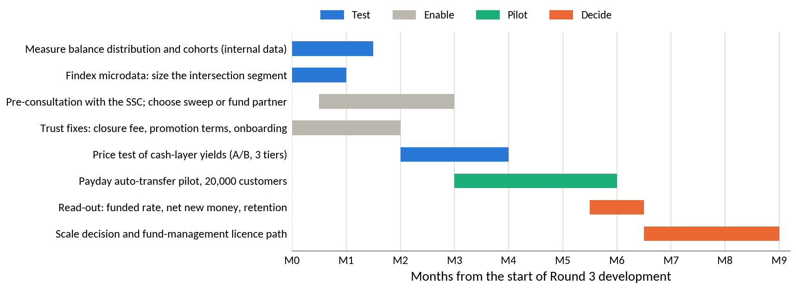
Source: authors' design.

5. Conclusion
DNSE has solved the hardest problem for a new broker, which is getting noticed. It opens one in five new accounts in Vietnam and handles a quarter of derivatives trading. It has not solved the problem that determines profit, which is getting customers to keep money with it. Its accounts hold less than a fifth of the market's cash per account and about a tenth of its borrowing, its core profit has not grown since 2022, and its brokerage has cost more than it earned for four years. The cause lies in DNSE's own design. Incentives reward opening accounts, the cash product pays typical customers less than inflation, and trust problems deter the customers with money.
Vietnam's conditions make the problem urgent and the opportunity large. Households keep a record VND 11 quadrillion in banks, deposit rates have risen, and cash is leaving brokers. Bank-affiliated brokers are winning the competition for balances with cheaper funding. Open banking standards will make salary links routine from March 2027. A wider scan of the firm leads to the same place. Shareholders, lenders and regulators all depend on DNSE turning accounts into funded relationships, and the share price already trades below the IPO price. Brokers abroad that faced the same problem solved it by gathering assets, through market-rate yields on cash, automatic savings plans and salary links.
Payday Portfolio applies those lessons to DNSE's strongest asset, a large base of digitally active customers, many of them entering salaried work. It targets the first 90 days of the relationship and the monthly payday decision, it builds on products DNSE already runs, and it changes the incentives that created the gap. Its direct income will be modest at first, and its value lies in rebuilding the balances on which DNSE's lending and fee income depend. Round 3 should test the legal structure, the price response and the enrolment rate before DNSE commits capital, and it should begin by measuring how many of DNSE's 1.7 million accounts are funded today.

Appendices

Appendix A. DNSE financial data
The tables below summarise the 395 line items of DNSE's filed statements used in the analysis. Annual figures are sums of quarters for flows and period-end values for balances.
Table A1. DNSE income statement summary, 2021 to the first half of 2026 (VND billion)
Item | 2021 | 2022 | 2023 | 2024 | 2025 | H1 2026
Operating revenue | 180.7 | 452.1 | 714.5 | 807.4 | 1,457.9 | 848.2
Interest on margin loans and advances | 42.7 | 223.1 | 286.2 | 360.5 | 555.8 | 336.1
Interest on deposits and bonds held to maturity | 20.1 | 112.9 | 196.0 | 245.0 | 303.9 | 193.4
Brokerage revenue | 90.0 | 84.8 | 67.6 | 144.8 | 404.0 | 222.1
Gains on financial assets at fair value | 20.4 | 18.7 | 157.9 | 47.9 | 171.4 | 77.2
Direct brokerage cost | 51.5 | 74.4 | 111.1 | 174.8 | 464.9 | 266.5
Losses on financial assets at fair value | 24.8 | 80.0 | (0.2) | 41.1 | 25.2 | 43.4
Interest expense | 2.7 | 29.8 | 22.1 | 28.0 | 66.8 | 75.2
Template line 24 (provisions and borrowing cost of the loan book) | 21.2 | 142.4 | 211.5 | 182.6 | 363.0 | 248.9
Administrative expenses | 14.8 | 37.1 | 94.3 | 151.9 | 181.4 | 95.4
Pre-tax profit | 68.2 | 95.0 | 285.6 | 227.5 | 340.2 | 111.6
Net proprietary result | (4.4) | (61.3) | 158.0 | 6.8 | 146.2 | 33.9
Core pre-tax profit | 72.5 | 156.3 | 127.6 | 220.7 | 194.0 | 77.7
Profit after tax | 54.5 | 77.8 | 229.0 | 181.8 | 272.5 | 93.1
Source: DNSE filed statements via Vietcap Securities (2026); first half of 2026 from the statements reviewed by KPMG; authors' calculations. Costs are shown as positive amounts. Core pre-tax profit excludes the net result on financial assets at fair value through profit or loss. Negative values are in parentheses.
Table A2. DNSE balance sheet and key ratios, 2021 to 30 June 2026
Item | 2021 | 2022 | 2023 | 2024 | 2025 | Jun 2026
Margin loans and advances | 1,192 | 2,280 | 2,483 | 3,882 | 5,832 | 6,303
Deposits and bonds held to maturity | 883 | 2,824 | 3,495 | 5,103 | 6,266 | 5,714
Financial assets at fair value | 84 | 576 | 299 | 167 | 2,086 | 1,540
Cash and equivalents | 21 | 432 | 505 | 1,093 | 511 | 842
Total assets | 2,315 | 6,409 | 7,446 | 10,637 | 15,139 | 15,208
Borrowings and bonds | 1,224 | 2,735 | 3,643 | 6,494 | 10,600 | 9,446
Owners' equity | 1,059 | 3,136 | 3,305 | 4,030 | 4,302 | 5,440
Investor cash held off balance sheet | 435 | 251 | 790 | 1,340 | 2,903 | 1,961
Pre-tax margin, % | 37.7 | 21.0 | 40.0 | 28.2 | 23.3 | 13.2
Brokerage revenue as % of direct cost | 174.9 | 114.0 | 60.9 | 82.8 | 86.9 | 83.3
Return on equity, % | 8.9 | 3.7 | 7.1 | 5.0 | 6.5 | 3.8
Loans as % of equity | 112.6 | 72.7 | 75.1 | 96.3 | 135.6 | 115.9
Yield on margin loans, % | 13.0 | 12.0 | 11.9 | 10.1 | 11.1 | 11.2
Estimated cost of funds, % | 6.5 | 6.8 | 7.3 | 4.1 | 5.1 | 6.3
Net interest margin, % | 6.2 | 5.4 | 4.8 | 5.0 | 4.2 | 3.5
Source: DNSE filed statements via Vietcap Securities (2026); authors' calculations. Balances are at the end of each period. Yields, cost of funds and net interest margin are averages of annualised quarterly values; the cost of funds is estimated as interest expense plus template line 24, less the rise in the allowance for loan losses, over average borrowings. Return on equity for the first half of 2026 is annualised.
Table A3. DNSE quarterly indicators, first quarter of 2024 to second quarter of 2026
Indicator | Q1 24 | Q2 24 | Q3 24 | Q4 24 | Q1 25 | Q2 25 | Q3 25 | Q4 25 | Q1 26 | Q2 26
Operating revenue | 182 | 198 | 194 | 234 | 243 | 290 | 489 | 435 | 395 | 453
Pre-tax profit | 88 | 43 | 55 | 42 | 66 | 91 | 171 | 12 | 14 | 97
Core pre-tax profit | 68 | 57 | 54 | 42 | 45 | 37 | 99 | 13 | 24 | 54
Net proprietary result | 20 | (14) | 1 | 0 | 21 | 54 | 72 | (1) | (10) | 43
Brokerage revenue | 32 | 40 | 33 | 39 | 49 | 74 | 156 | 125 | 120 | 103
Direct brokerage cost | 39 | 45 | 41 | 50 | 61 | 84 | 170 | 150 | 138 | 129
Margin loans and advances | 3,409 | 3,598 | 4,102 | 3,882 | 4,276 | 5,053 | 5,750 | 5,832 | 5,910 | 6,303
Investor cash | 1,278 | 1,486 | 1,637 | 1,340 | 429 | 2,516 | 3,192 | 2,903 | 2,869 | 1,961
Yield on margin loans, % | 10.1 | 10.0 | 9.7 | 10.6 | 10.2 | 10.7 | 12.7 | 10.8 | 10.1 | 12.3
Cost of funds, % | 4.5 | 3.6 | 3.6 | 4.6 | 4.6 | 4.6 | 5.2 | 5.7 | 6.1 | 6.5
Net interest margin, % | 4.9 | 5.5 | 4.8 | 4.7 | 4.2 | 3.9 | 5.1 | 3.4 | 2.8 | 4.1
Fee income, % of revenue | 18.9 | 21.2 | 18.2 | 18.1 | 21.3 | 26.8 | 33.0 | 31.2 | 31.8 | 25.5
Source: DNSE filed statements via Vietcap Securities (2026); authors' calculations. VND billion unless stated. Q2 2026 pre-tax profit is the reviewed half year less the first quarter. Negative values are in parentheses.

Appendix B. Market and industry data
Table B1 lists the eight share measures behind Figure 2 with their denominators. Table B2 places DNSE among the largest brokers in the same quarter.
Table B1. DNSE's position on eight measures, 2025 to mid-2026
Measure | DNSE | Market total | DNSE share, % | Ratio to account share
Securities accounts, mid-2026 | 1.70 million | 13.85 million | 12.27 | 1.00
New accounts, 2025 | 518,514 | about 2.57 million | 20.00 | 1.63
Derivatives brokerage, Q2 2026 | second place | HNX | 25.38 | 2.07
Listed-share brokerage on HNX, Q2 2026 | eighth place | HNX | 2.88 | 0.23
Cash equity trading, Q2 2026 (estimate) | VND 62.9 trillion | all exchanges | 2.13 | 0.17
Investor cash at brokers, 30 June 2026 | VND 1,961 billion | VND 86.6 trillion | 2.26 | 0.18
Margin lending, 30 June 2026 | VND 6,303 billion | VND 453.8 trillion | 1.39 | 0.11
Pre-tax profit, Q2 2026 | VND 97.4 billion | VND 15,200 billion | 0.64 | 0.05
Source: VnExpress (2026b); Vietstock (2026a, 2026f, 2026g); CafeF (2026b, 2026c, 2026d); VnEconomy (2026b); DNSE filings; authors' calculations. The ratio to account share compares each share with DNSE's 12.27 per cent of accounts.
Table B2. Securities industry cross-section, second quarter of 2026
Broker | HOSE brokerage share, % | Margin lending, VND billion | Pre-tax profit, VND billion | Change in profit on Q2 2025
VPS | 12.61 | 31,300 | 1,378.0 | plus 57%
SSI | 11.17 | 40,500 | 1,511.0 | plus 32%
TCBS | 9.36 | 51,500 | 2,097.0 | plus 21%
VPBankS | 3.57 | 38,200 | 2,159.0 | about 4 times
HSC | 6.80 | 29,000 | n.a. | n.a.
VNDirect | 3.96 | n.a. | 1,100.0 | plus 127%
DNSE | below 2.94 | 6,303 | 97.4 | plus 7%
Source: HOSE announcement as reported by CafeF (2026b); Vietstock (2026g); CafeF (2026d); company releases. Market shares are shares of HOSE brokerage value. n.a. means not available in the sources consulted.

Appendix C. Customer review analysis
The tables below document the cleaned Google Play sample, the theme coding and the cross-check against the App Store. Table C4 gives translated examples of the most-endorsed reviews.
Table C1. DNSE Google Play reviews by year after cleaning
Year | Retrieved | Removed, % | Retained | Mean rating | One-word, % | Substantive mean | Four-word rule, % | Substantive mean, four-word rule
2020 | 3 | 0.0 | 3 | 3.67 | 0.0 | 3.67 | 33.3 | 3.00
2021 | 72 | 11.1 | 64 | 2.03 | 6.2 | 1.83 | 26.6 | 1.75
2022 | 207 | 46.4 | 111 | 3.18 | 18.0 | 2.85 | 34.2 | 2.49
2023 | 154 | 53.9 | 71 | 2.68 | 9.9 | 2.42 | 16.9 | 2.22
2024 | 202 | 4.5 | 193 | 4.35 | 33.7 | 4.15 | 62.7 | 3.74
2025 | 159 | 0.6 | 158 | 2.65 | 12.0 | 2.38 | 25.9 | 2.01
2026 | 70 | 0.0 | 70 | 3.06 | 12.9 | 2.85 | 25.7 | 2.48
All years | 867 | 22.7 | 670 | 3.22 | 18.5 | 2.88
Source: Google Play, retrieved 23 September 2026; authors' cleaning and coding. Substantive reviews exclude one-word reviews; the four-word rule is a sensitivity test.
Table C2. Themes in DNSE's negative Google Play reviews
Theme | Negative reviews | Share of negative reviews, % | Share of helpful votes, % | All retained reviews with theme
Crashes, freezes, login failures, slow orders | 76 | 27.3 | 21.4 | 102
Account opening, identity checks, one-time passwords, chip reading | 59 | 21.2 | 17.9 | 70
Explicit accusation of deception or fake reviews | 49 | 17.6 | 28.2 | 52
Sign-up bonus terms, advertised rewards not received | 24 | 8.6 | 17.8 | 34
Deposits not credited, withdrawal delays | 14 | 5.0 | 6.7 | 24
Cannot close the account, closure fee | 10 | 3.6 | 11.3 | 11
Interface, charts, layout | 7 | 2.5 | 2.2 | 40
Arrived through a YouTube or social media referral | 5 | 1.8 | 1.3 | 15
Charges different from the advertised rate | 3 | 1.1 | 3.5 | 8
Any trust theme (deception, bonus terms, closure) | 67 | 24.1 | 42.9
Any product theme (stability, onboarding) | 118 | 42.4 | 34.1
Idle-cash product (Tài khoản không ngủ) | 0 | 0.0 | 0.0 | 3
Source: as for Table C1. 278 one and two-star reviews carrying 1,794 helpful votes. Themes are not exclusive, so shares sum to more than 100.
Table C3. Three applications compared on both stores
Application | Google Play, retained reviews | Google Play, mean rating | Google Play mean, 2025 to 2026 | App Store mean, 2025 to 2026 | App Store one-star share, % | Apple rating, all ratings
DNSE Entrade X | 670 | 3.22 | 2.77 | 2.25 | 59.0 | 4.04 (1,490 ratings)
VPS SmartOne | 1,171 | 2.58 | 2.10 | 1.47 | 77.2 | 3.03 (5,756 ratings)
FPTS EzTrade | 177 | 2.18 | 2.18 | 2.31 | 50.2 | 2.82 (76 ratings)
Source: Google Play (retrieved 23 September 2026) and Apple App Store (retrieved 24 September 2026); authors' cleaning. The store comparison covers 1 January 2025 to 21 September 2026.
Table C4. Selected DNSE reviews, translated from Vietnamese
Date | Stars | Helpful votes | Themes | Review
9 Jun 2025 | 1 | 58 | Bonus, deception, closure | "Everyone, be careful, it is a scam. You do not receive the 100k. To delete your account you have to pay it 100k. It steals your information."
24 May 2025 | 1 | 54 | Onboarding, closure | "I have been trapped. Anyone who wants to register should know that you cannot cancel the registration, even while the account is not yet approved ... after approval you have to go to the head office to delete the account."
28 Jun 2025 | 1 | 50 | Bonus, deception | "Deceptive and false. There is no 100k straight away. You have to deposit at least 2 million to get it."
6 Aug 2025 | 1 | 32 | Bonus | "False advertising. You have to deposit 2 million into the app to receive 100k, unlike the advertisement that says downloading the app earns 100k."
23 Sep 2021 | 1 | 28 | Onboarding | "Registered at 10 am and waited until nearly 1 pm without getting in; it keeps saying to wait an hour for verification ... when money is involved and it is this slow, who would dare to use it?"
12 Jul 2025 | 1 | 25 | Onboarding | "Why can it not scan the chip? Registering is so hard."
2 Jun 2025 | 2 | 18 | Stability, money | "When I deposit outside trading hours, the money leaves my bank account but the securities account does not receive it. Customer service replies slowly."
23 Jan 2025 | 1 | 17 | Bonus, fees, closure | "Closing the account costs a 100k fee. It is the first time I have heard of a securities company charging 100k to close an account. One star."
15 May 2026 | 5 | 13 | Stability, idle cash | "Apart from occasional errors ... the DNSE app is the best securities app in Vietnam. Low fees. The idle account is the best. Watching the interest rise in real time is satisfying, and money earns interest automatically once it is deposited."
Source: Google Play, retrieved 23 September 2026. Translated by the authors; abbreviations expanded and ellipses mark omitted text.

Appendix D. Findex segment analysis
The segment analysis uses the published Findex aggregates for Vietnam, which report each indicator for twelve segments defined one dimension at a time. Table D1 defines the two indices, Table D2 reports the inputs and Table D3 the ranks under four weighting schemes.
Table D1. Indicators in the two Findex indices
Index | Indicator code | Indicator
A, formally held surplus | fin17a | Saved at a bank or similar institution in the past year
A | fin17dm | Saved into an account every month
A | fin8 | Stores money in an account
A | fin17e | Received interest on savings in the past year
A | fin17f | Saved for old age
A | fin24bd | Could cover expenses for more than two months without income
B, digital habit | dig.acc | Has a digitally enabled account
B | con26d | Uses the internet daily
B | con9a | Main phone is a smartphone
B | fin25e3w | Makes an in-store mobile or card payment every week
B | fin9b | Used a mobile phone or the internet to check an account balance
B | fin32.acc | Received wages into an account
Source: World Bank (2025b). Each index is the simple mean of its six indicators, in per cent of adults in the segment.
Table D2. Findex segment indicators for Vietnam, 2024 fieldwork
Segment | Share of adults, % | Index A | Index B | Has an account, % | Saved at an institution, % | Gap, points | Unconverted adults, million | Wages into an account, % | Saves monthly into an account, % | Saved for old age, %
All adults | 100.0 | 36.8 | 59.4 | 70.5 | 43.1 | 27.5 | 22.1 | 37.0 | 19.6 | 20.2
Women | 51.2 | 38.6 | 59.0 | 69.9 | 45.1 | 24.8 | 10.2 | 34.8 | 22.4 | 23.4
Men | 48.8 | 35.0 | 59.8 | 71.2 | 41.0 | 30.2 | 11.9 | 39.3 | 16.7 | 16.8
Aged 15 to 24 | 18.2 | 31.1 | 66.2 | 72.2 | 38.6 | 33.6 | 4.9 | 36.9 | 19.8 | 8.2
Aged 25 and over | 81.8 | 38.1 | 57.9 | 70.2 | 44.1 | 26.1 | 17.2 | 37.0 | 19.6 | 22.8
Primary education or less | 11.2 | 15.6 | 26.5 | 33.5 | 14.0 | 19.5 | 1.8 | 10.4 | 4.1 | 7.9
Secondary education or more | 88.8 | 39.5 | 63.5 | 75.2 | 46.7 | 28.5 | 20.4 | 40.4 | 21.5 | 21.7
Poorest 40% | 40.0 | 23.1 | 40.5 | 48.1 | 27.1 | 21.1 | 6.8 | 18.1 | 9.6 | 10.6
Richest 60% | 60.0 | 46.0 | 72.0 | 85.5 | 53.8 | 31.7 | 15.3 | 49.5 | 26.4 | 26.5
Rural | 67.0 | 33.8 | 56.1 | 67.4 | 40.5 | 26.9 | 14.5 | 33.5 | 16.8 | 18.0
Urban | 33.0 | 43.0 | 66.0 | 77.0 | 48.4 | 28.6 | 7.6 | 44.1 | 25.4 | 24.6
Out of labour force | 20.1 | 18.4 | 36.6 | 41.3 | 21.9 | 19.4 | 3.1 | 4.4 | 6.2 | 8.0
In labour force | 79.9 | 41.5 | 65.1 | 77.9 | 48.4 | 29.5 | 19.0 | 45.2 | 23.0 | 23.2
Source: World Bank (2025b); authors' indices. Index A averages six indicators of formally held surplus and Index B six indicators of digital habit (Table D1). The gap is account ownership minus saving at a financial institution. Unconverted adults hold an account but do not save at a financial institution.
Table D3. Segment ranks under four weighting schemes
Segment | Equal weights | Value-heavy | Scale-heavy | Reach-heavy | Score, equal weights
Richest 60% | 1 | 1 | 1 | 1 | 0.933
In labour force | 2 | 2 | 2 | 2 | 0.844
Secondary education or more | 3 | 4 | 3 | 3 | 0.798
Urban | 4 | 3 | 5 | 4 | 0.751
Aged 25 and over | 5 | 5 | 4 | 6 | 0.710
Men | 6 | 7 | 7 | 5 | 0.655
Women | 7 | 6 | 8 | 8 | 0.636
Rural | 8 | 8 | 6 | 9 | 0.609
Aged 15 to 24 | 9 | 9 | 9 | 7 | 0.549
Poorest 40% | 10 | 10 | 10 | 10 | 0.233
Out of labour force | 11 | 11 | 11 | 11 | 0.066
Primary education or less | 12 | 12 | 12 | 12 | 0.024
Source: authors' calculations from Table D2. Each criterion is min-max normalised across the twelve segments. Weights on (Index A, Index B, gap, unconverted adults, wage receipt, saving for old age): equal 1,1,1,1,1,1; value-heavy 3,1,1,1,2,2; scale-heavy 1,1,1,3,1,1; reach-heavy 1,3,2,1,1,1.

Appendix E. Methods, assumptions and limitations
Table E1 defines the calculated measures. Table E2 separates the assumptions behind the main results from the measured evidence, and Table E3 lists the limitations of the data together with the steps taken to contain them.
Table E1. Definitions of calculated measures
Measure | Definition
Share of a market | DNSE's value divided by the market total for the same measure and date, kept within its own market
Ratio to account share | Share of a market divided by DNSE's share of securities accounts (12.27 per cent)
Value per account | Balance or flow divided by the number of accounts at the same date
Core pre-tax profit | Pre-tax profit less gains, plus losses, on financial assets at fair value through profit or loss
Brokerage coverage | Brokerage revenue divided by direct brokerage and custody cost
Estimated cost of funds | Interest expense plus template line 24, less the rise in the allowance for loan losses, multiplied by four and divided by average borrowings and bonds
Yields | Quarterly interest income multiplied by four and divided by the average of opening and closing balances
Net interest margin | Interest on loans and on deposits and bonds held to maturity, less the estimated cost of funds, over average interest-earning assets, annualised
Share of cash equity trading | Value of shares traded by DNSE customers (both sides) divided by twice the value traded on HOSE plus 7 per cent for HNX and UPCoM; the range uses total and order-matched values
Cohort decomposition | Assets of accounts opened in 2025 equal customer assets at the end of 2025 less end-2024 assets grown at an assumed rate between 0 and 40.9 per cent
Profit gap | Additional loans equal the gap between the 2026 profit target and annualised core profit divided by the net lending spread; required customer assets equal required loans divided by the 2025 ratio of loans to customer assets
Scenario model | Assets per saver equal monthly contribution times retention times 18 months; revenue equals layer assets times the revenue yield
Findex indices and scores | Indices are means of six indicators; segment scores are weighted means of six criteria, each min-max normalised across the twelve segments
Helpful-vote share | Helpful votes on negative reviews carrying a theme divided by all helpful votes on negative reviews
Weighted prioritisation | Sum of weight times score across criteria, with an equal-weight total reported as a check
Source: authors.
Table E2. Register of assumptions behind the main results
Assumption | Value used | Type | Effect if wrong | How Round 3 tests it
DNSE accounts at mid-2026 | 1.7 million | Company-reported | Per-account values move in proportion; 0.1 million more accounts lowers cash per account by about 6 per cent | Internal account register
Market totals | VND 86.6 trillion of investor cash; VND 453.8 trillion of lending; VND 15,200 billion of profit | External estimate | Narrower totals raise DNSE's shares to about 2.4 per cent of cash and 1.45 per cent of lending | Not needed; conclusions hold on either total
Allowance for HNX and UPCoM in trading value | 7 per cent of HOSE value | Assumption | A 3-point change moves the trading-share estimate by about 0.1 point | Exchange statistics by broker
Growth in existing customers' assets in 2025 | 0 to 40.9 per cent | Assumption | New accounts brought between VND 28 million and nothing each | Internal balances by cohort
Cost of funds | Interest expense plus line 24 less the allowance rise | Derived | If line 24 contains more provisions than assumed, the cost of funds is overstated | Notes on borrowing costs
Net lending spread for the profit gap | 4.88 points | Derived | A spread one point lower raises the required loans by about a quarter | Pricing and funding data
Scenario inputs | 60,000 to 300,000 savers; VND 1.5 to 3.5 million a month; 60 to 80 per cent retained; revenue yield 0.5 to 1.0 per cent | Assumption | Enrolment and contribution drive most of the variation | Payday pilot, yield test
Findex segment sizes | Population shares from the survey | External estimate | Sampling error of a few points on each estimate | Microdata cross-tabulation
Review themes reflect customer concerns | Cleaned public reviews | Measured, self-selected | Levels overstate dissatisfaction; comparisons across apps and years are more reliable | Complaint logs and customer survey
Source: authors. Type distinguishes measured facts, derived calculations, external estimates and assumptions.
Table E3. Limitations of the evidence
Limitation | Effect on the findings | Mitigation
No customer-level data from DNSE | Funnel stages and funded-account rates are inferred | Several independent measures point the same way; internal data are the first Round 3 task
Account definitions differ, and one person can hold several accounts | Per-account comparisons are approximate | Comparison with named peers on the same basis; ratios are large enough to survive errors of 20 per cent
Dates differ across sources (accounts in August, balances in June) | Small bias in shares | Dates stated in every note
Template line 24 combines provisions with borrowing costs | The cost of funds is an estimate | Allowance changes deducted; the direction of change holds under either treatment
Industry totals come from press tallies with different coverage | Shares vary by 0.1 to 0.2 points | Broader total used and alternatives reported
App store reviews are self-selected and contain spam | Levels are biased | One cleaning rule for three apps, helpful-vote weighting, App Store cross-check
Findex reports one dimension at a time from 1,000 interviews; the jump in formal saving between 2022 and 2024 may partly reflect survey changes | Segment intersections are unknown and the trend may be overstated | Ranks tested under four weightings; microdata analysis planned
Scores in the prioritisation and option matrices are judgements | Rankings could change with other weights | Explicit weights, equal-weight check, evidence cited for each score
Scenario figures are projections | They indicate scale and are not forecasts | Three scenarios and a validation plan with thresholds
Foreign models operate under different rules | Some lessons do not transfer | Transferability assessed design by design
Share price observed on one date | The valuation reading moves with the market | Ratios reported with their date
Source: authors.

Appendix F. Data sources and access
Table F1. Data sources, access and dates
Dataset | Provider and access | Coverage and date
DNSE statements | Vietcap IQ data service (iq.vietcap.com.vn), line by line; DNSE investor relations (ir.dnse.com.vn) for the reviewed half-year statements | First quarter of 2018 to second quarter of 2026; retrieved 24 September 2026
DNSE company indicators and product terms | DNSE releases and product pages; financial press | 2024 to September 2026; accessed 20 to 24 September 2026
Exchange and industry data | HOSE and HNX quarterly announcements and VSDC account statistics, as reported by the financial press; press tallies of broker statements | Second quarter of 2026; account data to August 2026
Google Play reviews | Public listings of vn.com.encapital.arrow, vn.com.vpbs.smartone and com.fpts.eztrade | Retrieved 23 September 2026; cut-off 21 September 2026
App Store reviews | Public review feeds of the same three applications | Retrieved 24 September 2026
World Bank Global Findex | World Bank Open Data interface (api.worldbank.org, source 28, Vietnam); microdata catalogue 7998 identified for Round 3 | Waves 2011 to 2024; retrieved 20 September 2026
Macro, banking and payments | National Statistics Office and State Bank of Vietnam releases as reported by the press; FiinRatings; KPMG | 2025 to September 2026
International comparators | Company results releases and regulators' publications | 2021 to August 2026
Share price | Simplize market data | 24 September 2026
Source: authors. Supporting files, including the consolidated data workbook (FBA_Round2_DNSE_data_pack.xlsx) and the Python and JavaScript scripts that collect, clean and chart the data, can be shared through the team's folder.

References
Acclime Vietnam, & UOB Vietnam. (n.d.). Breaking the digital frontier [Industry report]. https://www.uob.com.vn/assets/web-resources/business/pdf/en/industry-report/uobv-breaking-the-digital-frontier.pdf
Association of Mutual Funds in India. (2025). AMFI monthly note: October 2025. https://www.amfiindia.com/uploads/AMFI_Monthly_Note_Oct_2025_Final_8b27c12107.pdf
Báo Đấu thầu. (2026, September 3). CPI tháng 8/2026 tăng 0,47% [CPI rose 0.47% in August 2026]. https://baodauthau.vn/cpi-thang-82026-tang-047-post206275.html
Báo Đầu tư. (2026, March 26). ĐHĐCĐ DNSE: Sẵn sàng cho giao dịch T+0, đặt mục tiêu tham vọng năm 2026 [DNSE AGM: Ready for T+0 trading, ambitious 2026 targets]. https://baodautu.vn/dhdcd-dnse-san-sang-cho-giao-dich-t0-dat-muc-tieu-tham-vong-nam-2026-d553634.html
Bnews. (2025, January 21). DNSE chiếm 21,6% thị phần tài khoản chứng khoán mở mới năm 2024 [DNSE took 21.6% of new securities accounts in 2024]. https://bnews.vn/dnse-chiem-21-6-thi-phan-tai-khoan-chung-khoan-mo-moi-nam-2024/360881.html
Bnews. (2026, March 6). DNSE chia cổ tức bằng tiền mặt năm thứ tư liên tiếp [DNSE pays cash dividends for the fourth consecutive year]. https://bnews.vn/dnse-chia-co-tuc-bang-tien-mat-nam-thu-tu-lien-tiep/426153.html
CafeF. (2024a, January 20). Điều gì khiến DNSE đặt mục tiêu vốn hoá đạt 72.000 tỷ đồng trong 5 năm tới? [Why DNSE targets a market value of VND 72,000 billion within five years]. https://cafef.vn/dieu-gi-khien-dnse-dat-muc-tieu-von-hoa-dat-72000-ty-dong-trong-5-nam-toi-188240120172755536.chn
CafeF. (2024b, January 31). Theo đuổi mô hình zero fee, công ty chứng khoán tìm nguồn thu từ đâu? [Where do zero-fee brokers earn their revenue?]. https://cafef.vn/theo-duoi-mo-hinh-zero-fee-cong-ty-chung-khoan-tim-nguon-thu-tu-dau-188240130111539962.chn
CafeF. (2024c, November 21). Công ty đứng sau thương vụ IPO duy nhất của thị trường Việt Nam năm 2024 [The company behind Vietnam's only IPO of 2024]. https://cafef.vn/cong-ty-dung-sau-thuong-vu-ipo-duy-nhat-cua-thi-truong-viet-nam-nam-2024-chu-tich-tung-la-ceo-tre-nhat-lich-su-vndirect-loi-nhuan-tang-truong-hon-100-lan-trong-4-nam-188241121113910237.chn
CafeF. (2026a, March 25). DNSE hoàn tất tăng vốn ngay trước thềm ĐHĐCĐ thường niên [DNSE completes capital increase ahead of its AGM]. https://cafef.vn/dnse-hoan-tat-tang-von-ngay-truoc-them-dhdcd-thuong-nien-188260325144346909.chn
CafeF. (2026b, July 6). Thị phần môi giới HoSE quý 2/2026: VPS xuống thấp nhất 22 quý, SSI và TCBS áp sát [HOSE brokerage shares in Q2 2026]. https://cafef.vn/thi-phan-moi-gioi-hose-quy-2-2026-vps-xuong-thap-nhat-22-quy-ssi-va-tcbs-ap-sat-188260706171935801.chn
CafeF. (2026c, July 7). DNSE vào Top 8 thị phần môi giới cổ phiếu niêm yết HNX quý II/2026 [DNSE enters the top eight in HNX listed-share brokerage]. https://cafef.vn/dnse-vao-top-8-thi-phan-moi-gioi-co-phieu-niem-yet-hnx-quy-ii-2026-188260707191532025.chn
CafeF. (2026d, July 22). Soi số lợi nhuận 15.200 tỷ của ngành chứng khoán trong quý 2 [The securities industry's VND 15,200 billion profit in Q2]. https://cafef.vn/soi-so-loi-nhuan-15200-ty-cua-nganh-chung-khoan-trong-quy-2-mot-cuoc-doi-ngoi-dang-am-tham-dien-ra-188260722020054991.chn
CafeF. (2026e, July 23). Tiền nằm chờ trên tài khoản chứng khoán thấp nhất 6 quý [Idle cash in securities accounts at a six-quarter low]. https://cafef.vn/tien-nam-cho-tren-tai-khoan-chung-khoan-thap-nhat-6-quy-188260722231319651.chn
CB Insights. (2026). State of fintech Q1'26 report. https://www.cbinsights.com/research/report/fintech-trends-q1-2026/
Chinhphu.vn. (2026, July 3). GDP quý II ước đạt 8,39%; 6 tháng đầu năm 2026 tăng trưởng 8,18% [Q2 GDP estimated at 8.39%; first-half 2026 growth 8.18%]. https://xaydungchinhsach.chinhphu.vn/gdp-quy-ii-uoc-dat-839-6-thang-dau-nam-2026-tang-truong-818-119260703184319255.htm
Dân trí. (2022, December 13). Chứng khoán DNSE tiên phong ra mắt hệ thống quản trị theo từng giao dịch [DNSE launches deal-by-deal margin management]. https://dantri.com.vn/kinh-doanh/chung-khoan-dnse-tien-phong-ra-mat-he-thong-quan-tri-theo-tung-giao-dich-20221213172235616.htm
Dân trí. (2026a, May 21). Giao dịch chứng khoán từ 10 triệu đồng có thể phải xác thực sinh trắc học [Securities transactions from VND 10 million may require biometric authentication]. https://dantri.com.vn/kinh-doanh/giao-dich-chung-khoan-tu-10-trieu-dong-co-the-phai-xac-thuc-sinh-trac-hoc-20260521163618758.htm
Dân trí. (2026b, June 17). Nhà đầu tư cá nhân "gánh" chứng khoán: Lực đỡ hay rủi ro tiềm ẩn? [Individual investors carry the stock market: Support or hidden risk?]. https://dantri.com.vn/kinh-doanh/nha-dau-tu-ca-nhan-ganh-chung-khoan-luc-do-hay-rui-ro-tiem-an-20260617142528328.htm
Diễn đàn Doanh nghiệp. (2026, September 13). Đến 28/8, tín dụng đạt 20,5 triệu tỷ đồng [Credit reached VND 20.5 quadrillion by 28 August]. https://diendandoanhnghiep.vn/den-28-8-tin-dung-dat-20-5-trieu-ty-dong-77-3-du-no-vao-san-xuat-kinh-doanh-10184465.html
DNSE Securities. (2025). So sánh các chương trình "sinh lời tự động" từ tiền nhàn rỗi 2025 [Comparison of automatic-earning programmes for idle cash, 2025]. https://www.dnse.com.vn/hoc/chuong-trinh-sinh-loi-tu-dong
DNSE Securities. (2026a). Financial statements and investor relations releases, 2019 to the second quarter of 2026. https://ir.dnse.com.vn/vi/ctype-finance_report
DNSE Securities. (2026b). Tài khoản Không Ngủ [Idle-cash account, product page]. Retrieved September 24, 2026, from https://www.dnse.com.vn/san-pham/tai-khoan-khong-ngu
DNSE Securities. (2026c). Giao dịch ký quỹ theo deal: Thông tin chung [Margin Deal: General information]. Retrieved September 24, 2026, from https://hdsd.dnse.com.vn/san-pham-dich-vu/sp-giao-dich-ky-quy-theo-deal/thong-tin-chung
Do Ventures. (2025). Vietnam innovation and private capital report 2025. https://doventures.vc/assets/uploads/reports/download/vietnam-innovation-and-private-capital-report-2025-1747711844.pdf
Doanh nhân. (2026, March 26). ĐHĐCĐ DNSE: Lên kế hoạch tham gia sàn tín chỉ carbon, phát hành 3.500 tỷ đồng trái phiếu năm 2026 [DNSE AGM: Plans to join carbon-credit exchanges and issue VND 3,500 billion of bonds]. https://doanhnhan.baophapluat.vn/dhdcd-dnse-len-ke-hoach-tham-gia-san-tin-chi-carbon-phat-hanh-3-500-ty-dong-trai-phieu-nam-2026.html
FiinRatings. (2026). Banking sector: FY2025 recap and 2026 outlook. https://fiinratings.vn/Data/2026/Report/FiinRatings_Vietnam-Banking-2026-Outlook.pdf
Financial Industry Regulatory Authority. (2021, June 30). FINRA orders record financial penalties against Robinhood Financial LLC. https://www.finra.org/media-center/newsreleases/2021/finra-orders-record-financial-penalties-against-robinhood-financial
Financial Services Agency. (2026, February 12). Progress toward "Japan as a leading asset management center". https://www.fsa.go.jp/common/conference/danwa/20260212_2.pdf
Futu Holdings. (2026, March 12). Futu announces fourth quarter and full year 2025 unaudited financial results. https://ir.futuholdings.com/news-releases/news-release-details/futu-announces-fourth-quarter-and-full-year-2025-unaudited/
Google, Temasek, & Bain & Company. (2025). e-Conomy SEA 2025. https://services.google.com/fh/files/misc/e_conomy_sea_2025_report.pdf
Government of Vietnam. (2025). Decree No. 94/2025/ND-CP on the controlled testing mechanism in the banking sector.
Inc42. (2025, October 6). Zerodha, Angel One, Groww feel the squeeze from SEBI crackdown. https://inc42.com/features/zerodha-angel-one-groww-revenue-squeeze-sebi-crackdown/
The Investor. (2026, August 21). Which Vietnamese stocks made it into the FTSE Global Equity Index Series? https://theinvestor.vn/which-vietnamese-stocks-made-it-into-the-ftse-global-equity-index-series-d19852.html
Kemp, S. (2026). Digital 2026: Vietnam. DataReportal. https://datareportal.com/reports/digital-2026-vietnam
Kinh tế Chứng khoán. (2026, March 17). Hơn 42 triệu cổ phiếu DNSE đổi chủ, vai trò chi phối của hệ sinh thái Encapital dần rõ nét [More than 42 million DNSE shares change hands]. https://kinhtechungkhoan.vn/hon-42-trieu-co-phieu-dnse-doi-chu-vai-tro-chi-phoi-cua-he-sinh-thai-encapital-dan-ro-net-1434667.html
KPMG. (2026). Pulse of fintech H2'25. https://assets.kpmg.com/content/dam/kpmgsites/xx/pdf/2026/02/pulse-of-fintech-h2-2025.pdf
KPMG Vietnam. (2025). Vietnam 2026 outlook. https://assets.kpmg.com/content/dam/kpmgsites/vn/pdf/2025/10/vietnam-2026-outlook.pdf
Market Times. (2026, August 17). Chứng khoán DNSE (DSE) bị phạt hơn 800 triệu đồng vì loạt vi phạm trong hoạt động chứng khoán [DNSE fined more than VND 800 million for securities violations]. https://markettimes.vn/chung-khoan-dnse-dse-cua-chu-tich-nguyen-hoang-giang-bi-phat-128642.html
Mekong ASEAN. (2024, January 26). IPO thành công, Chứng khoán DNSE huy động về 900 tỷ đồng [DNSE raises VND 900 billion in its IPO]. https://mekongasean.vn/ipo-thanh-cong-chung-khoan-dnse-huy-dong-ve-900-ty-dong-22022.html
National Assembly of Vietnam. (2025). Law on Personal Data Protection No. 91/2025/QH15.
Người Quan sát. (2026, June 11). Lãnh đạo VSDC tiết lộ thời điểm triển khai T+0 và bán khống [VSDC leader on the timing of T+0 and short selling]. https://nguoiquansat.vn/lanh-dao-vsdc-tiet-lo-thoi-diem-trien-khai-t-0-va-ban-khong-297283.html
Nhân Dân. (2025, July 8). Công bố khảo sát 2025 về nhu cầu quản lý tài sản và đầu tư của người Việt [2025 survey of Vietnamese wealth management and investment needs]. https://nhandan.vn/cong-bo-khao-sat-2025-ve-nhu-cau-quan-ly-tai-san-va-dau-tu-cua-nguoi-viet-post892406.html
Nhân Dân. (2026). Tính đến hết năm 2025, Việt Nam có hơn 11,8 triệu tài khoản chứng khoán [Vietnam had more than 11.8 million securities accounts at the end of 2025]. https://nhandan.vn/viet-nam-co-them-26-trieu-tai-khoan-chung-khoan-nam-2025-vuot-xa-muc-tieu-11-trieu-tai-khoan-vao-nam-2030-post935997.html
Phụ nữ Việt Nam. (2026, August 19). Công ty Chứng khoán DNSE bị buộc dừng cung cấp dịch vụ tài chính [DNSE ordered to stop providing financial services]. https://phunuvietnam.vn/cong-ty-chung-khoan-dnse-bi-buoc-dung-cung-cap-dich-vu-tai-chinh-238260818165854342.htm
Rakuten Group. (2026, August 25). "Money Bridge" service linking Rakuten Bank and Rakuten Securities accounts surpasses 7 million accounts. https://global.rakuten.com/corp/news/press/2026/0825_02.html
Robinhood Markets. (2026, February 10). Robinhood reports fourth quarter and full year 2025 results. https://investors.robinhood.com/news-releases/news-release-details/robinhood-reports-fourth-quarter-and-full-year-2025-results
Simplize. (2026). DSE: Công ty Cổ phần Chứng khoán DNSE [Market data]. Retrieved September 24, 2026, from https://simplize.vn/co-phieu/DSE
State Bank of Vietnam. (2024). Circular No. 64/2024/TT-NHNN on the implementation of open application programming interfaces in the banking sector.
TCBS. (2026a). iPower [Product page]. Retrieved September 24, 2026, from https://www.tcbs.com.vn/ca-nhan/san-pham/ipower/
TCBS. (2026b, July 15). TCBS lập kỷ lục lợi nhuận quý 2/2026 với 2.097 tỷ đồng trước thuế [TCBS reports record Q2 2026 pre-tax profit of VND 2,097 billion] [Press release]. https://www.tcbs.com.vn/tin-tuc/thong-cao-bao-chi/tcbc-tcbs-lap-ky-luc-loi-nhuan-quy-2-2026-voi-2-097-ty-dong-truoc-thue/
Thanh Niên. (2023, July 17). ZaloPay hợp tác DNSE để trở thành ví điện tử hỗ trợ đầu tư chứng khoán [ZaloPay partners with DNSE to support securities investment]. https://thanhnien.vn/zalopay-hop-tac-dnse-de-tro-thanh-vi-dien-tu-ho-tro-dau-tu-chung-khoan-185230717103958115.htm
Thanh Niên. (2025, December 31). VN-Index kết thúc năm 2025 với mức tăng khủng gần 41% [The VN-Index ends 2025 up almost 41%]. https://thanhnien.vn/vn-index-ket-thuc-nam-2025-voi-muc-tang-khung-gan-41-185251231154434459.htm
TheLEADER. (2026). TCBS báo lãi quý II/2026 cao nhất lịch sử hoạt động [TCBS reports its highest quarterly profit in Q2 2026]. https://theleader.vn/tcbs-bao-lai-quy-ii-2026-cao-nhat-lich-su-hoat-dong-d46870.html
Thị trường Tài chính Tiền tệ. (2026a, March 27). 60% tài khoản mở mới tại TCX không qua Techcombank [60% of TCBS's new accounts did not come through Techcombank]. https://thitruongtaichinhtiente.vn/60-tai-khoan-mo-moi-tai-tcx-khong-qua-techcombank-80638.html
Thị trường Tài chính Tiền tệ. (2026b, April 5). Bức tranh thị trường tài chính tiền tệ quý I/2026 [The financial and monetary market in Q1 2026]. https://thitruongtaichinhtiente.vn/buc-tranh-thi-truong-tai-chinh-tien-te-quy-i-2026-tin-dung-tang-2-15-thi-truong-bao-hiem-phat-tin-hieu-khoi-sac-80876.html
Thời báo Tài chính Việt Nam. (2026, March 26). DNSE góp 10 tỷ đồng vào công ty tài sản số, sẽ đầu tư thêm data center trong năm 2026 [DNSE invests VND 10 billion in a digital-asset company and plans a data centre in 2026]. https://thoibaotaichinhvietnam.vn/dnse-gop-10-ty-dong-vao-cong-ty-tai-san-so-se-dau-tu-them-data-center-trong-nam-2026-194525.html
Tiền Phong. (2026, August 11). Hơn 190 triệu tỷ đồng giao dịch không tiền mặt trong 6 tháng [More than VND 190 quadrillion of non-cash transactions in six months]. https://tienphong.vn/hon-190-trieu-ty-dong-giao-dich-khong-tien-mat-trong-6-thang-post1867061.tpo
Trade Republic. (2025, October 15). Trade Republic has distributed €2.5 billion in interest to its customers and is now expanding its wealth management portfolio with fixed income [Press release]. https://assets.traderepublic.com/assets/files/251015_TradeRepublic_PressRelease_Fixed_Income_EN_2.pdf
UOB, PwC Singapore, & Singapore FinTech Association. (2025). FinTech in ASEAN 2025. https://www.uobgroup.com/assets/web-resources/techecosystem/fintech/pdf/fintech-in-asean-2025.pdf
Vietcap Securities. (2026). DSE financial statements, first quarter of 2018 to second quarter of 2026 [Data set]. Vietcap IQ. Retrieved September 24, 2026, from https://iq.vietcap.com.vn/api/iq-insight-service/v1/company/DSE/financial-statement
VietnamBiz. (2025, November 22). T+0 sắp vận hành: Cuộc cạnh tranh mili-giây bắt đầu trên thị trường chứng khoán Việt Nam [The millisecond race begins ahead of T+0]. https://vietnambiz.vn/t0-sap-van-hanh-cuoc-canh-tranh-mili-giay-bat-dau-tren-thi-truong-chung-khoan-viet-nam-2025112210020136.htm
VietnamNet. (2026, September 9). Lãi suất ngân hàng hôm nay 9/9/2026 [Bank interest rates on 9 September 2026]. https://vietnamnet.vn/lai-suat-ngan-hang-hom-nay-9-9-2026-lai-suat-ngan-hang-big4-len-den-8-nam-2553329.html
VietnamPlus. (2026, September 23). Hơn 1,22 triệu tỷ đồng đang nằm trong tài khoản thanh toán cá nhân [More than VND 1.22 quadrillion sits in individual payment accounts]. https://www.vietnamplus.vn/hon-122-trieu-ty-dong-dang-nam-trong-tai-khoan-thanh-toan-ca-nhan-post1137973.vnp
Vietstock. (2025a, April). DNSE nắm 33% thị phần tài khoản chứng khoán mở mới trong quý 1 [DNSE took 33% of new securities accounts in Q1]. https://vietstock.vn/2025/04/dnse-nam-33-thi-phan-tai-khoan-chung-khoan-mo-moi-trong-quy-1-830-1297161.htm
Vietstock. (2025b, May). Công ty chứng khoán Top 2 thị phần phái sinh "chơi lớn" miễn phí ký quỹ phái sinh [The number-two derivatives broker waives derivatives margin fees]. https://vietstock.vn/2025/05/cong-ty-chung-khoan-top-2-thi-phan-phai-sinh-choi-lon-mien-phi-ky-quy-phai-sinh-4186-1307372.htm
Vietstock. (2025c, May). DNSE ra mắt phiên bản bảng giá đầu tiên trên thị trường dành riêng cho Gen Z [DNSE launches a price board designed for Gen Z]. https://vietstock.vn/2025/05/dnse-ra-mat-phien-ban-bang-gia-dau-tien-tren-thi-truong-danh-rieng-cho-gen-z-737-1313381.htm
Vietstock. (2026a, January 29). DNSE duy trì thị phần tài khoản mở mới 20%, số lượng "active users" năm 2025 gấp đôi năm trước [DNSE keeps a 20% share of new accounts; active users doubled in 2025]. https://fili.vn/2026/01/dnse-duy-tri-thi-phan-tai-khoan-mo-moi-20-so-luong-active-users-nam-2025-gap-doi-nam-truoc-737-1396577.htm
Vietstock. (2026b, March 26). Những nội dung đáng chú ý ở ĐHĐCĐ thường niên DNSE 2026 [Highlights of DNSE's 2026 AGM]. https://vietstock.vn/2026/03/nhung-noi-dung-dang-chu-y-o-dhdcd-thuong-nien-dnse-2026-737-1415846.htm
Vietstock. (2026c, April 18). DNSE nối tiếp đà tăng trưởng doanh thu và dư nợ margin [DNSE continues to grow revenue and margin lending]. https://vietstock.vn/2026/04/dnse-noi-tiep-da-tang-truong-doanh-thu-va-du-no-margin-737-1429717.htm
Vietstock. (2026d, May 4). Giữa áp lực lãi suất tăng, VPBankS sẵn sàng bứt tốc mảng margin nhờ lợi thế về vốn [VPBankS ready to expand margin lending on its capital advantage]. https://vietstock.vn/2026/05/giua-ap-luc-lai-suat-tang-vpbanks-san-sang-but-toc-mang-margin-nho-loi-the-ve-von-737-1437083.htm
Vietstock. (2026e, June 2). Sự trỗi dậy của các công ty chứng khoán thuộc ngân hàng [The rise of bank-owned securities companies]. https://vietstock.vn/2026/06/su-troi-day-cua-cac-cong-ty-chung-khoan-thuoc-ngan-hang-757-1449465.htm
Vietstock. (2026f, July 7). DNSE giữ vững top 2 thị phần chứng khoán phái sinh [DNSE holds second place in derivatives brokerage]. https://vietstock.vn/2026/07/dnse-giu-vung-top-2-thi-phan-chung-khoan-phai-sinh-tiep-tuc-mo-rong-dau-an-tren-thi-truong-737-1463117.htm
Vietstock. (2026g, July 21). Dư nợ margin lập kỷ lục 454 ngàn tỷ đồng, cuộc đua có sự phân hóa [Margin lending reaches a record VND 454 trillion]. https://vietstock.vn/2026/07/du-no-margin-lap-ky-luc-454-ngan-ty-dong-cuoc-dua-co-su-phan-hoa-830-1468883.htm
Vietstock. (2026h, August 4). Mảng cho vay trở thành trụ cột lợi nhuận của ngành chứng khoán [Lending becomes the profit pillar of the securities industry]. https://vietstock.vn/2026/08/mang-cho-vay-tro-thanh-tru-cot-loi-nhuan-cua-nganh-chung-khoan-737-1475738.htm
Vietstock. (2026i, August 13). Tiền gửi cư dân vào ngân hàng lập kỷ lục hơn 11 triệu tỷ [Household bank deposits reach a record above VND 11 quadrillion]. https://vietstock.vn/2026/08/tien-gui-cu-dan-vao-ngan-hang-lap-ky-luc-hon-11-trieu-ty-757-1480068.htm
Visa. (2024, March 19). The revolution of cashless payments in Vietnam: A glimpse into the future of retail [Press release]. https://www.visa.com.vn/en_VN/about-visa/newsroom/press-releases/the-revolution-of-cashless-payments-in-vietnam-a-glimpse-into-the-future-of-retail.html
VnEconomy. (2025, July 8). Lời giải nào cho nghịch lý giữa kỳ vọng sinh lời và tâm lý e ngại của nhà đầu tư Việt? [Resolving the paradox between Vietnamese investors' return expectations and caution]. https://vneconomy.vn/loi-giai-nao-cho-nghich-ly-giua-ky-vong-sinh-loi-va-tam-ly-e-ngai-cua-nha-dau-tu-viet.htm
VnEconomy. (2026a, July 13). Cả nước có 6,3 triệu cơ sở kinh tế đang hoạt động và có kết quả sản xuất kinh doanh [Vietnam has 6.3 million active economic establishments]. https://vneconomy.vn/ca-nuoc-co-63-trieu-co-so-kinh-te-dang-hoat-dong-va-co-ket-qua-san-xuat-kinh-doanh.htm
VnEconomy. (2026b, July 22). Lãi suất cao khiến số dư tiền gửi của nhà đầu tư tại công ty chứng khoán giảm về mức thấp nhất 1 năm? [High interest rates push investor deposits at brokers to a one-year low]. https://vneconomy.vn/lai-suat-cao-khien-so-du-tien-gui-cua-nha-dau-tu-tai-cong-ty-chung-khoan-giam-ve-muc-thap-nhat-1-nam.htm
VnExpress. (2024, July 1). Chứng khoán DNSE lên sàn HoSE [DNSE Securities lists on HOSE]. https://vnexpress.net/chung-khoan-dnse-len-san-hose-4764695.html
VnExpress. (2025, July 21). Cách DNSE thu hút khách hàng gen Z [How DNSE attracts Gen Z customers]. https://vnexpress.net/cach-dnse-thu-hut-khach-hang-gen-z-4916725.html
VnExpress. (2026a, March 26). DNSE đầu tư vào công ty tài sản số của Sun Group [DNSE invests in Sun Group's digital-asset company]. https://vnexpress.net/dnse-dau-tu-vao-cong-ty-tai-san-so-cua-sun-group-5055171.html
VnExpress. (2026b, September 10). Người Việt mở thêm 2 triệu tài khoản chứng khoán sau 8 tháng [Vietnamese open 2 million more securities accounts in eight months]. https://vnexpress.net/nguoi-viet-mo-them-2-trieu-tai-khoan-chung-khoan-sau-8-thang-5118477.html
VnExpress. (2026c, September 23). Thêm nhiều ngân hàng trả lãi tiết kiệm trên 9% [More banks pay savings rates above 9%]. https://vnexpress.net/them-nhieu-ngan-hang-tra-lai-tiet-kiem-tren-9-5123534.html
VTV. (2026, September 21). VN-Index lùi dưới 1.800 điểm [The VN-Index slips below 1,800 points]. https://vtv.vn/vn-index-lui-duoi-1800-diem-100260921165748.htm
World Bank. (2025a). The Global Findex Database 2025. https://www.worldbank.org/en/publication/globalfindex/report
World Bank. (2025b). Global Financial Inclusion (Global Findex) database, Vietnam [Data set]. World Bank Open Data. Retrieved September 20, 2026, from https://api.worldbank.org/v2/sources/28/country/VNM/series/all/data?format=json

