FUTURE BUSINESS ANALYST SEASON 6
ROUND 2 BUSINESS ANALYTICS REPORT
From accounts to assets
A balance-first growth strategy for DNSE Securities and the Vietnamese customers who should fund it
Selected organisation: DNSE Securities Joint Stock Company (HOSE: DSE)
Category: wealthtech and technology-enabled financial institution
Prepared for the senior management team of DNSE
Team: KTQT FTUers
September 2026

Executive summary
DNSE Securities is one of Vietnam's most effective acquirers of investors. It opened 518,514 accounts in 2025, 19 per cent of all accounts opened in the country, held 12.7 per cent of Vietnam's securities accounts at the end of the year and handled a quarter of derivatives brokerage in the second quarter of 2026. Zero-fee trading on the Entrade X app, no branch network and fast technology made this possible.
The money has not followed the accounts. At 30 June 2026 DNSE held 2.3 to 3.5 per cent of the cash that investors keep at brokers, 1.4 to 1.8 per cent of margin lending and 0.6 to 0.8 per cent of the industry's quarterly pre-tax profit; each range runs from a press tally of all brokers to the sum of 42 filed statements. Only 5.7 per cent of accounts used any DNSE product in December 2025, and customer assets per account fell 9.5 per cent in 2025 while all three exchange indices rose. The gap is specific to DNSE. VPS, which has no parent bank, lends five times as much per account, and TCBS, which is also zero-fee and online, lends twelve times as much, with about a third of its customers trading each month.
The income statement shows the cost. Operating revenue rose 3.2 times between 2022 and 2025, while pre-tax profit excluding proprietary trading stayed between VND 128 and 221 billion a year. In the first half of 2026 each extra VND 100 of core revenue came with VND 102 of extra cost. The filings show where it went: 52 per cent to funding, 42 per cent to direct brokerage cost and only 6 per cent to administration, which includes staff and technology. Brokerage has cost more than it earned for 16 consecutive quarters, and DNSE's brokerage loss in the first half of 2026 was the largest among 42 brokers. DNSE's cost of funds is in line with bank-owned peers. What is unusual is that 38 per cent of its assets sit in term deposits and bonds, 93 per cent of them pledged to banks, that earn about what they cost, while margin lending, its widest margin, uses 116 per cent of equity against a 200 per cent ceiling. The constraint is customer money, not capital or technology.
Three causes are measured. DNSE's idle-cash account pays a typical customer 2.1 to 2.3 per cent, against 6.0 per cent at TCBS for the same balance from VND 5 million; DNSE offers no recurring investment plan, so every deposit is a fresh decision; and complaints about bonus terms and the closure fee, which set DNSE apart from VPS, draw 43 per cent of helpful votes on negative reviews. Targets that reward acquisition rather than balances remain a hypothesis for Round 3. Conditions raise the stakes. Deposit rates rose about 2.5 points in 2026, cash at brokers fell by more than a third in three quarters, and bank-owned brokers supplied more than half of the industry's lending growth in the second quarter.
The priority problem is therefore the balance gap: accounts that are opened but never funded with meaningful savings. Only 1.8 per cent of DNSE's accounts hold VND 10 million or more. The gap ranks first of seven candidate problems on scale, urgency, strategic relevance, strength of evidence and DNSE's control, and reaching the 2026 profit plan from lending would need a loan book 2.3 times the current one.
The recommended direction is Payday Portfolio, an automatic, goal-based savings plan for salaried adults of roughly 22 to 40, starting with about 1.4 million dormant accounts DNSE has already acquired. A standing order set by the customer moves a chosen amount on payday, through the customer's bank or ZaloPay, into Trứng Vàng bonds, VN30 exchange-traded funds and partner bond funds. A trust layer removes the closure fee, pays rewards only on money that stays and reports the product to the regulator before launch; margin is excluded at launch. The first phase uses only components DNSE already runs. In the base case 150,000 savers contributing VND 1.5 million a month would hold VND 2.8 trillion after 18 months, 1.4 times DNSE's investor cash today. A review of the per-trade costs DNSE absorbs should run alongside.
Round 3 should test seven assumptions before scale-up, starting with balances by cohort and a three-arm randomised pilot with 20,000 dormant customers that separates the effect of automation from that of a yield bonus. The headline measure is one DNSE already reports: the share of accounts holding VND 10 million or more, 1.8 per cent today, with a target of 5 per cent within 18 months.
Table of contents
Executive summary 2
1. Introduction 7
1.1 DNSE and its business model 7
1.2 Market context 7
1.3 Business area and question 7
2. Findings of observations 8
2.1 Evidence base and approach 8
2.2 Finding 1. DNSE wins accounts but not money 8
2.3 Finding 2. The gap is specific to DNSE 9
2.4 Finding 3. Revenue grows while core profit stands still 9
2.5 Finding 4. Brokerage and funding absorb the growth 10
2.6 Finding 5. Capital is not the constraint 11
3. Discussion and main analysis 12
3.1 Why the money does not stay 12
3.2 Market gap and customers 12
3.3 Lessons from abroad and from research 13
3.4 Target market, priority problem and problem statement 13
3.5 Strategic alternatives 14
4. Recommendations 15
4.1 The preliminary recommendation 15
4.2 Value logic and expected outcomes 15
4.3 Feasibility and risks 16
4.4 Validation direction 16
5. Conclusion 17
Appendices 18
Appendix A. Exhibits for the findings 18
Appendix B. Exhibits for the discussion and recommendation 25
Appendix C. DNSE financial data 37
Appendix D. Market and industry data 38
Appendix E. Customer review analysis 40
Appendix F. Findex segment analysis 42
Appendix G. Methods, assumptions and limitations 44
Appendix H. Data sources and access 48
References 49
List of figures
Figure 1. DNSE's share of each market against its share of accounts 8
Figure 2. Lending and profit per customer account, DNSE against VPS, VPBankS and TCBS 9
Figure 3. Operating revenue and pre-tax profit split into core business and proprietary trading 10
Figure 4. Brokerage revenue against direct brokerage cost, by quarter 11
Figure 5. Causes of the balance gap, the evidence behind each and the response 12
Figure 6. Vietnamese adult segments by digital habit and formally held surplus 13
Figure 7. How Payday Portfolio works 15
Figure 8. Payday Portfolio assets and accounts holding VND 10 million or more 16
Figure A1. DNSE customer accounts and derivatives brokerage share 19
Figure A2. Value of an average DNSE account relative to the average Vietnamese securities account 20
Figure A3. DNSE investor cash, margin lending and customer assets per account 20
Figure A4. Themes in DNSE's negative reviews, by count and by helpful votes 21
Figure A5. DNSE reviews per month, positive above the axis and negative below 21
Figure A6. Composition of DNSE operating revenue 22
Figure A7. Where each VND 100 of operating revenue goes 22
Figure A8. Yield on margin loans and on deposits and bonds held to maturity, against the estimated cost of funding 24
Figure A9. Composition of DNSE total assets 24
Figure B1. Returns available to a Vietnamese saver's idle cash, September 2026 27
Figure B2. Investor cash held at brokers, indexed to the third quarter of 2025 28
Figure B3. What the 2026 profit plan implies for loans, equity and customer assets 32
Figure B4. Validation roadmap for Round 3 37
Figure F1. Payday and saving behaviour by segment pair 44
List of tables
Table A1. DNSE at a glance 18
Table A2. Evidence base 19
Table A3. DNSE against three named peers with similar account bases 20
Table A4. Where DNSE's extra revenue and cost came from (VND billion) 22
Table A5. Brokerage revenue against direct brokerage cost, first half of 2026: DNSE and the largest brokers (VND billion) 23
Table A6. Funding cost and balance-sheet structure at 30 June 2026: DNSE and eight large brokers 24
Table A7. Summary of findings and their business implications 25
Table B1. Evidence on the customer lifecycle and the gaps to close in Round 3 26
Table B2. Five-whys analysis of the balance gap 26
Table B2a. Causes of the balance gap and the response to each 27
Table B3. Macroeconomic and banking indicators relevant to household savings, 2025 and 2026 28
Table B4. Where Vietnamese savers keep money, mid-2026 28
Table B5. Competitive map of Vietnamese retail brokerage business models 29
Table B6. Comparable business models abroad and their lessons for DNSE 30
Table B7. Transferability of foreign designs to Vietnam 31
Table B8. Scoring of candidate target markets 31
Table B9. Scope of the business problem for Round 3 31
Table B10. Prioritisation of candidate business problems 32
Table B11. Business problem statement 33
Table B12. Strategic alternatives assessed against the balance gap 33
Table B13. The first 90 days of a new DNSE customer, today and under Payday Portfolio 34
Table B14. Evidence behind each design choice 34
Table B14a. Customer fears, evidence, design responses and published proof 35
Table B15. Illustrative outcomes of Payday Portfolio 18 months after launch 35
Table B16. Feasibility conditions for Payday Portfolio 36
Table B17. Assumptions, tests and decision rules for Round 3 36
Table C1. DNSE income statement summary, 2021 to the first half of 2026 (VND billion) 37
Table C2. DNSE balance sheet and key ratios, 2021 to 30 June 2026 37
Table C3. DNSE quarterly indicators, first quarter of 2024 to second quarter of 2026 38
Table D1. DNSE's position on eight measures, 2025 to mid-2026 39
Table D2. Share of accounts that are active or funded, brokers that publish a measure 40
Table E1. Review cleaning log 40
Table E2. DNSE Google Play reviews by year after cleaning 41
Table E3. Themes in DNSE's negative Google Play reviews 41
Table E4. Three applications compared on both stores 41
Table E5. Selected DNSE reviews, translated from Vietnamese 42
Table F1. Indicators in the two Findex indices 42
Table F2. Findex segment indicators for Vietnam, 2024 fieldwork 43
Table F3. Segment ranks under four weighting schemes 43
Table G1. Definitions of calculated measures 44
Table G2. Register of assumptions behind the main results 46
Table G3. Limitations of the evidence 47
Table H1. Data sources, access and dates 48

1. Introduction

1.1 DNSE and its business model
DNSE Securities began in 2007 as Dai Nam Securities and became a technology-led broker after Encapital acquired it in 2020 (CafeF, 2024c). Listed on HOSE since July 2024, it had total assets of VND 15.2 trillion and equity of VND 5.4 trillion at 30 June 2026 (DNSE, 2026a; Table A1). It sells only through the Entrade X app and website and offers lifetime zero-fee trading in listed shares (CafeF, 2024b). Revenue therefore comes from interest on margin loans, managed deal by deal through Margin Deal, derivatives brokerage, interest on term deposits and bonds held to maturity, and proprietary trading. Each depends on customers keeping money on the platform.

1.2 Market context
Vietnam had 11.9 million securities accounts at the end of 2025, against 7.3 million two years earlier, and individuals supply more than 90 per cent of trading value (Vietnam Securities Depository and Clearing Corporation [VSDC], 2026; Dân trí, 2026b). With TCBS, MBS, Pinetree and DNSE all offering zero-fee trading, commissions no longer separate brokers (CafeF, 2024b). Profit comes from lending, which earned securities firms VND 12.2 trillion in the second quarter of 2026 against VND 3.7 trillion from brokerage (Vietstock, 2026h).

1.3 Business area and question
This report asks how DNSE can turn its account base into funded relationships and which savers to target first: where between sign-up and profit value is lost against the market and peers, why, and which response creates most value within DNSE's capabilities, funding and regulation. Investment banking, proprietary trading and new ventures are out of scope.

2. Findings of observations

2.1 Evidence base and approach
The analysis combines eight datasets (Table A2). Its core is 395 line items of DNSE's filed statements from 2018 to mid-2026, pulled from Vietcap's data service and reconciled to the half-year statements reviewed by KPMG, with the same template for 41 other brokers. Market shares come from the original HOSE and HNX announcements, account totals from VSDC and customer indicators from DNSE's 2025 annual report. One cleaning rule set, applied equally to VPS and FPTS, removed loan advertising and referral farming from 867 DNSE Google Play reviews, leaving 670 (Table E1). Every share uses a denominator of the same date and definition; where a press tally and the sum of filed statements give different industry totals, both are reported. Hypotheses are labelled as such and reappear in the validation plan. The main limitation is the absence of customer-level data, so demographics and funnel stages are inferred (Table G3).

2.2 Finding 1. DNSE wins accounts but not money
DNSE is one of Vietnam's most effective acquirers of customers. It opened 518,514 accounts in 2025, 19 per cent of the 2.68 million opened in the market, and held 12.7 per cent of all securities accounts at the end of the year (DNSE, 2026d; VSDC, 2026). Its share of derivatives brokerage rose from 4.0 per cent in the first quarter of 2024 to 25.4 per cent in the second quarter of 2026, second only to VPS (Hanoi Stock Exchange, 2026; Figure A1).
The picture reverses when money replaces registration as the measure (Figure 1). In the second quarter of 2026 DNSE handled 2.9 per cent of listed-share brokerage on HNX and stayed outside the HOSE top ten. At 30 June 2026 it held 2.3 to 3.5 per cent of investor cash at brokers, 1.4 to 1.8 per cent of margin lending and 0.6 to 0.8 per cent of quarterly industry pre-tax profit. An average DNSE account therefore holds 0.18 to 0.27 times the cash, and borrows 0.11 to 0.14 times the loans, of an average account in the market (Figure A2).
Figure 1. DNSE's share of each market against its share of accounts
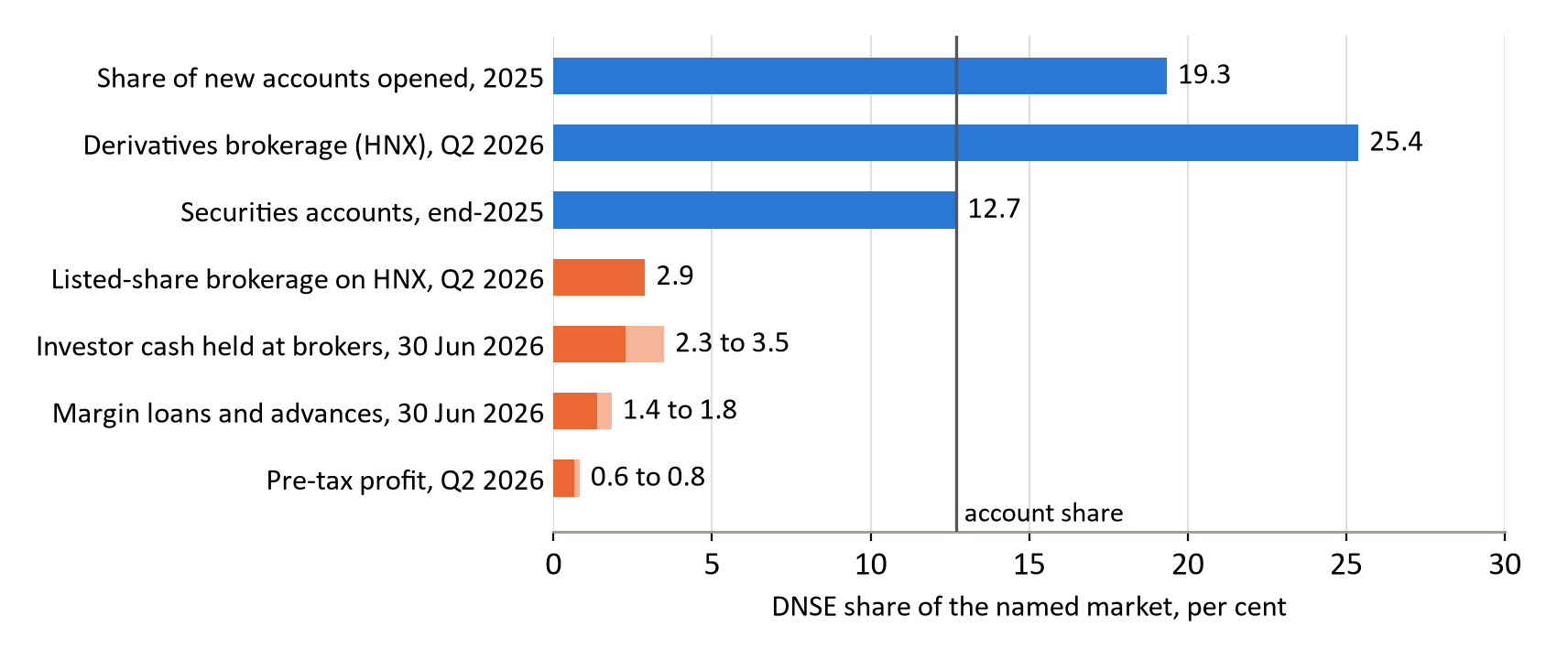
Source: VSDC (2026); DNSE (2026d); HNX; filings via Vietcap Securities (2026); press tallies (Table D1). Light bars span the two industry totals.
The gap widens as the base grows. Margin lending per account fell from VND 4.4 million at the end of 2023 to VND 3.7 million in June 2026, and cash per account fell to VND 1.15 million (Figure A3). Customer assets per account fell 9.5 per cent in 2025, to VND 35.3 million, in a year when the VN-Index rose 41 per cent, the UPCoM index 28 per cent and the HNX-Index 9 per cent (DNSE, 2026d). Only 85,739 customers, 5.7 per cent of accounts, used any DNSE product in December 2025, and only 27,100, or 1.8 per cent, held net assets of VND 10 million or more (DNSE, 2026d).

2.3 Finding 2. The gap is specific to DNSE
Three objections could explain the gap away: that every broker counts dormant accounts, that app-based zero-fee brokers attract only small savers, or that DNSE lacks a parent bank. Peers with similar account bases answer all three (Figure 2; Table A3). VPS, a retail broker without a parent bank, lends VND 20.2 million per account, more than five times DNSE's VND 3.7 million. TCBS, also zero-fee with 99 per cent of accounts opened online, lends VND 42.9 million per account, and about 34 per cent of its customers traded on its app in December 2025, against 5.7 per cent of DNSE accounts using any product (TCBS, 2026c; Table D2). Second-quarter pre-tax profit per account was VND 57,000 at DNSE and VND 0.9 to 1.7 million at VPS, VPBankS and TCBS. Account counts differ in date, but not enough to close gaps of this size.
Figure 2. Lending and profit per customer account, DNSE against VPS, VPBankS and TCBS
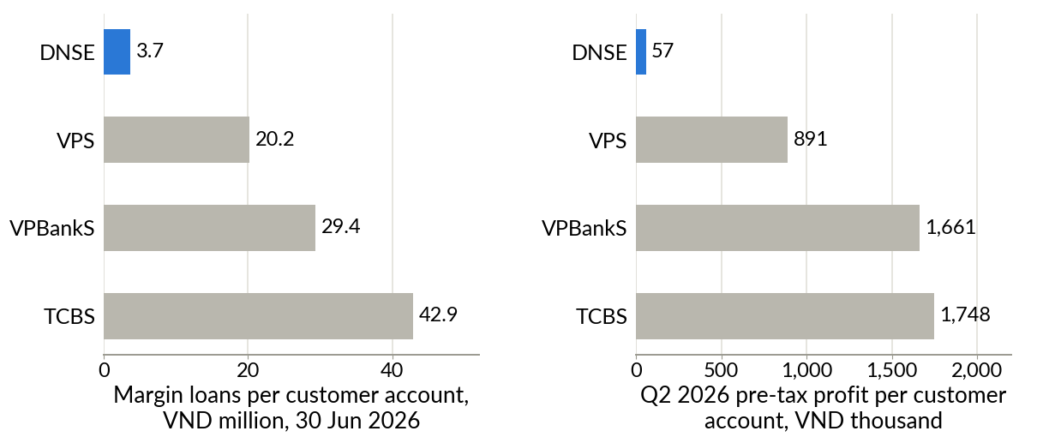
Source: filings for 30 June 2026 via Vietcap Securities (2026); company releases for account counts (Table A3).
Customer reviews place the problem at the start of the relationship. Since March 2023, 5.6 per cent of DNSE's cleaned Google Play reviews concern sign-up bonuses or rewards, against 0.7 per cent for VPS and none for FPTS. The most-endorsed complaints, from June 2025, say that a VND 100,000 sign-up reward required a VND 2 million deposit and that closing an account cost VND 100,000 (Figure A5; Table E5). Deception, bonus terms and closure appear in 24 per cent of negative reviews but attract 43 per cent of their helpful votes (Figure A4). Crashes and login failures are more common but do not set DNSE apart, since its Google Play rating is above those of VPS and FPTS.

2.4 Finding 3. Revenue grows while core profit stands still
Operating revenue rose 3.2 times, from VND 452 billion in 2022 to VND 1,458 billion in 2025 (Figure A6). Pre-tax profit excluding proprietary trading stayed between VND 128 and 221 billion a year (Figure 3). The two years of strong reported growth, 2023 and 2025, rested on trading gains of VND 158 and 146 billion.
Figure 3. Operating revenue and pre-tax profit split into core business and proprietary trading
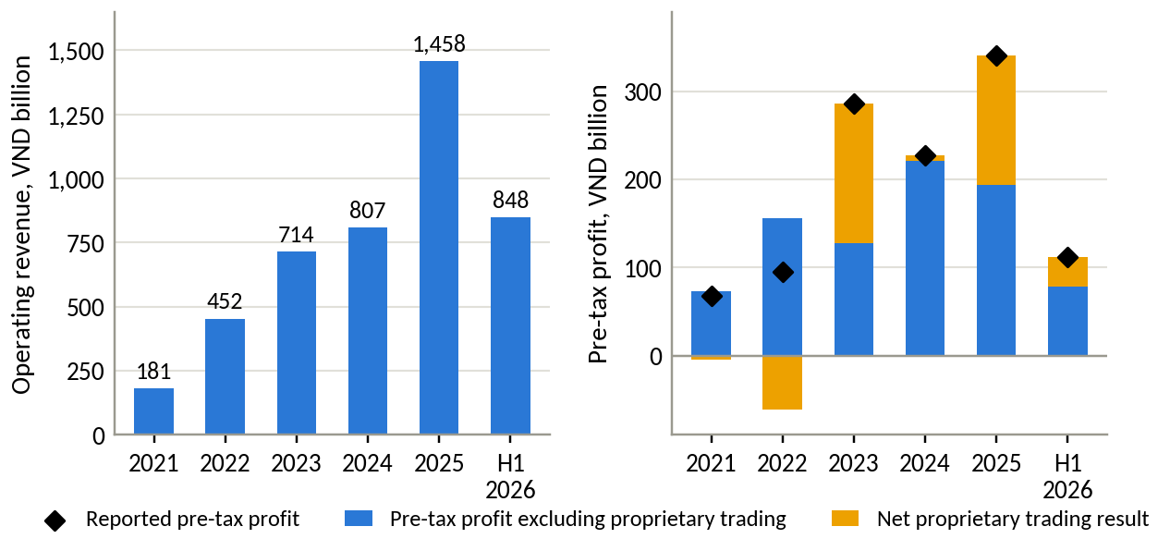
Source: DNSE filings via Vietcap Securities (2026); authors' calculations. H1 2026 is not annualised.
In the first half of 2026 core revenue rose by VND 285 billion on a year earlier and core costs by VND 289 billion, so each extra VND 100 of core revenue brought about VND 102 of extra cost; including trading losses, pre-tax profit fell 29 per cent (Figure A7). By mid-year DNSE had delivered 20 per cent of its 2026 pre-tax profit target of VND 550 billion (Vietstock, 2026b), and its annualised return on equity of 3.8 per cent was below the 6.8 per cent paid on a 12-month deposit at a state-owned bank (VietnamNet, 2026).

2.5 Finding 4. Brokerage and funding absorb the growth
The filings show where the extra cost went (Table A4). Of the VND 289 billion rise in core costs in the first half of 2026, funding took 52 per cent, direct brokerage cost 42 per cent and administration, which includes staff, outsourced services and technology, 6 per cent. Comparing 2025 with 2024 gives the same picture: brokerage 52, funding 40 and administration 5 per cent. Technology spending is not what absorbs revenue growth; fixed assets, including leased equipment, are 1 per cent of total assets.
Brokerage is the first source. Its direct cost has exceeded brokerage revenue in each of the 16 quarters since the third quarter of 2022, with a cumulative shortfall of VND 190 billion (Figure 4). The cost moves with revenue, which covered 78 to 92 per cent of it in each of the last eight quarters, so it behaves as a per-trade cost, not a fixed investment. In the first half of 2026 DNSE lost VND 44.5 billion on brokerage after direct costs, the largest loss among 42 brokers with filed statements and 2.6 times the next, while the industry earned VND 1.5 trillion (Table A5). The notes do not split this cost, but DNSE pays exchange fees on free share trades and has paid derivatives margin fees for customers since May 2025 (Vietstock, 2025b).
Figure 4. Brokerage revenue against direct brokerage cost, by quarter
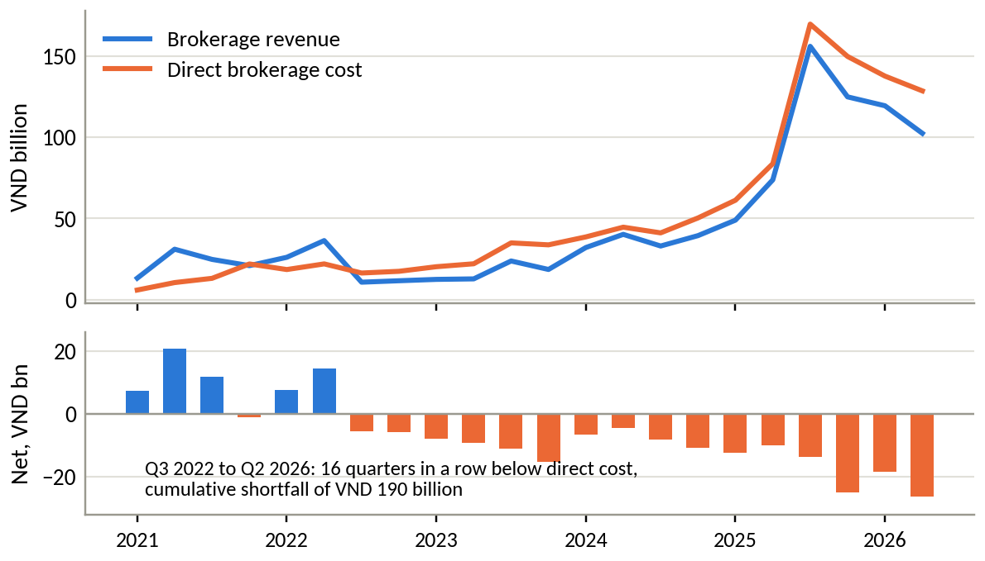
Source: DNSE filings via Vietcap Securities (2026); authors' calculations.
Funding is the second source. Average borrowings rose 43 per cent and the estimated cost of funds rose from 4.6 to 6.3 per cent between the first halves of 2025 and 2026 (Figure A8). The rate itself is normal: on the same method TCBS paid 7.8 per cent in the second quarter of 2026, VPBankS and MBS 6.8 per cent and VPS, which has no parent bank, 5.1 per cent, against DNSE's 6.5 per cent (Table A6).

2.6 Finding 5. Capital is not the constraint
Margin loans were 116 per cent of DNSE's equity at 30 June 2026 against a regulatory ceiling of 200 per cent, leaving room for about VND 4.6 trillion of additional lending, and shareholders added VND 1.3 trillion in March 2026 (CafeF, 2026a). Lending is the widest margin: an 11.2 per cent yield in the first half of 2026 left a spread of about 4.9 points over the cost of funds, so each extra VND 1 trillion lent adds about VND 49 billion of pre-tax profit a year before credit losses. What limits lending is demand from customers with money.
Meanwhile 38 per cent of total assets sits in term deposits and bonds held to maturity, against 1 to 22 per cent at eight large peers (Table A6), and 93 per cent of these assets were pledged to banks for DNSE's borrowing at 30 June 2026 (DNSE, 2026a, note 8(b)). They yielded about 6.0 per cent in the first half of 2026, close to the cost of the funds behind them (Figure A8), so they supply 23 per cent of revenue and almost no profit (Figure A9).

3. Discussion and main analysis

3.1 Why the money does not stay
Figure 5 traces the balance gap to five causes, each marked as measured or hypothesis (Tables B1, B2 and B2a). Three are measured and within DNSE's control.
The cash product gives savers no reason to stay. DNSE's idle-cash account pays a typical customer 2.1 to 2.3 per cent, against 6.0 per cent at TCBS's iPower for the same balance and 3.5 to 4.3 per cent on banks' automatic-earning accounts (DNSE, 2026b; TCBS, 2026a; Figure B1).
Nothing turns income into regular funding. DNSE offers no recurring investment or savings plan, so every deposit is a new decision (DNSE, 2026e). Yet 77 per cent of investors find managing their own assets difficult, and 36 per cent know a digital wealth service but only 16 per cent have used one (Nhân Dân, 2025; VnEconomy, 2025).
Trust breaks at the first deposit and at exit. Bonus terms appear in 5.6 per cent of DNSE's reviews against 0.7 per cent at VPS, and trust complaints draw 43 per cent of helpful votes on negative reviews (Section 2.3).
Two causes lie outside a savings product: derivatives build share and brokerage losses but no balances, because margin is posted at the clearing house; and targets may reward accounts rather than balances, a hypothesis for Round 3.
Alternative explanations fail: every index rose in 2025 while assets per account fell, DNSE's 2026 cash outflow matched the industry (Figure B2), capital is not binding and peers control for dormant accounts. Only "acquire young, monetise later" needs cohort data, the first Round 3 test.
Figure 5. Causes of the balance gap, the evidence behind each and the response
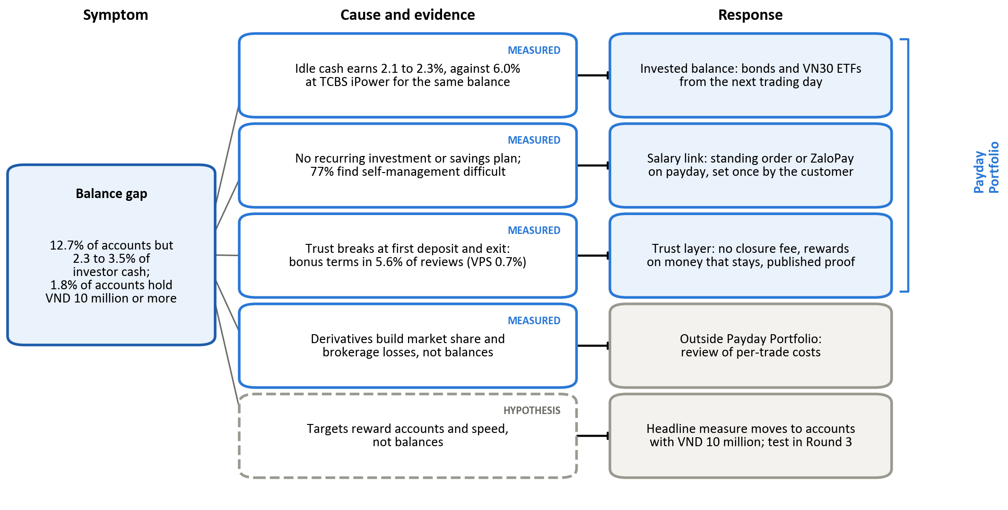
Source: authors' analysis of Sections 2 and 3.

3.2 Market gap and customers
Conditions in 2026 raise the cost of the gap (Table B3). Banks raised 12-month deposit rates by about 2.5 points, household deposits passed VND 11 quadrillion, cash at brokers fell by more than a third in three quarters, and bank-owned brokers supplied more than half of the second quarter's growth in margin lending (VietnamNet, 2026; Vietstock, 2026g, 2026i; VnEconomy, 2026b). One tenth of one per cent of household deposits equals 5.6 times DNSE's investor cash (Table B4).
The market gap lies between three kinds of provider (Table B5). Banks hold salaries and trust but offer little investment choice, fund apps offer monthly plans but no trading or lending, and brokers offer trading and lending but no path from a salary.
Findex data show that 37 per cent of adults receive wages into an account and that working adults in the upper income groups hold the largest formally saved surplus (World Bank, 2025b; Figure 6). DNSE's base is young: Gen Z held 31.5 per cent of its accounts in mid-2025 (VnExpress, 2025).
Figure 6. Vietnamese adult segments by digital habit and formally held surplus
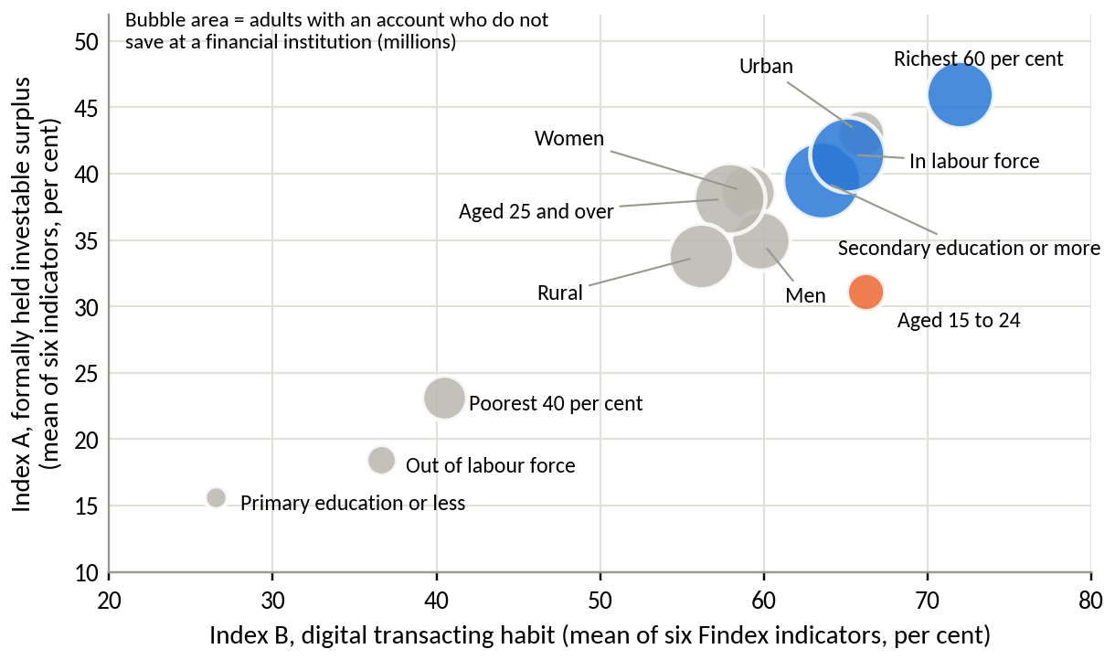
Source: World Bank (2025b); authors' indices (Appendix F).

3.3 Lessons from abroad and from research
Zero-fee brokers abroad solved the same problem by gathering assets: Robinhood through net deposits of USD 68 billion in 2025, Trade Republic through automated savings plans (Table B6). Research explains why automation works: automatic enrolment raised pension-plan participation from 37 to 86 per cent (Madrian & Shea, 2001), and pre-committed saving raised saving rates from 3.5 to 13.6 per cent (Thaler & Benartzi, 2004). Securities firms cannot take deposits, so DNSE needs partners (Table B7).

3.4 Target market, priority problem and problem statement
Of five candidate markets, salaried mass-affluent adults rank first under both weightings: they hold the formally saved surplus, earn monthly income and are already in DNSE's base (Table B8). About 1.4 million DNSE accounts neither used a product nor held VND 10 million at the end of 2025; those of working customers are the first wave, already acquired and verified. Young first-time investors are DNSE's strongest franchise but weakest source of balances, so the scope is salaried customers of roughly 22 to 40, including working Gen Z, in their first 90 days or restarting a dormant account (Table B9).
Of seven candidate problems, the balance gap ranks first under both weightings on scale, urgency, strategic relevance, data support and control (Table B10). Loss-making brokerage, reliance on trading gains and funding cost are partly its consequences; the trust deficit ranks second and becomes a design condition. Meeting the 2026 profit plan from lending would need a loan book 2.3 times today's (Figure B3). The response therefore targets the three measured causes that DNSE controls; the brokerage loss needs a cost review, and the incentive hypothesis a Round 3 test.
Problem statement. DNSE opens nearly one in five of Vietnam's new securities accounts, yet it holds 2.3 to 3.5 per cent of investor cash and only 1.8 per cent of its accounts hold VND 10 million or more. Its products give salaried customers no competitive, automatic or trusted way to keep money on the platform, above all in the first 90 days. As a result, core profit has not grown since 2022 while revenue tripled (Table B11).

3.5 Strategic alternatives
Eight responses were scored on six weighted criteria, and Payday Portfolio ranks first under both weightings (Table B12). Two cheap options are necessary but insufficient: repricing idle cash costs about VND 20 billion a year per point on today's investor cash and creates no path for new money, and a trust programme alone creates no deposits. Both become parts of the preferred option. Acquisition-led growth adds the customers with the least money; a derivatives-to-shares bridge deepens exposure to the activity penalised in August 2026; an advisory tier needs advisers DNSE avoided; an alliance is a channel, not a strategy; and fees would break the zero-fee promise. Payday Portfolio sacrifices speed and cannot rescue the 2026 plan; a review of per-trade costs runs alongside.

4. Recommendations

4.1 The preliminary recommendation
DNSE should build Payday Portfolio, a savings tab in Entrade X, separate from trading, that turns a salaried customer's monthly surplus into an invested balance (Figure 7). It starts with the dormant accounts of working customers aged roughly 22 to 40, and each component answers a measured cause (Tables B13 and B14).
Salary link, for the missing path from income. The customer sets a goal and an amount, from VND 1 million, once. A standing order in the customer's own banking app, or a ZaloPay authorisation, moves the money on payday (Thanh Niên, 2023); DNSE never debits a bank account. Open banking interfaces, standard by March 2027, will make set-up a single step (State Bank of Vietnam, 2024).
Invested balance, for the uncompetitive cash rate. Cash passes through the idle-cash account and is invested by goal on the next trading day in Trứng Vàng bonds, VN30 exchange-traded funds and, once a distribution agreement is signed, partner bond funds. A market-linked cash yield through a partner bank or money market fund follows in phase 2, after SSC confirmation.
Trust layer, for the breaks at deposit and exit. No closure fee; pause, skip or cancel in one tap; rewards only on money that stays; all terms on one screen; and a report to the SSC before launch, once the control gaps found in August 2026 are closed (Market Times, 2026). Each promise has a published proof (Table B14a).
Margin is excluded at launch; collateral use is considered after 12 months, with a suitability check.
Figure 7. How Payday Portfolio works
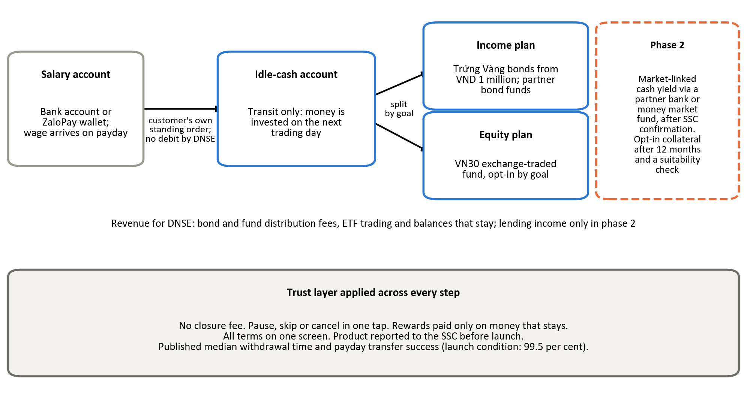
Source: authors' design.

4.2 Value logic and expected outcomes
Value comes, in order of certainty, from keeping balances that would leave, distribution fees, cheaper growth from accounts already acquired and, in phase 2, lending at a 4.9-point spread. In the base case 150,000 savers, one in nine dormant accounts, contribute VND 1.5 million a month, a sixth of the average worker's VND 9.0 million (National Statistics Office, 2026), and keep 70 per cent. After 18 months the layer holds VND 2.8 trillion, 1.4 times DNSE's investor cash, earns about VND 23 billion a year in fees and lifts accounts holding VND 10 million or more from 1.8 to 10 per cent (Table B15; Figure 8). Fees of about VND 150,000 per saver a year mean a saver acquired for less pays back within a year.
Figure 8. Payday Portfolio assets and accounts holding VND 10 million or more
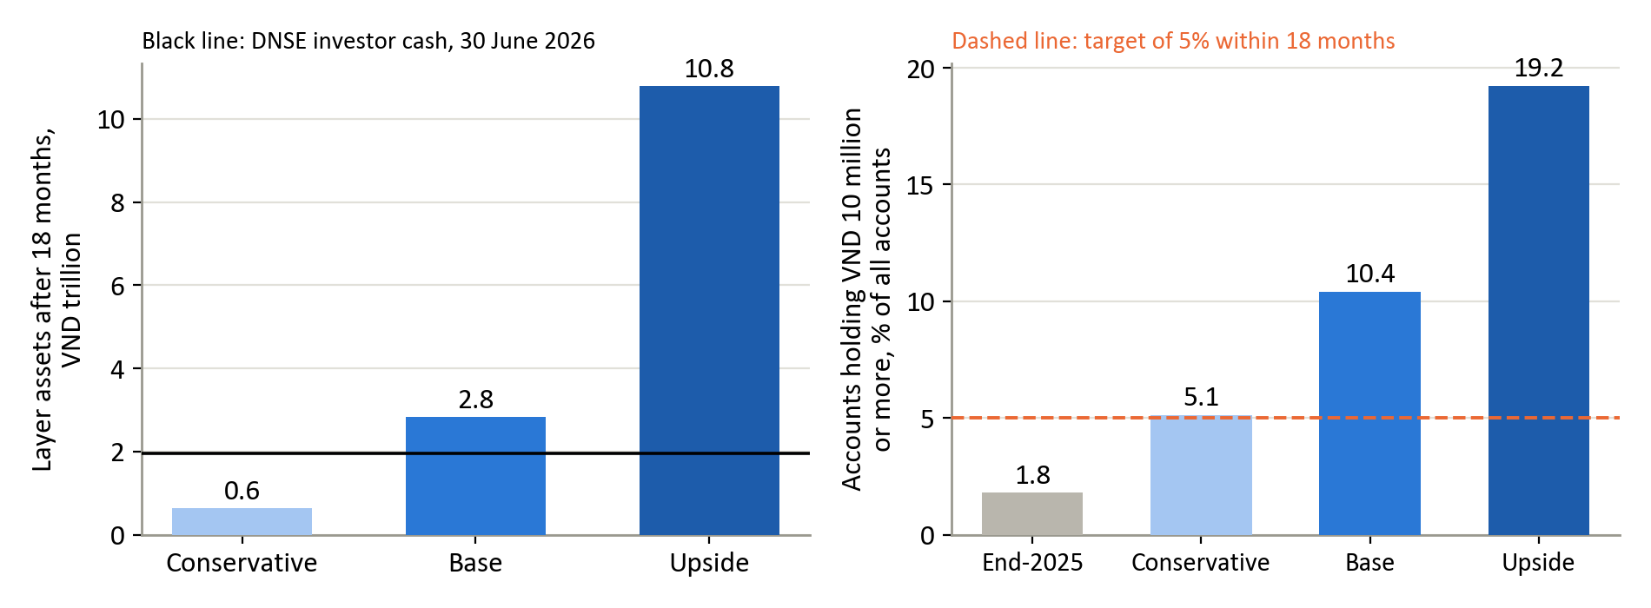
Source: Table B15.

4.3 Feasibility and risks
Phase 1 reuses what DNSE already runs: verified accounts, the idle-cash account, Trứng Vàng, exchange-traded fund trading, ZaloPay and Ensa as goal coach; the new build is a scheduling and goal engine (Table B16). Four risks each have a test. A bonus on all investor cash would cost VND 20 billion a year per point, so any bonus applies to new money and must pay for itself. The pilot needs no deposit-like structure. Inflows are tagged by source, so money moved from trading accounts is not counted as new. Payday transfers must reach 99.5 per cent success in shadow runs before launch.

4.4 Validation direction
Seven assumptions are tested before scale-up (Table B17; Figure B4). In months 3 to 6 a pilot randomises 20,000 dormant accounts of customers aged 22 to 40 into three arms: the current journey, Payday Portfolio, and Payday Portfolio with a bonus on new contributions, separating the effect of automation from that of yield. Thresholds follow the scenarios: enrolment of 11 per cent within 90 days, 70 per cent of contributions kept and 80 per cent new money support scale-up; below 4 per cent, the conservative case, the concept stops. The headline measure is one DNSE already reports: accounts holding VND 10 million or more, 1.8 per cent at the end of 2025, with a target of 5 per cent within 18 months.

5. Conclusion
DNSE has solved getting noticed, opening nearly one in five new securities accounts in Vietnam, but not getting customers to keep money with it. Only 1.8 per cent of its accounts hold VND 10 million or more, core profit has not grown since 2022, and each extra unit of revenue brings as much extra cost. Nothing turns a customer's income into money that stays. Payday Portfolio changes that with components DNSE already runs; Round 3 should test it in a three-arm pilot.

Appendices

Appendix A. Exhibits for the findings
Appendix A holds the figures and tables behind Section 2, in the order in which the text cites them.
Table A1. DNSE at a glance
Item | Detail
Legal name and listing | DNSE Securities Joint Stock Company, HOSE code DSE, listed 1 July 2024
Scale | Charter capital VND 4,282.5 billion; total assets VND 15,208 billion; equity VND 5,440 billion
Ownership | Encapital group and its chairman about 49.7 per cent; Capella Group 9.8 per cent (March 2026)
Customers | More than 1.7 million accounts (mid-2026); 518,514 accounts opened in 2025; 85,739 active users in December 2025
Distribution | Entrade X app and web only; no branches; account opening by electronic identity check; ZaloPay partnership since 2023
Pricing | Zero fees on cash equity trades without borrowing; 0.045 to 0.085 per cent on Margin Deal trades; derivatives margin deposit, withdrawal and management fees paid by DNSE since May 2025
Products | Entrade X (shares), Future X (derivatives), Margin Deal (deal-by-deal lending), Tài khoản không ngủ (idle-cash account paying 1.8 to 4.3 per cent), Trứng Vàng (bonds from VND 1 million), Ensa (artificial intelligence assistant), Lightspeed API (algorithmic trading)
Market position, Q2 2026 | Second in derivatives brokerage (25.38 per cent); eighth in listed-share brokerage on HNX (2.88 per cent); outside the HOSE top ten (below 2.94 per cent)
2026 plan | Revenue VND 1,736 billion; pre-tax profit VND 550 billion; VND 3,500 billion bond programme; securities subsidiary at the International Financial Centre
Regulatory record | Fined VND 802.5 million on 17 August 2026 and ordered to stop three derivatives financing services offered without prior notice to the State Securities Commission
Source: DNSE filings retrieved from Vietcap's data service; DNSE investor relations and product pages; DNSE (2026d); Vietstock (2026a, 2026b, 2026f); CafeF (2026c); Kinh tế Chứng khoán (2026) for ownership; Market Times (2026). Figures at 30 June 2026 unless stated.
Table A2. Evidence base
Dataset | Content and coverage | Main preparation step
DNSE filed statements | 395 line items of the income statement, balance sheet, cash flow and notes, first quarter of 2018 to second quarter of 2026 | Pulled line by line from Vietcap's data service and reconciled to the half-year statements reviewed by KPMG
DNSE company indicators | Accounts, new-account shares, active users, customer assets, derivatives share, 2026 plan, product terms and fee schedules | Taken from investor relations releases and product pages; each figure dated and cross-checked with a second report where possible
Exchange and industry data | HOSE and HNX brokerage shares; industry margin lending, investor cash at brokers and pre-tax profit; trading value; account statistics | Each share kept with its own exchange; competing industry totals recorded and one chosen per measure
Named peers | VPBankS and TCBS accounts, lending, profit and customer cash | Filed statements through Vietcap for lending and profit; company releases and the financial press for account counts, whose dates differ and are stated
Google Play reviews | 867 DNSE reviews (October 2020 to September 2026) and 1,377 reviews of VPS SmartOne and FPTS EzTrade | Collected on 23 September 2026 and cleaned with one rule set for all three apps
App Store reviews | 1,055 written reviews of the same three apps and Apple's star-rating counts | Collected on 24 September 2026; used as a cross-check for 2025 and 2026
World Bank Global Findex | 51 indicators for Vietnam across 13 demographic segments (2024 fieldwork) and five survey waves from 2011 | Retrieved from the World Bank open data interface; segment population shares recovered from the survey itself
Macro, banking and international | GDP, inflation, credit, deposits and rates (NSO, SBV, bank rate sheets); reference reports listed by the organisers; annual results of Robinhood, Futu and Indian and Japanese market data | Dated at source; forecasts and projections labelled as such
Source: compiled by the authors. Access dates between 20 and 27 September 2026. Full addresses in Appendix H.
Figure A1. DNSE customer accounts and derivatives brokerage share
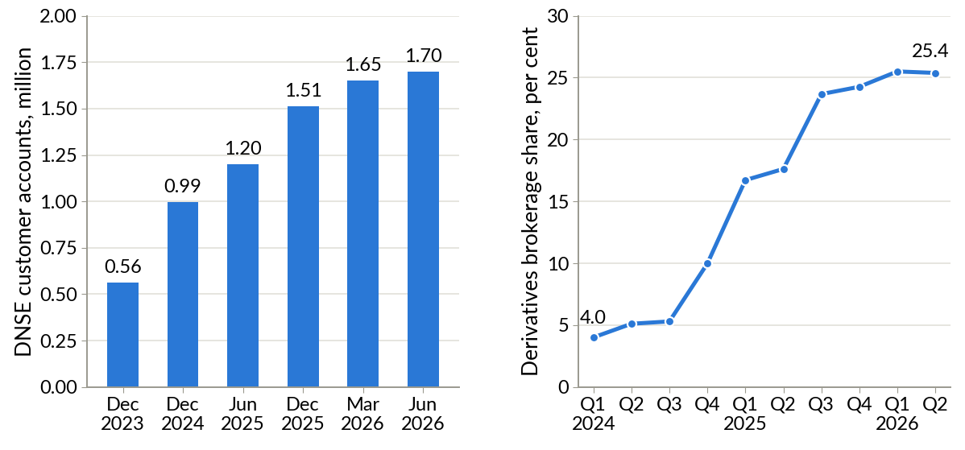
Source: DNSE's 2025 annual report (DNSE, 2026d) for year-end accounts; VnExpress (2025) and Vietstock (2026c) for June 2025 and March 2026; DNSE releases for mid-2026; Hanoi Stock Exchange (2026) for derivatives brokerage shares since DNSE entered the top ten in the first quarter of 2024.
Figure A2. Value of an average DNSE account relative to the average Vietnamese securities account
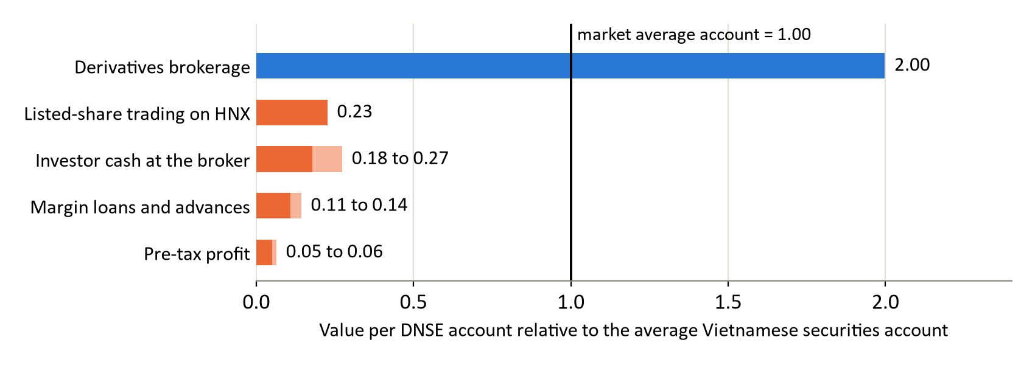
Source: as for Figure 1. Each value is DNSE's share of a market divided by its share of securities accounts, 12.7 per cent (1,512,920 of 11,871,933 accounts at the end of 2025; 12.66 per cent at 30 June 2026). Light bars span the two industry totals in Table D1.
Figure A3. DNSE investor cash, margin lending and customer assets per account
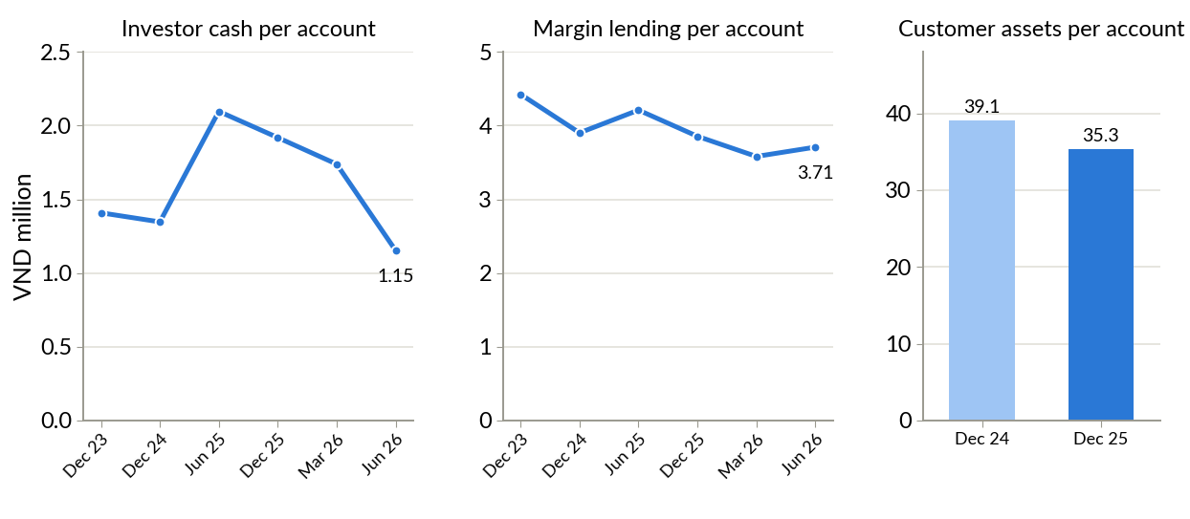
Source: DNSE filings (off-balance-sheet investor cash, loans); DNSE releases (accounts, customer assets); authors' calculations. Account counts for December 2023, 2024 and 2025 are from DNSE's 2025 annual report.
Table A3. DNSE against three named peers with similar account bases
Indicator | DNSE | VPBankS | TCBS | VPS
Customer accounts, million | 1.70 | 1.30 | 1.20 | 1.55
Margin lending, 30 June 2026, VND billion | 6,303 | 38,200 | 51,500 | 31,300
Lending per account, VND million | 3.7 | 29.4 | 42.9 | 20.2
Pre-tax profit, Q2 2026, VND billion | 97.4 | 2,159 | 2,097 | 1,378
Profit growth, Q2 2026 on Q2 2025 | +7% | about 4 times | +21% | +57%
Pre-tax profit per account, Q2 2026, VND thousand | 57 | 1,661 | 1,748 | 891
HOSE brokerage share, Q2 2026 | below 2.94% | 3.57% | 9.36% | 12.61%
Investor cash per account, VND million | 1.15 | 1.1 | 5.5 | 9.3
Parent bank | none | VPBank | Techcombank | none
Source: each firm's filed statements for the second quarter of 2026, retrieved through Vietcap Securities (2026), for lending, profit and investor cash; company releases for accounts (Vietstock, 2026d; TCBS, 2026c; VPS Securities, 2025); HOSE quarterly announcement for brokerage share; authors' calculations. Account figures are dated May 2026 (VPBankS), end-2025 (TCBS), September 2025 (VPS, from its IPO presentation) and mid-2026 (DNSE). VPS figures are filed under the ticker VCK. Per-account values are averages, which large clients raise at every firm. Investor cash is the off-balance-sheet cash each firm reports; bank-linked account models keep part of customers' cash at the parent bank, so this row is the least comparable.
Figure A4. Themes in DNSE's negative reviews, by count and by helpful votes
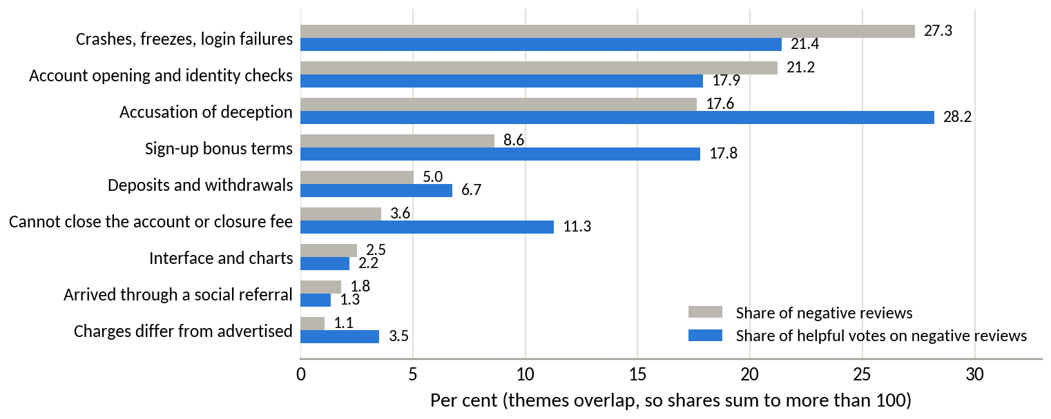
Source: Google Play, retrieved 23 September 2026; authors' cleaning and coding. 278 negative reviews carrying 1,794 helpful votes.
Figure A5. DNSE reviews per month, positive above the axis and negative below
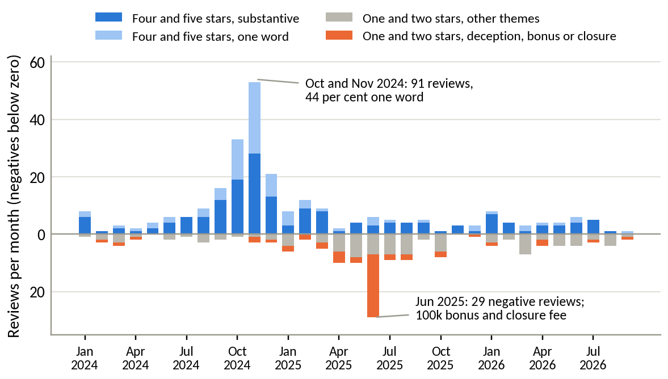
Source: Google Play, retrieved 23 September 2026; authors' cleaning and coding.
Figure A6. Composition of DNSE operating revenue
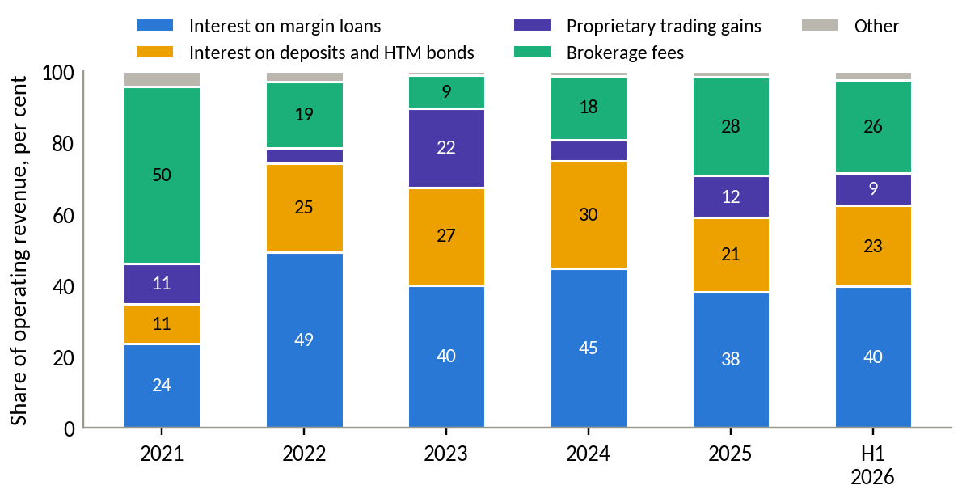
Source: DNSE filings, authors' calculations.
Figure A7. Where each VND 100 of operating revenue goes
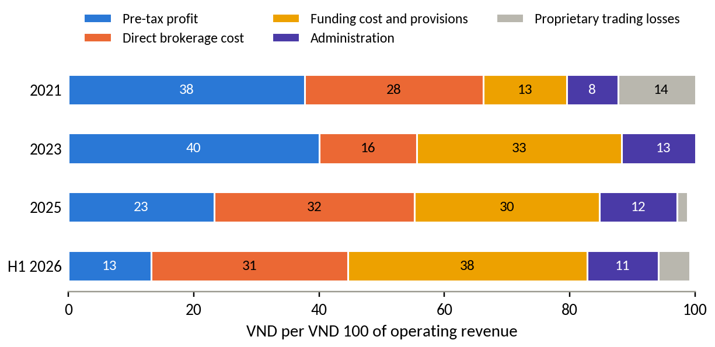
Source: DNSE filings, authors' calculations. Funding cost and provisions combine interest expense and template line 24.
Table A4. Where DNSE's extra revenue and cost came from (VND billion)
Item | H1 2025 | H1 2026 | Change | 2024 | 2025 | Change
Core operating revenue | 486.3 | 771.0 | +284.7 | 759.5 | 1,286.5 | +527.0
of which interest on margin loans and advances | 228.8 | 336.1 | +107.3 | 360.5 | 555.8 | +195.2
of which interest on deposits and bonds held to maturity | 128.1 | 193.4 | +65.3 | 245.0 | 303.9 | +58.9
of which brokerage revenue | 122.8 | 222.1 | +99.2 | 144.8 | 404.0 | +259.2
Core costs | 403.9 | 693.3 | +289.3 | 538.8 | 1,092.5 | +553.6
of which funding cost (interest expense and template line 24) | 172.3 | 324.1 | +151.9 (52%) | 210.6 | 429.8 | +219.2 (40%)
of which direct brokerage cost | 145.1 | 266.5 | +121.4 (42%) | 174.8 | 464.9 | +290.0 (52%)
of which administration (staff, outsourced services, depreciation) | 78.7 | 95.4 | +16.7 (6%) | 151.9 | 181.4 | +29.5 (5%)
of which other operating items (residual) | 7.9 | 7.2 | −0.7 | 1.5 | 16.4 | +14.9
Core pre-tax profit | 82.4 | 77.7 | −4.6 | 220.7 | 194.0 | −26.7
Net proprietary result | 75.1 | 33.9 | −41.3 | 6.8 | 146.2 | +139.4
Reported pre-tax profit | 157.5 | 111.6 | −45.9 | 227.5 | 340.2 | +112.7
Extra core cost per VND 100 of extra core revenue |  |  | 102 |  |  | 105
Source: DNSE filed statements via Vietcap Securities (2026); authors' calculations. Core excludes gains and losses on financial assets at fair value through profit or loss. Template line 24 combines loan-loss provisions with the borrowing cost of the loan book; the allowance for loan losses rose by only VND 9 to 11 billion in each half-year, so the line is mostly funding cost. Percentages are shares of the change in core costs.
Table A5. Brokerage revenue against direct brokerage cost, first half of 2026: DNSE and the largest brokers (VND billion)
Broker | Brokerage revenue | Direct brokerage cost | Result after direct cost | Revenue as % of direct cost
VPS | 1,637.0 | 1,415.1 | +221.9 | 116
SSI | 1,068.5 | 706.2 | +362.2 | 151
Vietcap | 565.5 | 349.1 | +216.4 | 162
HSC | 521.0 | 401.7 | +119.2 | 130
TCBS | 493.3 | 210.2 | +283.1 | 235
MBS | 405.0 | 349.4 | +55.6 | 116
VNDirect | 381.7 | 267.3 | +114.4 | 143
VPBankS | 260.4 | 257.7 | +2.7 | 101
DNSE | 222.1 | 266.5 | −44.5 | 83
All 42 brokers with filed statements | 7,032.2 | 5,568.8 | +1,463.4 | 126
Source: filed statements of 42 brokers via Vietcap Securities (2026); authors' calculations. Brokers are the nine with the highest brokerage revenue. 19 of the 42 brokers made a loss after direct costs; the three largest losses were DNSE (−44.5); PSI (−17.1); KAFI (−16.8).
Figure A8. Yield on margin loans and on deposits and bonds held to maturity, against the estimated cost of funding
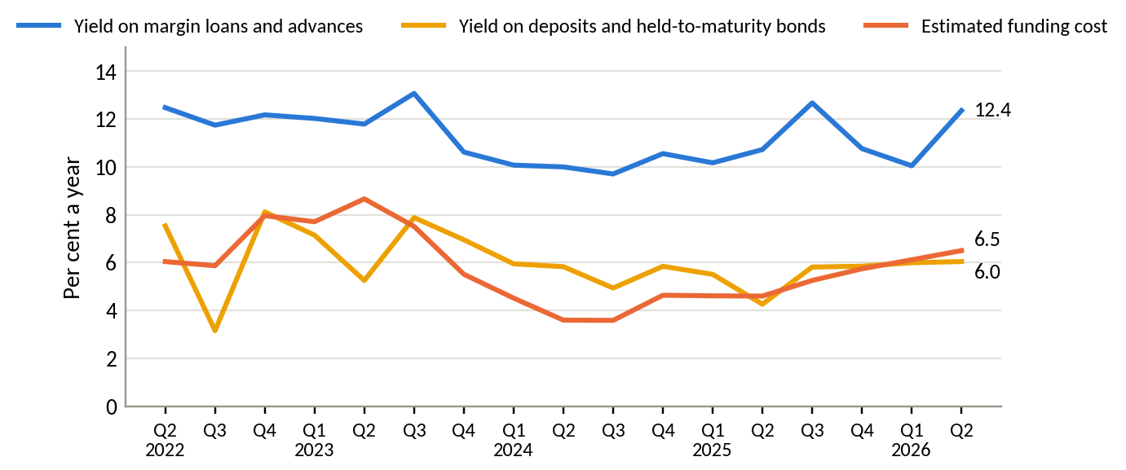
Source: DNSE filings, authors' calculations. Yields are annualised quarterly income over the average of opening and closing balances.
Figure A9. Composition of DNSE total assets
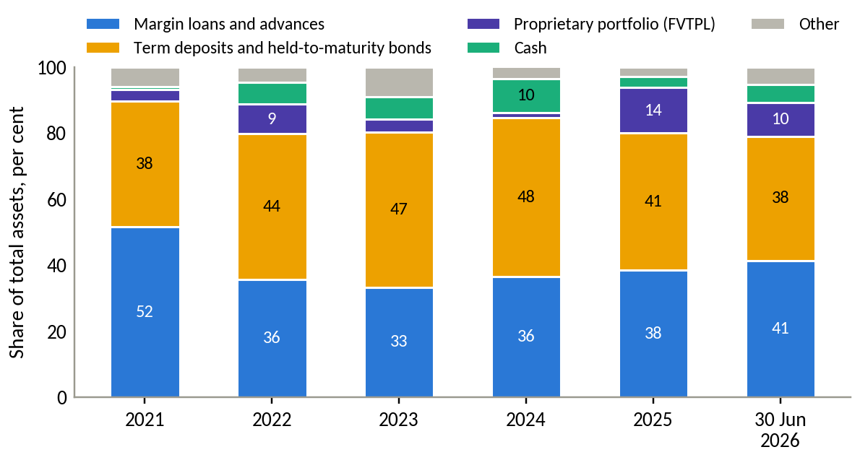
Source: DNSE filings, authors' calculations.
Table A6. Funding cost and balance-sheet structure at 30 June 2026: DNSE and eight large brokers
Broker | Parent bank | Estimated cost of funds, Q2 2026, % | Deposits and HTM bonds, % of total assets | Loans, % of equity | Short-term loans, % of borrowing
DNSE | none | 6.5 | 37.6 | 116 | 86
VPS | none | 5.1 | 4.3 | 100 | 68
SSI | none | 6.1 | 8.6 | 99 | 100
TCBS | Techcombank | 7.8 | 4.6 | 113 | 94
VPBankS | VPBank | 6.8 | 6.5 | 107 | 100
MBS | MB | 6.8 | 16.1 | 141 | 87
HSC | none | 7.9 | 0.9 | 198 | 100
Vietcap | none | 6.4 | 0.8 | 100 | 100
VNDirect | none | n.m. | 22.2 | 60 | 91
Source: filed statements via Vietcap Securities (2026); DNSE (2026a), note 8(b), for pledged assets; authors' calculations. The cost of funds is estimated with the same method for every firm: interest expense plus template line 24, less the rise in the allowance for loan losses, annualised over average borrowings and bonds. n.m.: not meaningful, as VNDirect's quarterly estimate falls below 1 per cent. At 30 June 2026 DNSE had pledged VND 4,257 billion of term deposits and bonds with a face value of VND 1,050 billion, 93 per cent of its held-to-maturity assets, as collateral for bank loans. Bank-owned brokers with filed statements (TCBS, VPBankS, MBS, BSI, CTS, Agriseco, LPBS and ABS) supplied 55 per cent of the rise in lending across all filers in the second quarter of 2026; a press tally of the top 20 brokers gives 62 per cent (Vietstock, 2026g).
Table A7. Summary of findings and their business implications
Finding | Main evidence | Evidence type | Implication
1. DNSE wins accounts but not money | 12.7% of accounts and 19% of 2025 openings against 2.3–3.5% of investor cash, 1.4–1.8% of lending and 0.6–0.8% of profit; 5.7% of accounts active in December 2025; assets per account down 9.5% in 2025 | Measured and derived | Value is lost after the account is opened
2. The gap is specific to DNSE | VPS lends 5 times and TCBS 12 times more per account; about 34% of TCBS customers trade monthly; bonus complaints in 5.6% of DNSE reviews against 0.7% at VPS | Measured; reviews self-selected | Not explained by dormant accounts, the zero-fee app model or the lack of a parent bank
3. Revenue grows while core profit stands still | Revenue 3.2 times from 2022 to 2025; core profit VND 128–221 billion a year; VND 102 of extra cost per VND 100 of extra core revenue in H1 2026 | Measured | Growth in activity does not create value on its own
4. Brokerage and funding absorb the growth | 52% of the H1 2026 rise in core costs from funding, 42% from brokerage, 6% from administration; brokerage below direct cost for 16 quarters and the largest brokerage loss among 42 brokers | Measured | Cost action must target per-trade costs and funding structure, not overheads
5. Capital is not the constraint | Loans at 116% of equity against a 200% ceiling; 38% of assets in deposits and bonds, 93% of them pledged, earning about their funding cost | Measured | The binding constraint is customer money
Source: Section 2.

Appendix B. Exhibits for the discussion and recommendation
Appendix B holds the figures and tables behind Sections 3 and 4, in the order in which the text cites them.
Table B1. Evidence on the customer lifecycle and the gaps to close in Round 3
Stage | Available evidence | What it shows | Measure needed from internal data
Sign-up | 518,514 accounts in 2025; 16 to 34% of the new accounts opened in the market in each quarter of 2025 | Acquisition works | Cost per account by channel and campaign
Identity verification (eKYC) | 21% of negative reviews on onboarding (NFC chip reading, one-time passwords, photo checks); peaks in 2021, 2022 and 2025 | Recurring friction | Completion rate and time to verify, by device and channel
First funding | Assets per account fell 9.5% in 2025 while accounts grew 52%; June 2025 complaints that a reward required a VND 2 million deposit | The weakest stage | Share of new accounts funded within 30 days, and amount
First trade and activity | 85,739 active users in December 2025, 5.7% of accounts, up from 41,900 a year earlier; about 34% at TCBS (Table D2) | Most accounts stay idle | First-trade rate; active rate by cohort month
Retention at 30 to 90 days | Cash per account fell 32% in the second quarter of 2026, in line with the industry | Money leaves when rates rise | Dormancy at 30, 60 and 90 days; balance retention
Second product | Idle-cash product in 3 of 670 reviews; Ensa used by 72,000 customers in 2025 | Depth is thin | Products held per funded customer
Source: DNSE releases; Section 2; Dân trí (2026a) on the draft circular.
Table B2. Five-whys analysis of the balance gap
Step | Question and answer | Evidence
Symptom | DNSE holds 12.7% of accounts but 2.3–3.5% of investor cash and 1.4–1.8% of margin lending, and only 5.7% of accounts were active in December 2025 | Figure 1; DNSE annual report 2025
Why 1 | Why do accounts stay small? Hypothesis: many customers open an account for a reward and deposit only what the reward requires | June 2025 complaints about a VND 100,000 reward that required a VND 2 million deposit; DNSE reviews raise bonus terms about eight times as often as VPS reviews
Why 2 | Why do reward seekers dominate the intake? Hypothesis: incentives pay for opening an account and a minimum deposit, and marketing targets young first-time investors | Reward waves in the review series (late 2024, June 2025); Gen Z price board, trading contests and social media content
Why 3 | Why does money not stay after the reward? Measured: the product gives no competitive reason to keep cash on the platform | Idle cash earns 2.1 to 2.3% for a typical customer against 6.0% at TCBS iPower for the same balance (4.5% base rate) and 3.5 to 4.3% on banks' automatic-earning accounts; no automatic saving; trading-first design
Why 4 | Why has the product not been built? Hypothesis: DNSE's goals and public measures centre on accounts, market share and speed | Published indicators are accounts, new-account share, derivatives share, active users and order speed of 3.9 milliseconds; balances appear only as total customer assets, without per-account or funded-account figures
Root cause | DNSE earns through lending and trading, which need customer balances, but it measures and rewards acquisition. To be confirmed with internal targets in Round 3 | Core profit flat since 2022 while accounts tripled from the end of 2023; lending per account falling
Source: authors' analysis of Sections 2 and 3; Vietstock (2025c) on the Gen Z price board.
Table B2a. Causes of the balance gap and the response to each
Cause | Evidence | Type | Response
Idle cash earns 2.1 to 2.3%, against 6.0% at TCBS iPower | DNSE and TCBS product pages; Figure B1 | Measured | Contributions are invested automatically in bonds and funds; a bonus on new contributions only if the pilot shows it pays for itself
No recurring investment or savings plan | DNSE product range (accessed 27 September 2026); 77% of investors find self-management difficult; 36% know and 16% use digital wealth services | Measured (product); survey | Salary link and goals
Trust breaks at the first deposit and at exit | Bonus terms in 5.6% of DNSE reviews against 0.7% at VPS; trust themes draw 43% of helpful votes on negative reviews | Measured; reviews self-selected | Trust layer with published proof (Table B14a)
Derivatives build share, not balances | Derivatives share 25.4%; margin posted at the clearing house; largest brokerage loss among 42 brokers | Measured | Outside Payday Portfolio; review of per-trade costs
Targets reward acquisition, not balances | Published indicators are accounts, shares, active users and order speed | Hypothesis | Headline measure moves to accounts holding VND 10 million or more; internal targets checked in Round 3
Source: Sections 2 and 3; DNSE (2026b, 2026e); TCBS (2026a); Nhân Dân (2025); VnEconomy (2025); Appendix E.
Figure B1. Returns available to a Vietnamese saver's idle cash, September 2026
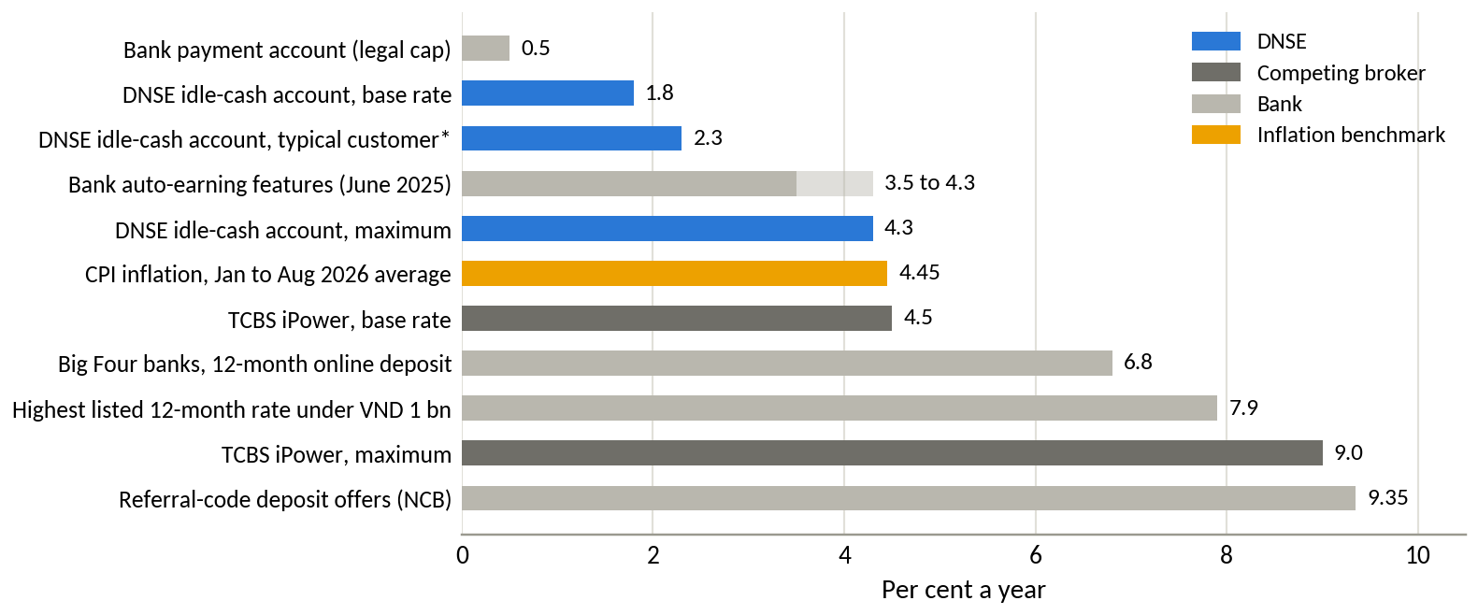
Source: DNSE (2026b) and TCBS (2026a) product pages, accessed 24 September 2026; DNSE (2025) comparison of bank auto-earning products; VietnamNet (2026) and VnExpress (2026c) bank rate surveys; Báo Đấu thầu (2026). * A customer holding VND 1 million to 500 million with trading value in the same band.
Figure B2. Investor cash held at brokers, indexed to the third quarter of 2025
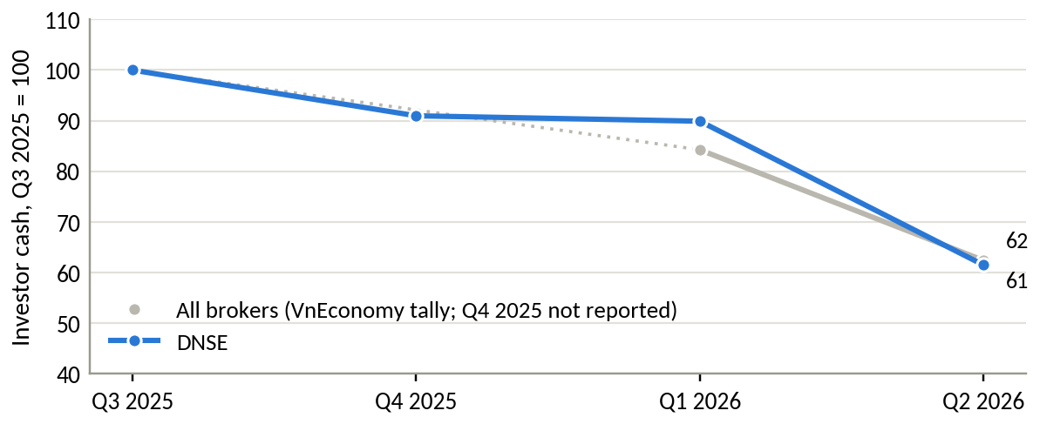
Source: VnEconomy (2026b) tally of investor deposits at securities firms; DNSE filings. The industry figure for the fourth quarter of 2025 was not reported.
Table B3. Macroeconomic and banking indicators relevant to household savings, 2025 and 2026
Indicator | Value | Period
GDP growth | 8.18% (Q2 8.39%) | First half of 2026
Consumer price inflation, average | 4.45% (core 4.24%) | January to August 2026
Credit growth against deposit growth | 19.0% against 11.4% | 2025
Credit growth, year to date | 10.24%, about VND 20.5 quadrillion outstanding | To 28 August 2026
Household deposits at banks | Above VND 11 quadrillion, +7.1% in six months | June 2026
Individual payment account balances | About VND 1.22 quadrillion in 256.7 million accounts, against about VND 1.35 quadrillion a year earlier | June 2026
12-month deposit rate, Big Four state banks | 6.8% | September 2026
Highest listed 12-month rate for deposits below VND 1 billion | 7.9% | September 2026
Change in 12-month deposit rates at large banks since January | About +2.5 percentage points | January to July 2026
Bank-owned brokers' share of the rise in margin lending | 55% (all filed statements); 62% (press tally of the top 20) | Q2 2026
Source: National Statistics Office via Chinhphu.vn (2026) and Báo Đấu thầu (2026); State Bank of Vietnam via Diễn đàn Doanh nghiệp (2026), Thị trường Tài chính Tiền tệ (2026b), Vietstock (2026i) and VietnamPlus (2026); FiinRatings (2026); VnEconomy (2026b); VietnamNet (2026); VnExpress (2026c); Vietstock (2026g); filed statements via Vietcap Securities (2026).
Table B4. Where Vietnamese savers keep money, mid-2026
Pool | Value, VND trillion | Multiple of DNSE investor cash
Household deposits at banks (June 2026) | above 11,000 | about 5,600
Individual payment accounts at banks (June 2026) | about 1,220 | about 620
Investor cash at all securities firms (June 2026) | 86.6 | 44
DNSE customer assets (December 2025) | 53.5 | 27
DNSE investor cash (June 2026) | 1.96 | 1
Source: Vietstock (2026i); VietnamPlus (2026); VnEconomy (2026b); DNSE filings and releases.
Table B5. Competitive map of Vietnamese retail brokerage business models
Model | Examples | How it earns | Strength | Weakness
Bank-affiliated balance-sheet brokers | TCBS, VPBankS, MBS, SHS | Margin lending, bond distribution, investment banking | Cheap funding, capital, bank customers | Less focus on first-time and young investors
Independent full-service brokers | SSI, HSC, Vietcap, VNDirect | Margin, institutional brokerage, advisory | Research, institutional clients, brand | Higher cost to serve retail
Retail trading platforms | VPS | Retail brokerage, derivatives, margin | Largest retail and derivatives share | HOSE share fell to 12.61% in Q2 2026, lowest in 22 quarters
Digital zero-fee challengers | DNSE, Pinetree | Margin and derivatives | Low cost, fast technology, young customers | Small balances, no bank parent, trust gaps
Digital wealth and fund platforms | Independent fund and savings apps | Fees on funds, bonds and savings products | Low minimums, periodic investing, goal-based design | Mostly fee income; no large trading or margin platform
Banks' own savings features | Techcombank, VPBank, VIB | Deposit spread | Salary accounts, trust, 3.5 to 4.3% auto-earning (2025) | Limited investment choice
Source: company releases and statements; Vietstock (2026e); CafeF (2026b); DNSE (2025); authors' assessment.
Table B6. Comparable business models abroad and their lessons for DNSE
Firm and market | How it grew | How it earns money | Lesson for DNSE
Robinhood, United States | Zero commissions since its 2015 launch; 27.0 million funded customers in 2025 | Trading 59%, net interest 34%, subscriptions and other 7% of USD 4.5 billion revenue in 2025 | Growth after 2021 came from assets. Net deposits reached USD 68 billion in 2025 (35% of opening assets), helped by retirement accounts, a paid tier with a higher cash yield and a bank account with direct deposit. A USD 70 million FINRA penalty in 2021 for outages and misleading information preceded the shift
Trade Republic, Germany and Europe | EUR 1 trades and free ETF savings plans | Interest on cash and trading | Passing the full central bank rate on uninvested cash and automating savings plans took customer assets past EUR 150 billion by October 2025; EUR 2.5 billion of interest was passed to customers from 2023
Zerodha and Groww, India | Flat or zero fees; Groww began as a mutual fund platform in 2016 | Zerodha earned 70 to 90% of its income from futures and options | After the regulator tightened derivatives trading in late 2024, derivatives turnover fell 29% and Zerodha's revenue fell from INR 10,000 crore to 8,500 crore. Groww, with monthly fund plans at its base, raised profit 12% in the quarter when peers fell. Monthly SIP inflows reached INR 29,529 crore in October 2025
SBI and Rakuten Securities, Japan | Zero commissions on domestic shares from October 2023, plus the tax-free NISA account from 2024 | Balances, fund distribution and group banking | NISA accounts reached 26.96 million and cumulative purchases JPY 63 trillion by June 2025. Rakuten's automatic sweep between its bank and broker passed 7 million accounts in August 2026 and pays a preferential deposit rate
Futu, Hong Kong | Low commissions and a strong community | Brokerage 46%, interest 46% of revenue in 2025 | Only 3.37 million of 29.2 million users are funded (11.5%), yet client assets reached HKD 1.23 trillion, with HKD 180 billion in wealth management products
DNSE, Vietnam | Zero fees on shares; 1.7 million accounts | Lending 40%, own-account investments 32%, brokerage 26% of revenue in H1 2026 | Has the reach and the technology; lacks a competitive cash product, automated saving and asset-based incentives
Source: Robinhood Markets (2026); FINRA (2021); Trade Republic (2025); Inc42 (2025); AMFI (2025); Financial Services Agency (2026); Rakuten Group (2026); Futu Holdings (2026a).
Table B7. Transferability of foreign designs to Vietnam
Design | Transferable | Condition in Vietnam
Market-rate yield on uninvested cash | Yes | Deliver through a bank sweep or a licensed money market fund; legal structure to be confirmed with the SSC
Automatic monthly investment plans | Yes | Periodic fund subscriptions and bond products from VND 1 million already exist
Salary-linked transfers | Partly | Wages arrive at banks; a pull on payday requires bank open interfaces (standard by March 2027) or ZaloPay
Asset-based rewards | Yes | Pay rewards on funding, saving and transferred portfolios instead of sign-ups
Paid subscription tier | Later | Useful once a funded base exists
Payment for order flow | No | Order-driven exchanges
Tax-advantaged accounts | No, for now | Requires policy change; DNSE can support industry proposals
Bank account with direct deposit | No | Securities firms cannot take deposits; partner banks can
Source: authors' assessment based on Table B6 and the Vietnamese regulation cited in Section 4.1.
Table B8. Scoring of candidate target markets
Candidate market | Wallet per customer (25%) | Reachable scale (20%) | Fit with balance-based revenue (20%) | DNSE's right to win (15%) | Low competitive intensity (10%) | Low conduct and regulatory risk (10%) | Weighted | Equal
Salaried mass-affluent adults (employed, secondary-educated, upper 60% income) | 4 | 5 | 5 | 3 | 3 | 4 | 4.15 | 4.00
Affluent and high-net-worth investors | 5 | 1 | 4 | 1 | 1 | 4 | 2.90 | 2.67
Household businesses | 3 | 4 | 2 | 1 | 2 | 3 | 2.60 | 2.50
Young first-time investors (15 to 24) | 1 | 3 | 2 | 5 | 2 | 2 | 2.40 | 2.50
Active derivatives traders | 2 | 1 | 2 | 5 | 2 | 1 | 2.15 | 2.17
Source: authors' assessment. Scores from 1 (weak) to 5 (strong). The weighted total uses the weights shown; the equal-weight total is a robustness check.
Table B9. Scope of the business problem for Round 3
Dimension | In scope | Out of scope for now
Customer segment | Salaried adults, roughly 22 to 40, in the upper 60% of the income distribution. The first wave comes from DNSE's own unfunded or low-balance accounts held by working customers, including Gen Z customers who have started work | Students without income, affluent advisory clients, institutional clients, household businesses
Journey stage | The first 90 days after an account is opened, from identity verification to first funding and the third payday, and the matching restart journey for dormant accounts | Brand marketing, trading features, derivatives, after-sales service beyond balance retention
Solution depth | Mechanism, value logic, main assumptions and measures of success | Detailed feature design, screens, pricing tables and budgets, which Round 3 will develop
Source: authors' assessment.
Table B10. Prioritisation of candidate business problems
Candidate problem | Scale anchor | Scale (25%) | Urgency (15%) | Strategic relevance (20%) | Data support (20%) | Control (20%) | Weighted | Equal
Balance gap (accounts not converted into funded, retained relationships) | 2026 plan gap of VND 395 billion; VND 83 billion a year per extra VND 1 million lent per account | 5 | 4 | 5 | 5 | 4 | 4.65 | 4.60
Trust and reliability deficit | Indirect; blocks conversion of the base | 3 | 4 | 4 | 4 | 5 | 3.95 | 4.00
Loss-making brokerage | About VND 89 billion a year below direct cost | 3 | 3 | 3 | 5 | 4 | 3.60 | 3.60
Derivatives concentration and regulatory exposure | Three services stopped in August 2026; Indian turnover fell 29% after new rules | 3 | 4 | 4 | 4 | 2 | 3.35 | 3.40
Control and conduct weaknesses | Fine of VND 802.5 million; insider lending over 30 months; reputational cost not measurable | 2 | 4 | 3 | 3 | 5 | 3.30 | 3.40
Earnings dependent on proprietary trading | Swings of about VND 150 billion a year | 4 | 2 | 2 | 5 | 3 | 3.30 | 3.20
Rising funding cost and pledged deposits | About VND 130 billion a year from a 1.4-point rise in the cost of funds | 4 | 4 | 3 | 3 | 2 | 3.20 | 3.20
Source: authors' assessment based on Sections 2 and 3. Scores from 1 (weak) to 5 (strong). Scale anchors are annual pre-tax profit effects estimated from DNSE filings where possible.
Figure B3. What the 2026 profit plan implies for loans, equity and customer assets
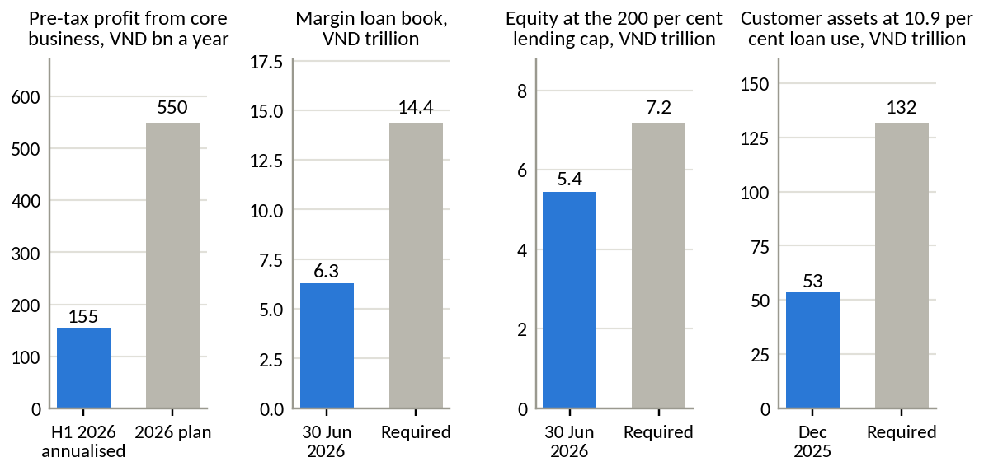
Source: DNSE filings and 2026 plan; authors' calculations. The calculation assumes that all additional profit comes from lending at the first-half 2026 net spread of 4.88 points, with no change in other lines. It is an order-of-magnitude illustration.
Table B11. Business problem statement
Element | Statement
Context | DNSE opened one in five of Vietnam's new securities accounts in 2025 and serves 1.7 million customers. Its income comes from lending, trading and its balance sheet, all of which depend on customer money held on the platform
Quantified gap | DNSE holds 12.7% of accounts but 2.3–3.5% of investor cash, 1.4–1.8% of margin lending and 0.6–0.8% of quarterly industry profit; 5.7% of accounts were active in December 2025; assets per account fell 9.5% in 2025; 1.8% of accounts held net assets of VND 10 million or more in December 2025
Economic impact | Core pre-tax profit has stayed between VND 128 and 221 billion a year since 2022 while revenue tripled; each extra VND 100 of core revenue brought VND 102 of cost in H1 2026. Each additional VND 1 million lent per account is worth about VND 83 billion of pre-tax profit a year. The 2026 plan implies a loan book 2.3 times the current one
Strategic urgency | Deposit rates have risen about 2.5 points in 2026 and cash is leaving brokers; bank-owned brokers supplied more than half of margin growth in the second quarter; open banking interfaces become standard by March 2027, after which every competitor can link salary accounts
Problem | DNSE converts sign-ups into funded, retained relationships at a low rate, above all in the first 90 days, because its products give salaried customers no competitive, automatic or trusted way to keep money on the platform. Incentives that reward opening accounts may add to this (hypothesis for Round 3)
Source: Sections 2 and 3.
Table B12. Strategic alternatives assessed against the balance gap
Alternative | Impact on funded balances (30%) | Profit potential by 2028 (20%) | Low capital and cost need (15%) | Low execution and regulatory risk (15%) | Fit with DNSE capabilities (10%) | Evidence support (10%) | Weighted | Equal
B. Payday Portfolio, a salary-linked savings-to-investing layer | 5 | 3 | 3 | 4 | 4 | 5 | 4.05 | 4.00
D. Upmarket advisory tier for affluent investors | 4 | 4 | 2 | 3 | 1 | 3 | 3.15 | 2.83
H. Trust and reliability programme only | 2 | 2 | 4 | 5 | 5 | 3 | 3.15 | 3.50
E. Distribution alliance with a bank or e-wallet | 3 | 3 | 4 | 2 | 3 | 3 | 3.00 | 3.00
C. Derivatives-to-shares bridge for traders on same-day trading | 2 | 3 | 4 | 1 | 5 | 2 | 2.65 | 2.83
G. Reprice the idle-cash account only | 3 | 1 | 1 | 4 | 5 | 3 | 2.65 | 2.83
F. Reintroduce trading fees | 1 | 3 | 5 | 2 | 1 | 2 | 2.25 | 2.33
A. Continue acquisition-led growth | 1 | 1 | 3 | 4 | 5 | 1 | 2.15 | 2.50
Source: authors' assessment. Scores from 1 (weak) to 5 (strong); for cost and risk, a higher score means lower cost or lower risk. Option B scores 4 on execution and regulatory risk because its first phase needs no new legal structure. Option C depends on same-day trading, possibly not before 2028 (Người Quan sát, 2026). Options G and H become parts of option B.
Table B13. The first 90 days of a new DNSE customer, today and under Payday Portfolio
Moment | Today | Under Payday Portfolio
Day 0, sign-up | Account opened, often in response to a cash reward; identity checks by chip reading and photos | Account opened through VNeID; the first screen asks for a savings goal and a payday amount
First funding | Deposit set by the reward condition (for example VND 2 million); no reason to add more | First transfer on the next payday; reward paid only on money that stays
Idle cash | Earns 2.1 to 2.3% unless the balance exceeds VND 500 million | Passes through the idle-cash account and is invested by goal on the next trading day; a market-linked cash yield follows in phase 2 if the SSC confirms the structure
Paydays 2 and 3 | No prompt; cash drifts back to banks as deposit rates rise | Automatic transfer; ladder allocation by goal; progress shown against the goal
Day 90 | Most accounts inactive (5.7% of accounts were active in December 2025) | Review of goal and allocation; invitation to the equity plan; no margin until month 12, then only after a suitability check
Closure | VND 100,000 fee reported by customers; slow cancellation | Free and immediate; data deleted on request
Source: authors' design; current journey reconstructed from DNSE product pages and customer reviews.
Table B14. Evidence behind each design choice
Design choice | Evidence in Vietnam | Lesson abroad
Target salaried adults and start with DNSE's own accounts | The three leading Findex segments rank first to fourth under four weightings; 40 to 50% receive wages into an account; 94% of DNSE accounts used no product in December 2025 | Groww built its base on monthly fund plans before trading
Act in the first 90 days | Assets per account fell 9.5% in 2025 while accounts grew 52%; complaints cluster at identity checks and first deposits | Robinhood tracks funded customers and net deposits, the measures that open and close this stage
Invested balance now; market-linked cash yield in phase 2 | DNSE pays 2.1 to 2.3% to typical customers against 6.0% at TCBS for the same balance (4.5% base) and 3.5 to 4.3% on bank auto-earning accounts; cash at brokers fell 38% in three quarters | Trade Republic passed the full central bank rate on cash and gathered EUR 150 billion; Rakuten's bank sweep passed 7 million accounts
Automatic payday transfers | Wages arrive in bank accounts; open banking standards by March 2027; ZaloPay link already live | Robinhood's direct deposit; India's SIPs of INR 29.5 thousand crore a month
Ladder into bonds and funds | TCBS earns most non-lending income from distribution; 75% of investors use only traditional channels and 81% want guidance | Futu holds HKD 180 billion in wealth products; Trade Republic added bond ETFs from EUR 1
No margin at launch; collateral later, by opt-in | Lending is DNSE's widest margin; the August 2026 penalty and derivatives risk argue for prudence | India's derivatives curbs cut broker revenue sharply
Trust layer | Trust complaints attract 43% of helpful votes on negative reviews; 34% of investors fear hidden fees; new data protection law | Robinhood's 2021 penalty for outages and misleading information preceded its shift to savings products
Source: Sections 2 and 3; TCBS (2026b); Nhân Dân (2025); VnEconomy (2025); and the sources of Table B6.
Table B14a. Customer fears, evidence, design responses and published proof
Customer fear | Evidence today | Design response | Published proof
"I cannot get my money out" | Deposits not credited or withdrawal delays in 5.0% of negative reviews | Withdrawal to the linked bank in one tap | Median withdrawal time
"I will be locked in" | Closure complaints draw 11.3% of helpful votes; a VND 100,000 closure fee reported | No closure fee; pause, skip or cancel in one tap | Cancellations completed in the app
"There are hidden conditions" | Bonus terms in 8.6% of negative reviews and 17.8% of helpful votes; 34% of investors fear non-transparent fees | All terms on one screen; rewards only on money that stays | Trust themes below 10% of negative reviews (24% today)
"Where is my money?" | Accusations of deception in 17.6% of negative reviews and 28.2% of helpful votes | Holdings shown in the customer's name; monthly statement | Monthly statement
"The app fails on payday" | Crashes in 27.3% of negative reviews, though not above peers | Transfers run as scheduled back-end jobs; reliability as a launch condition | Transfer success of 99.5% or more
"Is it legal?" | SSC fine of VND 802.5 million, August 2026 | Product reported to the SSC before launch | Written confirmation
Source: Table E3; VnEconomy (2025); Market Times (2026); authors' design.
Table B15. Illustrative outcomes of Payday Portfolio 18 months after launch
Assumption or outcome | Conservative | Base | Upside
Savers enrolled | 60,000 | 150,000 | 300,000
Share of about 1.4 million dormant accounts | 4% | 11% | 21%
Monthly contribution, VND million | 1.0 | 1.5 | 2.5
Contribution as a share of the average worker's monthly income (VND 9.0 million) | 11% | 17% | 28%
Share of contributions kept on the platform | 60% | 70% | 80%
Assets per saver after 18 months, VND million | 10.8 | 18.9 | 36.0
Layer assets, VND trillion | 0.65 | 2.84 | 10.80
Layer assets as a multiple of DNSE investor cash, June 2026 | 0.3 | 1.4 | 5.5
Net new money a year at full enrolment, VND trillion | 0.43 | 1.89 | 7.20
Fee yield on layer assets | 0.5% | 0.8% | 1.0%
Annual fee revenue, VND billion | 3 | 23 | 108
Fee revenue per saver a year, VND thousand | 54 | 151 | 360
Accounts holding VND 10 million or more, % of 1.7 million | 5.1 | 10.4 | 19.2
Phase 2 only: loans backed by layer assets (10, 15 and 20%), VND trillion | 0.07 | 0.43 | 2.16
Phase 2 only: net lending income at a 4.9-point spread, VND billion | 3 | 21 | 106
Source: authors' projections; National Statistics Office (2026) for income. All inputs are assumptions to be validated in Round 3. Assets per saver equal contribution times share kept times 18 months, before investment returns. The share of accounts holding VND 10 million or more adds savers to the 27,100 accounts already above that level, assuming savers were below it at enrolment, and divides by 1.7 million accounts. Costs of bonuses, marketing and technology are not included; the pilot measures them against fee revenue per saver (Table B17, test 5).
Table B16. Feasibility conditions for Payday Portfolio
Condition | Status | Detail
Product components | In place | Idle-cash account, Trứng Vàng bonds from VND 1 million, Margin Deal, VN30 ETF trading, Lightspeed interface
Technology | In place | Order processing in about 4 milliseconds; Lightspeed API; ZaloPay partnership since 2023; a new data centre planned for 2026
Funding and capital | In place | Lending at 116% of equity against a 200% ceiling; VND 3.5 trillion bond programme approved in March 2026
Cash layer structure | Phase 2 | Phase 1 uses the idle-cash account as transit; a bank sweep or licensed money market fund for a market-linked yield follows once the legal basis is confirmed
Fund distribution and management | Partial | A partner fund manager is needed now; the board plans to establish or acquire a fund manager, a step delayed by high valuations
Salary link at scale | Partial | ZaloPay now; bank open interfaces standard by March 2027
Regulatory clearance | Required | Prior report to the SSC, as the August 2026 penalty showed; the draft biometric circular affects onboarding and withdrawals
Reliability of the app and payday transfers | Decision needed | Targets for uptime, crash-free sessions and transfer success before launch; App Store reviewers cite crashes, login and onboarding in 51% of complaints
Trust and control changes | Decision needed | Remove the closure fee; replace sign-up rewards with funding rewards; publish reliability data; close the control gaps found by the 2026 penalty
Source: DNSE product pages and releases; Vietstock (2026b); Thời báo Tài chính Việt Nam (2026); State Bank of Vietnam (2024); Dân trí (2026a); authors' assessment.
Table B17. Assumptions, tests and decision rules for Round 3
No. | Assumption | Priority | Test | Measure and decision rule
1 | Most accounts hold little money, and the gap concentrates in reward-driven cohorts | High | Balances and cohort curves by channel and reward, from internal data (months 0 to 2) | Share funded within 30 days and balance at day 90 by cohort; if reward cohorts hold less, rewards move from sign-up to funding at once
2 | Enough dormant accounts belong to salaried customers aged 22 to 40 | High | Age from identity records; survey of 2,000 dormant customers on income and intent | At least 30% salaried and intending to invest; otherwise narrow the target
3 | A phase 2 cash yield can be structured legally | High | SSC pre-consultation; term sheets from two bank or fund partners | Written confirmation and net yield after fees; phase 1 proceeds regardless
4 | Automation turns intention into funding (arm 2 against arm 1) | High | Three-arm randomised pilot, 20,000 dormant accounts, months 3 to 6 | Enrolment within 90 days: 11% or more, scale up; 4 to 11%, redesign; below 4%, stop
5 | A bonus on new contributions pays for itself (arm 3 against arm 2) | High | Same pilot | Extra balance times fee yield at least equal to the bonus cost; otherwise drop the bonus
6 | Money stays and is new | High | Source tag on every inflow; retention at day 90 | 70% or more of contributions kept; 80% or more new money
7 | The trust layer works and reliability holds | Medium | Review themes before and after launch; shadow payday runs | Trust themes below 10% of negative reviews (24% today); transfer success of 99.5% or more before launch
Source: authors' design. The thresholds of 4 and 11 per cent equal the conservative and base cases in Table B15 as shares of dormant accounts. Thresholds are proposals to be agreed with DNSE management.
Figure B4. Validation roadmap for Round 3
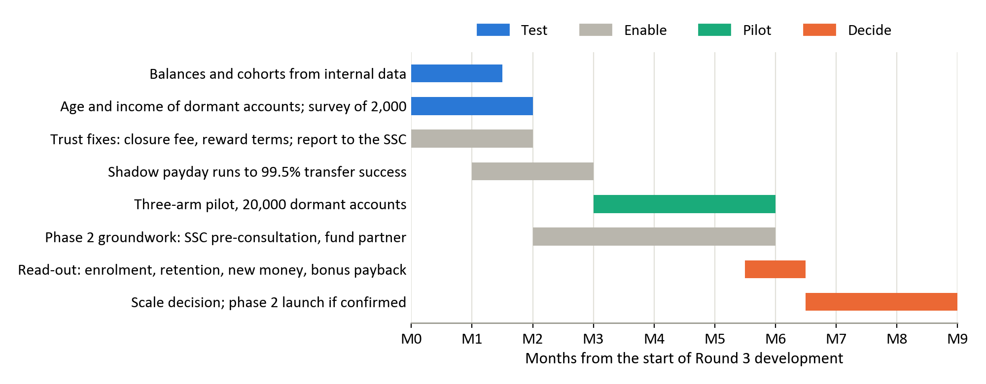
Source: authors' design.

Appendix C. DNSE financial data
The tables below summarise the 395 line items of DNSE's filed statements used in the analysis. Annual figures are sums of quarters for flows and period-end values for balances. Every value was recomputed from the source data for this version and matches.
Table C1. DNSE income statement summary, 2021 to the first half of 2026 (VND billion)
Item | 2021 | 2022 | 2023 | 2024 | 2025 | H1 2026
Operating revenue | 180.7 | 452.1 | 714.5 | 807.4 | 1,457.9 | 848.2
Interest on margin loans and advances | 42.7 | 223.1 | 286.2 | 360.5 | 555.8 | 336.1
Interest on deposits and bonds held to maturity | 20.1 | 112.9 | 196.0 | 245.0 | 303.9 | 193.4
Brokerage revenue | 90.0 | 84.8 | 67.6 | 144.8 | 404.0 | 222.1
Gains on financial assets at fair value | 20.4 | 18.7 | 157.9 | 47.9 | 171.4 | 77.2
Direct brokerage cost | 51.5 | 74.4 | 111.1 | 174.8 | 464.9 | 266.5
Losses on financial assets at fair value | 24.8 | 80.0 | (0.2) | 41.1 | 25.2 | 43.4
Interest expense | 2.7 | 29.8 | 22.1 | 28.0 | 66.8 | 75.2
Template line 24 (provisions and borrowing cost of the loan book) | 21.2 | 142.4 | 211.5 | 182.6 | 363.0 | 248.9
Administrative expenses | 14.8 | 37.1 | 94.3 | 151.9 | 181.4 | 95.4
Pre-tax profit | 68.2 | 95.0 | 285.6 | 227.5 | 340.2 | 111.6
Net proprietary result | (4.4) | (61.3) | 158.0 | 6.8 | 146.2 | 33.9
Core pre-tax profit | 72.5 | 156.3 | 127.6 | 220.7 | 194.0 | 77.7
Profit after tax | 54.5 | 77.8 | 229.0 | 181.8 | 272.5 | 93.1
Source: DNSE filed statements via Vietcap Securities (2026); first half of 2026 from the statements reviewed by KPMG; authors' calculations. Costs are shown as positive amounts. Core pre-tax profit excludes the net result on financial assets at fair value through profit or loss. Negative values are in parentheses.
Table C2. DNSE balance sheet and key ratios, 2021 to 30 June 2026
Item | 2021 | 2022 | 2023 | 2024 | 2025 | Jun 2026
Margin loans and advances | 1,192 | 2,280 | 2,483 | 3,882 | 5,832 | 6,303
Deposits and bonds held to maturity | 883 | 2,824 | 3,495 | 5,103 | 6,266 | 5,714
Financial assets at fair value | 84 | 576 | 299 | 167 | 2,086 | 1,540
Cash and equivalents | 21 | 432 | 505 | 1,093 | 511 | 842
Total assets | 2,315 | 6,409 | 7,446 | 10,637 | 15,139 | 15,208
Borrowings and bonds | 1,224 | 2,735 | 3,643 | 6,494 | 10,600 | 9,446
Owners' equity | 1,059 | 3,136 | 3,305 | 4,030 | 4,302 | 5,440
Investor cash held off balance sheet | 435 | 251 | 790 | 1,340 | 2,903 | 1,961
Pre-tax margin, % | 37.7 | 21.0 | 40.0 | 28.2 | 23.3 | 13.2
Brokerage revenue as % of direct cost | 174.9 | 114.0 | 60.9 | 82.8 | 86.9 | 83.3
Return on equity, % | 8.9 | 3.7 | 7.1 | 5.0 | 6.5 | 3.8
Loans as % of equity | 112.6 | 72.7 | 75.1 | 96.3 | 135.6 | 115.9
Yield on margin loans, % | 13.0 | 12.0 | 11.9 | 10.1 | 11.1 | 11.2
Estimated cost of funds, % | 6.5 | 6.8 | 7.3 | 4.1 | 5.1 | 6.3
Net interest margin, % | 6.2 | 5.4 | 4.8 | 5.0 | 4.2 | 3.5
Source: DNSE filed statements via Vietcap Securities (2026); authors' calculations. Balances are at the end of each period. Yields, cost of funds and net interest margin are averages of annualised quarterly values; the cost of funds is estimated as interest expense plus template line 24, less the rise in the allowance for loan losses, over average borrowings. Return on equity for the first half of 2026 is annualised.
Table C3. DNSE quarterly indicators, first quarter of 2024 to second quarter of 2026
Indicator | Q1 24 | Q2 24 | Q3 24 | Q4 24 | Q1 25 | Q2 25 | Q3 25 | Q4 25 | Q1 26 | Q2 26
Operating revenue | 182 | 198 | 194 | 234 | 243 | 290 | 489 | 435 | 395 | 453
Pre-tax profit | 88 | 43 | 55 | 42 | 66 | 91 | 171 | 12 | 14 | 97
Core pre-tax profit | 68 | 57 | 54 | 42 | 45 | 37 | 99 | 13 | 24 | 54
Net proprietary result | 20 | (14) | 1 | 0 | 21 | 54 | 72 | (1) | (10) | 43
Brokerage revenue | 32 | 40 | 33 | 39 | 49 | 74 | 156 | 125 | 120 | 103
Direct brokerage cost | 39 | 45 | 41 | 50 | 61 | 84 | 170 | 150 | 138 | 129
Margin loans and advances | 3,409 | 3,598 | 4,102 | 3,882 | 4,276 | 5,053 | 5,750 | 5,832 | 5,910 | 6,303
Investor cash | 1,278 | 1,486 | 1,637 | 1,340 | 429 | 2,516 | 3,192 | 2,903 | 2,869 | 1,961
Yield on margin loans, % | 10.1 | 10.0 | 9.7 | 10.6 | 10.2 | 10.7 | 12.7 | 10.8 | 10.1 | 12.3
Cost of funds, % | 4.5 | 3.6 | 3.6 | 4.6 | 4.6 | 4.6 | 5.2 | 5.7 | 6.1 | 6.5
Net interest margin, % | 4.9 | 5.5 | 4.8 | 4.7 | 4.2 | 3.9 | 5.1 | 3.4 | 2.8 | 4.1
Fee income, % of revenue | 18.9 | 21.2 | 18.2 | 18.1 | 21.3 | 26.8 | 33.0 | 31.2 | 31.8 | 25.5
Source: DNSE filed statements via Vietcap Securities (2026); authors' calculations. VND billion unless stated. Q2 2026 pre-tax profit is the reviewed half year less the first quarter. Negative values are in parentheses.

Appendix D. Market and industry data
Table D1 lists the share measures behind Figure 1 with their denominators, including both industry totals where they differ. Table D2 compares the share of accounts that are active or funded at brokers in Vietnam and abroad that publish such a measure.
Table D1. DNSE's position on eight measures, 2025 to mid-2026
Measure | DNSE | Market total | DNSE share, % | Ratio to account share
Securities accounts, 31 December 2025 | 1,512,920 | 11,871,933 (VSDC) | 12.74 | 1.00
New accounts opened, 2025 | 518,514 | 2,681,838 (VSDC) | 19.33 | 1.52
Securities accounts, 30 June 2026 | about 1.70 million | 13,430,517 (VSDC) | 12.66 | 1.00
Derivatives brokerage, Q2 2026 | second place | HNX announcement | 25.38 | 2.00
Listed-share brokerage on HNX, Q2 2026 | eighth place | HNX announcement | 2.88 | 0.23
Investor cash at brokers, 30 June 2026 | VND 1,961 billion | VND 86.6 trillion (press tally); VND 56.4 trillion (filed statements) | 2.26 to 3.48 | 0.18 to 0.27
Margin lending, 30 June 2026 | VND 6,303 billion | VND 453.8 trillion (press tally, with advances); VND 345.3 trillion (filed statements) | 1.39 to 1.83 | 0.11 to 0.14
Pre-tax profit, Q2 2026 | VND 97.4 billion | VND 15,200 billion (77 brokers, press tally); VND 11,871 billion (filed statements) | 0.64 to 0.82 | 0.05 to 0.06
Source: VSDC annual report 2025 and account statistics; DNSE (2026d); Hanoi Stock Exchange (2026); VnEconomy (2026b); Vietstock (2026g); CafeF (2026d); filed statements via Vietcap Securities (2026); authors' calculations. Filed-statement totals sum the brokers in Vietcap's data service, DNSE included. The ratio to account share divides each share by 12.7 per cent. HNX shares are shares of traded value on HNX only.
Table D2. Share of accounts that are active or funded, brokers that publish a measure
Broker and model | Base | Active or funded | Share, % | Measure and date
DNSE. Vietnam; zero-fee app, no branches | 1,512,920 accounts, 31 December 2025 | 85,739 customers using at least one product | 5.7 | Monthly, December 2025 (4.2 in December 2024)
TCBS. Vietnam; zero-fee, 99% of accounts opened online | 1,203,039 customers, 31 December 2025 | About 410,000 customers trading on TCInvest | about 34 | Monthly, December 2025; read from a chart
VNDirect. Vietnam; branches and app | About 1 million customers, 31 December 2025 | 134,507 individual customers using a product | 13.5 or less | 2025, window not stated; sum of three product tiers
SSI, Digital Sales channel. Vietnam; online channel of a full-service broker | Customers of the channel (number not disclosed) | Customers with a trade in the past 90 days | 19.2 | 90 days, 2025
Robinhood. United States; commission-free app | 23.4 million funded customers, December 2023 | 10.9 million monthly active users | 47 | Monthly, counts logging in; last disclosed for the fourth quarter of 2023
Futu (moomoo). Hong Kong and abroad; app-only broker | 6.64 million brokerage accounts, 30 June 2026 | 3.84 million funded accounts | 58 | Positive balance, 30 June 2026
Webull. United States and abroad; commission-free app | 28.2 million registered users, 30 June 2026 | 5.13 million funded accounts | 18 | Registered users need not open an account; 30 June 2026
eToro. Global; social trading app | About 38 million registered users | About 3.5 million funded accounts | about 9 | Registered users; as reported in 2025
Source: DNSE Securities (2026d); TCBS (2026c); VNDIRECT Securities (2026); SSI Securities Corporation (2026); Robinhood Markets (2024); Futu Holdings (2026b); Webull Corporation (2026); Ho Chi Minh City Securities Corporation (2025) for eToro; authors' calculations. The TCBS figure is read from an unlabelled chart and is accurate to about 0.02 million; Ho Chi Minh City Securities Corporation (2025) separately reports about 30 per cent of TCBS accounts active regularly in the first quarter of 2025. VNDirect's figure adds three product tiers and may count a customer more than once. Measures differ in window and in base (accounts opened, funded customers or app registrations), so the table shows direction rather than exact gaps. No activity count was found for VPS, VPBankS, FPTS, HSC or Vietcap.

Appendix E. Customer review analysis
The tables below document the review cleaning, the cleaned Google Play sample, the theme coding and the cross-check against the App Store. Every count was recomputed from the cleaned files for this version and matches. Table E5 gives translated examples of the most-endorsed reviews.
Table E1. Review cleaning log
Stage | DNSE, Play | VPS, Play | FPTS, Play | DNSE, iOS | VPS, iOS | FPTS, iOS
Reviews retrieved | 867 | 1,200 | 177 | 332 | 518 | 205
Loan advertising removed | 127 | 23 | 0 | 0 | 0 | 0
Referral farming removed | 70 | 3 | 0 | 73 | 6 | 0
Duplicates removed | 0 | 3 | 0 | 0 | 0 | 0
Reviews retained | 670 | 1,171 | 177 | 259 | 512 | 205
Mean rating before cleaning | 3.29 | 2.60 | 2.18 | 3.37 | 1.57 | 2.31
Mean rating after cleaning | 3.22 | 2.58 | 2.18 | 2.94 | 1.53 | 2.31
Source: Google Play and Apple App Store public listings; authors' cleaning code. VPS is its 1,200 most recent Google Play reviews, from 27 March 2023.
Table E2. DNSE Google Play reviews by year after cleaning
Year | Retrieved | Removed, % | Retained | Mean rating | One-word, % | Substantive mean | Four-word rule, % | Substantive mean, four-word rule
2020 | 3 | 0.0 | 3 | 3.67 | 0.0 | 3.67 | 33.3 | 3.00
2021 | 72 | 11.1 | 64 | 2.03 | 6.2 | 1.83 | 26.6 | 1.75
2022 | 207 | 46.4 | 111 | 3.18 | 18.0 | 2.85 | 34.2 | 2.49
2023 | 154 | 53.9 | 71 | 2.68 | 9.9 | 2.42 | 16.9 | 2.22
2024 | 202 | 4.5 | 193 | 4.35 | 33.7 | 4.15 | 62.7 | 3.74
2025 | 159 | 0.6 | 158 | 2.65 | 12.0 | 2.38 | 25.9 | 2.01
2026 | 70 | 0.0 | 70 | 3.06 | 12.9 | 2.85 | 25.7 | 2.48
All years | 867 | 22.7 | 670 | 3.22 | 18.5 | 2.88
Source: Google Play, retrieved 23 September 2026; authors' cleaning and coding. Substantive reviews exclude one-word reviews; the four-word rule is a sensitivity test.
Table E3. Themes in DNSE's negative Google Play reviews
Theme | Negative reviews | Share of negative reviews, % | Share of helpful votes, % | All retained reviews with theme
Crashes, freezes, login failures, slow orders | 76 | 27.3 | 21.4 | 102
Account opening, identity checks, one-time passwords, chip reading | 59 | 21.2 | 17.9 | 70
Explicit accusation of deception or fake reviews | 49 | 17.6 | 28.2 | 52
Sign-up bonus terms, advertised rewards not received | 24 | 8.6 | 17.8 | 34
Deposits not credited, withdrawal delays | 14 | 5.0 | 6.7 | 24
Cannot close the account, closure fee | 10 | 3.6 | 11.3 | 11
Interface, charts, layout | 7 | 2.5 | 2.2 | 40
Arrived through a YouTube or social media referral | 5 | 1.8 | 1.3 | 15
Charges different from the advertised rate | 3 | 1.1 | 3.5 | 8
Any trust theme (deception, bonus terms, closure) | 67 | 24.1 | 42.9
Any product theme (stability, onboarding) | 118 | 42.4 | 34.1
Idle-cash product (Tài khoản không ngủ) | 0 | 0.0 | 0.0 | 3
Source: as for Table E2. 278 one and two-star reviews carrying 1,794 helpful votes. Themes are not exclusive, so shares sum to more than 100.
Table E4. Three applications compared on both stores
Application | Google Play, retained reviews | Google Play, mean rating | Google Play mean, 2025 to 2026 | App Store mean, 2025 to 2026 | App Store one-star share, % | Apple rating, all ratings
DNSE Entrade X | 670 | 3.22 | 2.77 | 2.25 | 59.0 | 4.04 (1,490 ratings)
VPS SmartOne | 1,171 | 2.58 | 2.10 | 1.47 | 77.2 | 3.03 (5,756 ratings)
FPTS EzTrade | 177 | 2.18 | 2.18 | 2.31 | 50.2 | 2.82 (76 ratings)
Source: Google Play (retrieved 23 September 2026) and Apple App Store (retrieved 24 September 2026); authors' cleaning. The store comparison covers 1 January 2025 to 21 September 2026.
Table E5. Selected DNSE reviews, translated from Vietnamese
Date | Stars | Helpful votes | Themes | Review
9 Jun 2025 | 1 | 58 | Bonus, deception, closure | "Everyone, be careful, it is a scam. You do not receive the 100k. To delete your account you have to pay it 100k. It steals your information."
24 May 2025 | 1 | 54 | Onboarding, closure | "I have been trapped. Anyone who wants to register should know that you cannot cancel the registration, even while the account is not yet approved ... after approval you have to go to the head office to delete the account."
28 Jun 2025 | 1 | 50 | Bonus, deception | "Deceptive and false. There is no 100k straight away. You have to deposit at least 2 million to get it."
6 Aug 2025 | 1 | 32 | Bonus | "False advertising. You have to deposit 2 million into the app to receive 100k, unlike the advertisement that says downloading the app earns 100k."
23 Sep 2021 | 1 | 28 | Onboarding | "Registered at 10 am and waited until nearly 1 pm without getting in; it keeps saying to wait an hour for verification ... when money is involved and it is this slow, who would dare to use it?"
12 Jul 2025 | 1 | 25 | Onboarding | "Why can it not scan the chip? Registering is so hard."
2 Jun 2025 | 2 | 18 | Stability, money | "When I deposit outside trading hours, the money leaves my bank account but the securities account does not receive it. Customer service replies slowly."
23 Jan 2025 | 1 | 17 | Bonus, fees, closure | "Closing the account costs a 100k fee. It is the first time I have heard of a securities company charging 100k to close an account. One star."
15 May 2026 | 5 | 13 | Stability, idle cash | "Apart from occasional errors ... the DNSE app is the best securities app in Vietnam. Low fees. The idle account is the best. Watching the interest rise in real time is satisfying, and money earns interest automatically once it is deposited."
Source: Google Play, retrieved 23 September 2026. Translated by the authors; abbreviations expanded and ellipses mark omitted text.

Appendix F. Findex segment analysis
The segment analysis uses the published Findex aggregates for Vietnam, which report each indicator for twelve segments defined one dimension at a time. Table F1 defines the two indices, Table F2 reports the inputs and Table F3 the ranks under four weighting schemes. Figure 6 in Section 3.2 and Figure F1 summarise the results.
Table F1. Indicators in the two Findex indices
Index | Indicator code | Indicator
A, formally held surplus | fin17a | Saved at a bank or similar institution in the past year
A | fin17dm | Saved into an account every month
A | fin8 | Stores money in an account
A | fin17e | Received interest on savings in the past year
A | fin17f | Saved for old age
A | fin24bd | Could cover expenses for more than two months without income
B, digital habit | dig.acc | Has a digitally enabled account
B | con26d | Uses the internet daily
B | con9a | Main phone is a smartphone
B | fin25e3w | Makes an in-store mobile or card payment every week
B | fin9b | Used a mobile phone or the internet to check an account balance
B | fin32.acc | Received wages into an account
Source: World Bank (2025b). Each index is the simple mean of its six indicators, in per cent of adults in the segment.
Table F2. Findex segment indicators for Vietnam, 2024 fieldwork
Segment | Share of adults, % | Index A | Index B | Has an account, % | Saved at an institution, % | Gap, points | Unconverted adults, million | Wages into an account, % | Saves monthly into an account, % | Saved for old age, %
All adults | 100.0 | 36.8 | 59.4 | 70.5 | 43.1 | 27.5 | 22.1 | 37.0 | 19.6 | 20.2
Women | 51.2 | 38.6 | 59.0 | 69.9 | 45.1 | 24.8 | 10.2 | 34.8 | 22.4 | 23.4
Men | 48.8 | 35.0 | 59.8 | 71.2 | 41.0 | 30.2 | 11.9 | 39.3 | 16.7 | 16.8
Aged 15 to 24 | 18.2 | 31.1 | 66.2 | 72.2 | 38.6 | 33.6 | 4.9 | 36.9 | 19.8 | 8.2
Aged 25 and over | 81.8 | 38.1 | 57.9 | 70.2 | 44.1 | 26.1 | 17.2 | 37.0 | 19.6 | 22.8
Primary education or less | 11.2 | 15.6 | 26.5 | 33.5 | 14.0 | 19.5 | 1.8 | 10.4 | 4.1 | 7.9
Secondary education or more | 88.8 | 39.5 | 63.5 | 75.2 | 46.7 | 28.5 | 20.4 | 40.4 | 21.5 | 21.7
Poorest 40% | 40.0 | 23.1 | 40.5 | 48.1 | 27.1 | 21.1 | 6.8 | 18.1 | 9.6 | 10.6
Richest 60% | 60.0 | 46.0 | 72.0 | 85.5 | 53.8 | 31.7 | 15.3 | 49.5 | 26.4 | 26.5
Rural | 67.0 | 33.8 | 56.1 | 67.4 | 40.5 | 26.9 | 14.5 | 33.5 | 16.8 | 18.0
Urban | 33.0 | 43.0 | 66.0 | 77.0 | 48.4 | 28.6 | 7.6 | 44.1 | 25.4 | 24.6
Out of labour force | 20.1 | 18.4 | 36.6 | 41.3 | 21.9 | 19.4 | 3.1 | 4.4 | 6.2 | 8.0
In labour force | 79.9 | 41.5 | 65.1 | 77.9 | 48.4 | 29.5 | 19.0 | 45.2 | 23.0 | 23.2
Source: World Bank (2025b); authors' indices. Index A averages six indicators of formally held surplus and Index B six indicators of digital habit (Table F1). The gap is account ownership minus saving at a financial institution. Unconverted adults hold an account but do not save at a financial institution.
Table F3. Segment ranks under four weighting schemes
Segment | Equal weights | Value-heavy | Scale-heavy | Reach-heavy | Score, equal weights
Richest 60% | 1 | 1 | 1 | 1 | 0.933
In labour force | 2 | 2 | 2 | 2 | 0.844
Secondary education or more | 3 | 4 | 3 | 3 | 0.798
Urban | 4 | 3 | 5 | 4 | 0.751
Aged 25 and over | 5 | 5 | 4 | 6 | 0.710
Men | 6 | 7 | 7 | 5 | 0.655
Women | 7 | 6 | 8 | 8 | 0.636
Rural | 8 | 8 | 6 | 9 | 0.609
Aged 15 to 24 | 9 | 9 | 9 | 7 | 0.549
Poorest 40% | 10 | 10 | 10 | 10 | 0.233
Out of labour force | 11 | 11 | 11 | 11 | 0.066
Primary education or less | 12 | 12 | 12 | 12 | 0.024
Source: authors' calculations from Table F2. Each criterion is min-max normalised across the twelve segments. Weights on (Index A, Index B, gap, unconverted adults, wage receipt, saving for old age): equal 1,1,1,1,1,1; value-heavy 3,1,1,1,2,2; scale-heavy 1,1,1,3,1,1; reach-heavy 1,3,2,1,1,1.
Figure F1. Payday and saving behaviour by segment pair
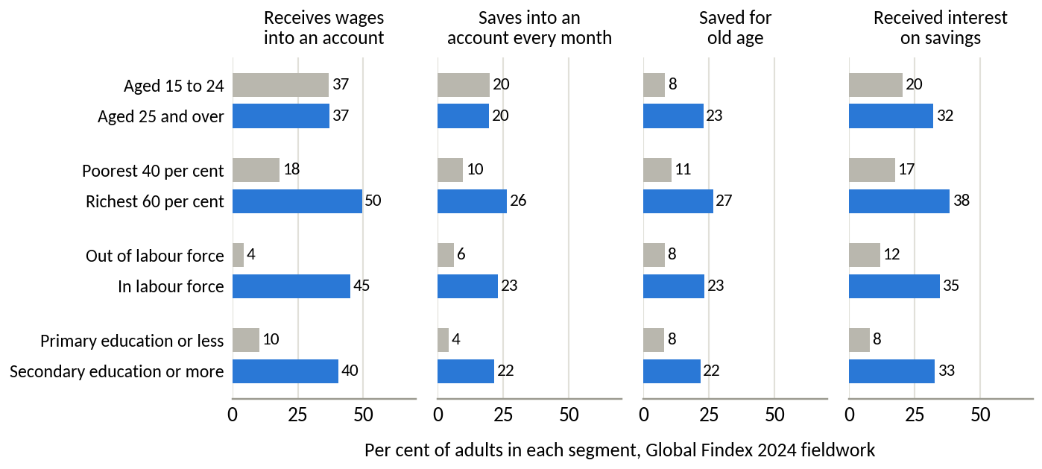
Source: World Bank Global Findex 2024 fieldwork.

Appendix G. Methods, assumptions and limitations
Table G1 defines the calculated measures. Table G2 separates the assumptions behind the main results from the measured evidence, and Table G3 lists the limitations of the data together with the steps taken to contain them.
Table G1. Definitions of calculated measures
Measure | Definition
Share of a market | DNSE's value divided by the market total for the same measure and date, kept within its own market
Ratio to account share | Share of a market divided by DNSE's share of securities accounts (12.7 per cent)
Value per account | Balance or flow divided by the number of accounts at the same date
Core pre-tax profit | Pre-tax profit less gains, plus losses, on financial assets at fair value through profit or loss
Brokerage coverage | Brokerage revenue divided by direct brokerage and custody cost
Estimated cost of funds | Interest expense plus template line 24, less the rise in the allowance for loan losses, multiplied by four and divided by average borrowings and bonds
Yields | Quarterly interest income multiplied by four and divided by the average of opening and closing balances
Net interest margin | Interest on loans and on deposits and bonds held to maturity, less the estimated cost of funds, over average interest-earning assets, annualised
Industry totals | Reported as a range between a press tally of all brokers and the sum of the filed statements of the brokers in Vietcap's data service
Incremental cost decomposition | Change in each core cost line between two periods as a share of the change in core costs; core excludes gains and losses on financial assets at fair value
Profit gap | Additional loans equal the gap between the 2026 profit target and annualised core profit divided by the net lending spread; required customer assets equal required loans divided by the 2025 ratio of loans to customer assets
Scenario model | Assets per saver equal monthly contribution times retention times 18 months; fee revenue equals layer assets times the fee yield; the share of accounts holding VND 10 million or more adds savers to the 27,100 accounts already above that level
Findex indices and scores | Indices are means of six indicators; segment scores are weighted means of six criteria, each min-max normalised across the twelve segments
Helpful-vote share | Helpful votes on negative reviews carrying a theme divided by all helpful votes on negative reviews
Weighted prioritisation | Sum of weight times score across criteria, with an equal-weight total reported as a check
Source: authors.
Table G2. Register of assumptions behind the main results
Assumption | Value used | Type | Effect if wrong | How Round 3 tests it
DNSE accounts at mid-2026 | 1.7 million | Company-reported | Per-account values move in proportion; 0.1 million more accounts lowers cash per account by about 6 per cent | Internal account register
Market totals | Press tally (VND 86.6 trillion of investor cash, 453.8 trillion of lending, 15,200 billion of quarterly profit) and sum of filed statements (56.4 trillion, 345.3 trillion and 11,871 billion) | Measured and external estimate | DNSE's shares move between the two ends of each range; the conclusions hold at either end | Not needed
Cost of funds | Interest expense plus line 24 less the allowance rise | Derived | If line 24 contains more provisions than assumed, the cost of funds is overstated | Notes on borrowing costs
Net lending spread for the profit gap | 4.88 points | Derived | A spread one point lower raises the required loans by about a quarter | Pricing and funding data
Scenario inputs | 60,000 to 300,000 savers; VND 1.0 to 2.5 million a month (base VND 1.5 million, a sixth of the average worker's VND 9.0 million); 60 to 80 per cent retained; fee yield 0.5 to 1.0 per cent; collateral only in phase 2 | Assumption | Enrolment and contribution drive most of the variation | Three-arm pilot
Dormant accounts | About 1.4 million: 1,512,920 accounts less 85,739 active users less 27,100 holding VND 10 million or more; the overlap is not published, so the true figure is 1.400 to 1.427 million | Derived | Pool size changes by under 2 per cent | Internal account register
Findex segment sizes | Population shares from the survey | External estimate | Sampling error of a few points on each estimate | Microdata cross-tabulation
Review themes reflect customer concerns | Cleaned public reviews | Measured, self-selected | Levels overstate dissatisfaction; comparisons across apps and years are more reliable | Complaint logs and customer survey
Source: authors. Type distinguishes measured facts, derived calculations, external estimates and assumptions.
Table G3. Limitations of the evidence
Limitation | Effect on the findings | Mitigation
No customer-level data from DNSE | Funnel stages and funded-account rates are inferred | Several independent measures point the same way; internal data are the first Round 3 task
Account definitions differ, and one person can hold several accounts | Per-account comparisons are approximate | Comparison with named peers on the same basis; ratios are large enough to survive errors of 20 per cent
Dates differ across sources (peer account counts from September 2025 to May 2026; balances at 30 June 2026) | Small bias in shares | Dates stated in every note; the gaps are large enough to survive the date differences
Template line 24 combines provisions with borrowing costs | The cost of funds is an estimate | Allowance changes deducted; the direction of change holds under either treatment
Industry totals differ between press tallies and the sum of filed statements | DNSE's shares vary by up to 1.2 points | Both totals reported as ranges
App store reviews are self-selected and contain spam | Levels are biased | One cleaning rule for three apps, helpful-vote weighting, App Store cross-check
Findex reports one dimension at a time from 1,000 interviews; the jump in formal saving between 2022 and 2024 may partly reflect survey changes | Segment intersections are unknown and the trend may be overstated | Ranks tested under four weightings; microdata analysis planned
Scores in the prioritisation and option matrices are judgements | Rankings could change with other weights | Explicit weights, equal-weight check, evidence cited for each score
Scenario figures are projections | They indicate scale and are not forecasts | Three scenarios and a validation plan with thresholds
Foreign models operate under different rules | Some lessons do not transfer | Transferability assessed design by design
Source: authors.

Appendix H. Data sources and access
Table H1. Data sources, access and dates
Dataset | Provider and access | Coverage and date
DNSE statements | Vietcap IQ data service (iq.vietcap.com.vn), line by line; DNSE investor relations (ir.dnse.com.vn) for the reviewed half-year statements | First quarter of 2018 to second quarter of 2026; retrieved 24 September 2026
DNSE company indicators and product terms | DNSE releases and product pages; financial press | 2024 to September 2026; accessed 20 to 24 September 2026
Exchange and industry data | HOSE and HNX quarterly announcements read from the exchanges' own news services (139 HNX notices from the fourth quarter of 2017; HOSE from 2023); VSDC annual reports 2018 to 2025 and the vsd.vn account counter; filed statements of 42 securities firms through Vietcap; press tallies only for industry totals of investor cash, lending and profit | Second quarter of 2026; account data to August 2026
Google Play reviews | Public listings of vn.com.encapital.arrow, vn.com.vpbs.smartone and com.fpts.eztrade | Retrieved 23 September 2026; cut-off 21 September 2026
App Store reviews | Public review feeds of the same three applications | Retrieved 24 September 2026
World Bank Global Findex | World Bank Open Data interface (api.worldbank.org, source 28, Vietnam); microdata catalogue 7998 identified for Round 3 | Waves 2011 to 2024; retrieved 20 September 2026
Macro, banking and payments | National Statistics Office releases (nso.gov.vn, also reported by Chinhphu.vn); State Bank of Vietnam data as reported by the press; FiinRatings; KPMG | 2025 to September 2026
International comparators | Company results releases and regulators' publications | 2021 to August 2026
Share price | Simplize market data | 24 September 2026
Source: authors. Supporting files, including the consolidated data workbook (FBA_Round2_DNSE_data_pack.xlsx) and the Python and JavaScript scripts that collect, clean and chart the data, can be shared through the team's folder.

References
Association of Mutual Funds in India. (2025). AMFI monthly note: October 2025. https://www.amfiindia.com/uploads/AMFI_Monthly_Note_Oct_2025_Final_8b27c12107.pdf
Báo Đấu thầu. (2026, September 3). CPI tháng 8/2026 tăng 0,47% [CPI rose 0.47% in August 2026]. https://baodauthau.vn/cpi-thang-82026-tang-047-post206275.html
Báo Đầu tư. (2026, March 26). ĐHĐCĐ DNSE: Sẵn sàng cho giao dịch T+0, đặt mục tiêu tham vọng năm 2026 [DNSE AGM: Ready for T+0 trading, ambitious 2026 targets]. https://baodautu.vn/dhdcd-dnse-san-sang-cho-giao-dich-t0-dat-muc-tieu-tham-vong-nam-2026-d553634.html
CafeF. (2024b, January 31). Theo đuổi mô hình zero fee, công ty chứng khoán tìm nguồn thu từ đâu? [Where do zero-fee brokers earn their revenue?]. https://cafef.vn/theo-duoi-mo-hinh-zero-fee-cong-ty-chung-khoan-tim-nguon-thu-tu-dau-188240130111539962.chn
CafeF. (2024c, November 21). Công ty đứng sau thương vụ IPO duy nhất của thị trường Việt Nam năm 2024 [The company behind Vietnam's only IPO of 2024]. https://cafef.vn/cong-ty-dung-sau-thuong-vu-ipo-duy-nhat-cua-thi-truong-viet-nam-nam-2024-chu-tich-tung-la-ceo-tre-nhat-lich-su-vndirect-loi-nhuan-tang-truong-hon-100-lan-trong-4-nam-188241121113910237.chn
CafeF. (2026a, March 25). DNSE hoàn tất tăng vốn ngay trước thềm ĐHĐCĐ thường niên [DNSE completes capital increase ahead of its AGM]. https://cafef.vn/dnse-hoan-tat-tang-von-ngay-truoc-them-dhdcd-thuong-nien-188260325144346909.chn
CafeF. (2026b, July 6). Thị phần môi giới HoSE quý 2/2026: VPS xuống thấp nhất 22 quý, SSI và TCBS áp sát [HOSE brokerage shares in Q2 2026]. https://cafef.vn/thi-phan-moi-gioi-hose-quy-2-2026-vps-xuong-thap-nhat-22-quy-ssi-va-tcbs-ap-sat-188260706171935801.chn
CafeF. (2026c, July 7). DNSE vào Top 8 thị phần môi giới cổ phiếu niêm yết HNX quý II/2026 [DNSE enters the top eight in HNX listed-share brokerage]. https://cafef.vn/dnse-vao-top-8-thi-phan-moi-gioi-co-phieu-niem-yet-hnx-quy-ii-2026-188260707191532025.chn
CafeF. (2026d, July 22). Soi số lợi nhuận 15.200 tỷ của ngành chứng khoán trong quý 2 [The securities industry's VND 15,200 billion profit in Q2]. https://cafef.vn/soi-so-loi-nhuan-15200-ty-cua-nganh-chung-khoan-trong-quy-2-mot-cuoc-doi-ngoi-dang-am-tham-dien-ra-188260722020054991.chn
CB Insights. (2026). State of fintech Q1'26 report. https://www.cbinsights.com/research/report/fintech-trends-q1-2026/
Chinhphu.vn. (2026, July 3). GDP quý II ước đạt 8,39%; 6 tháng đầu năm 2026 tăng trưởng 8,18% [Q2 GDP estimated at 8.39%; first-half 2026 growth 8.18%]. https://xaydungchinhsach.chinhphu.vn/gdp-quy-ii-uoc-dat-839-6-thang-dau-nam-2026-tang-truong-818-119260703184319255.htm
Dân trí. (2026a, May 21). Giao dịch chứng khoán từ 10 triệu đồng có thể phải xác thực sinh trắc học [Securities transactions from VND 10 million may require biometric authentication]. https://dantri.com.vn/kinh-doanh/giao-dich-chung-khoan-tu-10-trieu-dong-co-the-phai-xac-thuc-sinh-trac-hoc-20260521163618758.htm
Dân trí. (2026b, June 17). Nhà đầu tư cá nhân "gánh" chứng khoán: Lực đỡ hay rủi ro tiềm ẩn? [Individual investors carry the stock market: Support or hidden risk?]. https://dantri.com.vn/kinh-doanh/nha-dau-tu-ca-nhan-ganh-chung-khoan-luc-do-hay-rui-ro-tiem-an-20260617142528328.htm
Diễn đàn Doanh nghiệp. (2026, September 13). Đến 28/8, tín dụng đạt 20,5 triệu tỷ đồng [Credit reached VND 20.5 quadrillion by 28 August]. https://diendandoanhnghiep.vn/den-28-8-tin-dung-dat-20-5-trieu-ty-dong-77-3-du-no-vao-san-xuat-kinh-doanh-10184465.html
DNSE Securities. (2025). So sánh các chương trình "sinh lời tự động" từ tiền nhàn rỗi 2025 [Comparison of automatic-earning programmes for idle cash, 2025]. https://www.dnse.com.vn/hoc/chuong-trinh-sinh-loi-tu-dong
DNSE Securities. (2026a). Financial statements and investor relations releases, 2019 to the second quarter of 2026. https://ir.dnse.com.vn/vi/ctype-finance_report
DNSE Securities. (2026b). Tài khoản Không Ngủ [Idle-cash account, product page]. Retrieved September 24, 2026, from https://www.dnse.com.vn/san-pham/tai-khoan-khong-ngu
DNSE Securities. (2026c). Giao dịch ký quỹ theo deal: Thông tin chung [Margin Deal: General information]. Retrieved September 24, 2026, from https://hdsd.dnse.com.vn/san-pham-dich-vu/sp-giao-dich-ky-quy-theo-deal/thong-tin-chung
DNSE Securities. (2026d). Báo cáo thường niên 2025 [Annual report 2025]. https://cdn.dnse.com.vn/dnse-assets/CBTT/DSE%20-%20BCTN%202025.pdf
DNSE Securities. (2026e). Sản phẩm và dịch vụ [Products and services]. Retrieved September 27, 2026, from https://www.dnse.com.vn/gioi-thieu-khach-hang
Doanh nhân. (2026, March 26). ĐHĐCĐ DNSE: Lên kế hoạch tham gia sàn tín chỉ carbon, phát hành 3.500 tỷ đồng trái phiếu năm 2026 [DNSE AGM: Plans to join carbon-credit exchanges and issue VND 3,500 billion of bonds]. https://doanhnhan.baophapluat.vn/dhdcd-dnse-len-ke-hoach-tham-gia-san-tin-chi-carbon-phat-hanh-3-500-ty-dong-trai-phieu-nam-2026.html
FiinRatings. (2026). Banking sector: FY2025 recap and 2026 outlook. https://fiinratings.vn/Data/2026/Report/FiinRatings_Vietnam-Banking-2026-Outlook.pdf
Financial Industry Regulatory Authority. (2021, June 30). FINRA orders record financial penalties against Robinhood Financial LLC. https://www.finra.org/media-center/newsreleases/2021/finra-orders-record-financial-penalties-against-robinhood-financial
Financial Services Agency. (2026, February 12). Progress toward "Japan as a leading asset management center". https://www.fsa.go.jp/common/conference/danwa/20260212_2.pdf
Futu Holdings. (2026a, March 12). Futu announces fourth quarter and full year 2025 unaudited financial results. https://ir.futuholdings.com/news-releases/news-release-details/futu-announces-fourth-quarter-and-full-year-2025-unaudited/
Futu Holdings. (2026b, August 20). Futu announces second quarter 2026 unaudited financial results. https://www.globenewswire.com/news-release/2026/08/20/3348115/0/en/futu-announces-second-quarter-2026-unaudited-financial-results.html
Google, Temasek, & Bain & Company. (2025). e-Conomy SEA 2025. https://services.google.com/fh/files/misc/e_conomy_sea_2025_report.pdf
Hanoi Stock Exchange. (2026). Quarterly announcements of the ten securities companies with the largest brokerage market share in listed shares, UPCoM and derivatives, fourth quarter of 2017 to second quarter of 2026 [Data set]. Retrieved September 25, 2026, from https://www.hnx.vn
Ho Chi Minh City Securities Corporation. (2025, August 19). TCBS: Tiên phong trong lĩnh vực WealthTech tại Việt Nam [TCBS: A WealthTech pioneer in Vietnam]. https://www.tcbs.com.vn/documents/10181/757092/TCBS-Report-19-Aug-25-VN_byHSC.pdf
Ho Chi Minh Stock Exchange. (2026). Quarterly announcements of the ten securities companies with the largest brokerage market share, 2023 to second quarter of 2026 [Data set]. Retrieved September 25, 2026, from https://www.hsx.vn
Inc42. (2025, October 6). Zerodha, Angel One, Groww feel the squeeze from SEBI crackdown. https://inc42.com/features/zerodha-angel-one-groww-revenue-squeeze-sebi-crackdown/
The Investor. (2026, August 21). Which Vietnamese stocks made it into the FTSE Global Equity Index Series? https://theinvestor.vn/which-vietnamese-stocks-made-it-into-the-ftse-global-equity-index-series-d19852.html
Kinh tế Chứng khoán. (2026, March 17). Hơn 42 triệu cổ phiếu DNSE đổi chủ, vai trò chi phối của hệ sinh thái Encapital dần rõ nét [More than 42 million DNSE shares change hands]. https://kinhtechungkhoan.vn/hon-42-trieu-co-phieu-dnse-doi-chu-vai-tro-chi-phoi-cua-he-sinh-thai-encapital-dan-ro-net-1434667.html
KPMG. (2026). Pulse of fintech H2'25. https://assets.kpmg.com/content/dam/kpmgsites/xx/pdf/2026/02/pulse-of-fintech-h2-2025.pdf
KPMG Vietnam. (2025). Vietnam 2026 outlook. https://assets.kpmg.com/content/dam/kpmgsites/vn/pdf/2025/10/vietnam-2026-outlook.pdf
Madrian, B. C., & Shea, D. F. (2001). The power of suggestion: Inertia in 401(k) participation and savings behavior. The Quarterly Journal of Economics, 116(4), 1149–1187. https://doi.org/10.1162/003355301753265543
Market Times. (2026, August 17). Chứng khoán DNSE (DSE) bị phạt hơn 800 triệu đồng vì loạt vi phạm trong hoạt động chứng khoán [DNSE fined more than VND 800 million for securities violations]. https://markettimes.vn/chung-khoan-dnse-dse-cua-chu-tich-nguyen-hoang-giang-bi-phat-128642.html
National Assembly of Vietnam. (2025). Law on Personal Data Protection No. 91/2025/QH15.
National Statistics Office. (2026, July). Một số nét chính tình hình kinh tế – xã hội quý II và 6 tháng đầu năm 2026 [Socio-economic situation in the second quarter and first half of 2026]. https://www.nso.gov.vn/tin-tuc-thong-ke/2026/07/mot-so-net-chinh-tinh-hinh-kinh-te-xa-hoi-quy-ii-va-6-thang-dau-nam-2026/
Người Quan sát. (2026, June 11). Lãnh đạo VSDC tiết lộ thời điểm triển khai T+0 và bán khống [VSDC leader on the timing of T+0 and short selling]. https://nguoiquansat.vn/lanh-dao-vsdc-tiet-lo-thoi-diem-trien-khai-t-0-va-ban-khong-297283.html
Nhân Dân. (2025, July 8). Công bố khảo sát 2025 về nhu cầu quản lý tài sản và đầu tư của người Việt [2025 survey of Vietnamese wealth management and investment needs]. https://nhandan.vn/cong-bo-khao-sat-2025-ve-nhu-cau-quan-ly-tai-san-va-dau-tu-cua-nguoi-viet-post892406.html
Rakuten Group. (2026, August 25). "Money Bridge" service linking Rakuten Bank and Rakuten Securities accounts surpasses 7 million accounts. https://global.rakuten.com/corp/news/press/2026/0825_02.html
Robinhood Markets. (2024, February 13). Robinhood reports fourth quarter and full year 2023 results. https://www.globenewswire.com/news-release/2024/2/13/2828627/0/en/Robinhood-Reports-Fourth-Quarter-and-Full-Year-2023-Results.html
Robinhood Markets. (2026, February 10). Robinhood reports fourth quarter and full year 2025 results. https://investors.robinhood.com/news-releases/news-release-details/robinhood-reports-fourth-quarter-and-full-year-2025-results
Simplize. (2026). DSE: Công ty Cổ phần Chứng khoán DNSE [Market data]. Retrieved September 24, 2026, from https://simplize.vn/co-phieu/DSE
SSI Securities Corporation. (2026). Báo cáo thường niên 2025 [Annual report 2025]. https://www.ssi.com.vn/upload/files/IR/Reports/SSI_BCTN2025_VN.pdf
State Bank of Vietnam. (2024). Circular No. 64/2024/TT-NHNN on the implementation of open application programming interfaces in the banking sector.
TCBS. (2026a). iPower [Product page]. Retrieved September 24, 2026, from https://www.tcbs.com.vn/ca-nhan/san-pham/ipower/
TCBS. (2026b, July 15). TCBS lập kỷ lục lợi nhuận quý 2/2026 với 2.097 tỷ đồng trước thuế [TCBS reports record Q2 2026 pre-tax profit of VND 2,097 billion] [Press release]. https://www.tcbs.com.vn/tin-tuc/thong-cao-bao-chi/tcbc-tcbs-lap-ky-luc-loi-nhuan-quy-2-2026-voi-2-097-ty-dong-truoc-thue/
TCBS. (2026c). Báo cáo thường niên 2025 [Annual report 2025]. https://www.tcbs.com.vn/wp-content/uploads/2026/03/VIE_TCBS-BAO-CAO-THUONG-NIEN-2025-2603-compress.pdf
Thaler, R. H., & Benartzi, S. (2004). Save More Tomorrow™: Using behavioral economics to increase employee saving. Journal of Political Economy, 112(S1), S164–S187. https://doi.org/10.1086/380085
Thanh Niên. (2023, July 17). ZaloPay hợp tác DNSE để trở thành ví điện tử hỗ trợ đầu tư chứng khoán [ZaloPay partners with DNSE to support securities investment]. https://thanhnien.vn/zalopay-hop-tac-dnse-de-tro-thanh-vi-dien-tu-ho-tro-dau-tu-chung-khoan-185230717103958115.htm
Thị trường Tài chính Tiền tệ. (2026b, April 5). Bức tranh thị trường tài chính tiền tệ quý I/2026 [The financial and monetary market in Q1 2026]. https://thitruongtaichinhtiente.vn/buc-tranh-thi-truong-tai-chinh-tien-te-quy-i-2026-tin-dung-tang-2-15-thi-truong-bao-hiem-phat-tin-hieu-khoi-sac-80876.html
Thời báo Tài chính Việt Nam. (2026, March 26). DNSE góp 10 tỷ đồng vào công ty tài sản số, sẽ đầu tư thêm data center trong năm 2026 [DNSE invests VND 10 billion in a digital-asset company and plans a data centre in 2026]. https://thoibaotaichinhvietnam.vn/dnse-gop-10-ty-dong-vao-cong-ty-tai-san-so-se-dau-tu-them-data-center-trong-nam-2026-194525.html
Tiền Phong. (2026, August 11). Hơn 190 triệu tỷ đồng giao dịch không tiền mặt trong 6 tháng [More than VND 190 quadrillion of non-cash transactions in six months]. https://tienphong.vn/hon-190-trieu-ty-dong-giao-dich-khong-tien-mat-trong-6-thang-post1867061.tpo
Trade Republic. (2025, October 15). Trade Republic has distributed €2.5 billion in interest to its customers and is now expanding its wealth management portfolio with fixed income [Press release]. https://assets.traderepublic.com/assets/files/251015_TradeRepublic_PressRelease_Fixed_Income_EN_2.pdf
Vietcap Securities. (2026). Financial statements of DSE and 44 other securities companies, first quarter of 2018 to second quarter of 2026, and daily index prices [Data set]. Vietcap IQ. Retrieved September 24, 2026, from https://iq.vietcap.com.vn/api/iq-insight-service/v1/company/{ticker}/financial-statement
Vietnam Securities Depository and Clearing Corporation. (2026). Annual reports 2018 to 2025 and investor account statistics. Retrieved September 24, 2026, from https://vsdc.vn
VietnamNet. (2026, September 9). Lãi suất ngân hàng hôm nay 9/9/2026 [Bank interest rates on 9 September 2026]. https://vietnamnet.vn/lai-suat-ngan-hang-hom-nay-9-9-2026-lai-suat-ngan-hang-big4-len-den-8-nam-2553329.html
VietnamPlus. (2026, September 23). Hơn 1,22 triệu tỷ đồng đang nằm trong tài khoản thanh toán cá nhân [More than VND 1.22 quadrillion sits in individual payment accounts]. https://www.vietnamplus.vn/hon-122-trieu-ty-dong-dang-nam-trong-tai-khoan-thanh-toan-ca-nhan-post1137973.vnp
Vietstock. (2025b, May). Công ty chứng khoán Top 2 thị phần phái sinh "chơi lớn" miễn phí ký quỹ phái sinh [The number-two derivatives broker waives derivatives margin fees]. https://vietstock.vn/2025/05/cong-ty-chung-khoan-top-2-thi-phan-phai-sinh-choi-lon-mien-phi-ky-quy-phai-sinh-4186-1307372.htm
Vietstock. (2025c, May). DNSE ra mắt phiên bản bảng giá đầu tiên trên thị trường dành riêng cho Gen Z [DNSE launches a price board designed for Gen Z]. https://vietstock.vn/2025/05/dnse-ra-mat-phien-ban-bang-gia-dau-tien-tren-thi-truong-danh-rieng-cho-gen-z-737-1313381.htm
Vietstock. (2026a, January 29). DNSE duy trì thị phần tài khoản mở mới 20%, số lượng "active users" năm 2025 gấp đôi năm trước [DNSE keeps a 20% share of new accounts; active users doubled in 2025]. https://fili.vn/2026/01/dnse-duy-tri-thi-phan-tai-khoan-mo-moi-20-so-luong-active-users-nam-2025-gap-doi-nam-truoc-737-1396577.htm
Vietstock. (2026b, March 26). Những nội dung đáng chú ý ở ĐHĐCĐ thường niên DNSE 2026 [Highlights of DNSE's 2026 AGM]. https://vietstock.vn/2026/03/nhung-noi-dung-dang-chu-y-o-dhdcd-thuong-nien-dnse-2026-737-1415846.htm
Vietstock. (2026c, April 18). DNSE nối tiếp đà tăng trưởng doanh thu và dư nợ margin [DNSE continues to grow revenue and margin lending]. https://vietstock.vn/2026/04/dnse-noi-tiep-da-tang-truong-doanh-thu-va-du-no-margin-737-1429717.htm
Vietstock. (2026d, May 4). Giữa áp lực lãi suất tăng, VPBankS sẵn sàng bứt tốc mảng margin nhờ lợi thế về vốn [VPBankS ready to expand margin lending on its capital advantage]. https://vietstock.vn/2026/05/giua-ap-luc-lai-suat-tang-vpbanks-san-sang-but-toc-mang-margin-nho-loi-the-ve-von-737-1437083.htm
Vietstock. (2026e, June 2). Sự trỗi dậy của các công ty chứng khoán thuộc ngân hàng [The rise of bank-owned securities companies]. https://vietstock.vn/2026/06/su-troi-day-cua-cac-cong-ty-chung-khoan-thuoc-ngan-hang-757-1449465.htm
Vietstock. (2026f, July 7). DNSE giữ vững top 2 thị phần chứng khoán phái sinh [DNSE holds second place in derivatives brokerage]. https://vietstock.vn/2026/07/dnse-giu-vung-top-2-thi-phan-chung-khoan-phai-sinh-tiep-tuc-mo-rong-dau-an-tren-thi-truong-737-1463117.htm
Vietstock. (2026g, July 21). Dư nợ margin lập kỷ lục 454 ngàn tỷ đồng, cuộc đua có sự phân hóa [Margin lending reaches a record VND 454 trillion]. https://vietstock.vn/2026/07/du-no-margin-lap-ky-luc-454-ngan-ty-dong-cuoc-dua-co-su-phan-hoa-830-1468883.htm
Vietstock. (2026h, August 4). Mảng cho vay trở thành trụ cột lợi nhuận của ngành chứng khoán [Lending becomes the profit pillar of the securities industry]. https://vietstock.vn/2026/08/mang-cho-vay-tro-thanh-tru-cot-loi-nhuan-cua-nganh-chung-khoan-737-1475738.htm
Vietstock. (2026i, August 13). Tiền gửi cư dân vào ngân hàng lập kỷ lục hơn 11 triệu tỷ [Household bank deposits reach a record above VND 11 quadrillion]. https://vietstock.vn/2026/08/tien-gui-cu-dan-vao-ngan-hang-lap-ky-luc-hon-11-trieu-ty-757-1480068.htm
VNDIRECT Securities. (2026). Báo cáo của Ban điều hành tại Đại hội đồng cổ đông thường niên năm 2026 [Report of the Executive Board to the 2026 annual general meeting]. https://www.vndirect.com.vn/4.-Bao-cao-ban-dieu-hanh-VNDIRECT-2026.pdf
VnEconomy. (2025, July 8). Lời giải nào cho nghịch lý giữa kỳ vọng sinh lời và tâm lý e ngại của nhà đầu tư Việt? [Resolving the paradox between Vietnamese investors' return expectations and caution]. https://vneconomy.vn/loi-giai-nao-cho-nghich-ly-giua-ky-vong-sinh-loi-va-tam-ly-e-ngai-cua-nha-dau-tu-viet.htm
VnEconomy. (2026b, July 22). Lãi suất cao khiến số dư tiền gửi của nhà đầu tư tại công ty chứng khoán giảm về mức thấp nhất 1 năm? [High interest rates push investor deposits at brokers to a one-year low]. https://vneconomy.vn/lai-suat-cao-khien-so-du-tien-gui-cua-nha-dau-tu-tai-cong-ty-chung-khoan-giam-ve-muc-thap-nhat-1-nam.htm
VnExpress. (2025, July 21). Cách DNSE thu hút khách hàng gen Z [How DNSE attracts Gen Z customers]. https://vnexpress.net/cach-dnse-thu-hut-khach-hang-gen-z-4916725.html
VnExpress. (2026c, September 23). Thêm nhiều ngân hàng trả lãi tiết kiệm trên 9% [More banks pay savings rates above 9%]. https://vnexpress.net/them-nhieu-ngan-hang-tra-lai-tiet-kiem-tren-9-5123534.html
VPS Securities. (2025, October). Tài liệu giới thiệu IPO [IPO presentation]. https://s3-storage.shs.com.vn/shs-website/Sites/QuoteVN/SiteRoot/reportattach/20251023_145047_IPO%20VPS..pdf
Webull Corporation. (2026, August 19). Webull reports second quarter 2026 financial results [Press release, Form 6-K Exhibit 99.1]. https://www.sec.gov/Archives/edgar/data/0001866364/000121390026091702/ea030257601ex99-1.htm
World Bank. (2025b). Global Financial Inclusion (Global Findex) database, Vietnam [Data set]. World Bank Open Data. Retrieved September 20, 2026, from https://api.worldbank.org/v2/sources/28/country/VNM/series/all/data?format=json

