**Install Guide**

**Tools : Visual Studio, Microsoft SQL Server Management Studio 18**

**Framework: ASP.NET CORE 5.0**

1. Create Database OnlineHelpDesk

2. Open database  , then insert it.

DataBase + Schemal been written.

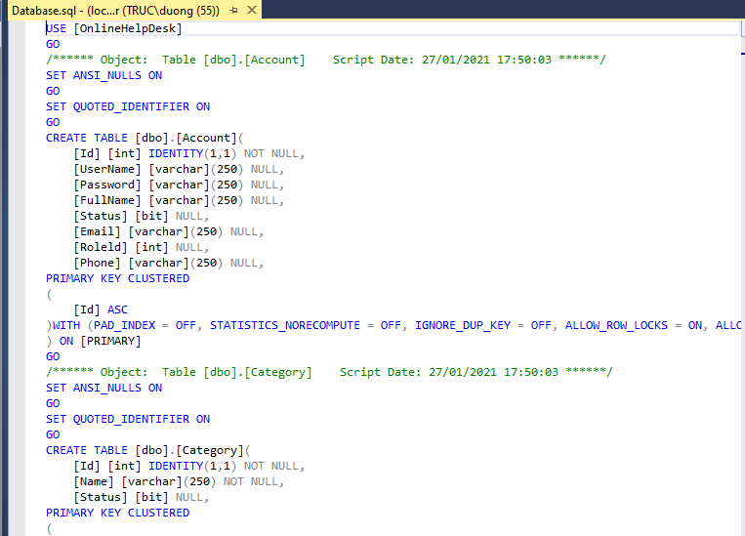

3. Open Visual Studio and Update-Database 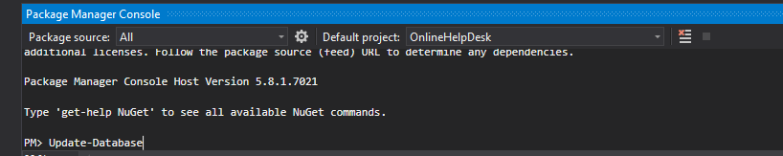

and finally Build Solution to run Project.

