Iran War Outlook: Q4 2026 – H1 2027
Nov 2, 2026 · @Faye

Key calls
Our base case to year-end is a frozen tanker war. Hormuz stays shut, Brent holds above $100, and the Fed stays on hold with a hawkish bias. The main risk is a US strike campaign after the 3 November midterms, at 35% by 30 November. A deal confirmed by both sides is the smaller tail, at 15%. By mid-2027 the strait is still more likely shut than open: 61% impaired.
Call | Probability | Resolves | What flips it
No US strike on Iranian soil before the vote | 90% (one day left, none so far) | 3 Nov 2026 | Any strike on Iranian land confirmed by CENTCOM
US strike campaign on Iran (3+ strike days) | 35% | 30 Nov 2026 | The Qatar track collapses after the vote
US–Iran deal confirmed by both governments | 15% | 30 Nov 2026 | Washington accepts Iran's two-day reopening plan
Brent front month settles at or above $100 | 80% | 30 Nov 2026 | Hormuz transits back above ~43 a day
Midterms held on schedule, with a federal fight over at least one state's count | 80% | 30 Nov 2026 | DOJ drops its Alaska appeal and no other state is contested
Fed hikes in December | No call (about 50%) | 9 Dec 2026 | October CPI on 10 Nov and the 2-year yield
US ground invasion of Iran | 10% | 31 Dec 2026 | Ground-force deployments, not strike packages
Attributed Israeli strike or major covert action on Iranian territory | 40% | 8 Jan 2027 | A US campaign that Israel joins
Hormuz still impaired (under half of pre-war transits) | 70% | 31 Mar 2027 | A signed deal, then 6–10 weeks of mine clearance
Brent front month settles at or above $85 | 70% | 31 Mar 2027 | Reopening
Fed funds upper bound still at or above 4.00% (no net cuts) | 75% | 30 Jun 2027 | A deal that pulls headline inflation down fast
No PLA blockade, quarantine or invasion of Taiwan | 90% | 30 Jun 2027 | Coast-guard patrols turning into inspections
We make no call between 40% and 60%. In that band our probabilities have historically carried no information, so we abstain rather than publish a coin flip.

Where we are
The strait has been effectively closed for eight months, and Brent closed at its war high of $117.64 on 30 October. The only real reopening came in late June, when traffic rose to about 30 ships a day and Brent fell to $72 within three weeks. That episode is our best measure of what a reopening is worth: roughly $40 a barrel.
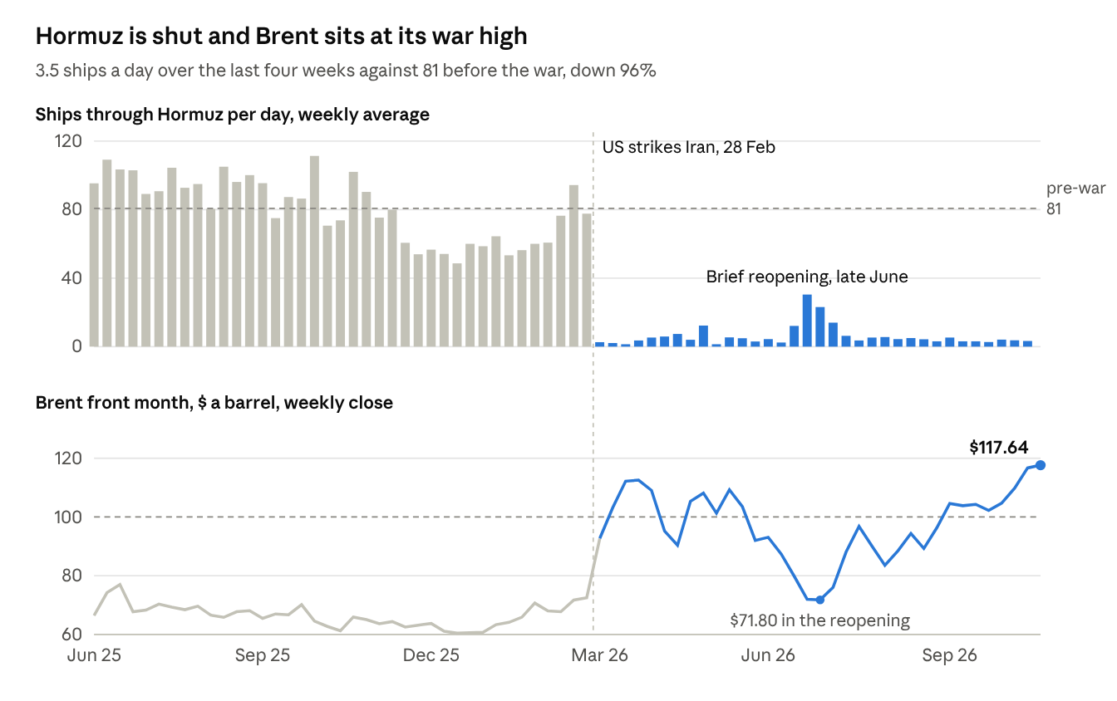
IMF PortWatch daily transits, weekly mean, to 25 Oct 2026 · ICE Brent front month via Yahoo Finance, Friday close, to 30 Oct 2026
- The strait is now being mined, not just blockaded. Iran's Revolutionary Guards say tankers hit mines on 29 October and again on 1 November. On 1 November a Qatari LNG carrier was also struck by "unidentified objects" in the Gulf. Mines outlast any ceasefire, so they lengthen the time from a deal to normal flows.
- The talks are live but conditional. Iranian negotiators spent a third day with Qatari mediators in Doha on 1 November. Foreign Minister Araghchi says Hormuz could reopen within two days of the US meeting Iran's conditions, and that there is no breakthrough yet.
- Supply offsets are small against the gap. OPEC+ held its December targets on 1 November, and Europe is releasing 42 million barrels. Neither replaces flows that are down more than 90%.
- Rates are reading growth damage, not just inflation. The 2-year Treasury yield fell 14 basis points in the week to 4.56% on 30 October, even as Brent made its high, and the S&P 500 fell 1.8% that day. Brent slipped to $111.6 in early trade on 1 November as the talks continued.
News items are wire headlines from 29 October to 1 November (Google News search, Hormuz plan). Flows are from IMF PortWatch.

Scenario map to mid-2027
We put 61% on Hormuz still being impaired at the end of June 2027. Even a deal does not reopen the strait at once, and the frozen case, at 50%, leaves it shut.
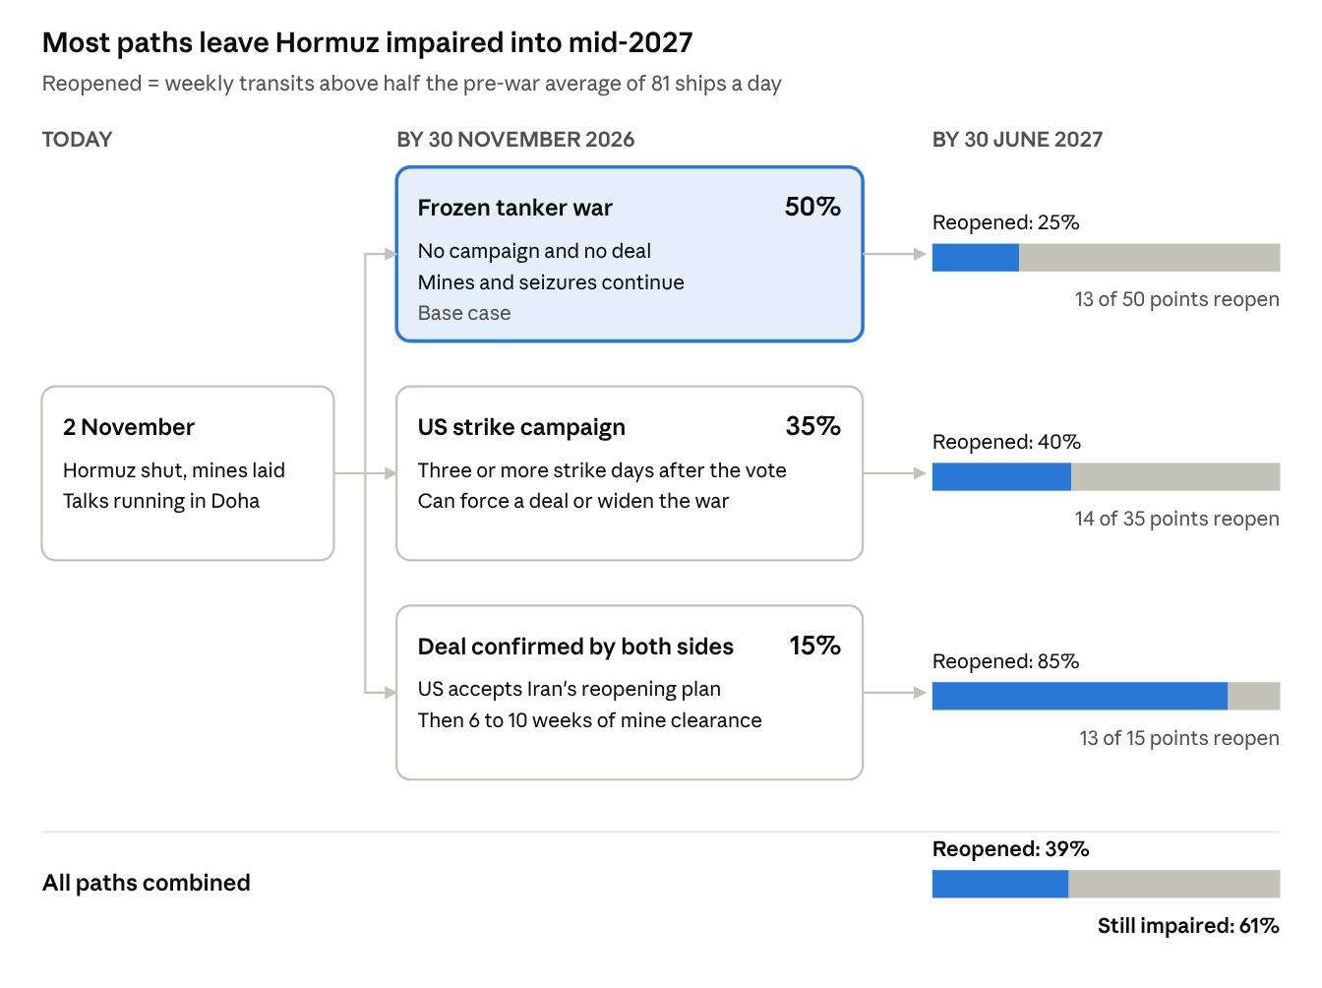
Desk scenario probabilities as of 2 Nov 2026 · reopening threshold from IMF PortWatch pre-war average (Jun 2025–Feb 2026)
- Frozen tanker war (50%). This is the equilibrium both sides can sustain. Iran gets leverage from the closure, and Washington avoids a ground war. Each month in this state lowers the odds of a quick exit, because mines and insurance exclusions build up.
- US strike campaign (35%). Reported planning has strikes sequenced after the 3 November vote. We cap this at 35% because strike planning by a leader prone to reversals has a poor record of turning into action on schedule. A campaign reopens the strait only if it coerces a deal, which we put at 40%.
- Deal confirmed by both sides (15%). Iran's two-day reopening plan is the first concrete offer. But it is conditional, and Iran says it has no plans to meet US officials directly. Even after a deal, clearing mines takes 6–10 weeks before traffic normalises.
The late-June episode shows the asymmetry. Traffic recovered to only 30 ships a day, less than half the pre-war level, before it collapsed again within three weeks.

Oil
We see Brent at about $110 at year-end and $93 by end-June 2027 on a probability-weighted basis. The spread between paths is $26 at end-June. That spread is the trade: the level depends almost entirely on which branch the war takes.
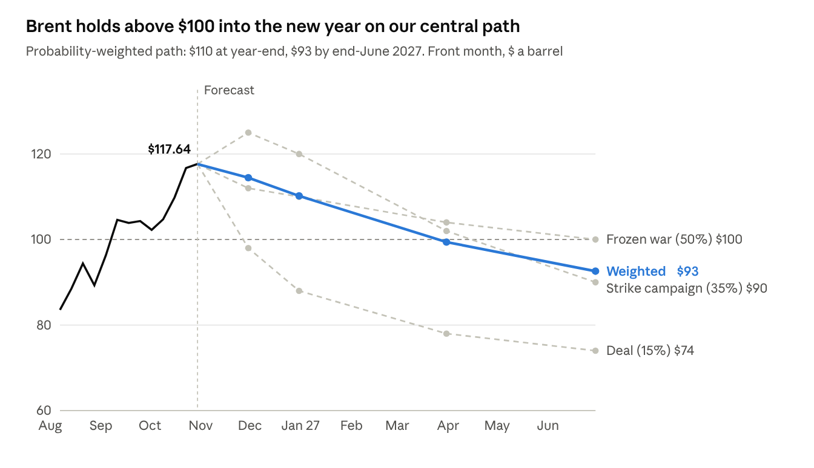
History: ICE Brent front month, Friday closes via Yahoo Finance, to 30 Oct 2026 · Paths: desk scenario medians, weighted by the 30 November branch probabilities
- No unwind call while the strait is shut. As long as transits stay under half the pre-war level, we do not forecast a sustained fall below $100. That gives 80% on Brent settling at or above $100 on 30 November, and 70% on $85 or more on 31 March.
- This is a supply shock, so watch the 2-year yield. A rising 2-year means markets see the shock feeding inflation and a hawkish Fed. A falling 2-year means demand destruction is taking over, which caps the upside. Last week the 2-year fell while Brent rose, the first sign of the second regime.
- The deal path reprices fast, the physical market slowly. In June, Brent fell about $40 in under a month once traffic recovered. A deal now would have to work through mines, so we expect the futures curve to move well before the tankers do.
- Upside tail. A strike campaign that hits Gulf export infrastructure, rather than Iranian targets, is the path to $130 or more. We put it inside the 35% campaign branch, not as a separate scenario.

Rates and the Fed
We make no call on a December hike: it is close to a coin flip, and October CPI on 10 November will decide it. Through June 2027 we put 75% on no net cuts, because cuts need a deal and lower oil, which we do not expect.
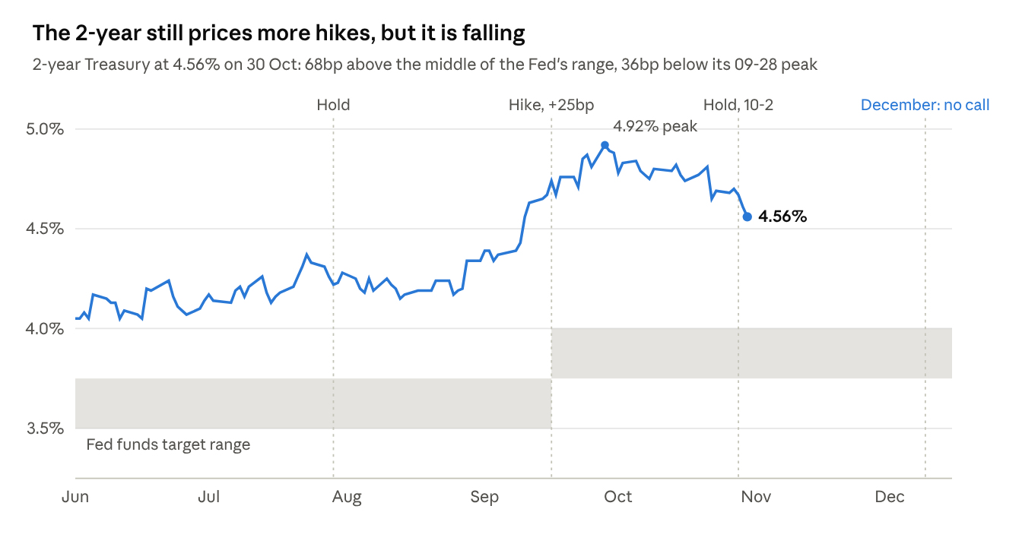
US Treasury 2-year constant-maturity yield, daily, to 30 Oct 2026 · Fed target range and decisions from FOMC statements
- The Fed has already shown it will not look through this shock. It hiked on 16 September to 3.75–4.00% and held on 28 October. Cook and Hammack dissented in favour of another hike, and the statement gave no forward guidance.
- October CPI is the swing print. Gasoline is up 34% from a year earlier and heating oil 74%. A hot core reading on top of that tips December toward a hike; a soft core lets the Fed wait.
- The 2-year is the tell. It still sits about 70bp above the middle of the Fed's range, so markets price more tightening. But it has fallen 36bp from its September peak, and 14bp in the last week alone. If it keeps falling while oil holds, markets are pricing recession risk ahead of inflation.
- What would bring cuts forward. A confirmed deal and a reopening by the first quarter. On our map that is about a 30% outcome, so cuts by June remain the minority case.

Politics and other theaters
The midterms matter for the war mainly as a timing gate. Reported strike planning is sequenced after the vote, so the four weeks from 4 November are the highest-risk window of the year. We make no call on which party controls either chamber.
Theater | Our call | Probability | Resolves | Signpost
US midterms | Held on schedule, with a federal fight over at least one state's count | 80% | 30 Nov 2026 | A judge dismissed the DOJ's Alaska Senate suit on 1 Nov; DOJ says it will appeal
Israel | Attributed strike or major covert action on Iranian territory | 40% | 8 Jan 2027 | The 27 Oct election left Netanyahu's bloc short of a majority, with a caretaker government likely. Trump and Netanyahu discussed Iran on 1 Nov
Taiwan | No PLA blockade, quarantine or invasion | 90% | 30 Jun 2027 | Taiwan reported Chinese patrols harassing shipping off its east coast on 1 Nov. Inspections of ships would move this call
US ground war | No US ground invasion of Iran | 90% | 31 Dec 2026 | Reported plans are strike packages; no ground-force build-up has been reported
Defense budget | FY27 Pentagon topline near $1.5 trillion | No call | 31 Jan 2027 | Appropriations after the vote
Taiwan is the one theater where the Gulf war lowers risk for now. Beijing gains little from a second chokepoint crisis while its own oil imports through Hormuz are cut.

Who profits from the spike
The record shows well-timed trading around the President's Iran announcements and a disputed response from the regulator. It does not show who placed the trades, and no one has been charged. The large, documented transfer is structural: the spike has moved tens of billions of dollars of extra profit to US producers and refiners. We think a deliberately engineered spike is the least likely reading, because gasoline up a third from a year earlier, going into a midterm, hurts the President's own party. Trading on the timing of announcements is the plausible risk, and it is unproven.
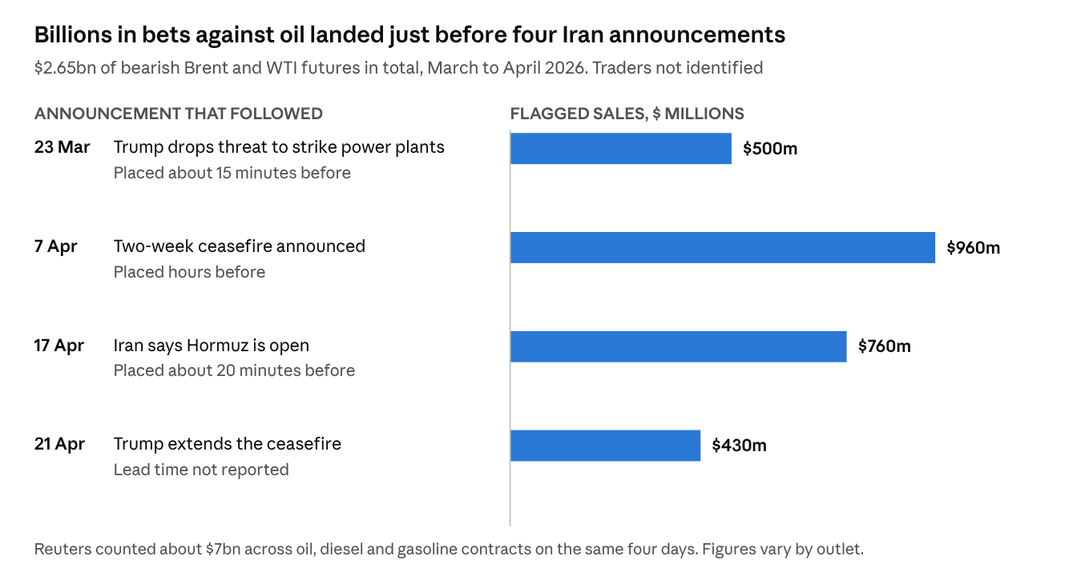
LSEG data as reported by ABC News (anonymous sources) and Reuters, May 2026 · figures are notional futures sold, not profits
Documented.
- On 23 March, sales of at least 6 million barrels of Brent and WTI hit the market between 6:49 and 6:51 a.m. ET, more than 8.5 times normal volume. About 15 minutes later the President posted that he was backing off strikes on Iranian power plants, and Brent fell as much as 14% (Daily Caller, citing Bloomberg).
- The day after that first trade, the White House emailed staff warning them not to bet in futures markets using nonpublic information. A White House official confirmed the email to Reuters (Washington Times).
- CFTC Chairman Michael Selig said on 16 April that "our enforcement division has been looking at all these trades" (S&P Global).
- The President's own accounts, which the White House says third-party managers run, sold $0.5–1 million of ExxonMobil on 7 April, the day the ceasefire was announced. They also traded Chevron and ConocoPhillips during the war, according to his OGE 278-T filings (CBS via Yahoo).
- ExxonMobil earned $15.4bn in the third quarter against $7.5bn a year earlier. Chevron earned $9.9bn against $3.5bn (CNBC).
Reported, not confirmed.
- DOJ and the CFTC are probing the four episodes in the chart (ABC News, anonymous sources).
- Bloomberg reported in October that CFTC analysts referred the 23 March trades to enforcement, and that an adviser to the chairman had the referral pulled and re-ran the analysis with his own team. The CFTC neither confirms nor denies investigations. A former enforcement director said such a retraction would be "never done" (Yahoo, The New Republic).
- New Polymarket wallets made about $1.2 million betting on the 28 February strike, some hours before the first explosions (CoinDesk).
Not found. No trader has been identified, no official has been tied to any trade, and there are no charges, Inspector General review or hearing. We found no new suspicious episode after 21 April.
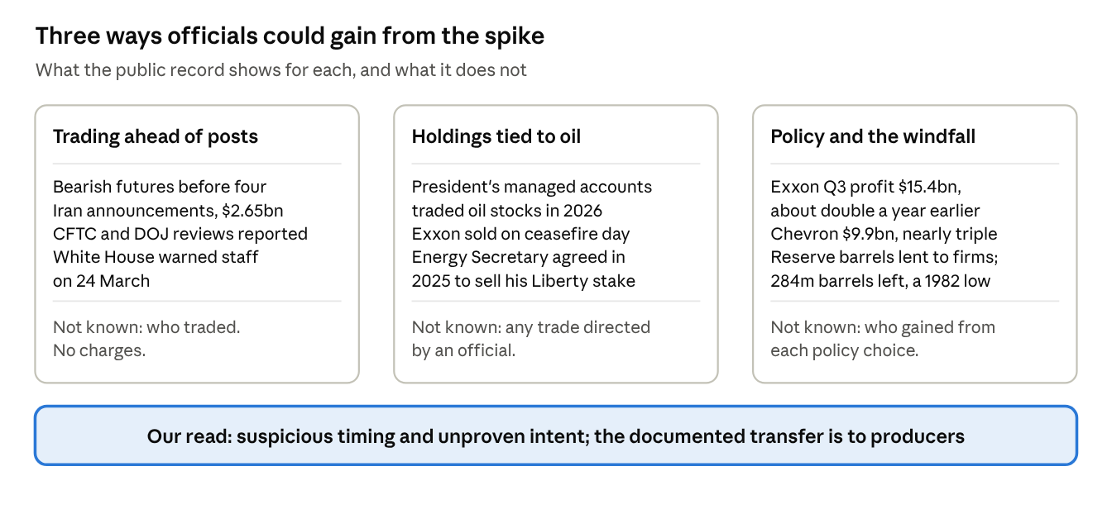
Three channels · sources as linked in this section
Why the timing of a post is worth money. The President decides when market-moving statements land. Anyone who learns that timing early holds a free option on the move, and the option is worth more the more volatile the policy. A pattern of threats followed by reversals maximises that value, whether or not anyone intends it. In game-theory terms, the posts are cheap talk: they reveal little about intent but everything about timing. The secret worth trading on is the clock, not the content.
The Brent market and the law.
- ICE Brent futures trade in London on ICE Futures Europe, which the UK's FCA supervises. The exchange is registered with the CFTC as a foreign board of trade, but ICE shares large-trader data with the CFTC only for its WTI contract (ICE). A US probe of the Brent leg therefore depends on UK cooperation. That fits a CFTC official's remark that the review was widened internationally.
- The Commodity Exchange Act bars federal officials from trading on nonpublic information they acquire through their jobs, and bars anyone from misappropriating it (7 U.S.C. §6c). The CFTC's anti-fraud rule also reaches insider trading in futures (17 CFR 180.1).
- Those provisions for officials were first charged in April 2026. The case was against a soldier accused of using classified information on the Maduro operation to bet on Polymarket (Skadden). The CFTC lost its first jury trial over futures insider trading in 2018 (BCLP).
- Brent's price-reporting system has been probed before. The EU raided Shell, BP, Statoil and Platts in 2013, and the case was dropped in 2015 (CNN, Equinor).
What the literature says. Leaks around government announcements are real and measurable, but a price move before news is not proof of one. On the evidence, traders did not create this spike; the lost supply did.
Study | Finding | What it means here
Bernile, Hu and Tang (2016), Journal of Financial Economics 121(3) | Order flow in S&P 500 futures during FOMC news embargoes predicts the decision; no such leak before jobs, PPI or GDP data | Leaks around government news can be measured from order flow, and the same test can be run on the Iran posts
Kurov, Sancetta, Strasser and Wolfe (2019), Journal of Financial and Quantitative Analysis 54(1) | Prices drift before several US macro releases, about 40% of the total move | Drift alone is common and does not prove a leak
Gu and Kurov (2018), Journal of Futures Markets 38(9) | Order flow before natural-gas storage reports tracks the surprise | Commodity futures show the same leak signature as financial futures
Ge, Kurov and Wolfe (2019), Journal of Financial Research 42(2) | Presidential tweets about companies move prices, volume and volatility | A post is a market event, so its timing has value
Bianchi, Gómez-Cram, Kind and Kung (2023), Journal of Monetary Economics 135 | Trump's tweets criticising the Fed lowered expected policy rates | Presidential posts shift asset prices within minutes
Ziobrowski et al. (2004, 2011); Eggers and Hainmueller (2013), Journal of Politics 75(2) | Early studies found members of Congress beat the market; later data found no edge | The evidence that officials profit from their information is mixed
Fattouh, Kilian and Mahadeva (2013), Energy Journal 34(3); Kilian and Murphy (2014), Journal of Applied Econometrics 29(3) | Fundamentals, not speculation, drove oil price levels after 2003 | Any trading edge is in timing, not in moving the price level
Singleton (2014), Management Science 60(2) | Investor flows did move oil futures in the 2008 boom and bust | Flows can matter at the margin, especially around news

Calendar and signposts
The four weeks after the 3 November vote carry most of this year's risk, because they decide the war branch that sets everything after it.
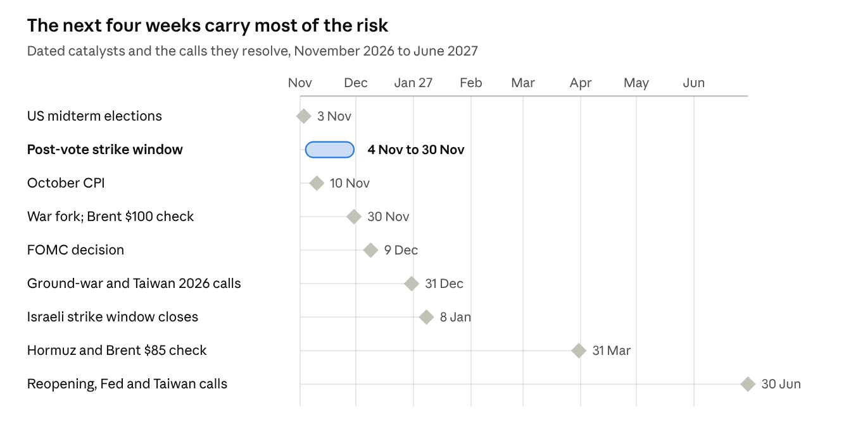
Desk catalyst calendar · dates of the calls in this note and the scheduled releases they depend on
Signpost | What it moves | Direction
Washington accepts Iran's reopening conditions | Deal branch to 40% or more; Brent paths down about $20 | Toward reopening
CENTCOM confirms strikes on Iranian land | Campaign branch to about 80%; Brent up $10–15 in the short run | Toward escalation
Mine strikes on shipping continue weekly | Frozen branch up; reopening pushed back by months | Toward a longer closure
PortWatch transits above 20 a day for a full week | Reopening under way; cut the Brent paths | Toward reopening
2-year yield back above 4.80% | December hike more likely | Hawkish
2-year below 4.40% with Brent above $110 | Markets pricing recession; cuts come sooner | Dovish
Chinese coast guard boards a Taiwan-bound ship | Taiwan call down from 90% | Toward escalation

Track record and method
Our geopolitical calls this year scored 12 of 19, a Brier score of 0.236 against 0.25 for a coin flip. The split matters more than the total. Calls on measured physical state (flows, prices, deployments) went 9 for 9. Calls on a leader's decision (strike, stop, sign) went 1 for 7. So read the Hormuz and Brent calls in this note as our strongest, and the strike and deal probabilities as our weakest.
- Probabilities are desk judgments. They combine the scenario tree above with historical base rates for how ceasefires hold and fail.
- No call between 40% and 60%. In that band our past calls carried no information, so we publish "no call" rather than a coin flip.
- Data. Shipping flows are from IMF PortWatch, Brent from ICE via Yahoo Finance, and yields from the US Treasury. News items carry the date they were reported.
- Scope. This is analysis of direction and mechanism. It is not investment advice and gives no position sizes.
Sources. IMF PortWatch · Google News, Hormuz plan · Dallas Fed, 8 Oct 2026 · CNBC, Q3 oil earnings · CNBC, CFTC probe · Reuters via Dawn, $7bn count · Senate Banking, Warren and Whitehouse · Rep. Torres · Bloomberg, Polymarket and the Iran war. Other sources are linked where they are cited.

