1D Diverging Duct
Objective
The case of 1D flow through a diverging duct is simple case of a pure Bernoulli problem that has an exact solution.
Definition
The problem models one-dimensional flow through a diverging duct. The width of the duct at inlet and outlet is one and two respectively, while its length is ten units (see the figure below). There is no viscosity, so that this is a pure Bernoulli problem with no change in elevation (i.e. no body force).

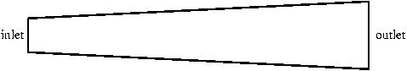

Metrics
Since this problem is a pure Bernoulli problem, the following relation between pressure and velocity exists:
This relation can be used to derive an exact solution.

For example, assuming a diverging duct in the direction of length ten with inlet width one and outlet width two, density and boundary conditions at the inlet, and at the outlet, the exact solution is
The computed solution should be close to the exact solution. We can measure, for example, the norm of the error in the pressure, and the norm of the error in the velocity.
Truchas Model
The problem domain is a quasi 1D mesh that has ten cells in the direction of the nozzle. In the other two coordinate directions, the mesh has a thickness of one cell. In particular, the cells are of unit thickness in the coordinate direction orthogonal to the 2D nozzle.

Possible variations of this problem are
- We can orient the duct in other coordinate directions. For example, a diverging duct in the direction that lies in the plane. The solutions of all such variations should be exactly the same, if an appropriately rotated mesh is used.
- We can model the duct using a quasi 1D mesh that covers only the upper half of the diverging duct (the area above the dashed line in the figure). Then we can set up the problem in such a way that the cells are partly filled with solid material (the black area in the figure) to model the upper wall of the diverging duct.

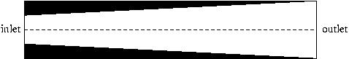

- We can use a quasi 1D mesh that is not orthogonal, to test the accuracy of other non-ortho discretizations.
- We can model the nozzle using a quasi 2D mesh.

The name of the input file is 1D_diverging_duct.inp.
Results
The results should be close to the exact solution of this pure Bernoulli problem.
Critique
To be added later.
References
To be added later.

