Transient Heat Conduction in Composite Materials

Objective

This problem is intended to test the transient heat conduction algorithms within truchas. There are two materials with sharply different thermal properties. The problem uses the following types of boundary conditions: convective transport, homogenous Neumann and Dirichlet. Although there are no analytical solutions to this problem, the truchas solution can be verified with solutions from commercial codes.

Definition

A square of unit side length has the thermal properties ρ₁=1, C_{p1}=0.1 and k₁=10. The bottom side (y=0) is insulated, while the top (y=1) is subject to a convective boundary condition with h=100 to an ambient temperature T∞=0. The left side (x=0) is subject to a fixed temperature value of T_{H}=100 and the right side (x=1) has the temperature fixed at T_{L}=0. A circle of a different material, with radius r=0.3 is concentric with the square and has the thermal properties ρ₂=1, C_{p2}=10 and k₂=0.1. There is perfect thermal contact between the two materials, and the entire system is initially at a temperature T_{o}=50. Figure 1, shows a schematic representation of the problem. We wish to calculate the temperature distribution as a function of time and space.

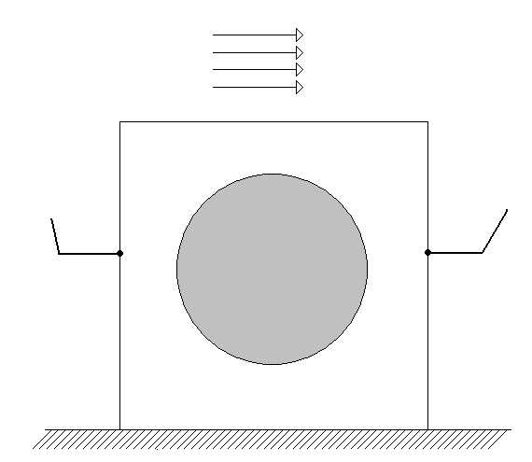
h, T∞
T_{L}
T_{H}
x
y
ρ₁, C_{p1}, k₁
ρ₂, C_{p2}, k₂

Figure 1. Schematic representation of Test Problem

Truchas Model

The problem domain is a unit square in the x-y plane, divided into ?? mesh cells in each direction. (The z direction is a single cell of thickness 0.1). The boundary and initial conditions described above are imposed. The simulation is run until a steady state is achieved, (this was determined to be t=20) in ?? steps, each of duration ??.

Variations

Explore effects of eccentricity of the circle with respect to the square center, use temperature-dependent properties, change T_{o}.

Results

The following are mesh-independent results obtained from simulations with the commercial finite element code Comsol Multiphysics. Figure 2, shows the temperature profile along the y=0.5 line for t=0.2, 0.4, 0.6, 0.8 and 1.0. The large temperature gradient changes around x=0.2 and x=0.8 stem from the differences in material properties
0.0
0.2
0.4
0.6
0.8
1.0
0
20
40
60
80
100

t=1.0
t=0.8
t=0.6
t=0.4
t=0.2
T
x

Figure 2. Temperature distribution across y=0.5 for selected times.

Figure 3, shows the temporal variation of temperature at the center of the circle, i.e, x=0.5; y=0.5. The final time is t=20 which is long enough to achieve a steady state.

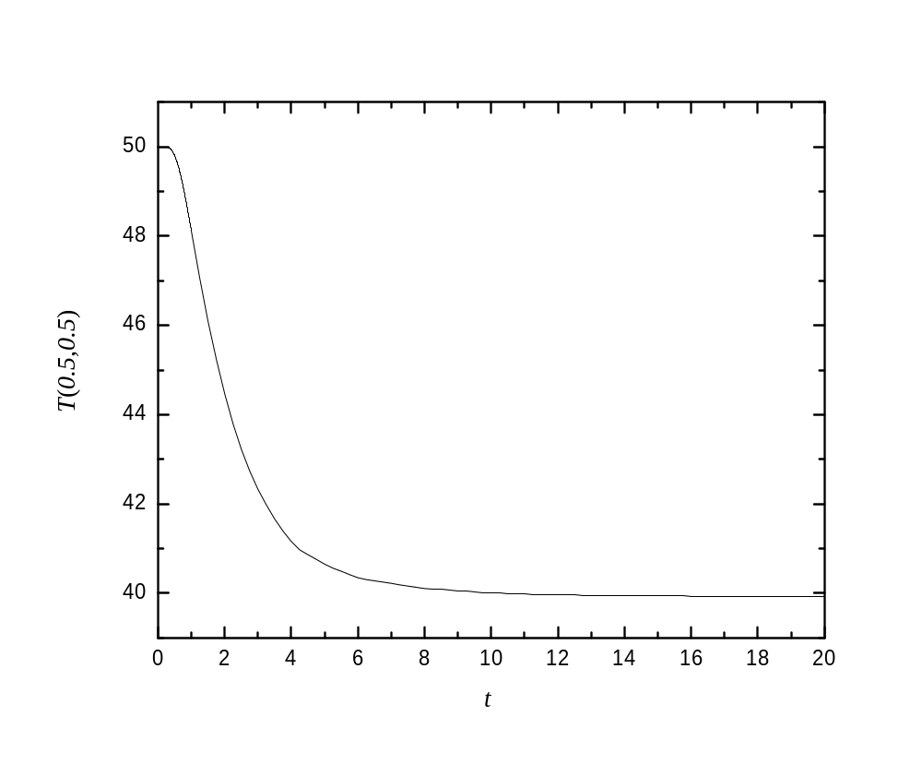

Figure 3. Time evolution of temperature at the circle center.

Critique

To be added

