Two-Dimensional Solidification of a Pure Substance

Objective

This problem is intended to test the pure substance phase change algorithms within truchas. There are two phases (solid & liquid) of the same substance. The problem uses Dirichlet and homogenous Neumann boundary conditions. Although there are no analytical solutions to the problem, a completely independent numerical solution was published by A. Lazaridis in Int. J. Heat Mass Transfer, Vol 13, (1970) pp 1459-1477.

Definition

A prism of square cross section and infinite length is filled with liquid at the melting temperature. At t=0, the walls of the prism are set to a temperature T_{a}, below that of the melting point. Due to symmetry, only one-quarter of the domain is modeled and homogenous Neumann b.c.s are employed at the symmetry planes, as shown in Figure 1.

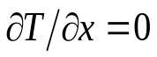
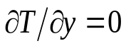
solid
liquid
T=T_{a}
T=T_{a}

Figure 1. Schematic representation of the present test problem

We wish to measure the solid fraction along the right-most vertical boundary as a function of time and compare with the numerical solution obtained by Lazaridis. To obtain the same dimensionless parameters as those of the paper by Lazaridis, the numerical values employed are (all physical properties are the same in the solid and liquid): L=70.26 (heat capacity), T_{a}=-45, T_{m}=0 (melting point), k=ρ=C_{p}=1.0.

Truchas Model

The problem domain is a square of length 4 in the x-y plane, divided into 20 mesh cells in each direction. (The z direction is a single cell of thickness 0.1). We solve the transient problem from t=0 to t=6, in 1200 steps, each of duration 0.005.
.

Results

Figure 2 is adapted from Figure 6 of the above referenced paper by Lazaridis. Figure 2 shows the time variation of the solid fraction along the x=4 line.

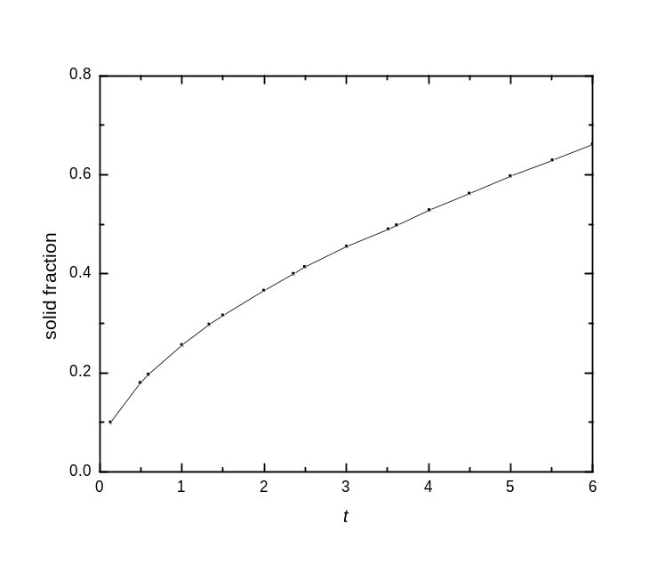

Figure 2. Temporal variation of solid fraction along right-most vertical boundary.

Some selected values of Figure 2 are shown in Table 1, and compared with the truchas output.

Table 1. Comparison of truchas results with Lazaridis’ results
t | solid fraction (Lazaridis paper) | solid fraction  (truchas)
0.50 | 0.18 | 0.18
1.00 | 0.26 | 0.26
1.50 | 0.32 | 0.32
2.00 | 0.37 | 0.36
2.50 | 0.41 | 0.41
3.00 | 0.45 | 0.45
3.50 | 0.49 | 0.49
4.00 | 0.53 | 0.52
4.50 | 0.56 | 0.56
5.00 | 0.60 | 0.59
5.50 | 0.63 | 0.62
6.00 | 0.66 | 0.65

