Species Advection
Objective
The objective for this problem is to test the advection of species with and without phase change active. In addition, this problem tests the capability to read the mesh from an Exodus file. The species concentration for this problem may be computed directly from a characteristic function.
Definition
The problem consists of a prescribed filling-flow in a square duct. The dimensions for the duct are

No-penetration boundary conditions are applied on the x-y and x-z planes. The channel is initially empty, and an inflow velocity () and concentration () are specified at the “left-end” of the channel.

The species transport equation, neglecting diffusion, is

Given the prescribed initial conditions, and boundary conditions, the solution will be constant along characteristics. Thus, for in this problem (given the unit x-velocity). This permits direct verification of the solution, since in a discrete sense, the solution for the species concentration will interpolate the continuous characteristic function at cell-centers as shown in Figure 1. Here, a time-step has been used. Due to the discrete nature of the finite-volume approximation, the discrete species concentration is essentially constant during each cell-transit.

For the purposes of regression testing, we prescribe a fixed time-step, and limit the calculation to 25 steps, i.e., . Probes are specified in elements 1, 2 and 3 corresponding to points (-4.5,-0.25,02.5), (-3.5,-0.25,0.25), and (-2.5,-0.25,0.25). The time-history data is compared to the exact characteristic function (Z=0.06) at t=0.5, 1.5 and 2.5.
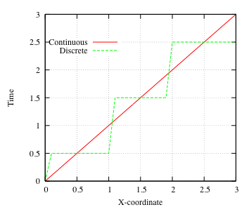
Figure 1: Characteristic function for species-transport problem.
Metrics
The flow problem itself is straightforward by design. This permits the species transport to be evaluated relatively independently. The primary metric for the regression test is

where the subscript refers to the element/probe number (1,2 or 3).
Truchas Model
The Truchas model consists of two parts, the Exodus grid consisting of a 10x2x2 Cartesian mesh, and the input file. The input file includes material prescriptions for the void and fill-fluid that consists of liquid uranium. A phase change model is included that uses the lever-rule, but is inactive for the basic transport test. The computation proceed for 25 time-steps so that sufficient probe data can be collected for the regression test.

Results
Figure 2 shows a snapshot of the species concentration at t=2.5.

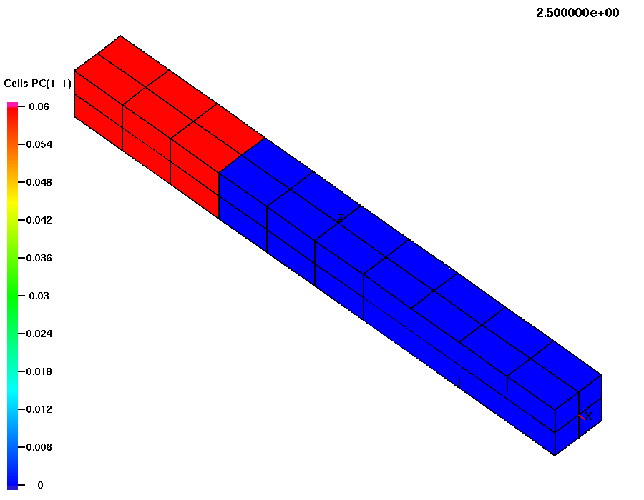
Figure 2: Species concentration at t=2.5.
Critique
This problem is a simple go/no-go regression test. In the future, it will be desirable to extend this test to include variations of the problem to test the sensitivity to the direction of advection, grid-bias, and phase change.

