Drop in Static Equilibrium
Objective
The case of a static drop in equilibrium is an analytical test case to verify the discrete solution to the pressure-Poisson equation. In this problem, the pressure jump across the interface should be balanced by the interface curvature times the surface tension coefficient. This test problem is a standard test case to verify the normal component of surface tension in a computational fluid dynamics code.
Definition
In a cube, a spherical drop of radius R is placed at its center. The resulting velocity field should be zero everywhere and the jump in pressure drop across the interface should be where is the surface tension and is the curvature. The curvature for a sphere (see Francois, et al. [2]) is
Here, σ, the surface tension coefficient is assumed to be constant.
Metrics
The metrics for this problem are mass conservation, error in pressure jump across the interface and L norms error for velocity.
The numerical jump in pressure is evaluated in three different ways:
- ΔP_{total}=P_{in}-P_{out} where the subscripts “in” denotes inside the drop (averaged for cells with ) and “out” outside the drop (averaged for cells with );
- ΔP_{partial}=P_{in}-P_{out} where the subscripts “in” denotes inside the drop (averaged for cells with ) and “out” outside the drop (averaged for cells with ) to avoid considering the transition region; and
- ΔP_{max} =P_{max}-P_{min} where the subscripts “max” denotes maximum and “min” minimum on the entire domain.
The relative pressure jump error is evaluated as:
, (1.2)
where the subscript n denotes one of the three different evaluations (total, partial or max).
To measure the error in velocity, we employ the following L error norms:
; (1.3)
; (1.4)
; (1.5)
where is the magnitude (norm) of the velocity vector u, and N the total number of cells in the domain.

Additional metrics can be L norms error for the curvature, the total kinetic energy evolution with time for both inviscid and viscous cases, plot of the pressure along a mid-plane (x=4 and y=4) or a diagonal axis.
Truchas Model
The problem domain is a 8x8x8 cube. The mesh consists of 20 cells in each direction. The spherical drop has a radius R=2 and is centered at x=y=z=4. the surface tension coefficient is constant and is 73. Using Eq. (1.1), the he resulting jump in pressure should be .

The boundary conditions for the velocity on the wall are set to default (free-slip). The curvature is computed using the smoothing approach (using Rudman’s kernel) with an interface smoothing length of three times the mesh spacing.

Possible future variations should be included to test both inviscid and viscous cases and to use different density ratios.
Results
For the 20x20x20 grid, the current results are shown in the pressure isosurface and cutplanes images in Figure 1.
a) 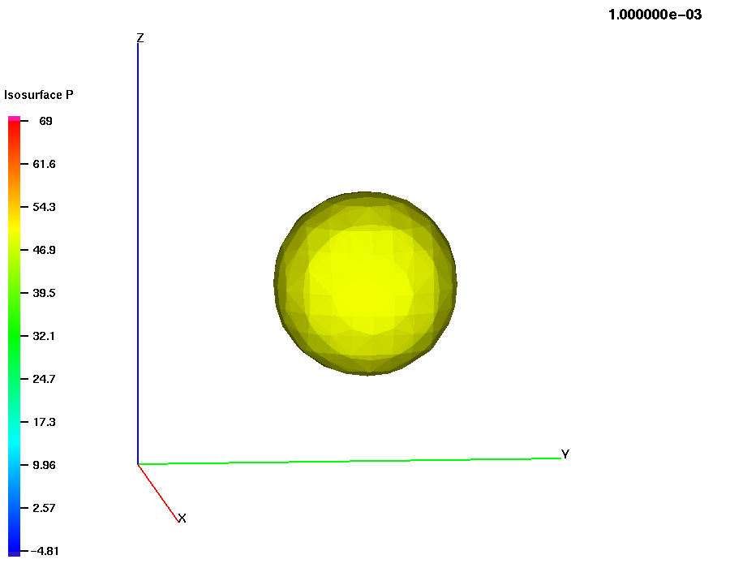 b) 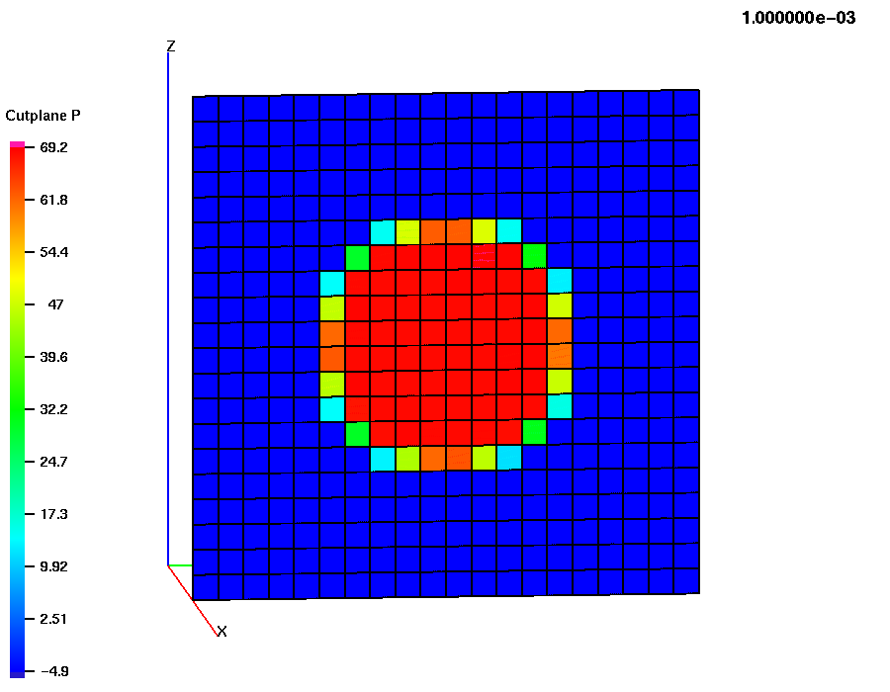
Figure 1. Snapshots of a) isosurface of volume-fraction with pressure mapped on the surface, and b) cutplane of pressure for the static drop problem on a 20x20x20 grid.
Critique
This problem shows sensitivity to the pressure drop in terms of the min/max values, and the inside/outside averages. The problem is convergent in these metrics, but require rather loose tolerances. The velocity field for this test should be scrutinized further as it has relatively large components of noise present.
References
- Brackbill J.U., Kothe D.B., Zemach C., A continuum method for modeling surface tension, Journal of Computational Physics, 100, 335-354, 1992.

- Francois M.M., Cummins S.J., Dendy E.D., Kothe D.B., Sicilian J.M., Williams M.W., A balanced-force algorithm for continuous and sharp interfacial surface tension models within a volume tracking framework, Journal of Computational Physics, article in press, also LA-UR-05-0674.

