Hydrostatic Problem
Objective
The objective for this problem is to test the interface reconstruction and advection algorithms in a problem with a triple point. The idea is to recover the steady hydrostatic pressure due to a gravity field in a liquid.
Definition
We consider a 2D rectangular container filled with liquid and void. We also include an embedded solid (to mimic an internal mold). In general, the boundary of the solid material does not lie on a mesh line. This makes the problem more challenging, since there is a cell containing three materials and a triple-point. We take the gravity at α=30° from the vertical axis. Initially, the liquid level is positioned to the equilibrium position (perpendicular to the gravity field). The volume of the liquid in the container is 0.535 (half full). The rectangular container is [0,1.2] x [0,0.05] x [0,1], and the solid layer is occupies [0,0.13] x [0,0.05] x [0,1].
The interface position at equilibrium is:
In the liquid (below the interface position) the pressure field is given by:
x
z
Liquid
Void
Solid layer
g
0.13
1.2
0
0
1.0
α
Figure 1:Hydrostatic problem definition
We will run the problem for a few time cycles.
Metrics
The resulting velocity field should be zero (static case). We can use any L norms error for velocity. In the general configuration, there may be spurious velocities because of the way Truchas currently handles the cell containing three materials. Since we have an analytical expression for pressure, we can compute any error norms. We can also compare the pressure along an axis.
Truchas Model
The model used for regression testing is configured to insure that a steady-state is achieved. In order to achieve a steady-state, the liquid, void and solid interfaces are aligned with mesh lines. The mesh is 12 x 1 x 10. For the steady-state test, the solid occupies the region bounded by . The void region occupies . For this test, , so that . Twenty time-steps are taken in the calculation, and the velocity field is checked to be sure it is very small, e.g., machine-zero. The solid material in the problem is “immobile”.
Results
This is a very simple triple-point problem that guarantees a steady-state solution results. The material distribution is shown in Figure 2.
a) 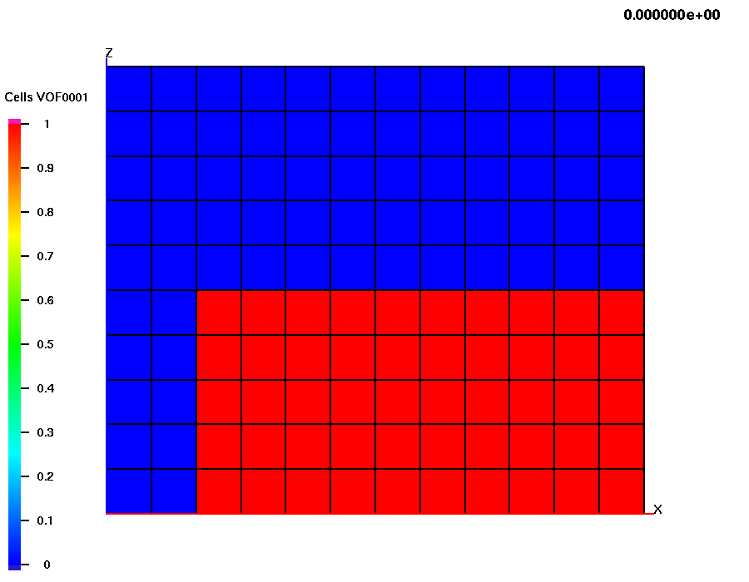 b) 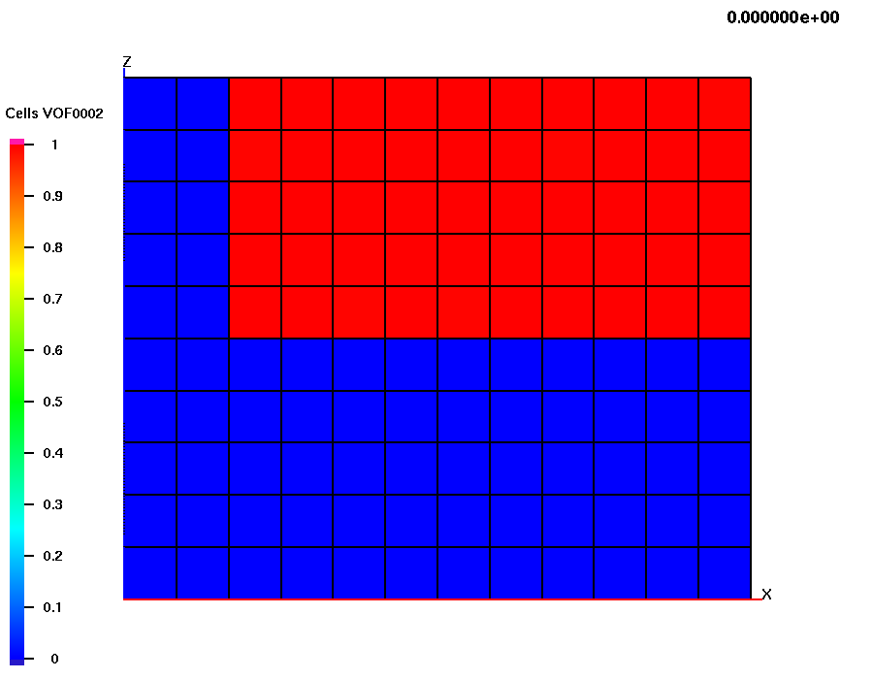 c) 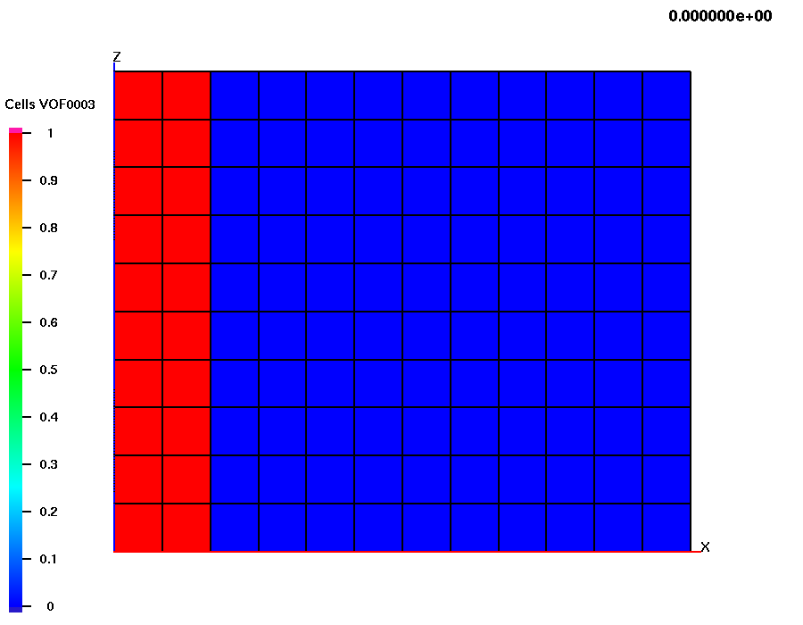
Figure 2: Volume fractions for the steady-state hydrostratic problem showing a) liquid, b) void, c) solid.
Critique
This problem is a simple go/no-go regression test. The general problem with the triple-point in a cell will result in a non-steady (and incorrect) result. When the interface reconstruction/advection is improved to handle this situation, the regression test will be extended for the more general case.

