Pressure Driven Inviscid Flow with Porous Drag
Objective
Pressure driven inviscid flow was selected to verify the porous drag model implemented in Truchas. Of particular importance, the governing equations for this model will permit a direct comparison of velocity predictions obtained using Truchas and the results expected from the exact solution. The connectivity of inviscid flow model, the implementation of the pressure boundary conditions, and the volume of fluid (VOF) algorithm will also be assessed.

Definition
Pressure driven inviscid flow between two parallel plates with a flow domain consisting of

No normal penetration is prescribed on both the upper and lower plates, and uniform pressures are prescribed at the inflow/outflow. The flow is uni-directional, assuming the flow is inviscid and gravity forces are neglected, and a linear pressure field is established after the initial startup transient. The flow field was divided in the z-direction so that half of the region contained a fluid and the remaining half contained a solid material

The porous drag model used here is presented by Voller and Prakash¹. The model proposes to define flows in regions of porosity by using source terms, S_{y} and S_{z}, that are included in the momentum equations given by
where A increases from zero to a large value as the local solid fraction, F_{s}, increases from its liquid value of zero to its solid value of 1. The terms v and w are the velocity components the y and z directions. For regions where no transient phase change is occurring, the value of A will be constant over time, as in this problem. Where a porous region does exist, the Carman-Koseny equation is derived from the Darcy Law given by
where λ is the porosity (interpreted here as fluid volume fraction). The value of C is the permeability constant, depends on the porous media, and is a required user input. The value of A, then, can be inferred by as

Metrics
The evaluation of the correct implementation of the porous drag model can be accomplished by comparing the steady state Truchas velocity, u, for known values of the fluid volume fraction. For the problem defined here, the pressure field is a linear function of the x-coordinate as well.
Truchas Model
To simulate pressure driven flow between two plates, the flow, inviscid flow, and porous drag physics models were selected using the gmres linear solver. The appropriate boundary conditions were imposed at each of the six planes flanking the flow region. For both bounding planes in the z-direction, the selection of no normal penetration boundary conditions resulted in the default or ‘free-slip’ condition. To achieve the desired inflow and outflow conditions and pressure gradient, Dirichlet pressure boundary conditions were prescribed at the inflow and outflow planes. For the stationary plates and inviscid flow, the free-slip condition was applied on both of the bounding y-planes.

To verify the porous drag model, a single cell in the z-direction was divided so that half of the region contained a fluid and the remaining half contained a solid material. A 20 x 5 x 1 computational mesh was used and all material properties were given a value of 1. The permeability constant C=1000 was used. A pressure gradient in the x-direction of 1000 was imposed. The simulation was performed for 0.5 seconds to allow the flow to reach steady state. A probe located at (x,y,z) = (15.0, 0.5, 0.5) was used to recorded a time-history of the velocity.
Results
The figure below shows the time-history of velocity for varying ‘porous_implictness’, i.e., for forward-Euler, backward-Euler and trapezoidal rules during the startup transient . After this time, the velocity is asymptotes to a value of 0.5. Note that for the forward Euler case, a maximum time-step of was specified due to the reduced stability limits for this time-integrator. For the purposes of regression testing, porous_implicitness = 0.5 corresponding to a trapezoidal rule for the velocity is used since it delivers second-order accuracy in time and is unconditionally stable.

Using the configuration described, the steady state velocity, u, was predicted to be 0.5000. The steady-state velocity can be calculated directly in terms of the pressure gradient and porosity using the Carman-Kosney equation which yields

The velocity is uniform for all cells in the y direction, and the asymptotic steady-state is identical for all three time-integrators.
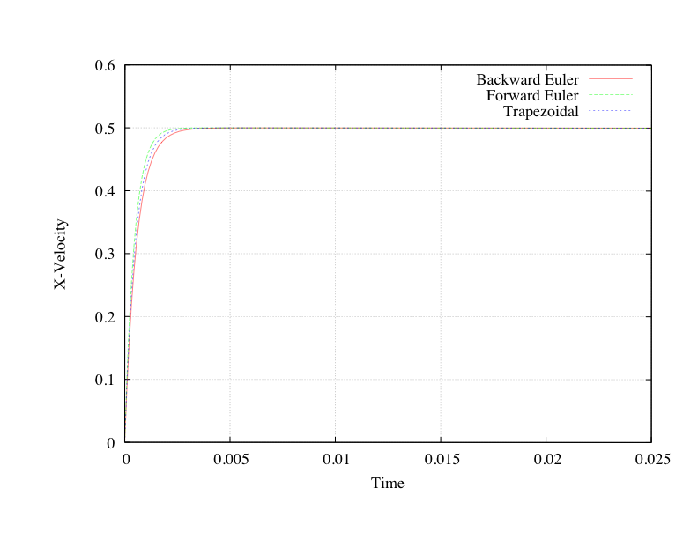
Critique
The porous drag model presented by Voller and Prakash was implemented and tested to verify the connectivity with the flow, inviscid, and VOF algorithms in Truchas. The connectivity of the porous drag with transient phase change and heat flow problems will also need to be evaluated. For this simple case, the simulation results verified the correct implementation of the porous drag model into Truchas. This regression should be repeated for several pressure gradients, solid to liquid fractions, and material constants.
References
1. Voller, V.R., Prakash, C.,”A Fixed Grid Numerical Modeling Methodology for Convection-Diffusion Mushy Region Phase-Change Problems,” International Journal of Heat and Mass Transfer, 30, pp. 1709-1719, 1987.

