Turbulence
Objective
This regression test exercises the algebraic turbulence model on a simple channel flow problem. The problem is designed to achieve a steady-state in a small number of time-steps, O(100), on a coarse grid. The test is intended to detect variations in the maximum horizontal velocity, the velocity in the first cell at the wall, and the pressure gradient.
Definition
This problem is designed to generate one-dimensional flow field by imposing fixed inlet and outlet pressures, i.e., a fixed pressure gradient. The algebraic turbulence model is setup in a non-dimensional form with the following parameters a viscosity of 1.0e-5, turbulence length of 0.1, unit density, and a pressure difference of 1.0e+5.

The channel is bounded on the top and bottom by plates with no-slip/no-penetration conditions, and we assume uniform inlet/outlet pressures. The channel is one unit high, and the length to height ratio is 5. A unit depth is used for the calculations. The pressure field is established nearly instantaneously and may be computed as
where , , and .
The average velocity may be computed by the correlations presented by White [1] as
where is the hydraulic diameter, the pressure gradient is 10e+5, and

Metrics
The maximum velocity occurs at the centerline between the two plates. However, because there is no exact value to compare to, we choose to compare to a wall value, and the maximum centerline values from a calculation that is essentially at steady-state. This was accomplished by examining time-history probe data and observing that the velocities reach steady-state values at a non-dimensional time of 0.3 as shown in the figure below. In addition, the pressure field is linear in the flow-direction and is also used as a metric.
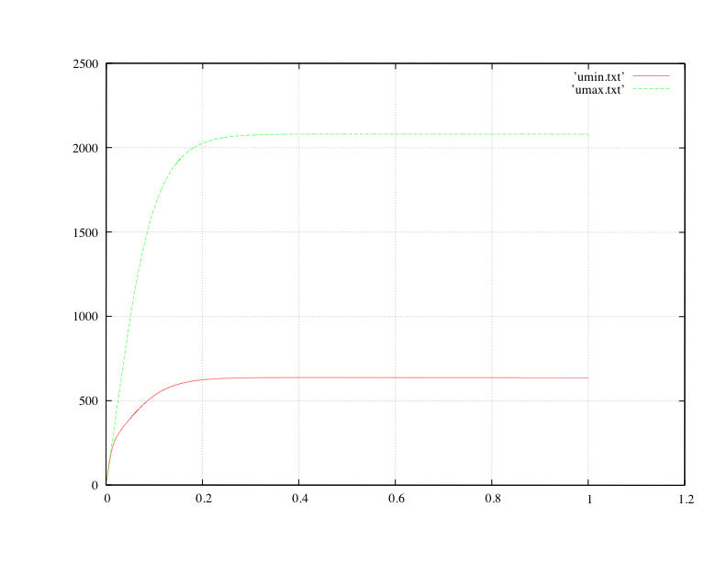
Truchas Model
A 5:1:1 aspect ratio domain is used for this problem with a 2x11x1 grid. The center of the domain corresponds to cell-centers permitting the maximum centerline velocities to be checked. The algebraic turbulence model is used, and two probes – one at the centerline, and one at the wall.
Results
The centerline velocity should be 2062.68, the wall velocity should be 632.876. The cell-centered pressures should be 75000.0 and 25000.0 in the “left” and “right” cells respectively.
Critique
This problem provides a regression that tests the execution of the algebraic turbulence model. However, this test does not really assess the quality or accuracy of the turbulence model. This test does check that a linear pressure field is calculated and matches the steady-state pressure field. In the future, additional turbulence tests are required that are more rigorous.
References
- White, F. M. “Viscous Fluid Flow,” McGraw-Hill, pp. 486-488, 1974.

