Welcome to Citizen Science 2013 Lee Kapp, Ph.D.
lkapp@bard.edu

The goal of this course is to improve your scientific literacy and to illustrate the relevance of science to your lives.
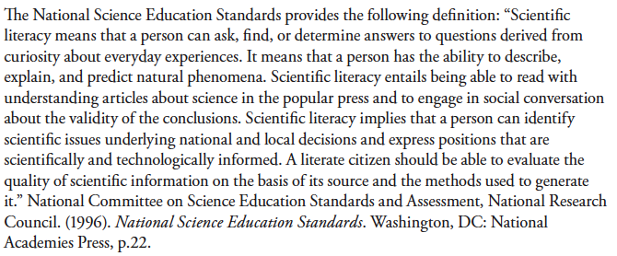
In this course we will think about:
The Nature of Science and Experimental Design
Genetics and Evolution
The Germ Theory of Disease (Bacteria and Viruses)
Antibiotic Resistance
Immunology and Vaccination
Bioethics

Week 1 = problem based learning
Week 2 = problem based learning and laboratory exercises
Week 3 = computer modeling

Grading
This course is graded pass/fail and only requires that you attend class (awake), you read the assigned readings, and contribute to class discussions. Engagement in class discussions is essential. Free write sessions will be featured in this class and your work in these sessions will be turned in and will contribute to your grade. In addition, you will be told to prepare your written reflections on certain readings ahead of class to hand in for grading. I will tell you which of the readings you will write about when they are assigned. Part of your grade will also be determined by your laboratory notebook.

Lastly, you will be required to prepare a final project that must illustrate the science behind some issue or detail how the scientific method has been applied to some matter of relevance to public policy. It should consist of no more than 2 single-spaced typed pages, a single poster board, or a 15 minute presentation. This project will be due by 3PM on January 23rd, but not before January 17th. I will be departing Bard at 3PM on January 23rd.

