**MINISTRY OF EDUCATION AND TRAINING**



**FPT UNIVERSITY**

Introduction to Software Engineering

**FIND ME**

|  |  |
| --- | --- |
| **Group 3** | |
| **Group members** | 1. Vũ Lâm Huy – SE140164 – [huyvlse140164@fpt.edu.vn](mailto:huyvlse140164@fpt.edu.vn) 2. Nguyễn Thị Thanh Trúc – SE140219 – [trucnttse140164@fpt.edu.vn](mailto:trucnttse140164@fpt.edu.vn) 3. Vũ Thị Thùy Linh – SE140214 – [linhvu263@gmail.com](mailto:linhvu263@gmail.com) 4. Quang Hòa – SE130608 – [st.qhoa.99@gmail.com](mailto:st.qhoa.99@gmail.com) 5. Tạ Minh Nhật – SE140165 – [minhnhat3105@gmail.com](mailto:minhnhat3105@gmail.com) |

-Ho Chi Minh City, 15/11/2020-

**Table of Contents**

Table of Contents 2

A. Introduction 3

 Project Information 3

 Introduction 3

 Current Situation in Viet Nam 3

 Problem Definition 3

 Proposed Solution 3

B. User Requirement Specification 4

 Guest requirement  4

 Member requirement  4

 Admin requirement  4

C. ERD/ or Physical Diagram 5

 Diagram  5

 Data Dictionary  5

**A. Introduction**

 **Project Information**

* Project name: **Find Me**
* Product Type: **Windows Phone Application, Website**
* Start Date: **September 15th, 2020**
* End Date: **November 15th, 2020**

 **Introduction**

Nowadays, life keeps us busier. We have a lot of things need to think and do in short time, so it is very easy for people to forget something in their packet, in cafeteria, in company or on the road,… So, if you forget something like phone, wallet, watch, etc… How can we find them?

In our project, we want to create a Windows Phone application that allows users to easily find for their lost things by searching for location, for people who found it,…etc…. or users can upload things they found but don’t know who they belonged to. Then, they can have some deserved awards. Besides that, to ensure accuracy of data, we also build a Web Application to manage data of system.

 **Current Situation in Viet Nam**

Below are some comparison application:

* On CHPlay and Appstore don’t exist any app to find lost things
* When we lost somethings, we usually find by upload information on facebook or group on facebook. But it get a lot of time to find and contact because it doesn’t have filter to search easier for people who found it.

 **Problem Definition**

Below are the disadvantages of current app application in Windows Phone store and website in Viet Nam:

* + - Take a lot of time to find items lost
    - Don’t know where and how to start find it
    - Cannot make people use it because app so bad
    - App too slow and have lots of advertisement while using
    - Theme is not comfortable for users

 **Proposed Solution**

* Build new application: design theme, add new function like search by location, search by name, create account, app will have 2 side: Find and Return, have an award for people.

**B. User Requirement Specification**

1. **Guest Requirement**

* Guest is a person who doesn’t have to access to the system. Guest have to register to use all function on app. (This requirement to minimize being fake and increase trust with people on the app):
  + Register.
  + Login in Website to become member/admin.
  + Login in Mobile Application to be come member/admin.

**2. Member requirement**

* Member is guest who uses his/her account to login to the system. These are some functions member can use:
  + Create new report.
  + Find items/ Return items.
  + Give feedback/report.
  + Post new post.
  + Message.
  + Own vouchers.
  + View list post.
  + Log out.

1. **Admin requirement**

* Admin is the person who manages data. These are some functions admin can use:
  + Manage report.
  + Manage voucher.
  + Manage post.
  + Manage user.
  + Co-operate with supplier.

**C. ERD/ or Physical Diagram**

1. **Diagram**

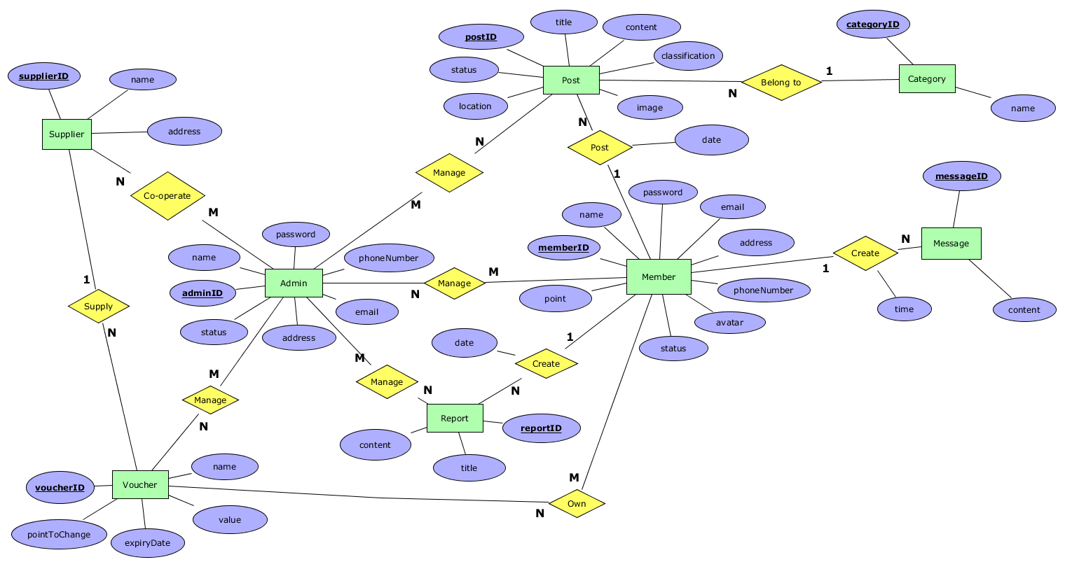

1. **Data dictionary**

|  |  |  |
| --- | --- | --- |
| **Table Name** | **Description** | **Main attributes/fields with explaination** |
| Member | Store member information. | memberID(varchar(20)), name(nvarchar(50)), avatar(image), point(can increase or decrease), status(1: available or 0: banned). |
| Admin | Store users are authorized to manage posts, users, vouchers, … and to cooperate with suppliers. | adminID(varchar(20)), name(nvarchar(50)), status(bit) 1 is working, password(nvarchar(20)) |
| Post | Store member’s post. | postID(varchar(20)), content(nvarchar(MAX)), location(where the item was picked up or lost), classification(1: find or 0: return items), status(1: successful). |
| Category | Store the categories to which the item belongs. | categoryID(varchar(20)). |
| Report | Store member reports that inform the admin about other member malicious behavior that is occurring on the app. | reportID(varchar(20)), titleReport(nvarchar(20)), content(nvarchar(MAX)), dateReport(date). |
| Message | Store user's chat messages. | messageID(varchar20), time(date, when the message was sent). |
| Supplier | Store brands will cooperate with the admin of the application to support the voucher. | supplierID(varchar(20)), name(nvarchar(50)) |
| Voucher | Store electronic codes are discounted when making purchases at stores cooperated by suppliers and admin. | voucherID(int), valueVoucher(float) the value of the voucher corresponds to VND ex: voucher(ID =1) =50.000vnđ ,expriryDate(date), pointToChange(int) Accumulate points to redeem the voucher |