**Guide:**

**Prepare Database:**

* Admin Login:

User Name: Admin_Login

Password: 1

* At Create Table Menu function, change the address of picture in folder Menu.

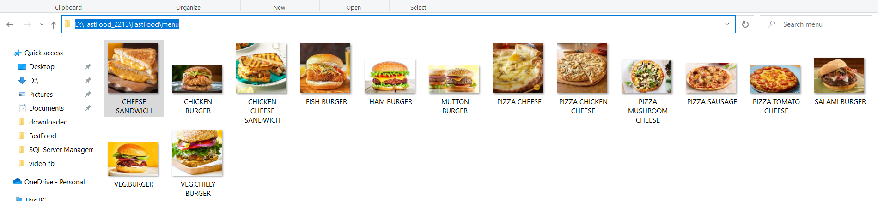

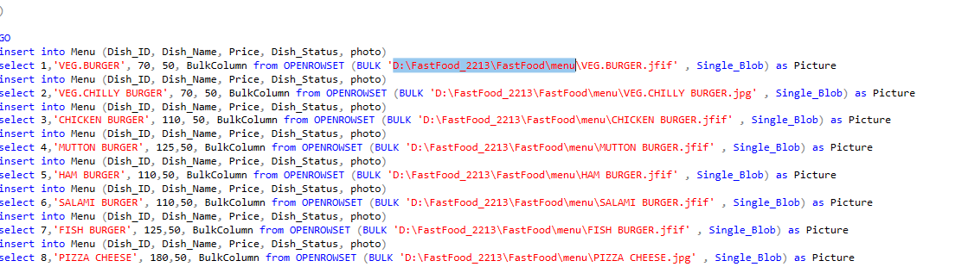

**Run the Application:**

At Program.cs class

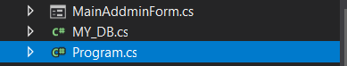

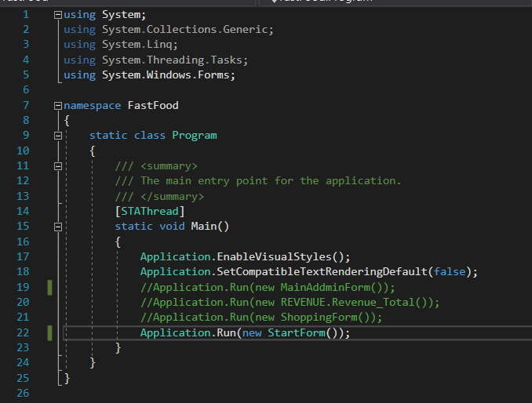

Make sure the StartForm is not comment.

**Shopping:**

Click ‘Lets eat!’ Button to start shopping.

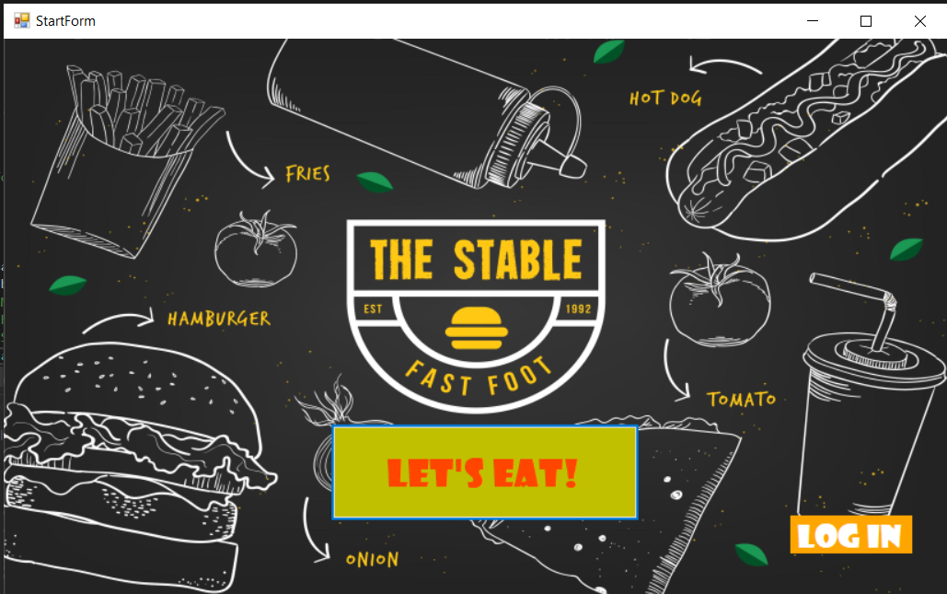

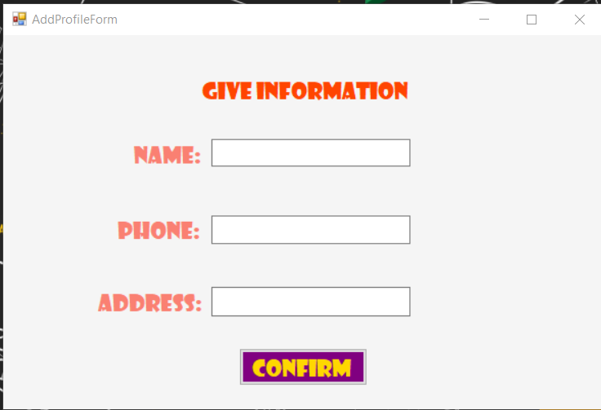

Fill information into text box for better service.

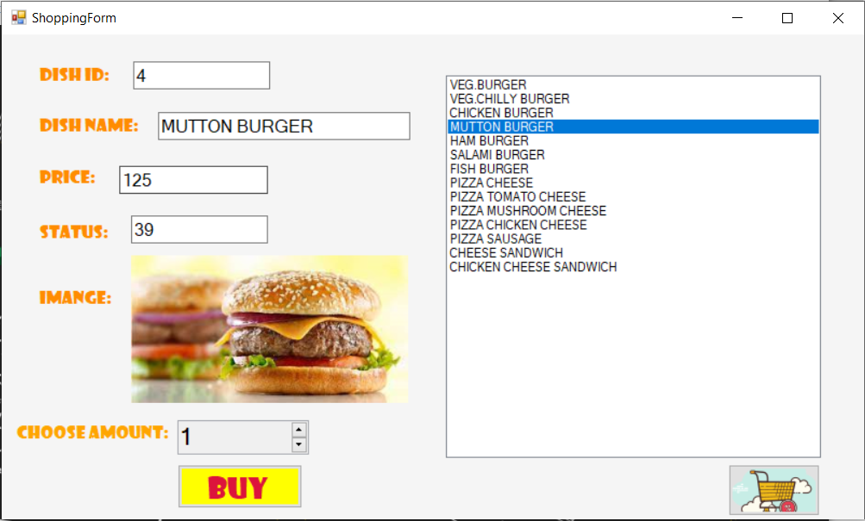

Click the ‘name of dish’ on the data table on the right to see detail dish information. (id, name, price,…)

Select the ‘amount’ and click ‘buy’ to add dish to your cart.

Click the ‘cart’ and we can see the list of dishes we have selected

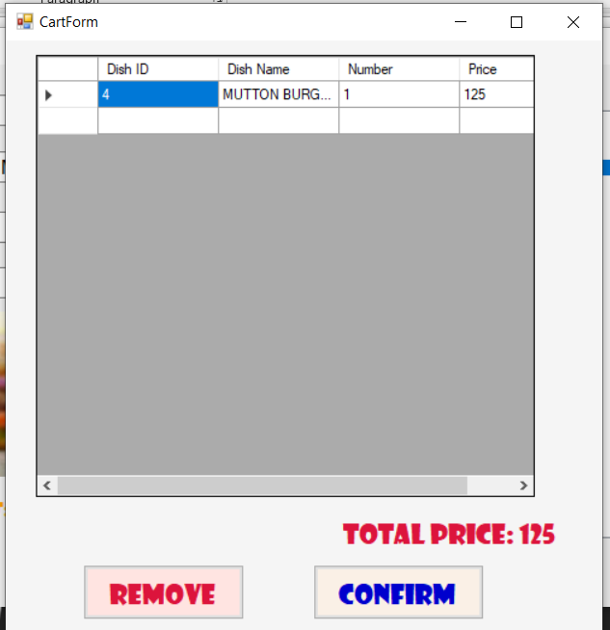

Click ‘remove’ to deleted selected dish.

Click ‘confirm’ to continue to delivery service

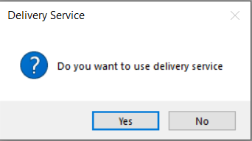

If we choose ‘yes’, a form will pop-up to fill in the address and the date for delivery service.

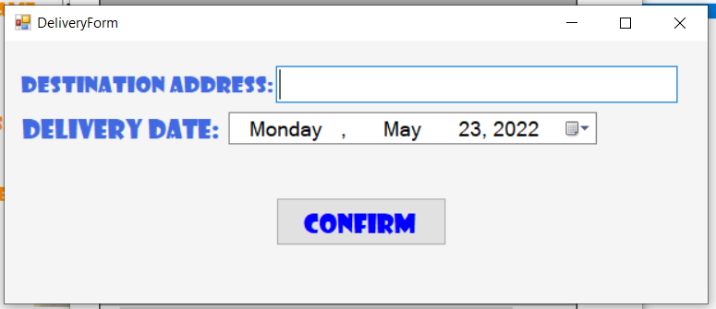

In case we don’t use the delivery service, click ‘no’ and finish your shopping.

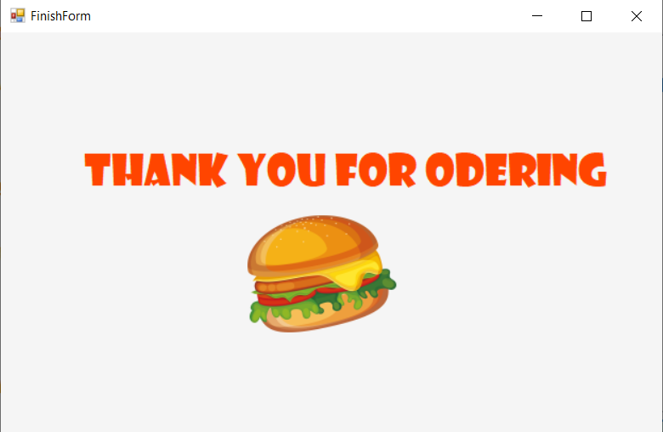

**Login:**

**Username:** user01

**Password:** 12321

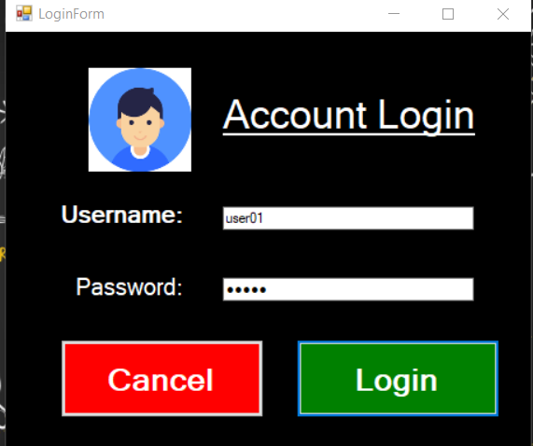

After Login:

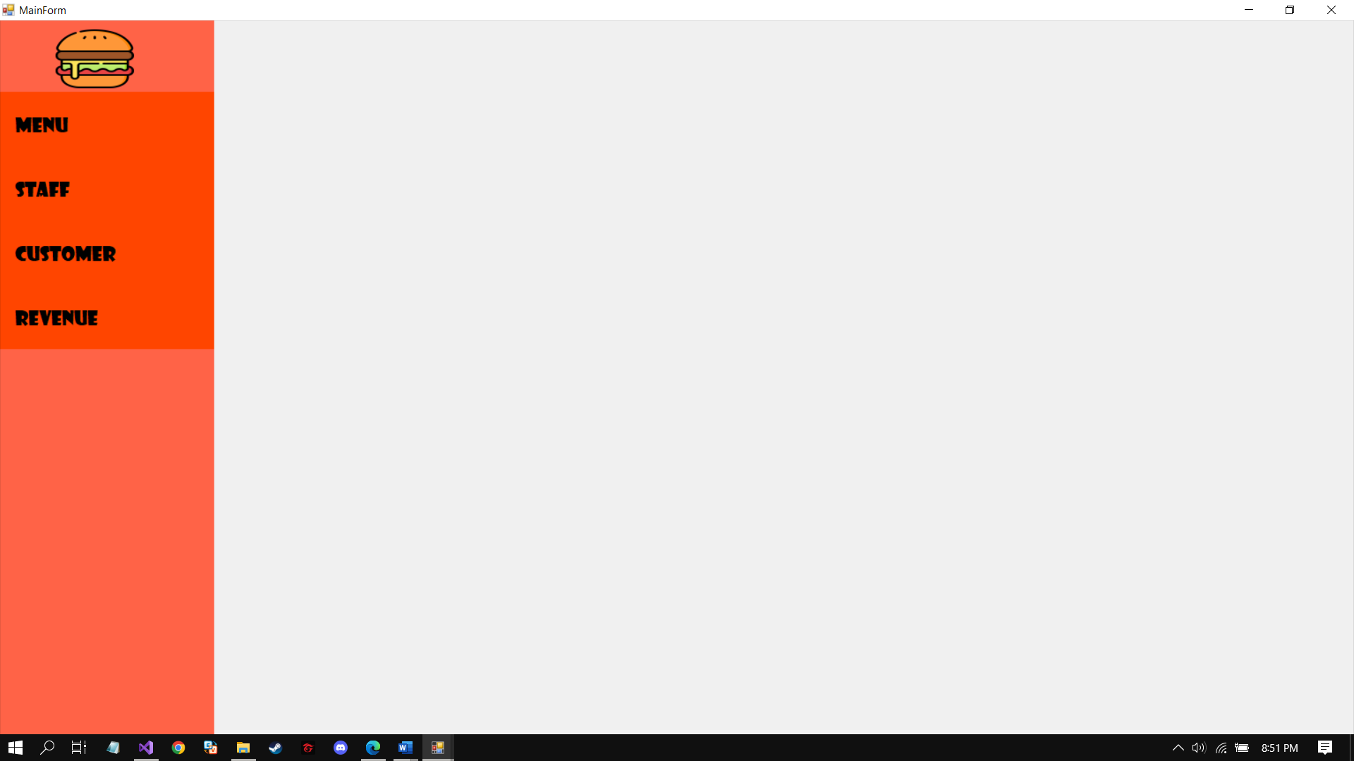

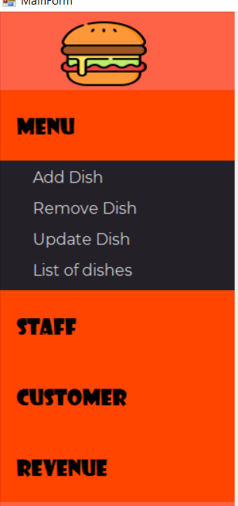

Click “menu”, “staff”, “customer”, “revenue” for further management.

**Menu:**

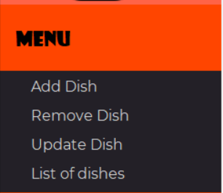

**Add Dish:**

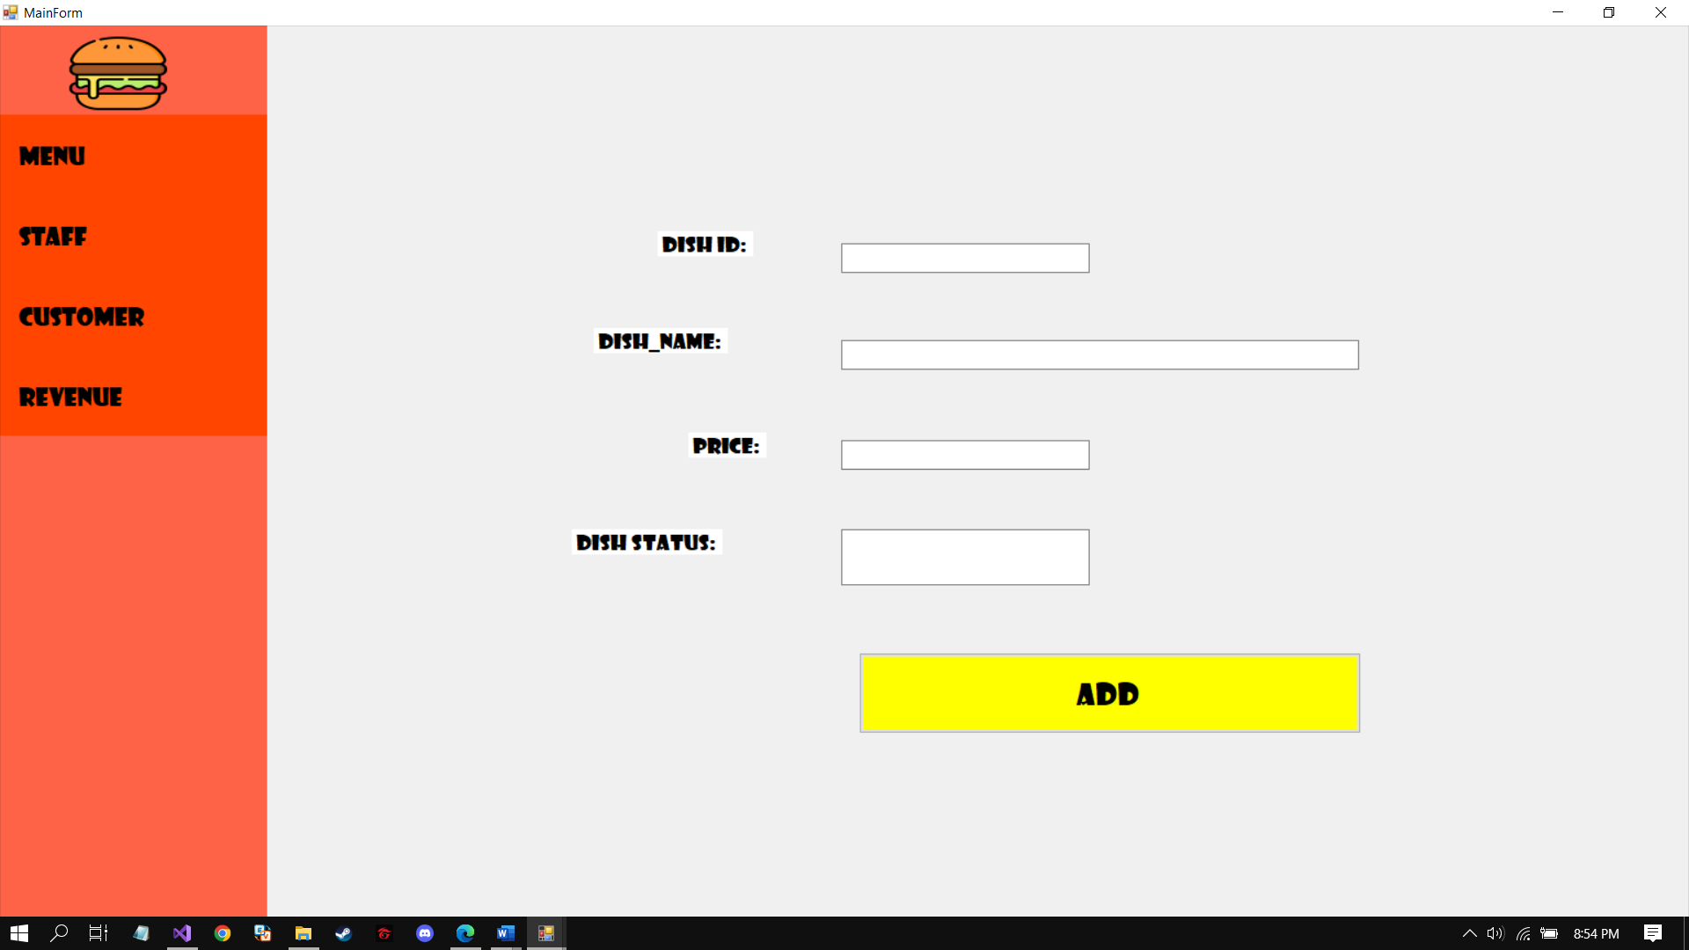

Enter dish information to add a new dish.

**Remove Dish:**

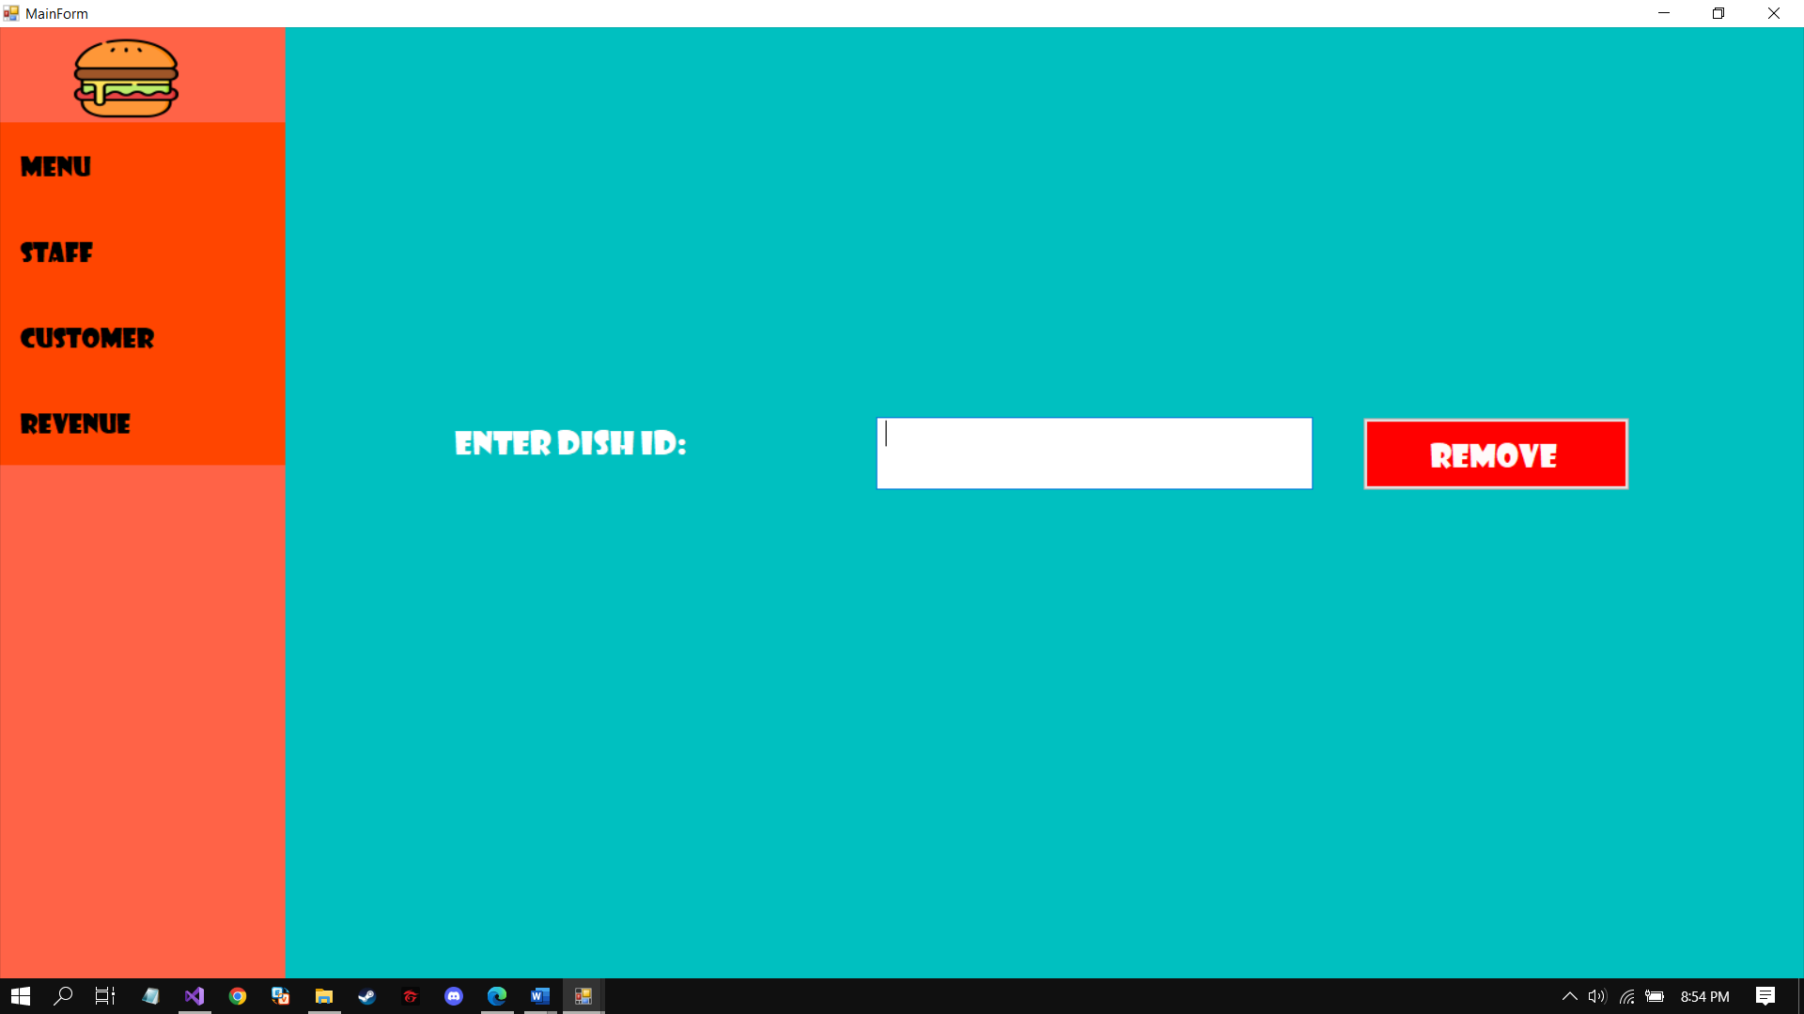

Enter Dish ID to remove dish.

**Edit Dish:**

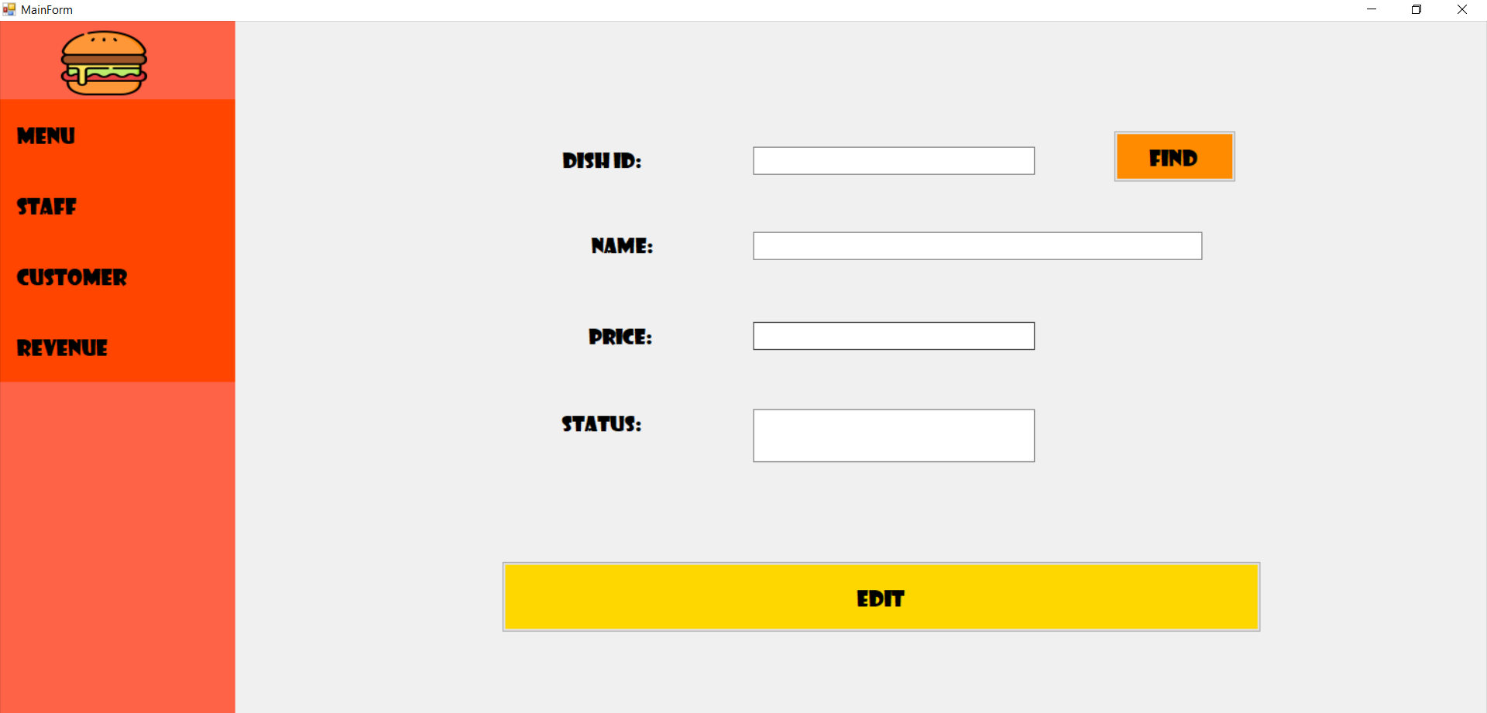

Enter Dish ID and click “find” to see the information

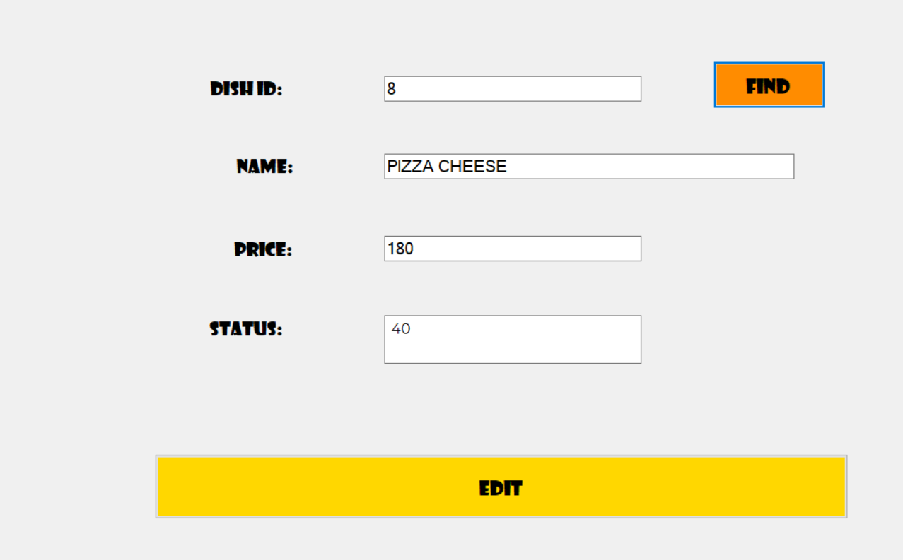

Change the information you wish. Click “edit” to finish edit dish.

**List of dishes:**

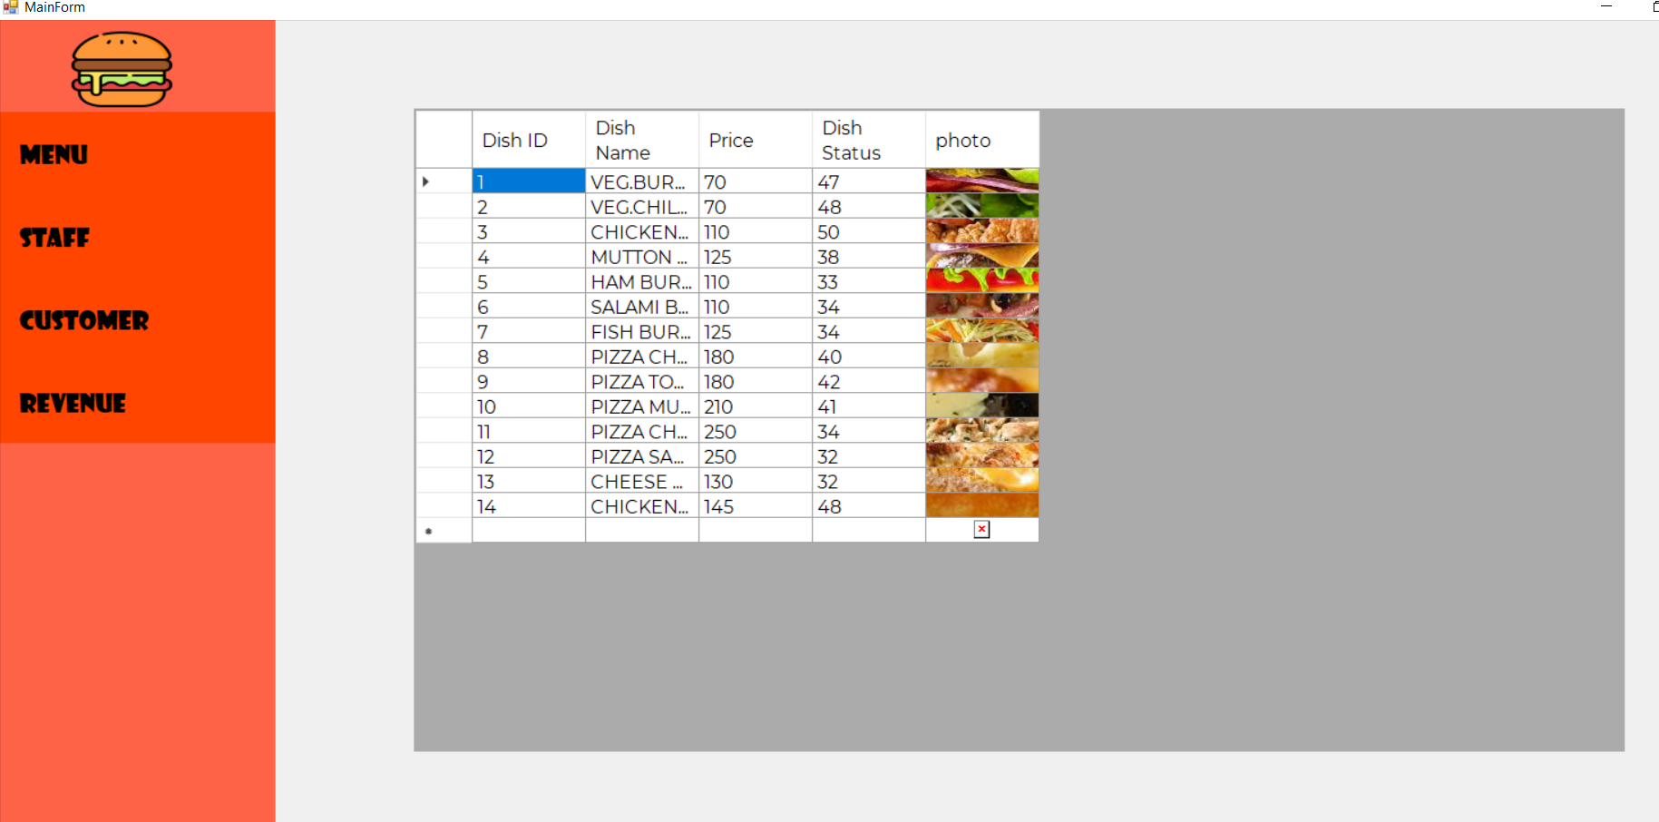

This will show you the list of dishes available in the restaurant.

**Staff:**

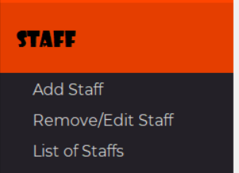

**Add Staff:**

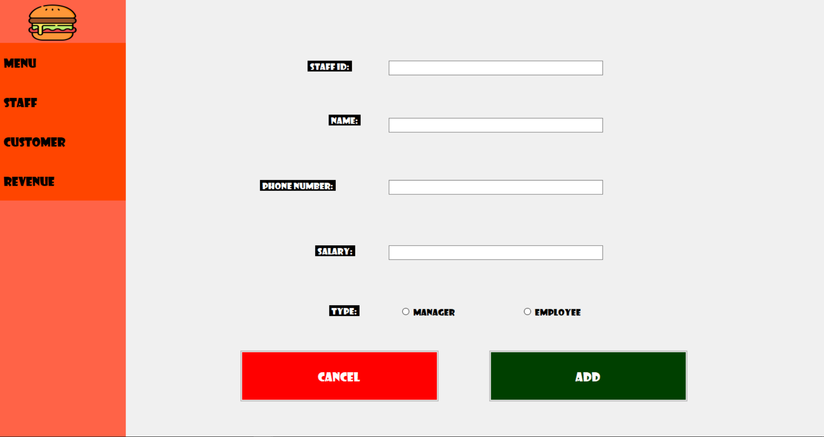

Enter the employee information and click “add” to add a new employee.

**Remove/Edit Staff:**

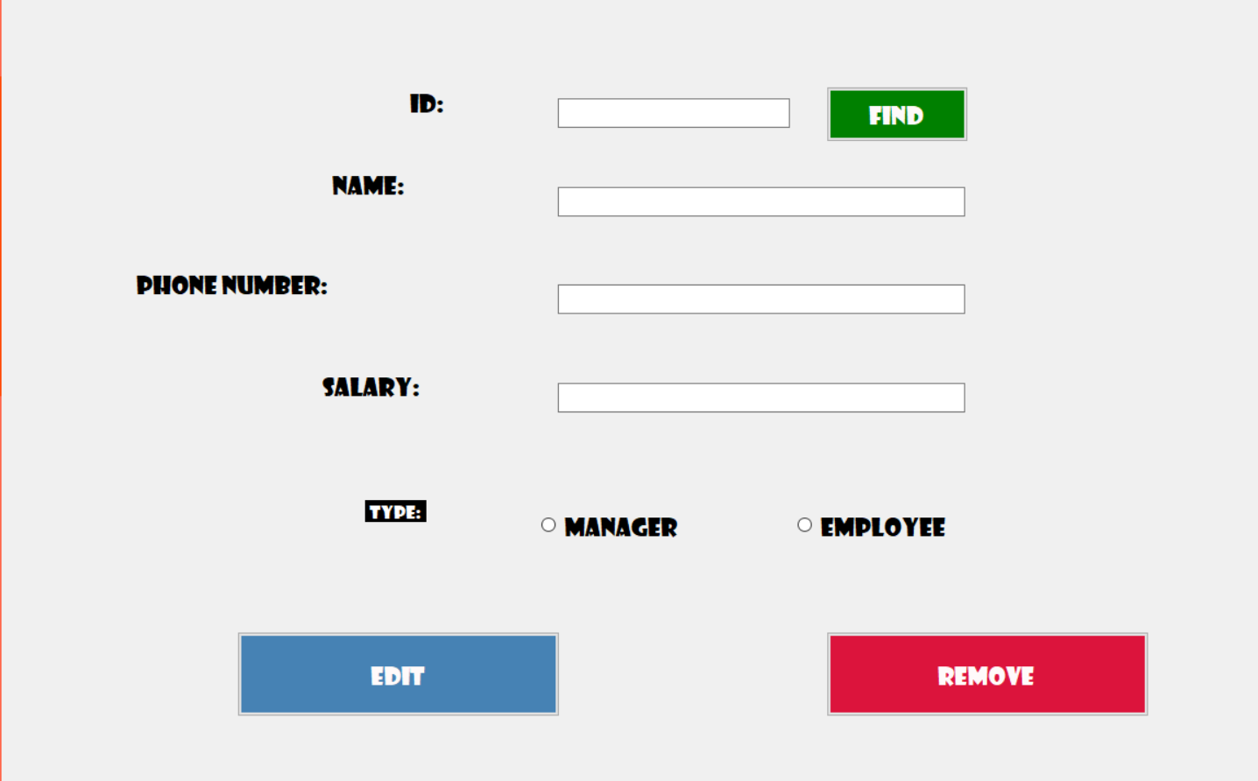

Enter the staff ID.

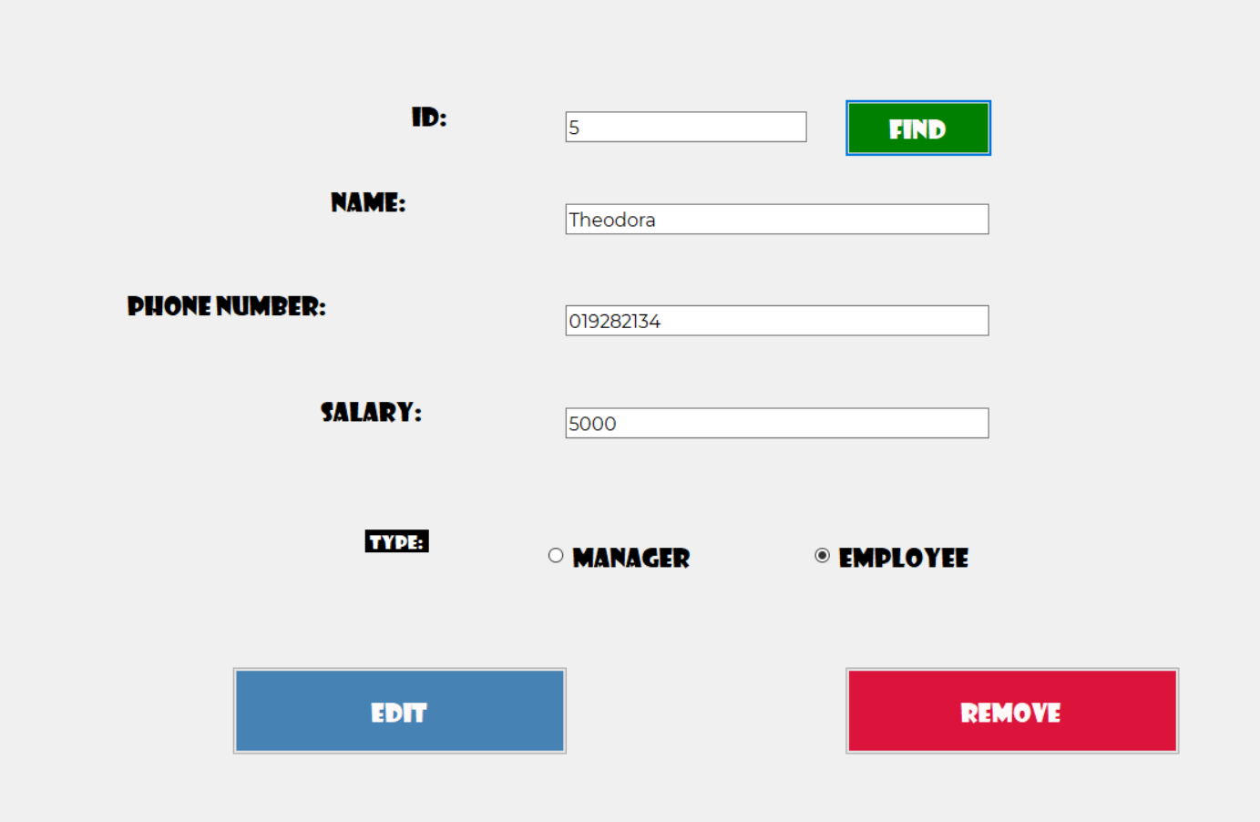

Click remove if you want to remove this employee.

Change the information and click edit if you want to update employee information.

**List of Staffs:**

This will show the list of employees who are working at the restaurant.

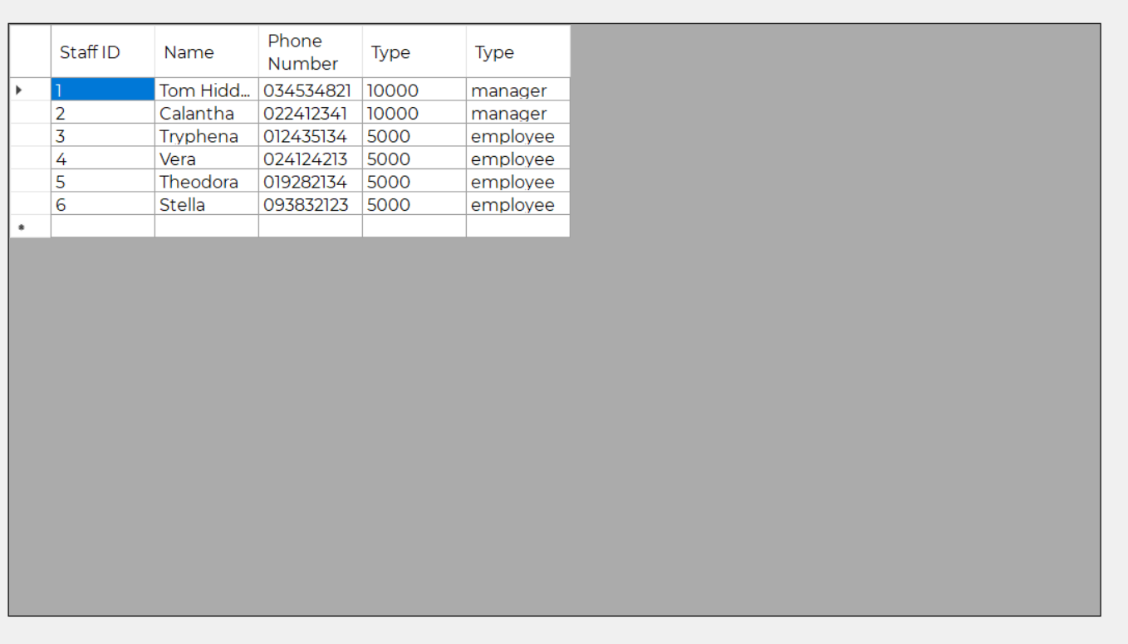

**Customer:**

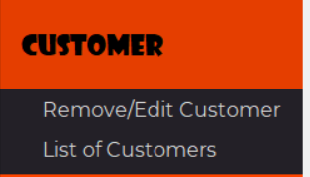

**Remove/Edit Customer:**

Similar, enter the ID to find customer.

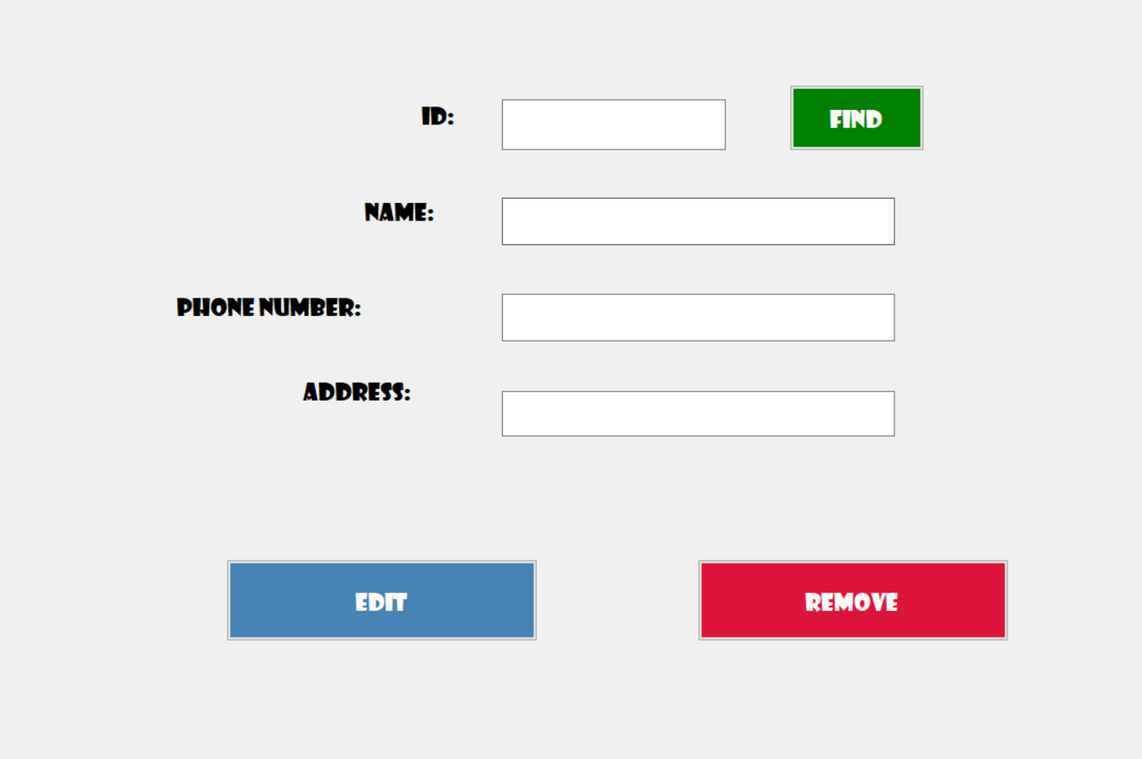

After found the customer, we can remove or update customer information:

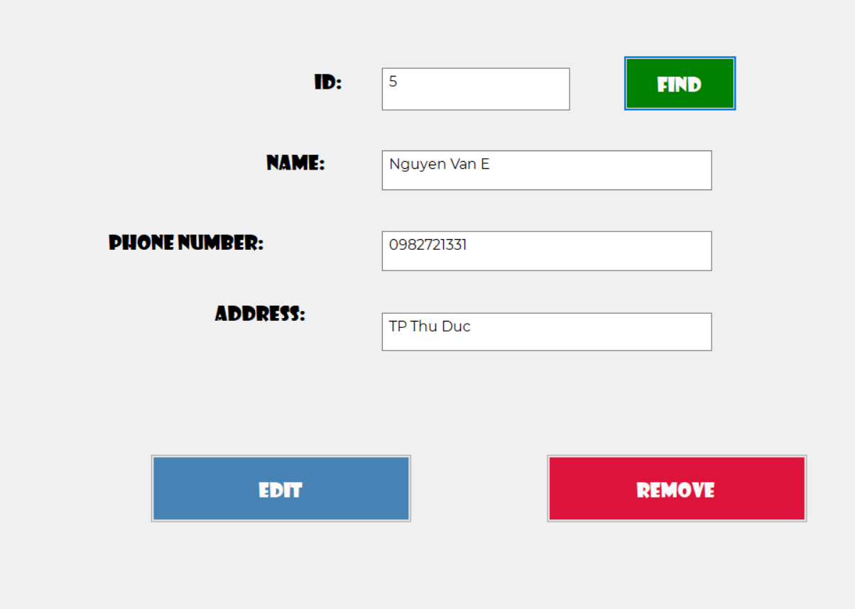

**List of customers:**

Show us the list of customers.

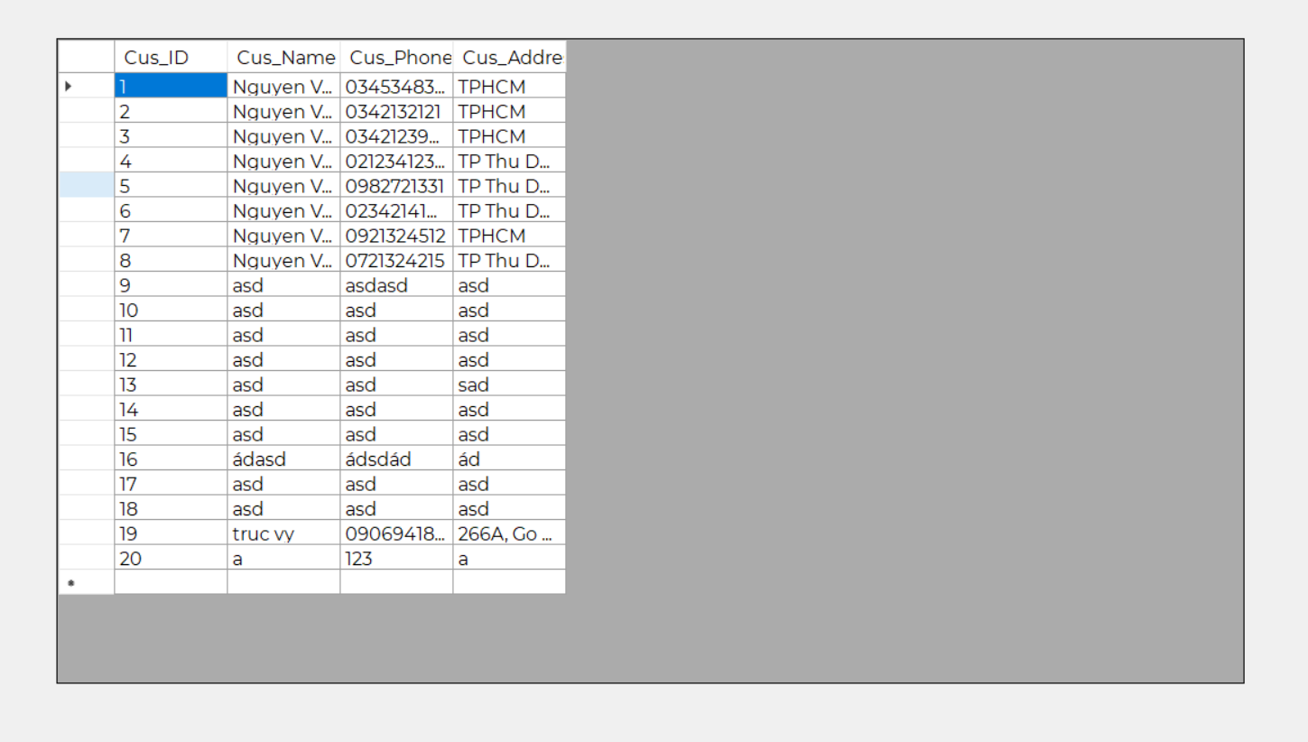

**Revenue**

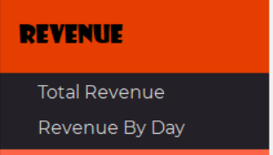

**Total Revenue:**

Show us all the selling information. Total revenue and the most profit customer ID.

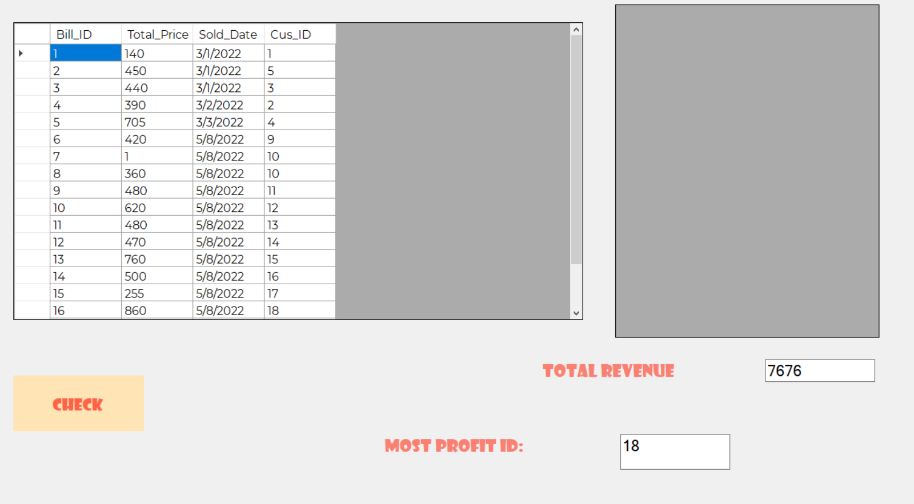

Click at the Customer_ID and click “check”to see the list of dishes that customer buy (on the right data table).

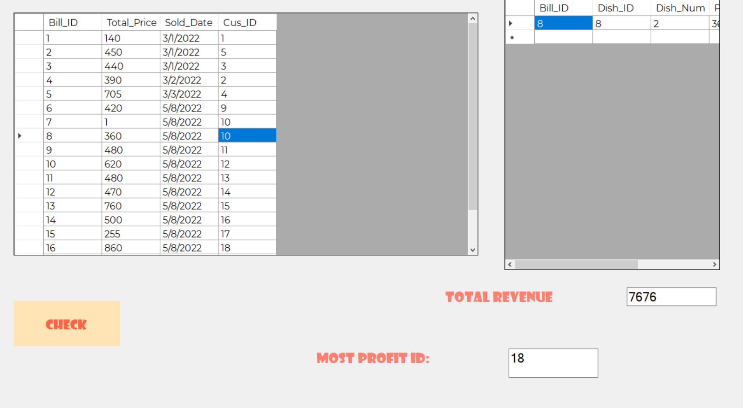

**Revenue By Day:**

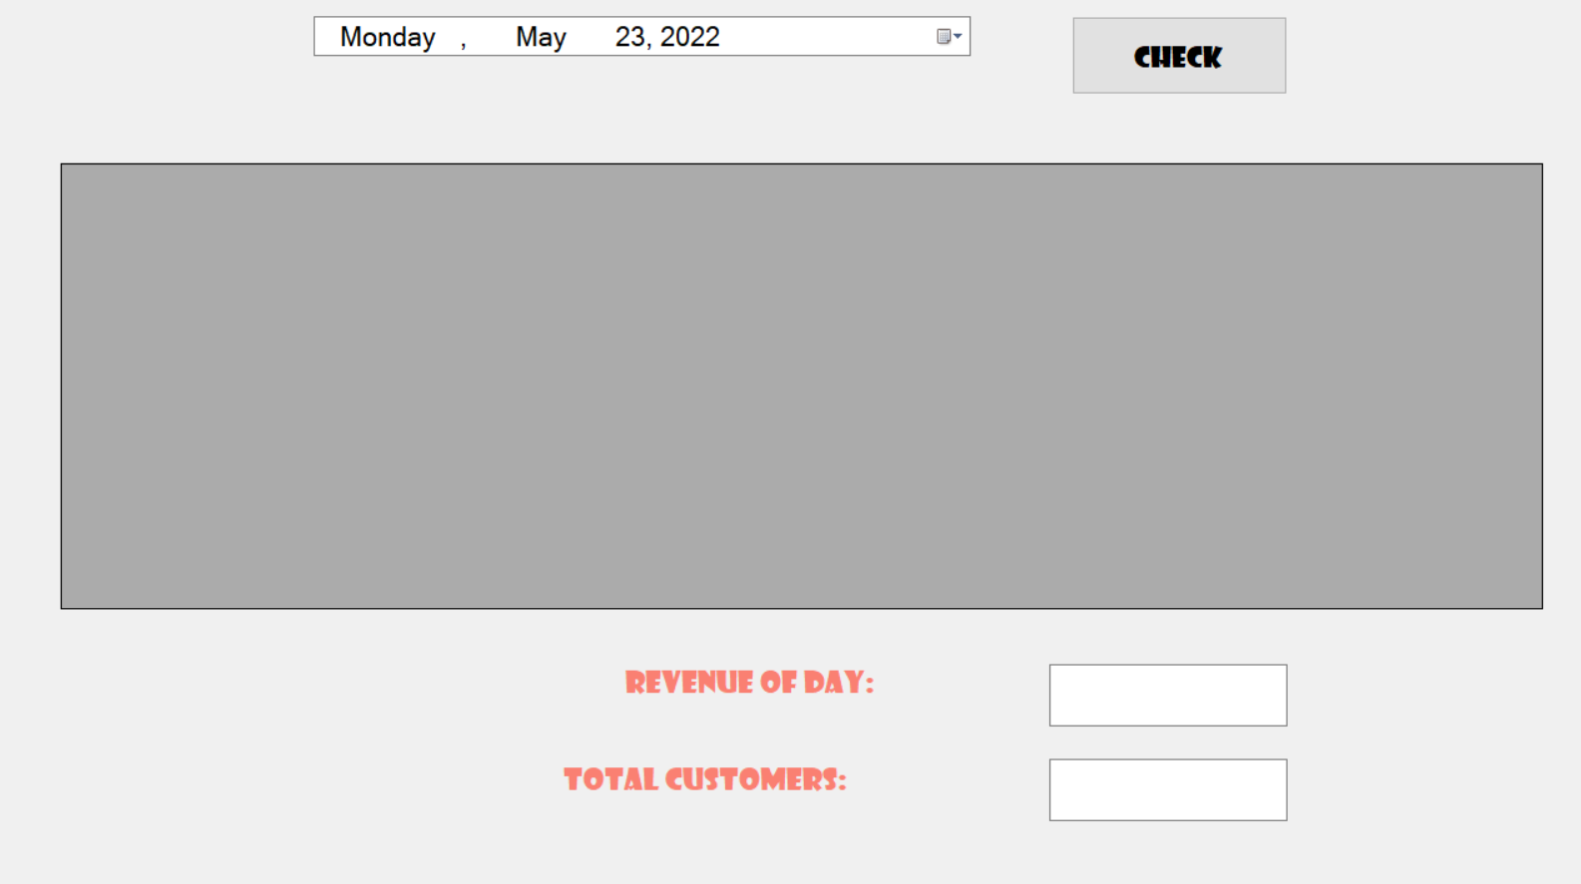

Select the day we want to see.

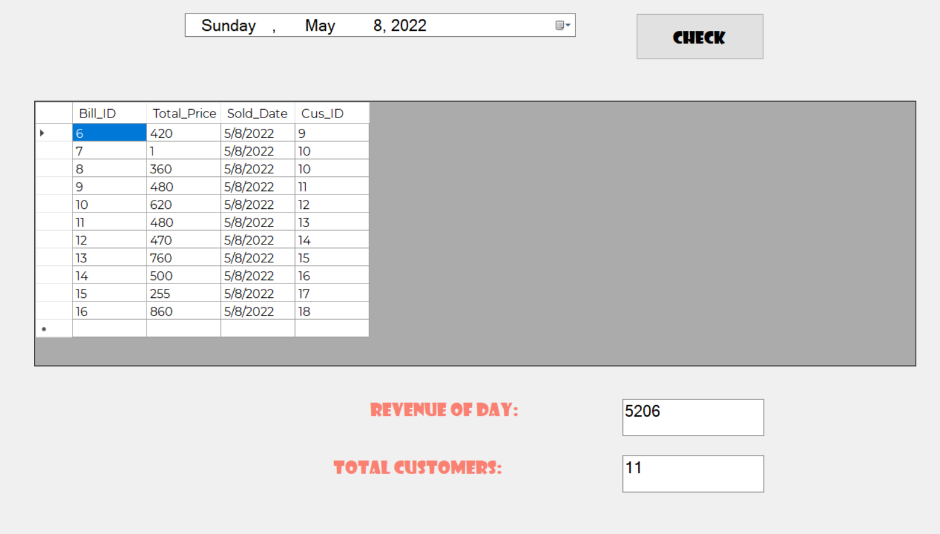

The list of customers will appear. Revenue and total customers of that day will be calculated.