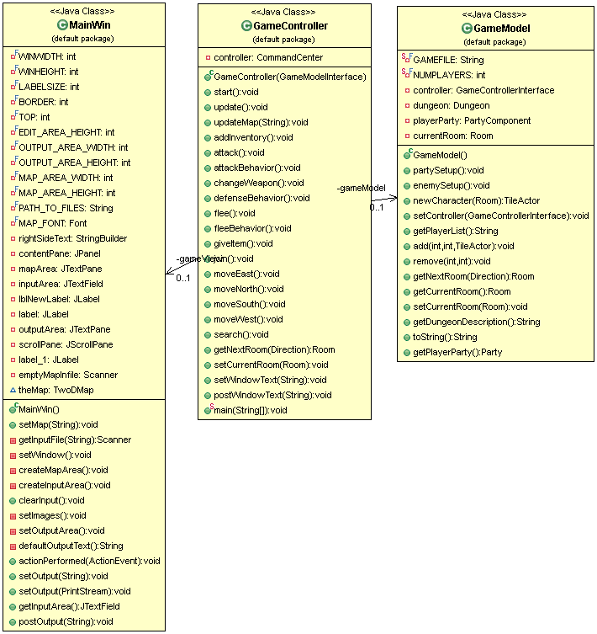

Model-View-Controller

This pattern was central to our game. It provided a way to manage, control, and communicate information between all of the various components of our game. We used this pattern because it seemed to be the most applicable for connecting the large numbers of classes together, and because it provided an easy way to update the GUI with information from the underlying Model. In practice, it worked perfectly. The controller worked as a mediator between the Model and the View, and decided what each Command typed in from the View would do in relation to the Model.

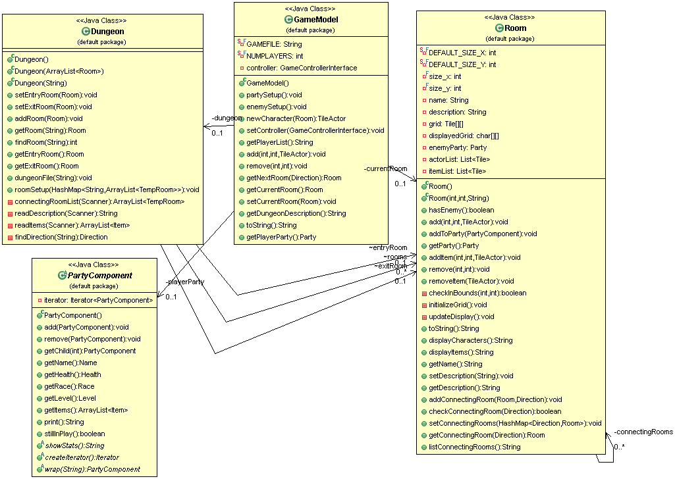

Model-View-Controller continued
Here is the detail for the model portion of the model-view-controller. The model holds a Dungeon and a currentRoom Room reference. Within Dungeon the party, item, and enemy handling occurs, and currentRoom allows the Model to know which room in Dungeon is currently being displayed and acted upon. For updating the View, the Controller makes a request to GameModel's toString – which then returns Dungeon's currentRoom as a string, first drawing the background tiles and then filling in with enemies, the party, and items.
Overall, the Model-View-Controller was not terribly complex and proved to be a great boon to our program. It streamlined the communication from the underlying model to the view, and provided a path for commands typed in the text box to communicate with the model and receive feedback. As the core of our game, MVC held up very well.

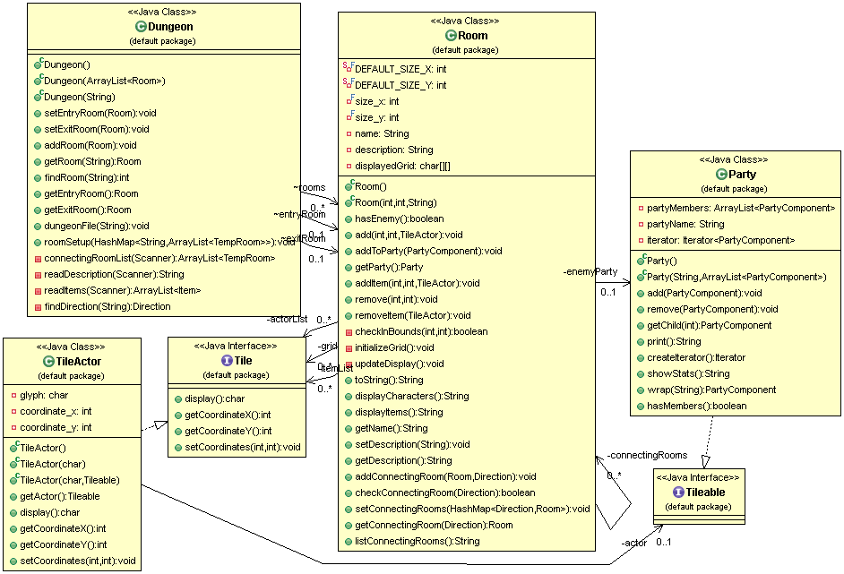

Delegation and Composition
The design and function of the Room changed quite a bit from the beginning stages of our project. Initially, it was designed to hold “actors” – anything from items, to enemies, to recruitable NPCs. These actors would then be able to move about freely within the room, colliding with each other to produce events such as triggering a battle, picking up an item, or running right into a wall. As the design goals shifted, we realized that this was too overcomplicated for our project. Instead, we shifted to a retro-style text-based dungeon crawler type of game, where actors can move between rooms but not within them.
Despite this shift, most of the code did not need to be updated. This was thanks in part to programming to an interface originally. When functionality was to be removed from the Tile interface, only one class needed to change – TileActor. This was because rather than each Tileable actor (items, parties, etc.) implementing the movement and collision behaviors, only TileActor did, which was then composed of a single Tileable-implementing actor. This allowed calls such as getting the party members and item descriptions to be delegated to the Tileable object, while displaying on the map and handling coordinates was done by the TileActor class. Separating the responsibilities between two interfaces like this and then delegating method calls between them made future changes easy and quick.

