Fred Vela
Midterm
100 points
100/100 Fabulous!

Rename the file (midterm_Summer13) to include your name (e.g. capaultmidterm_Summer13). Open book, open notes (including our website and the links on it). YOU ARE NOT ALLOWED TO GOOGLE. YOU MAY ONLY WORK IN THE CONTEXT OF THE ITEMS AND LINKS PROVIDED ON OUR WEBSITE. Discuss your answers with no one until after the due date. You are on the honor system with regards to these items. You signed a code of ethics document as part of your acceptance into this department. Honor it!

For most questions you may use words, class diagrams or Java/C# code to illustrate your
answer, unless the question asks for a specific format. When you draw a class diagram, indicate the methods that make the pattern work. Also specify the type of relation (inheritance / composition) between classes and type of class (interface / abstract class / regular) as indicated in the sample UML class diagram on the right. You may also use the terms “is-a” or “has-a” to indicate the relationships. For each class & interface in your diagram indicate what it does. Use a circle to describe the responsibilities of each class. The more detail you include, the better chance you have at earning full credit.

1. (4 points) List (at least) four of the most important benefits that design patterns provide to communities of developers?

- Elevates the thinking about architectures by letting you think at the pattern level, allowing designers to "stay in design" longer, and not resorting to discussing implementations of objects and classes

- A team well versed with patterns can move more quickly, and with less room for misunderstanding

- Patterns allow you to say more with less; when you use a pattern, other developers know precisely what you have in mind

- A shared vocabulary. You are not just communicating a pattern name, but an entire set of qualities, characteristics, and constraints the pattern represents
2.(6 points) How are structural patterns different from behavioral patterns? Give an example for each type and discuss what system quality each patterns seeks to improve to show how they differ.

- Structural patterns are patterns working with systems of classes and subsystems, while behavioral patterns are patterns that work with objects' state(s).

- For example, provide a unified interface to interfaces within a subsystem. The structural pattern facade can shield a client from subsystem components,and allow the client to communicate with complex subsystems. Looks to promote a weak coupling between a client and subsystem components. Its intent is to simplify the structure, making the structure easier to use and offering clarity.

- The behavioral pattern oberver defines a one-to-many relationship, so that if one state changes, all other dependent objects are notified and automatically updated. This pattern defines how the objects interact with each other. This improves the interaction with subjects and observers so that there can be a dependency from one-to-many. The subject and the observer don't have to know anything about each other, loosening the coupling between them. In an observer pattern, however, a listener is an observer.

- (5 points) Explain the reasoning behind the OO design principle “Tell, don’t ask”. What system qualities does this design principle improve? Illustrate your answer with a simple example (in words/code/UML).

- We talked in class about how "Tell, don't ask" can eliminate some code smells. A conditional or a switch statement could be refactored into a command, rather than a series of "asks" which an if clause or an if else clause generates. Also, conditionals often are hard to manage and can be painful, especially when there are code changes.

- if (value == true){ return true;}
- if(value == false){ return false;}
- Could be refactored into: return(value);

- (10 points) Give a class diagram for the Bridge *and* the Adapter design patterns. Follow the instructions for drawing and describing a class diagram on the first page of this midterm. NOTE: you should have two UML diagrams, one for each pattern.

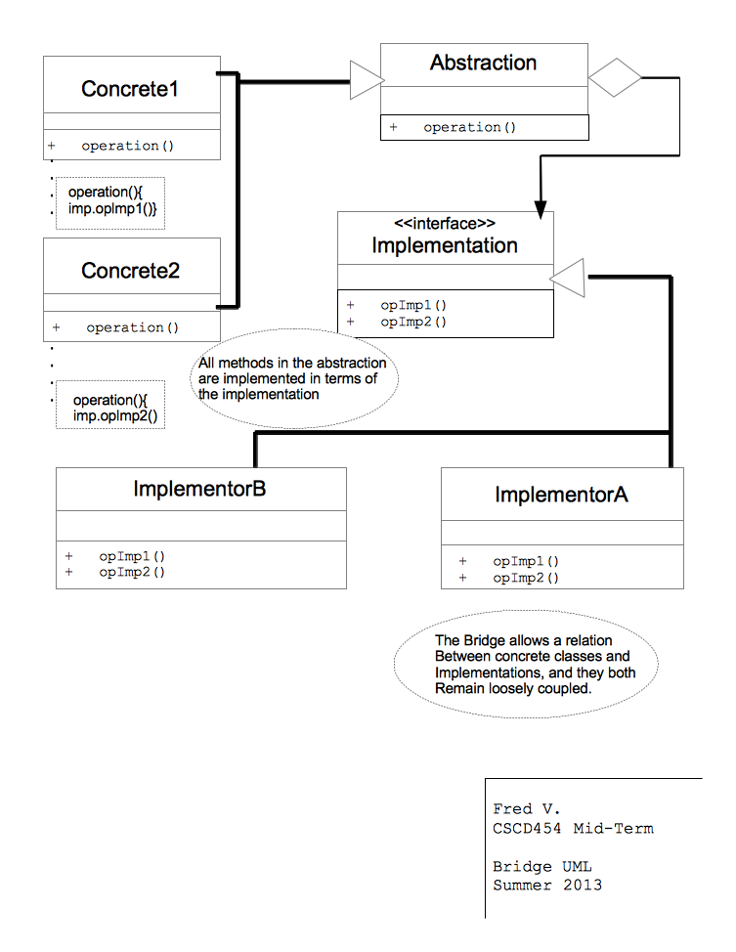
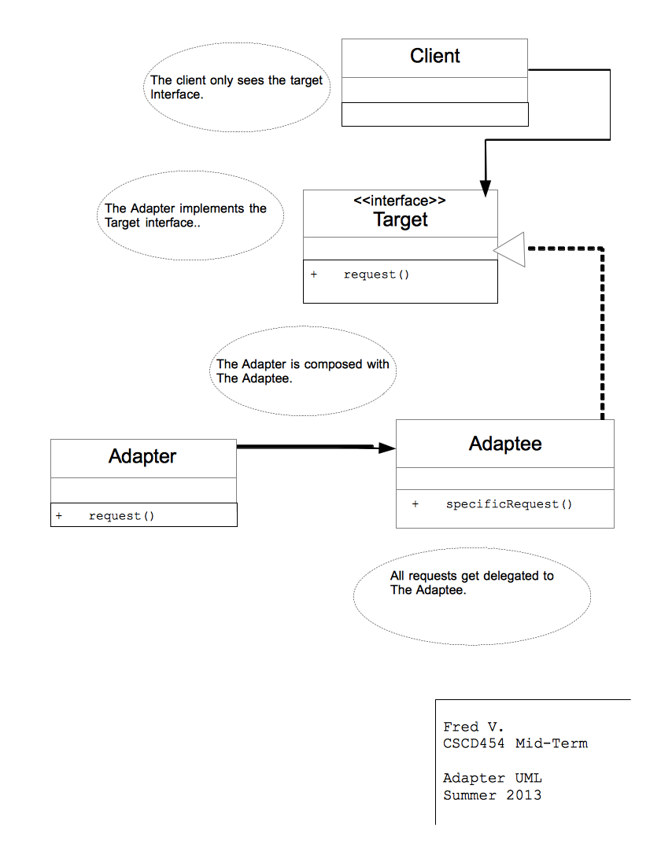

5.(15 points) (a) List (at least) five OO principles, (b) explicitly describe what each means, and (c) describe a design pattern that employs each principle. Note that inheritance, polymorphism, encapsulation, and abstraction are the Pillars of OOP and not principles in and of themselves. An example of an OO principle is ‘favor composition over inheritance’ – you may not use this as one of your five, BTW.

1a. Program to an interface, not implementation.

1b. Look to exploit polymorphism by programming to a supertype so that the runtime object isn't locked in the code.

1c. The strategy pattern uses interfaces to change behavior at runtime by implementing the correct behavior interface.

2a. "Talk only to your friends"

2b. Describes systems for objects to be careful of the number of classes it interacts with, and how it interacts with other classes. Prevents creation so that changes in one part of the system cascade to other parts. Only invoke the object itself, objects passed in as a parameter to a method, any object the method creates or instantiates, or any components of the object.

2c. The adapter pattern looks to reduce dependencies between objects and adheres to the Law of Demeter.

3a. Strive for loosely coupled designs between objects that interact

3b. Objects that are loosely coupled can interact, but have very little knowledge about each other.

3c. The observer pattern's subject and observer objects interact with each other, yet the don't know much about each other, and don't have to as long as they adhere to the implementations.

4a. Classes are open for extension, but closed for modification

4b. Allow classes to be easily extended to incorporate new behavior, without modifying the existing underlying code.

4c. The decorator pattern allows for classes to be extended, by easily extending behaviors as other decorations to an object, and the underlying decoratee does not need to be changed.

5a. Depend on abstractions. Do not depend on concrete classes.

5b. Our high level components should not depend on the lower level components or concrete classes. The same for the lower level, it should depend on abstractions. This implies the dependency inversion principle.

5c. The factory pattern is a great example. Both the high-level component, PizzaStore and low-level component, the concrete Pizzas themselves, depend on the abstraction Pizza. This adheres to the Dependency Inversion Principle.

6.(15 points) List 5 code smells, describe what each means, and describe how to refactor each.

- Duplicated code is a smell that refers to code that can be subtle or explicitly duplicated, appearing in structures or processing.
An example: A class “Engineer” suppose a class of “Salesperson” with both containing a field of “name” as they both extend a class of “Employee”. Rather than creating a name field in each class, move the field to the superclass to refactor.

- Inappropriate intimacy is a smell that exists when classes spend too much time on each other's private parts.
By changing the association of these classes from being bi-directional, to unidirectional, you can refactor. Other remedies include extracting a class out of the data being used, or instead replace inheritance with delegation.

- Divergent change code smell be smelled when classes are being changed in different ways for different reasons. Remember, a class should only have one reason to change.
Refactor this smell by moving the necessary fields and methods from the old class into a new class. Continue to reduce the classes so that they have a single reason for changing.

- Data clumps is a common smell in that it is code that is virtually the same type of data that can be seen together in different places.
Refactor this smell by introducing a parameter object, group naturally grouped items into an object.

- Refused bequest is a smell where a use any of the implemented methods. Maybe 3 or 4 of the dungeon characters in the game don't use the attack method that is inherited, let's say.
A refactoring need for this smell is to just not allow these characters to use inheritance altogether for their creation.

7. (5 points) Assign each design pattern to the right category by placing an ‘X’ at the right spot. Each pattern belongs to one category. Choose the category that best fits the pattern

Pattern | Stuctural | Behavioral | Creational
Bridge | X
Facade | X
Singleton |  |  | X
Command |  | X
Decorator |  | X

Design Problems
Four design problems are listed on the pages that follow – you must provide solutions for three. If you solve a fourth, that one is worth 5 points extra credit (clearly label which is extra credit if you attempt it, please). Select the most appropriate design pattern to use to address the problem and clearly motivate how it addresses the problem. Furthermore, show an appropriate class diagram and enough code fragments to illustrate the implementation of your pattern.

8. (10 points). You work for a company that develops medical imaging equipment. You developed a medical imaging application which collects data from a computed axial tomography (CT) scanner via TCP/IP sockets. The imaging application was originally
written to communicate with one scanner but was expanded when your company started to develop a functional magnetic resonance imaging (FMRI) scanner. Unfortunately, this FMRA scanner does not speak the same language as the CT scanner. Marketing required your application to support both types of scanners, since the imaging software is the same for both types of scanners and hospitals may use the scanners in tandem. The R&D department of your company recently announced that they will launch a photo acoustic (PA) scanner in 2014 which use a different communication protocol than the CT and FMRI scanner. Because this is medical software it runs on custom operating system that is ultra reliable and consequently does not support unreliable hardware abstraction through drivers. This means the drivers for the scanners are part of your application. Your application works as follows: you place a patient in the scanner and press the scan button upon which the scanner will send a request for image transmittal to your application. Your software keeps track of which
driver is required for which IP address.

- The motivation behind this design is the complexity of three different protocols performing the image transmittal to the application. The application shouldn't care which of the three protocols is being used at a given time, it just cares that the action be performed, so a Facade pattern here makes sense. Look at the ScannerFascade class. Its a unified interface to the three different scanning protocols necessary to perform the image transmittal.

- Each subsystem class has its own protocol that it needs to work,
so the scan() for each subclass will independently utilize its own protocol when sending in the scan() request;

public class ScannerFacade
{
CT_Scan ct_scan;
PA_Scan pa_scan;
FRMI_Scan frmi_scan;

public ScannerFacade(CT_Scan ct_scan, PA_Scan pa_scan, FRMI_Scan frmi_scan)
{
this.ct_scan = ct_scan;
this.pa_scan = pa_scan;
this.frmi_scan = frmi_scan;
}

public abstract void scan();

public class CT_Scan
{
CT_Data ct;

public CT_Scan(CT_Data ct)
{
this.ct = ct;
}

public void scan(){
{
ct.getData()//stream the data using its own protocol
}

- As indicated, each subclass will use the scan method as they require it.

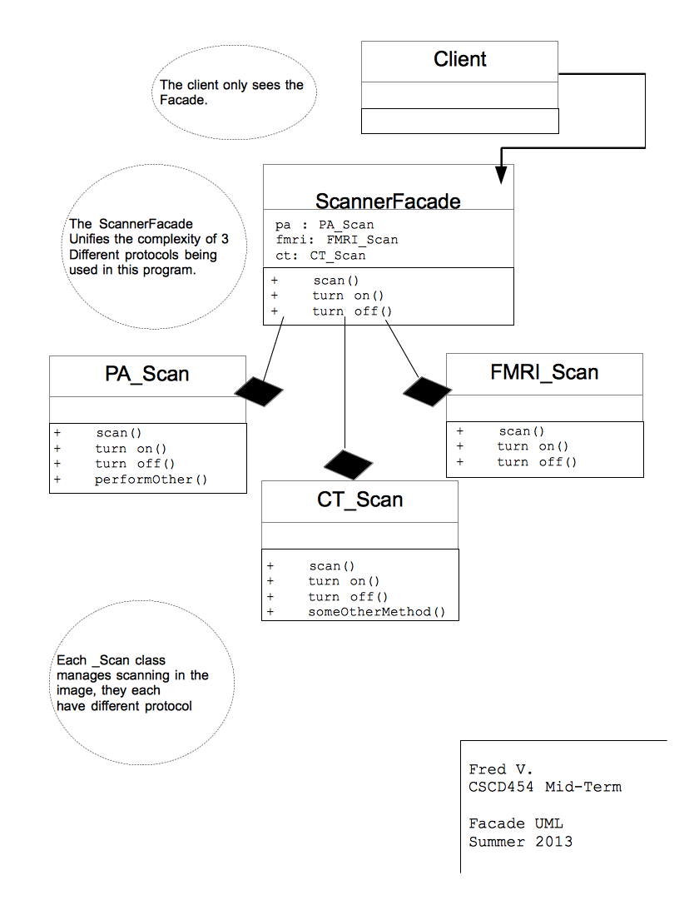

9. (10 points) You work for a webhosting company that offers a ton of hosting services (Flash Media, MySQL, Subversion) to its customers in addition to a base web hosting
plan. You need to write an application that can easily compute the total monthly service
fees for each plan. Your application must be able to easily support adding new types of
hosting services (such as Ruby on Rails) when they become available.

Sample output could be:
> Basic Hosting, Subversion Hosting, Flash Media Server Hosting, MySQL Hosting(w/3 databases): 59.94 a month.

- The customer requires flexibility in supporting new types, and a system that easily computes the costs of service fees. As each customer could vary in that there are many combinations of services, a customer could be "dectorated" with service fees.(This is good for business!) A decorator pattern makes sense because its almost impossible to make classes that can suit every possible scenario that a customers' service fee calculation could amass.

- An appropriate fee is added to the total cost, as each service is "wrapped" around the customer.

- This supports new types in that existing code need not be changed to add new service fee plans to be offered.

- A ServicesDecorator will extend the customer, so we can manage the same datatype, in this case type Service.

public abstract class Service
{ String description;
public abstract double cost();
public String getDescription(){ return description; }
}

public abstract class ServiceDecorator extends Service
{ public abstract getDescription(); }

public class FlashMedia extends ServiceDecorator
{ Service service;

public FlashMedia(Service request)
{ this.service = request; }

public double cost()
{ return 17.99 + service.cost(); }

public getDescription()
{ return service.getDescription() + "Flash Media, "; }
}
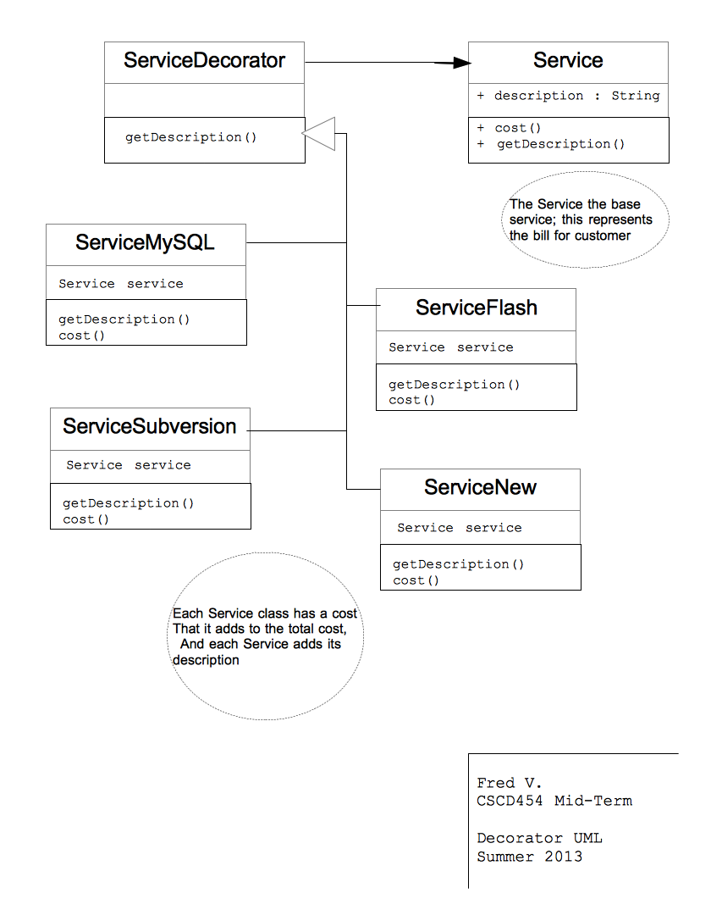

10. (10 points). For an online bookstore you need to design a database engine. This engine processes transactions that it receives from it’s users through a web based interface. A database transaction could be the insertion of a new book, the recording of
a sale, or searching for particular books on different fields (title/author). Your engine must keep a list of transactions that need to be executed and cues these as it may take a while for a transaction to complete and transactions are performed sequentially. Should one of these transactions fail, all others can be reverted or discarded (called a rollback). For example, if two database tables which refer to each other must be updated, and the second update fails, the transaction can be rolled back, so that the first table does not now contain an invalid reference.

11.(10 points). You have been hired to work for a web-based personal financial management service (like mint.com). Users can get an overview of their financial situation and they can add checking, savings and credit card accounts from different banks that are conveniently compiled into one or more views. Users can access this financial management service either through a desktop application or a mobile device like an iphone which have different screen sizes and interaction capabilities and hence different views may be required. Bank accounts are checked periodically and whenever a new transaction is detected views must be updated.

- Since we want to update different devices, we can set them up to interface an observer. This way, when an update occurs, the other devices will also have the same information. We have different views, desktop and mobile. By interfacing the devices with a DisplayElement, we can ensure that each display() will do what it needs to do to support the viewing window.
- We want to be notified of changes, so we need to first call setChanged() to signify
that the state has changed in the object
- Then call notifyObservers()
- Update() method calls the getOverview(); then call display();

public class DesktopDisplay implements Observer, DisplayElement
{
Observable observable;
public DesktopDisplay(Observable oberservable)
{
this.observable = observable;
observable.addObserver(this);
}
public void update(Observable obs, Object arg)
{
if(obs instanceof FinancialData)
{
FinancialData data = (FinancialData)obs;
data.getOverview();
display();
}
}
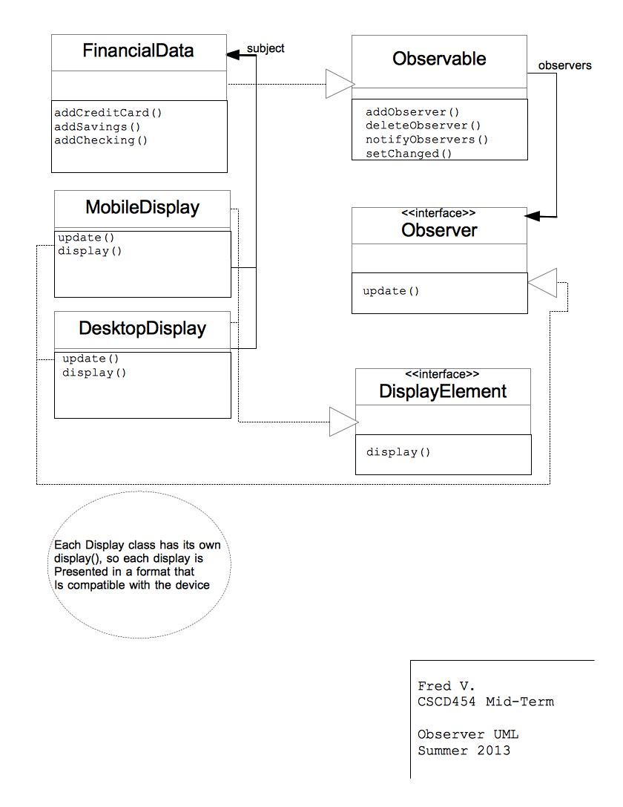

12.(6 points) List three things that cause software to change. With each thing you list, describe an OO principle or pattern that helps with that problem.

- A client's requirements can change. The company will now offer additional options on some of their products. The principle of “open for extension, closed for modification.” This principle will help because it will allow the company to add new options to existing products such that the company can feel free to add options, without having to go back and make major changes the existing products.

- System hardware or architecture can change. Perhaps the introduction of a new technology changes the way that the existing code interacts with devices. A pattern like a facade can be applied, so that the new components can be added to the subsystem. Simplifying the subsystem with a the facade pattern can ease the complexity of working with multiple hardware configurations.

- A client's needs can change. For example, a successful business may expand, thus requiring the software in production and manufacturing to change. Maybe a new manufacturing plant is needed to keep up with the demand. By subclassing a new creator class, or in this case new manufacturing plant, the existing product classes are unchanged, and will be ready for production in the newly added manufacturing plant. The new plant will know how to manufacture the existing product line, without having to explicitly write code for the new plant. So, adding a new facility for the client doesn't require new code for existing products.

13.(4 points) Describe the difference between published and public with regards to interfaces as discussed by Eric Gamma on the link provided on our website. The discussion references Martin Fowler, who formally identified the difference between the two. NOTE: in describing the difference between two items, you must clearly define what each means, then you can clearly and correctly point out the differences.

- With regards to interfaces, published can be regarded as API, and public refers to implementation. Published interfaces are API's. Overriding a method takes a strong commitment than defining that a method be called. Public is writing code to the interface of a non-published class. When analyzing Folwer's example, he cites an interface, with five methods, and an implementation class of this interface, with 10 additional methods. If an object were to call a method from the 10, it would be an internal call. The object has not been written to the highest part of the hierarchy; its out of contract, and the code could break. Its the difference between writing to an interface and writing to an implementation. A change to the implementation could "ripple" through the rest of the code, where a published interface would not cause harm. The object is locked into implementation and not free to change.

