IEEE 索引：

Linear Programming Solution for Transporting Multiple Petroleum Products Using Pipelines

Feng Zhen, Andrew Lim, Yibo Chen

Oil Products Transportation with Combinatorial Auctions

Yibo Chen, Andrew Lim, Hong Ma, Feng Zhen

ICGA Journal：

RICOCHET ROBOTS IS SOLVED

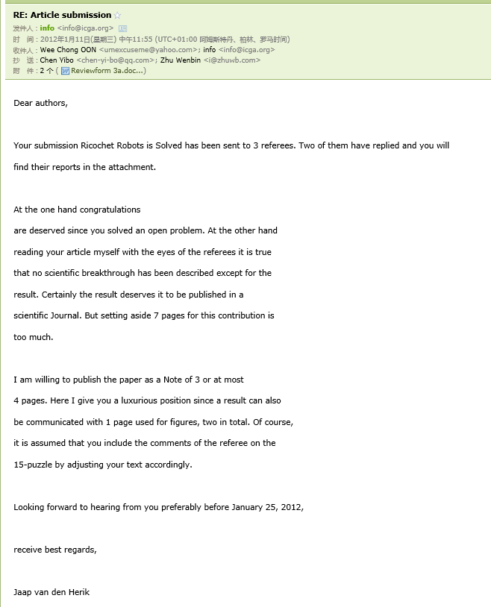

Industry Data Mining Conference:

Mining Social Media to Predict China Stock Market

