# Quote Management System

**Administration and set up documentation**

Contents

Quote Management System 1

Overview 2

Limitation. 2

Requirements 2

Architecture 3

Overview 3

Detailed Description 3

Azure Resource Grid 3

Azure Storage 3

Azure Function 3

Azure Web Application 3

Azure Policy 4

Solution Schema 4

Interaction 4

QMS Portal. 5

Overview 5

Main interface for user from **QMS Managers** group. 5

Bulk update resource group option for **QMS Managers** group. 6

Update default settings interface for **QMS Managers** group. 7

QMS Role management 7

Role Assessments 7

# Overview

The Quote Management System (QMS) is designed as alternative solution for Quote management available only on Subscription level for IaaS in Azure.

QMS consist of PaaS resources internally monitoring deployment activity on the Subscription and setup limitation or deny deployment depends of the provided settings for each Resource Group.

The purpose of the QMS is setting up live monitoring and limitation for the deployment of new IaaS environment in resource group, including VM and Scale set.

# Provisioned Services

Current implementation of the QMS solution contains following Azure services.

* Azure Resource Grid – 1 per subscription
* Azure Storage Account with Table and Queue – 1 per solution
* Azure Function – 1 instance per solution hosted 2 functions.
* Azure Web Application – 1 per solution
* Azure Application Insights – 2 per solution
* Solution Resource Group – 1 per solution
* Custom Policy definition - 2 per subscription.
* Policy Assignment - If exists, 1 per Resource Group and Per subscription.

# Provision script.

Provisioning script provided with solution **deploy.sh** contains CLI command to provision solution.

Part 1 - Template deployment

Part 2 -

# Default Solution Settings

From provisioned storage account the following tables need to be manually created:

**Quotes** and **Settings**

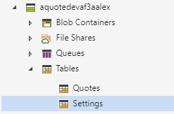

Following default settings need to be provisioned before first start of the application.

Settings name: “Active” and “vCoreCount”

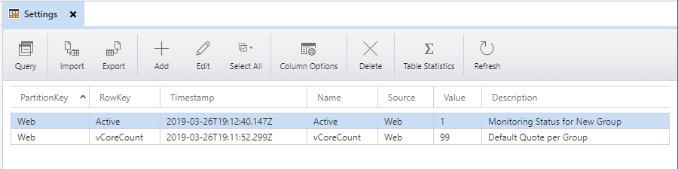

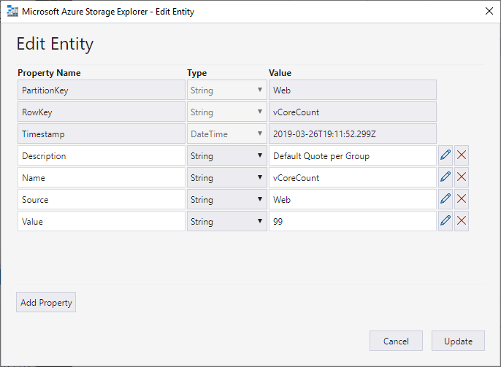

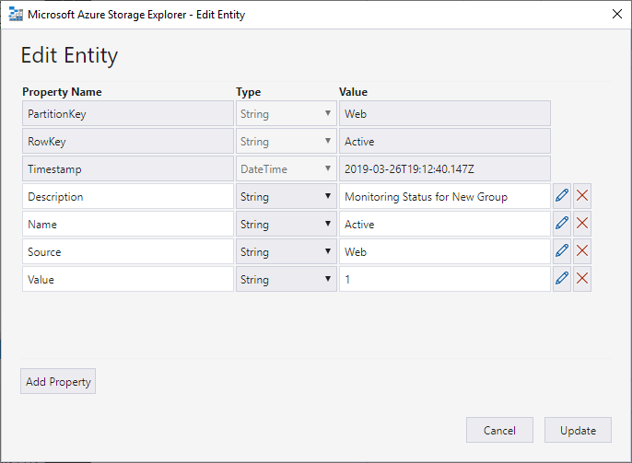

# QMS Service Account Registration

# QMS Portal account Registration.

# Application settings.

# Setting Up Roles and Assignment

# Adding new Subscription.

# Disable QMS