# Quote Management System

**User documentation**

Contents

Quote Management System 1

Overview 2

Limitation. 2

Requirements 2

Architecture 3

Overview 3

Detailed Description 3

Azure Resource Grid 3

Azure Storage 3

Azure Function 3

Azure Web Application 3

Azure Policy 4

Solution Schema 4

Interaction 4

QMS Portal. 5

Overview 5

Main interface for user from **QMS Managers** group. 5

Bulk update resource group option for **QMS Managers** group. 6

Update default settings interface for **QMS Managers** group. 7

QMS Policy Assignment 7

QMS Role management 7

Role Assessments 7

# Overview

The Quote Management System (QMS) is designed as alternative solution for Quote management available only on Subscription level for IaaS in Azure.

QMS consist of PaaS resources internally monitoring deployment activity on the Subscription and setup limitation or deny deployment depends of the provided settings for each Resource Group.

The purpose of the QMS is setting up live monitoring and limitation for the deployment of new IaaS environment in resource group, including VM and Scale set.

## Limitation.

* QMS is provide as PoC AS-IS. All support and changes can be done by C# skillful developer. Walmart is own the code.
* Because of nature of Event Grid, the notification triggering the main process can be delayed for 30sec-1 minute.
* Azure Policy provide option to validate the deployment template before Deployment, during deployment the policy cannot be modified, or modification will not affect the current deployment.
* Azure Policy applied for groups only if the different between allowed vCore and existed vCore in Resource Group more then 120. It means that new deployment in the RG which has limits in more then 120 can be accepted even deployment core count more than allowed.

## Requirements

1. Monitor existed vCore count per Resource Group and set up quotes how many vCore can be used for next deployment.
2. Monitor deletion and creation of new Resource group in monitored subscription.
3. Deny deployment if the count of quote vCore are exceeded.
4. Monitor more than one subscription.
5. Define default settings for new Resource Group and persist the settings.
6. Have interface to monitor current count of the vCore and set up quote limit
7. Implement Bulk update for selected resource group per subscription.
8. Provide only certain authorized accounts access to the set up quotes. Provide rest of the authorized company account access to view the core limitation.
9. Minimize cost of the solution.
10. Provide deployment and support documentation.

# Architecture

## Overview

Current implementation of the QMS solution contains following Azure services.

* Azure Resource Grid – 1 per subscription
* Azure Storage Account with Table and Queue – 1 per solution
* Azure Function – 1 instance per solution hosted 2 functions.
* Azure Web Application – 1 per solution
* Azure Application Insights – 2 per solution
* Solution Resource Group – 1 per solution
* Custom Policy definition - 2 per subscription.
* Policy Assignment - If exists, 1 per Resource Group and Per subscription.

## Detailed Description

### Azure Resource Grid

Resource Grid monitor successful changes in the resource groups for specified subscription and generate message with workload contained the changes.

### Azure Storage

Storage Table keep settings per groups for current vCore count and its vCore quote.

Storage Table also keep default settings for newly created Resource Group.

Storage Queue keep messages generated by Resource Grid and trigger Azure Function.

### Azure Function

Function triggered when new messages arrived in the Storage Account and process the messages.

Function assign policy for specific resource group based on vCore count and quote.

Function can be triggered manually to process vCore settings changes or to revaluate applied Policy manually.

### Azure Web Application

Web Application is set up to let users monitor current quote settings and summery of existed vCore per resource group and subscription.

Web Application has a role-based security to allow only specified users change quotes and authorized users monitor quotes.

Web Application provide access to the default settings for newly created resource group.

### Azure Policy

Two custom policy definition is set up for Limited deployment (allowed only specific size of the VM based on the limit of vCore quote) and Denyed deployment policy to prevent any IaaS deployments.

Details <https://docs.microsoft.com/en-us/azure/governance/policy/samples/not-allowed-res-type>. Policy can be applied based on the quote settings for any resource group in monitored subscriptions.

## Solution Schema



## Interaction

1. User Create Resource Group.
2. User Create VM.
3. VM provisioning updates Resource Grid.
4. The Function has been trigged by Webhook and update the Storage Table. Change quotes or add new group settings.

(6) Function apply/modify Policy for resource Group.

(7) Current Core count and result of applying policy is update in group table.

(8) User monitor result and update quotes.

(9) User can trigger function manually.

(10) User can change the settings for newly created resource group.

# QMS Portal.

## Overview

The portal is set up on the Web Application and available for connection of authorized users. Users could be assigned on two types of roles: “QMS managers” and “Default Access”

**QMS Managers** have access to change vCore Quotes and disable or enable Resource Group for monitor. Change settings and force policy checks.

**Default Access** has only read only access to monitor current quotes per resource group.

## Main interface for user from **QMS Managers** group.

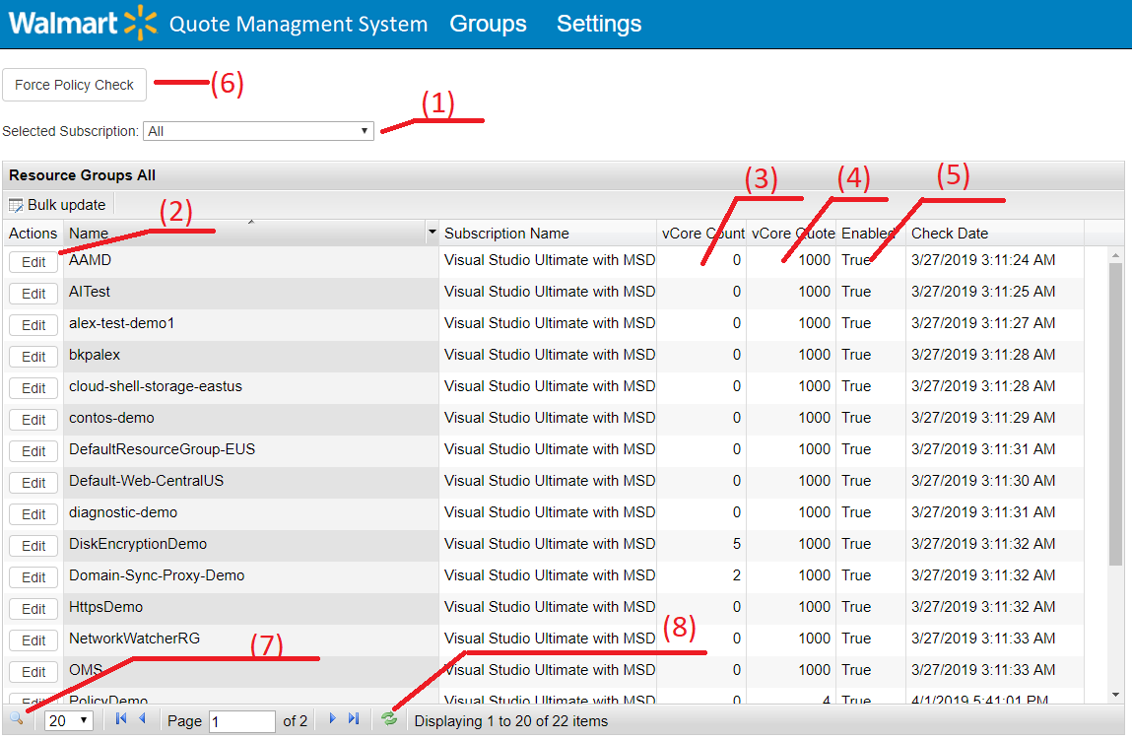

1. – Subscription list. User can pick up one subscription or All subscriptions.
2. – To edit quotes for the resource group user can click on “Edit” button
3. – vCore Count – current core consumed by VM deployed in the group.
4. – Quote of vCore set up per resource group.
5. – Enable or Disable groups from monitoring.
6. – Force policy check for resource group belongs to selected subscription
7. – Search Resource group by name
8. – Refresh of the table without reloading page.

## Bulk update resource group option for **QMS Managers** group.

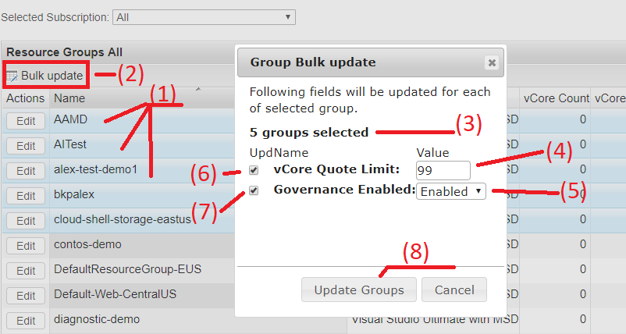

1. Select with “shift” several groups by clicking on the its name.
2. Click “Bulk update” button to proceed with “Group Bulk update” window.
3. Check the count of the selected group for update.
4. Default value of the vCore Quote count. It can be changed for 0 to 10000
5. Default state of the monitoring group. “False” it means that group is not monitored and no limitation for deployment.
6. This control needs to be ticked if the update of the vCore Quote count should be changed for selected group.
7. This control needs to be ticked if the enabling Quote monitoring should be changed for selected group.
8. Update Groups button will complete the chose and update selected groups.

## Update default settings interface for **QMS Managers** group.

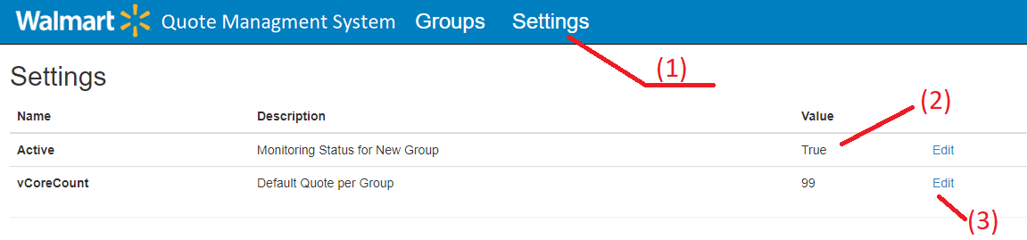

1. Click on “Settings” in menu to update default values.
2. Check the value of the settings.
3. Click to edit the value.

More information about settings and its values you can find in admin documentation.

# QMS Policy Assignment

New policy will be assigned for resource group if that resource group will be enabled monitored and different between vCore Current and vCore Quote will be less than 128. Policy could be “Denied deployment” or allowed for Limited Deployment – only specific machine will be available for deployment.

Here is example of assignment for resource group allowed only VM with 4 cores to be created



# QMS Role management

## Role Assessments

Role assignment can be done by following steps. Select Walmart Azure Active Directory then click on (1) - “Enterprise application”. (2) Chose the QMS Application (it might be a different name). (3) Select “User and Groups” for selected application. (4) – Chose user. Group will be predefined.

|  |  |  |
| --- | --- | --- |
| (1) | (2)    (3) | (4) |

ALL users, who not explicitly assigned on “QMS Manager” role will get access as “Default Access”.

**Default** access do not need to be explicitly assigned.

QMS Poral main page for “Default Access” users.

Only read access provided for “Default Access” group.

