BI Concepts, Planning, and Implementation Project
  - Certificate in Business Intelligence and Database Development
In this project, you create, plan, and implement a BI solution using a simple OLTP source database. The solution will include a SQL Server Data warehouse database, a SQL ETL scripts, an SSAS Tabular model database.
NOTE: This activity will take you about 20 to 30 hours over four weeks, so plan accordingly!

Project Scope
This BI solution is for a small private school with less than thirty employees. They are interested in student enrollments. You will create a prototype of your solution for their evaluation. For the prototype, you need only a few rows of sample data in each table.
The project will be performed and turned in as four milestone assignments:
Milestone 1: Design a Data Warehouse:

- Create a Visual Studio solution
- Create the OLTP source database (Azure Cloud)
- Design a data warehouse
- Create a data warehouse

Milestone 2: Create an ETL process:

- Create an ETL process script
- Create and ETL report

Milestone 3: Create a Tabular Database and Reports:

- Create a Tabular ETL objects Script
- Create an SSAS Tabular Model database
- Create sample reports

Milestone 4: Create Documentation:

- Write an Admin manual document
- Write a "Lessons Learned" document

Important: You must submit your assignment once for each Milestone (a total of 4 times). However, only the fourth submittal is graded. The other three submittals track your progress, and we review them during class sessions 8, 9, and 10 to help keep your designs on the right track!

Milestone 01 (Due by Nov 25th)
In this Milestone, you start your BI solutions by designing and creating a data warehouse (modules 1, 2, and 3).

Step 1: The Visual Studio Solution
Create a BLANK Visual Studio Solution called "EnrollmentsFirstInitialLastName", then add the following two virtual and physical folders called "Documents" and "Scripts" to organize your project. Then, add the "_BI ConceptsPlanningAndImplementationProject.docx" file to the folder and the "0-CreateTheStudentEnrollmentsDatabase.sql" to the scripts folder.
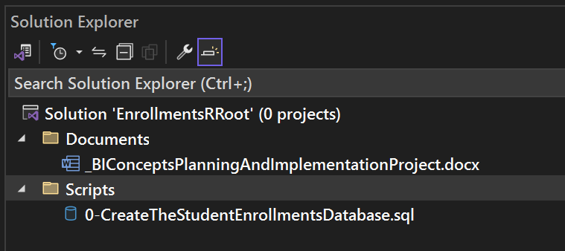
Figure: Creating the solution, folders, and files

Step 2: The OLTP Source Database
Open and review the OLTP source database script "0-CreateTheStudentEnrollmentsDatabase.sql" then use it to create a database hosted on the Azure cloud named "StudentEnrollments" on a SQL Server named BIDD-25-26-FirstInitial-LastName.

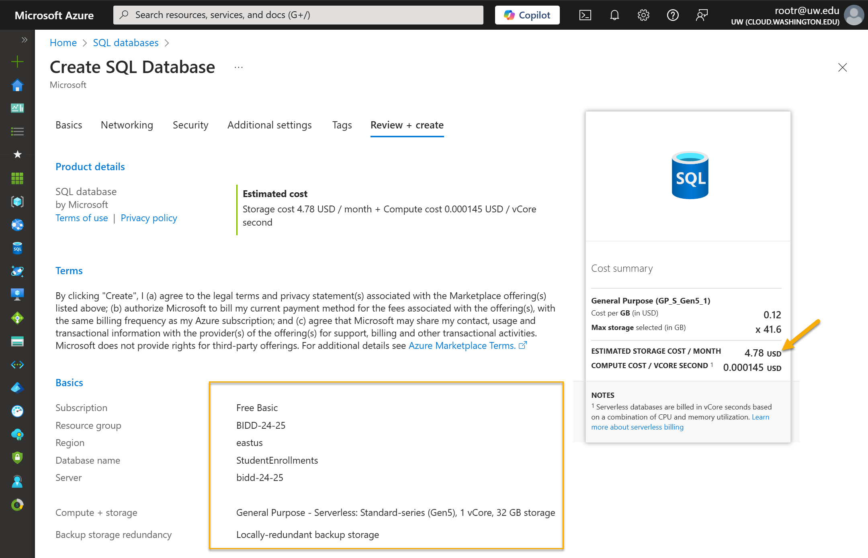

Notes:
- Make sure the estimated cost is under $5.
- Make sure you select "Yes" for the "Add current client IP address" setting.
- Use the same server you created in Module06 (bidd-25-26-FirstInitial-LastName), the login and password will be the same (biddadmin with a password of biddP@$$word)
- You create all the other databases on your personal "development" computer! The only database in the cloud will be the StudentEnrollments source database.
- If you cannot connect to or create the database in the cloud, you may use the provided script to create a local version of the database and use that.
- Make sure to review the tables, columns, constraints, and datatypes of the StudentEnrollments database as defined in the script.

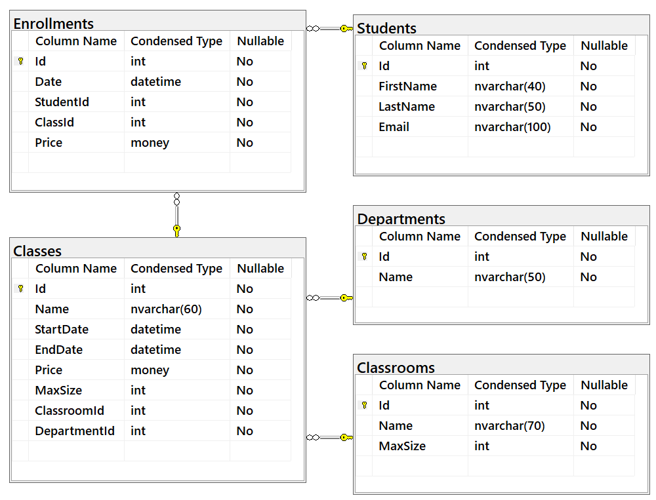
Figure: The source database

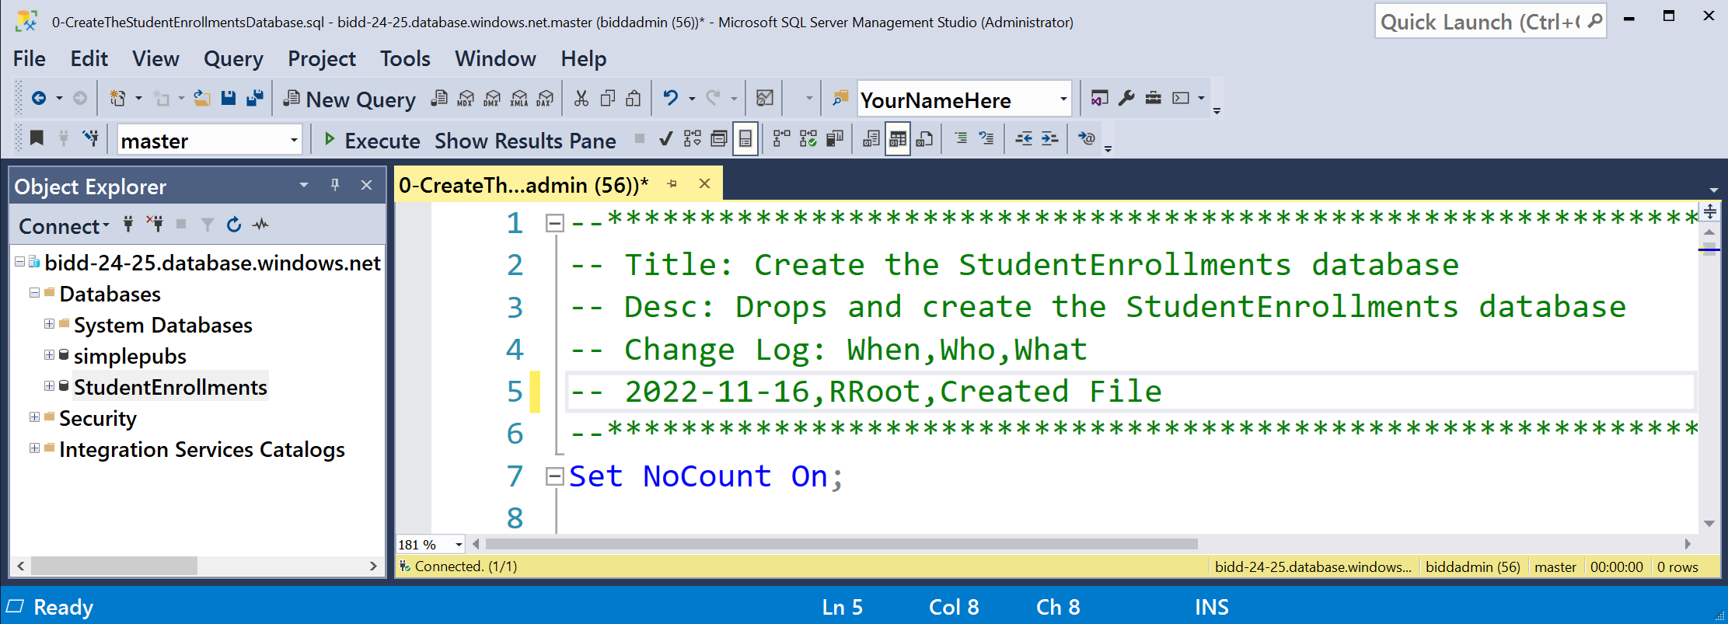
Figure: Creating the source database tables

Step 3: Design the Data Warehouse Database
Design a data warehouse based on the StudentEnrollments database. Use the Metadata worksheet technique you learned in module 03.
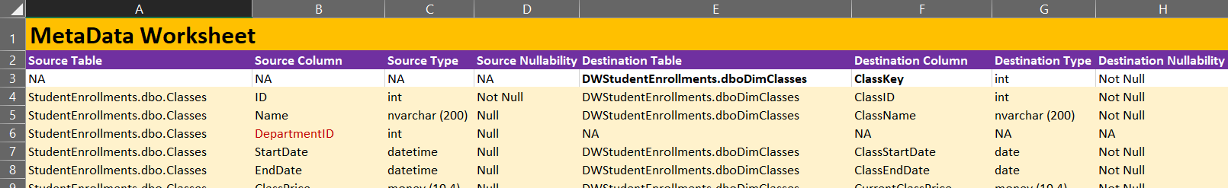
Figure: Creating the metadata worksheet

Notes:
- You do not need to connect the ClassStartDate and ClassEndDate to the date dimension table.
- Use a Star Schema Design.
- Create an ERD of the Database using https://app.diagrams.net/ (formally DrawIO) and save it as a PDF file called "DWStudentEnrollmentsERD.pdf". (Creating Entity Relationship Diagrams using Draw.io).
- Add the Metadata worksheet and the ERD to Visual Studio's documents physical and virtual folder.
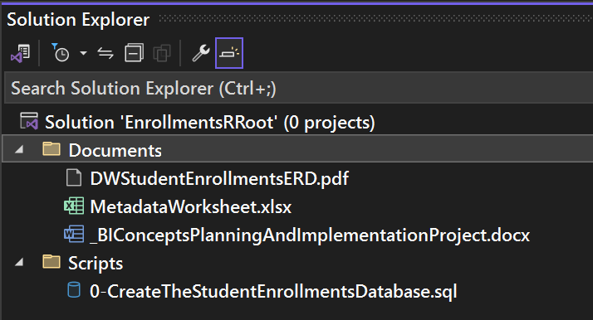
Figure: Adding the new files to Visual Studio

Step 4: Create the Data Warehouse Database
You must create a data warehouse database on your local computer based on the StudentEnrollments database. Use the same techniques you learned in module 2 to complete the "1-CreateThe DWStudentEnrollmentsDatabase.sql" file.
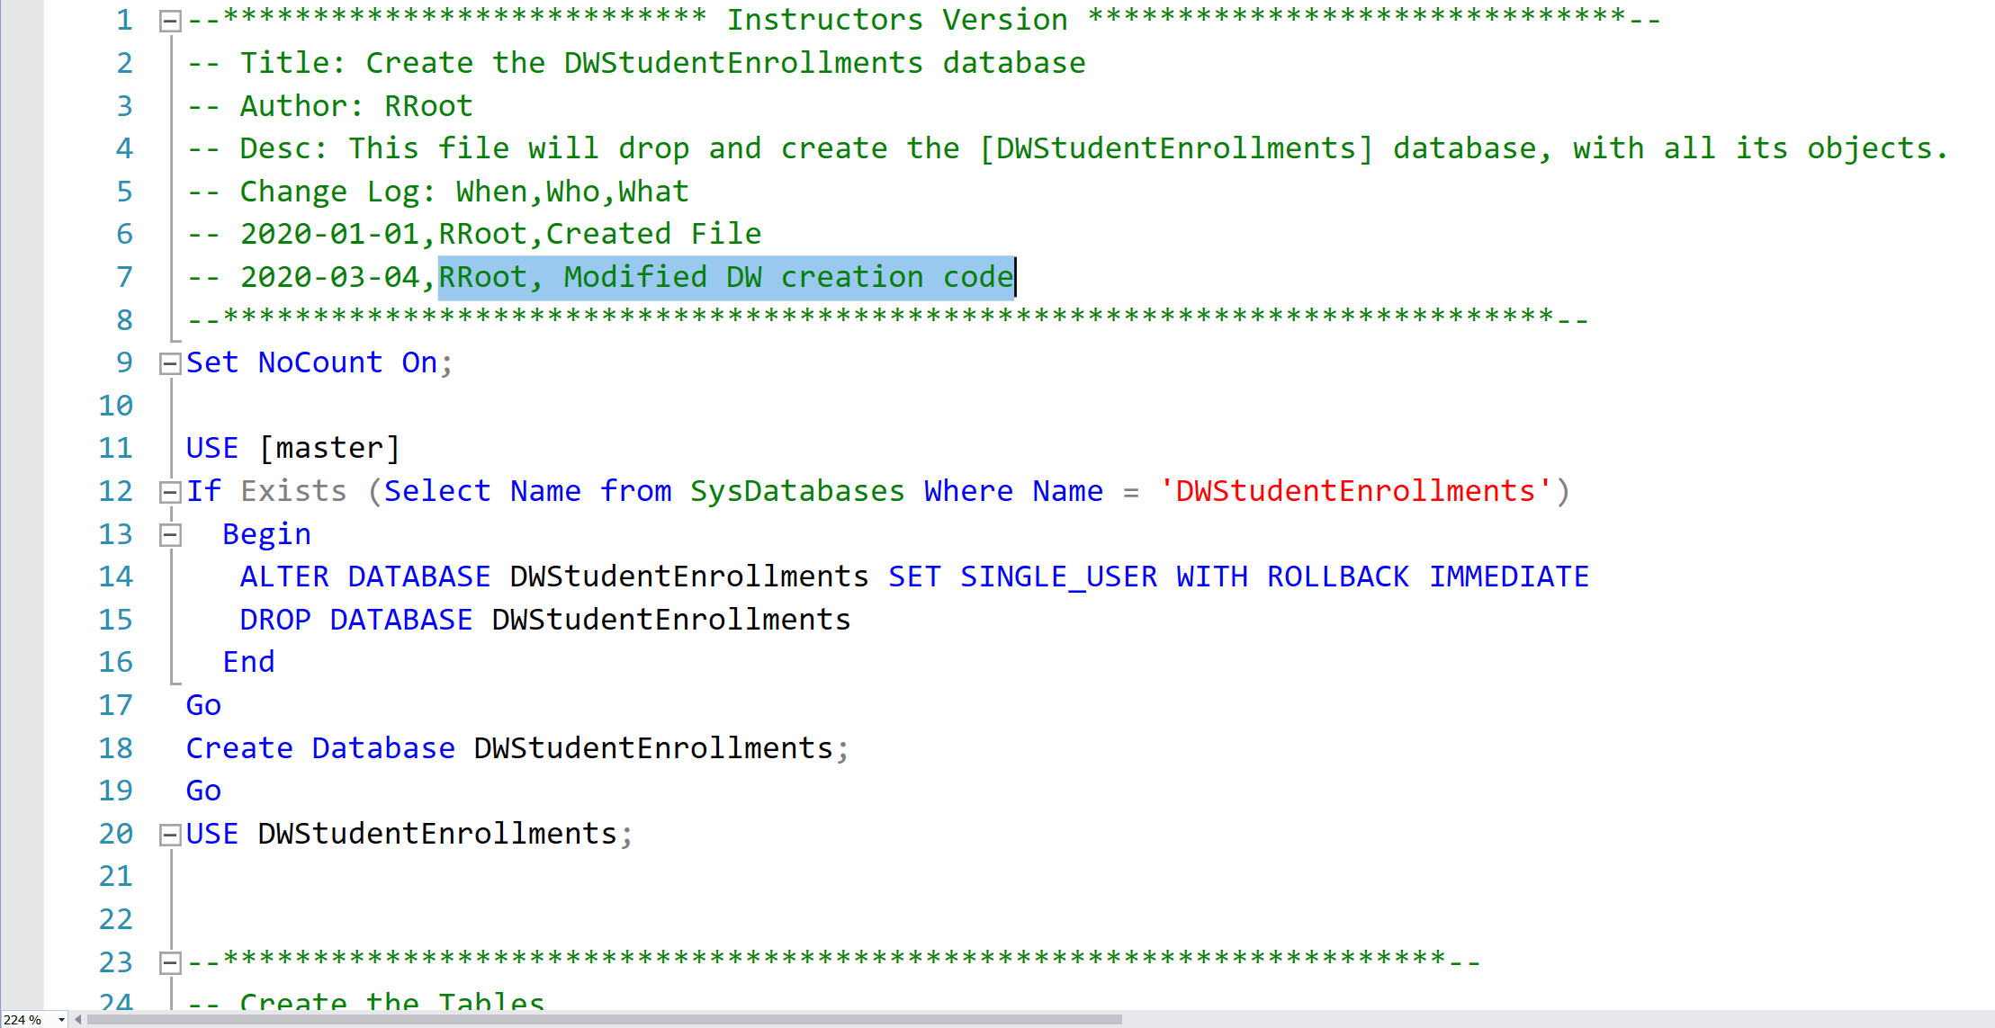
Figure: Creating the data warehouse database script

Note: Add the completed "1-CreateThe DWStudentEnrollmentsDatabase.sql" script to Visual Studio's documents physical and virtual folder.
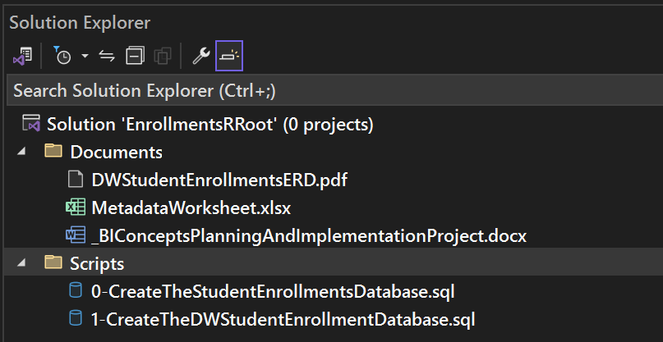
Figure: Adding the new files to Visual Studio

Step 5: Submit your work to the Canvas
Once you finish the Milestone 01 tasks:
- Make sure all your SQL scripts are in the "Scripts" physical folder and virtual folders.
- Make sure all your Documents are in the "Documents" physical folder and virtual folders.
- Use Visual Studio's "Save All" button in to save your work.
- Exit Visual Studio and Compress the Solution folder into a single zip file.
- Submit the zip file on the Canvas website, under the Final Project Assignment.
Important: You must submit your assignment once for each Milestone (a total of 4 times). However, only the fourth submittal is graded. The other three submittals track your progress, and we review them during class sessions 8, 9, and 10 to help keep your designs on the right track!

Milestone 02 (Due by Dec 2nd)
In Milestone 02, you create a SQL ETL process that extracts data from the Student Enrollment database into your DWStudentEnrollments database, using the techniques you learned in module 4.
Important: Start by making any adjustments uncovered by the Milestone01 Review session.

Step 1: The ETL Process Script
Create an ETL process script to fill the local DWStudentEnrollments database with data from the Azure StudentEnrollments database. See Module04 for examples of what should be in the "2-PerformTheETLProcess.sql" script file.
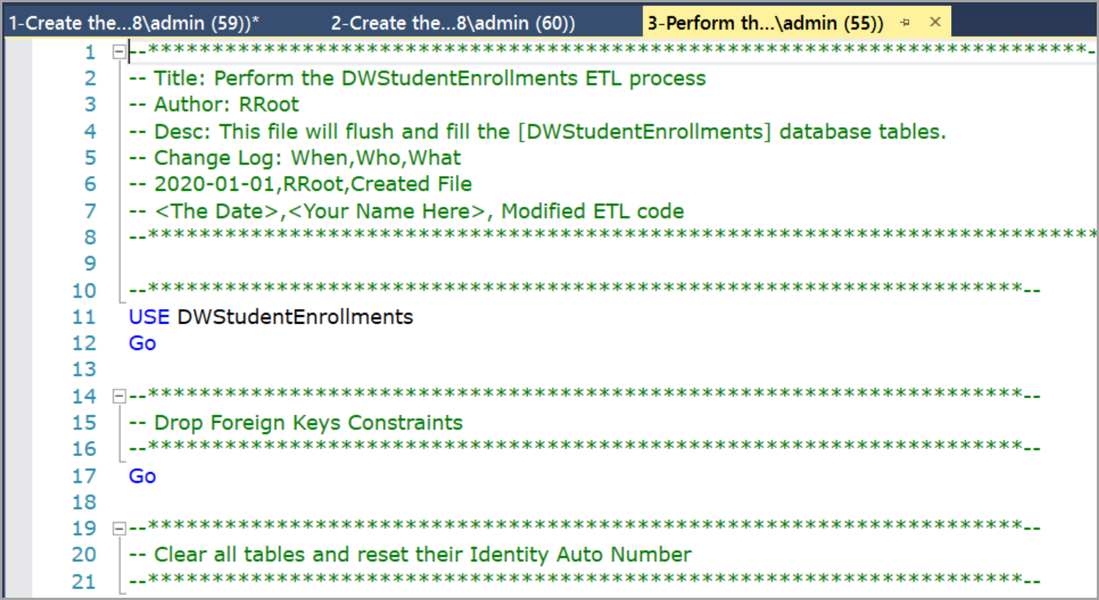
Figure: Creating the data warehouse ETL process script

Step 2 - Create an ETL Operations Report
Now, you create an operations report named "ETLProcess.rdl" showing the contents of the ETL logging table. See Module04 for examples of what should be in the report.

Step 3: Submit your work to the Canvas
Once you finish the Milestone 02 tasks:
- Add the new SQL script to the "Scripts" physical folder and virtual folders.
- Add the new report to the "Reports" physical folder and virtual folders.
- Use Visual Studio's "Save All" button in to save your work.
- Exit Visual Studio and Compress the Solution folder into a single zip file.
- Submit the zip file on the Canvas website, under the Final Project Assignment.
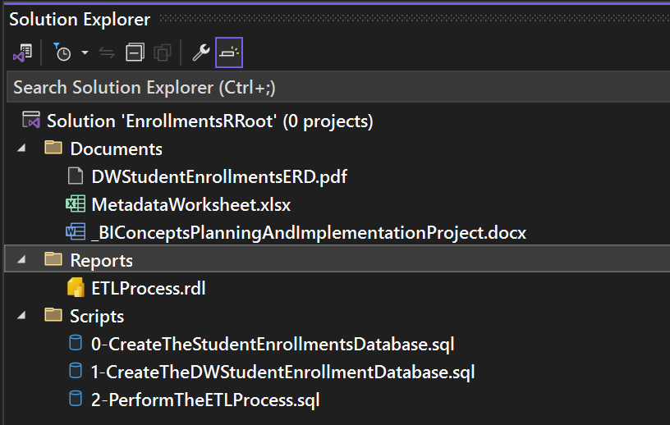
Figure: Adding the ETL process script and report to Visual Studio

Important: You must submit your assignment once for each Milestone (a total of 4 times). However, only the fourth submittal is graded. The other three submittals track your progress, and we review them during class sessions 8, 9, and 10 to help keep your designs on the right track!

Milestone 03 (Due by Dec 9th)
In Milestone 03, you create a SSAS Tabular database and sample reports that use both the data warehouse and the tabular model using techniques you learned in module 02 and 05.
Important: Start by making any adjustments uncovered by the Milestone02 Review session.

Step 1: The Tabular ETL Script
Create a SQL script with Tabular ETL views to shape the data for your Tabular Model Name the script "3-ETLViewsForTabularModel.sql". See Module05 for examples of what should be in the views.
Notes:
- Create ETL views to load data into your Tabular Model
- Use Convert(date, Cast([EnrollmentDateKey] as char(8)), 110) to convert the DateKey and EnrollmentDateKey columns to date.

Step 2: The Tabular Model SSAS Database
You need to add an SSAS tabular model project called "StudentEnrollmentTabularModel" to your Visual Studio solution. Please use the integrated workspace option then create and configure a Tabular Model using the data in the DWStudentEnrollments database.
Notes:

- Use the "Integrated Workspace" option.
- Set the Unique Property on each "table's" Primary Key column.
- Create relationships between the columns.
- Set the Date table using the converted Enrollment Date key.
- Create the relationships for each dimension hierarchy.
- Include EnrollmentsID, Students, Classes, and Dates dimensions.
- Create EnrollmentDollars and EnrollmentCounts measures.
- Verify the measures and dimension data using Excel.

Step 3: Create Sample Reports
Create sample reports using data from the data warehouse and tabular model using Excel.
Notes:
- Create a report file called StudentEnrollmentExcelReports.xlsx (you will have a total of 2 reports in the one document).
- Please format your document as shown below.
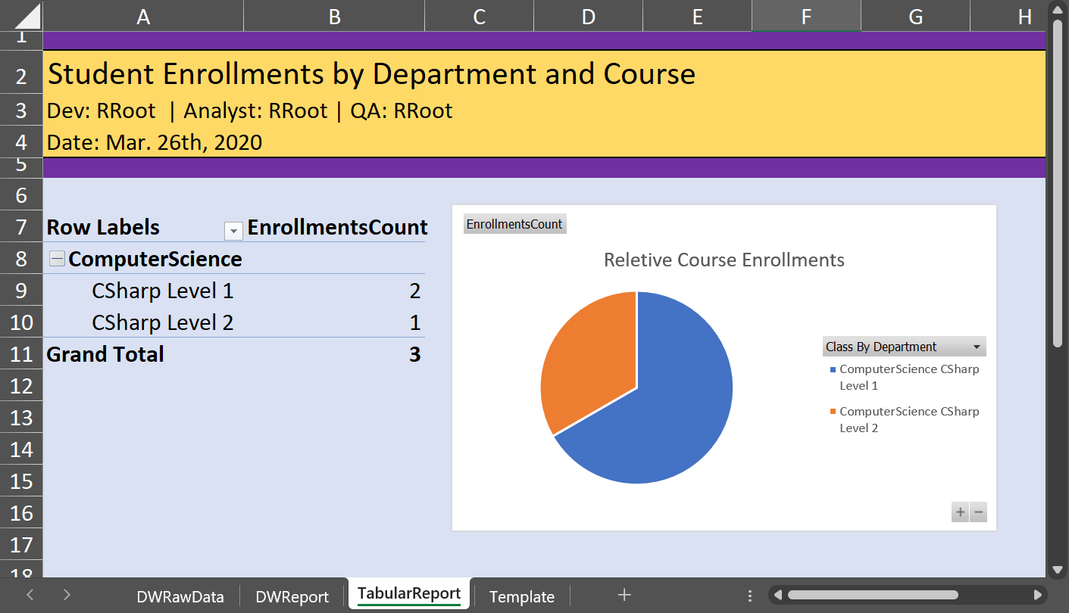
Figure: The typical format of each report

Step 4: Submit your work to the Canvas
Once you finish the Milestone 03 tasks:
- Add the new SQL script to the "Scripts" physical folder and virtual folders.
- Add the new report to the "Reports" physical folder and virtual folders.
- Use Visual Studio's "Save All" button in to save your work.
- Exit Visual Studio and Compress the Solution folder into a single zip file.
- Submit the zip file on the Canvas website, under the Final Project Assignment.
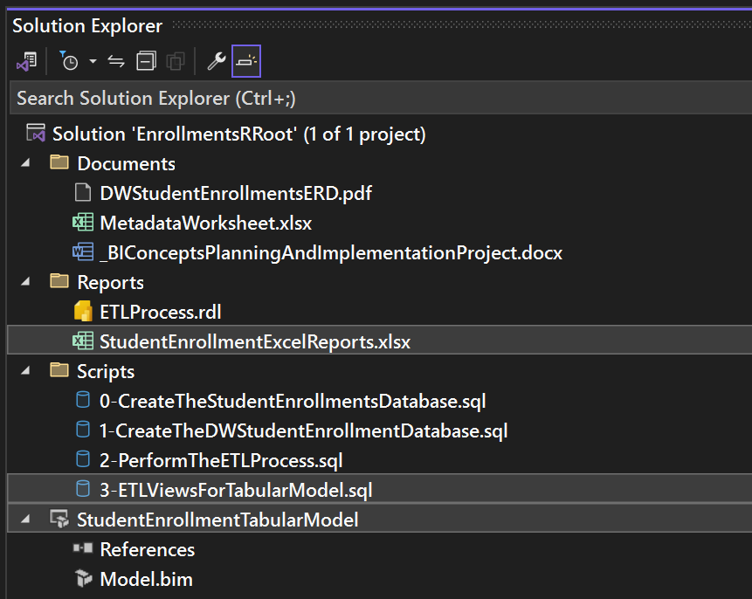
Figure: Adding Tabular project, tabular ETL script, sample report to Visual Studio

Important: You must submit your assignment once for each Milestone (a total of 4 times). However, only the fourth submittal is graded. The other three submittals track your progress, and we review them during class sessions 8, 9, and 10 to help keep your designs on the right track!

Milestone 04 (Due by Dec 16th - LAST DAY TO UPDATE SOLUTION)
In Milestone 04, you create a manual for you BI solution and reflect on the lessons you learned in this quarter.

Step 1: The Admin Manual
Create a simple administrative manual describing the components of the solution. I have provided a starter document that you can add to. You can keep it simple this quarter, but we will expand on it next quarter.
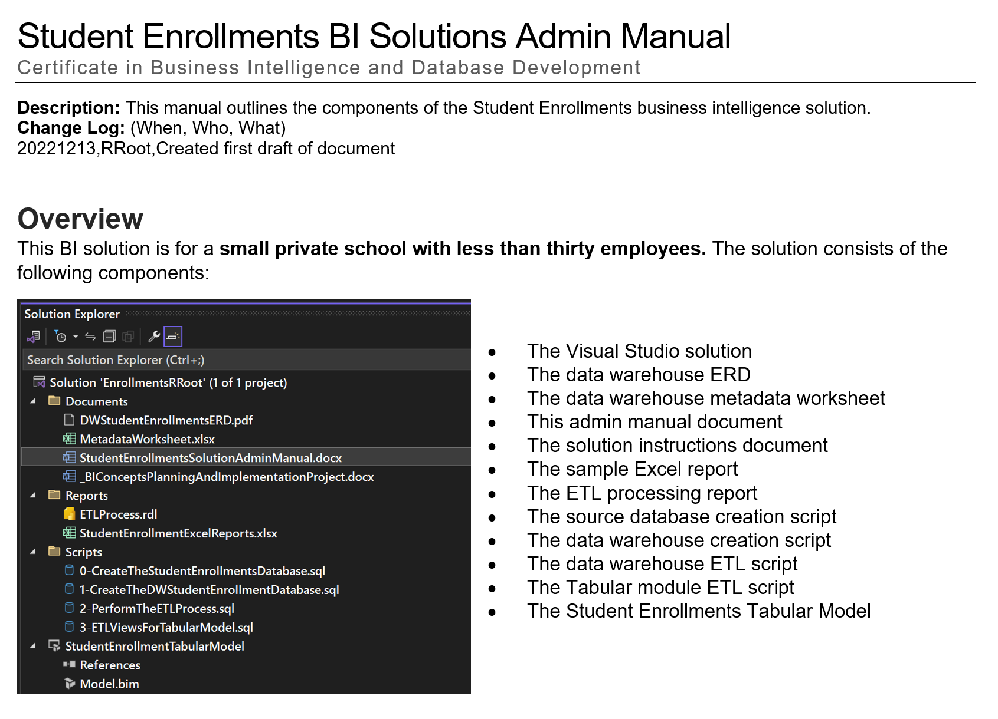
Figure: The administrative manual starter document

Step 2: The Lessons Learned Document
Write a paper that outlines what you have learned in this class. This document helps both you and me to understand your progress in this course. You may be surprised to see how this process also solidifies what you have learned (or at least other students have told me it does!)
Tell me about what you discovered about BI and database technology and the learning process. This does not need to be an exhaustive coverage of the technology and how you used it. Just a few paragraphs on what you experience was like will do.

Step 3: Submit your work to the Canvas
Once you finish the Milestone 04 tasks:
- Add the new documents into the "Documents" physical folder and virtual folders.
- Use Visual Studio's "Save All" button in to save your work.
- Exit Visual Studio and Compress the Solution folder into a single zip file.
- Submit the zip file on the Canvas website, under the Final Project Assignment.

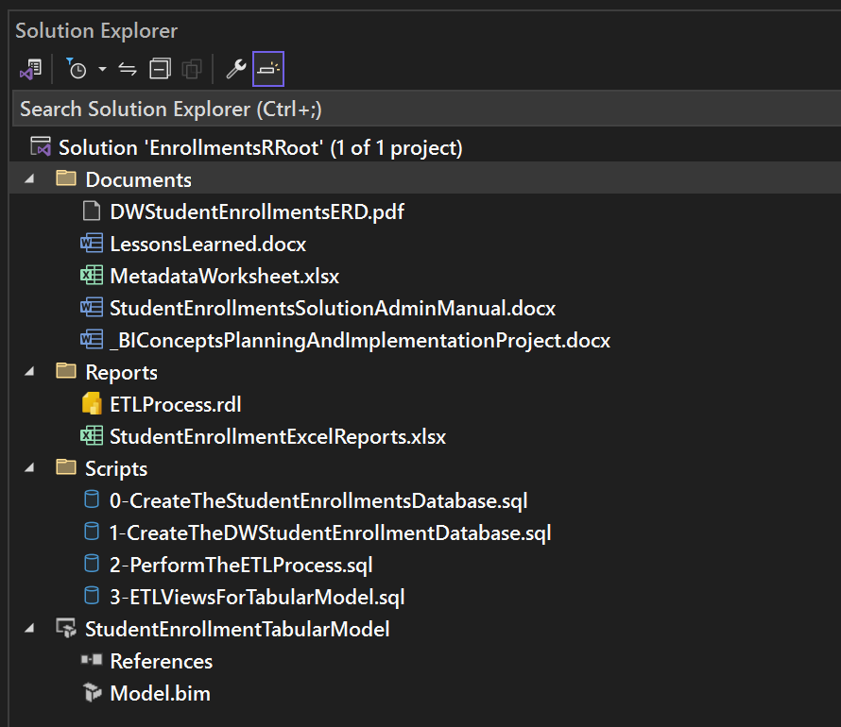
Figure: Files and folders added for milestone 4

Important: You must submit your assignment once for each Milestone (a total of 4 times). However, only the fourth submittal is graded. The other three submittals track your progress, and we review them during class sessions 8, 9, and 10 to help keep your designs on the right track!
Congratulations! You have completed the final!

