## EX:9_INTER VLAN ROUTING TYPES,DISTANCE VECTOR ROUTING

## **1)LEGACY INTER-VLAN ROUTING:**

SWITCH:

Switch>en

Switch#config t

Enter configuration commands, one per line. End with CNTL/Z.

Switch(config)#vlan 10

Switch(config-vlan)#name ece-a

Switch(config-vlan)#exit

Switch(config)#vlan 20

Switch(config-vlan)#name ece-b

Switch(config-vlan)#exit

Switch(config)#interface fa0/3

Switch(config-if)#switchport mode access

Switch(config-if)#switchport access vlan 10

Switch(config-if)#interface fa0/4

Switch(config-if)#switchport mode access

Switch(config-if)#switchport access vlan 10

Switch(config-if)#interface fa0/5

Switch(config-if)#switchport mode access

Switch(config-if)#switchport access vlan 10

Switch(config-if)#interface fa0/8

Switch(config-if)#switchport mode access

Switch(config-if)#switchport access vlan 20

Switch(config-if)#interface fa0/9

Switch(config-if)#switchport mode access

Switch(config-if)#switchport access vlan 20

Switch(config-if)#interface fa0/10

Switch(config-if)#switchport mode access

Switch(config-if)#switchport access vlan 20

Switch(config-if)#exit

Switch(config)#exit

%SYS-5-CONFIG_I: Configured from console by console

**ROUTER:**

Router>en

Router#config t

Enter configuration commands, one per line. End with CNTL/Z.

Router(config)#interface g0/0/0

Router(config-if)#ip address 192.168.20.1 255.255.255.0

Router(config-if)#no shut down

Router(config-if)#

%LINK-5-CHANGED: Interface GigabitEthernet0/0/0, changed state to up

%LINEPROTO-5-UPDOWN: Line protocol on Interface GigabitEthernet0/0/0, changed state to up

Router(config-if)#interface g0/0/1

Router(config-if)#ip address 192.168.10.1 255.255.255.0

Router(config-if)#no shut down

Router(config-if)#

%LINK-5-CHANGED: Interface GigabitEthernet0/0/1, changed state to up

%LINEPROTO-5-UPDOWN: Line protocol on Interface GigabitEthernet0/0/1, changed state to up

Router(config-if)#

**ROUTER ON STICK INTERVLAN ROUTING:**

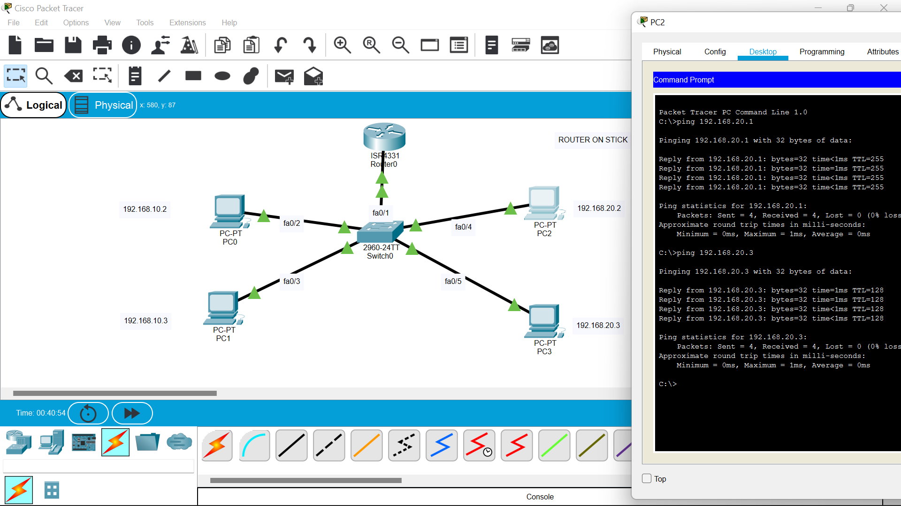

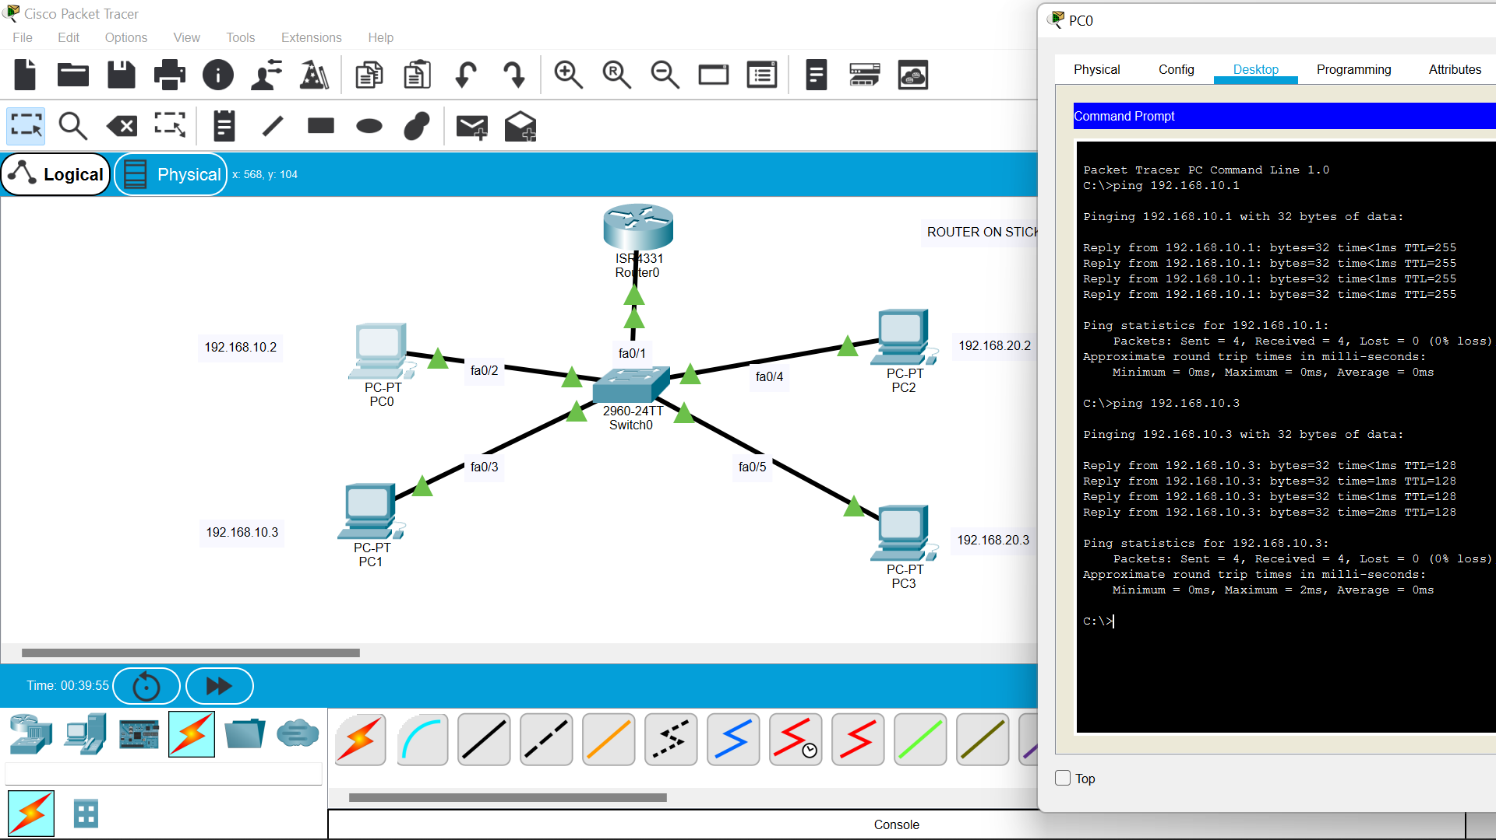

**SWITCH:**

Switch>en

Switch#config t

Enter configuration commands, one per line. End with CNTL/Z.

Switch(config)#vlan 10

Switch(config-vlan)#name ece-a

Switch(config-vlan)#vlan 20

Switch(config-vlan)#name ece-b

Switch(config-vlan)#exit

Switch(config)#interface fa0/2

Switch(config-if)#switchport mode access

Switch(config-if)#switchport access vlan 10

Switch(config-if)#interface fa0/3

Switch(config-if)#switchport mode access

Switch(config-if)#switchport access vlan 10

Switch(config-if)#interface fa0/4

Switch(config-if)#switchport mode access

Switch(config-if)#switchport access vlan 20

Switch(config-if)#interface fa0/5

Switch(config-if)#switchport mode access

Switch(config-if)#switchport access vlan 20

Switch(config-if)#interface fa0/1

Switch(config-if)#switchport mode trunk

Switch(config-if)#no shut down

Switch(config-if)#exit

Switch(config)#exit

Switch#

%SYS-5-CONFIG_I: Configured from console by console

**ROUTER:**

Router>en

Router#config t

Enter configuration commands, one per line. End with CNTL/Z.

Router(config)#interface g0/0/0

Router(config-if)#no shut down

Router(config-if)#

%LINK-5-CHANGED: Interface GigabitEthernet0/0/0, changed state to up

%LINEPROTO-5-UPDOWN: Line protocol on Interface GigabitEthernet0/0/0, changed state to up

Router(config-if)#interface g0/0/0.10

Router(config-subif)#

%LINK-5-CHANGED: Interface GigabitEthernet0/0/0.10, changed state to up

%LINEPROTO-5-UPDOWN: Line protocol on Interface GigabitEthernet0/0/0.10, changed state to up

Router(config-subif)#encapsulation dot1q 10

Router(config-subif)#ip address 192.168.10.1 255.255.255.0

Router(config-subif)#exit

Router(config)#interface g0/0/0.20

Router(config-subif)#

%LINK-5-CHANGED: Interface GigabitEthernet0/0/0.20, changed state to up

%LINEPROTO-5-UPDOWN: Line protocol on Interface GigabitEthernet0/0/0.20, changed state to up

Router(config-subif)#encapsulation dot1q 20

Router(config-subif)#ip address 192.168.20.1 255.255.255.0

Router(config-subif)#exit

Router(config)#exit

Router#

%SYS-5-CONFIG_I: Configured from console by console

**MULTILAYER SWITCH INTER VLAN ROUTING:**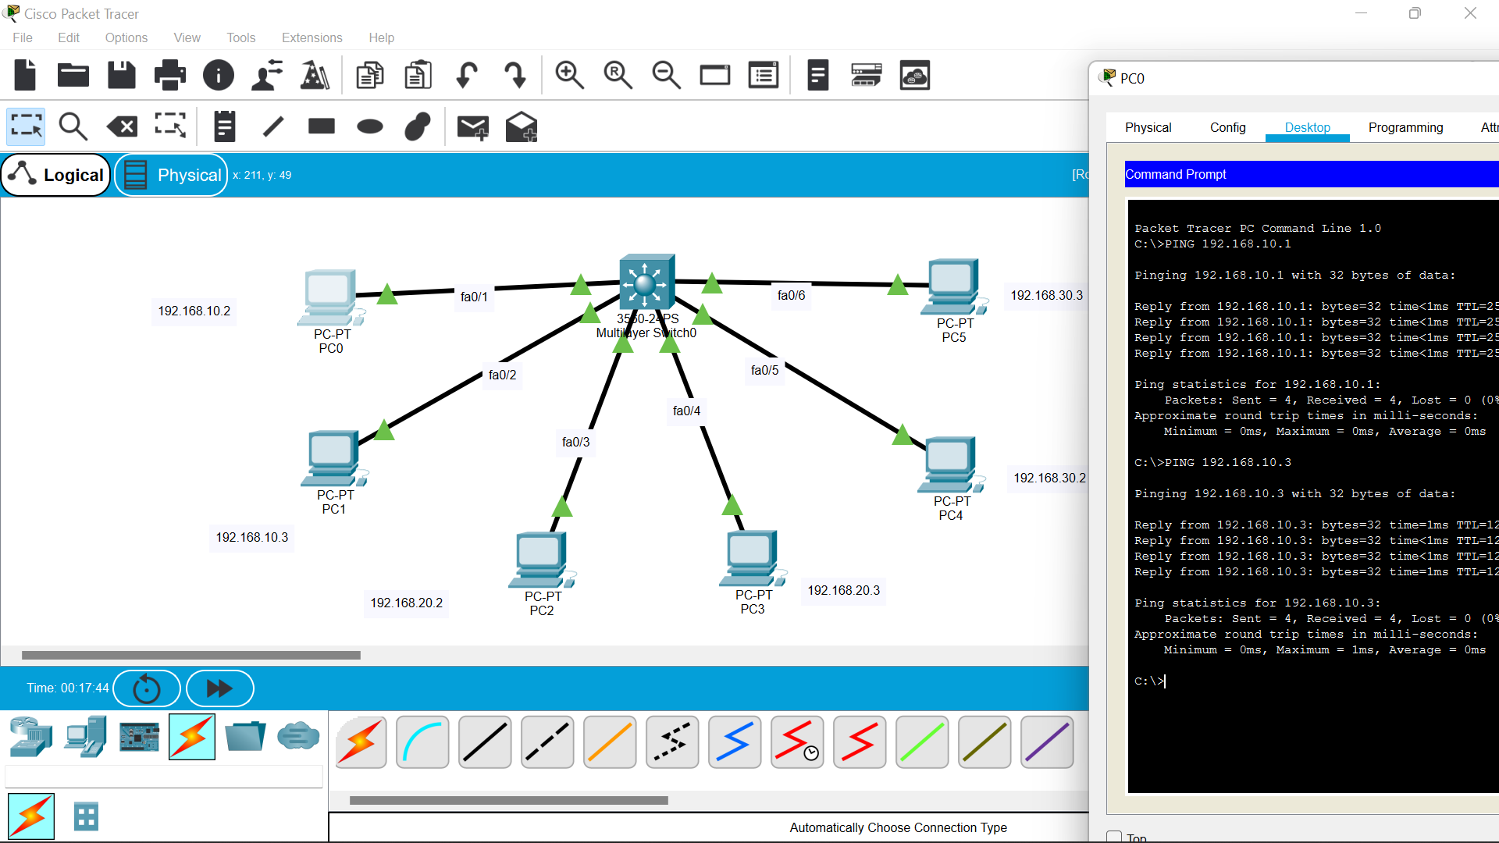

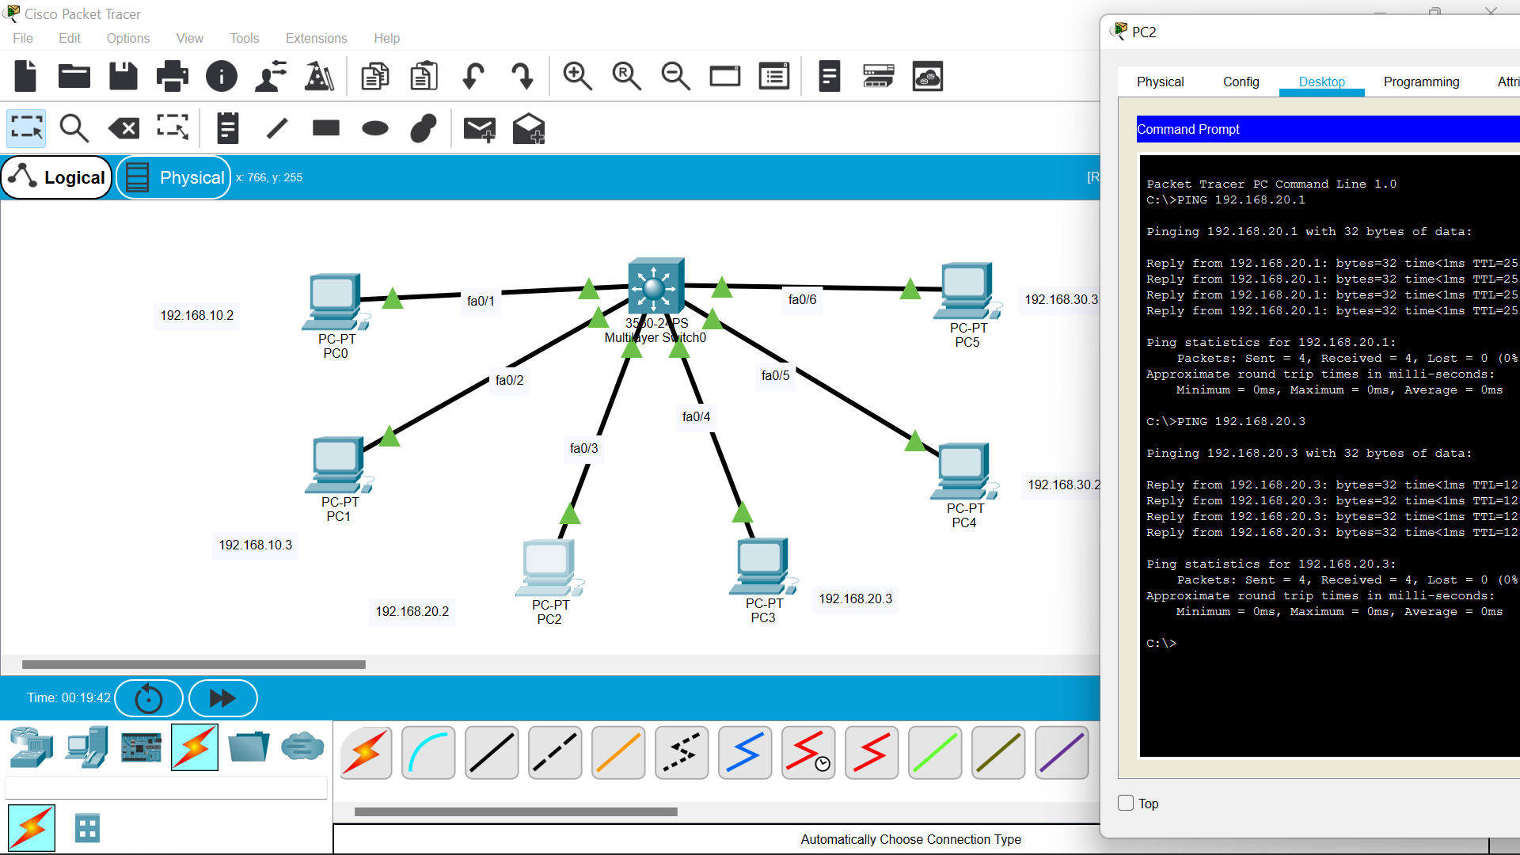

**AT MULTILAYER SWITCH:**

Switch>en

Switch#config t

Enter configuration commands, one per line. End with CNTL/Z.

Switch(config)#vlan 10

Switch(config-vlan)#name ece-a

Switch(config-vlan)#vlan 20

Switch(config-vlan)#name ece-b

Switch(config-vlan)#vlan 30

Switch(config-vlan)#name ece-c

Switch(config-vlan)#exit

Switch(config)#interface fa0/1

Switch(config-if)#switchport mode access

Switch(config-if)#switchport access vlan 10

Switch(config-if)#interface fa0/2

Switch(config-if)#switchport mode access

Switch(config-if)#switchport access vlan 10

Switch(config-if)#interface fa0/3

Switch(config-if)#switchport mode access

Switch(config-if)#switchport access vlan 20

Switch(config-if)#interface fa0/4

Switch(config-if)#switchport mode access

Switch(config-if)#switchport access vlan 20

Switch(config-if)#interface fa0/5

Switch(config-if)#switchport mode access

Switch(config-if)#switchport access vlan 30

Switch(config-if)#interface fa0/6

Switch(config-if)#switchport mode access

Switch(config-if)#switchport access vlan 30

Switch(config-if)#exit

Switch(config)#interface vlan 10

Switch(config-if)#

%LINK-5-CHANGED: Interface Vlan10, changed state to up

%LINEPROTO-5-UPDOWN: Line protocol on Interface Vlan10, changed state to up

Switch(config-if)#ip address 192.168.10.1 255.255.255.0

Switch(config-if)#ip routing

Switch(config)#interface vlan 20

Switch(config-if)#

%LINK-5-CHANGED: Interface Vlan20, changed state to up

%LINEPROTO-5-UPDOWN: Line protocol on Interface Vlan20, changed state to up

Switch(config-if)#ip address 192.168.20.1 255.255.255.0

Switch(config-if)#ip routing

Switch(config)#interface vlan 30

Switch(config-if)#

%LINK-5-CHANGED: Interface Vlan30, changed state to up

%LINEPROTO-5-UPDOWN: Line protocol on Interface Vlan30, changed state to up

Switch(config-if)#ip address 192.168.30.1 255.255.255.0

Switch(config-if)#ip routing

Switch(config)#exit

Switch#

%SYS-5-CONFIG_I: Configured from console by console

Switch#

**DISTANCE VECTOR ROUTING:**

**CODE:**

#-----------------------------------------------------

# Any line begining with '#' is a comment

#Number of nodes

N=6

#Number of Edges

E=9

# Give the coordinates for nodes N1,N2,N3 etc

N0={100,300}

N1={250,200}

N2={250,400}

N3={500,200}

N4={500,400}

N5={650,300}

# Give the details for each edge (node1,node2,w_f,w_r)

E0={n0,n1,6,4}

E1={n0,n2,8,5}

E2={n1,n3,3,8}

E3={n2,n4,6,11}

E4={n3,n5,10,18}

E5={n4,n5,4,9}

E6={n1,n2,7,5}

E7={n3,n4,15,10}

E8={n1,n5,10,6}

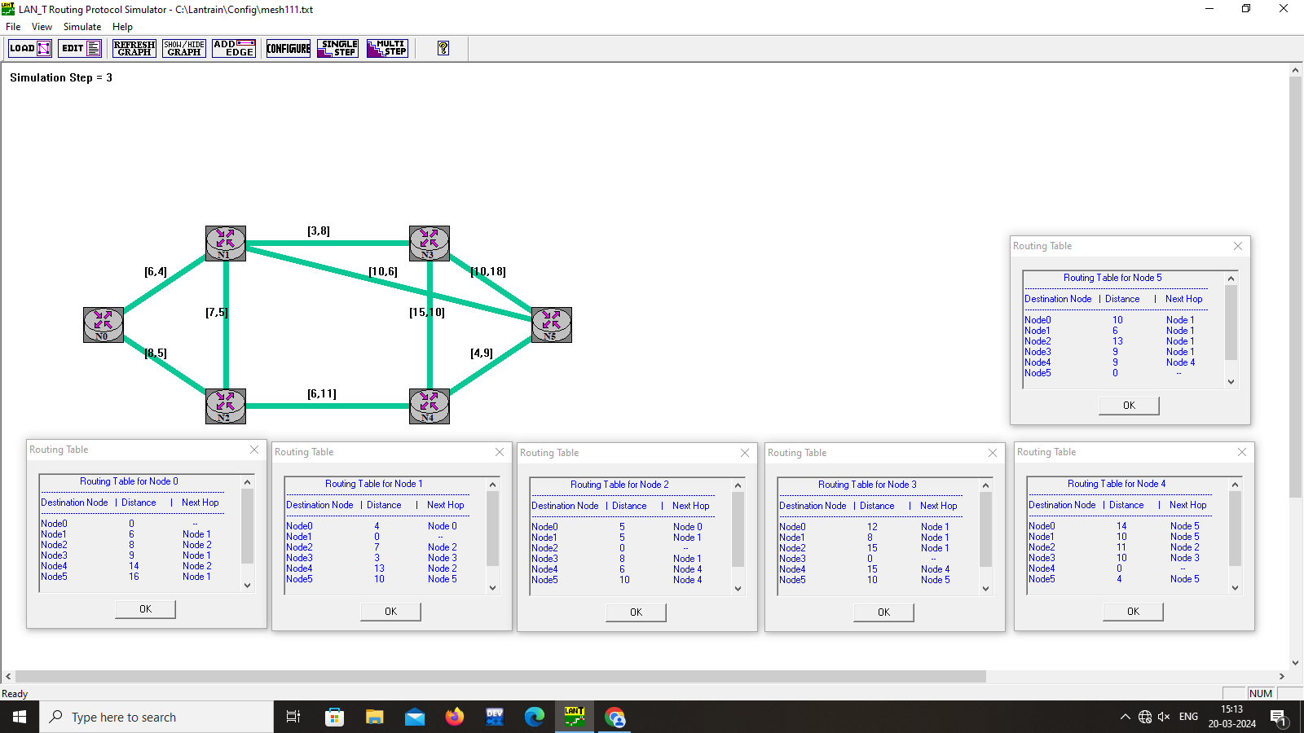

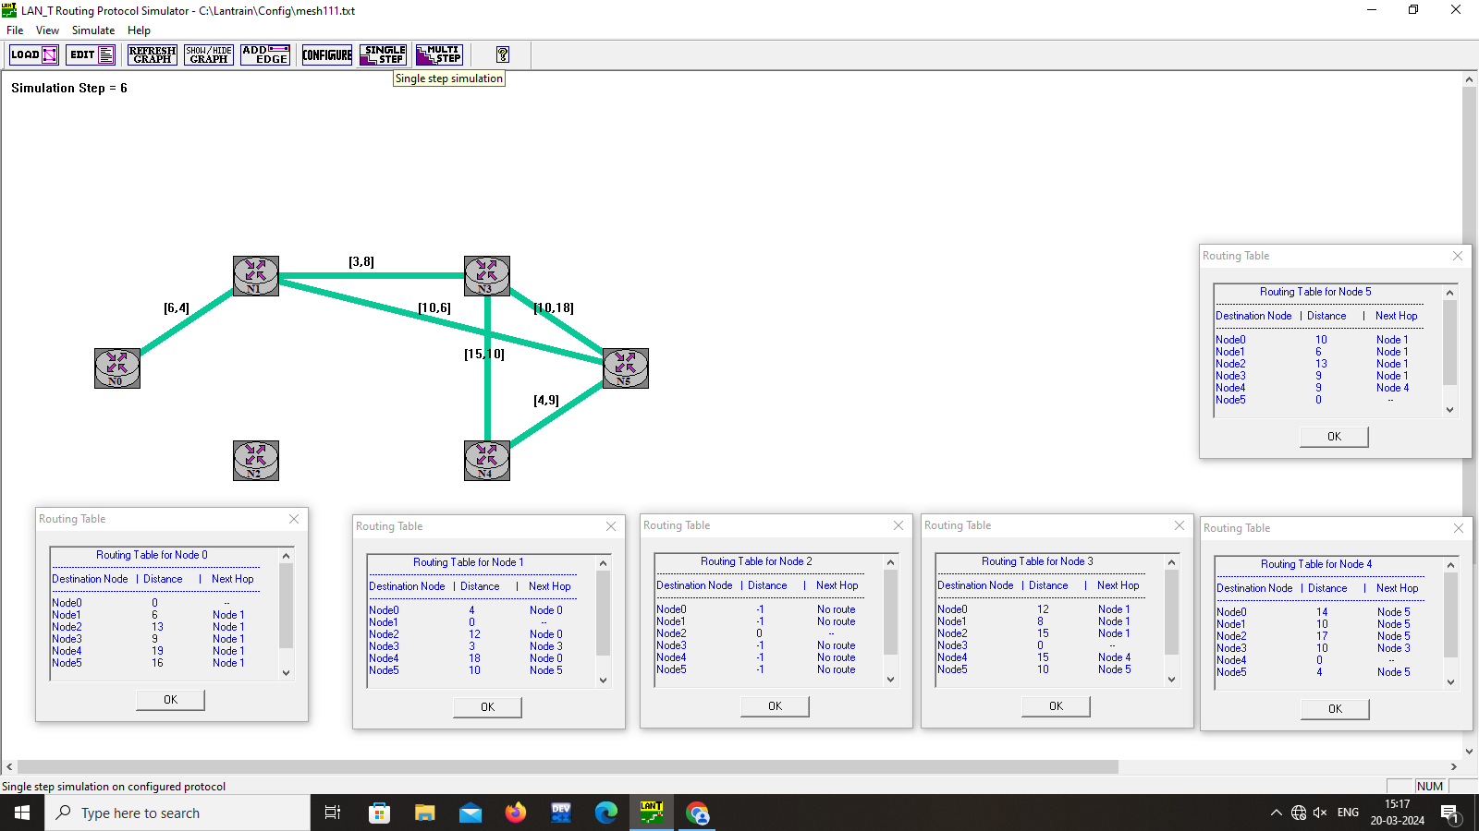

LOOP TO INFINITE PROBLEM:

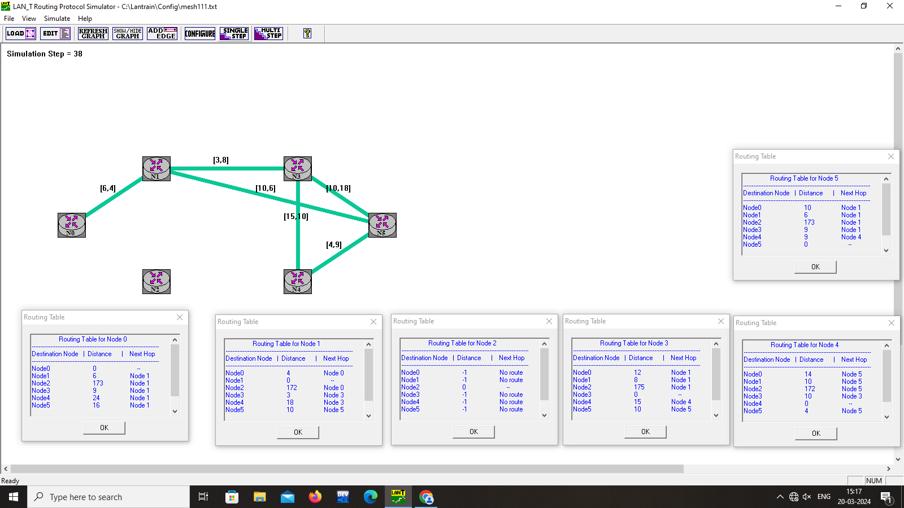

**LINK STATE ROUTING:**

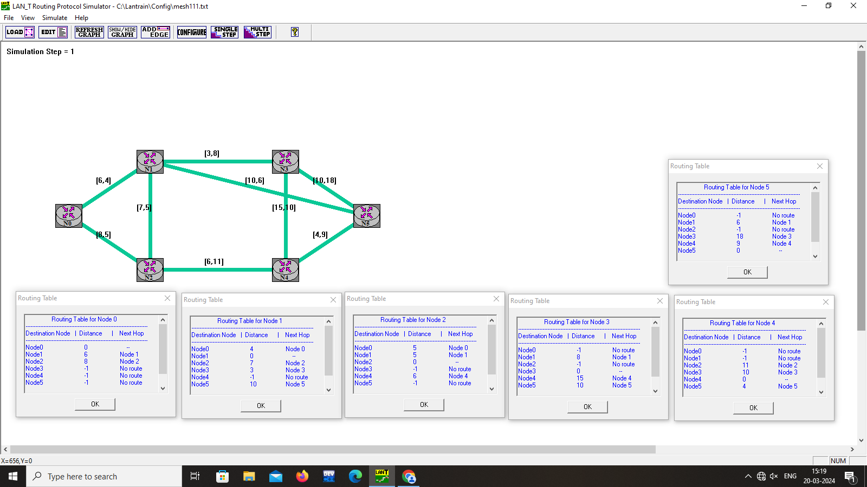

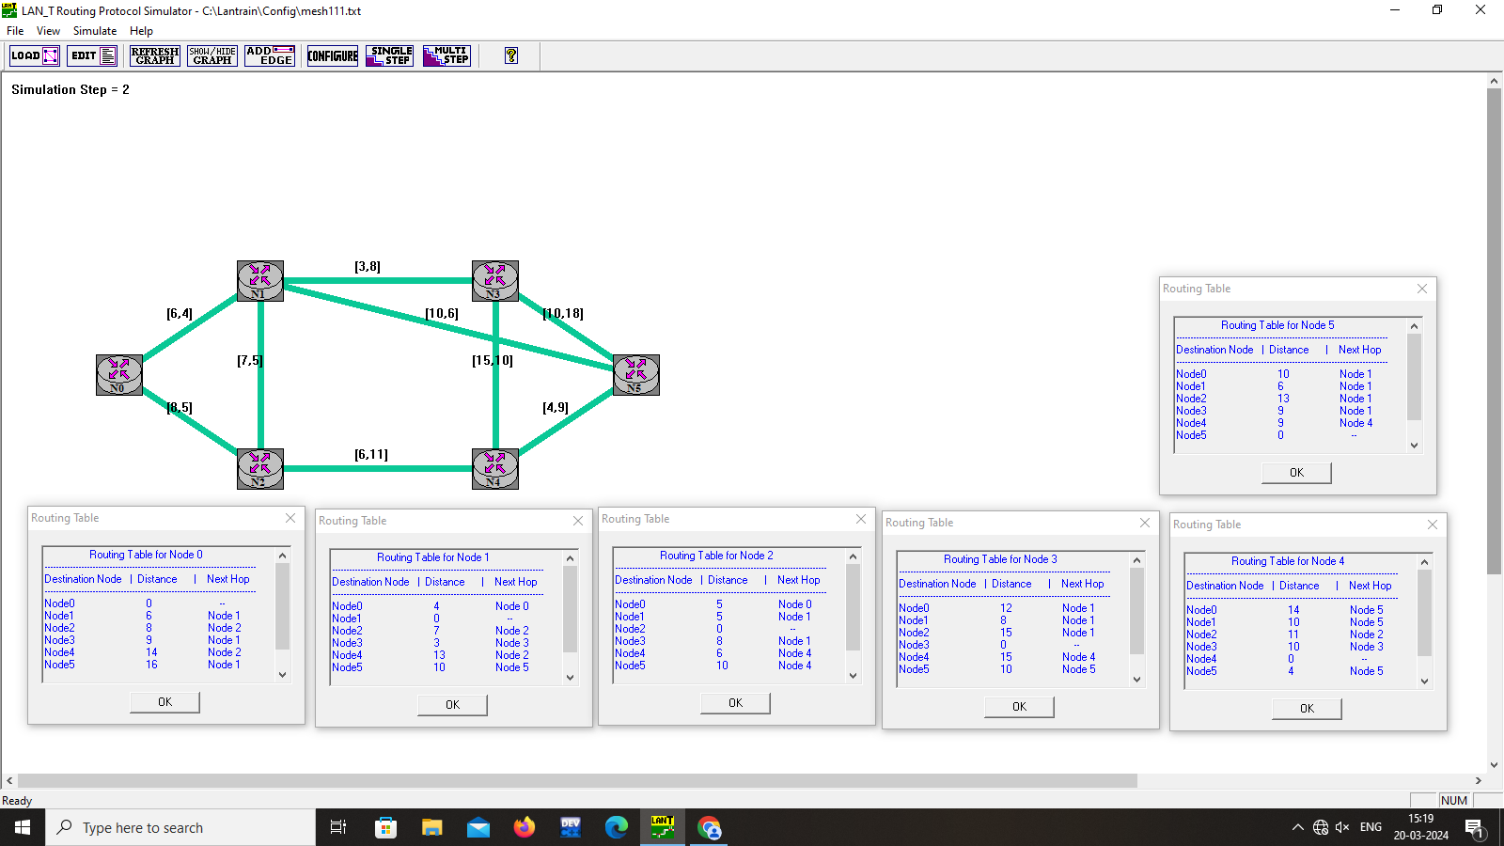

**DISTANCE VECTOR ROUTING(ADDITIONAL):**

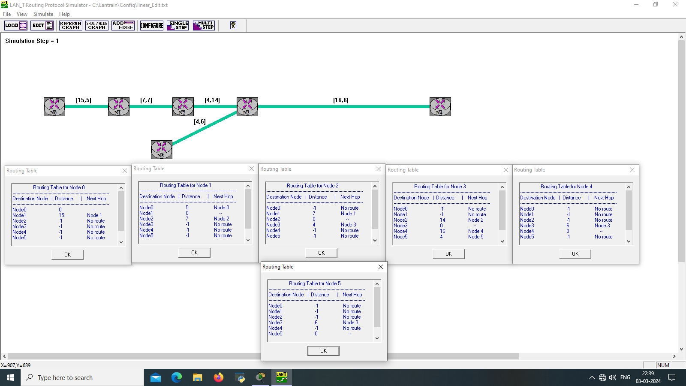

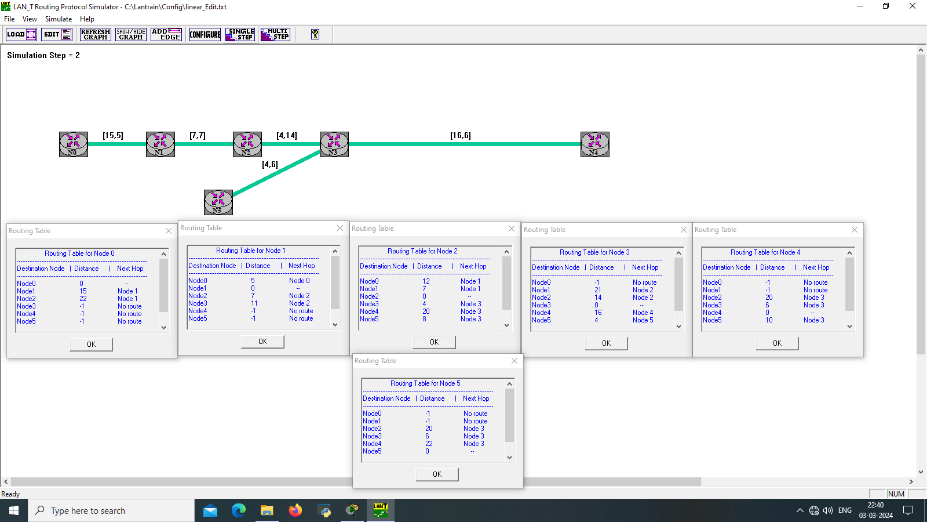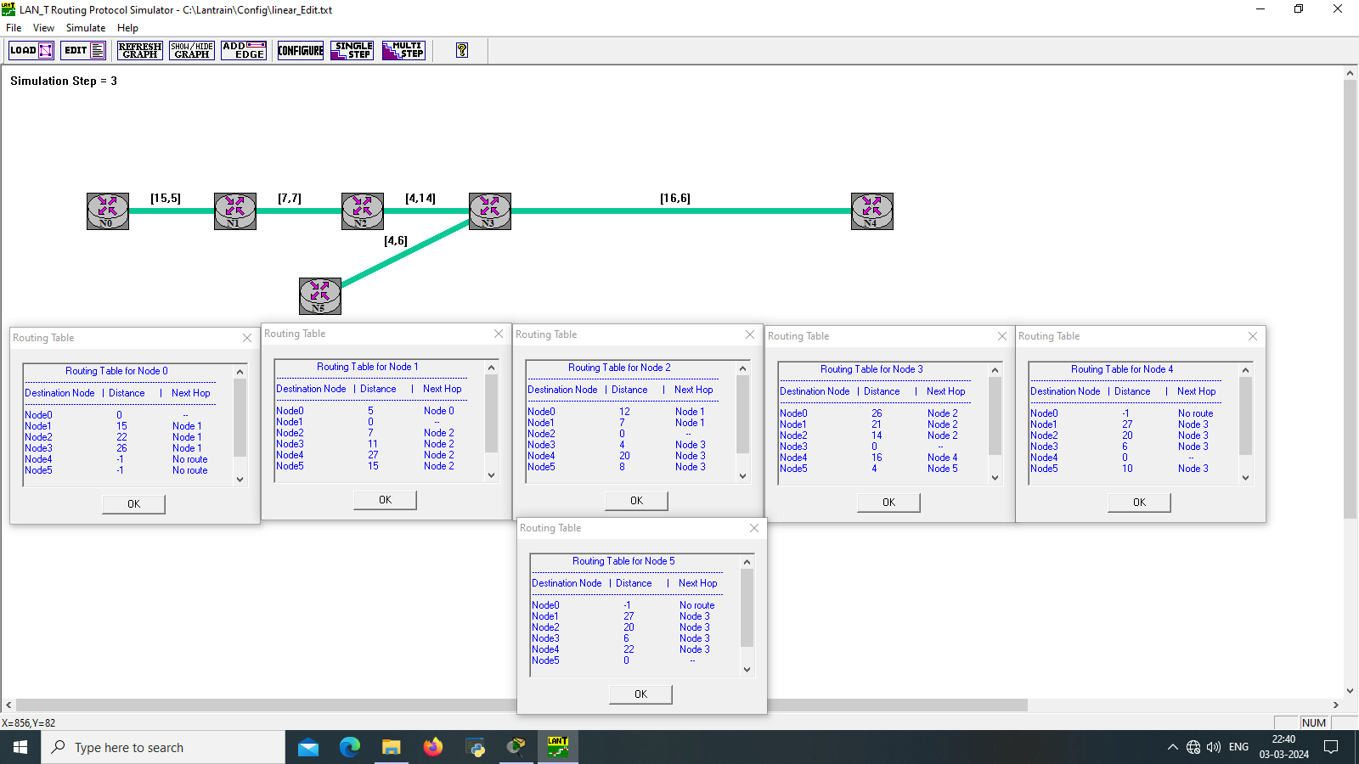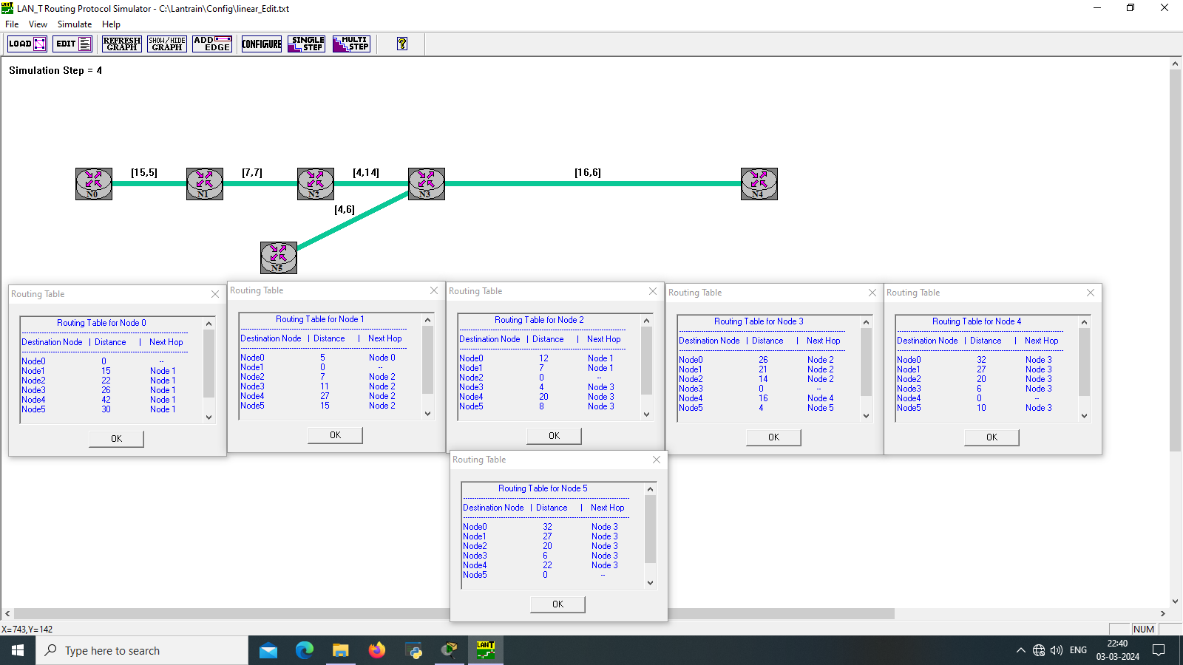

**LOOP TO INFINITE PROBLEM:**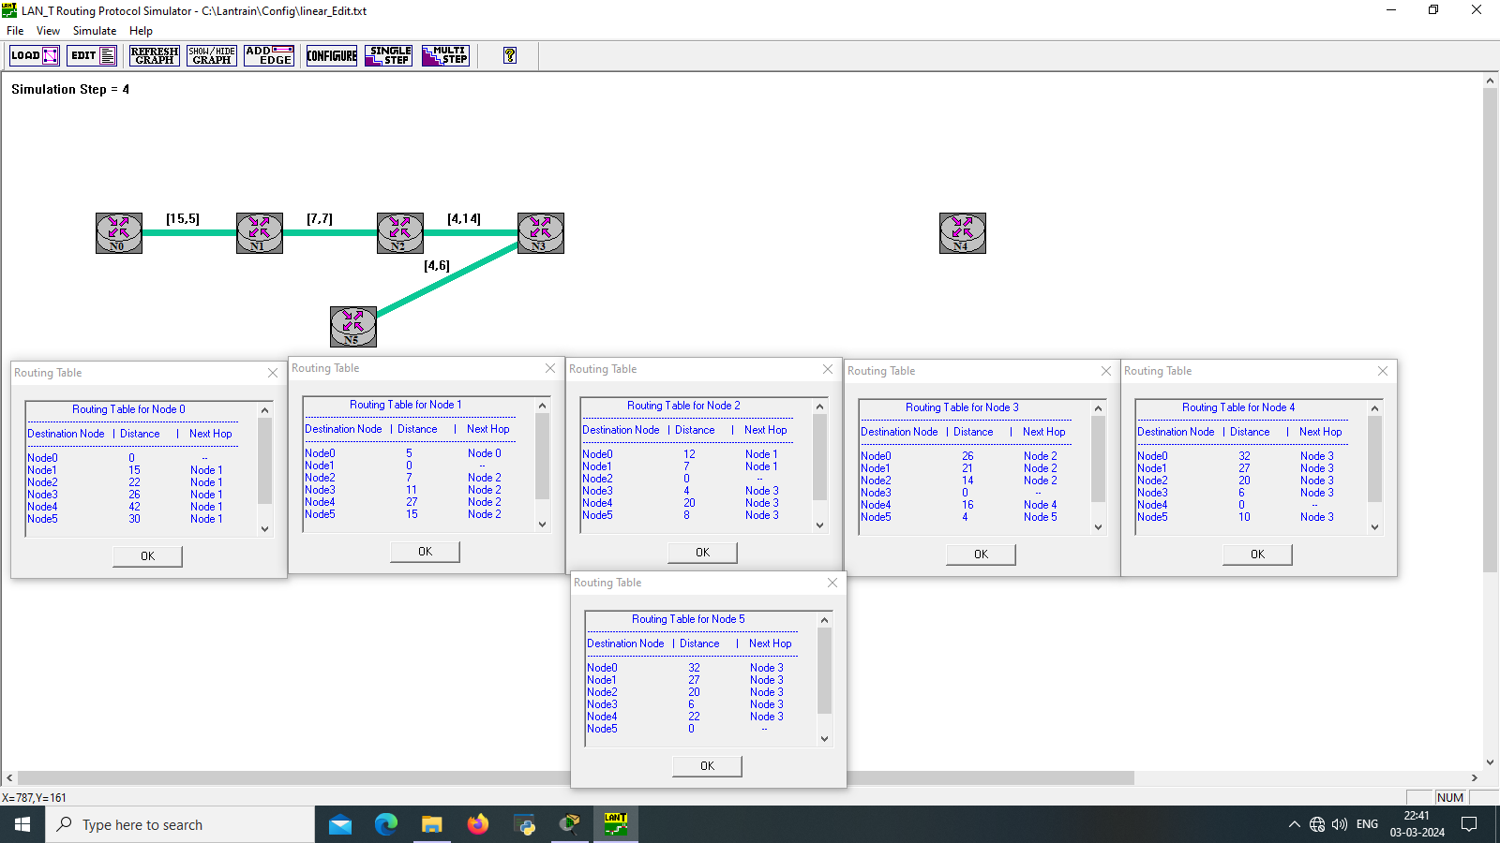

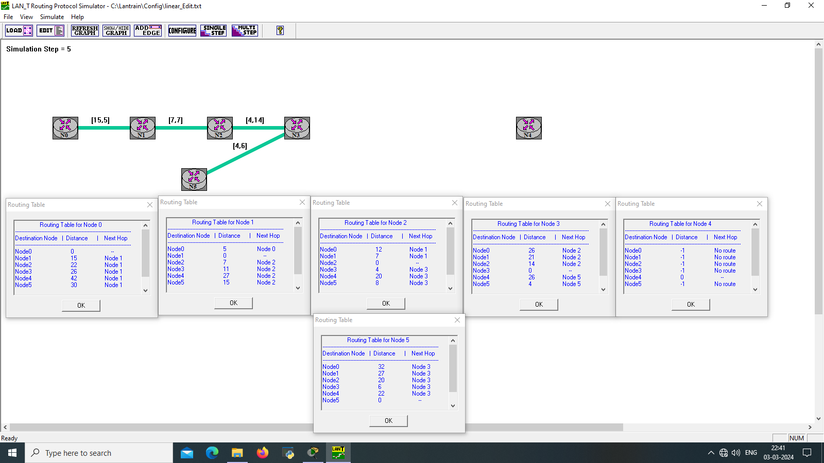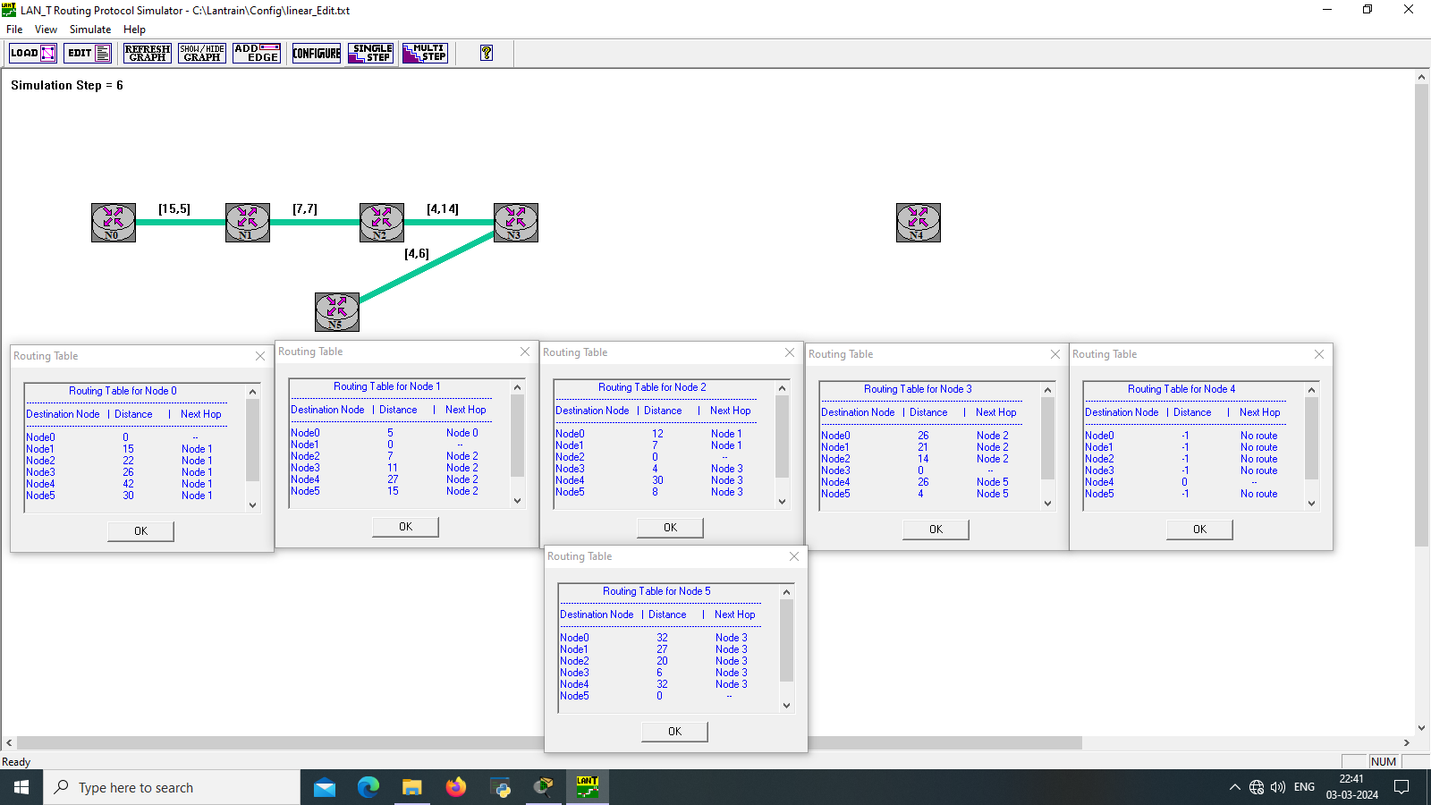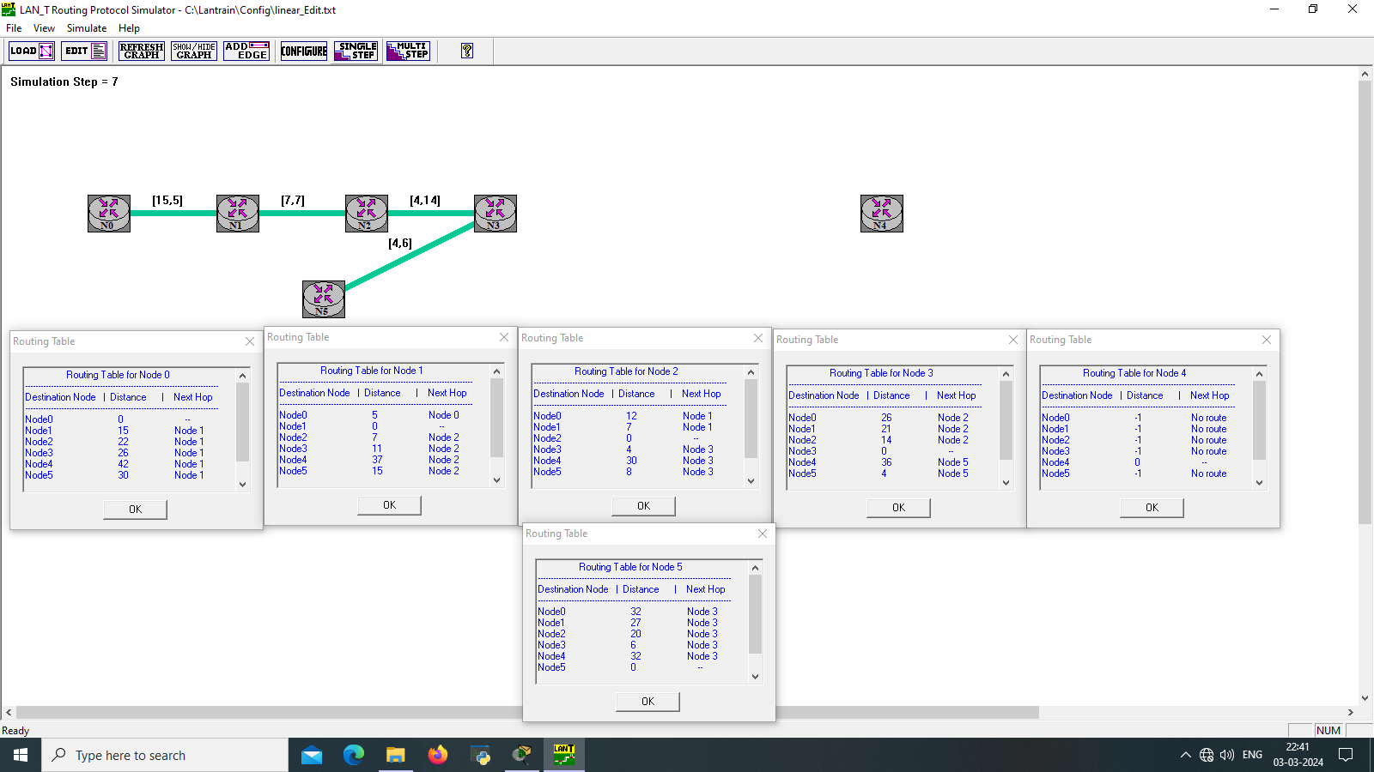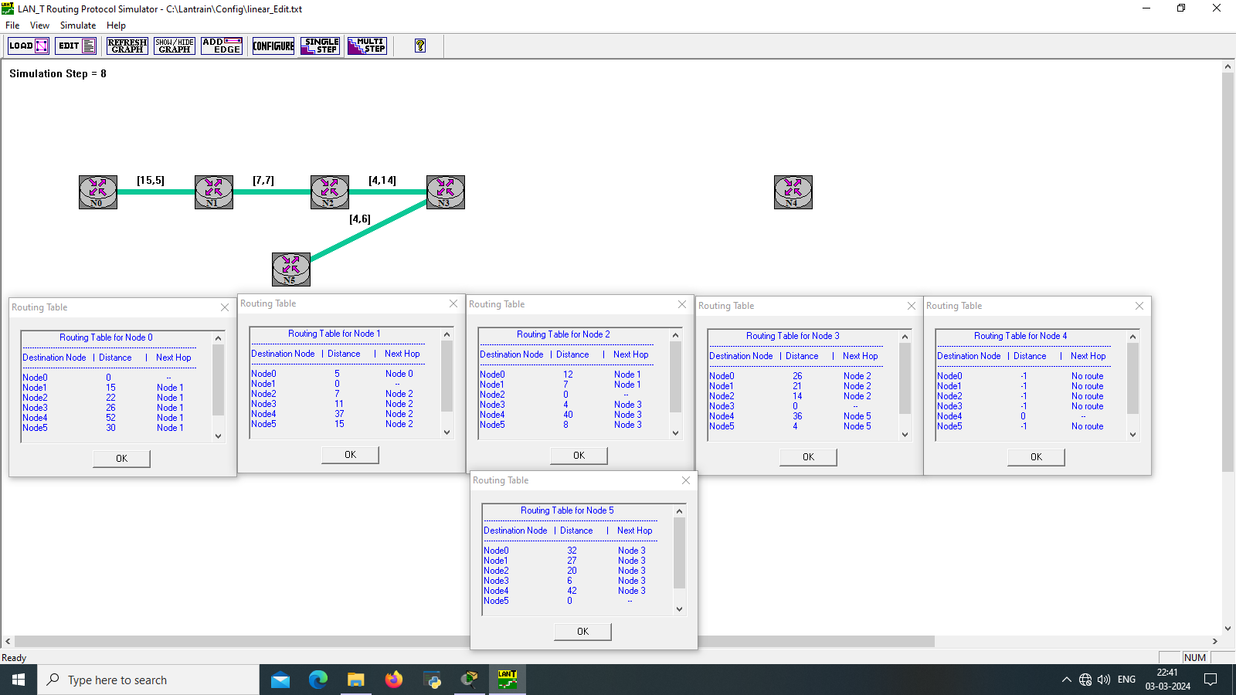

**CODE:**

