NAND

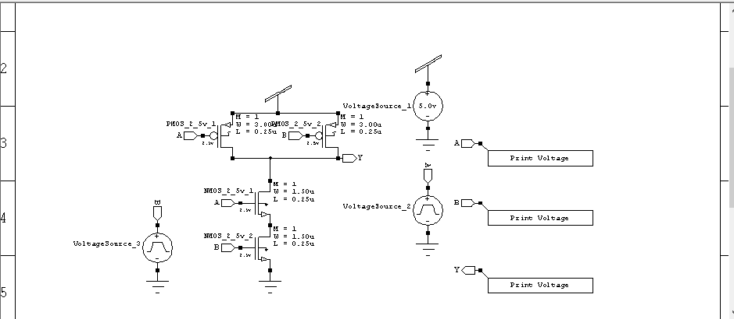

*-------- Devices With SPICE.ORDER > 0.0 --------

VVoltageSource_1 Vdd Gnd DC 5 $ $x=5500 $y=4900 $w=400 $h=600

VVoltageSource_2 A Gnd PULSE(0 5 0 5n 5n 95n 200n) $ $x=5500 $y=3500 $w=400 $h=600

VVoltageSource_3 B Gnd PULSE(0 5 0 5n 5n 95n 200n) $ $x=1900 $y=3000 $w=400 $h=600

.PRINT TRAN V(A) $ $x=6950 $y=4250 $w=1500 $h=300

.PRINT TRAN V(B) $ $x=6950 $y=3450 $w=1500 $h=300

.PRINT TRAN V(Y) $ $x=6950 $y=2550 $w=1500 $h=300

.PRINT DC V(A) $ $x=6950 $y=4250 $w=1500 $h=300

.PRINT DC V(B) $ $x=6950 $y=3450 $w=1500 $h=300

.PRINT DC V(Y) $ $x=6950 $y=2550 $w=1500 $h=300

********* Simulation Settings - Analysis Section *********

.tran 10n 1u

.dc lin VVoltageSource_2 0 5 500m lin VVoltageSource_3 0 5 500m

********* Simulation Settings - Additional SPICE Commands *********

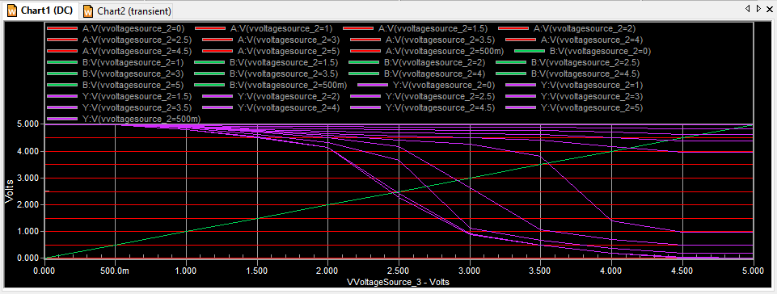

NOR

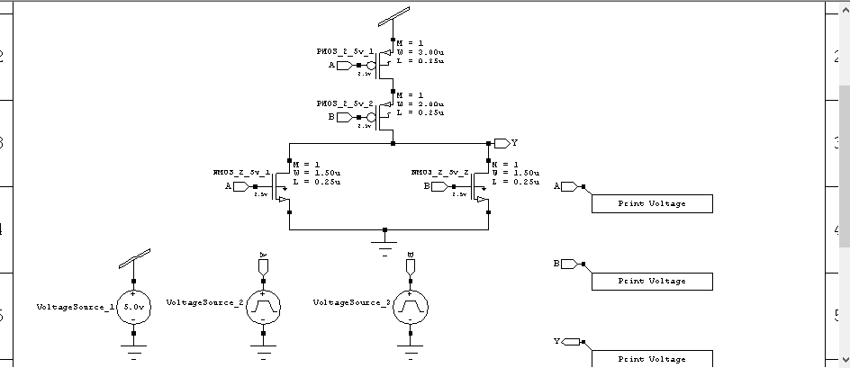

*-------- Devices With SPICE.ORDER == 0.0 --------

***** Top Level *****

MNMOS_2_5v_1 Y A Gnd 0 NMOS25 W=1.5u L=250n AS=975f PS=4.3u AD=975f PD=4.3u $ $x=2993 $y=3900 $w=414 $h=600

MNMOS_2_5v_2 Y B Gnd 0 NMOS25 W=1.5u L=250n AS=975f PS=4.3u AD=975f PD=4.3u $ $x=5293 $y=3900 $w=414 $h=600

MPMOS_2_5v_1 N_1 A Vdd Vdd PMOS25 W=3u L=250n AS=1.95p PS=7.3u AD=1.95p PD=7.3u $ $x=4193 $y=5300 $w=414 $h=600

MPMOS_2_5v_2 Y B N_1 Vdd PMOS25 W=3u L=250n AS=1.95p PS=7.3u AD=1.95p PD=7.3u $ $x=4193 $y=4700 $w=414 $h=600

*-------- Devices With SPICE.ORDER > 0.0 --------

VVoltageSource_1 Vdd Gnd DC 5 $ $x=1400 $y=2500 $w=400 $h=600

VVoltageSource_2 A Gnd PULSE(0 5 0 5n 5n 195n 400n) $ $x=2900 $y=2500 $w=400 $h=600

VVoltageSource_3 B Gnd PULSE(0 5 0 5n 5n 95n 200n) $ $x=4600 $y=2500 $w=400 $h=600

.PRINT TRAN V(A) $ $x=7350 $y=3750 $w=1500 $h=300

.PRINT TRAN V(B) $ $x=7350 $y=2850 $w=1500 $h=300

.PRINT TRAN V(Y) $ $x=7350 $y=1950 $w=1500 $h=300

.PRINT DC V(A) $ $x=7350 $y=3750 $w=1500 $h=300

.PRINT DC V(B) $ $x=7350 $y=2850 $w=1500 $h=300

.PRINT DC V(Y) $ $x=7350 $y=1950 $w=1500 $h=300

********* Simulation Settings - Analysis Section *********

.tran 10n 1u

.dc lin VVoltageSource_2 0 5 500m lin VVoltageSource_3 0 5 500m

********* Simulation Settings - Additional SPICE Commands *********

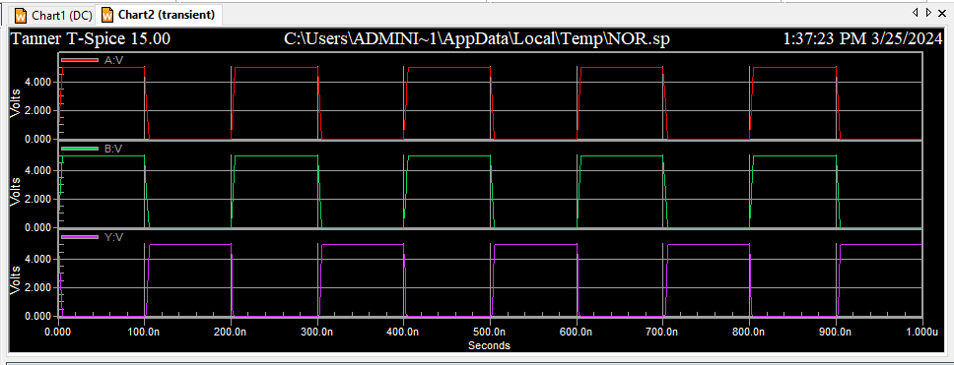

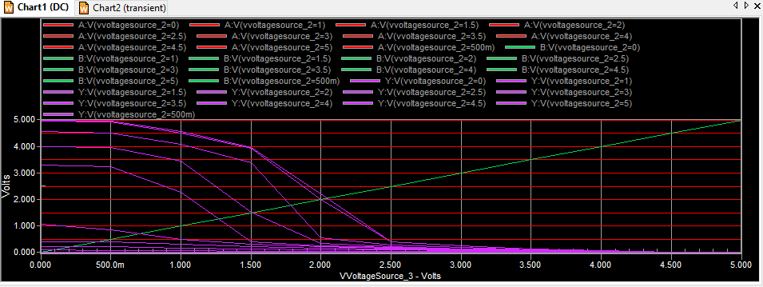

AND:

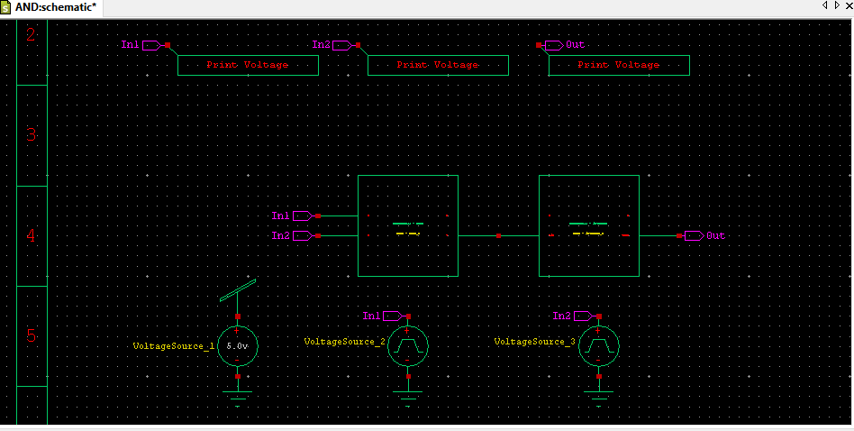

MNMOS_2_5v_1 Y A N_1 0 NMOS25 W=1.5u L=250n AS=975f PS=4.3u AD=975f PD=4.3u $ $x=3193 $y=3600 $w=414 $h=600

MNMOS_2_5v_2 N_1 B Gnd 0 NMOS25 W=1.5u L=250n AS=975f PS=4.3u AD=975f PD=4.3u $ $x=3193 $y=3000 $w=414 $h=600

MPMOS_2_5v_1 Y A Vdd Vdd PMOS25 W=3u L=250n AS=1.95p PS=7.3u AD=1.95p PD=7.3u $ $x=2693 $y=4500 $w=414 $h=600

MPMOS_2_5v_2 Y B Vdd Vdd PMOS25 W=3u L=250n AS=1.95p PS=7.3u AD=1.95p PD=7.3u $ $x=4093 $y=4500 $w=414 $h=600

.ends

*-------- Devices With SPICE.ORDER == 0.0 --------

***** Top Level *****

Xinverter_1 N_1 Out Gnd Vdd inverter $ $x=5400 $y=3500 $w=1800 $h=1000

XNAND_1 In1 In2 N_1 Gnd Vdd NAND $ $x=3600 $y=3500 $w=1800 $h=1000

*-------- Devices With SPICE.ORDER > 0.0 --------

VVoltageSource_1 Vdd Gnd DC 5 $ $x=1900 $y=2300 $w=400 $h=600

VVoltageSource_2 In1 Gnd PULSE(0 5 0 5n 5n 190n 400n) $ $x=3600 $y=2300 $w=400 $h=600

VVoltageSource_3 In2 Gnd PULSE(0 5 0 5n 5n 95n 200n) $ $x=5500 $y=2300 $w=400 $h=600

.PRINT TRAN V(In1) $ $x=1950 $y=5150 $w=1500 $h=300

.PRINT TRAN V(In2) $ $x=3850 $y=5150 $w=1500 $h=300

.PRINT TRAN V(Out) $ $x=5650 $y=5150 $w=1500 $h=300

.PRINT DC V(In1) $ $x=1950 $y=5150 $w=1500 $h=300

.PRINT DC V(In2) $ $x=3850 $y=5150 $w=1500 $h=300

.PRINT DC V(Out) $ $x=5650 $y=5150 $w=1500 $h=300

********* Simulation Settings - Analysis Section *********

.tran 10n 1u

.dc lin VVoltageSource_2 0 5 500m lin VVoltageSource_3 0 5 500m

********* Simulation Settings - Additional SPICE Commands *********

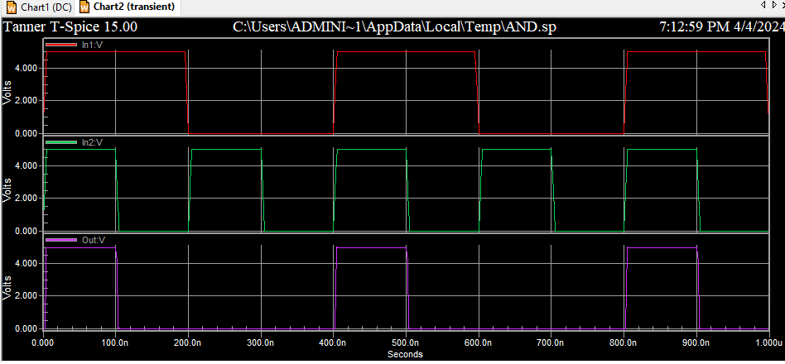

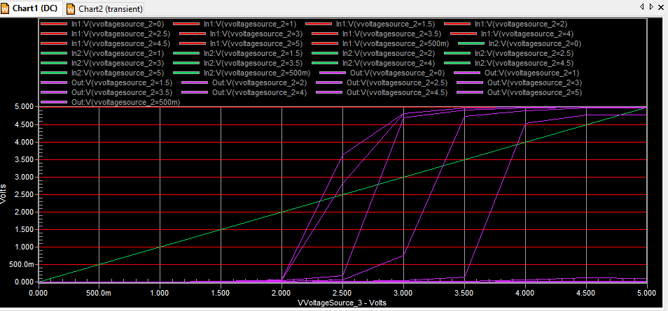

OR:  
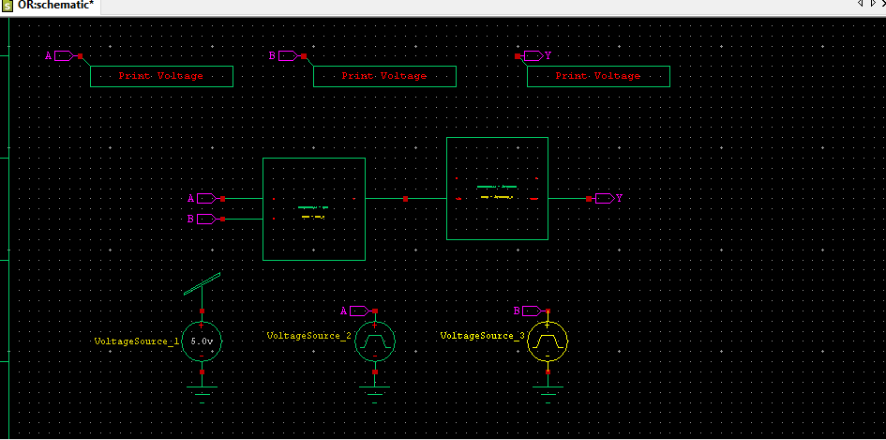

MNMOS_2_5v_1 Vout Vin Gnd 0 NMOS25 W=1.5u L=250n AS=975f PS=4.3u AD=975f PD=4.3u $ $x=4293 $y=3300 $w=414 $h=600

MPMOS_2_5v_1 Vout Vin Vdd Vdd PMOS25 W=3u L=250n AS=1.95p PS=7.3u AD=1.95p PD=7.3u $ $x=4293 $y=3900 $w=414 $h=600

.ends

.subckt NOR A B Y Gnd Vdd

*-------- Devices With SPICE.ORDER == 0.0 --------

MNMOS_2_5v_1 Y A Gnd 0 NMOS25 W=1.5u L=250n AS=975f PS=4.3u AD=975f PD=4.3u $ $x=2993 $y=3900 $w=414 $h=600

MNMOS_2_5v_2 Y B Gnd 0 NMOS25 W=1.5u L=250n AS=975f PS=4.3u AD=975f PD=4.3u $ $x=5293 $y=3900 $w=414 $h=600

MPMOS_2_5v_1 N_1 A Vdd Vdd PMOS25 W=3u L=250n AS=1.95p PS=7.3u AD=1.95p PD=7.3u $ $x=4193 $y=5300 $w=414 $h=600

MPMOS_2_5v_2 Y B N_1 Vdd PMOS25 W=3u L=250n AS=1.95p PS=7.3u AD=1.95p PD=7.3u $ $x=4193 $y=4700 $w=414 $h=600

.ends

*-------- Devices With SPICE.ORDER == 0.0 --------

***** Top Level *****

Xinverter_1 N_1 Y Gnd Vdd inverter $ $x=4800 $y=3600 $w=1800 $h=1000

XNOR_1 A B N_1 Gnd Vdd NOR $ $x=3000 $y=3400 $w=1800 $h=1000

*-------- Devices With SPICE.ORDER > 0.0 --------

VVoltageSource_1 Vdd Gnd DC 5 $ $x=1900 $y=2100 $w=400 $h=600

VVoltageSource_2 A Gnd PULSE(0 5 0 5n 5n 190n 400n) $ $x=3600 $y=2100 $w=400 $h=600

VVoltageSource_3 B Gnd PULSE(0 5 0 5n 5n 95n 200n) $ $x=5300 $y=2100 $w=400 $h=600

.PRINT TRAN V(A) $ $x=1450 $y=4750 $w=1500 $h=300

.PRINT TRAN V(B) $ $x=3650 $y=4750 $w=1500 $h=300

.PRINT TRAN V(Y) $ $x=5750 $y=4750 $w=1500 $h=300

.PRINT DC V(A) $ $x=1450 $y=4750 $w=1500 $h=300

.PRINT DC V(B) $ $x=3650 $y=4750 $w=1500 $h=300

.PRINT DC V(Y) $ $x=5750 $y=4750 $w=1500 $h=300

********* Simulation Settings - Analysis Section *********

.tran 10n 1u

.dc lin VVoltageSource_2 0 5 500m lin VVoltageSource_3 0 5 500m

********* Simulation Settings - Additional SPICE Commands *********

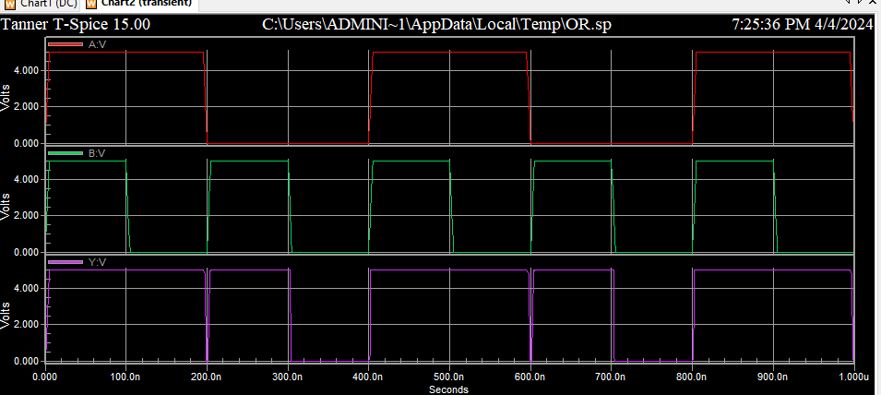

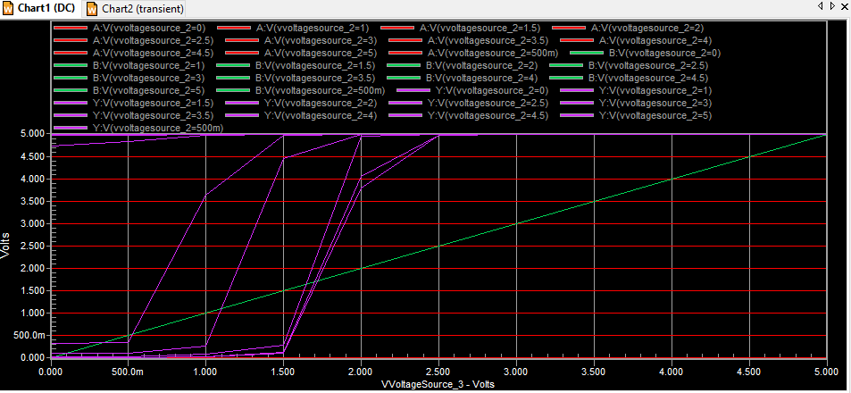

XOR:

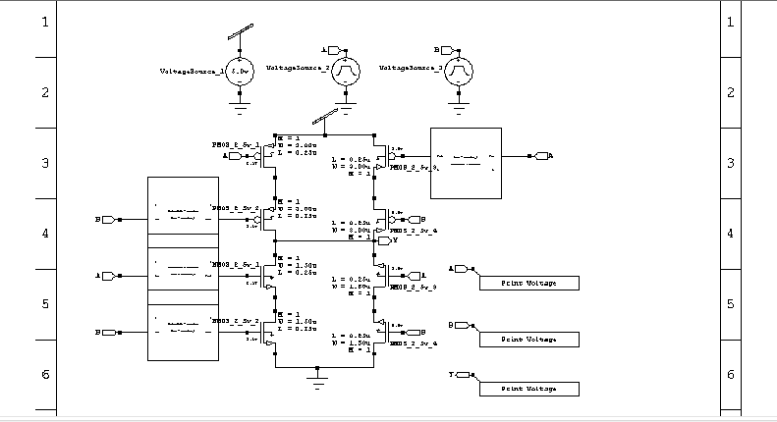

*-------- Devices With SPICE.ORDER == 0.0 --------

MNMOS_2_5v_1 Vout Vin Gnd 0 NMOS25 W=1.5u L=250n AS=975f PS=4.3u AD=975f PD=4.3u $ $x=4293 $y=3300 $w=414 $h=600

MPMOS_2_5v_1 Vout Vin Vdd Vdd PMOS25 W=3u L=250n AS=1.95p PS=7.3u AD=1.95p PD=7.3u $ $x=4293 $y=3900 $w=414 $h=600

.ends

*-------- Devices With SPICE.ORDER == 0.0 --------

***** Top Level *****

MNMOS_2_5v_1 Y N_5 N_6 0 NMOS25 W=1.5u L=250n AS=975f PS=4.3u AD=975f PD=4.3u $ $x=2893 $y=2800 $w=414 $h=600

MNMOS_2_5v_2 N_6 N_7 Gnd 0 NMOS25 W=1.5u L=250n AS=975f PS=4.3u AD=975f PD=4.3u $ $x=2893 $y=2000 $w=414 $h=600

MNMOS_2_5v_3 N_8 A Y 0 NMOS25 W=1.5u L=250n AS=975f PS=4.3u AD=975f PD=4.3u $ $x=4707 $y=2800 $w=414 $h=600 $r=180

MNMOS_2_5v_4 Gnd B N_8 0 NMOS25 W=1.5u L=250n AS=975f PS=4.3u AD=975f PD=4.3u $ $x=4707 $y=2000 $w=414 $h=600 $r=180

MPMOS_2_5v_1 N_1 A Vdd Vdd PMOS25 W=3u L=250n AS=1.95p PS=7.3u AD=1.95p PD=7.3u $ $x=2893 $y=4500 $w=414 $h=600

MPMOS_2_5v_2 Y N_2 N_1 Vdd PMOS25 W=3u L=250n AS=1.95p PS=7.3u AD=1.95p PD=7.3u $ $x=2893 $y=3600 $w=414 $h=600

MPMOS_2_5v_3 Vdd N_4 N_3 Vdd PMOS25 W=3u L=250n AS=1.95p PS=7.3u AD=1.95p PD=7.3u $ $x=4707 $y=4500 $w=414 $h=600 $r=180

MPMOS_2_5v_4 N_3 B Y Vdd PMOS25 W=3u L=250n AS=1.95p PS=7.3u AD=1.95p PD=7.3u $ $x=4707 $y=3600 $w=414 $h=600 $r=180

Xinverter_1 A N_4 Gnd Vdd inverter $ $x=5800 $y=4400 $w=1800 $h=1000 $r=180

Xinverter_2 B N_2 Gnd Vdd inverter $ $x=1800 $y=3700 $w=1800 $h=1000

Xinverter_3 A N_5 Gnd Vdd inverter $ $x=1800 $y=2900 $w=1800 $h=1000

Xinverter_4 B N_7 Gnd Vdd inverter $ $x=1800 $y=2100 $w=1800 $h=1000

*-------- Devices With SPICE.ORDER > 0.0 --------

VVoltageSource_1 Vdd Gnd DC 5 $ $x=2600 $y=5700 $w=400 $h=600

VVoltageSource_2 A Gnd PULSE(0 5 0 5n 5n 190n 400n) $ $x=4100 $y=5700 $w=400 $h=600

VVoltageSource_3 B Gnd PULSE(0 5 0 5n 5n 95n 200n) $ $x=5700 $y=5700 $w=400 $h=600

.PRINT TRAN V(A) $ $x=6650 $y=2750 $w=1500 $h=300

.PRINT TRAN V(B) $ $x=6650 $y=1950 $w=1500 $h=300

.PRINT TRAN V(Y) $ $x=6650 $y=1250 $w=1500 $h=300

.PRINT DC V(A) $ $x=6650 $y=2750 $w=1500 $h=300

.PRINT DC V(B) $ $x=6650 $y=1950 $w=1500 $h=300

.PRINT DC V(Y) $ $x=6650 $y=1250 $w=1500 $h=300

********* Simulation Settings - Analysis Section *********

.tran 10n 1u

.dc lin VVoltageSource_2 0 5 500m lin VVoltageSource_3 0 5 500m

********* Simulation Settings - Additional SPICE Commands *********

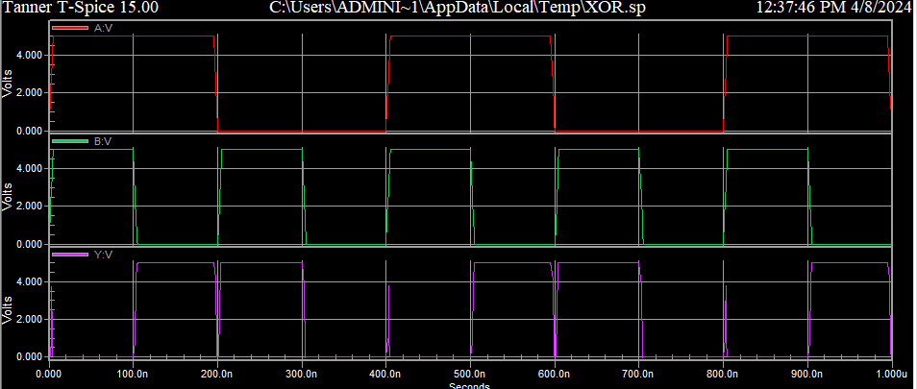

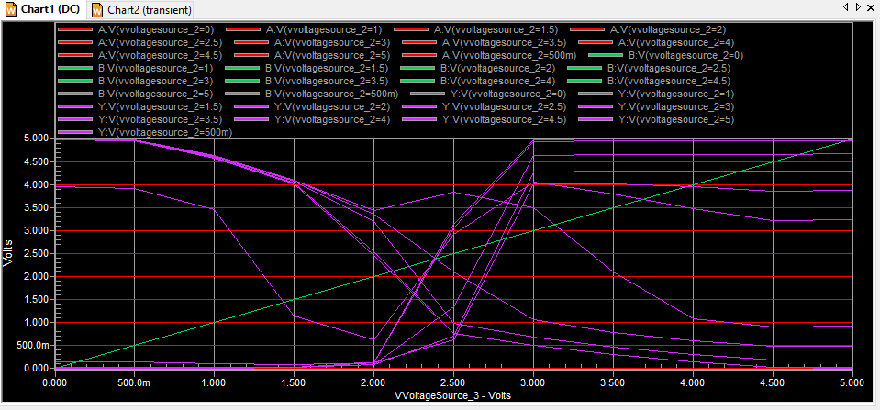

XNOR:

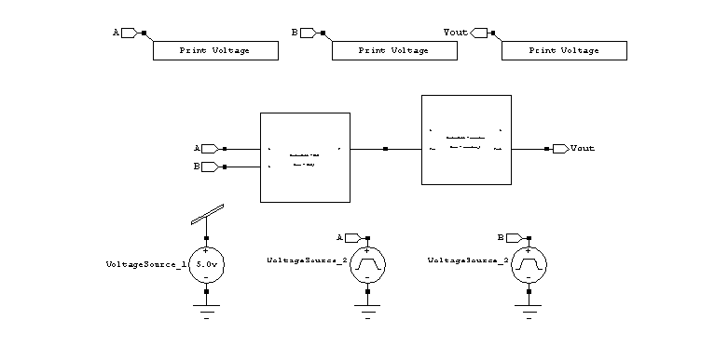

*-------- Devices With SPICE.ORDER == 0.0 --------

MNMOS_2_5v_1 Vout Vin Gnd 0 NMOS25 W=1.5u L=250n AS=975f PS=4.3u AD=975f PD=4.3u $ $x=4293 $y=3300 $w=414 $h=600

MPMOS_2_5v_1 Vout Vin Vdd Vdd PMOS25 W=3u L=250n AS=1.95p PS=7.3u AD=1.95p PD=7.3u $ $x=4293 $y=3900 $w=414 $h=600

.ends

.subckt XOR A B Y Gnd Vdd

*-------- Devices With SPICE.ORDER == 0.0 --------

MNMOS_2_5v_1 Y N_5 N_6 0 NMOS25 W=1.5u L=250n AS=975f PS=4.3u AD=975f PD=4.3u $ $x=2893 $y=2800 $w=414 $h=600

MNMOS_2_5v_2 N_6 N_7 Gnd 0 NMOS25 W=1.5u L=250n AS=975f PS=4.3u AD=975f PD=4.3u $ $x=2893 $y=2000 $w=414 $h=600

MNMOS_2_5v_3 N_8 A Y 0 NMOS25 W=1.5u L=250n AS=975f PS=4.3u AD=975f PD=4.3u $ $x=4707 $y=2800 $w=414 $h=600 $r=180

MNMOS_2_5v_4 Gnd B N_8 0 NMOS25 W=1.5u L=250n AS=975f PS=4.3u AD=975f PD=4.3u $ $x=4707 $y=2000 $w=414 $h=600 $r=180

MPMOS_2_5v_1 N_1 A Vdd Vdd PMOS25 W=3u L=250n AS=1.95p PS=7.3u AD=1.95p PD=7.3u $ $x=2893 $y=4500 $w=414 $h=600

MPMOS_2_5v_2 Y N_2 N_1 Vdd PMOS25 W=3u L=250n AS=1.95p PS=7.3u AD=1.95p PD=7.3u $ $x=2893 $y=3600 $w=414 $h=600

MPMOS_2_5v_3 Vdd N_4 N_3 Vdd PMOS25 W=3u L=250n AS=1.95p PS=7.3u AD=1.95p PD=7.3u $ $x=4707 $y=4500 $w=414 $h=600 $r=180

MPMOS_2_5v_4 N_3 B Y Vdd PMOS25 W=3u L=250n AS=1.95p PS=7.3u AD=1.95p PD=7.3u $ $x=4707 $y=3600 $w=414 $h=600 $r=180

Xinverter_1 A N_4 Gnd Vdd inverter $ $x=5800 $y=4400 $w=1800 $h=1000 $r=180

Xinverter_2 B N_2 Gnd Vdd inverter $ $x=1800 $y=3700 $w=1800 $h=1000

Xinverter_3 A N_5 Gnd Vdd inverter $ $x=1800 $y=2900 $w=1800 $h=1000

Xinverter_4 B N_7 Gnd Vdd inverter $ $x=1800 $y=2100 $w=1800 $h=1000

.ends

*-------- Devices With SPICE.ORDER == 0.0 --------

***** Top Level *****

Xinverter_1 N_1 Vout Gnd Vdd inverter $ $x=5300 $y=3700 $w=1800 $h=1000

XXOR_1 A B N_1 Gnd Vdd XOR $ $x=3500 $y=3500 $w=1800 $h=1000

*-------- Devices With SPICE.ORDER > 0.0 --------

VVoltageSource_1 Vdd Gnd DC 5 $ $x=2400 $y=2300 $w=400 $h=600

VVoltageSource_2 A Gnd PULSE(0 5 0 5n 5n 190n 400n) $ $x=4200 $y=2300 $w=400 $h=600

VVoltageSource_3 B Gnd PULSE(0 5 0 5n 5n 95n 200n) $ $x=6000 $y=2300 $w=400 $h=600

.PRINT TRAN V(A) $ $x=2450 $y=4750 $w=1500 $h=300

.PRINT TRAN V(B) $ $x=4450 $y=4750 $w=1500 $h=300

.PRINT TRAN V(Vout) $ $x=6350 $y=4750 $w=1500 $h=300

.PRINT DC V(A) $ $x=2450 $y=4750 $w=1500 $h=300

.PRINT DC V(B) $ $x=4450 $y=4750 $w=1500 $h=300

.PRINT DC V(Vout) $ $x=6350 $y=4750 $w=1500 $h=300

********* Simulation Settings - Analysis Section *********

.tran 10n 1u

.dc lin VVoltageSource_2 0 5 500m lin VVoltageSource_3 0 5 500m

********* Simulation Settings - Additional SPICE Commands *********

