Truechain main network setup tutorial

system version：Ubuntu 18.04

Required environment：
- Git
- Go => version 1.7 +
- Compilation tools

Install Git:
$ sudo apt-get install git

Install Golang:
$ sudo apt-get install golang-go

Now let’s set the environment variable. Firstly, you need to create the GOPATH folder

$ cd ~
$ mkdir go
$ cd go
$ mkdir bin pkg src

Add the following command at the end of the ‘$HOME/.profile’ file

export GOPATH=$HOME/go
export PATH=$PATH:/usr/local/go/bin:$GOPATH/bin

Then run the following command

$ source $HOME/.profile

Now it is time to check whether test installation is successful by following:

First, write the following code to $HOME/go/src/hello/hello.go

package main
import "fmt"
func main() {
fmt.Printf("hello, world\n")
}

Then compile and run:

$ cd $HOME/go/src/hello
$ go build
$ ./hello // print：hello,world

If the expected output “hello, world” appears, congratulations!

Install the build environment
$ sudo apt-get install build-essential

Compile TrueChain
Go to a directory of your choice, such as $GOPATH/src/ and run the following command

$ cd $GOPATH/src/
$ git clone https://github.com/truechain/truechain-engineering-code.git

After the download is completed, go to the truechain-engineering-code directory:

$ make getrue // Only compile getrue
or
$ make all // Compile all tools

After the compiled executable file is ready in the build/bin/ directory, execute the following command to view the getrue version information.

$ ./getrue version

In order for the getrue command to run in any folder, the following operations are required (path is the directory where getrue located)

$ cp path/getrue $GOPATH/bin

If you have any questions about the above installation process, please refer to the Ubuntu environment (Link: https://github.com/truechain/wiki/blob/master/developer/3-1.Ubuntu_env_build.md).

Running the main chain
Run the following command to start to connect to other peers and then automatically sync the blocks:

./build/bin/getrue --datadir ./data --cache 4096 --rpc --rpcport 33333 --rpcaddr 0.0.0.0

Note: The parameters are added according to your personal situation. Running getrue --datadir path/data can also be running.

Please find below explanation for several parameters in the command:

(1). --datadir "xxxx": Specify data directory and used to store blockchain data, status data, keystore data and soon. This directory takes up a lot of space, and the specified directory must have enough disk space.
(2). --cache value: The amount of memory MB allocated to the internal cache, the default is 128, we have to set a larger size, at least 1024, because this value can improve the efficiency of data synchronization.
(3). --rpc: Enable HTTP-RPC server
(4). --rpcaddr : HTTP-RPC Server interface address(Default: "localhost"), By default only local connections are allowed, set to 0.0.0.0 can receive connection requests from any address
(5). --rpcport : HTTP-RPC server listening port (default: 8545), can be changed to a different port

It looks like this when it runs:
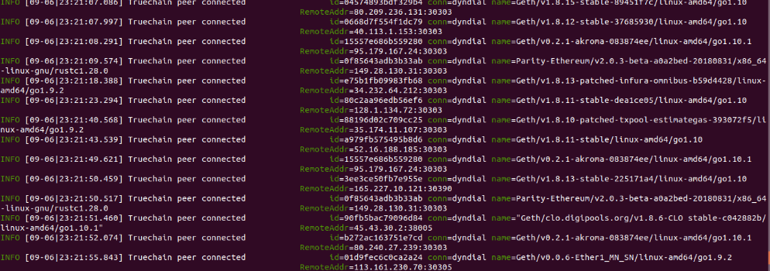

Automatically sync blocks after a while
Then go through a long wait, and when the block synchronization is complete, the node can receive the transaction request.

references: https://www.jianshu.com/p/719a34fe484d

