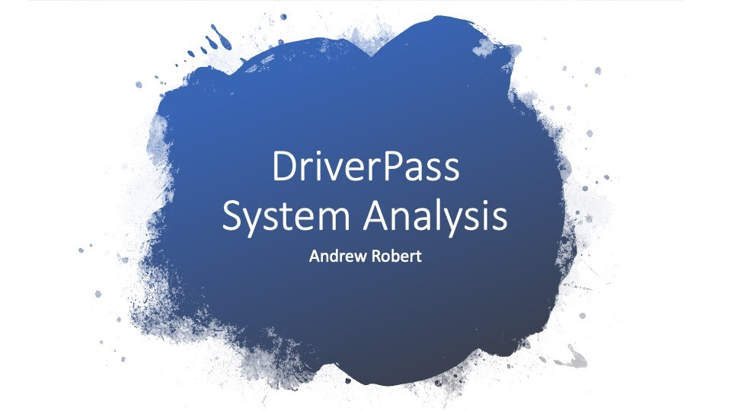
No

speaker notes
here.
DriverPass
System
Analysis
Andrew Robert

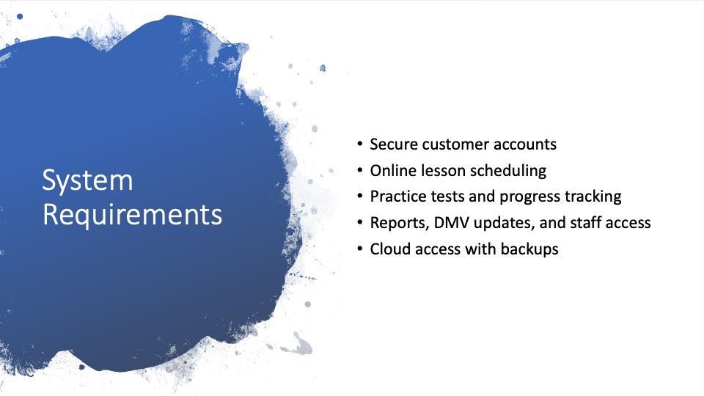
System
Requirements
•
•
•
•
•

For DriverPass, the main functional needs are customer accounts, lesson scheduling, practice tests, reports, and DMV updates. Functional means the system actions people need to complete. Customers need to create accounts, schedule lessons, change appointments, and take practice tests. Staff need to enter appointments, manage packages, and view reports. The main nonfunctional needs are security, reliability, cloud access, and ease of use. These support DriverPass because Liam wants the system available from different devices while Ian wants secure access and fewer technical problems for the business.
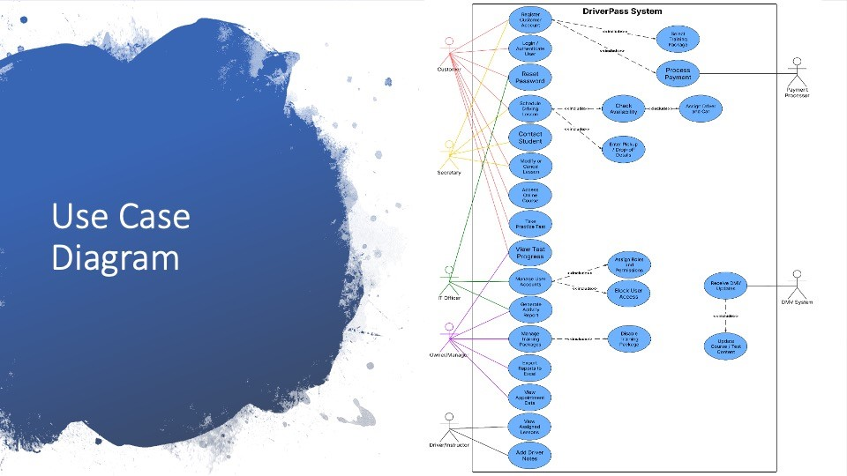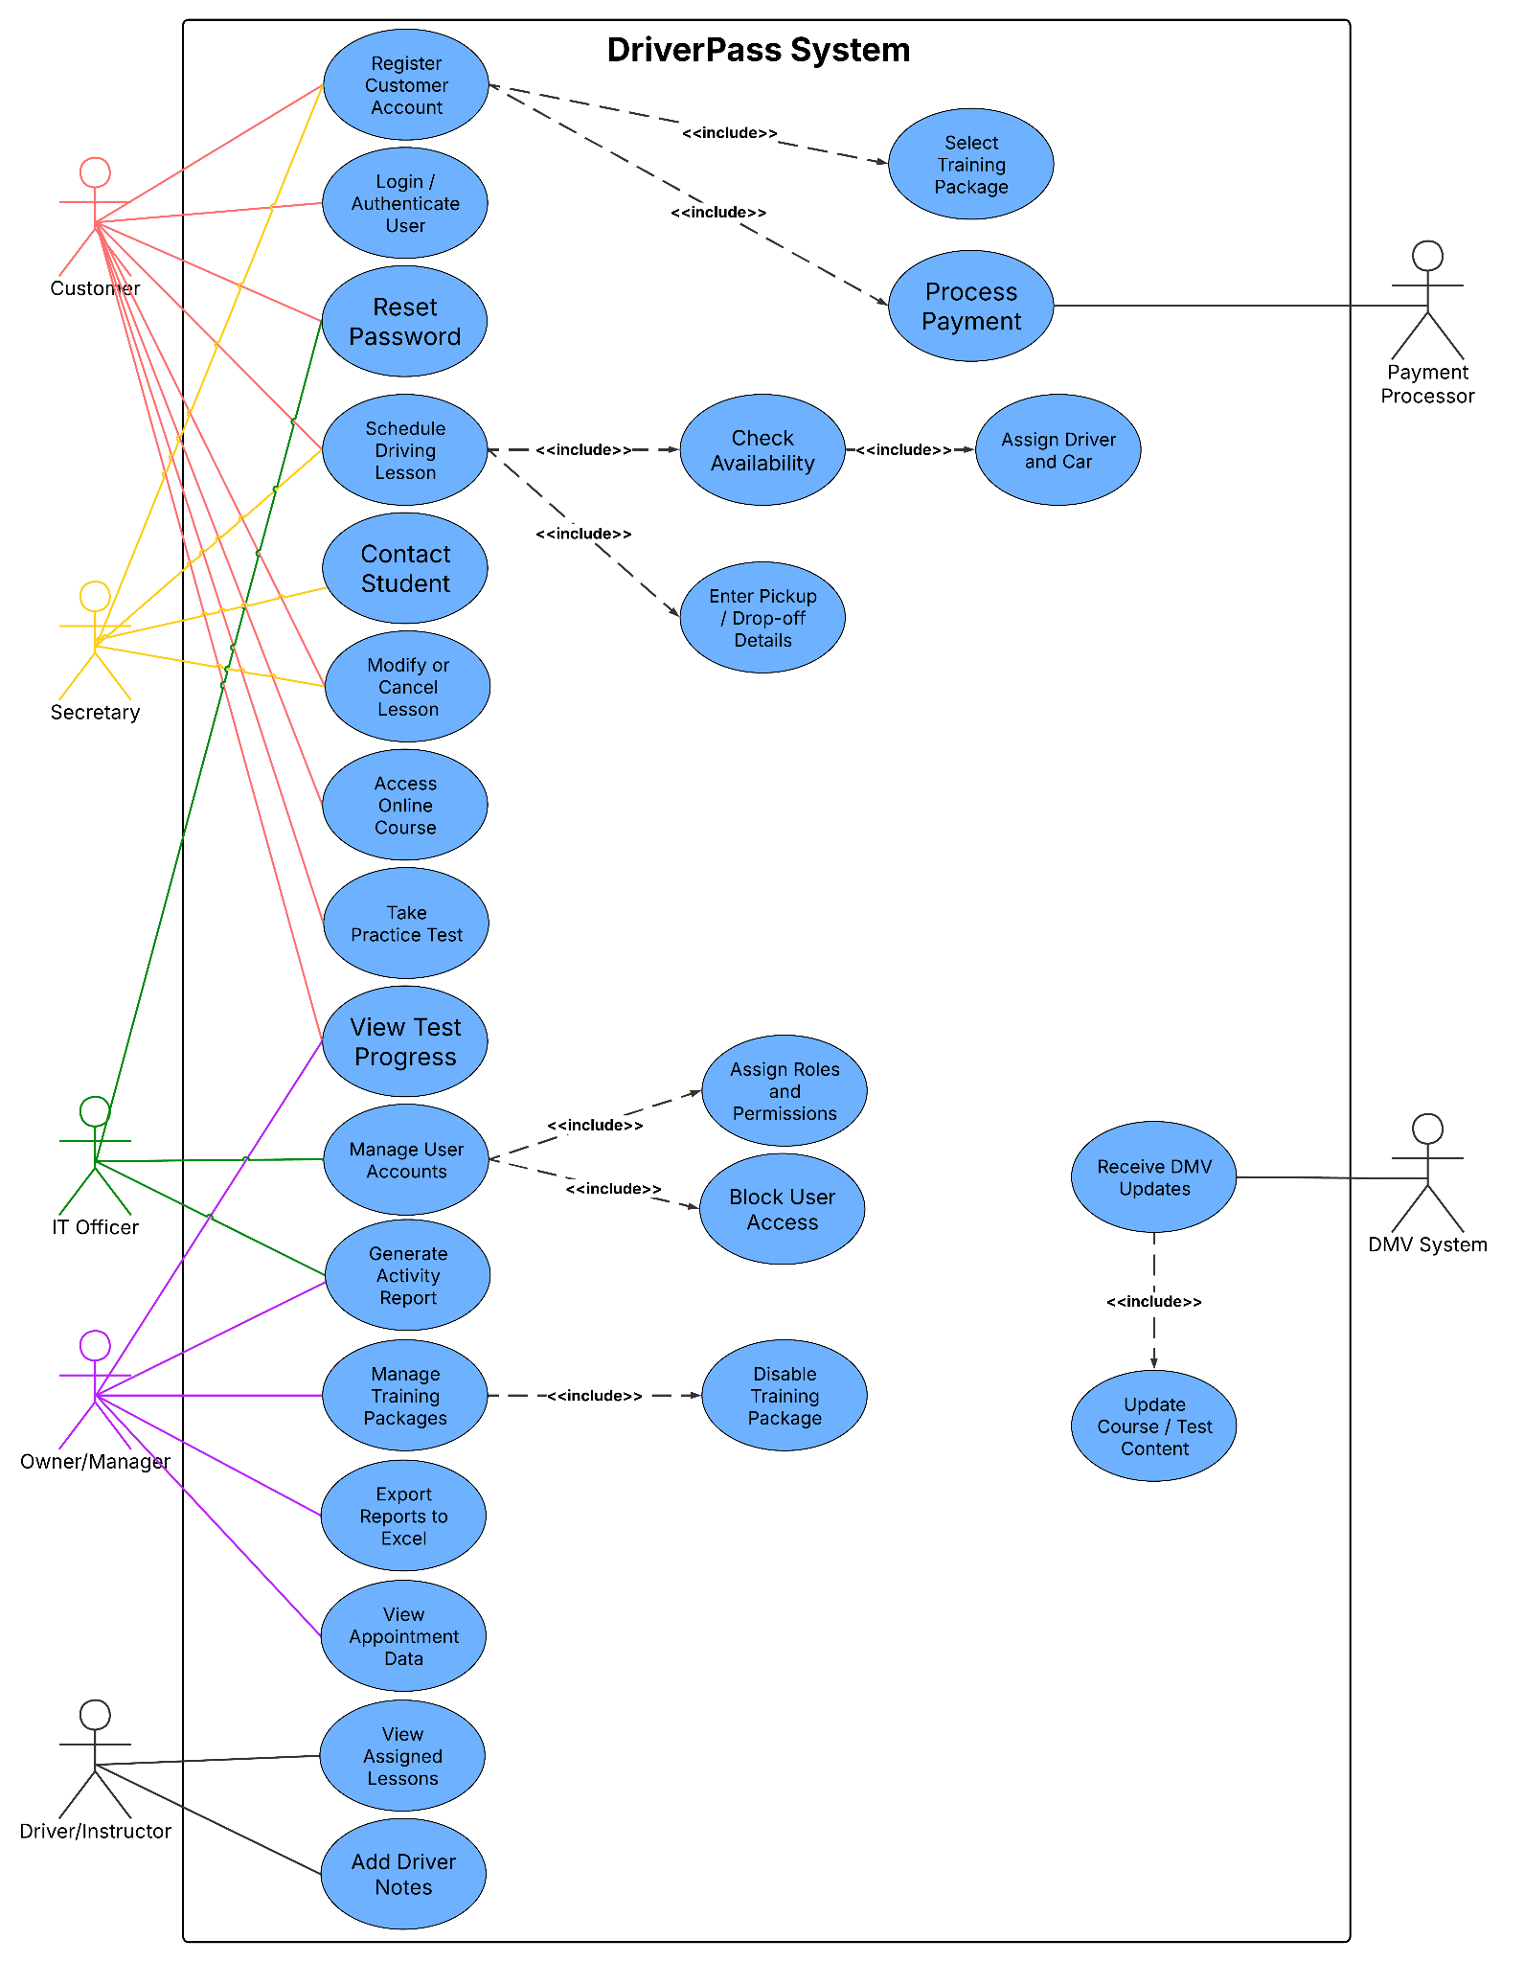
Use Case
Diagram
This slide shows who uses the DriverPass system and what each group needs to do. Customers can create accounts, choose training packages, schedule lessons, take online classes, and view their test progress. The secretary can help enter customer information and schedule or change lessons for customers who call or visit in person. Drivers can view assigned lessons and add notes after driving sessions. The owner can review reports, view appointment data, and manage training packages. The IT officer handles user accounts, roles, and access. The DMV system and payment processor are outside services that support updated course content and payments. This design meets DriverPass's needs because it keeps the main customer process, staff responsibilities, payments, and DMV updates connected in one system.
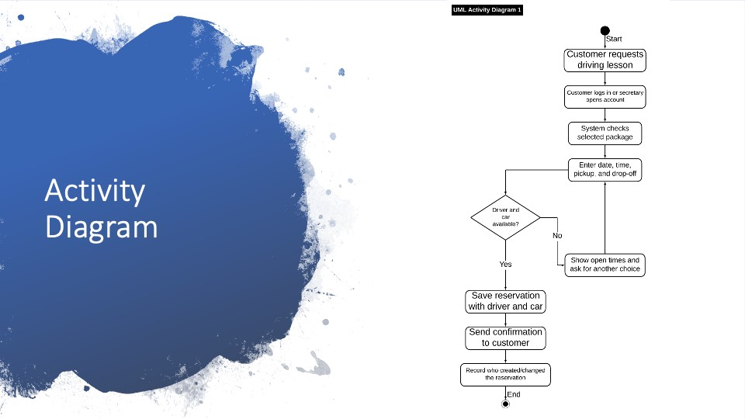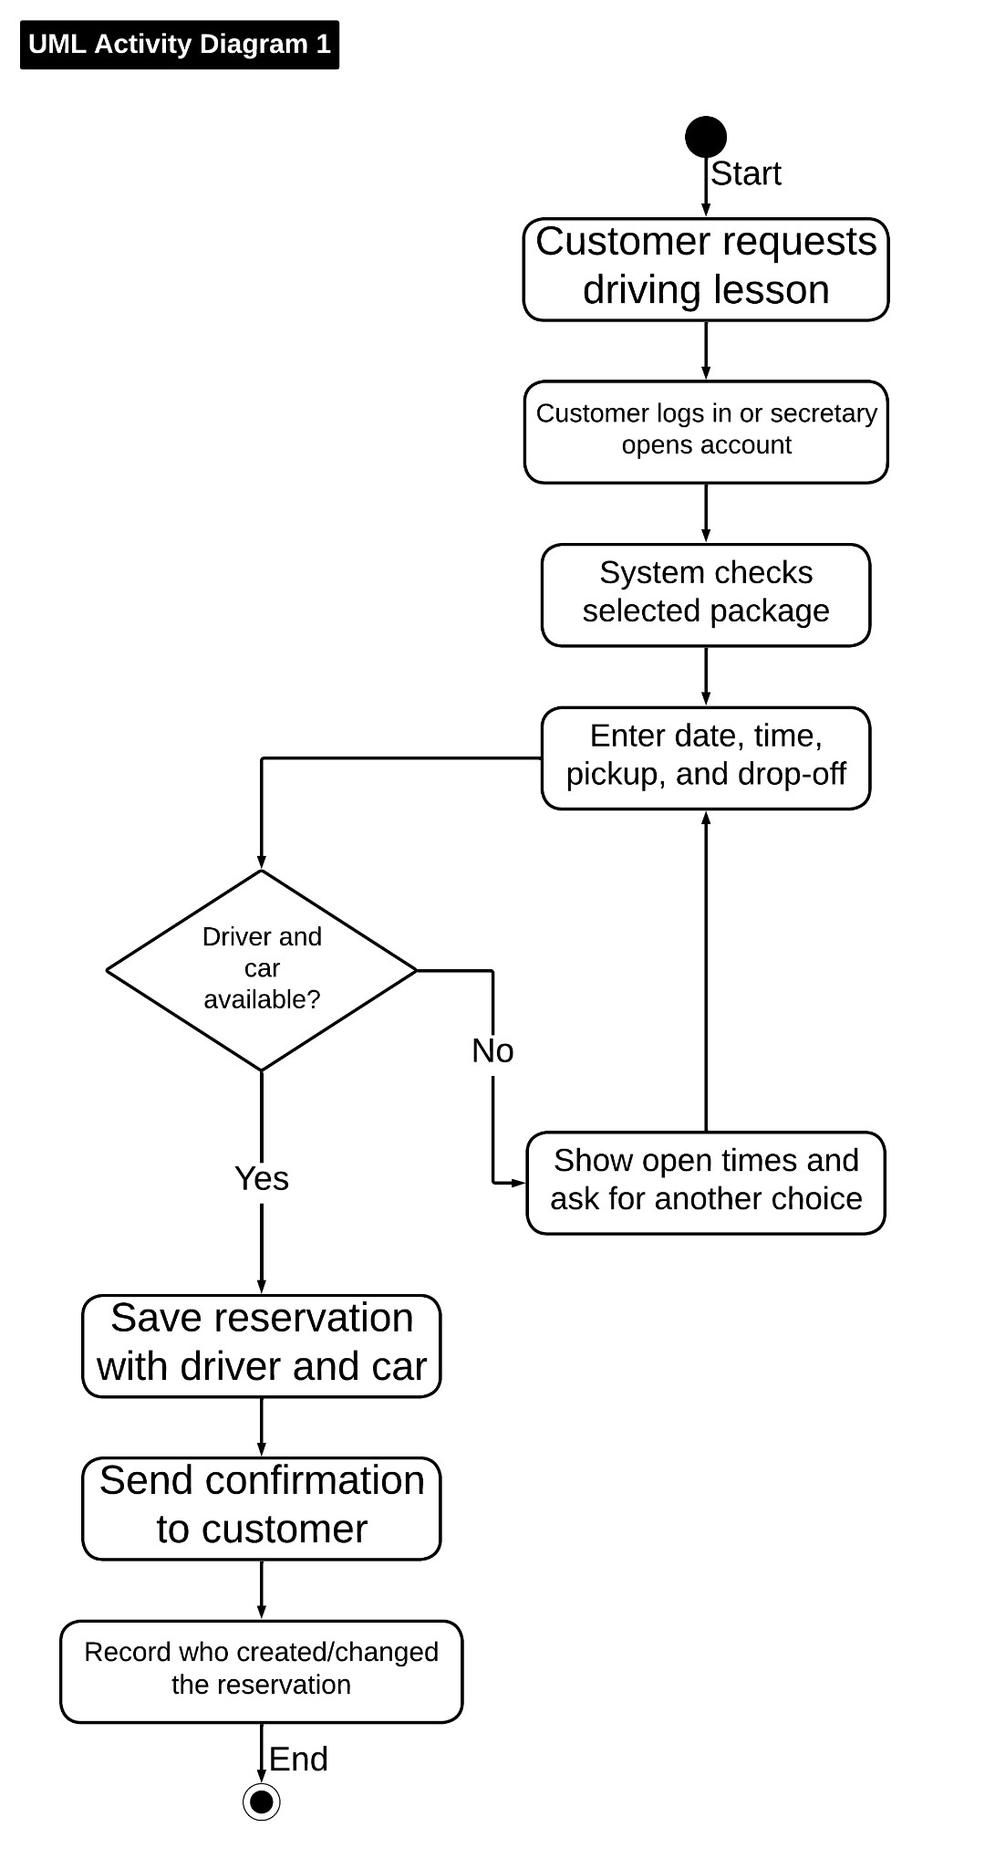
Activity
Diagram
This diagram breaks down the driving lesson scheduling process. The customer starts by requesting a lesson, or the secretary opens the customer account if the request happens by phone or in person. The system checks the selected package, then the customer chooses a day, time, pickup location, and drop-off location. If a driver and car are available, the system saves the reservation and sends a confirmation. If nothing is available, the system asks for another time. This supports DriverPass because each two-hour lesson needs to be matched with the correct customer, driver, car, and time.
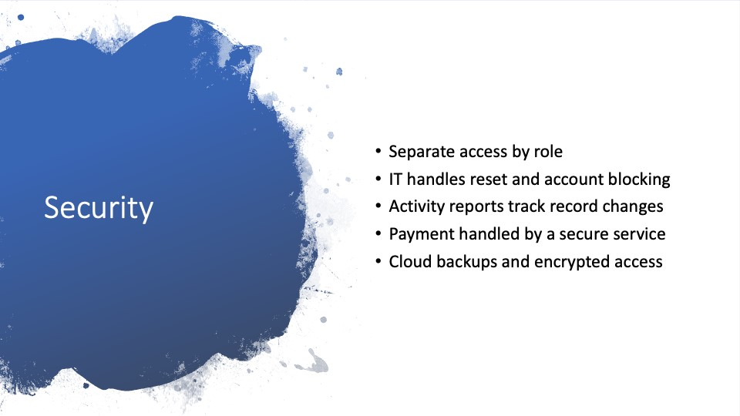
Security
•

•
•

•
•

Security is important because DriverPass stores customer information, reservations, payments, and staff records. My design gives each person access only to what they need. Customers can manage their own appointments and progress. Drivers can add lesson notes. The secretary can schedule appointments. The owner and IT officer have broader access for reports and account support. The activity report is also important because Liam wants to know who created, changed, or canceled a reservation. Payment information should be handled through a secure payment service so DriverPass does not store full credit card details in an unsafe way.
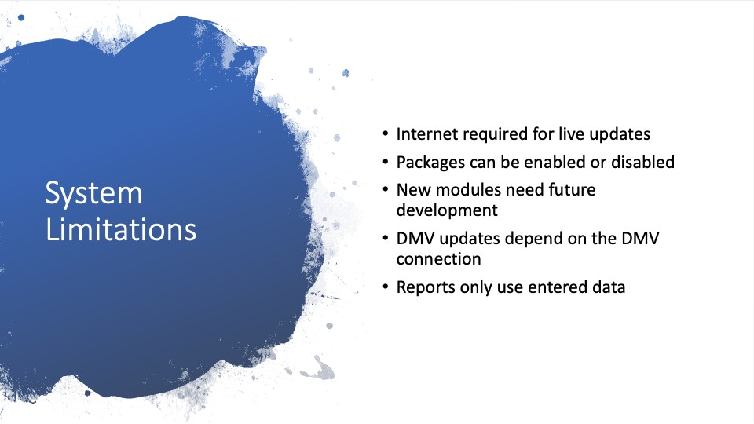
System
Limitations
•

•
•

•

•

The system has a few limits. DriverPass can view some downloaded information offline, but changes to live data need internet access so records do not get duplicated or out of sync. The owner can disable a package, but adding a brand-new type of training module would be a future update. DMV information also depends on the DMV connection being available and accurate. Reports are only as good as the information entered into the system. These limits are realistic for the first version and keep the project focused on the main needs DriverPass asked for first.

