CS 255 System Design Document
Andrew Robert
This document gives a simple design for the DriverPass system. The goal is to support customer accounts, lesson scheduling, online practice tests, reports, and secure staff access without making the design harder to understand than it needs to be.

UML Diagrams
The diagrams below describe the main parts of the system and how they connect. I kept the design focused on the client’s main needs: scheduling lessons, matching customers with drivers and cars, tracking progress, receiving DMV updates, and protecting user access.

UML Use Case Diagram
This diagram shows the main people and outside services that interact with DriverPass. Customers schedule lessons and take tests, staff manage appointments, drivers add notes, the owner reviews
reports, the IT officer manages access, and the DMV provides updates.
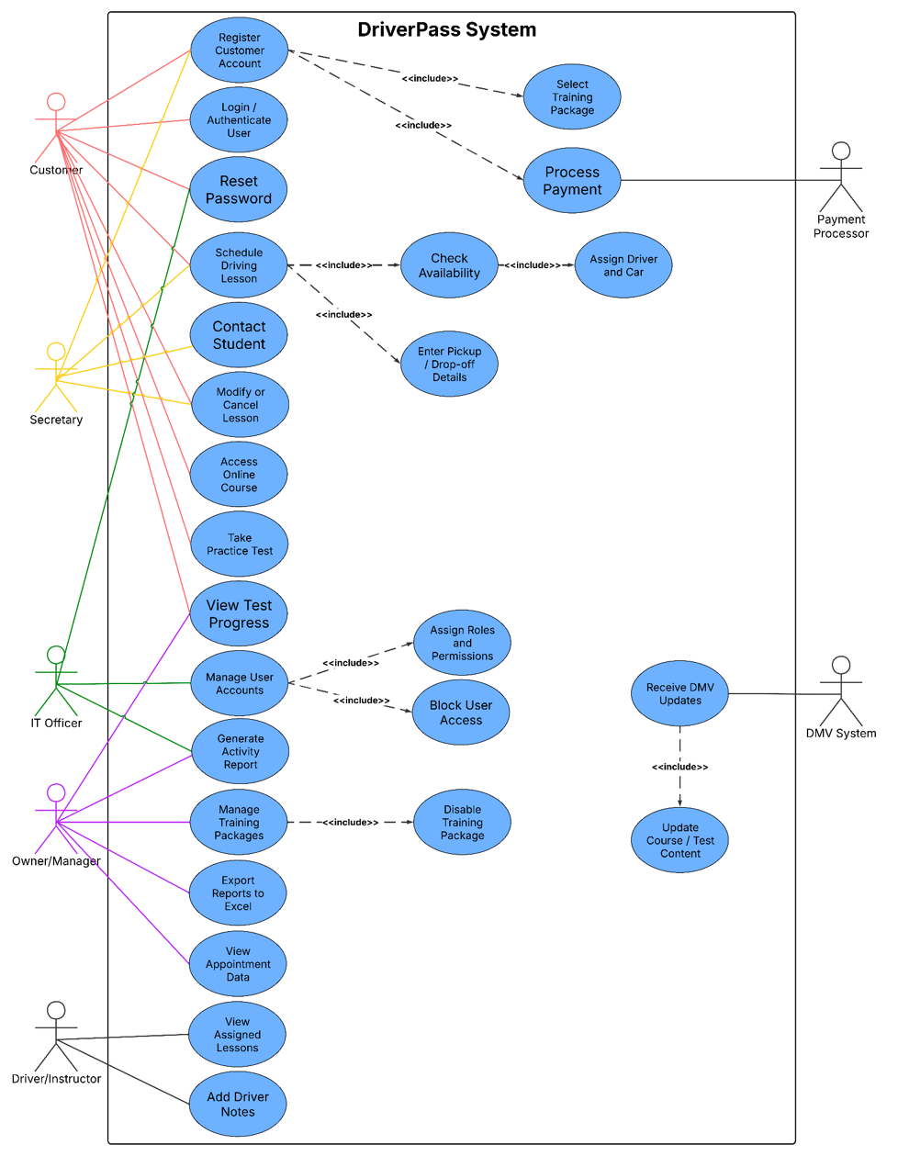

UML Activity Diagrams

This diagram breaks down the lesson scheduling process. It includes the normal path when a driver and car are available and the alternate path when the customer needs to choose another time.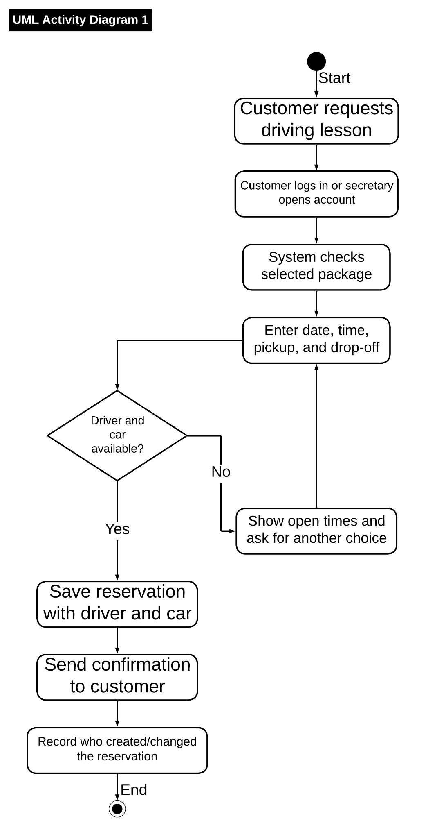
This diagram breaks down the practice test process. It checks whether the customer has online access, loads current DMV-based questions, scores the test, and updates the customer progress page.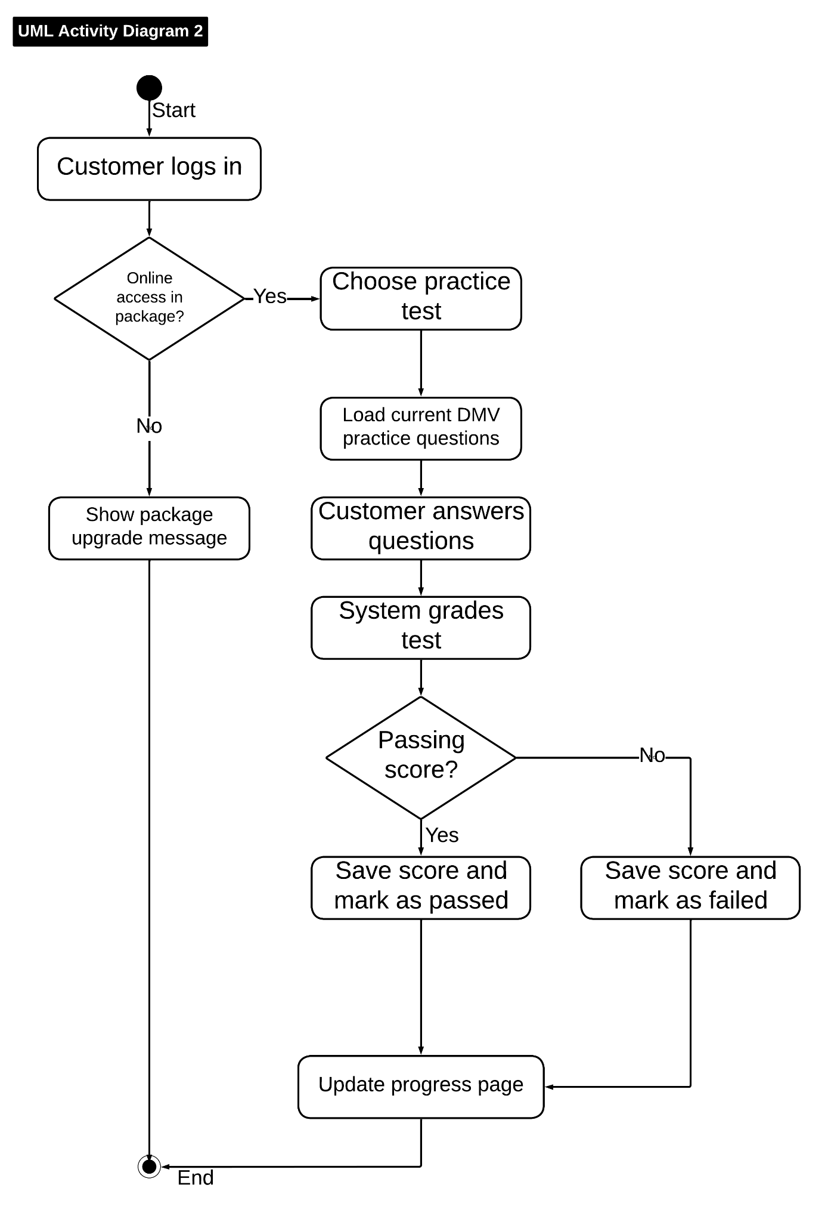

UML Sequence Diagram
This sequence diagram shows how the website checks access, checks the database for an open driver and car, saves the reservation, records the activity, and sends a confirmation.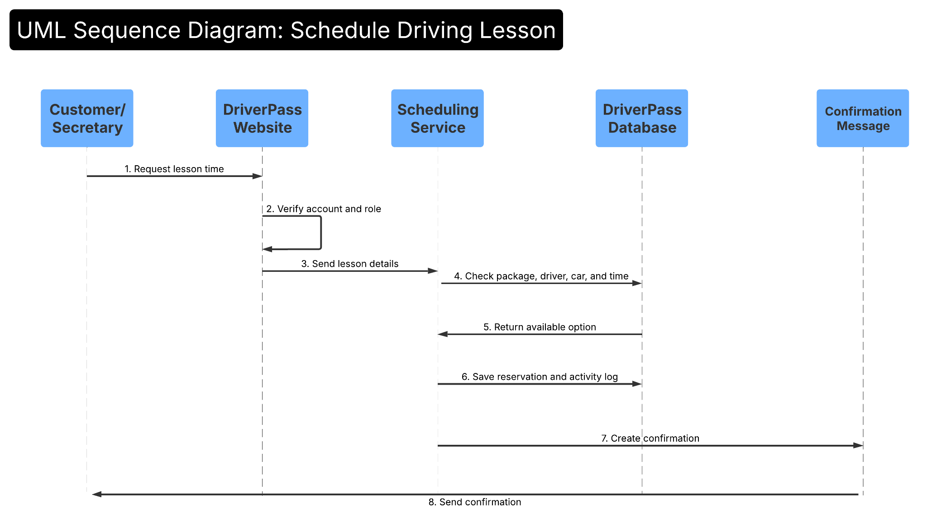

UML Class Diagram
This class diagram shows the main data the system needs to store. It connects customers, reservations, vehicles, drivers, packages, practice tests, payments, DMV updates, and activity logs.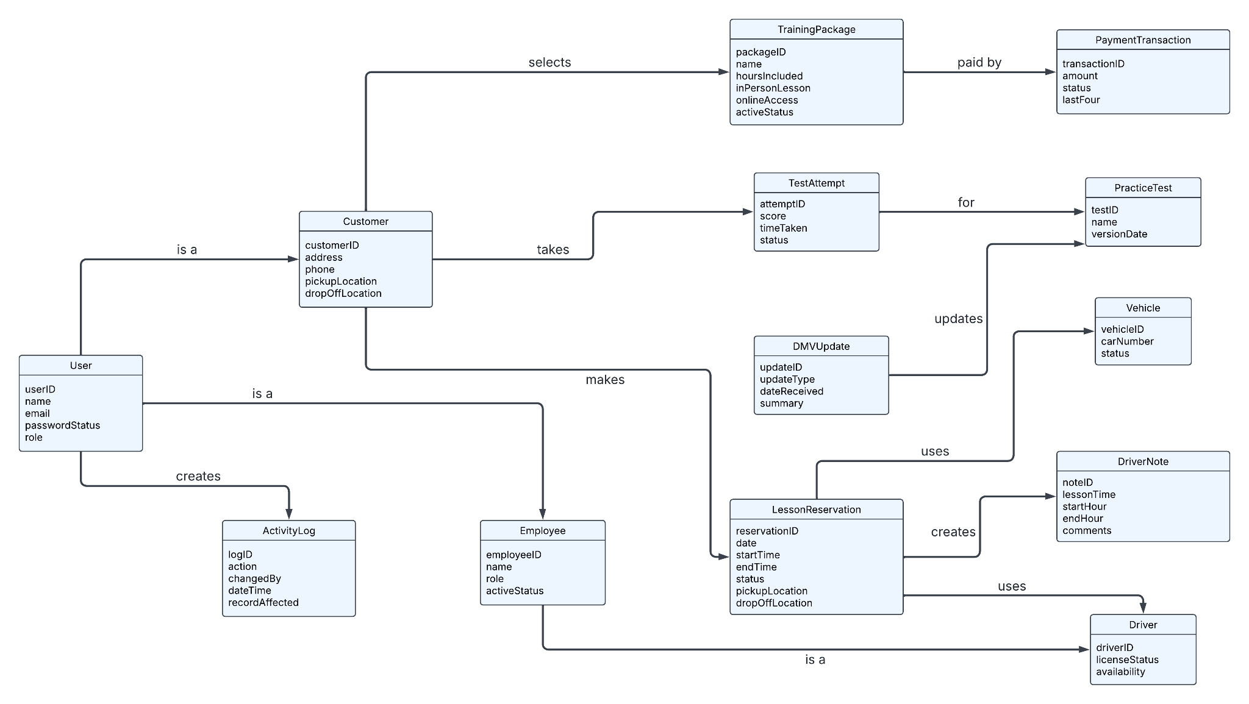

Technical Requirements
The technical requirements below are based on the DriverPass design and the client’s need for online access, scheduling, reports, security, and DMV updates.
Requirement Area | DriverPass Requirement
Hardware | Customers need phones, tablets, or computers with internet access. The office needs staff workstations, a printer for reports when needed, and reliable internet. Drivers may use a phone or tablet to review assigned lessons and add notes.
Software | DriverPass needs a web application with customer accounts, staff accounts, lesson scheduling, package management, practice tests, driver notes, reporting, and Excel export.
Database | The system needs a central database for customers, reservations, packages, vehicles, drivers, test progress, driver notes, DMV updates, payments, and activity logs.
Tools | The project should use a CASE tool such as Lucidchart for UML diagrams, a cloud development platform, a database tool, testing tools, and a reporting/export tool.
Infrastructure | The system should run on cloud hosting with managed backups, secure login, encrypted web traffic, role-based access, and regular updates. DriverPass should not have to manage servers on its own.
Security | The system must separate customer, secretary, driver, owner, and IT officer access. It should record who creates, changes, or cancels a reservation. Credit card handling should use a secure payment service instead of storing full card details in plain text.
External Connections | The system should connect with DMV content updates so practice tests and rules stay current. It should also connect with a payment service and a message service for confirmations.

Design Notes
- The schedule process supports both online reservations and reservations entered by the secretary.
- The design tracks the assigned driver, car, time, and pickup/drop-off location for each lesson.
- The online practice test area records the test name, time taken, score, and status so customers can see progress.
- The owner and IT officer can use activity reports to see who changed important records.
- The package design allows DriverPass to disable a package without deleting old customer history.

