Git – version control software whereby you can maintain multiple versions of your software, used for collaborating with others, also for deploying their code from their local machines to some staging server to some testing server and ultimately to production.
sudo apt install git
Version control (Git)
1 keeping track of different changes to your code
2 synchronizing code between different people
3 test your code without losing your original copy
4 revert back to old versions of your code

GitHub is just a website whose purpose in life is to store Git repositories on the internet
repository is just a fancy word for the place where we are going to keep track of all of your code and all of the changes to your code
Git commands:
git clone command has just one purpose. What it does is it takes a repository stored somewhere else like on some server like GitHub. And what happens is that when you run git clone followed by the URL of that GitHub repository, that remote version of your code will be downloaded onto your computer
rm -rf lecture0/ – to remove from PC
cd lecture0/ – to change current directory
ls – to list all files in that directory
touch <filename>– to create a brand new file
sublime_text . (Win) subl (Ubuntu)– to open redactor (this is name of exe file, must be environment variable?)
git add <filename>– basically means we're going to take some number of files, one or more files that we've changed and tell Git that these are files that we want to include the next time we make a commit
git add * – where a star just means add everything. And that will add all of the files that you have unsaved
git commit – fancy way of saying take a snapshot of the repository in the current moment and save it
git commit -m – m for message, and then in quotation marks some English message describing what it is that I've changed in this commit
git status – simple command that effectively just tells you what's currently going on in your repository
git push – push our code from our local computer to the repository that's stored somewhere on the internet. And so when we run git push, that causes those changes, whatever changes that we've made to our code locally to be pushed to the remote server so that GitHub is now able to keep track of those changes that we've made.
git pull – download the latest version of that repository
Merge conflicts – if you and another person have both made changes to the same lines of the same files you may run into a merge conflict, which is what happens when you try and run git pull
One is that anything between HEAD and all the equal signs are your changes. The things that you did on your computer before you tried to do the pull. Anything between these equal signs and the greater than signs here, these are the remote changes.

Whenever you make a commit in Git, Git represents that using a long hash. Just a long sequence of numbers and letters so that you can uniquely identify one commit out of a series in a history of commits
git log – If you run git log while you're inside of a Git repository, you'll see a list of all the different commits that have been made
git reset --hard <commit>– that will reset your whole repository back to that version, whichever version was marked by that commit hash
git reset --hard origin/master– fancy way of saying (reset to) the version of the repository that was the origin of this repository (where I got it from)
git commit -am – two commands into one simpler command where the a stands for add to both add files to the staging area and commit them all together in one command
git reflog - just a log of all of the different references that Git has kept track of; you can see all the different changes that are still there.
Branching is a method of moving into a new direction when creating a new feature, and only combining this new feature with the main part of your code, or the main branch, once you’re finished. This workflow will look more like the below graphic:

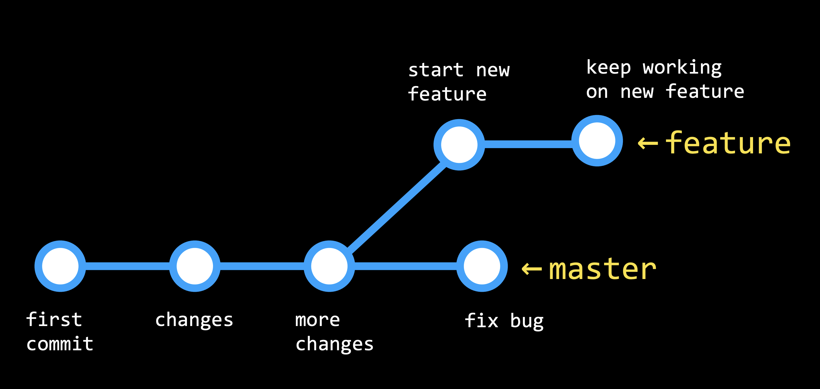

The branch you are currently looking at is determined by the HEAD, which points to one of the two branches. By default, the HEAD is pointed at the master branch, but we can check out other branches as well.
Now, let’s get into how we actually implement branching in our git repositories:
Run git branch to see which branch you’re currently working on, which will have an asterisk (star) to the left of its name
To make a new branch, we’ll run git checkout -b <new branch name>
Switch between branches using the command git checkout <branch name> and commit any changes to each branch.
When we’re ready to merge our two branches together, we’ll check out the branch we wish to keep (almost always the master branch) and then run the command git merge <other branch name>. This will be treated similarly to a push or pull, and merge conflicts may appear.
git push --set-upstream origin style – copy new branch (created locally) to github
Forking: As a GitHub user, you have the ability to fork any repository that you have access to, which creates a copy of the repository that you are the owner of. We do this by clicking the “Fork” button in the top-right.
Pull Requests: Once you’ve forked a repository and made some changes to your version, you may want to request that those changes be added to the main version of the repository.
And GitHub Pages is a feature of GitHub which effectively lets you take a GitHub repository and deploy it to the internet so that people online can look at the HTML contents of that web page.

HTML (HTML5)
HTML is a language we'll use to describe the structure of a web page. And CSS is the language we'll use to describe the style of a web page
<!DOCTYPE html> is placed at the start of an HTML file to indicate to the browser that HTML5 is being used
<html lang =”en”>
<br> - brake line
<img src = “/home/k0ct1/lecture0/kitty.jpg”>
src – html attribute (can be link) also attributes are height width alt(alternative text)
not all of the HTML tags require a beginning tag and an end tag, a start and an end because some things like images, it doesn't really make sense to say, OK, start the image and end the image and what goes in the middle. You're not going to type text in the middle of the image for instance. And so for tags like the image tag you don't need an end tag.
if I just say, height is 700 pixels but leave off the width for example and just say render it as a 700 pixel tall cat it will render to 700 pixels tall and adjust the width appropriately in order to match.
Width = 50%
if you start to think about how to make your web pages responsive to people using mobile phones or tablets or devices of different sizes, making sure that your content looks good both on a computer but also on smaller devices as well is very, very important nowadays as web applications become more and more useful on varieties of different platforms. And so techniques like that of using a percentage instead of a number of pixels to say I want this to only show up as 50% can often be a helpful tool to make sure that you have that dynamism, that responsiveness in your website to make sure that it's able to adapt accordingly.
anytime users can provide input to a web page, we generally call that a form, or some place where a user can fill out a form in order to provide information to the web page.
There are a number of different ways that users might provide input to a form. They might type in text. They might choose from a dropdown menu. They might choose from a radio button option. Or they might provide input as by clicking on a button, for example.
a new feature of HTML5, is something we might call a data list, where we might have the user choose in a dropdown from a number of different options.
<input name="country" list="countries" placeholder="Country">
<datalist id="countries">
<option value="Afghanistan">
<option value="Albania">
type of this input is password - our web browser will know not to actually display those individual characters.
<form>
<input type="password" placeholder="Full Name" name="name">
<button>Submit!</button>
</form>
like the image tag there is no end tag here. This is just going to be a place where users can input text and we need to tell the web browser what type of information the user is going to be inputting. In this case, we're saying the type of that information is just going to be text. And we're specifying a couple of other optional attributes that give additional information to this form
a button to click on. That's created just by using a button tag. And the name of this button is going to be Submit
Submit button is a button that would theoretically submit that form. Now, this form doesn't yet do anything because we haven't hooked it up. We haven't told the form what to do after someone clicks on the Submit button
</html>
CSS (CSS3)
<body>
<h1 style="color:green;text-align:right;">Hello, world!</h1>
</body>
style - attribute
two CSS properties
CSS property is just some specific style property that the browser is going to understand and render in a particular way.
You could move the styling information, move this style attribute, change it from the h1 and escalating it to this body. And if I move the style to the body, then everything inside of the body is going to be styled in that way.

here is how CSS should style any h2 that it finds:
<head>
<style>
h2 {
color:#28b5bd;
text-align:center;
}
</style>
</head>

just create a new file, call it styles.css, inside of which is going to be all of the CSS that you care about.
<link rel="stylesheet" href="styles.css">

here is inside the body I have a div. And a div just basically means a division of my code. Some section of my code that doesn't really have any real formal meaning. It's just a section of my code that I want to do something with, maybe style in a particular way. And here's a style I've applied to it.
<head>
<style>
div {
background-color: teal;
width: 300px;
height: 100px;
margin: 30px;
padding: 20px;
font-family: Arial, sans-serif;
font-size: 28px;
font-weight: bold;
border: 5px dotted red;
}
</style>
</head>
set the margin of the div to be 30 pixels, now we see that Goodbye! has a margin around it. It's got this sort of 30 pixel invisible border that's surrounding it. And it helps to space that out from different elements.
And so margin and padding are both used in order to control spacing. But the key difference is that the margin of an element is the space outside of the border of the element and the padding is the space between the content of the element and that elements border.
So there are two ways that we've added spacing thus far in this course where margins are around the outside of the box and paddings on the inside of the box.
the web browser will first try and match the first font that I provide. It will try and use the font Arial if at all possible. But if it doesn't have the font Arial, if the web browser doesn't know what Arial is or can't find that font, it's just going to default to any sans serif font. And so oftentimes if you want to use fancier fonts on a web page it can be a good idea to include the font that you want, but after that some additional more common fonts that might be more common in other browsers on older browsers in particular that way you can guarantee, or at least know with high probability that when a user looks at your page they're seeing what it is that you actually want them to be looking at.
<head>
<style>
table {
border: 2px solid black;
border-collapse: collapse;
width: 50%;
text-align: center;
}
th, td {
border: 1px solid black;
padding: 5px;
}
th {
background-color: lightgrey;
}
</style>
</head>
CSS selectors — th, td
if we need some way to uniquely reference this particular HTML element, we can given HTML element an ID. An ID is just some unique name we give to an HTML element, so that we can reference it more easily later on.

The divs and span tags really don't do anything at all, but they allow us to label different parts of our page. I can say div and then give this an id, where an id is just an attribute that uniquely identifies a section of my web page via a name that I give it.
if the pound sign (#) means id the dot sign in CSS means class.
So dot name means take anything whose class is name and style it in this particular way.
And these names they're all styled in this particular way because they were inside of spans that had a class of name.
<head>
<style>
#top {
font-size: 12px;
}
.name {
font-weight: lighter;
}
</style>
</head>
<body>
<div id="top">
This is the <span class="name">top</span> of my web page.
</div>
</body>
You can use id's in class attributes on any HTML element. So I could have put a class on the div. I could have put an id on the span. id and class are just two different ways of identifying HTML elements in a style sheet, for instance, or using JavaScript as we'll soon see later. The only difference is that an id must be unique. if you want to style one thing in just one part of the web page you use an id, but if you want to style a bunch of different things you'll use a class.
what happens if there are conflicts - CSS will default to picking the more specific thing: the name is more local to it, because it's part of that span that's deeper within the tree
specificity goes in a particular order
So in short, the type ( h1, ordered list, table) is the least specific. Class is slightly more specific. ID is more than that. And the most specificity we can provide is by literally putting the CSS inline with the HTML element itself.
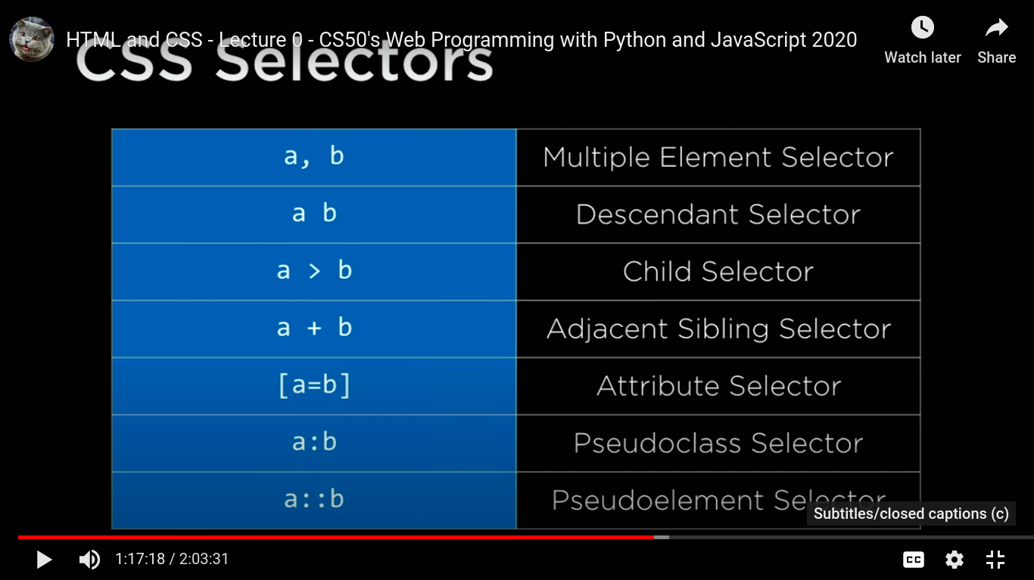

descendent selector is used to select all of the elements that are descendants of some other element
ul > li
greater than symbol here is specifying immediate children. I could get rid of it, ul li, like this, and this would also work. You still see sublist item 1 and 2. But this is a more general selector called the descendent selector that selects all descendant elements. So they might not be the children elements. They might be grandchildren element, so to speak, if those children elements have other children that are attached to them as well.
<style>
a[href="https://facebook.com"] {
color: red;
}
</style>
this square bracket notation I can use to specify a particular attribute of an HTML element.

Responsive design
1. viewport is the visual part of the screen that the user can actually see.
By default, many phones will use a viewport that's actually wider than the width of the device, treat it as if they're loading a page in a computer, and then shrinking it down to the size of a mobile device. If you and your web page specify, though, that you want the viewport to be just the device width, oftentimes a page is going to look a whole lot better on a mobile device.
<meta name=”viewport” content=”width=device-width, initial-scale=1.0”
2. Media queries are all about controlling how our page is going to look depending on how we render that particular page, or what size screen we're rendering that page on.
if the size of the screen is a certain width, then I want to style the page in one way. And if the size of the page is a different width, then I might want to style the page in a different way. You might imagine that as you shrink the screen you want to move elements around in order to rearrange them to make the page just look a little bit nicer on a mobile screen.
@media (min-width: 500px) {
body {
background-color: red;
}
}

@media (max-width: 499px) {
body {
background-color: blue;
}
}
3. flexbox is quite helpful if we have multiple elements that we're all trying to display on the same page at the same time that might overflow if we're not careful about how we do responsive design.
4. grid

Bootstrap was a very popular CSS library that we can use in order to use some styling that they have written, such that we don't need to write all the styling from scratch.
Sass is a language that is essentially an extension to CSS.
And one of the key features of Sass is the ability to have variables.
Sass is a different language, though. So it's going to require a different extension. We're going to conventionally use dot scss to stand for this is a Sass file.
In Sass, all variables begin with a dollar sign.
Chrome and Safari and Firefox can't by default understand SCSS, or Sass. So in order to solve this problem, once we've written our Sass file, we need to compile it, convert it, translate it, so to speak, from Sass into plain old CSS so that our browser is able to understand it.
in order to do this, you'll need to install a program called Sass on your computer.
I'm going to say Sass variables.scss, the file I'd like to compile, colon variables.css.
I changed the Sass file. But that doesn't automatically change the CSS file. I need to now recompile the CSS file by saying Sass variables.scss variables.css, to compile the file again using the updated Sass file.
Now, in practice, it's going to be pretty annoying if I'm building a web page, building using Sass, if I constantly need to go back and recompile my Sass into CSS every single time. What I'd like to do is just automate that process.
I can just say, Sass dash dash watch variables.scss variables.css. And what that's going to do is now you see Sass is watching for changes.
Sass gives us the ability to do, one of them is the ability to nest CSS selectors inside of other CSS selectors.
by @extend %message what I mean is that anything with a class of .success is going to inherit all of these CSS properties

Java Script (ES6 or ECMAScript 6)
how we can use JavaScript to run in users' web browsers to make web pages just a little bit more interactive. In particular, we'll use JavaScript in the context of user interfaces, looking at modern user interfaces and exploring how it is that those interfaces work and how we can develop those user interfaces with a combination of Python and JavaScript.

toolchain, something called SAS that allows you to programmatically generate and maintain more readily, more complicated style sheets especially as your web apps become themselves more complicate
Flask a very popular framework for making web based applications using Python

API
Front Ends, the idea of actually building a front end user interface using JavaScript, techniques like Ajax or SPAs (single page applications)
heavier weight framework something known as Django
Django is a web programming framework written in the Python programming language that we're going to use to make it easy to design and develop our web applications Django in particular makes it easy to design web applications that interact with data.
SQL, or structured query language with which you can query databases and store your actual data
SQL is a language that we can use to interact with databases, in particular looking at how Django allows us to use models and migrations to interact with data and allow users to interact with data all the more easily.

Testing - DevOps, development and operations kind of united in one
CI/CD continuous integration and continuous delivery, which is just a fancy way of saying setting yourself up for success with the right tools and with the right scripts, the right environments so that when you run a command on your laptop or desktop the code actually goes somewhere and it goes not only into a code repository to be saved and versioned and shared with other people, but you can test it automatically and continuously so to speak. And you can even deploy it to the cloud simply by having set up some of those steps in advance.
Scalability. So topics like DNS and load balancing and how you think about anticipating that 101st user that might not fit on just one server
Security

