Sprint Report 4 - Nov 17th - Please Help Me App

Tiago Cruz - MAM 17 - tiago.cruz@yale.edu

Marco di Mare - MAM 17 - marco.dimare@yale.edu

**Burndown chart**

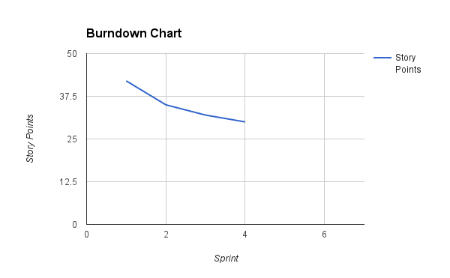

**Previous sprint:**

* Built index.html and subscribe.htm. However, project changed to use the Express framework with Node.js. We were able to get the application running in Heroku but Cloud9 fails to launch it on its own environment, preventing us to continue developing. Hours were spent trying to identify the problem with Express to get it up and running to no avail.
* As such we have decided to switch the Framework completely to PHP, which has an easier technological configuration for the group members to start from 0.

**Next sprint (Nov 18th to Nov 23rd)::**

* Switch environment from Node.js to PHP.
* Re-code index and database connection using PHP.
* Finish story 1..

**Product backlog:**

|  |  |  |  |  |  |  |  |  |  |
| --- | --- | --- | --- | --- | --- | --- | --- | --- | --- |
| **Story ID** | **StoryName** | **Status** | **Size** | **Sprint** | **Priority** | **Comments** | **Checked by** | **Completed** | **Date Completed** |
| **1** | **Student wants to register** | **Ongoing** | **16** | **3** | **1** | **This is the main story that allows a student to register to the site** |  |  |  |
| **1** | **Database setup to receive and retrieve student info** | **Ongoing** | **5** | **3** | **1** |  | **TIago Cruz** | **Yes** | **09-11-2016** |
| **1** | **Build HTML welcome screen** | **Paused** | **2** | **3** | **1** | **HTML must have a LOGIN/Register option** | **Marco** | **Partial** |  |
| **1** | **Build HTML Student Register page** | **Paused** | **3** | **3** | **1** | **Page must write to databse, name, email. photo, phonenumber** | **Tiago Cruz** | **Partial** |  |
| **1** | **Build HTML Student Login Page** | **Paused** | **3** | **3** | **1** | **Page must confirm with database if student is registered and send to new page after login. Must also create a session for the student to be loggedi n** | **Marco** |  |  |
| **1** | **Build HTML Student Profile Page** | **Paused** | **3** | **3** | **1** | **Must have name, photo, phone number, email** |  |  |  |

**Reference:**

Github url: <https://github.com/truemadman/please-help-me.git>

Personas, stories and DB Schema:<https://docs.google.com/spreadsheets/d/1zPfMpR8Nx-7uMFE6uENHy7XS6vDk3GaZVPLXitp2ciU/edit?usp=sharing>

Heroku App Link: <https://please-help-me.herokuapp.com/>