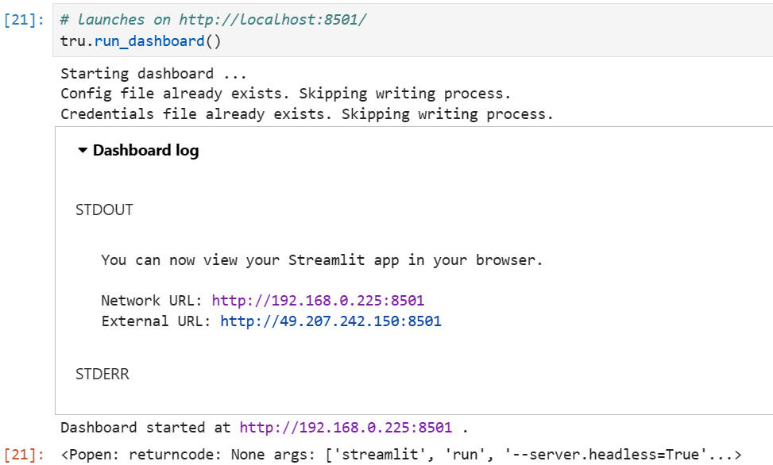
The above screenshot is before clicking URL.
When clicked on ‘http://192.168.0.225:8501’ new tab is opened and Below screenshot shows blank tab.
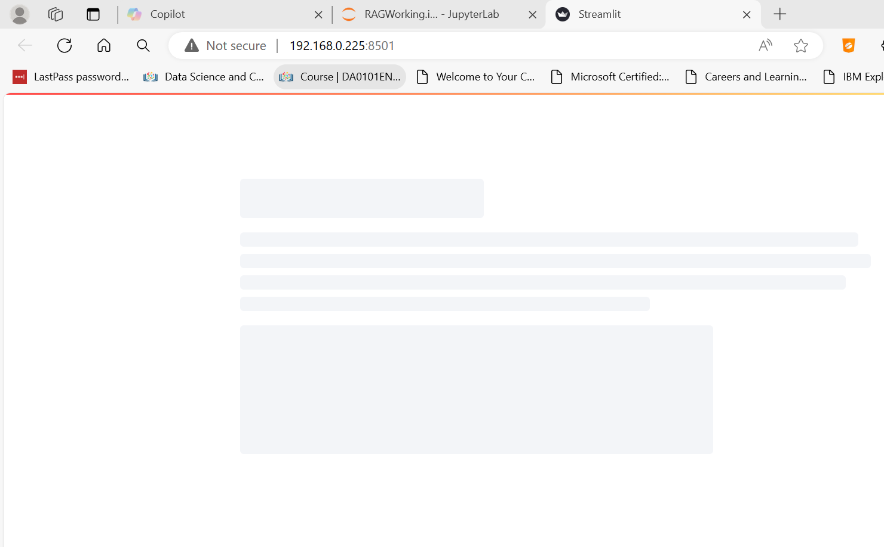
Now we can see error:
