Cyberthon
Summer 2025
August 7th, 2025
Team 1
Mohammad Ahmad
Ibrahim Shatah

Contents
Executive Summary 3
Tools Used 3
Methodology 4
Findings and Risk Assessment 8
Mitigations 9
Screenshots 10
Conclusion 20

Executive Summary
Digital Center of Excellence (CLIENT) engaged Team NCSA to carry out a thorough penetration test against the security controls of the provided Metasploitable Linux machine in order to demonstrate the methods by which security vulnerabilities are discovered, and exploited, and how CLIENT can take preventive measures to ensure proper mitigations are in place which may significantly reduce the security risk of the provided system.
The environment of the system provided by CLIENT contains a concerning amount of vulnerabilities, including critical security flaws such as the vsFTPd or Bind Shell backdoors, which may result in malicious users gaining root access to the system, as well as the usage of SSL 2.0/3.0 which allow an attacker to conduct man-in-middle attacks.

Tools Used
The following tools were used for the purposes of our vulnerability investigation:
- nmap – network mapping tool to scan a network and list various details
- Metasploit – open-source framework used for penetration testing and vulnerability research
- Nessus – vulnerability scanner used to identify security weaknesses in various technologies
- xtightvncviewer – client application which allows users to interact with desktops remotely as if they were physically present
- Netcat/nc – utility that uses TCP/UDP connections to read/write in a network

Methodology
The methodology of our testing can be split into three distinct phases. Please refer to the Screenshots section for visual showcases of each command/tool used and its output respectively.
Phase 1
Network Reconnaissance – In this phase we first scan the network to discover our target host, in this case the Metasploitable Linux machine , through the various commands provided by the ‘nmap’ tool. Once the host is discovered, we get further information regarding the services available, open ports, and exploitable vulnerabilities using ‘nmap’ as well. This information will be useful for the following phases.
Tools
nmap
Steps
- Network Scan: Ensure the CLIENT machine and our testing machine are on the same network by using the ‘ip a’ command on both terminals. Once this is established, proceed to note down the network IP address.
Bash (target and tester):
ip a
Result: Network IP address obtained.
- Nmap Recon: Confirm that CLIENTs system is on the network using the ‘nmap’ tool on the pen tester machine (note down the target’s IP address as well). After this is confirmed, further run a full service scan using ‘nmap’ to obtain information regarding the open services and their ports on the target machine using the obtained address. Results can be found in Figures 1, 2 & 3.
Bash:
nmap -sP <network address>
nmap -sS -p -T4 <CLIENTs system IPv4 address>
nmap -sV -O <CLIENTs system IPv4 address>
Result: Details of the open services and their ports found on the target machine obtained.
- Nmap Vulnerability Scan: Gain a detailed report of potential vulnerabilities found on the target machine using the various vulnerability detection scripts provided by ‘nmap’. This information will be used for cross-checking and confirming the presence of vulnerabilities before we attempt exploitation. Results can be seen in Figures 4.0, 4.1, 4.2 & 4.3.
Bash:
nmap --script vuln <CLIENTs system IPv4 address>
Result: Various details about the vulnerabilities found on the open ports and running services on the target machine.
Phase 2
Nessus Scanning – In this phase, the tester machine utilizes Nessus in order to get a detailed scan of the target system. After launching Nessus, we run the Basic Network Scan in order to get a detailed report of all vulnerabilities present on CLIENTs system. We use the information found in our ‘nmap’ vulnerability scan in the prior phase to cross-check with our Nessus findings if a vulnerability is truly present in CLIENTs system.
Tools
Nessus
Steps
- Nessus Scan Execution: Start a Basic Network Scan on CLIENTs environment using its IPv4 address on the pen tester machine.
- Findings Summary: 9 security vulnerabilities of critical risk level, 5 of high risk level, 23 with medium and 8 with low risk levels (all with detailed information available in the Nessus scan report). Results can be found in Figures 5.0 & 5.1.
Result: Scan completed in 30 minutes.

Phase 3
Exploiting Discovered Vulnerabilities – In this phase, we launch various attacks on CLIENTs system to demonstrate the security breaching in action. The process varies depending on the vulnerability. The focus is on some of the critical and high-level vulnerabilities found by Nessus in the previous phase, as well as an additional vulnerability found by ‘nmap’ known as the vsFTPd backdoor. It should be noted that not all found vulnerabilities were exploited in this case.
Tools
Metasploit, xtightvncviewer, netcat
Note: Some of the following require the usage of the Metasploit console and are prefixed with ‘(M)’, access it using ‘msfconsole’ in the terminal. (Optional) Run a port scan using the following set of commands:
use auxiliary/scanner/portscan/tcp
set RHOSTS <CLIENTs system IPv4 address>
run

(M) vsFTPd Backdoor (Critical)
Steps
- (Optional) Search for the vsFTPd backdoor exploit.
msfconsole:
search vsftpd
- Run the vsFTPd backdoor exploit (ensure the host is set as the CLIENTs system).
msfconsole:
use exploit/unix/ftp/vsFTPd_234_backdoor (or ‘use 1’ if searched from the previous step)
set RHOSTS <CLIENTs system IPv4 address>
run
Result: CLIENTs system’s root access is compromised by the pen tester system.

VNC Server ‘password’ Password (Critical)
This security vulnerability allows potential remote access to easily compromise root access to CLIENTs system by establishing a VNC connection. The password is configured to be ‘password’ which is default and is easy to get past.
Steps
- Run the xtightvncviewer with the CLIENTs system IPv4 address along with the port at which the VNC service is running.
Bash:
xtightvncviewer <CLIENTs system IPv4 address>:<VNC service port>
(enter ‘password’ as the requested password)
Result: CLIENTs system’s root access is compromised by the pen tester system as the pen tester system is now connected remotely.
Bind Shell Backdoor (Critical)
This security vulnerability allows potential remote access to easily compromise root access to CLIENTs system by using various payloads to get it to open a port and listen for connections, for simplicity’s sake we have chosen to use ‘netcat’. There is no password nor any form of authentication in place to prevent this connection, so the attacker is able to establish this connection with no effort.
Steps
- Use ‘netcat’ to establish a connection with CLIENTs system on the port at which the Bind Shell service is running.
Bash:
nc <CLIENTs system IPv4 address> <port of Bind Shell service>
Result: CLIENTs system’s root access is compromised by the pen tester system as the pen tester system is now connected remotely.

Findings and Risk Assessment
The results and risk analysis of our test run have been compiled in the table below.
Vulnerability | Port/Service | Tools Used | CVE | Risk Level | Figure Ref.
vsFTPd Backdoor | 21/ftp | Nmap/Metasploit | CVE-2011-2523 | Critical | 6.0, 6.1, 6.2
Canonical Ubuntu Linux 8.04.x | 80/tcp/www | Nessus | CVE-2021-3493, CVE-2015-1328, CVE-2015-8660… (See details here.) | Critical | N/A
VNC Server ‘password’ Password | 5900/tcp/vnc | Nessus/xtightvncviewer | N/A | Critical | 7.0, 7.1
SSL Version 2 & 3 Protocol Detection | 25/tcp/smtp  5432/tcp/postgresql | Nessus | CVE-2014-3566 | Critical | N/A
Apache Tomcat AJP Connector Request Injection | 8009/tcp/ajp13 | Nessus | CVE-2020-1745, CVE-2020-1938 | Critical | N/A
Bind Shell Backdoor Detection | 1524/tcp/wild_shell | Nmap/Nessus/netcat | N/A | Critical | 8.0, 8.1
Debian OpenSSH/OpenSSL Package Random Number Generation Weakness | 5432/tcp/postgresql  25/tcp/smtp  22/tcp/ssh | Nessus | CVE-2008-0166 | Critical | N/A
Samba Badlock Vulnerability | 445/tcp/cifs | Nmap/Nessus | CVE-2016-2118 | High | N/A
Table 1 – Findings & Risk Assessment

Mitigations
Based on our findings, we recommend the following mitigation measures which should be considered immediately to ensure the safety of CLIENTs system environment.
Vulnerability | Mitigation
vsFTPd Backdoor | Uninstall vsFTPd 2.3.4 and install secure version; add firewall rule to restrict port 21
Canonical Ubuntu Linux 8.04.x | Upgrade to a version of Canonical Ubuntu Linux that is currently supported with latest patches that offer greater security
VNC Server ‘password’ Password | Secure the VNC service with a strong password or disable the service if not needed
SSL Version 2 & 3 Protocol Detection | Consult application documentation to disable SSL 2.0 and 3.0, use TLS 1.2 or higher instead
Apache Tomcat AJP Connector Request Injection | Update the AJP configuration to require authorization and/or upgrade the Tomcat server to 7.0.100, 8.5.51, 9.0.31 or later
Bind Shell Backdoor Detection | Verify if host has been compromised and reinstall system if necessary; disable service if not in use, otherwise secure with strong password. Add firewall rule to restrict port 1524
Debian OpenSSH/OpenSSL Package Random Number Generation Weakness | All previously generated cryptographic material on remote host is guessable; all SSH, SSL and OpenVPN key material must be regenerated
Samba Badlock Vulnerability | Upgrade to Samba version 4.2.11 / 4.3.8 / 4.4.2 or later
Table 2 – Mitigations

Screenshots
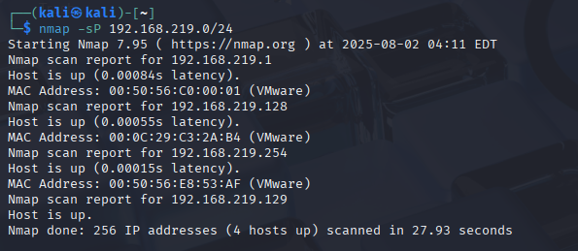
Figure 1 – Network scan via nmap
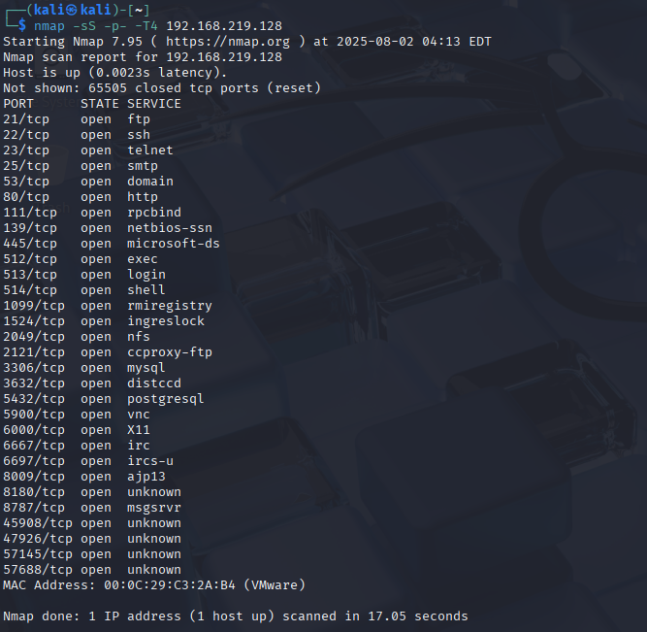
Figure 2 – Full port scan of CLIENTs system using nmap
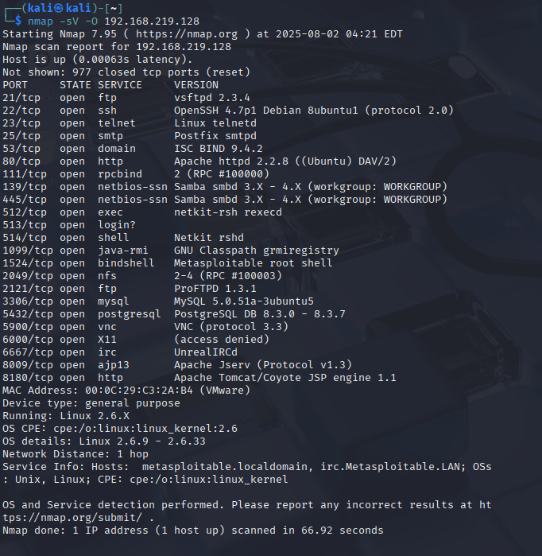
Figure 3 – Full service version scan of CLIENTs system using nmap
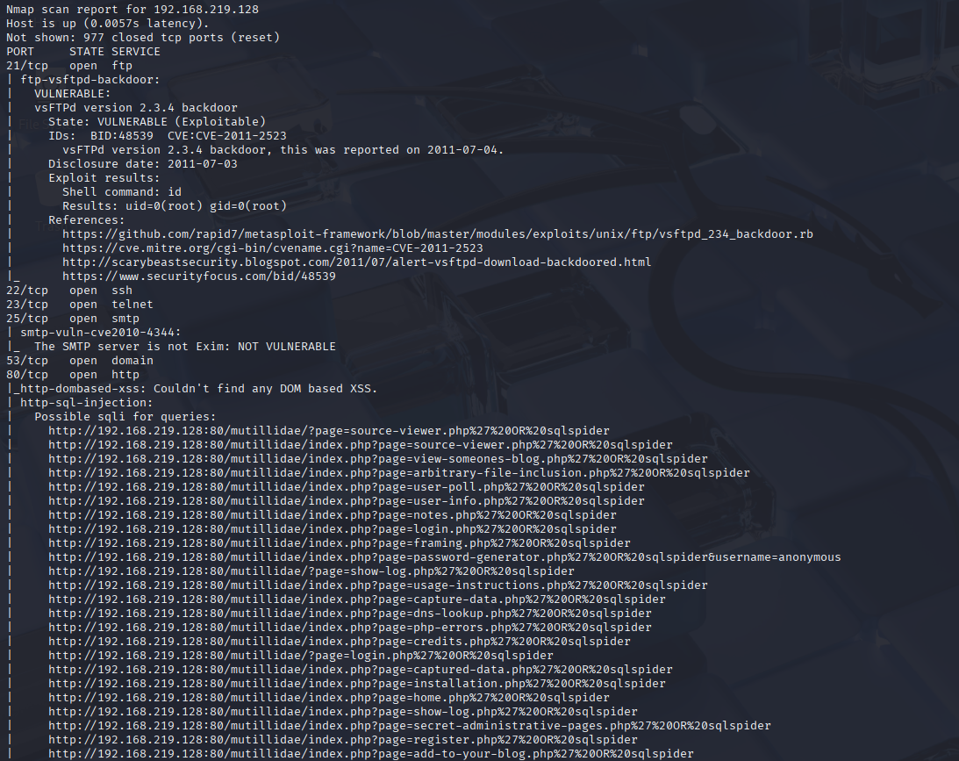
Figure 4.0 – Vulnerability scan using nmap
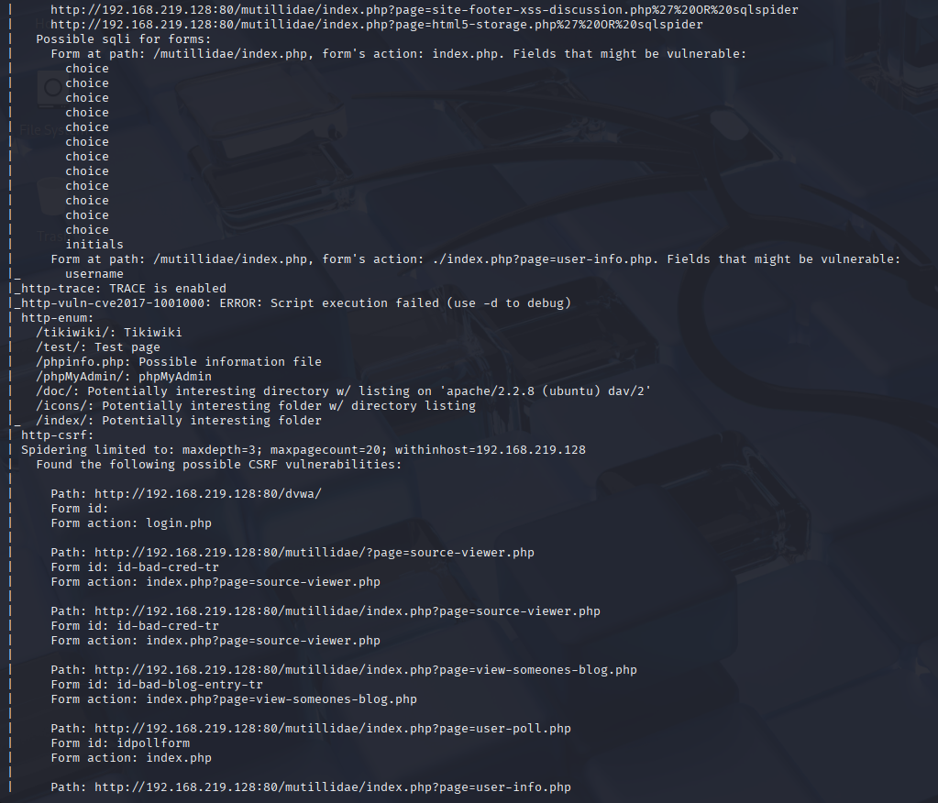
Figure 4.1 – Further vulnerability scan information via nmap
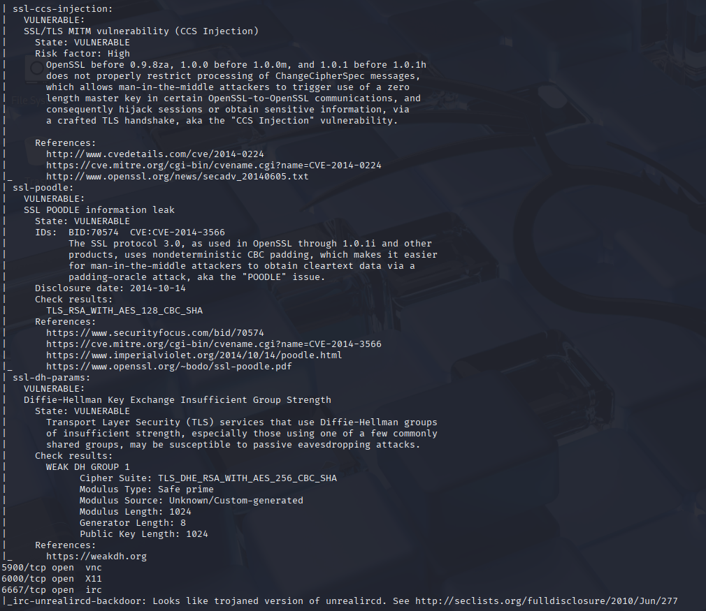
Figure 4.2 – Even more vulnerability scan information via nmap
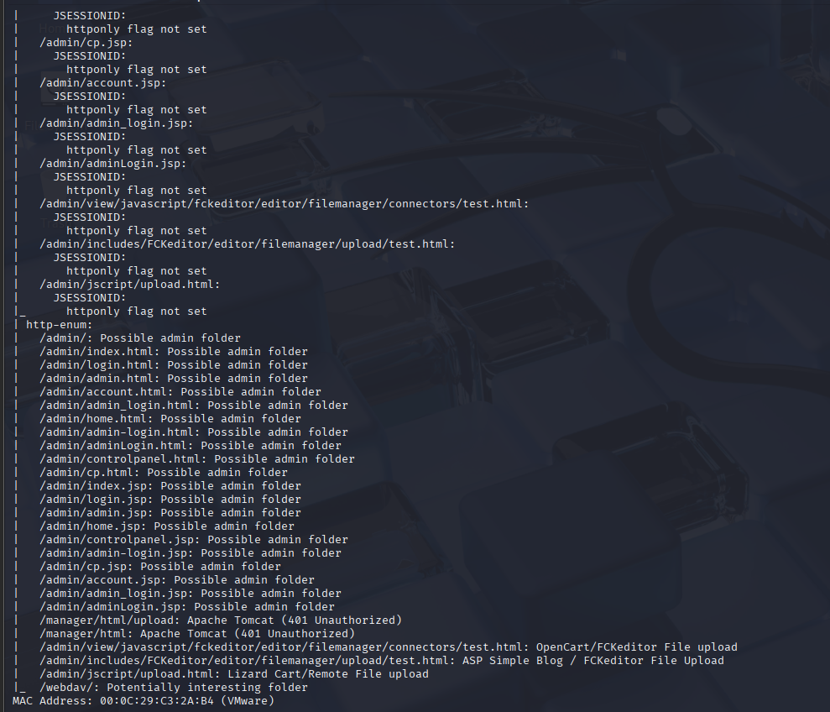
Figure 4.3 – Last of the vulnerability scan information from nmap
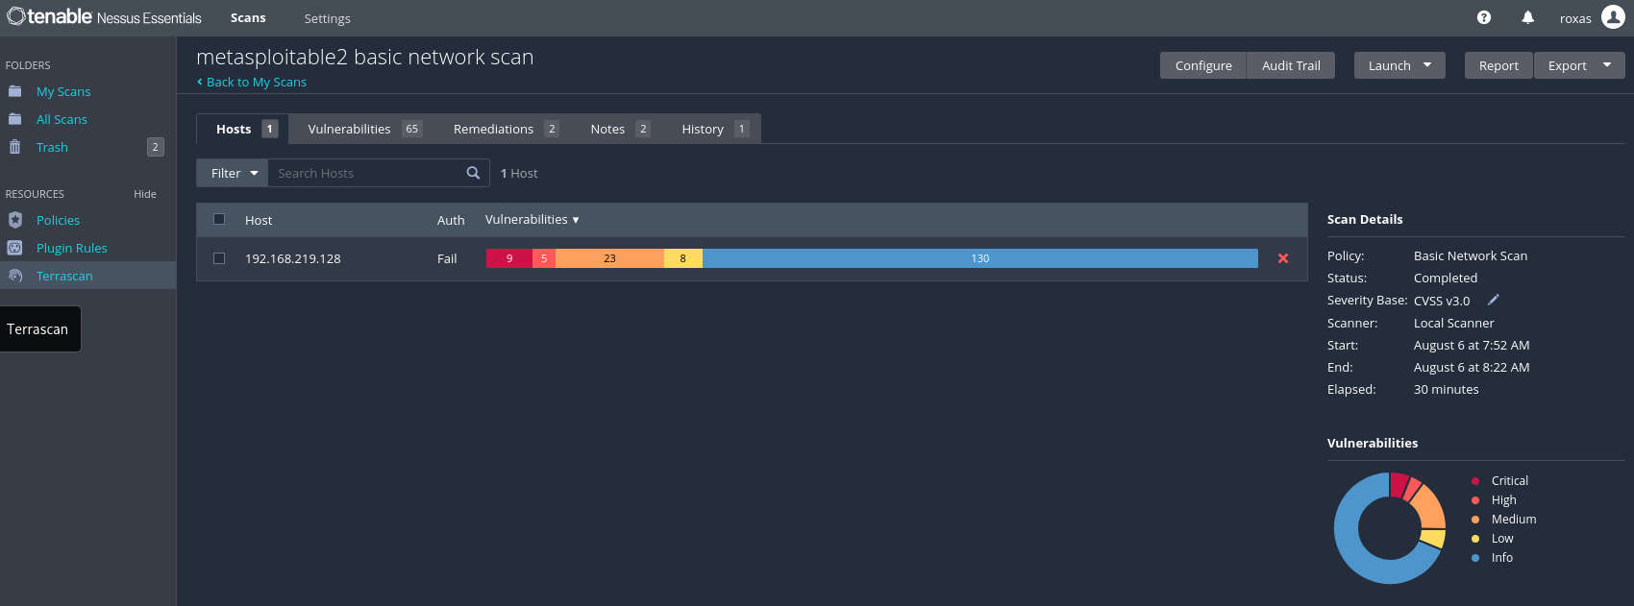
Figure 5.0 – Nessus scan, summary
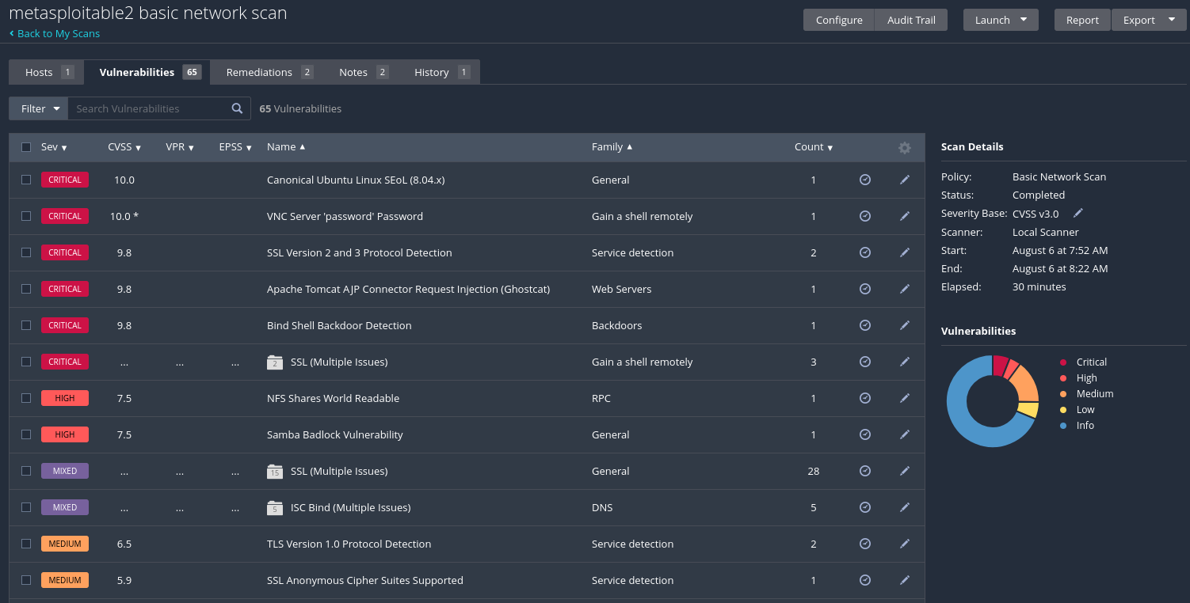
Figure 5.1 – Nessus scan, further details
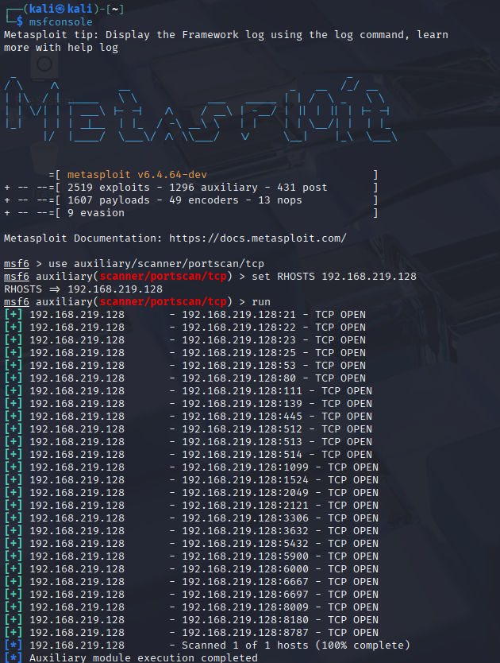
Figure 6.0 – Port scan
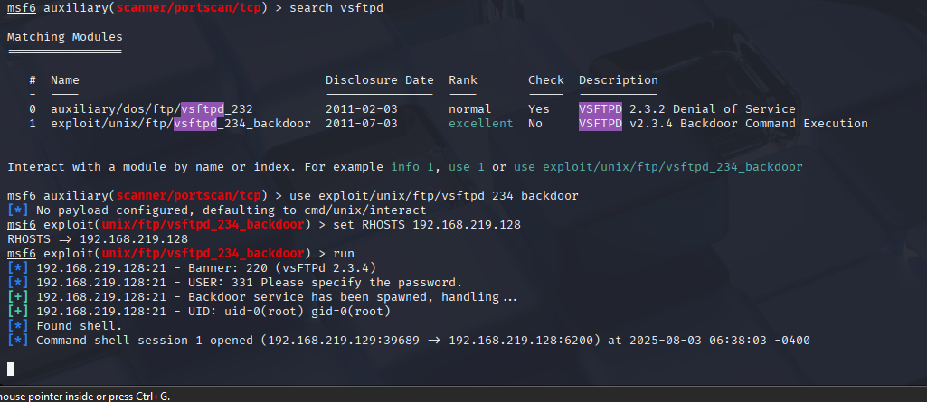
Figure 6.1 – Exploit successful
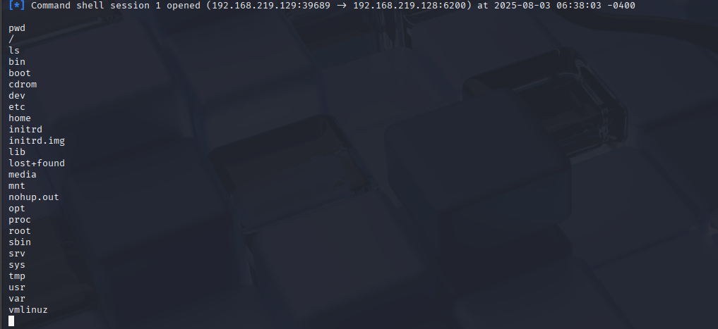
Figure 6.2 – System compromised
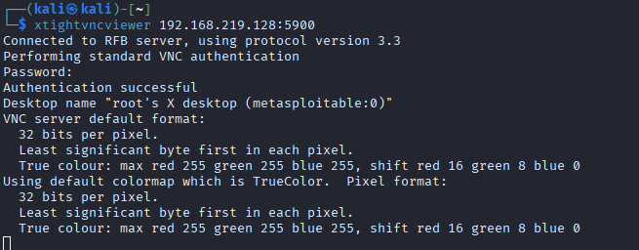
Figure 7.0 – xtightvncviewer command execution
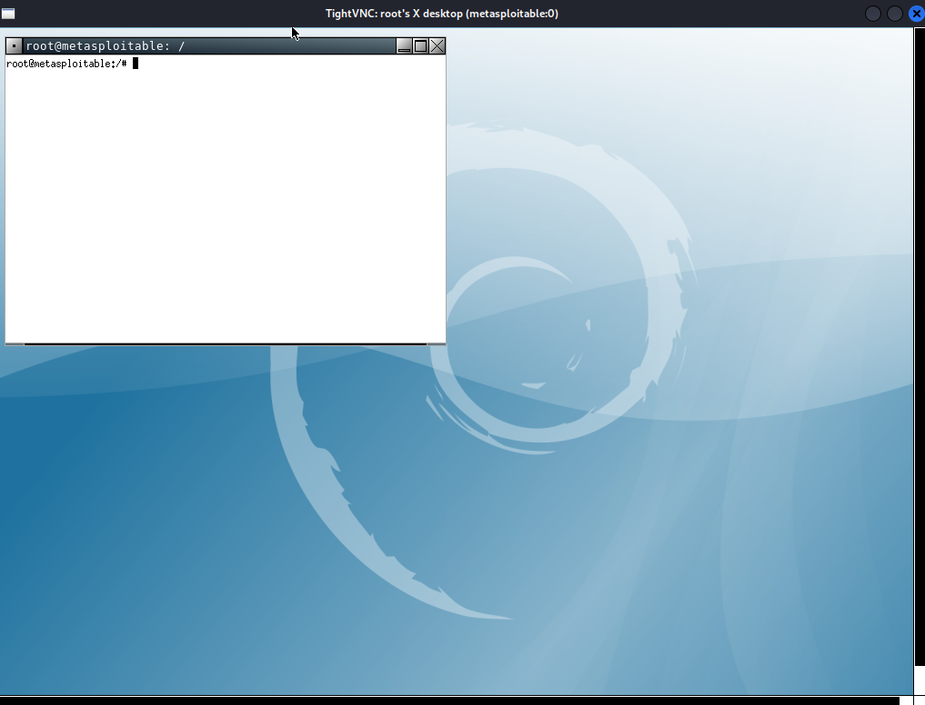
Figure 7.1 – Remote access to system established at root level
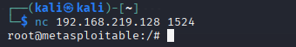
Figure 8.0 – Connection to system established at root level
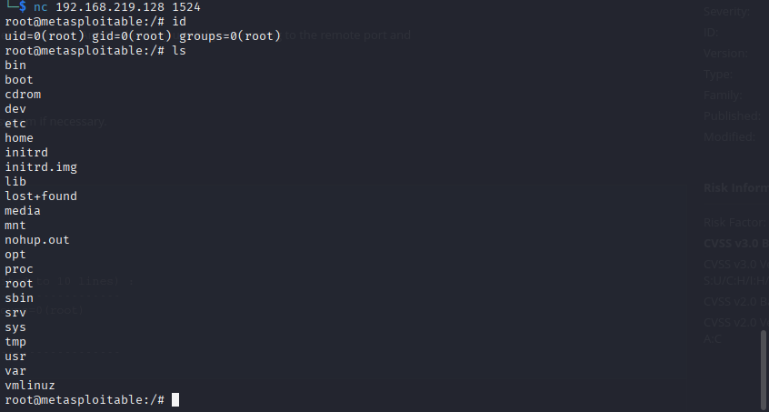
Figure 8.1 – Root compromised

Conclusion
CLIENTs system environment is critically vulnerable with multiple routes that allow root access to it such as the vsFTPd and bind shell backdoors, weakly secured VNC server also allows for the same. Along with various different outdated software and services and weak cryptographic protocols, the environment is easily breach-able for attackers.

