Qatar University
Network Penetration
Spring 2025
CMPS380 - L01
Cybersecurity Fundamentals
Dr. Khaled Khan
April 17th, 2025
Group 32
Mohammad Ahmad | 202002453 | 25%
Taim Naamah | 202211566 | 25%
Mostafa Youssef | 202106932 | 25%
Mohammed Alsayegh | 202006031 | 25%
Word Count | 995 (Excluding Appendices)
Contents
Overview 3
Procedure 3
Environment 3
Tools Used 3
Methodology 4
Findings and Risk Assessment 6
Recommendations 6
Conclusion 6
Appendix A: Student Reflection 7
Appendix B: User Manual 8
Bash Commands Execution 8
Bash Command Details 8
References 15

Overview
The aim of this project was to break into a WPA2-protected network with a weak password, and through it attack a Raspberry Pi with misconfigured SSH, resulting in the gain of root access from a foreign system. The nature of this attack is brute-force, specifically targeting WPA2 and SSH. We captured a WPA2 handshake using ‘airodump-ng’ and cracked the network’s password using Hashcat. Afterwards, we scanned the network using ‘nmap’ in order to identify the vulnerable Raspberry Pi to which we, finally, gained access to via Hydra using the ‘rockyou’ word list.

Procedure
In this section of the report, we aim to address the exact details pertaining to the environment of our setup, the tools used, the exact methodology of our procedure, the findings of our project along with the risk assessment and what others can take away from it.

Environment
A penetration test was conducted through a Kali Linux [1] system, which is a good OS for conducting ethical hacking as mentioned in [2], against a WPA2-protected target network, velvetcake, and a Raspberry Pi with misconfigured SSH. The password of the network was set to ‘password123velvetcake’ while the Raspberry Pi was set up with SSH password authentication (with the password set as ‘password123rpi’) which makes it vulnerable to password-cracking, especially if the password is weak.

Tools Used
The following tools were used for the demonstration of our project:
- Kali Linux – OS through which the attack was launched
- ALFA AWUS1900 – router for the wireless network
- Airmon – script to enable monitor mode on wireless interfaces [3]
- Airodump – packet dump tool for Aircrack-ng [4]
- hcxtools – portable solution for capturing WLAN traffic and conversion to hashcat formats [5], specifically we use hcxpcapngtool
- Hashcat – password recovery tool which can also be used maliciously [6]
- nmcli & ip – tools for managing networks through the command-line interface
- nmap – network mapping tool to scan a network and list various details
- Hydra – parallelized network login cracker, this is used to breach SSH password auth [7]

Methodology
The methodology of our project can be split into three distinct phases. Please refer to Appendix B: User Manual for further details and screenshots of each command and its output respectively.
Phase 1
Wireless Attack (WPA2 Cracking) – In this phase we first observe the packet traffic using Airmon and, through Airodump, hcxpcapngtool and Hashcat on our Kali Linux system, capture the WPA2 handshake and through that are able to crack the password of the Wi-Fi network, therefore infiltrating it.
Tools
Airmon, Airodump, hcxpcapngtool, Hashcat
Steps
- Packet Capture: Set the wireless adapter to monitor mode using ‘airmon-ng’. Capture the WPA2 handshake using ‘airodump-ng’.
Bash:
airmon-ng start wlan1
airodump-ng wlan1mon
airodump-ng --bssid C8:9E:43:BA:74:1C -c 1 -w cap wlan1mon
Result: Handshake captured in 1m 41s (depends on network traffic).
- Password Cracking: Convert the captured handshake to the Hashcat format using ‘hcxpcapngtool’. Then, use Hashcat with ‘rockyou’ to crack the password.
Bash:
hcxpcapngtool -o handshake.hccapx cap.cap
hashcat -m 22000 handshake.hccapx rockyou -w 3 -O --show
Result: Password ‘password123velvetcake’ cracked in 1m 6s seconds (handshake conversion time excluded).

Phase 2
Network Reconnaissance – In this phase, we run connect to the network the same Kali Linux system using ‘nmcli’ with the ‘velvetcake’ network details. Then, we get the IP address using ‘ip’. Lastly, we use ‘nmap’ to gather the IP addresses and other details of the devices connected on the network. We discovered a Raspberry Pi with potentially misconfigured SSH.
Tools
nmcli, ip, nmap
Steps
- Network Scan: Connect to the network using nmcli, get the network IP address using ip, and run a network scan using nmap.
Bash:
nmcli device wifi connect velvetcake password password123velvetcake
ip addr show wlan0 | grep -o '[0-9]\{1,3\}\.[0-9]\{1,3\}\.[0-9]\{1,3\}\.[0-9]\{1,3\}'
nmap -sP 192.168.10.0/24
- Findings: Raspberry Pi detected at ‘192.185.10.3’.
Result: Scan completed in 28 seconds.

Phase 3
SSH Brute-Force Attack – In this phase, we launch an attack of brute-force nature on the Raspberry Pi via Hydra on the same Kali Linux system. We use the ‘rockyou’ word list which holds a list of commonly used passwords to eventually crack the password of the Raspberry Pi with misconfigured SSH and as a result are able to gain root access to the system through our Kali Linux system.
Tools
Hydra

Steps
- Hydra: Run Hydra against the Raspberry Pi.
Bash: hydra -l pi -t 4 -P rockyou 192.168.1.105 ssh
- Credentials Found: login ‘pi’, password ‘password123rpi’
Result: Brute-Force took 40s with a success rate of 100% due to the weak password.
- Compromise Root: SSH into the Raspberry Pi with the stolen details.
Bash: ssh pi@192.168.10.3
Result: Raspberry Pi’s root access is compromised by the remote Kali Linux.

Findings and Risk Assessment
The results and risk analysis of our test run have been compiled in the table below.
Vulnerability | Risk Level | Exploit Difficulty | Impact
Weak WPA2 Password | Critical | Low (1m 6s) | Full Network Access
SSH Password Auth | Critical | Low (40s) | Root Compromise
No Fail2Ban/SSH Rate-Limiting | High | Trivial | Brute-Force Allowed
Table 1 – Results & Risk Analysis

Recommendations
From our findings, we recommend that the wireless network should be secured via WPA3 or a strong passphrase, preferably consisting of 12+ characters which do not contain dictionary words. The user may also enable MAC filtering if it proves to be feasible for the network setup. When it comes to the Raspberry Pi itself, we highly recommend that SSH password auth be disabled and key-based authentication be used instead. Fail2Ban should also be installed and set up as a precautionary measure against brute-force attempts. The default credentials should also be changed to use a stronger password.

Conclusion
Our project concludes with the network and Raspberry Pi being compromised in around 7 minutes total time (counting from the beginning of the attack to the root compromise of the Raspberry Pi) due to weak passwords and misconfigured SSH, with a success rate of 100% due to poor security practices. Mitigations such as stronger passwords and SSH hardening would help prevent such attacks.

Appendix A: Student Reflection
Mohammad Ahmad
Compiling and reviewing the report with the context of the test implementation and compiled data, and also responsible for video voiceover (25%). I faced no major problems in this project, I learned about the existence of tools like Hashcat and Hydra and how they can be used for cracking Wi-Fi passwords and breaching systems connected to such networks via SSH.
Taim Naamah
Responsible for hardware and network setup, conducting the demo run and recording the video (25%). Setting up everything for the project proved to be slightly troublesome but I learned more about network password cracking and SSH breaching practices.
Mostafa Youssef
Gathering references to further solidify the basis of the project, setting up the report structure (25%). Timing was an issue as I had to wait for my teammates to decide on the idea, I learned a lot about password cracking through Kali Linux.
Mohammed Alsayegh
Researching for technologies we could use to bring our conceptual project to life (Airmon, Airodump, Hashcat…) and providing relevant information to the team (25%). Looking for the right technologies to utilize was tricky but I managed to succeed after a bit of research. In doing so, I also learned about how easy it is to crack passwords of different types in different methods.

Appendix B: User Manual
We will first provide all commands used in the exact order for the demonstration of our project and afterwards provide further details on each command used along with screenshots of their outputs.

Bash Commands Execution
sudo su
cd ~/
airmon-ng start wlan1
airodump-ng wlan1mon
airodump-ng --bssid C8:9E:43:BA:74:1C -c 1 -w cap wlan1mon
hcxpcapngtool -o handshake.hccapx cap.cap
hashcat -m 22000 handshake.hccapx rockyou -w 3 -O --show
nmcli device wifi connect velvetcake password password123velvetcake
ip addr show wlan0 | grep -o '[0-9]{1,3}.[0-9]{1,3}.[0-9]{1,3}.[0-9]{1,3}'
nmap -sP 192.168.10.0/24
hydra -l pi -t 4 -P rockyou -I 192.168.10.3 ssh
ssh pi@192.168.10.3

Bash Command Details
In this section of the appendix, we will provide details on every bash command executed as well as their respective output screenshots.
- sudo su
This command is used to switch to the root (superuser) account and is required because we require administrative privileges in order to run administrative tasks. Nearly all other commands used in our demonstration require superuser permission. ‘sudo’ is used to execute a command that requires superuser privileges. ‘su’ specifies the switch user command, which defaults to root (superuser) if no arguments are specified.
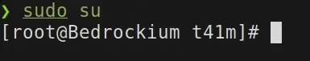
- cd ~/
This command changes the current working directory to the user’s home folder (/home/username). ‘cd’ specifies the change directory command, while the argument ‘~’ is a shortcut for the home directory. This command is executed so that we are in a known location before executing any other commands.
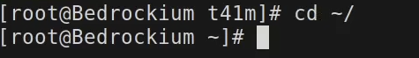
- airmon-ng start wlan1
The purpose of this command is to enable monitor mode on wlan1 for packet sniffing. This is a prerequisite for the execution of commands that capture WPA2 handshakes. The ‘start’ flag specifies the activation of the monitor mode while the ‘wlan1’ argument specifies the wireless interface to modify.
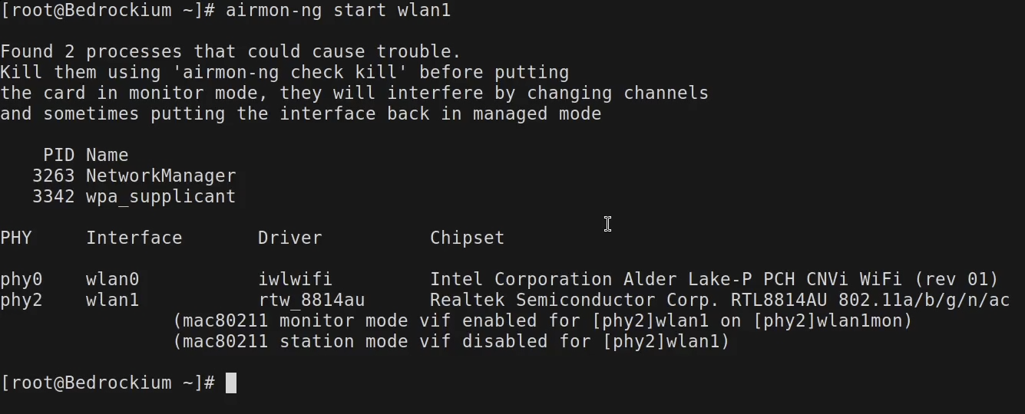
- airodump-ng wlan1mon
This command scans nearby Wi-Fi networks and clients in monitor mode in order to identify the target network’s BSSID, channel, and clients. The argument ‘wlan1’ specifies which monitor-mode interface to use for capturing traffic.
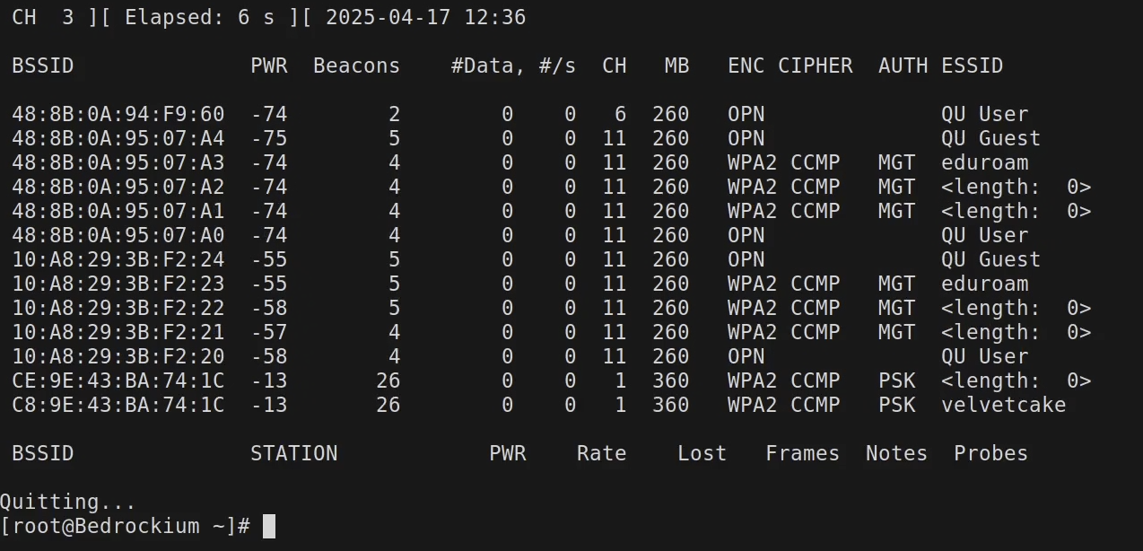
- airodump-ng bssid C8:9E:43:BA:74:1C -c 1 -w cap wlan1mon
This command captures packets from the specified Access Point (AP) in order to obtain a WPA handshake which is require for the password-cracking. The ‘--bssid' flag followed by the ‘C8:9E:43:BA:74:1C’ argument specify the target AP’s MAC address, while the ‘-c’ flag and the ‘1’ argument dictate which channel to listen on; ‘-w’ flag and the ‘cap’ argument specify the output file, and lastly ‘wlan1’ is the argument that specifies the monitor-mode interface.
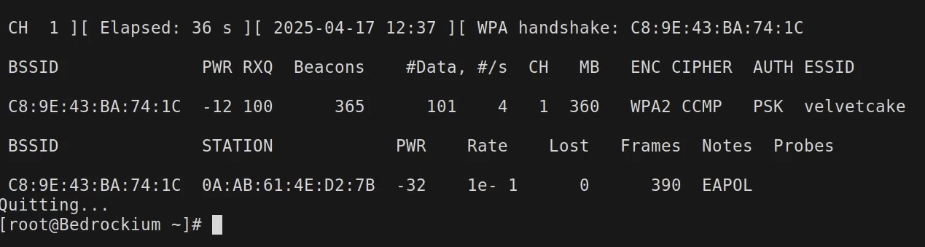
- hcxpcapngtool -o handshake.hccapx cap.cap
This command converts the ‘cap.cap’ packet capture into a format which is compatible with Hashcat (hccapx). The ‘-o’ flag and ‘handshake.hccapx’ argument specify the output file for Hashcat. This is done to prepare the handshake for password cracking.
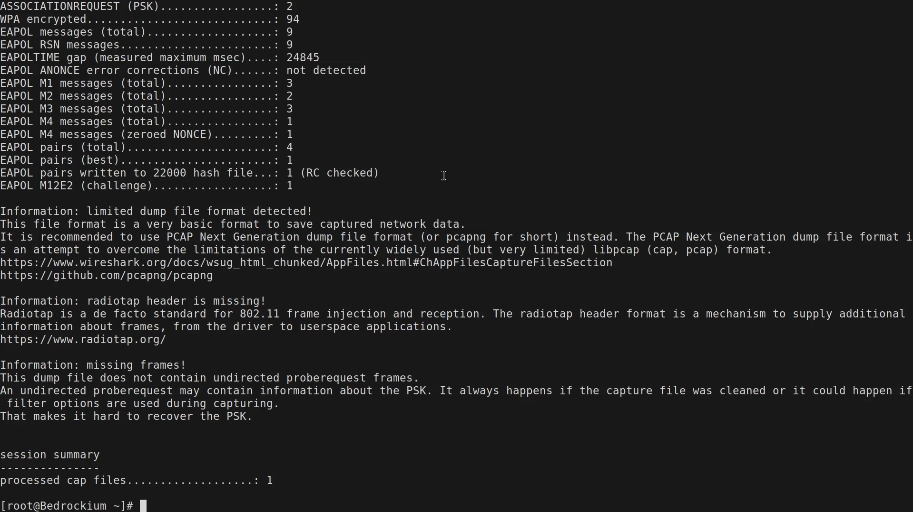
- hashcat -m 22000 handshake.hccapx rockyou -w 3 -O --show
This command cracks the WPA2 handshake using the ‘rockyou’ word list. The flag and argument combination ‘-m 22000’ specifies the hash mode for WPA-PMKID/PBKDF2, ‘handshake.hccapx’ is the input file for this command which we generated using the previous command, ‘rockyou’ is the word list that contains common passwords. The ‘-w 3’ flag and argument combination specify to use medium workload in order to balance speed and stability, the ‘-O’ flag enables optimized kernels for faster cracking while ‘--show' displays the results when the password has been cracked.
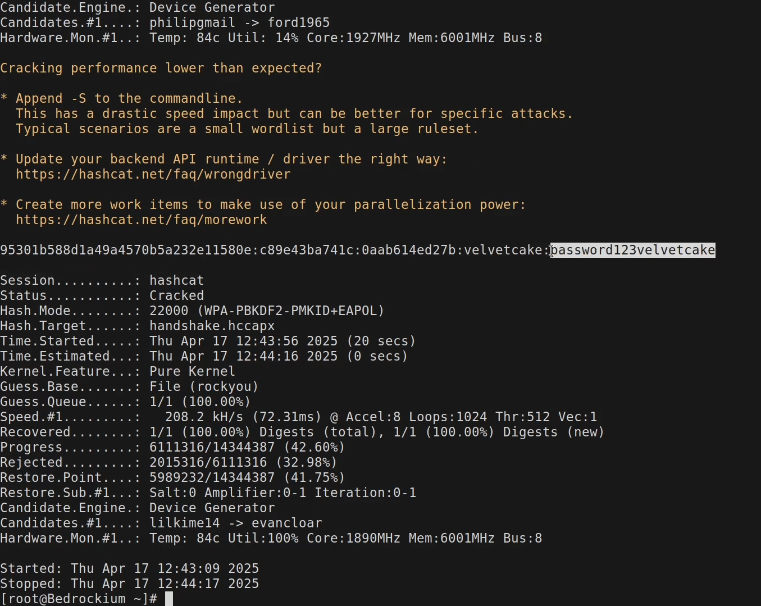
- nmcli device wifi connect velvetcake password password123velvetcake
This command connects the device to the Wi-Fi network ‘velvetcake’ with the password we obtained via cracking earlier, ‘password123velvetcake’. The ‘device wifi connect’ arguments specify the connection be made to a Wi-Fi network, ‘velvetcake’ is the SSID and the ‘password password123velvetcake’ part specifies the password of the network. We use this command to connect to the network to then run the proceeding commands.
- ip addr show wlan0 | grep -o '[0-9]\{1,3\}\.[0-9]\{1,3\}\.[0-9]\{1,3\}\.[0-9]\{1,3\}'
We use this command to extract the IP address assigned to wlan0 which will be used for scanning using nmap. ‘ip addr show wlan1’ specifies to display the network interface details while the output is piped into ‘grep -o ‘[0-9\{1,3\}\....’ in order to filter the IPv4 addresses.
- nmap -sP 192.168.10.0/24
This command runs a scan to discover the live hosts on the subnet. The ‘-sP’ flag sets the command to ping scan without port scanning and the ‘192.168.10.0’ argument specifies the subnet to scan. We use this command to identify the devices connected to this network (velvetcake).
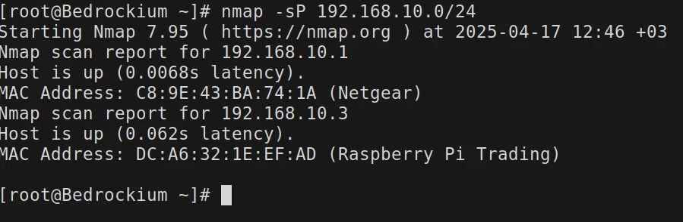
- hydra -l pi -t 4 -P rockyou -I 192.168.10.3 ssh
This command brute-forces the SSH login for user ‘pi’ on ‘192.168.10.3’. The ‘-l pi’ combination specifies the target username, in this case pi. ‘-t 4’ specifies that 4 parallel tasks should be run which speeds up the cracking process, ‘-P rockyou’ is used to specify the password list to use for brute-forcing, ‘-I’ is a flag which skips already-tried logins and lastly ‘192.168.10.3 ssh’ specifies the target’s IP and service.
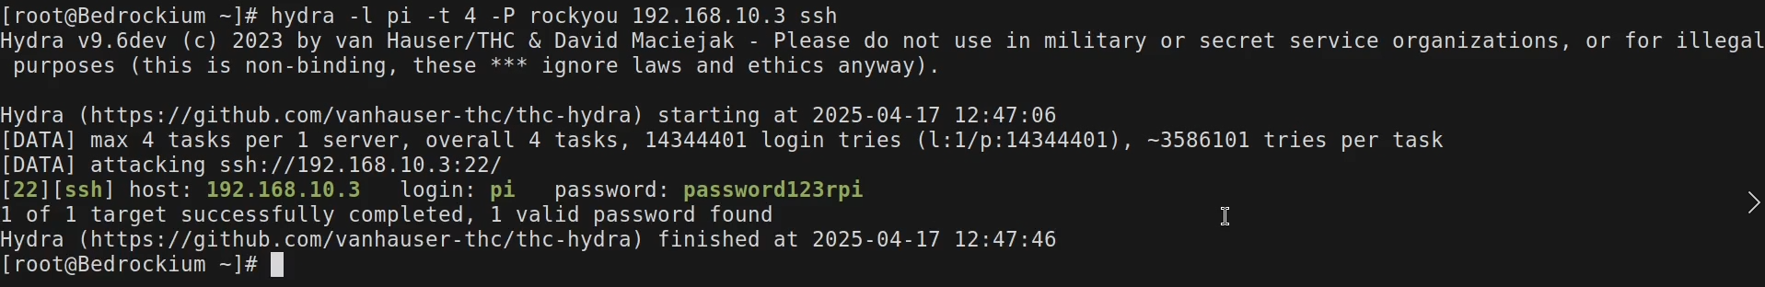
- ssh pi@192.168.10.3
This command grants us root access to the Raspberry Pi from a foreign device using SSH login. We are prompted for a password, for which we enter the password we cracked using the previous command (password123rpi).
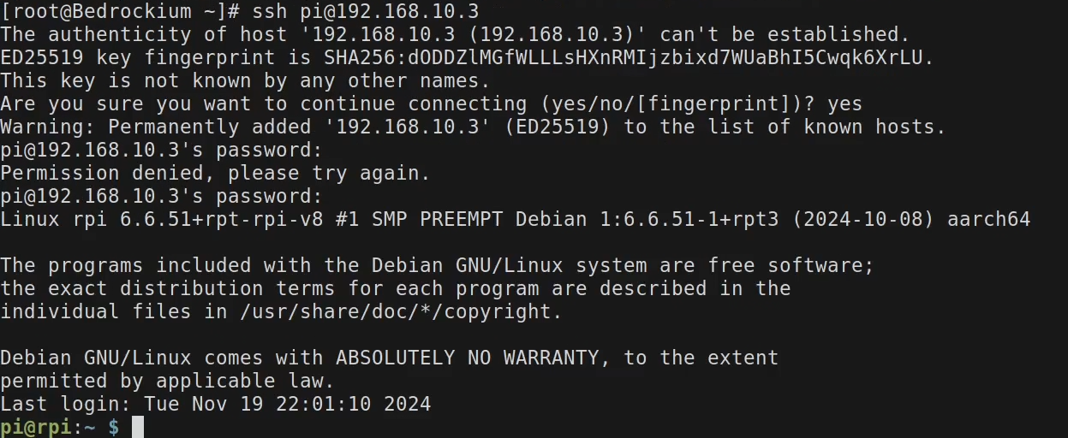

References
[1] Our Most Advanced Penetration Testing Distribution, Ever. (2019, December 31). Kali.org. https://www.kali.org
[2] InfosecTrain. (2024, January 3). Why do Hackers Use Kali Linux? Medium. https://medium.com/@Infosec-Train/why-do-hackers-use-kali-linux-5217e95e7a97
[3] airmon-ng [Aircrack-ng]. (2019). Aircrack-Ng.org. https://www.aircrack-ng.org/doku.php?id=airmon-ng
[4] Aircrack-ng. (2018). airodump-ng [Aircrack-ng]. Aircrack-Ng.org. https://www.aircrack-ng.org/doku.php?id=airodump-ng
[5] Linux, K. (2024, November 17). hcxtools | Kali Linux Tools. Kali Linux; hcxtools | Kali Linux Tools. https://www.kali.org/tools/hcxtools/
[6] Hashcat. (2018). hashcat - advanced password recovery. Hashcat.net. https://hashcat.net/hashcat/
[7] KALI. (2024). hydra | Kali Linux Tools. Kali Linux. https://www.kali.org/tools/hydra/

