 | Qatar University  College of Engineering  Department of Computer Science and Engineering
Senior Project Report

Helping Students Choose the Right Major
(Your personal academic guide)
Acadeguide

Project Group Members:

Mohammad Ahmad (202002453)
Omar Qutb (202106170)
Obada Alrefai (202110207)
Supervisor: Rehab Duwairi
20
This project report is submitted to the Department of Computer Science and Engineering of Qatar University in partial fulfillment of the requirements of the Senior Project course.

Declaration

This report represents our original work, and any external sources utilized have been appropriately cited. It details the work we have undertaken for our senior project. We are aware of the University strict policy on plagiarism and the corresponding penalties, and we declare that this report is the product of our own work.

Student: Omar Qutb Date: 17/4/2025
Signature: OQ

Student: Obada Alrefai Date: 17/4/2025
Signature: OR

Student: Mohammad Ahmad Date: 17/4/2025
Signature: MA

Abstract
Many high school graduates face uncertainty when deciding their future, especially when choosing a college major or whether to pursue higher education. This confusion often comes from a lack of guidance, external pressure, or not fully understanding their own interests. Making the wrong choice can lead to frustration, while the right one can set the foundation for success.
Our project offers a smart and supportive mobile app that helps students make better academic decisions. Through a series of personalized questions, the app identifies their strengths and interests, then suggests majors that best match their profile. The goal is to help students feel more confident and aligned with their chosen path.
The app also addresses key issues like the lack of academic advisors and scattered university information. By providing a 24/7 intelligent chatbot and centralizing important academic data, students get continuous guidance whenever they need it.
Technically, the project combines cross-platform mobile development with elements from AI, user experience design, and educational psychology. This mix allows the app to deliver a personalized and accessible experience for all users.
In short, our solution aims to guide students toward choices that reflect who they are, leading to a more rewarding and successful educational journey.

Acknowledgment
We wish to express our profound gratitude to several individuals and entities whose guidance and support were instrumental in the completion of this senior project.
Foremost, we extend our deepest appreciation to our project supervisor, Professor Rehab Duwairi. Her unwavering support, dedication, and persistent belief in our abilities were the driving force behind this project. Throughout our journey, she consistently went above and beyond to ensure we were equipped to deliver our best. Her encouragement instilled in us the hope and confidence that our application would function and that our ambitious idea could, indeed, be successfully accomplished.
We are also deeply thankful to the Department of Computer Science and Engineering. The robust academic foundation and the technical knowledge imparted by the department's curriculum and faculty were essential in qualifying us to design and build an application of this complexity.

Table of Contents
Declaration iii
Abstract iv
Acknowledgment v
List of Figures viii
List of tables x
1. Introduction and Motivation 11
1.1. Problem statement 11
1.2. Project objectives 12
1.3. Expected benefits and impacts 12
1.4. Market Research and Business Viability 13
2. Background and related work 15
2.1. Background 15
2.2. Related work 17
3. Requirements analysis 19
3.1. Software development process 19
3.2. Applying the software development process 19
3.1. Functional requirements 22
3.2. Non-functional requirements 23
3.3. Assumptions 24
3.4. Ethics 24
4. Project Plan 26
4.1. Project milestones 26
4.2. Project timeline 27
4.3. Anticipated risks 30
5. System Architecture 30
5.1. High level system architecture 30
5.2. Alternative solutions and tradeoffs 37
6. Detailed Design 39
6.1. Structural model 39
6.2. Behavioral model 40
6.3. Database design 45
6.4. User interface design 45
6.5. Design patterns 60
7. Implementation 63
7.1. Hardware/software used 63
7.2. Challenging issues and solutions 63
8. Testing and evaluation 63
8.1. Functional testing 63
8.2. Non-functional testing 84
9. Conclusion 92
10. Future work 93
11. Student reflections 94
References 94
Appendix A – Use cases specification 98
Appendix B – Test cases specification 108
Other Appendices 115
Appendix C – Questionnaire Report 115
Appendix D – Questionnaire Questions 118

List of Figures
Figure 1 RIASEC chart 16
Figure 2 5 Big 5 model for personality traits. 17
Figure 3. Login and register sketch 20
Figure 4. Search university sketch 21
Figure 5. Reset password sketch 21
Figure 6. Use cases diagram 22
Figure 7. Project Gantt chart: Timeline of key tasks and milestones 29
Figure 8. High-level system architecture diagram 31
Figure 9. Class diagram 39
Figure 10. Register account sequence diagram 41
Figure 11. Login/logout sequence diagram 42
Figure 12. Reset password sequence diagram 43
Figure 13. Search university sequence diagram 44
Figure 14. Entity Relationship Diagram 45
Figure 15. Login page 47
Figure 16. Registration form page 48
Figure 17. Reset password page 49
Figure 18. Reset password OTP page 50
Figure 19. Dashboard page 51
Figure 20. Search universities page 52
Figure 21. University info page 53
Figure 22. Forums page 54
Figure 23. Forum details page 55
Figure 24. Create forum page 56
Figure 25. Profile page 57
Figure 26. Assessment page 59
Figure 27 Result Page 59
Figure 29. MVC pattern class diagram 60
Figure 30. Factory design pattern class diagram 61
Figure 31. Observer pattern sequence diagram 62
Figure 31. Test and result screens 64
Figure 33. Profile screen with generated data 65
Figure 34. Recommendation system backend 66
Figure 35. Result screen based on user traits 67
Figure 36. Discussion forums partial unit test 67
Figure 37. Create forum test 68
Figure 38. Delete forum test 68
Figure 39. Reply in forum test 69
Figure 40. University reading test 70
Figure 41. Search forums test 70
Figure 42. Login-logout test 71
Figure 43. User registers a new account 72
Figure 44. User takes assessment 73
Figure 45. User views generated profile 74
Figure 46. User edits profile 75
Figure 47. User searches for universities 75
Figure 48. User searches forums 76
Figure 49. User posts a new forum 77
Figure 50. User replies to a forum post 77
Figure 51. User interacts with Rasheed 78
Figure 52. Returning user logs in 79
Figure 53. Returning user views their profile 79
Figure 54. Returning user edits their profile 80
Figure 55. Returning user searches universities 81
Figure 56. Returning user searches forums 81
Figure 57. Returning user posts a new forum 82
Figure 58. Returning user replies to a forum post 83
Figure 59. Returning user interacts with Rasheed 84
Figure 60. Assessment performance test 85
Figure 61. Database interaction performance testing 86
Figure 62. Client A - android device user 86
Figure 63. Client B - iOS device user 86
Figure 64. Client A makes a forum post 87
Figure 65. Client B can see A’s post 87
Figure 66. Client B makes a post 88
Figure 67. Client A can see B’s post 88
Figure 68. Client B replies to A’s post 89
Figure 69. Client A can observe B’s reply 90
Figure 70. Client A posts a reply for B 91
Figure 71. Client B Is able to observe A's reply 91

List of tables
Table 1. Expected benefits and impacts on various contexts 12
Table 2 Comparison between existing solutions 13
Table 3. Use cases summary 23
Table 4. Evaluation plan for the non-functional requirement 23
Table 5. Project-specific code of ethics and professional responsibilities 25
Table 6. Project milestones 26
Table 7. Project timeline 27
Table 8. Project Risks 30
Table 9 Component Dependencies 35
Table 10. Hardware/software to be used 63

Introduction and Motivation

Problem statement

Many high school graduates are unsure about their next steps, whether to pursue higher education or follow a different path. Research shows that 66.2% of students who choose a major that does not suit them experience uncertainty in their career paths. [1]
Additionally, a study by the National Center for Education Statistics found that 60.5% of people under the age of 25 enrolled in majors that were not their own choice. [2] These findings highlight the challenges high school students face in selecting the right major, often due to uncertainty or parental pressure.

Finding a solution to this problem is important, as choosing a major is a crucial decision that can impact at least four years of a student’s life. The right choice can be beneficial, while the wrong one may feel like a waste of time.
That’s why our app is designed to ease this process. It guides students and early diploma graduates through a series of questions to assess their interests and preferences. Based on their responses, the app suggests the most suitable major, ensuring their higher education journey is both beneficial and enjoyable by aligning their studies with their true passions.

Our problem can be considered a complex computing problem based on key aspects. As there is currently no single, clear solution that effectively addresses the problem. Existing approaches presented in academic research are largely theoretical and serve only as recommendations for educational institutions. Practical implementations are rare and limited in scope, highlighting the complexity of developing a universal and scalable solution. We also serve multiple stakeholders such as
- Students, who are the primary users seeking guidance.
- Educational institutions, which may indirectly benefit from more informed student choices.
And when it comes to technical tradeoffs and challenges our solution comes across many as we to develop a cross-platform mobile application (for iOS and Android) introduces technical tradeoffs related to user experience, performance, scalability, and data integration. Ensuring accessibility, usability, and personalized recommendations adds further technical depth.
Solving this problem requires the knowledge from multiple disciplinaries such as:
- Artificial Intelligence (for the chatbot advisor)
- Human-Computer Interaction (for user-friendly interfaces)
- Data Management (to collect and organize university information)
- Educational Theory and Psychology (to understand advising needs and user behavior)
This all leads to tackling a significant problem as it could help students make better informed academic and career choices, leading to more successful educational outcomes.

Project objectives
Our project's main objective is to design and implement a service that makes the major selection process easier and more accurate for high school students and freshmen, to help them enjoy their education journey in the coming years. By achieving this, we aim to lower the percentage of students who are uncertain about their major choices. To ensure our objectives are clear and achievable, we will follow the SMART principles.
Specific:
- Designing an interactive system that guides the students through the process of major selection by assessing their interests and traits based on short quizzes.
Measurable:
- Our aim is to reduce the percentage of uncertainty among students by 20% to 30%, based on feedback from users. This will be measured based on a question asked to the student before and after the assessment and receiving a result, and we can then use these data to find the difference of percentages among various users.
Achievable:
- The development team has the required skills to design and develop the service.
Relevant:
- The project aims to solve a well-known problem among students who are not satisfied with their majors. This aligns with our goal to make the higher education journey more enjoyable.
Time-Bound:
- We aim to achieve the modification of our overall concept and 100% of the app features, and have our final prototype, by the end of Senior Design Project II
- We aim to have a fully working app with all features completed by the end of our Senior Design Project II journey.

Expected benefits and impacts
Table 1. Expected benefits and impacts on various contexts
Context | Expected benefits and impacts
Individuals | Our project has an impact on high school students as individuals. The students, in this case, will be assisted in choosing the best possible major that fits their desires and interests, helping them enjoy and love what they are studying. This will allow the students to be more productive and show a better understanding of the material provided.
Organizations | Our project also has an impact on universities as organizations. Since our project helps students choose the most suitable major for them, this will affect universities by improving the distribution of students across different majors and faculties. This will reduce the admission pressure on some crowded majors like medicine and engineering, allowing for a much smoother education process.
Society | Our project also has a significant impact on society, especially on the job market. By helping students choose majors that suit their interests and abilities, universities will see a more balanced distribution of students across different faculties. This will encourage universities to open and invest more in majors that were previously overlooked, creating new teaching opportunities and hiring more professors. In addition, having graduates from a wider variety of fields will help meet the demands of the job market, reducing the skill gap between graduates and employers. This will lead to lower unemployment rates and a more qualified workforce.
Global | Our project has a positive impact on the global economy. As more students graduate in fields that match market needs, job opportunities will increase, and unemployment rates will decrease. A lower unemployment rate means more people are contributing to production and innovation, which boosts economic growth. In the long term, this can lead to stronger economies and better living standards worldwide.

Market Research and Business Viability
The market for our project is fairly narrow, with only limited similar apps available particularly in Qatar. Some of the existing options include Career Guide QCDC Qatar [3] and QARARI [4] (Not Available at the mean time), the latter being very similar to our concept. Our main target audience includes high school students and university students who are considering a change in their major. We focus on users between the ages of 15 to 25, both male and female, based in Qatar, and with a flexible budget. This gives us a great opportunity to fill the gap in the local market and provide a valuable tool for students making important academic decisions.

Table 2 Comparison between existing solutions
Category | QCDC Career Guide | QARARI App (Not Available anymore)
Main Objective | - Instill a career-driven mindset through awareness and interest-building programs- Nurture effective career policies and planning through stakeholder collaboration- Leverage the education system through guidance tools and professional services | - Gateway to explore higher education opportunities- Career assessment to help choose the right major- Search engine for universities in Qatar- Courses and internships in different entities
Primary Target Users | - Pre-University Students- University Students and Fresh Graduates- Parents- Academic Advisors and Counselors | - Pre-University Students- University Students
Age Group Focus | 15–30 | 15–25
Localization for Qatar | Local | Local
Visual Design & User Experience | User-friendly website; mobile app only provides outdated newsletters | Based on online screenshots, app had a modern and user-friendly interface
Access to Updated University Data | No access to university information | Provided updated university information
Level of Personalization | Not Applicable | Personalized experience based on assessment
Technology Integration (AI, RAG) | Not Specified | Not Available
Availability (iOS/Android/Web) | Available on all platformsWeb application provides more detailed features | Available on iOS only
Innovation Compared to Market | Not Specified | Not Specified
Partnerships / Official Support | - Ministries and Governmental Entities- Academic and Research Institutions- Educational Policy Makers- Public and Private Sectors- NGOs/NPOs- Professional Associations- Media and Opinion Leaders | Not Specified

Our app stands out from others by providing a smooth and user-friendly experience. First, users can take a personalized test that matches their interests, goals, and personality traits with suitable majors. In addition, they can search for universities in Qatar and find key details like available majors, tuition fees per semester, and more. Our App will be available on all platforms including IOS, Android, and Web.

One of our most important features is the AI-powered chatbot advisor. Using Retrieval Augmented Generation (RAG) technology help`s users find the right major based on their test results or information they provide through chat. It can also give useful tips on how to succeed in a specific major. This makes the process of choosing a career path much easier and more interactive.

Background and related work

Background
A major in higher education is the main area or field of study that a student focuses on during university. Every student needs to choose one major to study. There are many different types of majors, and each one has its own requirements and qualities that students should meet.
For example, a major in Arts and Humanities may require a student to have an interest in literature. Some majors also have smaller specializations that students can choose from. A student majoring in Arts and Humanities might specialize in Philosophy, Art History, World Religions, and more.
However, many students are not sure what major to choose after finishing high school. Some follow the most popular or trending majors, while others go with what their parents choose for them, thinking it will be the best fit. This often leads to students studying something that doesn’t match their interests, which can cause them to switch majors or even drop out.
Our project aims to solve this problem. We offer a tool that helps students choose a major that matches their interests, personality traits, skills, and academic desires. Students take a simple personality test, and based on the results, we suggest majors that could be a good fit.
In addition, we provide a chatbot advisor that gives fast and helpful career advice. This advisor supports students by helping them understand their chosen major and gives tips on how to succeed in it.
The domain that our projects is targeting is the education domain especially in Qatar. We provide information about different educational entities like universities and colleges around the region, allowing students to get the latest information about the university or college they will be joining. Each entity has its different majors, facilities, benefits for students, and range of tuition fees.
In addition to having the right tech knowledge, it's also important to understand some psychology. This helps us connect a person’s interests and personality traits with their career goals. A journal paper, namely, “Major Decisions: Motivations for Selecting a Major, Satisfaction, and Belonging” mentioned that personality has a bigger impact on major choice than family advice or even how prepared someone is. [5] Using Holland’s RIASEC theory, which was about grouping of people based on personality types, can help someone figure out what kind of work they enjoy and are more likely to succeed in. This makes it easier to narrow down career options that fit them. [6]
That’s why in our app, we aim to include personality-based assessments to guide students toward majors and universities that truly match who they are, not just what they think they should choose.

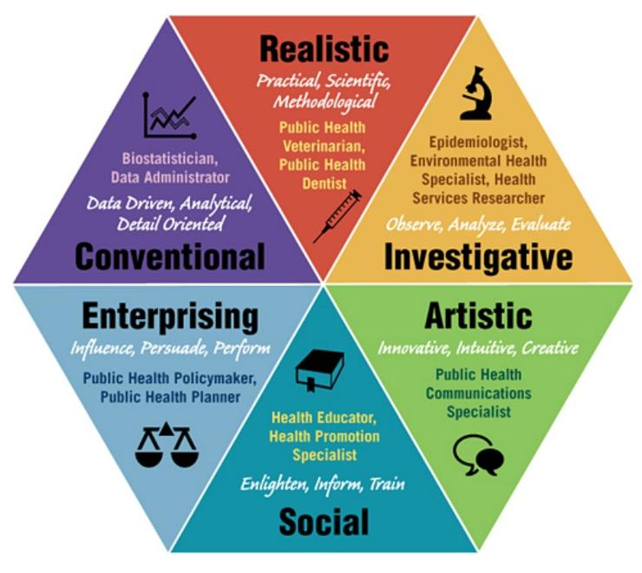
Figure 1 RIASEC chart

From a user perspective, having a basic understanding of both education and technology will make it easier to grasp our project and use the final product effectively.
For example, the user should know about recommendation systems for instance, since many users are already familiar with recommendation systems—tools that leverage AI algorithms to suggest options based on input—they’ll recognize how this applies to our solution. [7] In our case, the system will recommend suitable university majors based on the student’s personality traits gathered from the test.
Users will also appreciate the integration of a chatbot, which uses AI and Natural Language Processing (NLP) to engage in helpful and natural conversations.
Each Major was associated with one or more factor of the RAISEC model that best fits this major for example, most engineering majors are associated with being Realistic.
In addition to that the majors selection is not just based on the RAISEC model, it’s also based on the Big 5 personality traits which categorizes personality into 5 models that include Extraversion, Agreeableness, Openness to experience, consciousness, extraversion
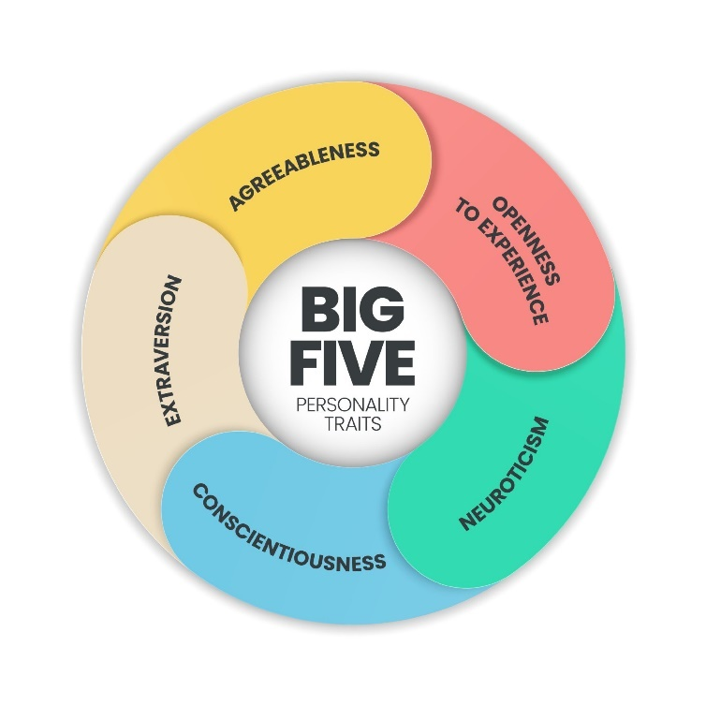
Figure 2 5 Big 5 model for personality traits.
These 2 psychological models assisted us with assessing the user and making the matching between the user interests and our dataset of majors.

Related work
Over the past ten years, research has focused on how students make decisions when choosing a college major. The studies examine the factors that help students decide and what influences their choices. Some research ended without a solid solution, while others provided only theoretical recommendations and tips on how students can pick a major.

One thesis titled "Transformational Experiences and Decision-Making Processes: Factors Influencing the Choice of College Major" [8] by Ashley Hunsaker explored how transformational experiences affect students’ major choices. The study used one-on-one interviews with students discussing their experiences and decision-making process. The results showed that internal factors [9] (like determination) and external factors [10] (such as work-life balance and the desire to make an impact) play a role in their decisions. For example, one student chose prosthetics and robotics after being inspired by helping people. Another student mentioned determination as a reason to stick with their major, saying: “There have been experiences that have pushed me forward toward my goals... And generally, it gives me more insights to get to my goals.”

The study concluded with recommendations for universities and advising offices. It suggested that universities should:
- Provide hands-on learning opportunities.
- Support self-exploration.
- Offer mentorship programs.
- Build a strong sense of community.
These steps help students understand their strengths, feel connected, and make confident decisions about their majors and careers.
Another study, "Choosing and Changing Course: Postsecondary Students and the Process of Selecting a Major Field of Study" [11] by Patrick A. Denice, focused on why students switch majors. It explained that choosing a major is an important decision that affects learning, career earnings, and job stability. The study also noted that students from different backgrounds (especially by gender and income level) often pick different majors, which can lead to future income gaps.
The study recommended that colleges should:
- Continue support beyond the first year (since many students change majors later).
- Provide better guidance for students who switch majors, especially those who do it multiple times, as they are more likely to fall behind or drop out.
Most current solutions rely on career counseling offices that offer the same services in the same way. However, a few tech-based solutions exist, like mobile apps or interactive games, to help students choose a major that fits their interests. Below is a list of available solutions, both locally and globally, with their strengths and weaknesses:
Local Solutions (Qatar):
- Qatar Career Development Center (QCDC)
  - Strengths: Provides structured career guidance through schools and national programs.
  - Limitations: Mostly in-person services, which limit accessibility.
- Qarari App (Currently unavailable)
  - Strengths: Offers digital tools and assessments for local students.
  - Limitations: Not very interactive or personalized.
Global Solutions
- MyMajors
  - Strengths: Recommends majors based on grades and interests.
  - Limitations: Mostly designed for the U.S. education system.
- Encourage App
  - Strengths: Helps students find colleges and majors based on preferences.
  - Limitations: Focuses more on matching schools rather than exploring interests deeply.
- Find Your Calling
  - Strengths: Uses data to connect careers with education paths.
  - Limitations: Sometimes oversimplifies results and doesn’t fit all students’ goals
Our solution, on the other hand, provides a more unique experience for the user by offering multiple features that assist in the process of choosing a major. It starts with an assessment that determines possible majors based on the user’s interests, personal preferences, financial budget, and more. Our app delivers a personalized experience, ensuring relatability and precision in its results.
We also provide information about local universities in Qatar, with the ability to compare them, allowing the user to select the best option that fits their needs. Additionally, we want users to share their experiences and concerns on a shared platform across all users, functioning as a discussion forum or blog where they can learn from others’ experiences, increasing engagement.
One valuable feature we offer is a chatbot advisor, which lets users chat and receive career guidance based on the information they provided earlier in their assessment.

Requirements analysis

Software development process
We have adopted the SCRUM (a framework of Agile process) as our software development process as this is what is most suitable for our project. Acadeguide is a platform that requires constant user feedback for improvements in regard to user-friendliness and feature feedback, as such it requires a development approach that is highly adaptable. Our team also works, one might even say sprints, throughout the week and holds one major scrum meeting by the end of it to discuss progress and the upcoming sprint. We also update each other on our assigned tasks through daily scrums in the form of short online meetings. It is through this that we are able to make substantial progress efficiently when compared to other development processes. The only downside is the lack of time to polish our ideas between meetings, but this can be tackled over time through user feedback and future application patches.

Applying the software development process

In the first half of our project, we have decided to develop UC 11, 12, 15, 16 and 18 (please refer to Table 2 below). For the use cases of UC 11 and 12, since these are related to searching and filtering, we will be using dummy data for this phase. Extensive data collection will take place beyond this phase when we focus on more proper implementation of all our use cases for Acadeguide.

We started development from UC 15 and 16 as these make up most of the user authentication process, part of which will help our users get started with using our application. Starting with UC 15 and 16, we held our first meeting to draft the process of registering and the UI design for the various screens the user would have to go through in order to complete this task. We initiated our first sprint planning through a meeting. The goal for this meeting was to decide on a UI theme (colors, button shapes, sound design etc.) as well as the process of registration itself (what details would be required, mandatory 2FA, email verification etc.). Below are drafts of screens and registration process ideas we came up with prior development.
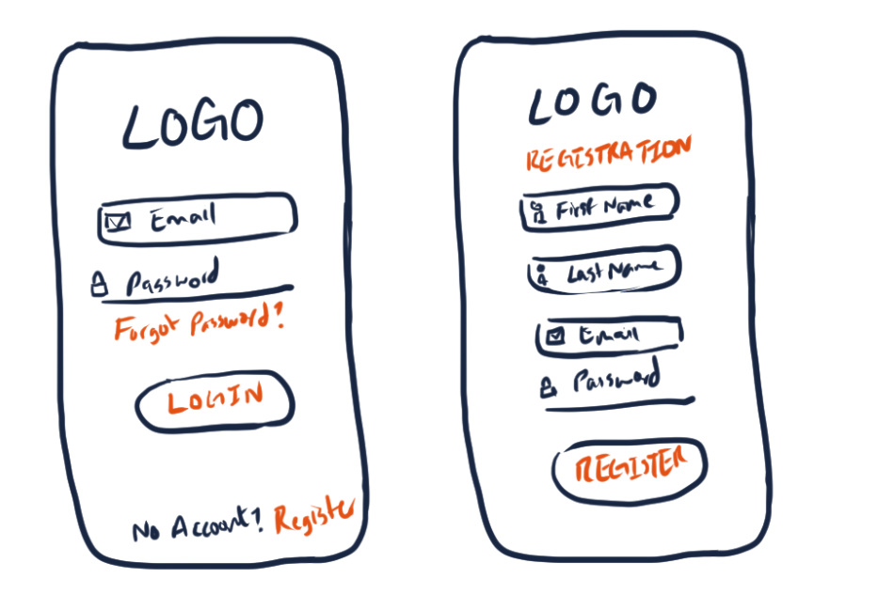
Figure 3. Login and register sketch
Once we settled on the process and the design, we, the scrum team, started development functionally first and then focused on the visual design aspect of our application. Daily scrums in the form of online meetings were held to ensure that everyone in development was on the same page and that development was proceeding smoothly. We were able to accomplish our tasks within the 1-week timeframe before our next sprint planning meeting and consulted potential consumers regarding the design choice, the fluidity of the registration process and the login/logout functionality and gathered feedback to make any required adjustments since these two features are what make or break the initial impression for any application, and we wanted to ensure our users have the best experience possible.

Next, we held our second sprint planning meeting to discuss the remaining use cases from our chosen ones for the first phase. In a similar fashion to last time, we discussed the processes of resetting passwords and searching, and their possible screen designs and drafted out examples of such designs as well. Below are the samples that we drafted. We also conducted a sprint review towards the end of our meeting to review the completeness of our previous sprint.

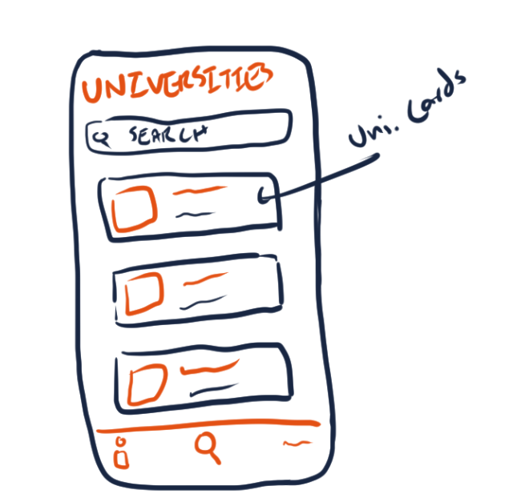
Figure 4. Search university sketch

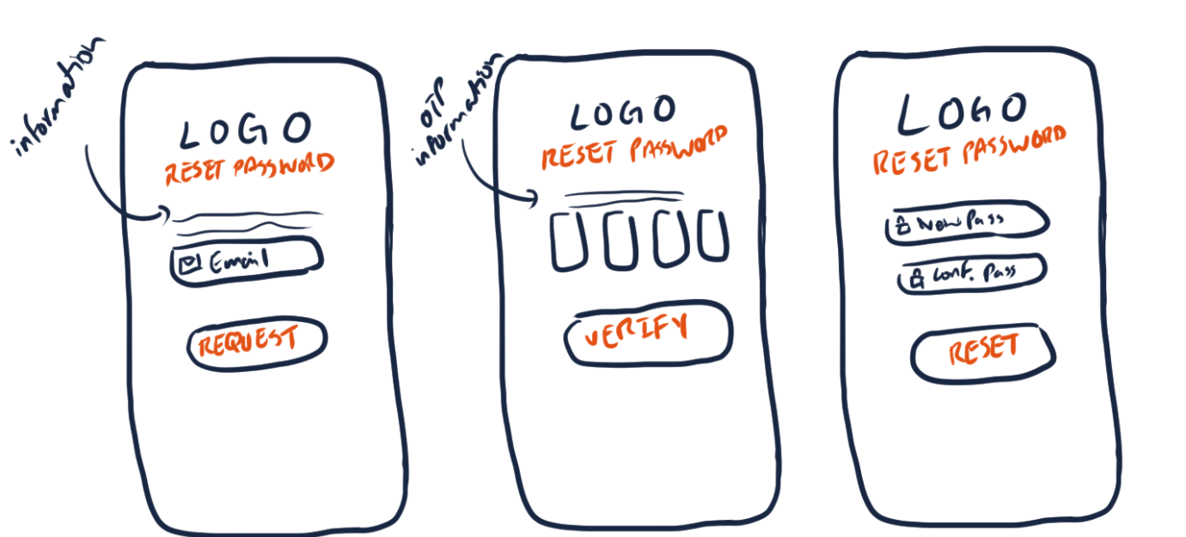
Figure 5. Reset password sketch
With our next goals set, we, the scrum team, spent the following week sprinting with the ideas that we settled on as a group. We decided to implement the bulk of our use cases in this second meeting as this was a more efficient approach to gathering feedback from users and making the required adjustments instead of waiting for another week by splitting the work further. After development was done, we once again gathered feedback and made the required adjustments necessary to our design and the processes.

As one can clearly deduce, this style of development suited our team greatly, especially within the context of our project as well since it aims to provide a very smooth and satisfactory user experience. Because we were able to gather feedback during development, we were able to streamline the process of adding more features while adjusting existing features to suit the needs of our consumers. In this way, we managed to meet our deadlines comfortably and also made something our customers would be satisfied with. One way in which this approach does fall slightly short is the lack of time for us as the developers to think more about the implementation of our use cases in both design and process aspects since we have to get things done before the next meeting, and the time span available for us to ponder ideas and concepts is far from adequate let alone greatest.

Functional requirements

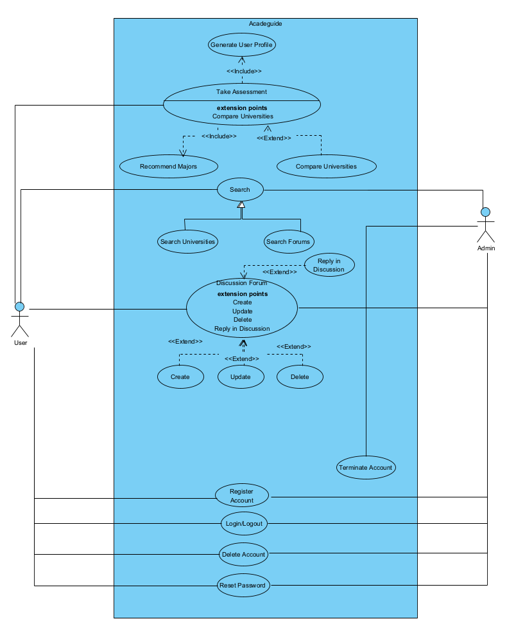
Figure 6. Use cases diagram

Table 3. Use cases summary
ID | Use case | Brief description
1 | Take Assessment | Captures the main functionality of the software where the user takes a detailed test, which gives the software the following information regarding the user:  Personality traits, skills and strengths, financial situation, and interests and career goals.
2 | Generate User Profile | Generates a profile for the user based on the data generated by the user taking the test. This data can then be used by the software for various purposes.
3 | Recommend Majors | Recommends the majors to the user based on the data stored in the user profile by matching the data with various stored metrics.
4 | Compare Universities | Lists the best universities based on the data stored in the user profile generated by the assessment ordered from the best choice to worst choice.
5 | Discussion Forums | Captures the second main functionality of the software where the user or admin can view and interact with various discussion forums or create new ones.
6 | Create Forum | Allows the user or admin to create a forum thread.
7 | Delete Forum | Deletes the user's or admin's forum thread.
8 | Reply in Discussion | Posts a reply in a forum thread.
9 | Search | Captures the third main functionality of the software which is the ability to allow the user or admin to search through the various available information. It is the generalization of the two specialized use cases UC 12 and 13.
10 | Search Universities | Allows the user or admin to search up universities through various parameters and filters.
11 | Search Forums | Allows the user or admin to search up forums through various parameters and filters.
12 | Register Account | Registers a new user or admin account after validating details and verifying the user's or admin's email address.
13 | Login/Logout | Logs a user or admin into or out of a session.
14 | Delete Account | Deletes a user or admin account when requested.
15 | Reset Password | Allows the user or admin to reset their password in case they forget it.
16 | Terminate Account | Terminates the user account requested by the admin.

Non-functional requirements
Table 4. Evaluation plan for the non-functional requirement
Non-functional requirement | Measurable targets | Evaluation Plan
Performance | Certain backend and frontend tasks should not take longer than an expected amount of average time (e.g. taking the assessment should not take longer than 15 minutes, the account termination process should not take longer than 3 minutes, database operations should not take longer than 3 seconds etc.) | Add a timer in various segments of code that keeps track of the time taken for certain tasks’ completion.
Resilience | In case of server failure, the application should continue to offer its services to the user in real time with no significant delay (2+ minutes) | Have at least two backup servers with replicants of the main server database on standby at all times and check application performance on client-side by simulating the failure of the main server.
Availability | Services from the application must be available to the consumer 24/7 without fail excepting maintenance times for scheduled updates and server restarts. | Add a script on the server machines that records complete server downtime outside maintenance and restart times (i.e. no server is available and functioning).
Interoperability | Information from the backend must be shared across both Android and iOS clients seamlessly and on demand. | Check data updates from both Android and iOS clients simultaneously.

Assumptions
- The Flutter framework will be used for developing our application. We assume that the functionalities provided by this framework (UI customizability, flexibility, data handling, accessibility etc.) will be more than sufficient for us to deliver quality user experience through the developed application.
- We will be using Firebase as our prototype’s database, as such we assume Firebase will be able to host the necessary data in a cloud-based environment which we can then connect our Flutter application to for retrieving data and performing operations.

Ethics
Acadeguide is a platform which involves the handling of sensitive user data (real names, educational background, financial status, and so on) and as such we have selected appropriate codes of ethics to discuss in this report. We have selected all the below-mentioned codes from the ACM and the IEEE Software Engineering Code of Ethics and Professional Practice and therefore will be referring to them by their respective code numbers.
Our first chosen code of ethics falls within the Public Principle which states that software engineers shall act in accordance with the public interest. Specifically, Principle 1.06 which states that software engineers must be fair and avoid deception in all statements, especially public ones, regarding development. We shall address this by making our users aware of our user data protection and privacy policies during various parts of the application’s experiences, such as but not limited to the sign-up process, taking the assessment, posting on forums etc. Another route would be to disclose related information to the user during the sign-up process through a ‘Terms of Service’ agreement, which the user will have to agree to before signing up for our offered services. Most users nowadays, however, tend to not read the ‘Terms of Service’ and because it is also a one-time occurrence in the life cycle of a user’s experience in the application, this option does not seem viable since the user may simply overlook the disclaimers. This is why, in addition to this, we opt to display disclaimers during important processes that require the user to be made aware of the data protection and privacy policies.
Moving on, the next chosen code of ethics falls within the Product Principle which states that their products and related modifications meet the highest professional standards possible shall be ensured by software engineers. We have selected Principle 3.13 which states that software engineers should be careful and use only accurate data derived by ethical and lawful means which is only used in properly authorized ways. To address this, we will ensure that the data we obtain for our various assessments that Acadeguide runs in the backend is as accurate as possible. We will verify the validity and accuracy of the data through the sources themselves, whether they are universities in cases like calculations regarding acceptance likelihood or the books/papers (in this case cross-referencing) for the case of assessing the user’s strengths and weaknesses for deriving the appropriate major for them.
Our third chosen code of ethics falls within the Management Principle which states that software engineers and leaders shall subscribe to and promote an ethical approach to the management of software development and maintenance. Within this principle, we have selected Principle 5.01 which states that we must ensure good management of every product which we work on, including effective procedures for promotion of quality. We shall ensure this by assigning our tasks on a weekly basis through our meetings and continuing development in the SCRUM fashion as this ensures that we make enough progress regularly while also factoring in feedback from our users to improve the quality of our product all the time while simultaneously reducing the risk factors since reported bugs and/or unexpected application behavior may be easily tackled and patched as a result. As explained earlier in Section 3.1 of the report, the SCRUM software development process is the most suitable one for the development of Acadeguide with our current context and team, therefore it has been adopted as the approach to development for ensuring good management while maintaining a sense of quality and risk mitigation.
Finally, the last two codes of ethics chosen for discussion in regard to our project fall under the Colleagues Principle. This principle states that software engineers should be fair to and supportive of their colleagues. The first principle we have chosen from this category is Principle 7.04, which states that we must review the work of others in an objective, candid, and properly documented way. To address this, we ensure to review each other’s work put into the task they were assigned with in the fairest and most constructively critical way possible. This sometimes results in making changes to parts of the work we have done but in doing so we help each other grow as better developers by realizing our shortcomings and learning from them. Different perspectives help drastically improve the quality of a product. The final principle is Principle 7.06, which states that we assist our colleagues in being fully aware of current standard work practices, including policies and procedures for protecting passwords, files and other confidential information, and security measures in general. We aim to tackle this by educating the team on password protection via encryption and other cyber security measures which we may be able to adopt in order to secure the data of our users.
Table 5. Project-specific code of ethics and professional responsibilities
Ethical consideration / professional responsibility | How to address it throughout the project's lifecycle
1.06. Be fair and avoid deception in all statements, particularly public ones, concerning software or related documents, methods and tools. | Make our users aware of our user data protection and privacy policies during various parts of the application’s experiences, such as but not limited to the sign-up process, taking the assessment, posting on forums, etc.
3.13. Be careful to use only accurate data derived by ethical and lawful means and use it only in ways properly authorized. | Ensure that the data we obtain for our various assessments that Acadeguide runs in the backend be as accurate as possible by verifying the validity and accuracy of the data through the sources.
5.01 Ensure good management for any project on which they work, including effective procedures for promotion of quality and reduction of risk. | Assign our tasks on a weekly basis through our meetings and continue development in the SCRUM fashion as this ensures that we make enough progress regularly while also factoring in feedback from our users to improve the quality of our product all the while simultaneously reducing the risk factors since reported bugs and/or unexpected application behavior may be easily tackled and patched as a result.
7.04. Review the work of others in an objective, candid, and properly documented way. | Ensure to review each other’s work put into the task they were assigned with in the fairest and most constructively critical way possible.
7.06. Assist colleagues in being fully aware of current standard work practices including policies and procedures for protecting passwords, files and other confidential information, and security measures in general. | Educating the team on password protection via encryption and other cyber security measures which we may be able to adopt in order to secure the data of our users.

Project Plan

Project milestones
Table 6. Project milestones
Id | Milestone | Description | Deliverables | Duration (Days)
1 | Sign Up | Simplify onboarding with third-party social media authentication (e.g., Google). | Social OAuth integration, user profile sync, UI for sign-up options. | 6
2 | Register Account | Allow users to create an account via email/password. | email/password., Registration form, email validation, backend user creation logic, database integration. | 3
3 | Login/Logout | Implement secure user authentication and session termination. | session termination. Login form, JWT token handling, logout functionality, session management. | 4
4 | Reset Password | Enable users to reset forgotten passwords via email verification. | email verification., Reset password form, email service integration, token generation/validation | 5
5 | Search Forums | Enable users to search forum content using keywords and filters. | Search bar UI, backend API for querying forums, results display component. | 7
6 | Search Universities | Enable users to find universities by name, The system should support partial matching. | Responsive search interface, backend search API with query optimization,  real-time search suggestions,  integration with university database. | 9
7 | Reply in discussion | Enable users to post replies to existing forum threads. | Backend API for reply submission and storage, real-time update system for thread activity. | 8
8 | Chat bot advisor | Develop a chatbot that can answer frequently asked questions about majors, universities, admissions, and provide personalized recommendations based on user profiles and preferences. | Interactive chat interface, Natural Language Processing (NLP) integration, response training and customization,  integration with user profile system | 10
9 | Questionnaire implementation | Develop an interactive questionnaire that assesses users personality traits, and interests to generate personalized academic recommendations. | Dynamic questionnaire interface, user profile generation and updating system, recommendation algorithm integration, results dashboard | 6

Project timeline
Table 7. Project timeline
Id | Task name | Start Date | End Date | Duration (Days) | Assigned To | Dependencies
1 | Project Initiation
1.1 | Explore Project Ideas | 30-Jan-2025 | 06-Feb-2025 | 7 | All
1.2 | Search for Similar Apps | 30-Jan-2025 | 06-Feb-2025 | 7 | All | 1.1
2 | Planning
2.1 | Choose name for the app idea | 06-Feb-2025 | 13-Feb-2025 | 7 | All
2.2 | Describe the app idea | 06-Feb-2025 | 13-Feb-2025 | 7 | All
2.3 | Prepare Survey Questions | 06-Feb-2025 | 13-Feb-2025 | 7 | All
2.4 | Questionnaire research | 04-Sep-2025 | 11-Sep-2025 | 7 | All
2.5 | Questionnaire design | 19-Sep-2025 | 26-Sep-2025 | 7 | All | 2.4
2.6 | Think of front-end design for discussion forum | 02-Oct-2025 | 09-Oct-2025 | 7 | All
2.7 | tweak questionnaire questions | 22-Oct-2025 | 29-Oct-2025 | 7 | All | 2.5
3 | Use-Cases
3.1 | Refine Use-cases from project ideas | 13-Feb-2025 | 20-Feb-2025 | 8 | All | 1.1,2.2
3.2 | Draw Use-case diagram | 20-Feb-2025 | 13-March-2025 | 22 | All | 3.1
3.3 | Fill use-case specs | 13-March-2025 | 6-April-2025 | 25 | All | 3.2
4 | Designing Diagrams |  |  |  | All
4.1 | Design Class Diagram | 10-April-2025 | 14-April-2025 | 5 | All | 3.3
4.2 | Design System Arch Diagram | 14-April-2025 | 18-April-2025 | 5 | All
4.3 | Design Database Model Diagram | 17-April-2025 | 18-April-2025 | 2 | All
4.4 | Design Sequence Diagrams for 30% of the use cases. | 18-April-2025 | 19-April-2025 | 2 | All | 4.1
4.5 | adding design pattern class diagrams | 16-Oct-2025 | 23-Oct-2025 | 7 | All
4.6 | adding design pattern sequence diagram | 16-Oct-2025 | 23-Oct-2025 | 7 | All
5 | Project Report
5.1 | Project Description Section 1 & Section 2 | 1-March-2025 | 14-April-2025 | 45
5.1 | Non-Functional Requirements documentation | 20-March-2025 | 14- April-2025 | 26 | All
5.2 | Ethical Consideration documentation | 10-April-2025 | 14-April-2025 | 5 | All
5.3 | System Arch Documentation | 10-April-2025 | 17-April-2025 | 8 | All
5.4 | Diagrams Documentation | 18-April-2025 | 19-April-2025 | 2 | All | 4.1,4.2,4.3,4.4
5.5 | Documenting Challenges | 23-April-2025 | 26-April-2025 | 4 | All
5.6 | Finalizing Gantt Chart | 18-April-2025 | 27-April-2025 |  | All
5.7 | Questionnaire report | 19-Sep-2025 | 26-Sep-2025 | 7 | All
5.8 | complete non-functional testing | 30-Oct-2025 | 06-Nov-2025
5.9 | complete functional testing | 09-Nov-2025 | 16-Nov-2025 | 7 | All
6 | Code Implementation
6.1 | Backend for Signup | 20-April-2025 | 21-April-2025 | 2 | All
6.2 | Backend for login/logout | 20-April-2025 | 21-April-2025 | 2 | All
6.3 | Backend for Resetting Password | 21-April-2025 | 22-April-2025 | 2 | All | 6.1,6.2
6.4 | Backend for Searching Universities | 24-April-2025 | 24-April-2025 | 1 | All
6.5 | Frontend for Login/logout | 22-April-2025 | 22-April-2025 | 1 | All | 6.2
6.6 | Frontend for Signup | 22-April-2025 | 22-April-2025 | 1 | All | 6.1
6.7 | Frontend for Resetting Password | 22-April-2025 | 23-April-2025 | 2 | All | 6.3
6.8 | Frontend for Searching Universities | 25-April-2025 | 25-April-2025 | 1 | All | 6.4
6.9 | Recommendation algorithm implementation | 05-Sep-2025 | 19-Sep-2025 | 14 | All
6.10 | Discussion forum implementation | 07-Oct-2025 | 14-Oct-2025 | 7 | All
6.11 | questionnaire implementation in app | 09-Oct-2025 | 18-Oct-2025 | 9 | All
6.12 | Implement reply in discussion forums | 12-Oct-2025 | 19-Oct-2025 | 7 | All | 6.10
6.13 | Implement chatbot | 23-Oct-2025 | 29-Oct-2025 | 6 | All
6.14 | complete functional testing | 03-Nov-2025 | 17-Nov-2025 | 14 | All
6.15 | tweak questionnaire questions | 06-Nov-2025 | 13-Nov-2025 | 7 | All
6.16 | Fix forum reply issue | 06-Nov-2025 | 13-Nov-2025 | 7 | All | 6.12

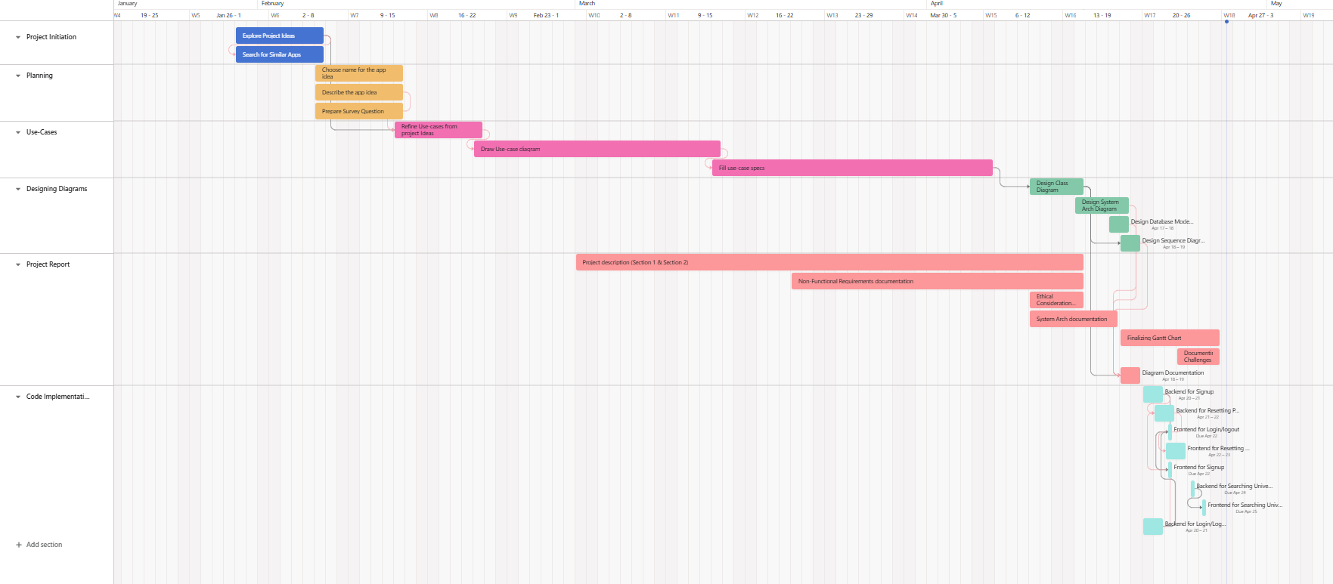
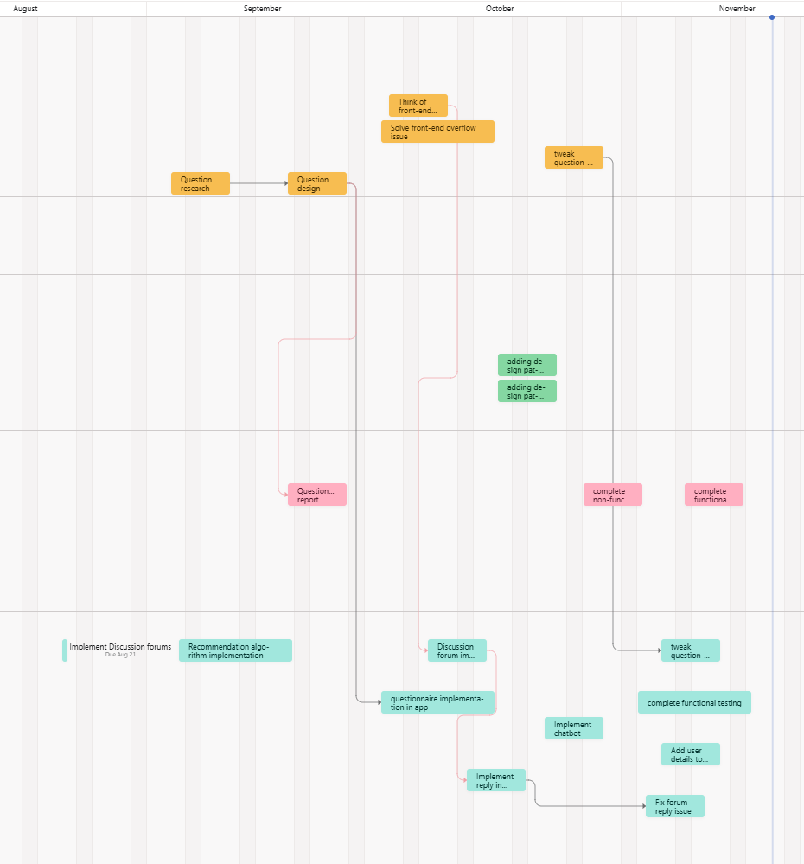

Figure 7. Project Gantt chart: Timeline of key tasks and milestones

Anticipated risks
Table 8. Project Risks
Risk | Approach to mitigate the risk
Technical Risks: potential challenges or failures in the development, integration, or operation of technologies used in the project. | - Prototype core algorithms early.  - Use modular design for easier iteration.
Scope Creep: Uncontrolled expansion of features risking timeline/budget overruns. | - Define clear project scope upfront.  - Implement a formal change control process.
Data Security: Risks of breaches in local storage or cloud databases. | - Encrypt sensitive data.  - Conduct regular penetration testing.

System Architecture

High level system architecture
Acadeguide is a university and career planning platform designed to help users explore academic pathways, compare institutions, and manage goals. Key components include the Auth/Profile service for secure authentication, the Recommendation Engine for personalized major/university suggestions, and the Search Service for dynamic queries. The Create/Edit Service enables academic plan management, while the Threads/Replies Service supports forum interactions. External integrations include payment gateways (e.g. PayPal), third-party university APIs for real-time data, email services, and Data is managed using SupaBase. User workflows, such as registration and search, leverage seamless interactions between microservices and external systems.
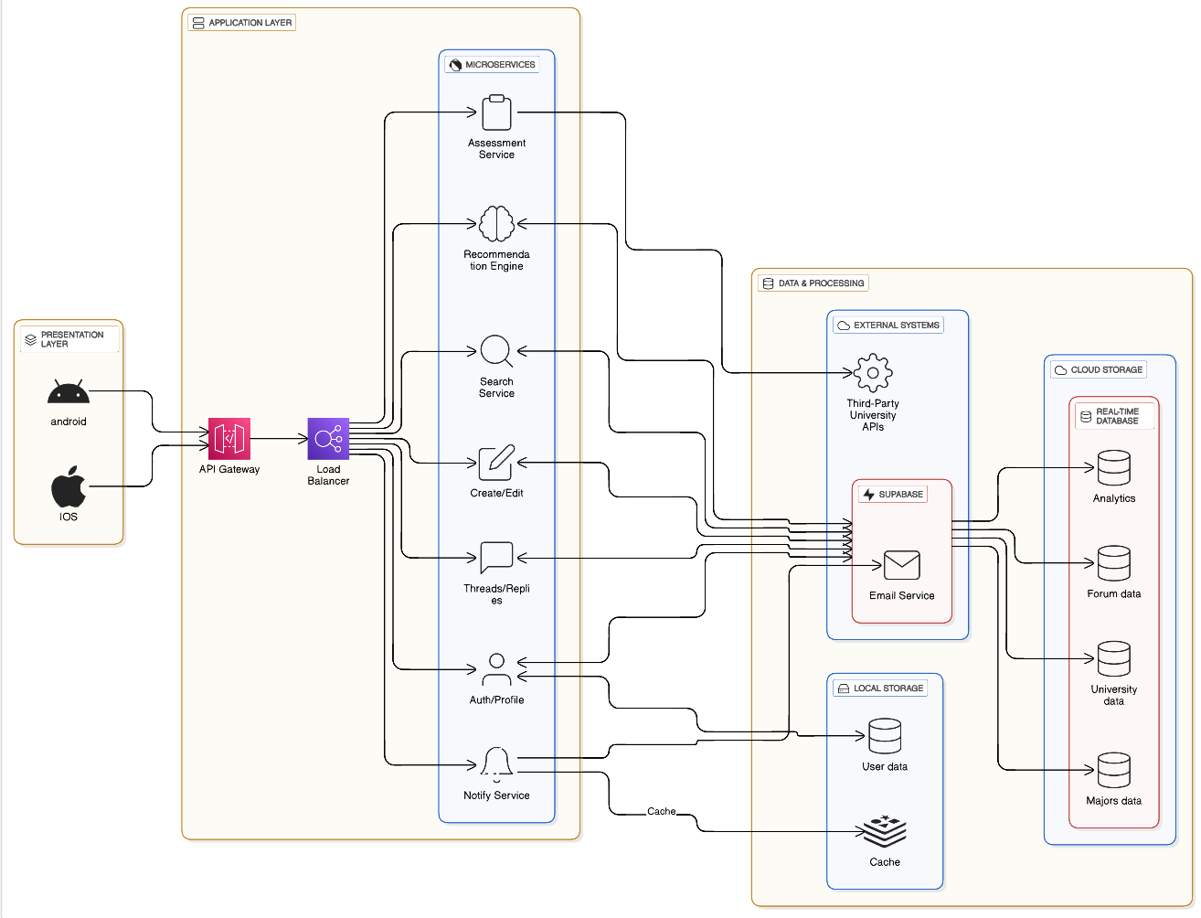
Figure 8. High-level system architecture diagram

Presentation Layer

This layer includes the Android and iOS Applications, serving as the user interface (see Figure 2.1). These applications allow users to perform actions such as registering accounts, taking assessments, searching universities, creating academic plans, and participating in forums. They communicate with backend services via HTTP/HTTPS APIs, ensuring secure data transfer.

Application Layer
The core functionality of Acadeguide is driven by modular microservices. Accessed by API Gateway which accepts incoming HTTP/HTTPS requests forwarding them to the load balancer, directing them to the appropriate microservice. The Auth/Profile service handles user authentication, profile management, and role-based access control. The Recommendation Engine employs tailored algorithms to generate personalized university and major suggestions, relying on gRPC/HTTP interfaces to process user profiles and integrate with university data. The Search Service enables the system to deliver fast, filtered results for universities and forums through REST endpoints such as /search/universities.

The Create/Edit service manages academic plan creation and updates, storing data in a Postgres database. Forum interactions, including posting threads and replies, are handled by the Threads/Replies service. User assessments, processed by the Assessment Service, feed into profiles that drive recommendations. The Notify Service dispatches emails and SMS via asynchronous messaging, ensuring reliable delivery of verification links and payment confirmations. Lastly, the Transactions service processes payments through integrations with payment services, exposed via REST APIs like /payment/process.

Data & Processing Layer
This layer combines external systems with the platform’s data infrastructure, that combines local storage with cloud storage managed by Supabase, a modern, scalable backend-as-a-service solution that combines PostgreSQL for relational data management with built-in authentication, real-time capabilities, and storage [12].

Cloud Storage
Data requiring high availability, scalability, and complex search/analytics is centralized within a PostgreSQL instance hosted on Supabase. This includes all Forum Data, such as threads and replies, which is organized into specialized schemas utilizing flexible, nested JSON structures to manage dynamic content effectively. Crucial Test Results are stored here, and to centralize authentication and access control, core User Data (including credentials, roles, and profiles) is also maintained securely in the cloud. Furthermore, Supabase integrates with its PostgREST API to expose this data, enabling sophisticated analytics processing in external tools like Apache Spark or Python-based pipelines.
Local Storage
For improved user experience, data that benefits from fast retrieval and offline accessibility is strategically stored locally on the user's device, significantly reducing cloud dependency and latency. This includes a cached version of University Data, such as rankings, programs, and admission criteria, allowing users to access fast, filtered results even without a continuous connection, while the canonical source resides in the cloud. Additionally, user-defined information such as interests, traits, and the complete list of majors are stored locally for immediate personalized filtering and recommendation generation.

External Systems
Acadeguide integrates with external platforms like Supabase to use its extensible architecture, ensuring seamless interoperability while maintaining centralized control. Payment gateways like PayPal connect via Supabase Edge Functions, which handle transaction processing and securely store billing records in PostgreSQL tables protected by Row-Level Security (RLS) [13]. Third-party university APIs feed real-time admission and scholarship data into Supabase PostgreSQL using HTTP-triggered Edge Functions, ensuring data freshness for recommendations and eligibility checks. Email and SMS providers (e.g., SendGrid, Twilio) are invoked directly by Supabase Edge Functions, replacing async messaging queues—database events (e.g., user sign-ups, payment confirmations) trigger notifications without requiring standalone services.

1. User Registration & Authentication (see Figure 2.1)
Data Flow:
- Presentation Layer (Web/Mobile App) → Sends registration request via HTTP/HTTPS to Auth/Profile Service.
- Auth/Profile Service → Uses Supabase Auth to validate credentials and store user data in PostgreSQL tables.
- Supabase Auth → Triggers a database event (e.g., user_signup), invoking a Supabase Edge Function.
- Edge Function → Calls SendGrid/Twilio via REST API to send a verification email/SMS.
Protocols:
- HTTP/HTTPS for client-server communication.
- Supabase Realtime for event triggers.
- REST APIs for external email/SMS services.
Dependencies:
- Auth/Profile relies on Supabase Auth and PostgreSQL RLS for security.
- Notifications depend on Edge Functions and third-party providers.

2. University Search & Recommendations
Data Flow:
- Presentation Layer → Submits search query (e.g., "engineering programs") via HTTP to Search Service.
- Search Service → Uses Supabase’s PostgreSQL full-text search to query university data.
- Recommendation Engine → Fetches user profile from PostgreSQL, combines with search results, and ranks universities.
- Presentation Layer → Displays results in real time via Supabase Realtime subscriptions.
Protocols:
- REST APIs for search and recommendation requests.
- Supabase Realtime WebSockets for live updates.
Dependencies:
- Search Service depends on PostgreSQL full-text indexing.
- Recommendation Engine requires user profile data and third-party university APIs.

3. Academic Plan Creation
Data Flow:
- Presentation Layer → Sends plan details (e.g., courses, deadlines) to Create/Edit Service via HTTP.
- Create/Edit Service → Stores plan in PostgreSQL with versioning.
- Supabase Realtime → Broadcasts updates to all connected devices (e.g., mobile app, web).
- Recommendation Engine → Periodically scans plans to suggest optimizations.
Protocols:
- HTTP for plan submission.
- WebSockets (via Supabase Realtime) for sync.
Dependencies:
- Plan data relies on PostgreSQL’s JSONB for nested timelines.
- Real-time updates require Supabase Realtime subscriptions.

4. Forum Interactions
Data Flow:
- Presentation Layer → Posts a forum thread via HTTP to Threads/Replies Service.
- Threads/Replies Service → Stores thread in PostgreSQL (using JSONB for nested replies).
- Supabase Realtime → Pushes updates to all subscribed clients.
- Search Service → Indexes forum content via PostgreSQL full-text search.
Protocols:
- HTTP for thread/reply submission.
- WebSockets for live forum updates.
Dependencies:
- Forum data uses PostgreSQL’s JSONB for flexibility.
- Search depends on full-text indexing.

5. Analytics & Reporting
Data Flow:
- Supabase PostgreSQL → Exposes anonymized data via PostgREST API.
- Apache Spark → Pulls data for batch processing (e.g., user engagement trends).
- Edge Functions → Generate real-time dashboards using lightweight SQL queries.
Protocols:
- REST (PostgREST) for data access.
- SQL for querying.
Dependencies:
- Analytics require PostgREST API and RLS for data privacy.

Key Communication Protocols
- HTTP/HTTPS: Primary protocol for client-server interactions.
- WebSockets: Used by Supabase Realtime for live updates.
- REST APIs: Integrate payment gateways, email/SMS providers, and third-party APIs.
- Supabase Edge Functions: Replace traditional async queues for event-driven workflows.

Table 9 Component Dependencies
Component | Depends On | Purpose
Auth/Profile Service | Supabase Auth, PostgreSQL RLS | Secure user authentication and profile storage.
Recommendation Engine | PostgreSQL (user profiles, university data) | Generate personalized suggestions.
Search Service | PostgreSQL full-text search | Fast, filtered university/forum queries.
Notify Service | Edge Functions, SendGrid/Twilio | Trigger emails/SMS via database events.

Acadeguide adopts a three-tier architecture, consisting of the Presentation Layer, Application Layer, and Data Layer, to ensure modularity, scalability, and clear separation of concerns. This design aligns with the project’s requirements for real-time interactions, secure data handling, and integration with external systems. Below is the justification for this choice:

Separation of Concerns:
- Presentation Layer focuses on UI/UX, Application Layer on logic, and Data Layer on storage.
- Example: The Recommendation Engine (Application Layer) processes data from PostgreSQL (Data Layer) without exposing queries to the UI.
Scalability:
- Each tier scales independently. For instance:
  - Presentation Layer: Add CDNs for global users.
  - Application Layer: Deploy additional Recommendation Engine instances during admission seasons.
  - Data Layer: Supabase auto-scales PostgreSQL connections.
Security:
- Data Layer: Supabase RLS restricts access at the row level (e.g., users can’t view others’ plans).
- Application Layer: Edge Functions isolate payment processing from other logic.
Real-Time Capabilities:
- Supabase Realtime in the Data Layer streams updates (e.g., forum replies) directly to clients via WebSockets, avoiding polling.
Cost Efficiency:
- Supabase’s managed services reduce DevOps overhead, while PostgreSQL’s open-source nature avoids vendor lock-in.

Blew is a clarification on how the three-tier architecture aligns with the project's requirements:
Performance:
- Supabase’s PostgreSQL connection pooling prevents database bottlenecks during peak usage.
- Full-text search replaces Elasticsearch, reducing latency for university/forum queries.
- Edge Functions execute payment processing and notifications without blocking user workflows.
Resilience:
- PostgreSQL replication (managed by Supabase) ensures data durability during outages.
- Microservices and Edge Functions are stateless, allowing quick recovery from failures.
Utilization:
- Supabase auto-scales PostgreSQL connections and compute, avoiding over-provisioning.
- Serverless Edge Functions activate only during demand, optimizing cost and resource use.
Availability:
- Multi-region PostgreSQL deployments minimize latency and downtime risks.
- Supabase Realtime’s WebSocket fallback mechanisms maintain sync during network issues.
Interoperability:
- REST APIs and PostgREST adhere to open standards, simplifying third-party integrations.
- Supabase Auth supports OAuth/SAML, enabling seamless SSO with university portals.

Alternative solutions and tradeoffs
1. Monolithic Architecture
Description: A single-tiered application where UI, business logic, and data access are tightly coupled [14].
- Merits:
- Simplicity: Easier to develop, test, and deploy for small-scale projects.
- Lower Initial Complexity: No cross-service communication overhead.

- Tradeoffs:
- Scalability: Vertical scaling only (adding more resources to a single server), which struggles under high traffic.
- Resilience: A single bug or failure can crash the entire system.
- Utilization: Over-provisioning resources leads to inefficiency.
- Interoperability: Harder to integrate third-party tools due to rigid code structure.
- Alignment with Acadeguide: Unsuitable due to real-time requirements, scalability needs, and reliance on external APIs.

2. Microservices Architecture
Description: Decentralized services (e.g., Auth, Search, Payments) deployed independently [15].
- Merits:
- Scalability: Scale individual services (e.g., Search Service during admission season).
- Resilience: Fault isolation (e.g., payment failures won’t crash forums).
- Technology Flexibility: Use different tools per service (e.g., Python for ML, Go for APIs).

- Tradeoffs:
- Complexity: Requires service discovery, API gateways, and distributed tracing.
- Data Consistency: Challenges in managing transactions across services (e.g., user profile updates).
- Operational Overhead: Higher DevOps costs for monitoring, logging, and deployment.
- Alignment with Acadeguide: Overkill for a mid-sized project; Supabase simplifies data/authentication needs without microservices’ overhead.

3. Serverless Architecture
Description: software design where developers leave managing the underlaying architecture to the cloud provider and focus on the application implementation [16].
- Merits:
- Cost Efficiency: Pay-per-execution reduces idle resource costs.
- Scalability: Auto-scales to handle traffic spikes (e.g., assessment submissions during peak hours).
- Utilization: Optimal resource use with no need to manage servers.

- Tradeoffs:
- Cold Starts: Latency spikes when functions initialize, impacting real-time interactions (e.g., forum updates).
- Vendor Lock-In: Heavy reliance on cloud providers (e.g., AWS, Supabase).
- Debugging: Harder to trace distributed function executions.
- Alignment with Acadeguide: Partially adopted via Supabase Edge Functions for notifications/payments, but not for core real-time features requiring WebSockets.

Advantages and Superiority Over Alternatives:

1. Separation of Concerns
- Advantage: Modular design isolates UI, business logic, and data storage, enabling independent updates and maintenance.
- Superiority: Avoids tight coupling (monolithic) and excessive complexity (microservices).
2. Scalability
- Advantage: Each tier scales independently (e.g., presentation layer via CDNs, data layer via indexing).
- Superiority: Eliminates cold-start latency (serverless) and unpredictable performance (P2P).
3. Resilience
- Advantage: Fault isolation and centralized security (e.g., RBAC, encryption).
- Superiority: Reduces single points of failure (event-driven) and security risks (P2P).
4. Resource Utilization
- Advantage: Optimized compute/storage allocation (stateless app layer, structured databases).
- Superiority: Avoids over-provisioning (monolithic) and redundant infrastructure (microservices).

Detailed Design

Structural model
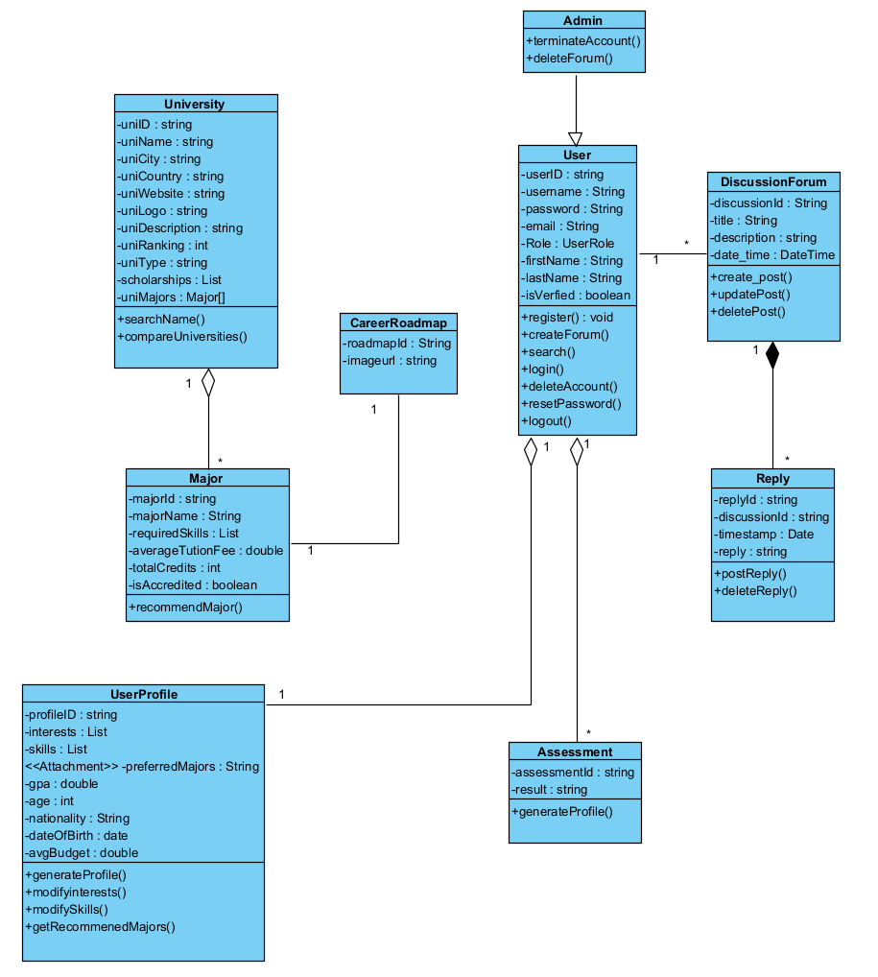
Figure 9. Class diagram

Our Diagram consists of multiple classes that define the core of our system:
- User:
Base class with attributes like userID, username, email, and methods like login () and register (). This is the core class that will deal with the user credentials when using with the system.
- Admin:
A class that inherits its details from user class, it acts as a more specialization of the user class having specific methods like terminateAccount () and deleteForum (). This class will deal with users with admin roles that monitor the system.
- University:
One of the core classes that contains attributes like uniName, uniRanking. It aggregates Major class with a multiplicity of (1 University has many Majors).
- Major:
Linked to the University class via an aggregation relationship, where the university has multiple majors and a major is offered by a single university. It has key attributes like majorName, totalCredits.
- DiscussionForum & Reply:
This is divided into 2 different classes with similar functionalities. It defines the forum that gets posted by the Use. A discussion Forum can have multiple replies having a multiplicity of 1 to Many relationship.

Key Design Decisions:

We based our class and attribute choices on the use case specifications (see Appendix A for details). Here’s how we structured the relationships:
Inheritance: For example, the Admin class extends User to reuse shared attributes like firstName, lastName, and email, while adding admin-specific methods such as terminateAccount() and deleteForum().
Aggregation: This creates a "has-a" relationship, like how University contains a list of Major objects. This setup allows flexible updates to majors without directly impacting the university class.

Behavioral model
Sequence Diagrams:
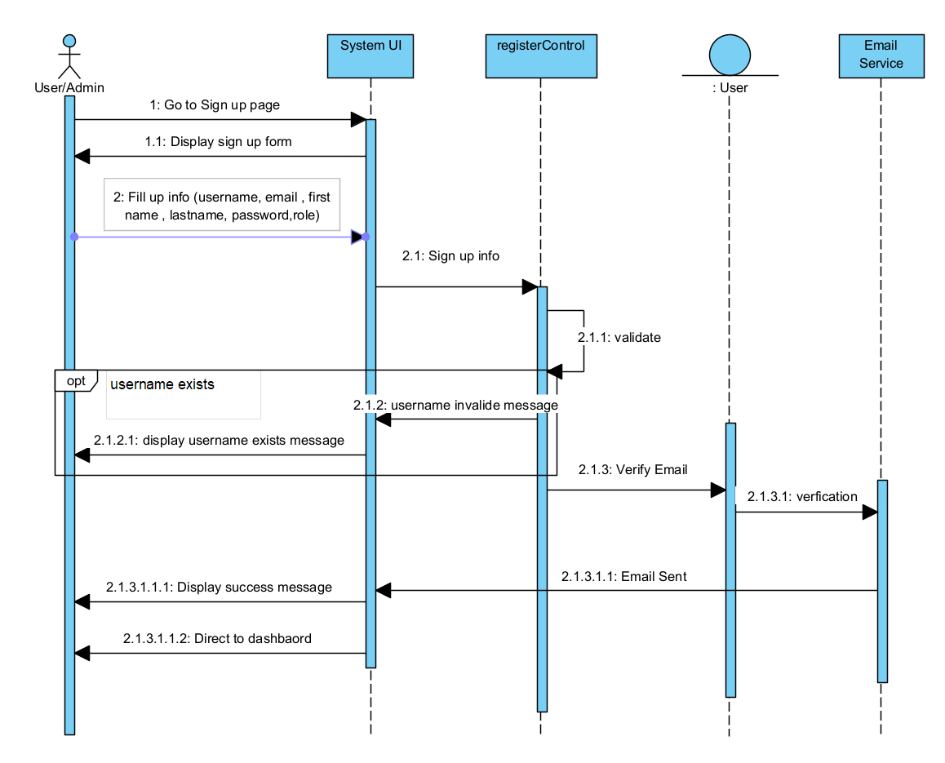
Figure 10. Register account sequence diagram
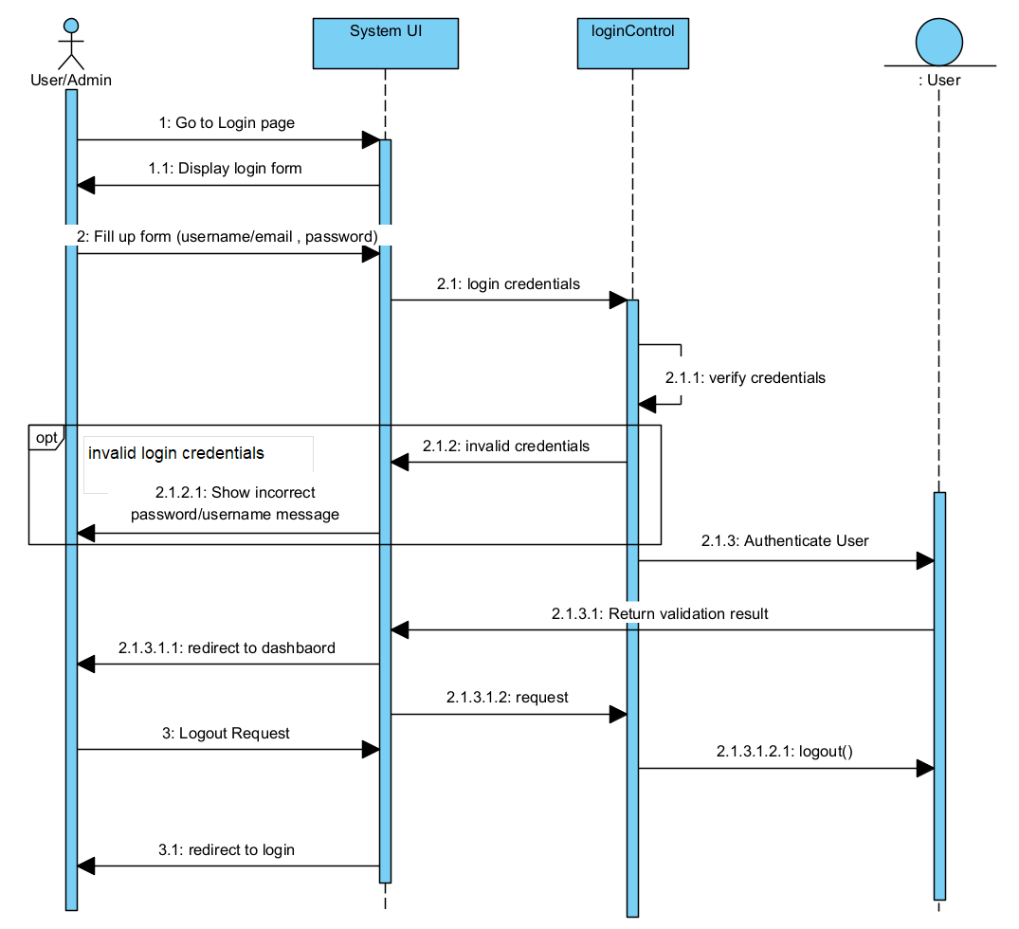
Figure 11. Login/logout sequence diagram

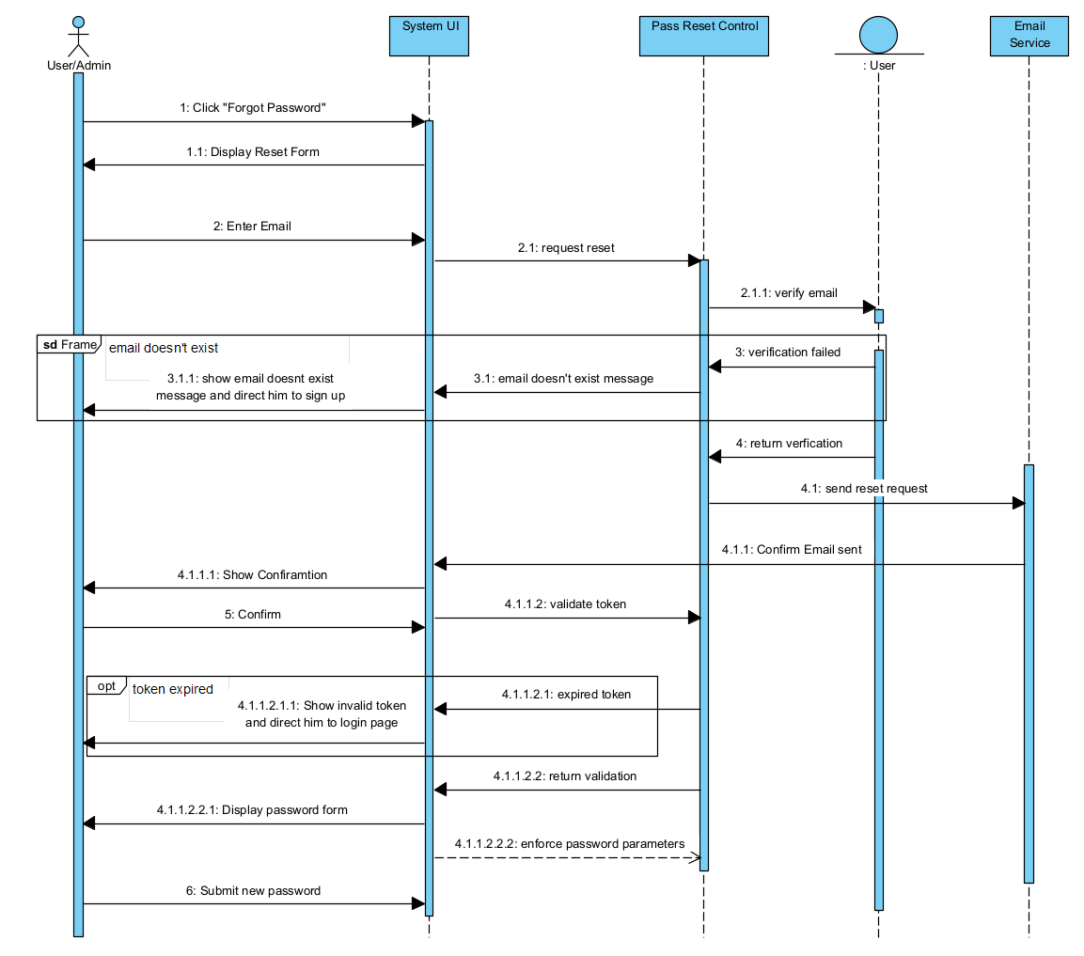
Figure 12. Reset password sequence diagram
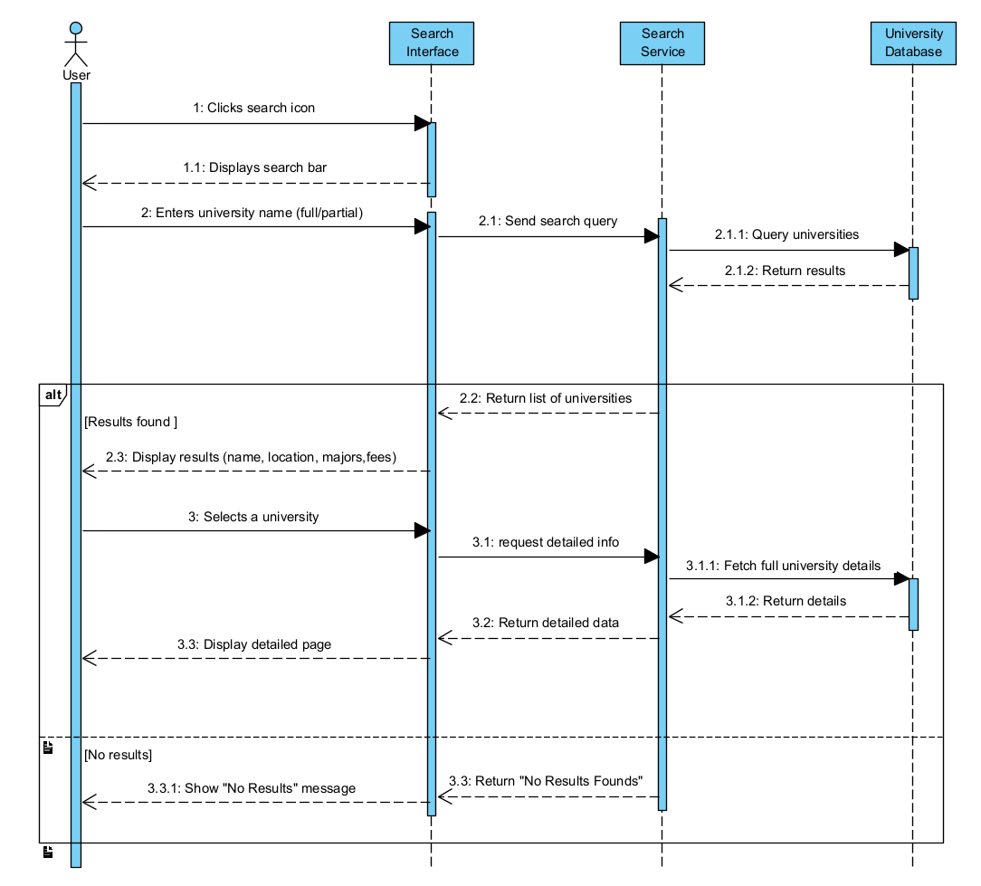
Figure 13. Search university sequence diagram

Database design
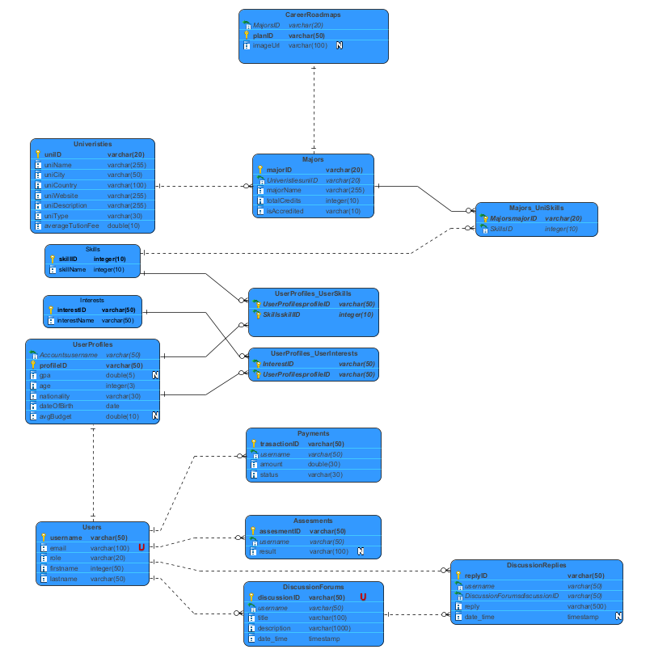
Figure 14. Entity Relationship Diagram

User interface design
Target Users and Design Influence
The primary target users of Acadeguide are high school students, university freshmen, and students considering a major change. These users often seek intuitive and visually engaging interfaces that require minimal technical knowledge. Many of them are digital natives who expect mobile applications to feel modern, responsive, and friendly. This influenced our decision to adopt a simple, youth-oriented interface that balances aesthetics with usability. Accessibility was also an important factor, as our target group includes users with varying levels of familiarity with educational tools. Therefore, we prioritized clarity, minimal text clutter, and recognizable icons to make navigation easy for first-time users.
Overall Layout and Visual Design
The Acadeguide interface follows a clean and consistent layout built using Flutter’s material design principles. Each page maintains a uniform header, central content area, and a bottom navigation bar for primary actions. The color scheme uses orange and white as the primary colors, with accent colors in blue for interactive elements like buttons and icons to draw user attention.
Icons are simple and vector-based to maintain consistency across platforms. Subtle gradients and rounded corners were integrated into buttons and containers to give a modern and welcoming feel without overwhelming the user.
Screen Mockups and Key Design Decisions
The interface was structured around the app’s main use cases, which include user registration, taking assessments, viewing recommendations, and exploring universities. The Login and Registration pages feature minimal input fields, large buttons, and clear validation messages to ensure smooth onboarding. The Dashboard page serves as the main hub, presenting key actions like “Take Assessment” and the ability to view your student card.
The Search Universities page uses a prominent search bar and category filters for faster access to relevant data. The University Info page provides key statistics, tuition costs in a structured card layout for easy comparison. These mockups were designed with consistency and user flow in mind, ensuring that every screen transition feels predictable and logical.
Navigation Design
Acadeguide employs a bottom navigation bar to facilitate easy access to the app’s primary modules—Dashboard, Search, and Profile. Each screen uses a top app bar containing either a title or a back arrow to maintain orientation and support quick return navigation. For secondary flows such as “Reset Password” or “Edit Profile,” modal dialogs or full-screen routes are used, following mobile UX conventions.
Gestural navigation is also supported, allowing users to swipe between tabs or scroll through content smoothly. Clear visual cues, such as highlighted icons and breadcrumb titles, guide users and reduce confusion. The overall navigation flow is intentionally flat and intuitive, minimizing the number of taps required to complete common tasks.
Novel and Usability-Enhancing Features
One of the novel aspects of Acadeguide’s UI is its personalized dashboard, which dynamically adapts to each user’s progress. For instance, after completing the assessment, the dashboard automatically updates to display recommended majors and links to related universities. This provides a sense of progression and engagement.
Additionally, Acadeguide integrates a chatbot advisor interface powered by AI, designed with a conversational bubble layout familiar from messaging apps, reducing user anxiety in seeking guidance. Visual feedback mechanisms, such as animated loading icons, success notifications, and error messages with contextual tips, enhance user confidence during interactions.
Accessibility considerations include high color contrast ratios, scalable text sizes, and responsive layouts for various screen dimensions. Overall, these design innovations improve usability, promote engagement, and make the system feel approachable and human centered.
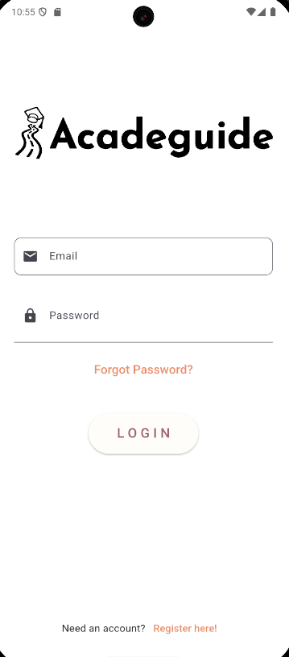
Figure 15. Login page
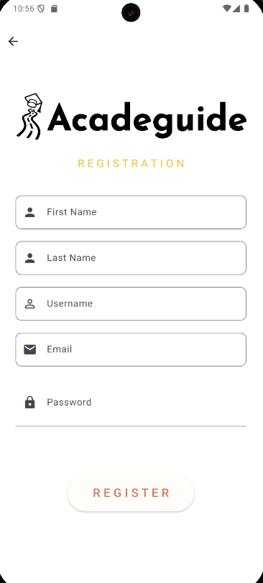
Figure 16. Registration form page
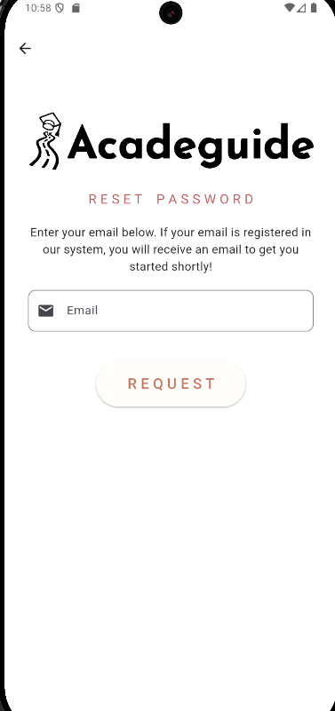
Figure 17. Reset password page
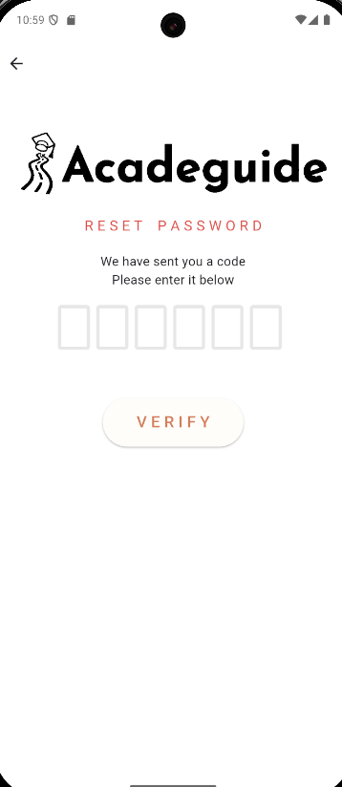
Figure 18. Reset password OTP page
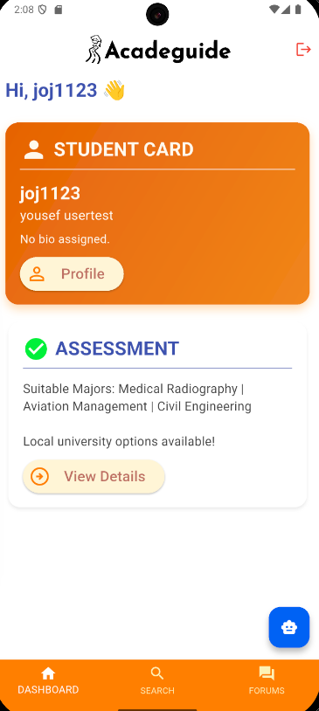
Figure 19. Dashboard page
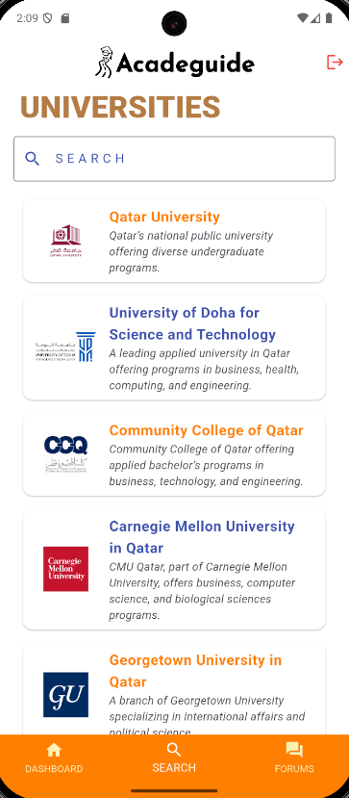
Figure 20. Search universities page
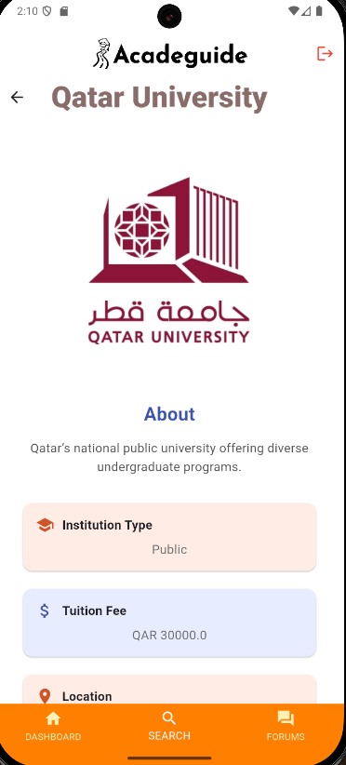
Figure 21. University info page

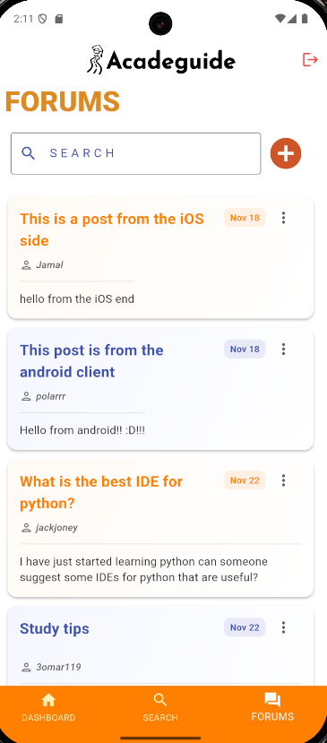
Figure 22. Forums page

]
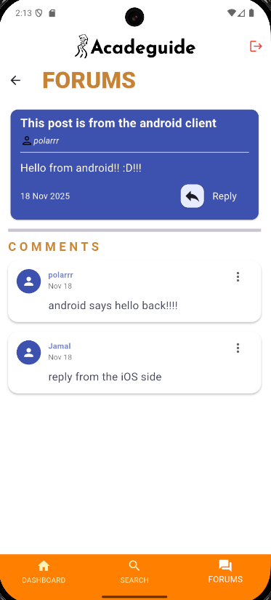
Figure 23. Forum details page
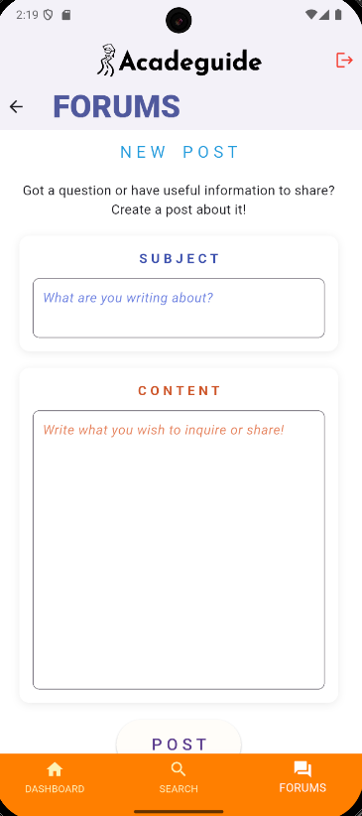
Figure 24. Create forum page

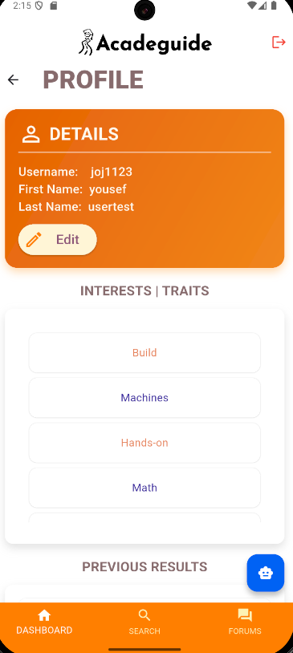
Figure 25. Profile page

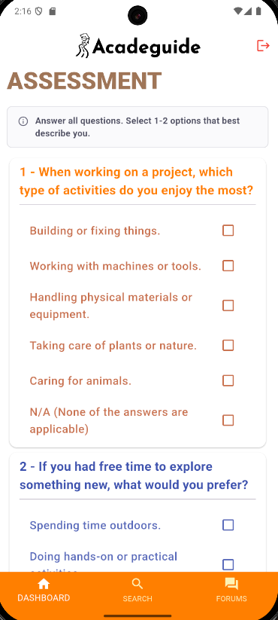
Figure 26. Assessment page
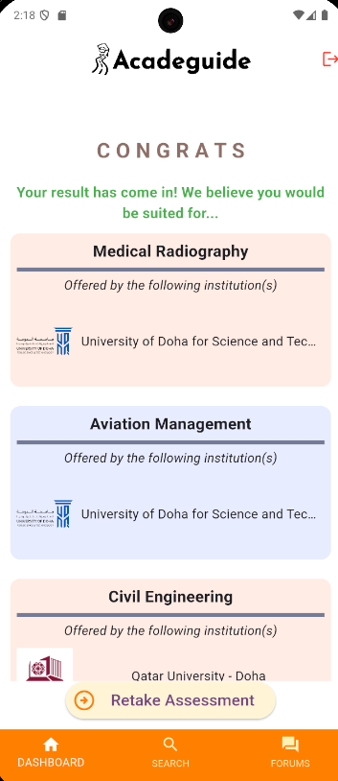
Figure 27 Result Page

Design patterns
1. Model–View–Controller (MVC) Pattern

Rationale:
The MVC pattern was adopted to separate user-interface code from business logic and data management. In Flutter, the View corresponds to UI widgets, the Controller handles input and coordination logic, and the Model manages structured data classes. This separation simplifies development and debugging, as each layer can evolve independently.
Class Diagram:
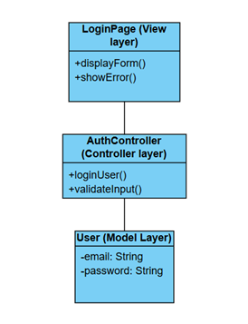
Figure 29. MVC pattern class diagram

Impact:
Applying MVC improved maintainability and testability by enforcing clear boundaries between presentation and logic layers. Developers can test controllers without rendering the UI, and designers can modify interfaces without breaking functional code. However, if developers place too much logic inside widgets, coupling may reappear, reducing some of the intended modularity benefits.
2. Factory Pattern
Rationale:
The Factory pattern was applied to streamline the creation of ForumPost objects from user input. Each forum post has essential attributes such as a subject, description, userId, and timestamp. Instead of constructing these objects manually in multiple parts of the codebase, the system centralizes object creation in ForumPostFactory. This ensures consistent parsing, validation, and initialization of posts.
Class Diagram:
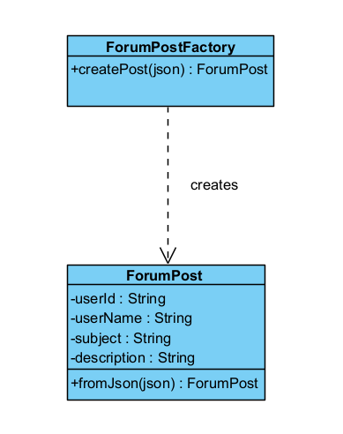
Figure 30. Factory design pattern class diagram
Impact:
This pattern improves reusability and reliability by encapsulating object-creation logic and preventing inconsistent constructors. It also simplifies future changes to data formats. The main drawback is a minor abstraction layer that new contributors must learn before extending model classes.

3. Observer Pattern
Rationale:
The Observer pattern is realized through Flutter’s ChangeNotifier/Provider. When user data changes in Supabase Realtime, the model notifies registered UI widgets automatically. This ensures a reactive interface where components remain synchronized with backend data without manual refreshes.

Sequence Diagram:
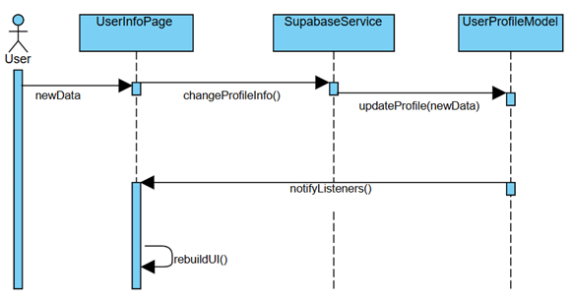
Figure 31. Observer pattern sequence diagram

Impact:
It strengthens usability, responsiveness, and performance by eliminating redundant polling. Yet, if not optimized, excessive listeners may cause unnecessary UI rebuilds, slightly affecting efficiency in large widget trees.

Implementation

Hardware/software used
Table 10. Hardware/software to be used
HW/SW details | Justifications
Flutter | The reason to choose Flutter as the main framework for our Mobile app development is because Flutter allows us to create responsive apps multi platforms from a single codebase. This saves time and money and offers a smooth user experience with its wide range of built-in widgets along with a huge support community that provides tips and extra widgets to make it even better.
Dart | We chose Dart because it’s the programming language used with Flutter. It’ easy to learn, looks like Java and supports OOP and reactive programming. It allows us to be modular and supported across almost all services.
Supabase | We chose Supabase because it’s an open-source backend that’s easy to setup and works perfectly with Flutter. It provides features for Authentication, real-time database, and storage all in one platform. This helps us build and manage our app’s backend faster without needing to deal with servers.

Challenging issues and solutions
During our implementation, we faced several challenges when trying to reset the password. At first, we used a method that sent a reset link, but it required deployment, which wasn't ideal at this stage. So, we decided to take a different approach and built our own way of verifying the user while keeping the process secure. We used the Supabase authentication system to send a 6-digit OTP to the customer. The customer enters the OTP to verify their identity and is then redirected to reset their password. The main lesson we learned from this experience is that there's no single way to solve a problem, there are many options that can lead to the same result. What matters is choosing the one that best fits your needs.

Testing and evaluation

Functional testing

8.1.1. Unit testing

1. Take Assessment
The Take Assessment use case cannot be fully unit tested because it depends on continuous user interaction, dynamic question flow, UI state changes, and communication with the backend. These behaviors span multiple components and cannot be isolated into small, testable units. Instead, this feature is more appropriately evaluated through acceptance testing, where the entire assessment workflow is tested as a real user would experience it. Acceptance testing verifies that questions load correctly, navigation between steps works as intended, answers are recorded, scoring is accurate, and the results are stored and displayed properly. It also checks that error handling, timing, and UI feedback behave correctly under different user actions. While individual utility functions inside the assessment logic can be unit tested, only acceptance testing can confirm that the complete end-to-end assessment process meets user and system requirements.
The following is a part of the questionnaire screen and the results screen:
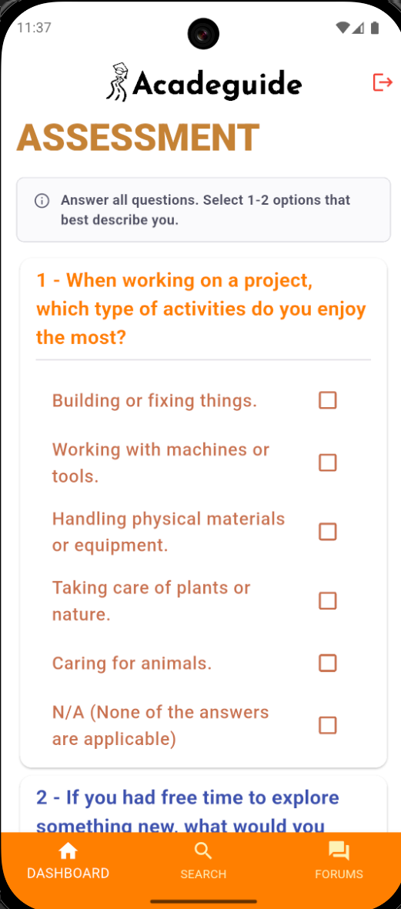
Figure 31. Test and result screens

For this use case, acceptance testing was performed due to its interactive and multi-step nature, which cannot be fully verified through unit testing alone. The acceptance tests showed that the assessment screen loads properly, questions are displayed in the correct order, answers are recorded, navigation between questions works smoothly, and the system correctly transitions to the results screen when the assessment is completed. The expected system responses matched the actual outcomes in all tested scenarios, including starting the assessment, answering questions, finishing the last step, and viewing the recommended major. These results indicate that the implemented solution satisfies the requirements for guiding the user through the assessment workflow and generating accurate results based on their inputs.
2. Generate User Profile
For unit testing, predefined input data sets representing different types of assessment outcomes are fed into the profile generation function to verify that the correct profile is produced. This allows the testing process to confirm that the system consistently assigns the appropriate profile fields, handles edge cases, and follows the intended decision logic.

Using controlled data also ensures that the tests remain repeatable, independent of the user interface or backend services. As a result, the unit tests provide strong validation that the underlying logic for generating user profiles is accurate, reliable, and behaves as expected across a variety of predefined scenarios.
User profile generated using test data:
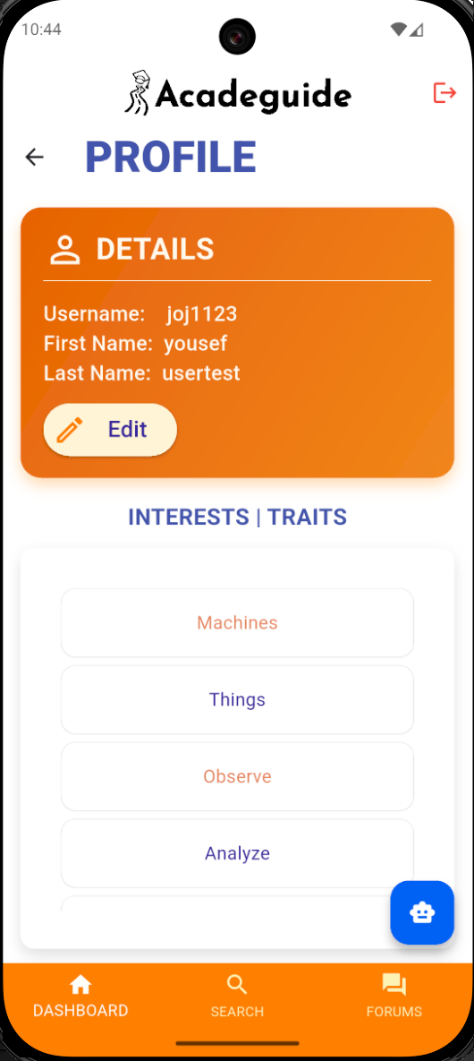
Figure 33. Profile screen with generated data
Testing of the Generate User Profile use case showed that the implemented logic behaves consistently and meets the functional requirements. By using predefined assessment data sets, the unit tests verified that the profile generator correctly maps input scores and personality indicators to the expected profile attributes. The system produced accurate and repeatable results across multiple scenarios, including edge cases such as tied category scores or minimal input values. All tests passed successfully, demonstrating that the profile generation rules were implemented correctly and that the output structure aligned with the required profile format.

3. Recommend Majors
The Recommend Majors use case was tested with predefined user profiles, we can verify the engine correctly maps attributes like personality and interests to the intended majors, independent of the UI or backend. This ensures consistent, rule-based recommendations, even for edge cases.

Two sample lists are created, one having personality traits and the other having interests. These lists then link to specific skills (e.g., "Investigative" maps to "Problem Solving"). This two-level structure allows the system to match a user's specific preferences against broader academic profiles. The algorithm scores majors by comparing them to user selections. For each major, it awards points whenever a user's specific interests or personality traits match those linked to the major. Each match adds one point.

The majors are sorted by their score and printed in descending order. Majors like Computer Science and Civil Engineering rank highest because their linked categories and traits (e.g., "Investigative" and "Conscientiousness") best match the user's selections.
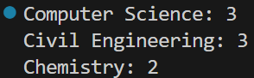
Figure 34. Recommendation system backend
Test results confirm that the solution works accurately. All unit tests passed, showing the engine correctly interprets various profile types, from strongly dominant to mixed traits and generates the expected major suggestions, meeting all core requirements.

4. Compare Universities
The Compare Universities use case relies on deterministic logic that filters and organizes university data based on predefined criteria linked to the user’s recommended major. After the assessment is completed and majors are generated, the system provides a curated list of universities relevant to the user’s academic direction. Using predefined datasets for example, a fixed list of universities, unit tests can verify that the comparison logic correctly sorts, filters, and aligns universities according to the calculated major.
Figure 35. Result screen based on user traits
The unit testing results for the Compare Universities use case demonstrate that the implemented solution satisfies the established requirements. All tests produced outcomes that matched the expected comparison results, validating the correctness of the filtering and ranking logic. The system consistently displayed the correct universities associated with a given recommended major. These successful results indicate that the comparison feature meets its functional requirements by allowing users to evaluate universities side-by-side and supporting informed decision-making based on their recommended major.
5. Discussion Forums
The Discussion Forums use case can be partially unit tested because the primary functionality under evaluation is the system’s ability to retrieve and display existing forum posts. Since this workflow relies on reading predefined data from the backend and mapping it to the corresponding ForumPost objects, it fits well within the scope of unit testing. By using predefined JSON structures representing forum posts—with fields such as subject, description, author ID, and timestamp the system’s parsing, data conversion, and list-building logic can be tested in isolation from the user interface.
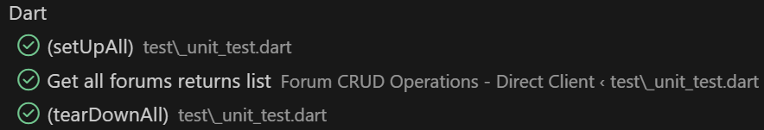

Figure 36. Discussion forums partial unit test
The test results for the Discussion Forums use case show that the implemented solution satisfies the required functionality for viewing forum posts. All unit tests executed with predefined data produced the expected results, demonstrating that the system successfully retrieves forum entries, converts them into ForumPost objects, and prepares them for display without errors.
6. Create Forum
The Create Forum use case test validates the creation process, that involves generating a ForumPost object with the appropriate fields, including subject, description, author ID, and timestamp. By testing the creation function with predefined valid and invalid inputs, the unit tests can verify that the system correctly validates required fields, rejects empty fields, and produces well-formed ForumPost objects when the inputs are correct.
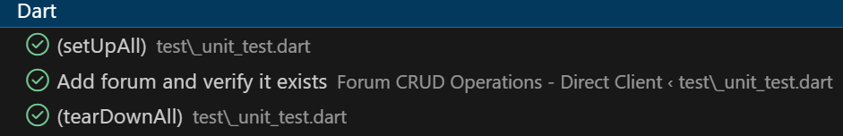
Figure 37. Create forum test
The test results for the Create Forum use case show that the solution satisfies the functional requirements for generating valid forum posts. All unit tests using predefined data successfully produced the expected outcomes, confirming that valid subjects and descriptions result in correctly structured ForumPost objects. Tests with missing fields behaved as intended, with the system detecting errors and preventing the creation of incomplete posts. This demonstrates that the system’s validation logic is robust and capable of handling a wide range of input conditions.
7. Delete Forum
The Delete Forum use case test was done using predefined forum post data, the unit tests can verify that the system correctly identifies posts eligible for deletion—typically those created by the same user—and properly updates the internal list of posts once a deletion request is initiated. The tests can also validate essential behaviors such as handling invalid deletion attempts, ensuring that posts without valid identifiers are rejected, and confirming that the post list is updated accurately after removal.
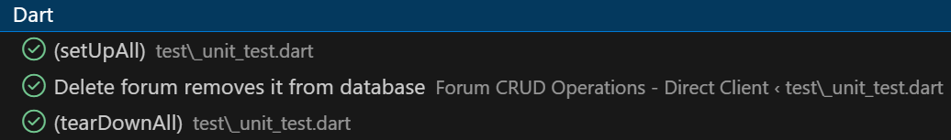
Figure 38. Delete forum test
The test results for the Delete Forum use case indicate that the implemented solution satisfies the required functionality. All unit tests executed with predefined data produced the expected outcomes: valid posts were successfully removed from the data structure, and the system correctly prevented deletion attempts when the user lacked permission. The system consistently updated the list of forum posts after each deletion, maintaining data integrity and ensuring that no orphaned references remained.
8. Reply in Discussion

Unit testing for the Reply in Discussion use case focuses on verifying the correctness of the logic that creates and associates a reply with the appropriate forum post. Using predefined data, the tests provide sample reply inputs such as text content, author ID, and timestamp and check that the system generates a valid Reply object and attaches it to the correct post.

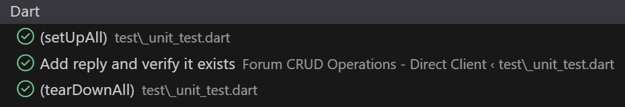
Figure 39. Reply in forum test

The test results for the Reply in Discussion use case show that the implemented solution meets the functional requirements for allowing users to add replies to a forum post. All unit tests using predefined reply inputs produced the expected results, valid replies were successfully created, associated with the correct post, and added to the existing reply list in the proper order. Invalid replies such as those missing content—were correctly identified and rejected by the validation logic.

9. Search
Unit testing for the Search use case focuses on validating the logic that filters and retrieves relevant universities or majors based on the user’s search query. Using predefined datasets, the tests supply different search terms—such as full names, partial names, uppercase variations, and invalid or empty queries—and verify that the search function returns a correct and consistent subset of results. These tests check for proper string matching, case-insensitivity, handling of whitespace, and correct behavior when there are no matching results.
The test results for the Search use case demonstrate that the implemented solution meets the required functionality. All unit tests produced the expected filter results for a wide range of valid and invalid search terms, confirming that the logic accurately identifies relevant entries and excludes unrelated ones. The system handled edge cases correctly, such as returning an empty list for invalid queries and preserving dataset integrity throughout the process. No unexpected behavior, crashes, or incorrect matches were observed during testing, and the search performance remained consistent across different input scenarios.

10. Search Universities
Unit testing for the Search Universities use case focuses on validating the logic that filters and retrieves universities from the predefined dataset based on user entered keywords or criteria. Using static university lists and controlled input values, the tests verify that the search function correctly identifies matches by university name, program availability, or other key attributes. The tests include variations such as full matches, partial matches, case insensitive searches, and unrelated keywords to ensure the logic handles all typical input scenarios.

Figure 40. University reading test
The test results for the Search Universities use case show that the implemented solution meets all functional requirements related to retrieving appropriate university results. Across multiple test scenarios, the system consistently returned the correct subset of universities for valid and partial search terms, and appropriately returned an empty list when no matches were found. The logic demonstrated reliable performance even in cases where university entries were incomplete, ensuring that missing data did not cause failures or inaccurate matches.

11. Search Forums
Unit testing for the Search Forums use case focuses on verifying that the system correctly filters forum posts based on a user-entered search keyword. Using predefined forum post data each containing fields such as subject, description, and author ID the tests evaluate whether the search logic accurately retrieves posts whose subjects or descriptions contain the query text.
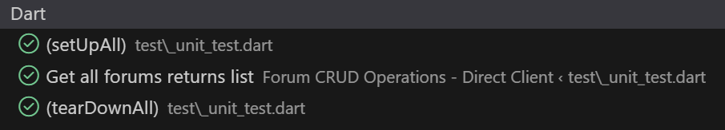
Figure 41. Search forums test
The test results for the Search Forums use case demonstrate that the implemented solution meets the functional requirements for enabling users to quickly locate relevant forum posts. Across all tested scenarios, the system consistently returned accurate and relevant results: matching posts were correctly identified and partial keywords produced expected subsets.
12. Register Account
The Register Account use case cannot be fully unit tested because it requires the user to verify their email through an external inbox, which introduces interaction outside the system’s codebase. Instead, the functionality is validated through acceptance testing, where the complete workflow is executed from the user’s perspective. During testing, the user enters valid registration details such as name, email, and password, and the system responds by validating the inputs, creating the account, and sending a verification email through the backend service.

The acceptance test results for the Register Account use case demonstrate that the implemented solution satisfies the intended functional requirements. All tested scenarios behaved as expected: valid registration attempts successfully triggered account creation and email verification, while invalid inputs appropriately resulted in error prompts.
13. Login/Logout
Unit testing for the Login/Logout use case focuses on validating the internal authentication logic responsible for processing user credentials, handling input validation, and updating the application’s authentication state. Using predefined datasets containing valid and invalid email–password combinations, the tests verify that the login function correctly authenticates valid credentials and appropriately rejects incorrect or incomplete ones.
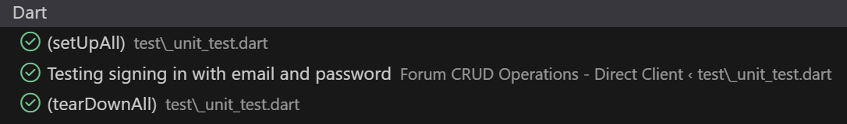
Figure 42. Login-logout test
The test results for the Login/Logout use case indicate that the implemented solution meets all relevant authentication requirements. The login tests showed that users with valid credentials were authenticated successfully, while invalid logins were consistently rejected with appropriate error messages. The system correctly updated the user’s authentication status upon successful login and maintained session integrity throughout the interaction.

14. Reset Password
The Reset Password use case cannot be fully unit tested because it depends on an external verification process. This step occurs outside the application and requires human interaction, making it unsuitable for isolated unit testing. Instead, the functionality is validated through acceptance testing by simulating the full user workflow.

The acceptance test results demonstrate that the Reset Password feature performs reliably and meets the intended system requirements. The application correctly prevented password changes until the external verification was completed, ensuring both security and compliance with standard authentication practices. After completing the email verification step and submitting a new password, the system updated the account credentials correctly and allowed the user to log in using the new password.

8.1.2. Integration testing

The integration testing performed for Acadeguide evaluates how major system components work together across realistic end-to-end user journeys, ensuring that authentication, assessment, profile management, search modules, forums, and the chatbot function cohesively as a unified platform. Two scenarios were tested: a new user experiencing the full workflow from registration to interacting with Rasheed, and a returning user accessing their previously generated data while performing routine actions. These scenarios verify that data flows correctly between the frontend and backend and that state is preserved across modules.

Scenario 1: New User Full Journey

1. User Registers a New Account
The user opens the app, navigates to the registration screen, and submits their personal details. The system validates the inputs, sends a verification email through Supabase, and waits for the user to confirm. After email verification, the account becomes active, and the user can login.
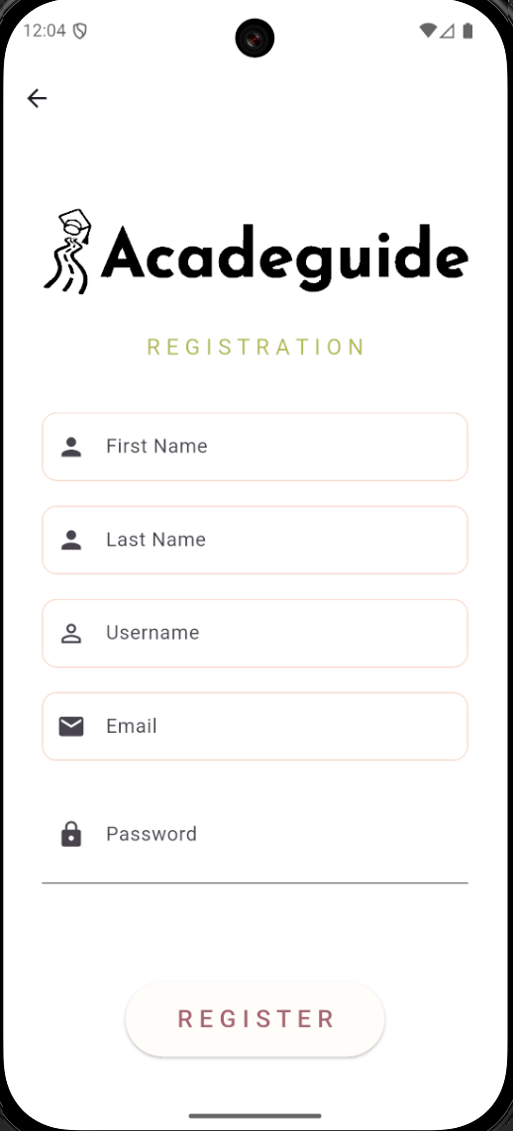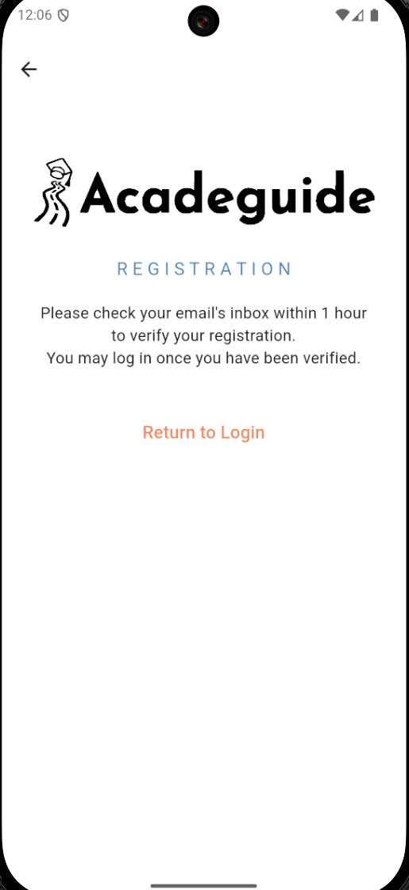
Figure 43. User registers a new account

2. User Takes the Assessment
From the dashboard, the user selects “Take Assessment.” The assessment module loads all questions, records the user’s responses, and calculates an initial profile. The scoring module communicates with the profile generator to produce major recommendations based on interests and strengths.
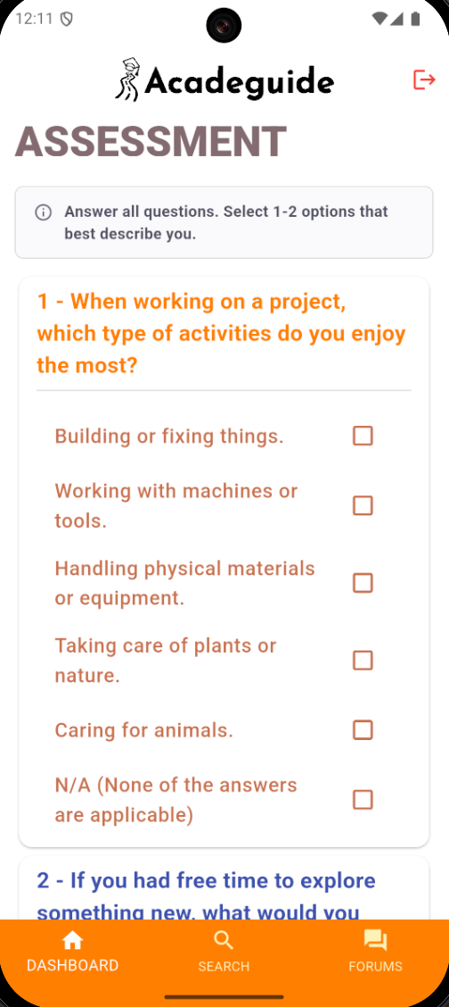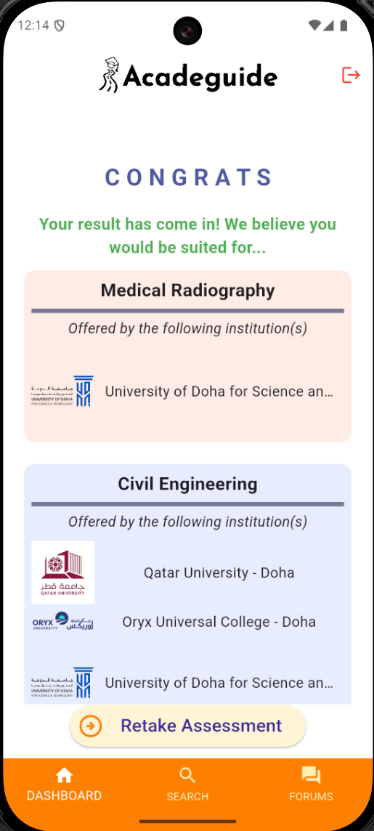
Figure 44. User takes assessment

3. User Views Their Generated Profile
After completing the assessment, the user opens the “Profile” section. The system retrieves stored assessment results, interests, and traits from Supabase.
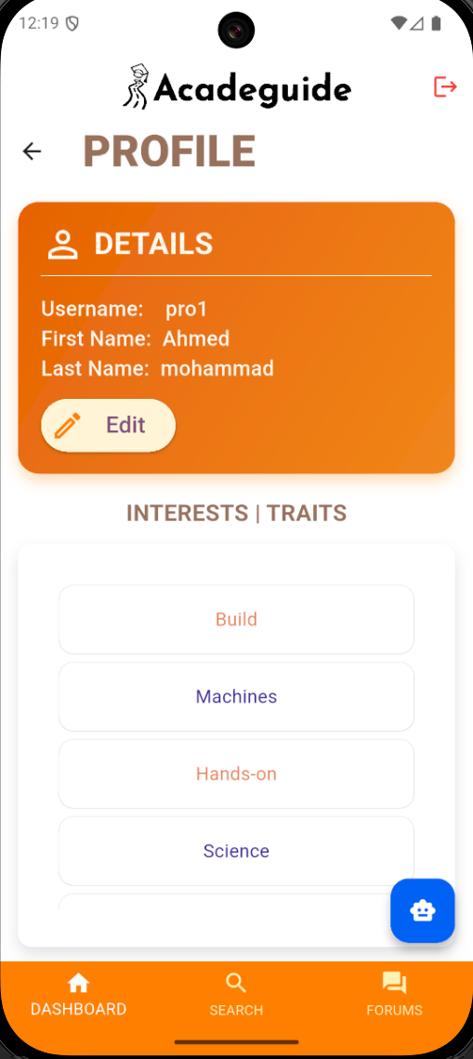
Figure 45. User views generated profile
4. User Edits Their Profile
The user modifies specific profile details such as Username or first name. A confirmation message is displayed ensuring that no unintended changes are made. When confirmed, the updated data is saved to the backend.
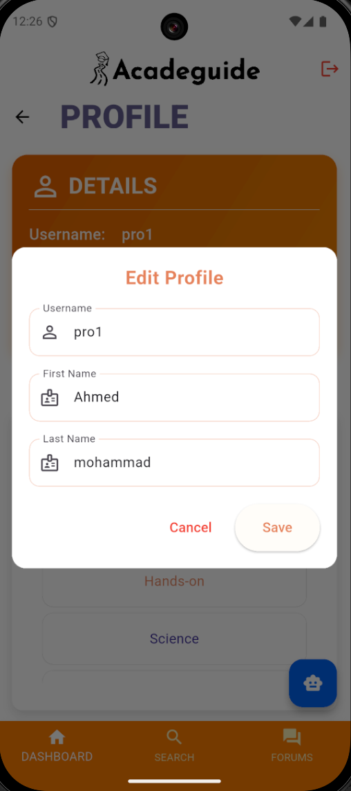
Figure 46. User edits profile
5. User Searches for Universities
The user navigates to “Search” and enters a search term. The system filters the university dataset and displays matching results.
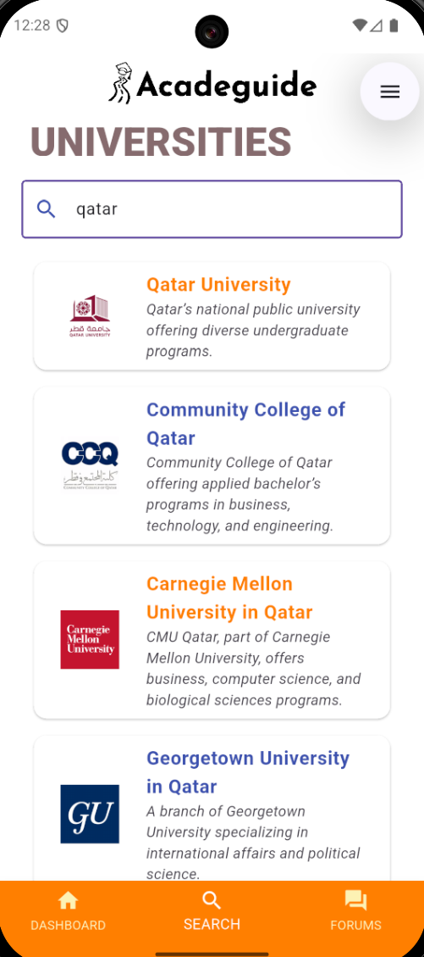
Figure 47. User searches for universities

6. User Searches Forums
The user navigates to “Forums” and searches for topic keywords. The system retrieves forum posts matching the search term and displays them.
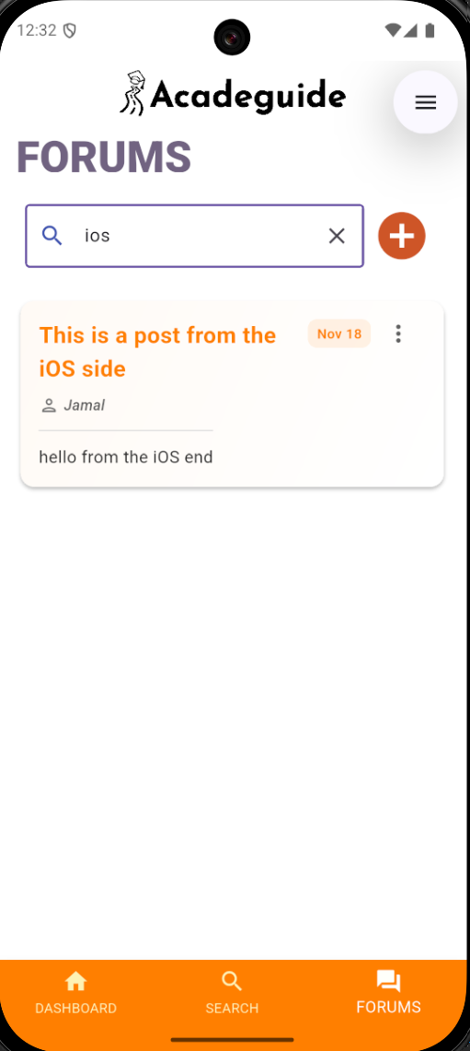
Figure 48. User searches forums
7. User Posts a New Forum
The user creates a new forum post by entering a subject and description. The forum module sends the post to Supabase, stores it, and refreshes the list.
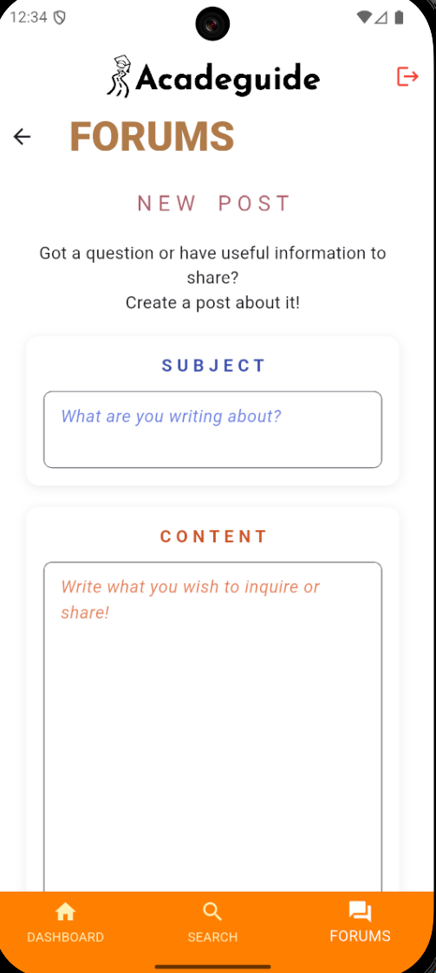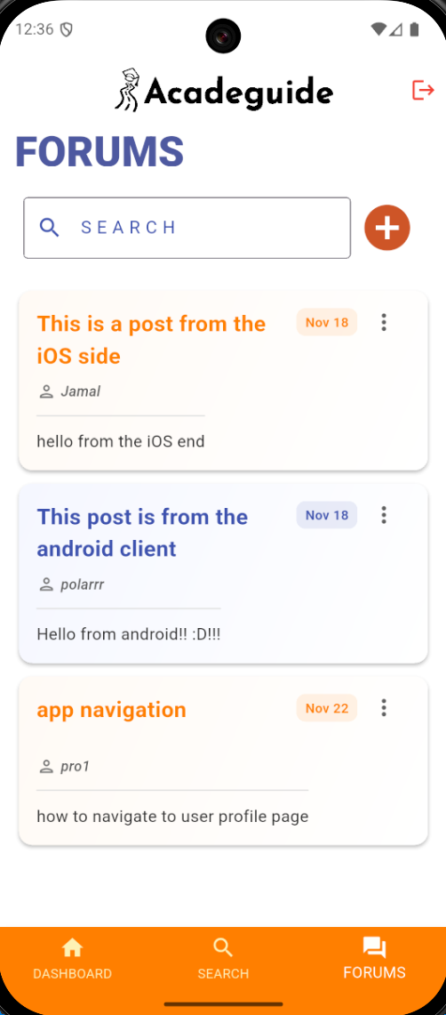
Figure 49. User posts a new forum
8. User Replies to a Forum Post
The user opens a forum post and submits a reply. The reply is stored in the backend and linked to the correct parent post. The updated list of replies is immediately shown.
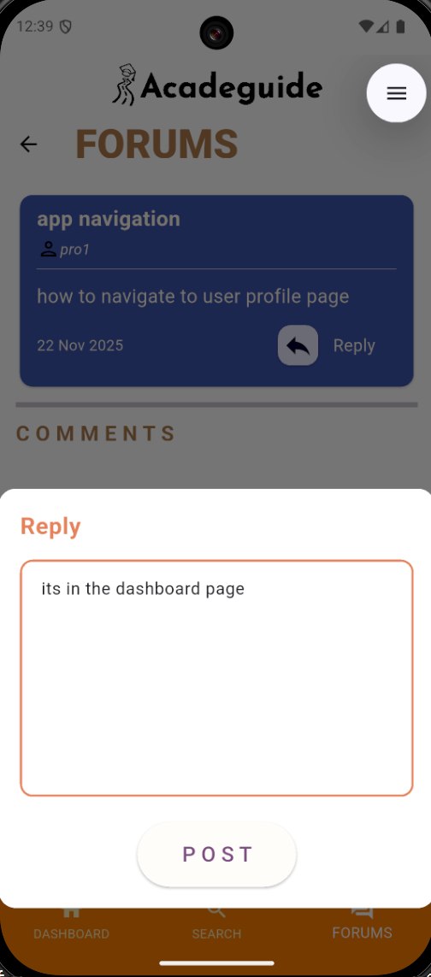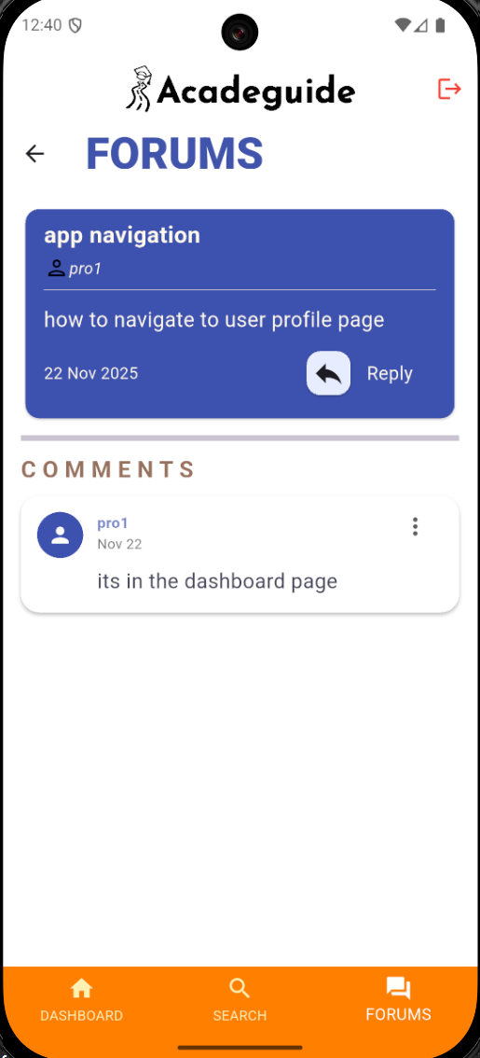
Figure 50. User replies to a forum post

9. User Uses the Chatbot (Rasheed)
The user opens the AI chatbot "Rasheed," types a question about majors or admissions, and views the response.
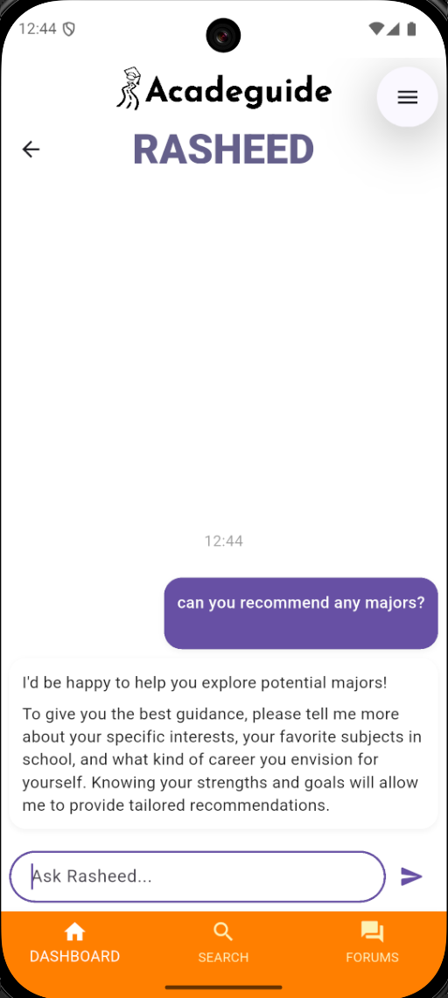
Figure 51. User interacts with Rasheed
Scenario 2: Returning User Workflow
1. User Logs into Existing Account
The user enters their email and password. The system validates the credentials and retrieves the user's stored assessment results, profile data, and forum interactions.
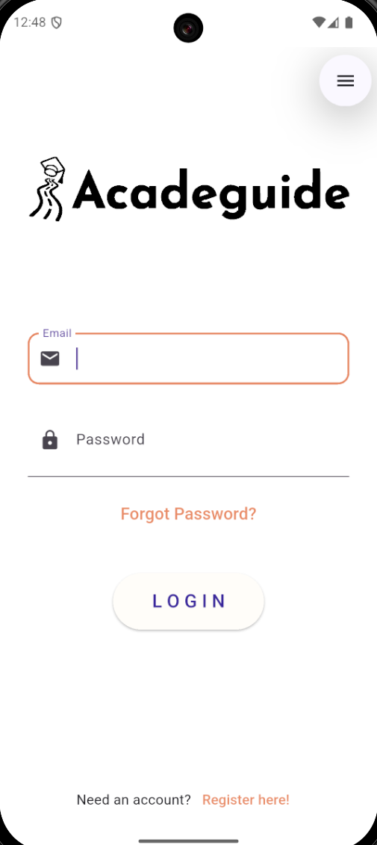
Figure 52. Returning user logs in
2. User Views Their Generated Profile
After completing the assessment, the user opens the “Profile” section. The system retrieves stored assessment results, interests, and traits from Supabase.
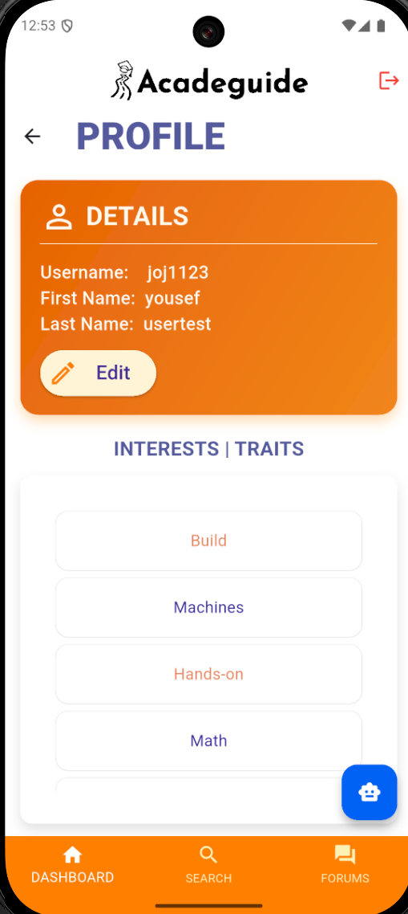
Figure 53. Returning user views their profile
3. User Edits Their Profile
The user modifies specific profile details such as Username or first name. A confirmation message is displayed ensuring that no unintended changes are made. When confirmed, the updated data is saved to the backend.
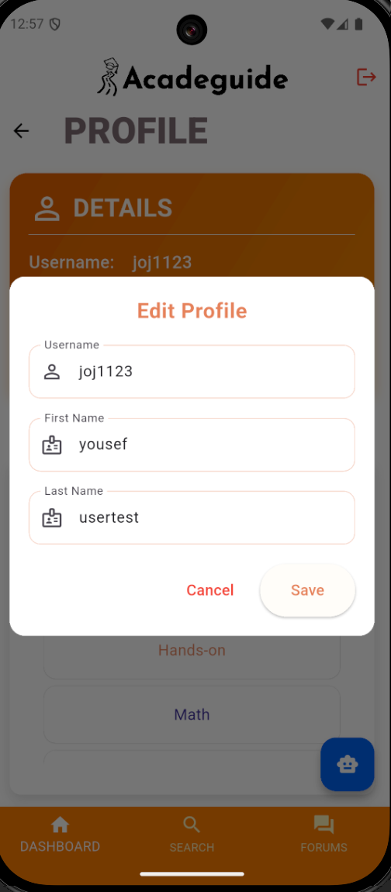
Figure 54. Returning user edits their profile
4. User Searches for Universities
The user navigates to “Search” and enters a search term. The system filters the university dataset and displays matching results.
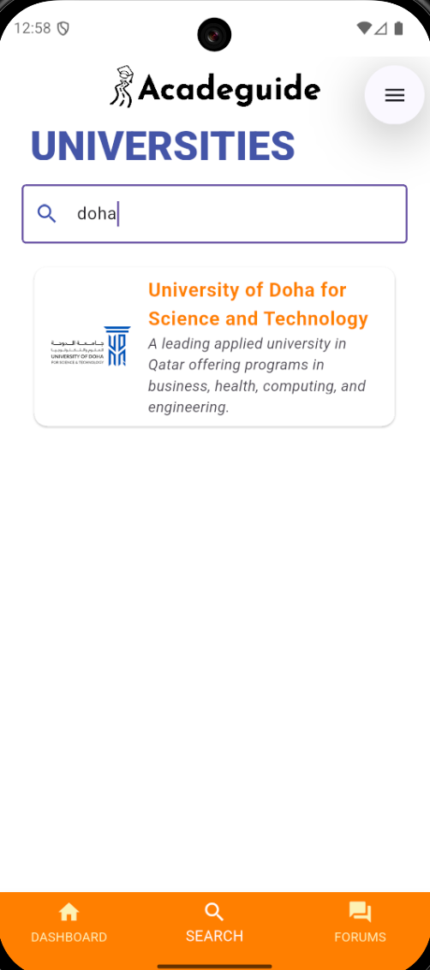
Figure 55. Returning user searches universities
5. User Searches Forums
The user navigates to “Forums” and searches for topic keywords. The system retrieves forum posts matching the search term and displays them.
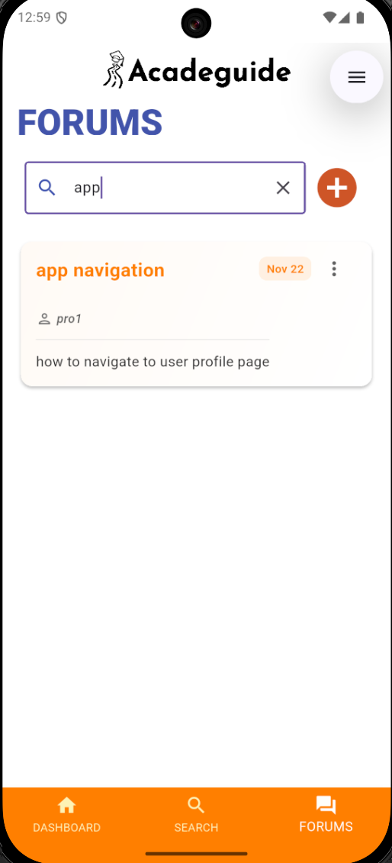
Figure 56. Returning user searches forums
6. User Posts a New Forum
The user creates a new forum post by entering a subject and description. The forum module sends the post to Supabase, stores it, and refreshes the list.
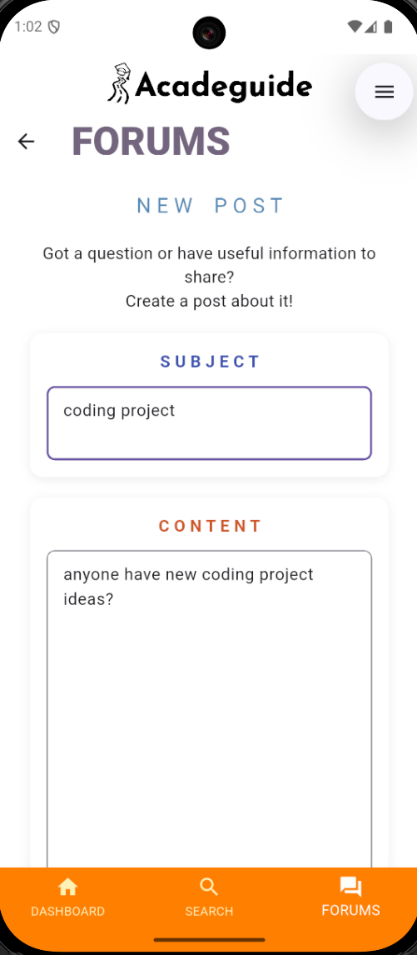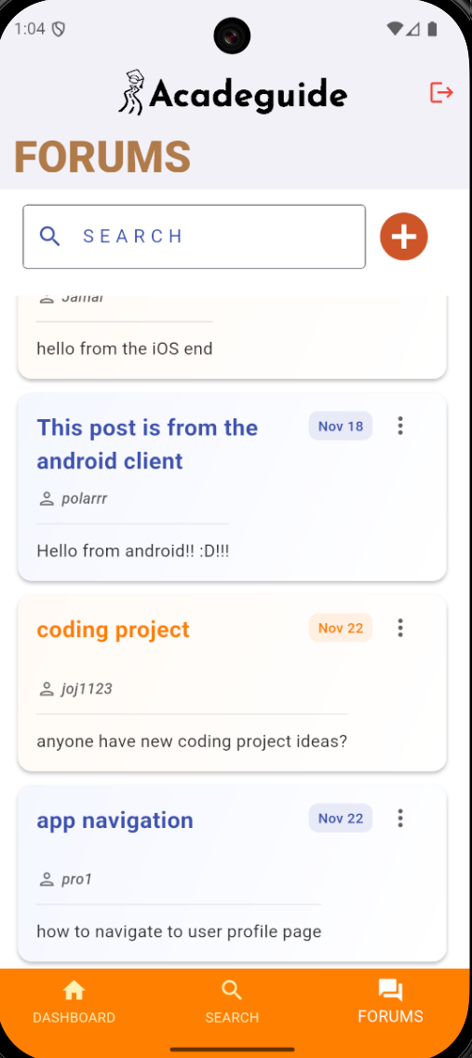
Figure 57. Returning user posts a new forum

8. User Replies to a Forum Post
The user opens a forum post and submits a reply. The reply is stored in the backend and linked to the correct parent post. The updated list of replies is immediately shown.
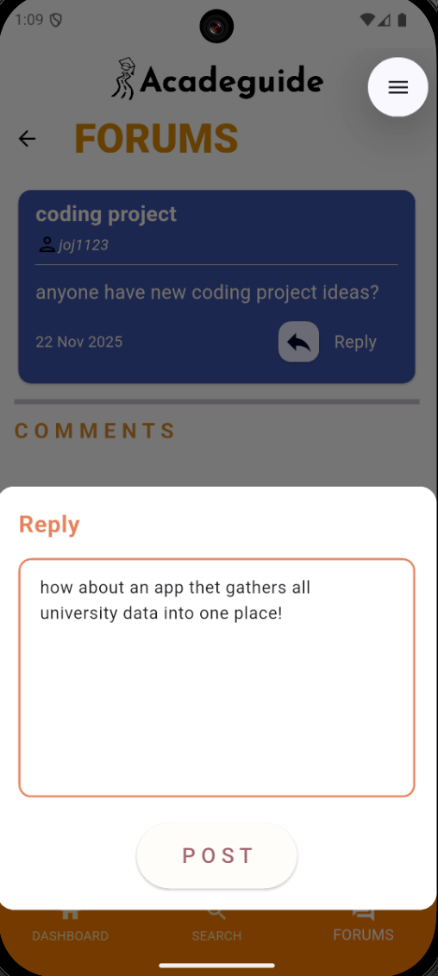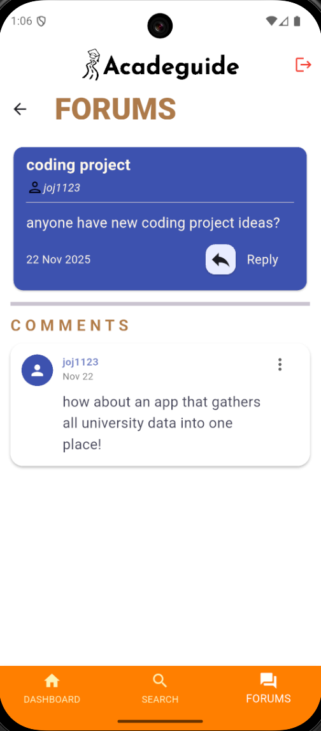
Figure 58. Returning user replies to a forum post
9. User Uses the Chatbot (Rasheed)
The user opens the AI chatbot "Rasheed," types a question about majors or admissions, and views the response.
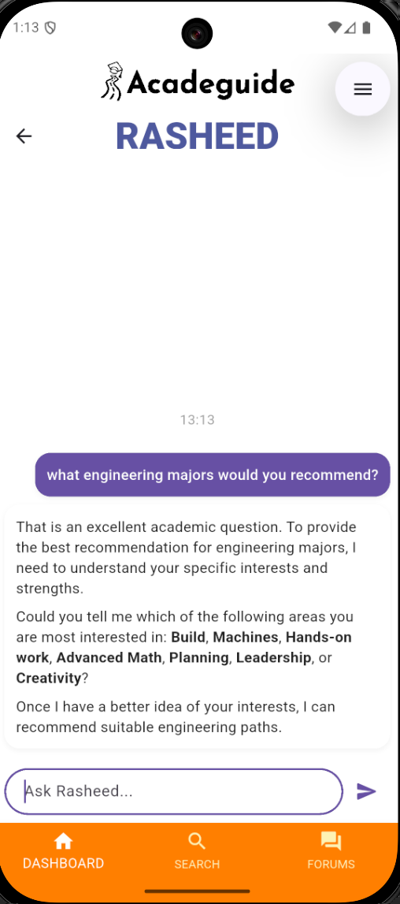
Figure 59. Returning user interacts with Rasheed

The integration testing confirms that Acadeguide’s interconnected features operate smoothly and reliably when used together in realistic user journeys. Both scenarios demonstrated consistent data flow between the frontend and backend, stable transitions across modules, and accurate preservation of user specific information. Critical functionalities, such as registration, assessment processing, profile generation, searching, forum participation, and chatbot interaction, performed cohesively without conflicts or breakdowns. Overall, the results validate that the system functions as a unified platform, meeting its intended purpose of guiding students through academic exploration while maintaining a seamless and intuitive user experience.

Non-functional testing

Performance:
The performance aspect of Acadeguide is measured with the help of the Stopwatch class that comes with Dart. We included a timer to measure the time taken during various tasks of the application. One such task which was assessed for the time taken was the undertaking of the main assessment, which happens to be one of the core features of our application. Realistically speaking, we aimed for the test to take around 5-10 minutes for completion. We were able to achieve this goal relatively easily as our assessment ended up being quite simplified for the purpose of improving user experience. Below is a screenshot showcasing the time taken for an assessment:
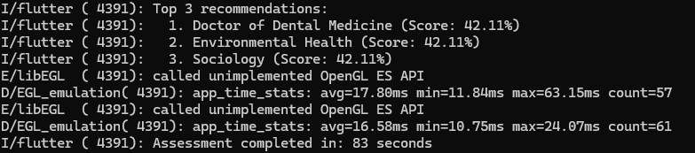
Figure 60. Assessment performance test
Another area of performance we wanted to assess was the time taken for database operations for Acadeguide. Like the assessment, we utilized the Stopwatch class and measured the time taken for various database operations to complete; we wanted this to be under 3 seconds for every individual operation. We were successful in achieving this. A few example screenshots have been provided below:
Figure 61. Database interaction performance testing
Interoperability:
To test the interoperability of Acadeguide, we launched our application on two clients of differing operating systems. Client A uses an android device while client B uses an iOS device.
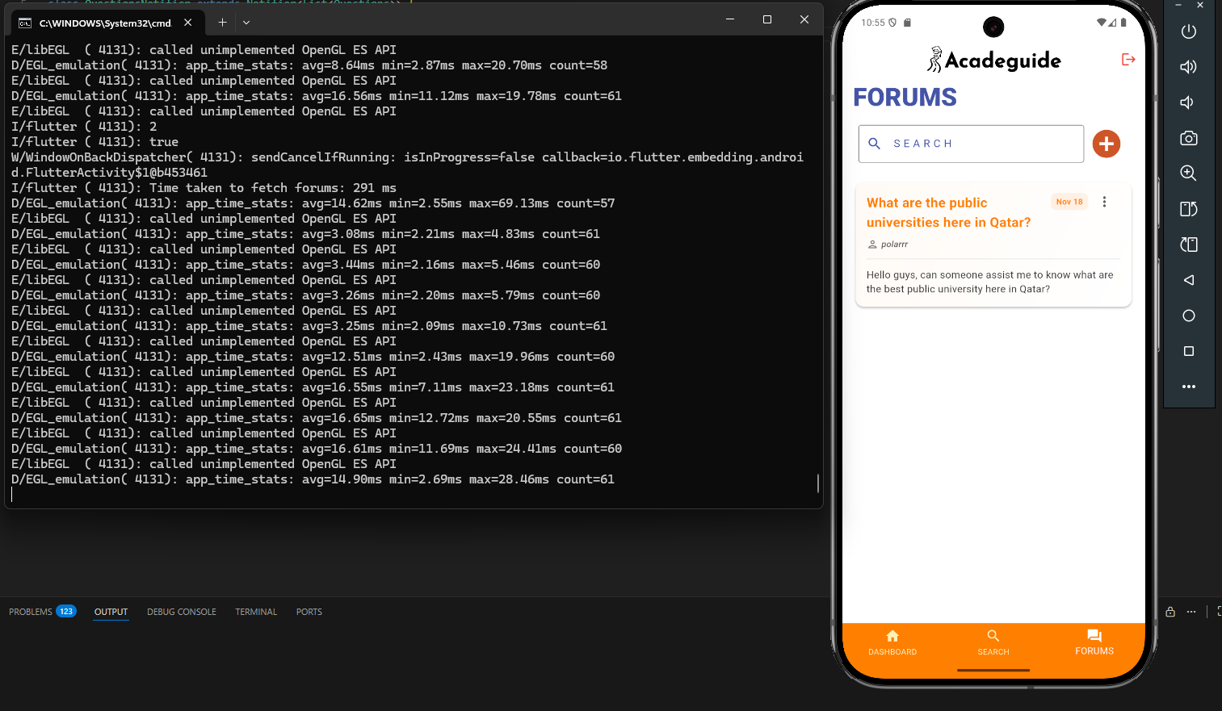
Figure 62. Client A - android device user
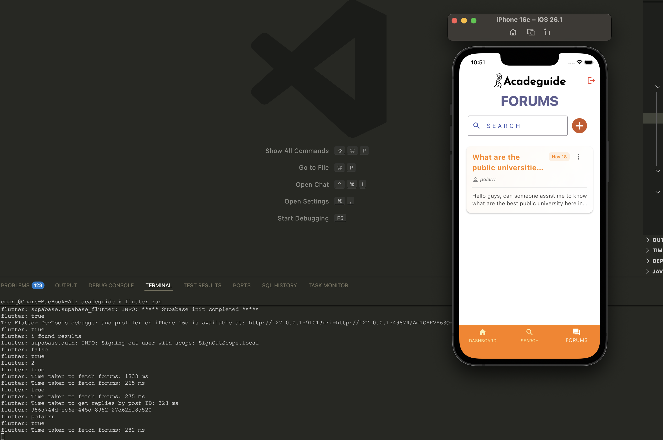
Figure 63. Client B - iOS device user

Client A makes a forum post as seen below.
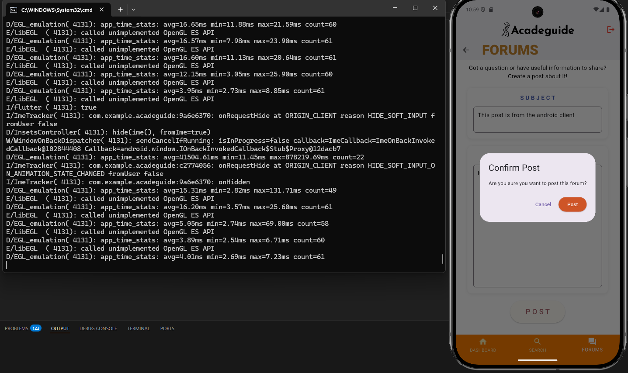
Figure 64. Client A makes a forum post
Client B can immediately observe the post the moment it gets added to our database backend which shows how despite running on different OS, the application works as intended.
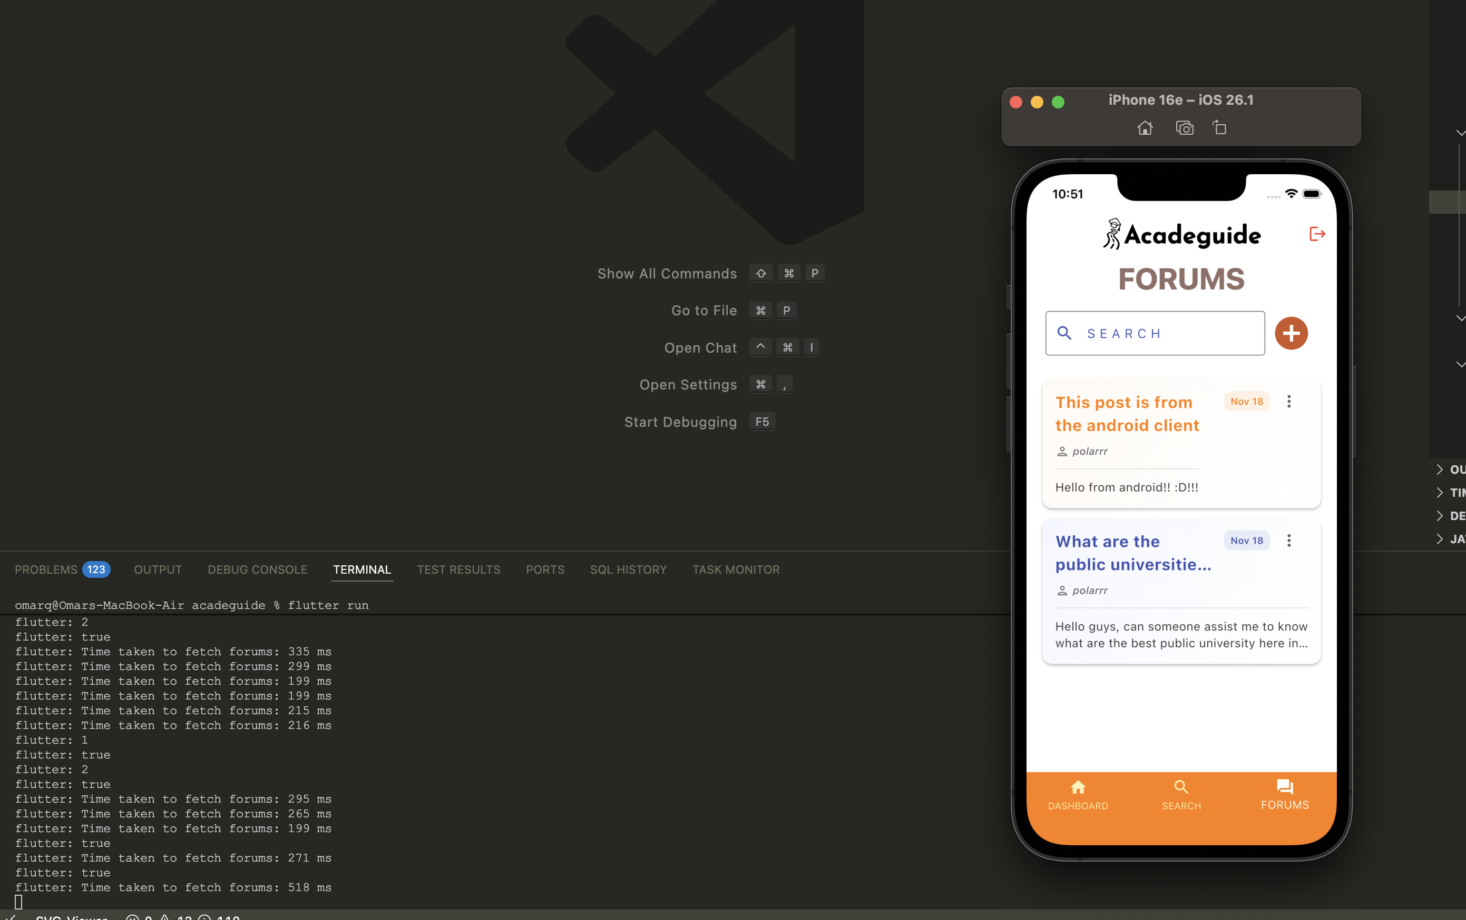
Figure 65. Client B can see A’s post

Testing the converse scenario, client B puts up a post on the Acadeguide forums.
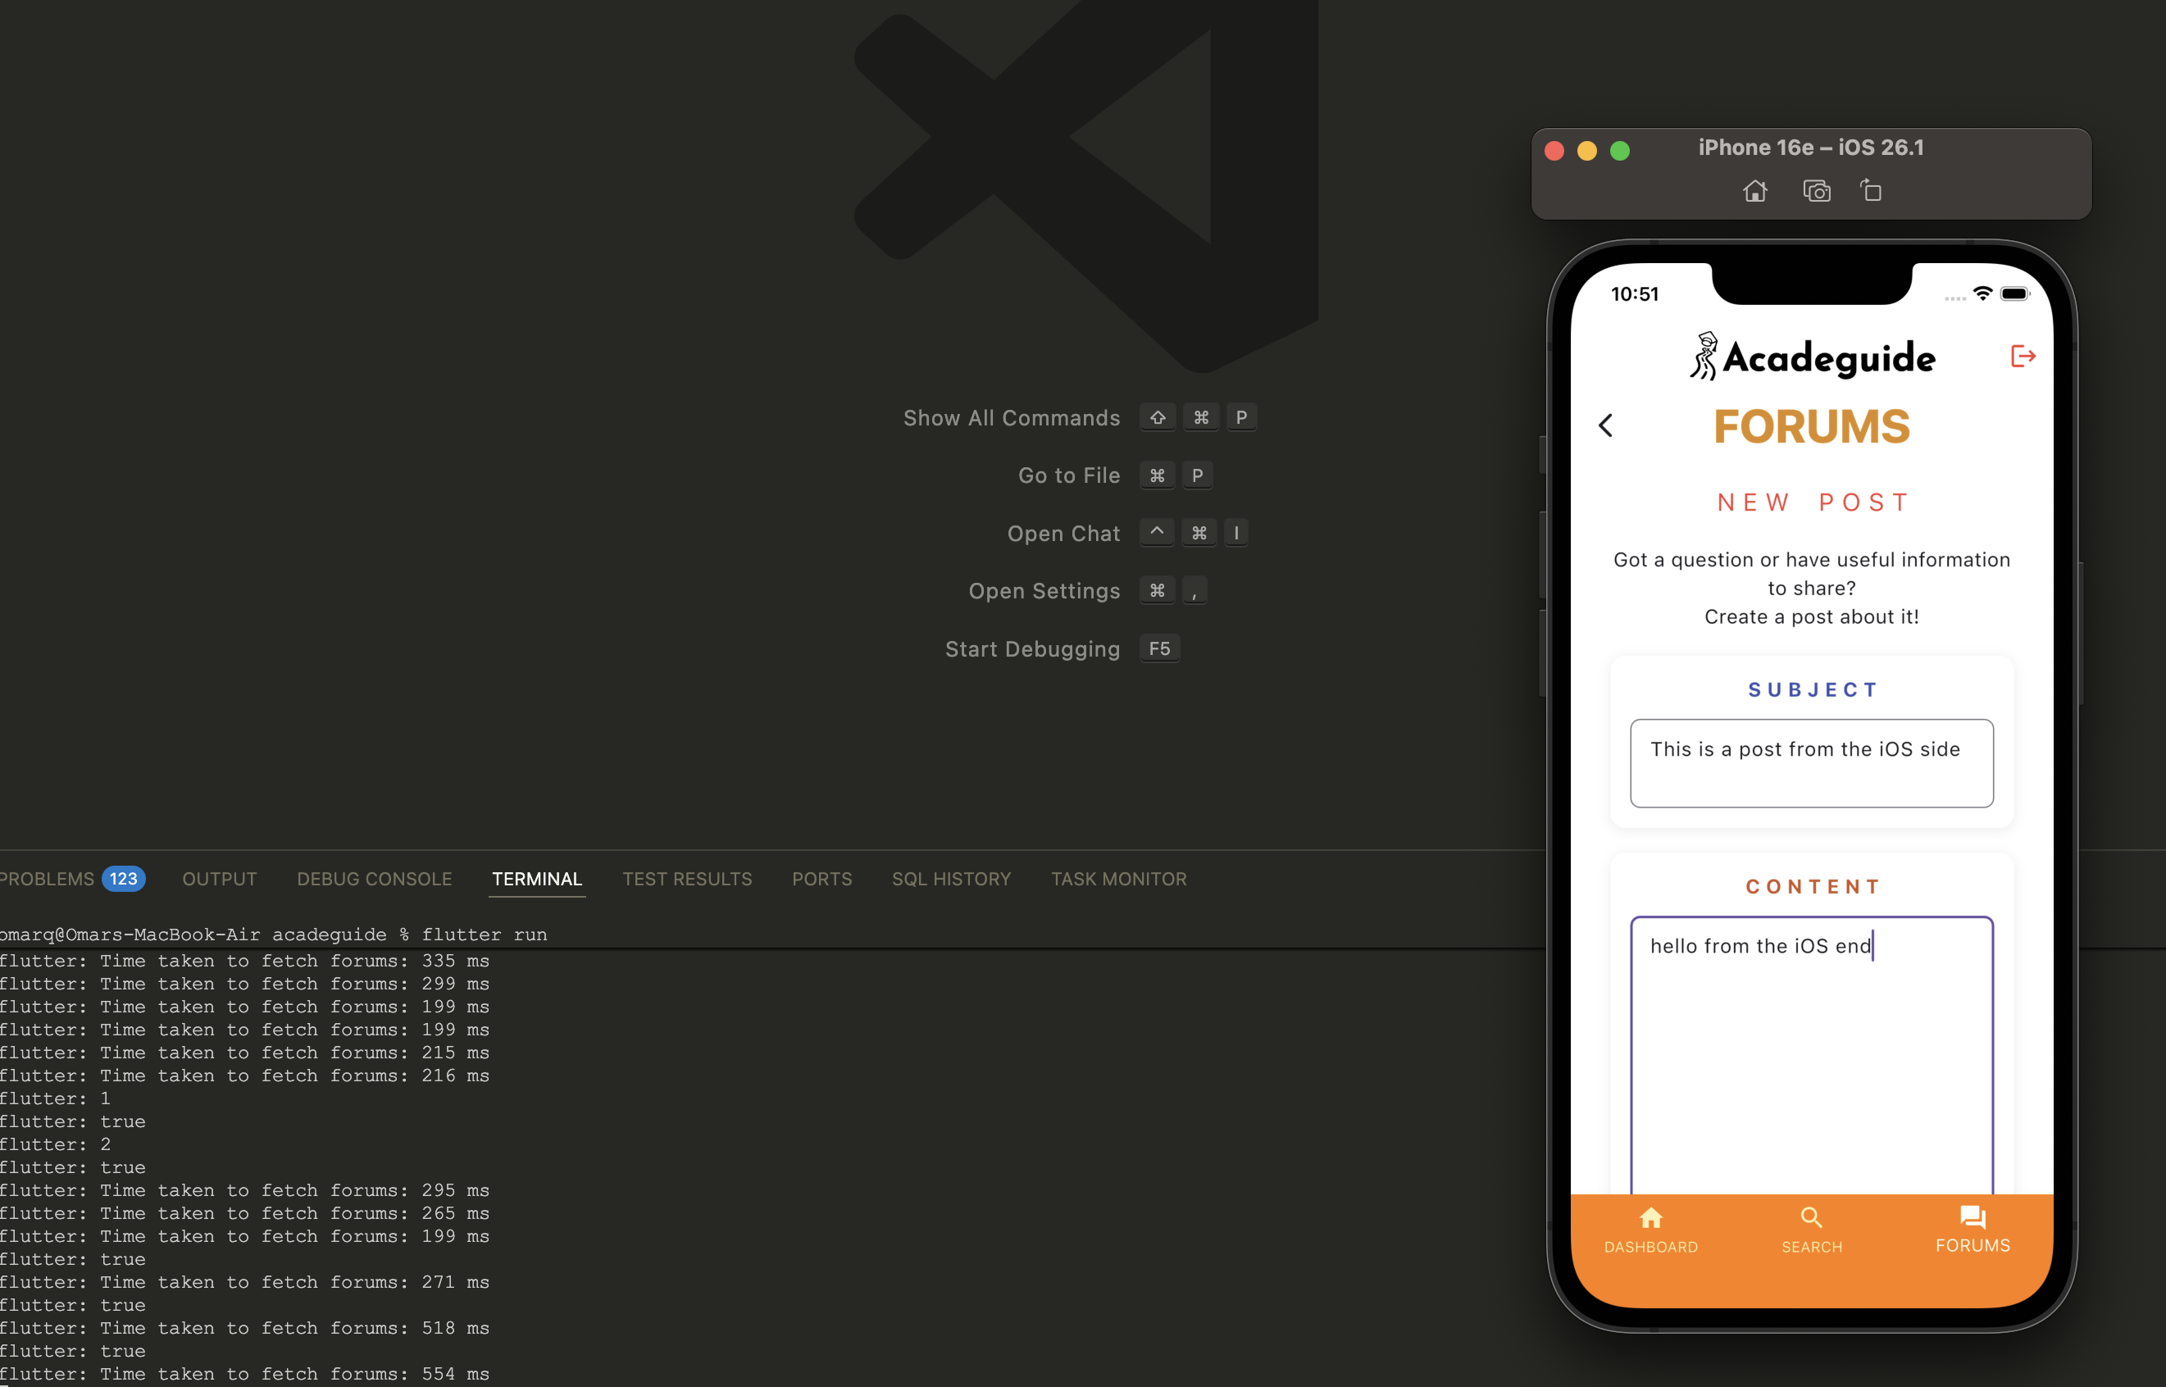
Figure 66. Client B makes a post
As we can observe, client A is able to see client B’s post normally upon B's successful post.
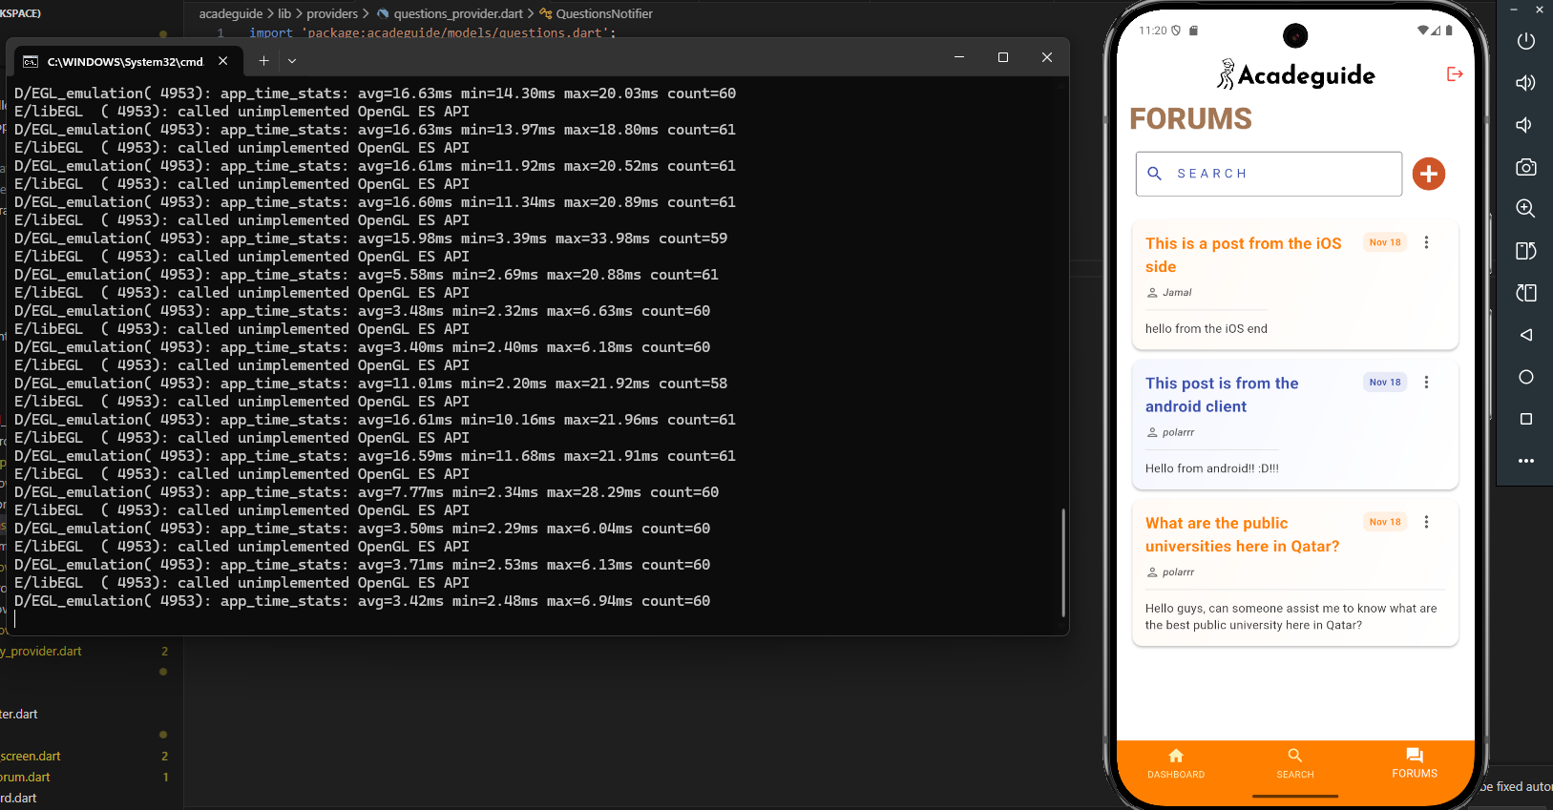
Figure 67. Client A can see B’s post

To take this a step further, we also tested the interoperability in our replies feature. Client B posts a reply to A’s forum post.
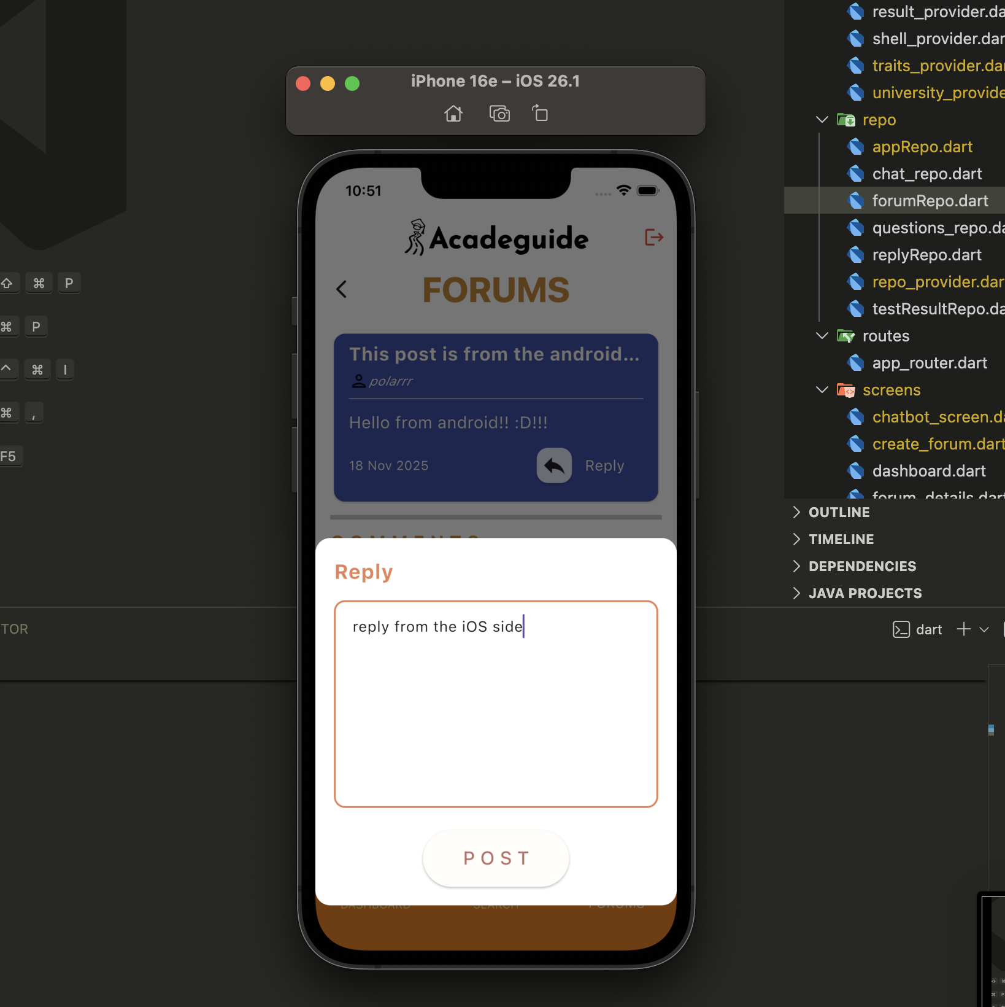
Figure 68. Client B replies to A’s post

B’s reply can be seen in A’s discussion post’s comments section by A.
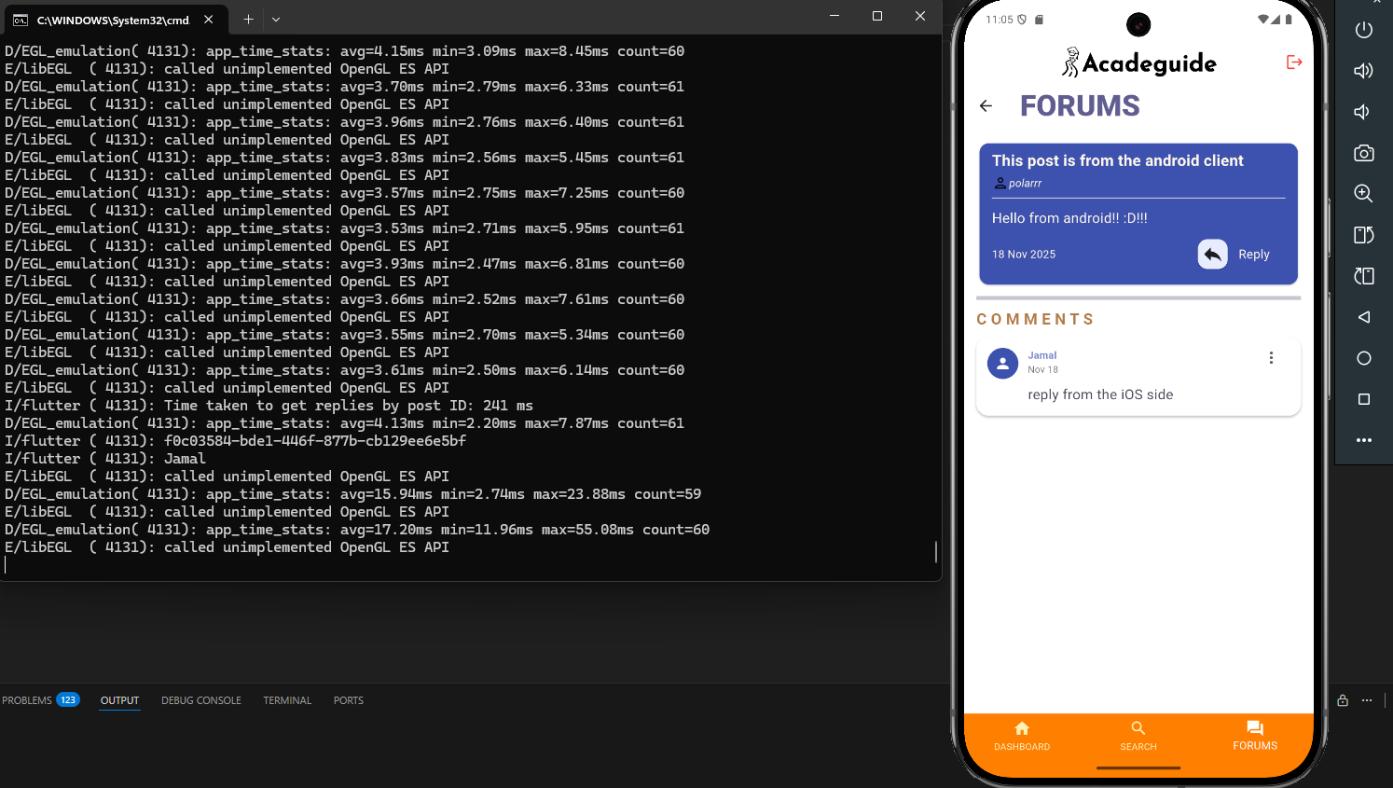
Figure 69. Client A can observe B’s reply

A then posts a reply to test if B can observe it.
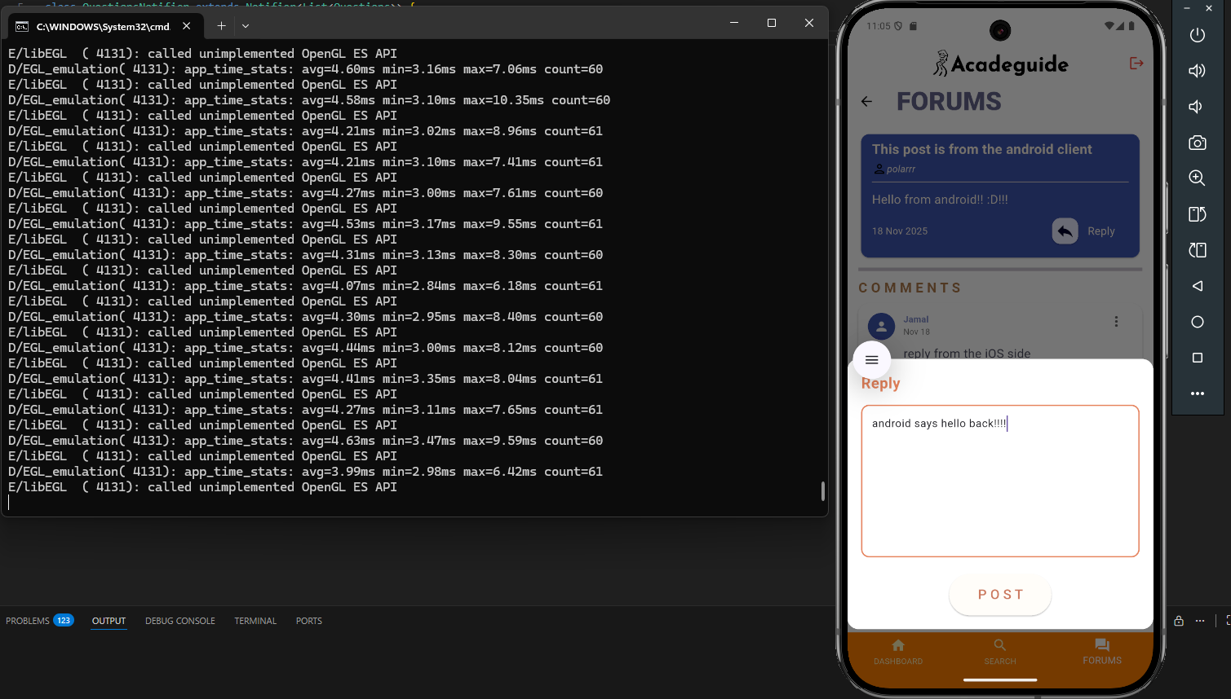
Figure 70. Client A posts a reply for B
And as we can see, A’s reply is also observed on B’s end in real time.
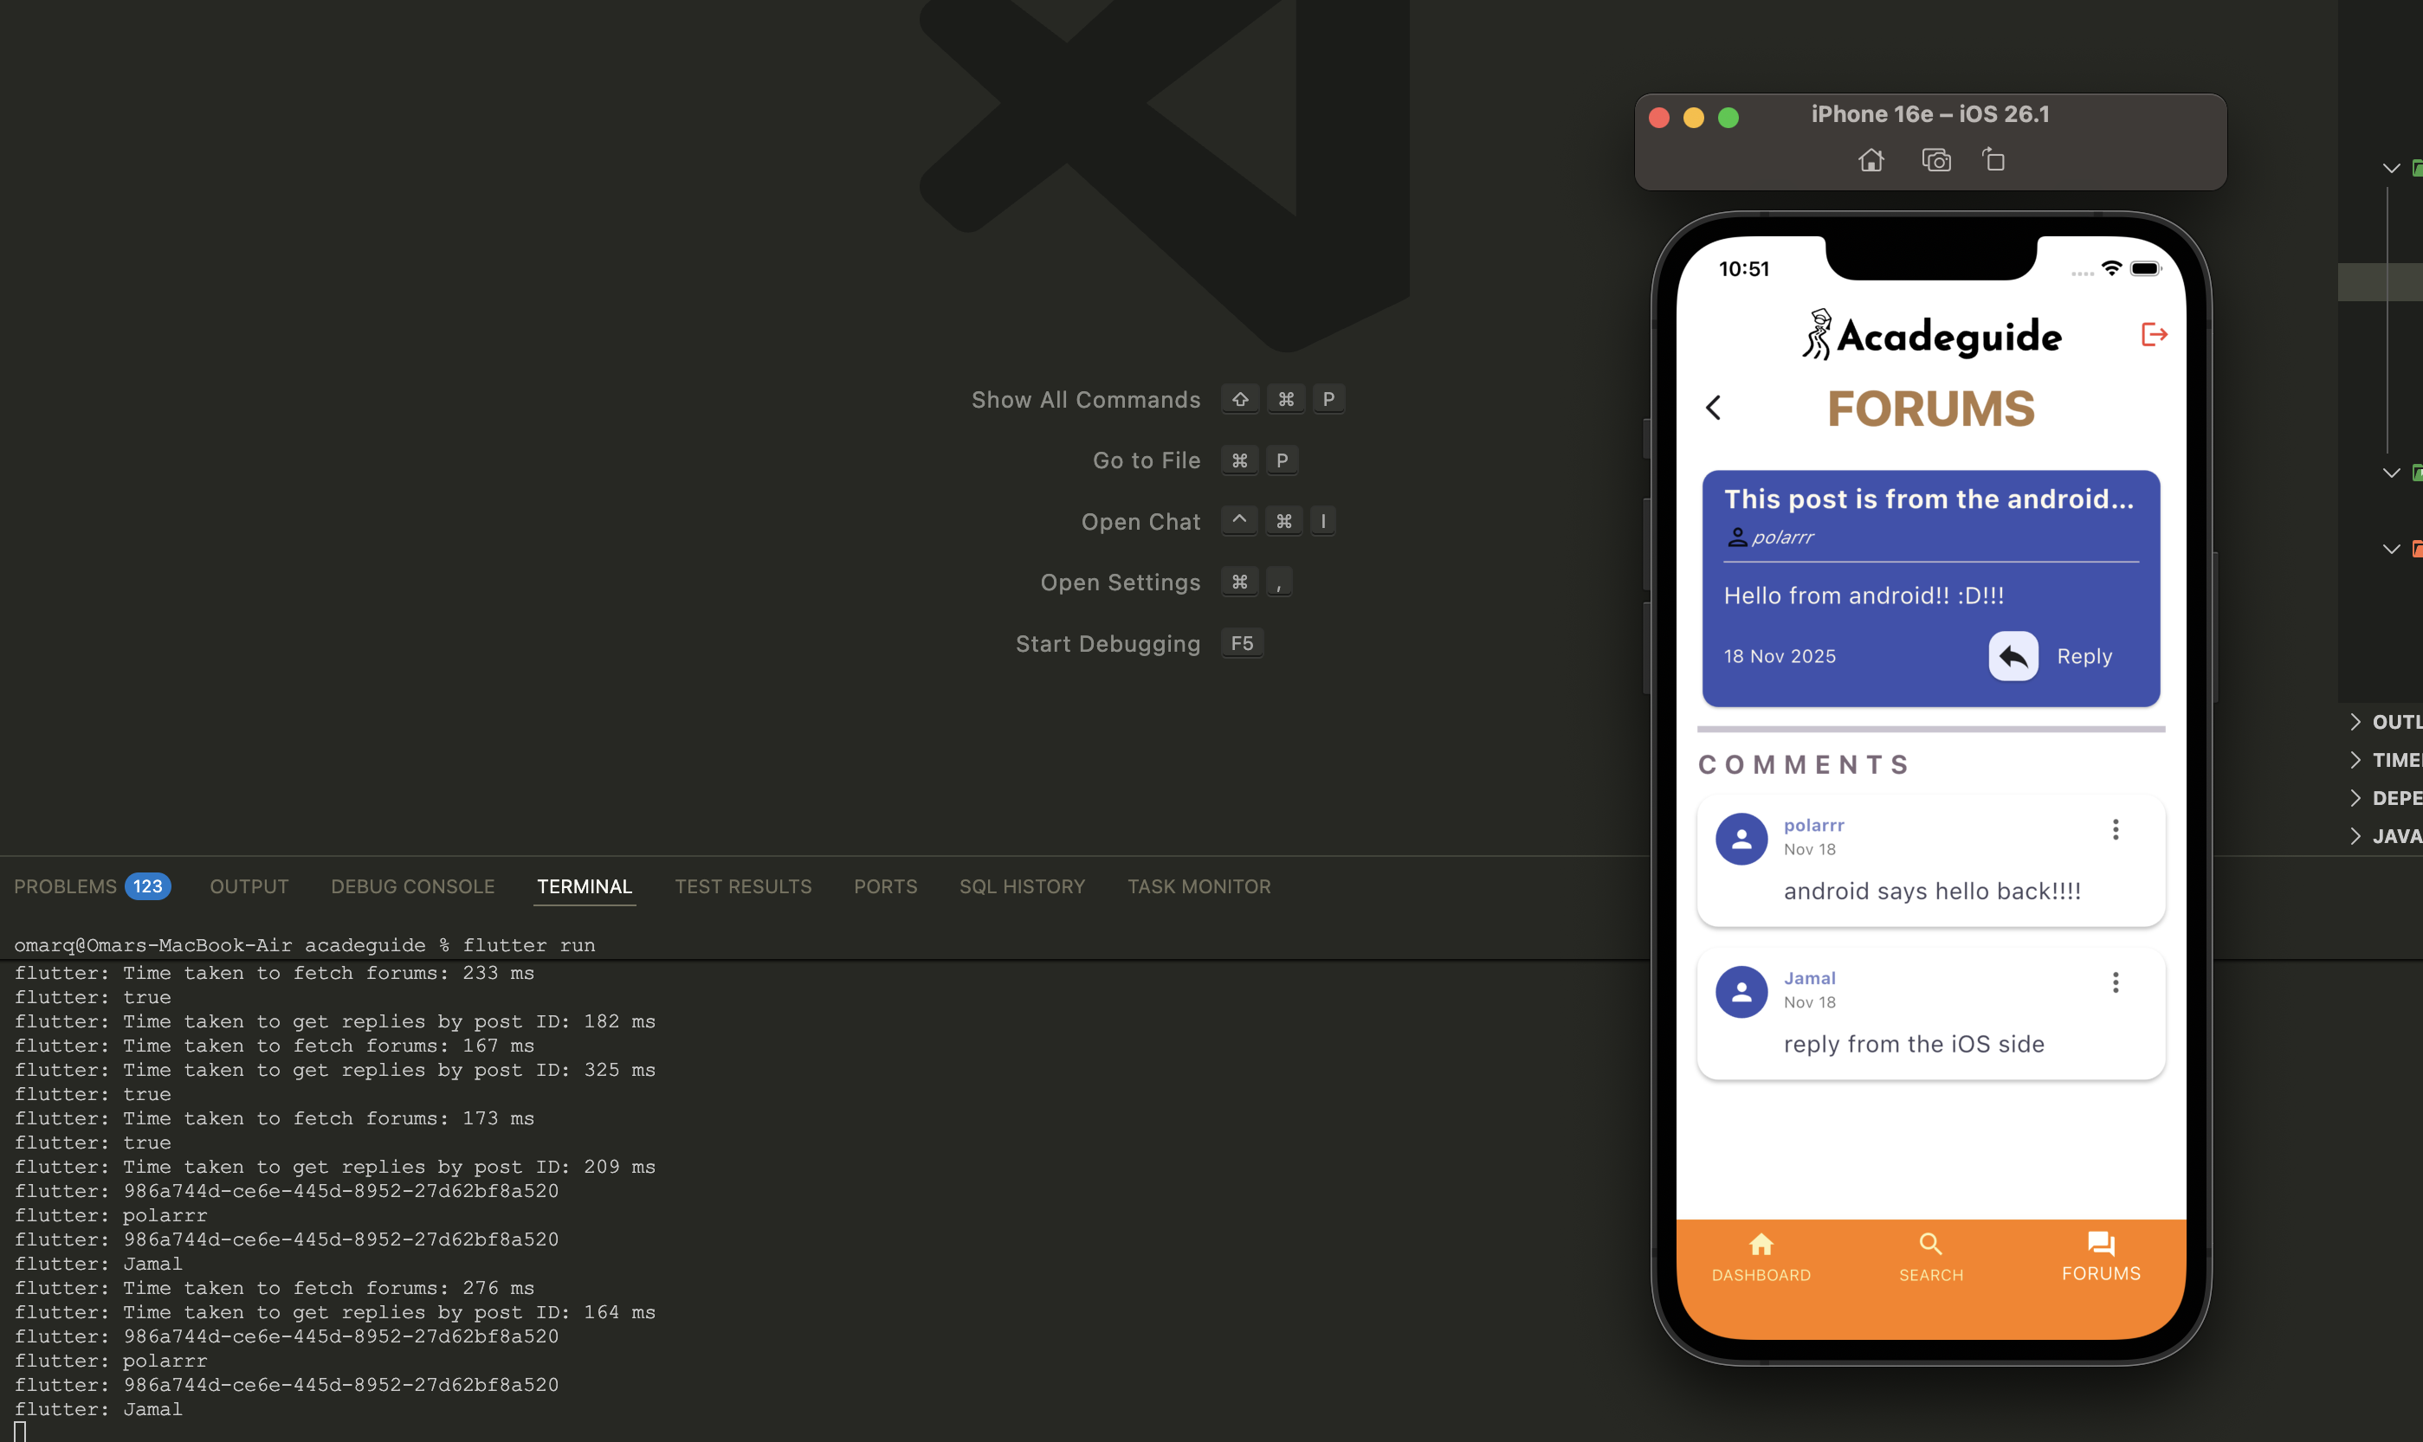
Figure 71. Client B Is able to observe A's reply

Conclusion

The Acadeguide project set out to create an intelligent, accessible, and user-friendly mobile application that assists students in choosing the right academic major based on their interests, strengths, and goals. By revisiting the project objectives, it is evident that most of them were successfully achieved. The team designed and implemented a cross-platform application using Flutter and Supabase, meeting the goal of providing a smooth and responsive user experience on both Android and iOS. The application’s key features such as the personalized assessment, university search tool, and AI-powered chatbot demonstrate that the project effectively fulfills its main objective of helping students make informed academic decisions. Although some advanced functionalities like full-scale data analytics and broader integration with external educational APIs remain as future work, the project achieved a high degree of completion and alignment with its initial vision.

The strengths of Acadeguide lie in its clear functionality, strong technical foundation, and user-centric design. The use of Flutter allowed for a seamless and consistent interface across devices, while Supabase provided a reliable and scalable backend with authentication, real-time updates, and secure data management. The modular system architecture and use of design patterns such as MVC, Observer, and Factory contributed to a maintainable and extensible structure. Additionally, the app’s interactive chatbot advisor and personality-based recommendation system distinguish it from traditional academic guidance tools, making it both intelligent and approachable. However, certain limitations were identified during development. Integration with third-party APIs was occasionally inconsistent due to API rate limits and data formatting issues. Moreover, further optimization of the chatbot’s response accuracy is still needed. Despite these limitations, the overall functionality and performance were robust and reliable throughout testing.

The key contributions of Acadeguide are its innovative integration of AI guidance, psychological assessment principles, and educational data into a single mobile platform. The project introduces a novel approach to academic advising by combining RIASEC-based personality evaluation with real-time recommendations for universities and majors in Qatar. It also contributes to the local educational technology ecosystem by addressing a genuine need, that is supporting students who lack access to professional academic counseling. Overall, Acadeguide stands as a strong proof of concept for using intelligent systems to empower students, and it establishes a foundation for future enhancements such as broader international coverage, advanced analytics, and deeper chatbot integration with career development tools.

Future work
While Acadeguide successfully achieved its main objectives and delivered a functional prototype, there remain several areas for improvement and expansion that can enhance both the system’s intelligence and user experience. One major improvement would be to transform the current assessment into a multistage, procedurally generated questionnaire. Instead of relying on a fixed set of questions, the system could dynamically select follow-up questions based on previous answers, making the process more adaptive and personalized. This would improve the accuracy of the personality and interest evaluation, allowing the recommendation engine to generate even more relevant academic suggestions.
Another valuable improvement involves automating data collection through web scraping and API integrations with official university websites and educational platforms. This would significantly reduce the manual effort required to update university information such as available majors, tuition fees, and admission requirements. However, implementing this feature presents technical challenges since not all university websites provide structured or complete data. Some institutions may lack tuition details or omit certain admission requirements, so the system would need a robust data validation and fallback mechanism to handle missing or inconsistent information. Over time, this automation could lead to a continuously updated and reliable university database that improves the accuracy of recommendations.
Further enhancements could include the addition of a Planning Tool and Career Roadmap module. This feature would allow students to visualize their academic journey, plan their semesters, and explore potential career paths based on their chosen major. Integrating it with real-world labor market data and job listings could help users understand how their education aligns with professional opportunities. This addition would transform Acadeguide from a one-time guidance tool into a long-term educational companion that supports students throughout their academic life cycle.
To implement these extensions, additional resources such as larger datasets, cloud infrastructure credits, and access to educational APIs would be beneficial. Collaboration with local universities, government education departments, or career development centers could also provide official data access and domain expertise. Overall, these enhancements would significantly expand Acadeguide’s capabilities, transforming it into a fully intelligent, automated, and comprehensive academic guidance ecosystem that continues to grow and adapt with the educational landscape.

Student reflections
11.1 Mohammad Ahmad
I did not acquire any new skills nor experience any professional growth. Nothing new of value was gained that would impact my future career advancement in any way. There were no major shortcomings encountered during this project; minor development hiccups occurred which were resolved quickly thanks to my own past experiences and endeavors. I did not learn anything new in terms of lessons therefore I cannot carry anything forward to my professional life since there is nothing to carry.
11.2 Omar Qutb
During this project, we improved our teamwork skills, such as communicating clearly, managing tasks together, and stepping up when leadership was needed. Personally, I learned to adapt to changes, stay professional, and respect different opinions. These skills will help a lot in future careers by making it easier to work in teams and handle real-world projects. One of the challenges we faced was not managing our time properly in the beginning, which caused some delays. In the future, we should plan better from the start. Overall, we learned the value of good teamwork, staying flexible, and keeping a positive attitude even when things get hard.

11.3 Obada Alrefai
Through the Acadeguide project I learned to make system architecture diagrams, which I have never done before. I have also Expanded my knowledge of sequence diagrams, as well as use case diagrams that I and my group members have completed. Working with others and listening to feedback has helped me improve a lot. I strengthened interpersonal skills ensuring alignment across design and development workflows, and making sure the work stays consistent. Personally, I grew in adaptability, embracing agile shifts and prioritizing ethical data practices.

References

[1] C. E. Harper, R. Orr, and E. B. Stolzenberg, Demographics, purpose, and dreams: Predicting entering college as an undecided major student | Nacada Journal, https://meridian.allenpress.com/nacada-journal/article/43/2/136/498952/Demographics-Purpose-and-Dreams-Predicting (accessed Apr. 25, 2025).
[2] National Center for Education Statistics, “Postsecondary Students,” Condition of Education, U.S. Department of Education, 2023. [Online]. Available: https://nces.ed.gov/programs/coe/indicator/csb/postsecondary-students [Accessed: 27-Apr-2025].
[3] Qatar Career Development Centre (QCDC.EN), https://qcdc.org.qa/ (accessed Apr. 25, 2025).
[4] Appadvice, “Qarari by Nayif Aljaber,” AppAdvice, https://appadvice.com/app/qarari/1436598712 (accessed Apr. 25, 2025).
[5] K. M. Soria and M. Stebleton, “Major decisions: Motivations for selecting a major, satisfaction, and belonging,” NACADA Journal, vol. 33, no. 2, pp. 29–43, Dec. 2013. doi:10.12930/nacada-13-018
[6] “Finding the right career with the ABCS OF RIASEC,” Education, Career and Personal Development, https://www.myskillsfuture.gov.sg/content/portal/en/career-resources/career-resources/education-career-personal-development/finding-the-right-career-with-the-abcs-of-riasec.html?cid=a1%3AMySF%7Ca2%3Aarticle%7Ca3%3Ac0018_coursesearchguide19052021_linkto_article-selfassessment%7Csl (accessed May 12, 2025).
[7] “What is a recommendation system?,” NVIDIA Data Science Glossary, https://www.nvidia.com/en-us/glossary/recommendation-system/ (accessed Apr. 25, 2025).
[17] What is Rag? - retrieval-augmented generation AI explained - AWS, https://aws.amazon.com/what-is/retrieval-augmented-generation/ (accessed Apr. 25, 2025).
[8] A. Hunsaker, “BYU scholarsarchive ,TRANSFORMATIONAL EXPERIENCES AND DECISION-MAKING PROCESSES: F PROCESSES: FACTORS INFL ORS INFLUENCING THE CHOICE OF COLLEGE UENCING THE CHOICE OF COLLEGE MAJOR,” Undergraduate Honors Thesis, https://scholarsarchive.byu.edu/cgi/viewcontent.cgi?article=1386&context=studentpub_uht#:~:text=Personal%20exploration%20The%20overall%20theme,of%20belonging%20and%20%E2%80%9Cfit.%E2%80%9D (accessed Apr. 27, 2025).
[9] A. Hunsaker, “Transformational experiences and decision-making processes: Factors influencing the choice of college major,” Undergraduate Honors Thesis, Brigham Young Univ., p.16, sec. IV Results. Available: https://scholarsarchive.byu.edu/cgi/viewcontent.cgi?article=1386&context=studentpub_uht#:~:text=Personal%20exploration%20The%20overall%20theme,of%20belonging%20and%20%E2%80%9Cfit.%E2%80%9D (accessed Apr. 27, 2025).
[10] A. Hunsaker, “Transformational experiences and decision-making processes: Factors influencing the choice of college major,” Undergraduate Honors Thesis, Brigham Young Univ., p. 19 sec. IV Results. Available: https://scholarsarchive.byu.edu/cgi/viewcontent.cgi?article=1386&context=studentpub_uht#:~:text=Personal%20exploration%20The%20overall%20theme,of%20belonging%20and%20%E2%80%9Cfit.%E2%80%9D (accessed Apr. 27, 2025).
[11] P. A. Denice, “Choosing and changing course: Postsecondary students and the process of selecting a major field of study,” Sociological Perspectives, vol. 64, no. 1, pp. 82–108, Jun. 2020. doi:10.1177/0731121420921903
[13] Supabase, "Supabase Documentation," [Online]. Available: https://supabase.com/docs. (Accessed 25 April 2025).
[14] Supabase, "Working With Arrays," [Online]. Available: https://supabase.com/docs/guides/database/arrays. (Accessed 26 April 2025).
[15] Supabase, "REST API," [Online]. Available: https://supabase.com/docs/guides/api. (Accessed 26 April 2025).
[16] Supabase, "Row Level Security," [Online]. Available: https://supabase.com/docs/guides/database/postgres/row-level-security. (Accessed 26 April 2025).
[17] IBM, "What is monolithic architecture?," [Online]. Available: https://www.ibm.com/think/topics/monolithic-architecture. (Accessed 26 April 2025).
[18] IBM, "What are microservices?," [Online]. Available: https://www.ibm.com/think/topics/microservices. (Accessed 26 April 2025).
[19] Google Cloud , "What is Serverless Architecture?," [Online]. Available: https://cloud.google.com/discover/what-is-serverless-architecture. (Accessed 26 April 2025).
[20] J. Holland, "Making vocational choices: A theory of vocational personalities and work environments, 3rd ed.," psycnet.apa.org, 1997. https://psycnet.apa.org/record/1997-08980-000.
[21] H. Gardner, "Gardner, H. (1983). Frames of Mind A Theory of Multiple Intelligences. NewYork Basic Books. - References - Scientific Research Publishing," www.scirp.org, 1983.https://www.scirp.org/reference/referencespapers?referenceid=2633225.
[22] T.J. G. Tracey and S. B. Robbins, "The interest-major congruence and college successrelation: A longitudinal study," Journal of Vocational Behavior, vol. 69, no. 1, pp. 64-89, Aug.2006, doi: https://doi.org/10.1016/j.jvb.2005.11.003.
[23] S. D. Brown and R. W. Lent, Career development and counseling : Putting theory and research to work, 2nd ed. Hoboken, N.J.: Wiley, 2013.
[24] P. L. Ackerman, "Cognitive Ability and Non-Ability Trait Determinants of Expertise,"
Educational Researcher, vol. 32, no. 8, pp. 15-20, Nov. 2003, doi:
https://doi.org/10.3102/0013189x032008015.
[25] A. Joshi, S. Kale, S. Chandel, and D. K. Pal, "Likert Scale: Explored and Explained,"
British Journal of Applied Science & Technology, vol. 7, no. 4, pp. 396-403, 2015, doi:
https://doi.org/10.9734/BJAST/2015/14975.

Appendix A – Use cases specification

Use case Id: UC01 | Take Assessment
Brief Description | Captures the main functionality of the software where the user takes a detailed test, which gives the software the user’s personality traits, skills and strengths, financial situation, interests and career goals.
Primary actors | User
Preconditions:
  - The user must be registered.
  - The user must be logged in.
Post-conditions:
  - User profile is generated.
  - User is recommended majors based on the generated profile.
Main Success Scenario:
Actor Action |  | System Response
1. User clicks on the “Take a Test” button |  | 2. System shows the test window
3. User enters gender, age, country, education level, GPA and tuition budget. |  | 4. System validates the input fields to ensure completeness and correctness.
5. User clicks on "Next". |  | 6. System displays a list of available interests and prompts the user to select at least 5.
7. User selects at least 5 interests. |  | 8. System verifies the selection and enables the "Next" button.
9. User clicks on "Next". |  | 10. System prompts the user to enter additional preferences such as hobbies, skills, personal traits and career goals (if available).
11. User fills in the additional preferences and clicks "Next." |  | 14. System presents a set of questions to assess the user's responses to certain questions that will determine their personality and key traits.
15. User answers the questions. |  | 16. System records the responses to be processed later.
17. User clicks on "Finish". |  | 18. System initiates UC02 – “Generate User Profile”.
 |  | 19. System informs the user about where they can find their user profile details and make changes if needed.
 |  | 20. System initiates UC03 – “Recommend Majors”.
 |  | 21. System asks whether the user wants to compare university options based on the recommended majors.
22. User selects “Yes”. |  | 23. System initiate UC04 – “Compare University Options”.
Alternative flows:
4.a. If any required field is empty or contains invalid data (e.g., GPA out of range), the system prompts the user to correct the input before proceeding.
8.a. If the user selects fewer than 5 interests, the system displays a message prompting them to select at least 5 before proceeding.
22.a. If user selects “No”, skip the next step.
Special Requirements:
  - The test should take no longer than 10 minutes on average.

Use case Id: UC02 | Generate User Profile
Brief Description | Describes the process of generating a user profile after the user completes the assessment. The system collects and stores the user's responses, including demographic details, academic background, skills, interests, personality traits, and career goals. The generated profile is available for the user to view on the Account Dashboard.
Primary actors | User
Preconditions:
  - User is logged in
  - User has finished taking the assessment
Post-conditions:
  - User profile is created and stored in the system.
  - Users can access these profile details from the dashboard.
  - Data collected will be used to recommend university majors.
Main Success Scenario:
<ToDo: List the included use cases. Add rows to the table below if needed />
Actor Action |  | System Response
 |  | 1. The system records the selected interests, preferences, traits, and responses in the database
 |  | 2. The system generates the user profile based on the provided data.
 |  | 3. The system redirects the user to the Dashboard, where they can view their profile.
Alternative flows:

Special Requirements:
- Profile generation and storing should take no longer than 10 seconds.

Use case Id: UC03 | Recommend Majors
Brief Description | Recommends majors to the user based on their profile data by matching it with predefined metrics.
Primary actors | User
Preconditions:
  - User has finished taking the assessment.
  - User profile has been generated.
  - System has access to major-related metrics and data.
Post-conditions:
  - A list of recommended majors is displayed to the user.
Main Success Scenario:
<ToDo: List the included use cases. Add rows to the table below if needed />
Actor Action |  | System Response
 |  | 1. System retrieves the user's profile data.
 |  | 2. System matches the profile data with major-related metrics.
 |  | 3. System generates a list of recommended majors.
 |  | 4. System displays the list of recommended majors to the user.
Alternative flows:

Special Requirements:
<ToDo: List the non-functional requirements that the use case must meet>

Use case Id: UC04 | Compare University Options
Brief Description | Lists the best universities for the user based on their profile data, ordered from the best choice to the worst choice.
Primary actors | User
Preconditions:
  - The user has completed their profile.
  - The system has access to university-related metrics and data.
Post-conditions:
  - A ranked list of universities is displayed to the user.
Main Success Scenario:
<ToDo: List the included use cases. Add rows to the table below if needed />
Actor Action |  | System Response
 |  | 1. System sends user to the "Compare University Options" page.
 |  | 2. System retrieves the user's profile data.
 |  | 3. System matches the profile data with university-related metrics.
 |  | 3. System matches the profile data with university-related metrics.
 |  | 4. System generates a ranked list of universities.
 |  | 5. System displays the ranked list to the user.
Alternative flows:
Special Requirements:
<ToDo: List the non-functional requirements that the use case must meet>
  - System should not take more than 5 seconds when fetching and displaying relevant information.

Use case Id: UC05 | Discussion Forum
Brief Description | Captures the second main functionality of the software where the user or admin can view and interact with various discussion forums or create new ones.
Primary actors | Admin/User
Preconditions:
  - User/Admin is logged in
Post-conditions:
  - User/Admin is taken to the forums tab with relative information displayed.
Main Success Scenario:
<ToDo: List the included use cases. Add rows to the table below if needed />
Actor Action |  | System Response
1. User/Admin selects the forums tab. |  | 2. System navigates the user/admin to the forums screen.
 |  | 3. System fetches and displays the trending forum posts.
Alternative flows:
Special Requirements:
<ToDo: List the non-functional requirements that the use case must meet>
  - System shouldn’t take more than 5 seconds while transitioning screens and fetching information.

Use case Id: UC06 | Create Forum
Brief Description | This case describes the process of creating a new discussion forum post. The user can provide a subject and content, choose to post with their registered name or anonymously, and confirm the post after accepting policy regulations.
Primary actors | User
Preconditions:
  - The user must be logged in to create a discussion forum.
Post-conditions:
  - A new discussion forum post is created and made available for replies.
Main Success Scenario:
<ToDo: List the included use cases. Add rows to the table below if needed />
Actor Action |  | System Response
1. User clicks on "Add New Discussion." |  | 2. System displays a form for entering the subject and content.
3. User fills in the subject and content. |  | 4. System verifies that the content is at least 50 characters long.
5. User selects posting preference (registered name or anonymous). |  | 6. System records the selection.
7. User clicks on "Post." |  | 8. System shows a warning about content policy violations and asks for confirmation.
9. User confirms the post. |  | 10. System creates the discussion forum and makes it available for replies.
Alternative flows:
4.a. If the content is less than 50 characters, the system prompts the user to enter at least 50 characters before posting.

Special Requirements:
<ToDo: List the non-functional requirements that the use case must meet>

Use case Id: UC07 | Delete Forum
Brief Description | This use case describes the process for a user to delete a discussion forum they own, including all replies associated with it.
Primary actors | Admin/User
Preconditions:
  - Admin/user must be logged in to create a discussion forum.
Post-conditions:
  - A new discussion forum post and all replies are removed from the system and reflects on blog.
Main Success Scenario:
<ToDo: List the included use cases. Add rows to the table below if needed />
Actor Action |  | System Response
1. User selects an existing discussion forum that they own. |  | 2. System displays the discussion content with a Delete button.
3. User clicks "Delete" |  | 4. System asks for confirmation message asking if the user really wants to delete.
5. User confirms deletion. |  | 6. System may prompt the user with a CAPTCHA verification.
7. User completes CAPTCHA. |  | 8. System deletes the discussion forum and all its replies from the database.
Alternative flows:
6.a If the user fails the CAPTCHA verification, the update is not saved, and the user is asked to retry.
Special Requirements:
<ToDo: List the non-functional requirements that the use case must meet>
  - The system should prompt a CAPTCHA challenge before deleting the discussion to prevent bots from mass-deleting posts.
  - Once deleted, the discussion and all associated replies cannot be recovered.

Use case Id: UC8 | Reply in Discussion
Brief Description | This use case describes the process for a user reply to an existing discussion forum post. The system ensures that the reply follows content policies before posting.
Primary actors | Admin/User
Preconditions:
  - Admin/user must be logged in to reply to a discussion forum.
Post-conditions:
  - The reply is posted and made visible under the discussion forum
Main Success Scenario:
<ToDo: List the included use cases. Add rows to the table below if needed />
Actor Action |  | System Response
1. User Clicks on “Reply” button under a discussion forum available in the blog |  | 2. System displays a form for entering the reply content.
3. User types in their reply
4. User clicks “Post” |  | 5. System shows a warning about content policy violations and asks for confirmation.
6. User Confirms the reply |  | 7. System posts the reply and makes it visible under the discussion forum.
Alternative flows:
7.a If the reply to length doesn’t satisfy the required length the system prompts the user to type the minimum reply to length.

Special Requirements:

Use case Id: UC9 | Search
Brief Description | Captures the third main functionality of the software which is the ability to allow the user or admin to search through the various available information.
Primary actors | Admin/User
Preconditions:
  - Admin/User is logged in.
Post-conditions:
  - Search results are displayed based on the search parameters.
Main Success Scenario:
<ToDo: List the included use cases. Add rows to the table below if needed />
Actor Action |  | System Response
1. Admin/user selects the search option. |  | 2. System prompts the user to choose an option from searching for universities or searching for forums.
3. Admin/user selects their desired option and is prompted with the desired search menu.
Alternative flows:
3.a. If the actor selects “Search Universities” option, system initiates UC12 – “Search Universities”.
3.b. If the actor selects “Search Forums” option, system initiates UC13 – “Search Universities”.

Special Requirements:

Use case Id: UC10 | Search Universities
Brief Description | This use-case allows users to search for universities through the main dashboard. The system filters results based on the entered university name or partial input query, displaying relevant details such as name, location, available majors, and expected tuition fees. Users can select a university to view more detailed information.
Primary actors | Admin/User
Preconditions:
  - Admin/user is logged in.
Post-conditions:
  - The system displays a list of matching universities, and if a university is selected, a detailed information page is opened.
Main Success Scenario:
<ToDo: List the included use cases. Add rows to the table below if needed />
Actor Action |  | System Response
1. User clicks on the search icon in the main dashboard |  | 2. System provides a search bar for entering university names.
3. User types a university name (full or partial). |  | 4 System searches for universities matching the input.
 |  | 5. System displays a list of matching universities with details such (name, location, number of majors, tuition fees range).
6. User selects a university from the list. |  | 7. System opens a page with detailed information about the selected university.
Alternative flows:
4.a If no matching universities are found, the system displays a "No Results Found" message.

Special Requirements:

Use case Id: UC11 | Search Forums
Brief Description | This use case allows users to search for discussion forums by subject title or message content. The system filters and displays a list of relevant forums containing the search query entered.
Primary actors | Admin/User
Preconditions:
  - Admin/user is logged in.
Post-conditions:
  - The system displays a list of matching forums based on the search query
Main Success Scenario:
<ToDo: List the included use cases. Add rows to the table below if needed />
Actor Action |  | System Response
1. User clicks on the search icon in the Forums Page |  | 2. System provides a search bar for entering keywords
3. User types a keyword related to a forum subject or message content. |  | 4 System searches for forums that contain the query in their title or content.
 |  | 5. System displays a list of matching forums.
6. User selects a forum from the search results. |  | 7. System opens the selected discussion to show it fully.
Alternative flows:
4.a If no matching forums are found, the system displays a "No Results Found" message.

Special Requirements:

Use case Id: UC12 | Register Account
Brief Description | Registers a new user or admin account with necessary details. The system validates the information and sends a verification email to complete the registration process.
Primary actors | Admin/User
Preconditions:
  - Admin/user is not already registered in the system.
Post-conditions:
  - A new account has been created and stored in the database.
  - A verification email is sent to the provided email address.
Main Success Scenario:
<ToDo: List the included use cases. Add rows to the table below if needed />
Actor Action |  | System Response
1. User/Admin navigates to the registration page. |  | 2. System displays the registration form.
3. User/Admin fills in the form.
4. User/Admin submits the form. |  | 5. System checks for duplicate accounts.
 |  | 6. System creates a new account and sends a verification email.
7. User verifies account. |  | 8. System confirms successful registration.
Alternative flows:
5.a If the email is already registered, the system displays an error message and prompts the user/admin to use a different email.
6.b If the verification email fails to send, the system retries until 10 minutes have passed and then stops.
Special Requirements:
  - The system must ensure data privacy and security (e.g., password encryption).
  - The verification email must be sent within 1 minute of registration.
  - The system must support multi-language input for user details.

Use case Id: UC13 | Login/Logout
Brief Description | This use case allows a user or admin to log in to or log out of their account securely.
Primary actors | Admin/User
Preconditions:
  - Admin/user has a registered account.
Post-conditions:
  - Admin/user is logged in or logged out of the system.
Main Success Scenario:
<ToDo: List the included use cases. Add rows to the table below if needed />
Actor Action |  | System Response
1. User/Admin navigates to the login page. |  | 2. System displays the login form.
3. User/Admin enters Username and password, then submits form.
4. User/Admin submit form. |  | 5. System validates the credentials.
 |  | 7. System grants access and redirects to Homepage.
8. User/Admin clicks "Logout". |  | 9. System ends the session and redirects to the login page.
Alternative flows:
5.a. If the credentials are invalid, the system displays an error message and prompts the user/admin to retry.

Special Requirements:
  - The system must use secure authentication protocols (e.g., HTTPS).
  - Session timeouts must be implemented after 15 minutes of inactivity.

Use case Id: UC14 | Reset Password
Brief Description | Resets an Admin’s/User’s password.
Primary actors | Admin/User
Preconditions:
  - Admin/user has a registered account.
Post-conditions:
  - Admin/user receives a password reset link via email.
Main Success Scenario:
<ToDo: List the included use cases. Add rows to the table below if needed />
Actor Action |  | System Response
1. User/Admin clicks "Forgot Password". |  | 2. System sends a password reset link to email.
3. User/Admin clicks the reset link. |  | 4. System displays password update form.
5. User/Admin enters a new password. |  | 6. System updates the password and confirms the change.
Alternative flows:
4.a If the reset link expires, the system prompts the user/admin to request a new link.

Special Requirements:
  - The reset link must expire after 10 minutes.

Appendix B – Test cases specification
Test case # | 1 | Associated use case ID | U10
Test designed by | Omar Qutb | Test design date | 23/04/2025
Executed by | Omar Qutb | Execution date | 26/04/2025
Test case name | Search Universities
Short description | Test the Search Universities functionality

Pre-conditions:
  - The user is logged in
 | Test Step | Expected System Response | Actual Result | Pass/ Fail | Comment
1 | Click “Search” in the Bottom navigation bar | Redirects to Universities screen | As expected, | Pass
2 | User types “Doha” | Universities that contain the word Doha should appear | As expected, | Pass
3 | User clears the search bar | All universities get back to original list dynamically | As expected, | Pass
4 | User types a random string (e.g., "asdsawsda") | University list becomes empty | As expected | Pass
5 | Search with different casing (e.g., "doha" vs "DOHA") | Results should be case-insensitive | As expected | Pass
Post-conditions:
  - User find the desired university

Test case # | 2 | Associated use case ID | U12
Test designed by | Omar Qutb | Test design date | 23/04/2025
Executed by | Omar Qutb | Execution date | 26/04/2025
Test case name | User Register Account
Short description | Test Registering an account

Pre-conditions:
  - User doesn’t have an account
Step | Test Step | Expected System Response | Actual Result | Pass/ Fail | Comment
1 | Clicks on “Register Account” | Sign up screen appears with input fields of Firstname lastname username email and password. | As expected | Pass
2 |  | First Name input is recorded | As expected | Pass
  User enters a valid First Name
3 | User enters a valid Last Name | Last Name input is recorded | As expected | Pass
4 | User enters username | Username is recorded | As expected | Pass
5 | User enters a valid email (“user@example.com”) | Email input is recorded | As expected | Pass
6 | User enters a valid password consisting of 8 characters | Password input is recorded | As expected | Pass
7 | User clicks “Register” button | User should receive a confirmation email to confirm his account and account gets created | As expected | Pass
8 | Leave one or more fields empty and click "Register" | Error message shown: "All fields are required" | As expected | Pass
9 | Enter invalid Email format ( "userexample.com") | Validation error shown | As expected | Pass
10 | Enter weak password (1234) | Validation error “Password should be at least 8 characters ” | As expected | Pass
Post-conditions:
- User account gets created and stored in the cloud datastore
- User redirected to login screen

Test case # | 3 | Associated use case ID | U13
Test designed by | Mohammad Ahmad | Test design date | 23/04/2025
Executed by | Mohammad Ahmad | Execution date | 27/02/2025
Test case name | User Login/Logout
Short description | Complete testing of the Login/Logout use case

Pre-conditions:
  - User is registered in the system
  - User is logged out
Step | Test Step | Expected System Response | Actual Result | Pass/ Fail | Comment
1 | Enter email ‘omarqu2003@gmail.com’ and password ‘newpass123’, tap ‘LOGIN’ button | The system verifies if valid information is entered in the input fields | As expected | Pass
2 |  | The system checks the credentials with supabase and verifies the credentials for user ‘omar’. Session is established | As expected | Pass
3 |  | The system grants the user access to the application, displays dashboard | As expected | Pass
4 | Check post-condition 1
5 | Tap ‘logout’ icon | The system terminates the user session and logs user out. User is sent to the login screen again | As expected | Pass
6 | Check post-condition2
7 | Repeat step 1 using information which does not exist in the system, such as ‘user@example.com’ and ‘password12345’ | The system checks supabase for a user with provided credentials and does NOT find a match, returns null along with associated error message | As expected | Pass
8 | Check post-condition 3
9 | Repeat step 1 with one of the input fields empty, such as ‘omarqu2003@gmail.com’ and an empty password field | The system displays a message asking the user to provide both an email address and a password | As expected | Pass
10 | Check post-condition 4
Post-conditions:
1. User ‘omar’ is logged into the system
2. User ‘omar’ is logged out of the system
3. System does not find a match in supabase
4. System displays message to user asking to provide the required information

Test case # | 4 | Associated use case ID | U14
Test designed by | Mohammad Ahmad | Test design date | 23/04/2025
Executed by | Mohammad Ahmad | Execution date | 27/02/2025
Test case name | User Password Reset
Short description | Complete testing of the Reset Password use case

Pre-conditions:
  - User is registered in the system
  - User is logged out
Step | Test Step | Expected System Response | Actual Result | Pass/ Fail | Comment
1 | Tap ‘Forgot Password?’ text button | The system shows user the first forget password screen, where the user must provide an email address. | As expected | Pass
2 | Enter ‘omarqu2003@gmail.com’ and tap ‘REQUEST’ button | The system checks the email address with supabase and locates it, sends an OTP to the address | As expected | Pass
3 | Enter received OTP | The system verifies entered OTP, sends user to password reset screen | As expected | Pass
4 | Enter and confirm strong, valid password | The system updates user’s password in supabase and redirects them to the login screen | As expected
5 | Check post-condition 1
6 | Repeat step 2 but enter an email address which is not registered in the system, for example ‘example@user.com’ | The system does not find a match in supabase, returns null and the corresponding error message | As expected | Pass
7 | Check post-condition 2
8 | Repeat step 3 but enter an incorrect OTP | The system is unable to verify OTP and notifies user to enter the correct OTP | As expected | Pass
9 | Check post-condition 3
10 | Repeat step 4 but enter and confirm a weak password | The system notifies the user to enter a stronger password | As expected | Pass
11 | Check post-condition 4
12 | Repeat step 4 but enter passwords that do not match | The system notifies the user to enter a matching confirming password | As expected | Pass
13 | Check post-condition 5
Post-conditions:
1. User’s password is changed to the newer one
2. No OTP is sent by the system
3. System does not allow user to proceed to reset password
4. System informs user to enter a stronger password
5. System informs user to enter matching password
Test case # | 5 | Associated use case ID | U1
Test designed by | Obada Alrefai | Test design date | 19/11/2025
Executed by | Obada Alrefai | Execution date | 20/11/2025
Test case name | Take Assessment
Short description | Complete testing of the Take Assessment use case
Pre-conditions:
  - The user is logged in.
  - The user is on the Dashboard Screen.
  - The assessment module is available and connected to the backend.
Step | Test Step | Expected System Response | Actual Result | Pass/ Fail | Comment
1 | Tap the “Take Assessment” button on the Dashboard Screen. | The system navigates to the Assessment Screen and displays the first question, including the question text and the available answer choices. | As expected | Pass
2 | Select one of the answer choices. | The system records the selected answer. | As expected | Pass
3 | Repeat step 2 for remaining questions | The system records the selected answer. | As expected | Pass
4 | Select an answer for the last question and tap “Embark”. | The system submits the assessment responses, calculates the results, and navigates to the Results Screen. | As expected | Pass
5 | View the Recommended Major section displayed on the Results Screen. | The system displays the recommended major(s) based on the user’s assessment results, including major name and description. | As expected | Pass
6 | Repeat step 4 but leave some questions unanswered. | The system notifies the user to complete the questionnaire. | As expected | Pass
Post-conditions:
- The assessment has been submitted and stored in the backend.
- The system has generated assessment results, including scoring or category calculation.
- The user is now on the Results Screen, and the completed assessment is associated with their account.
- The assessment cannot be modified unless the user retakes it.

Test case # | 6 | Associated use case ID | U2
Test designed by | Obada Alrefai | Test design date | 19/11/2025
Executed by | Obada Alrefai | Execution date | 20/11/2025
Test case name | Generate User Profile
Short description | Complete testing of the Generate User Profile use case
Pre-conditions:
  - The user has completed the assessment.
  - The user is on the Results or Profile Screen.
  - The user is logged in.
Step | Test Step | Expected System Response | Actual Result | Pass/ Fail | Comment
1 | Navigate to the dashboard by clicking the dashboard button. | The system navigates to the dashboard Screen and displays the profile card with profile button. | As expected | Pass
2 | Tap the “Profile” button. | The system loads and displays the profile screen. | As expected | Pass
Post-conditions:
- A new User Profile object has been created.
- The user can view and scroll through the full generated profile.
- All profile fields are visible and correctly populated.
- The user’s generated profile is now stored in the backend under their account.
Test case # | 7 | Associated use case ID | U3
Test designed by | Obada Alrefai | Test design date | 19/11/2025
Executed by | Obada Alrefai | Execution date | 20/11/2025
Test case name | Recommend Majors
Short description | Complete testing of the Recommend Majors use case
Pre-conditions:
  - The user has completed the assessment.
  - The user is on the Results Screen.
  - The user is logged in.
Step | Test Step | Expected System Response | Actual Result | Pass/ Fail | Comment
1 | Trigger the recommendation function using the user’s Lists of interests and personality traits. | The system calculates the scores for each major and sorts them and then displays the results. | As expected | Pass
Post-conditions:
- The user can view all generated major recommendations.
- The list of recommended majors is saved.
Test case # | 8 | Associated use case ID | U4
Test designed by | Obada Alrefai | Test design date | 19/11/2025
Executed by | Obada Alrefai | Execution date | 20/11/2025
Test case name | Compare Universities
Short description | Complete testing of the Compare Universities use case
Pre-conditions:
  - The user has completed the assessment.
  - The user is on the Results Screen.
  - The user is logged in.
Step | Test Step | Expected System Response | Actual Result | Pass/ Fail | Comment
1 | Trigger the recommendation function using the user’s Lists of interests and personality traits. | The system calculates the scores for each major and sorts them and then compares universities to recommend with each major then finally it displays the results. | As expected | Pass
Post-conditions:
- The user can view all generated university recommendations.
- The list of recommended universities is saved.
Test case # | 9 | Associated use case ID | U5
Test designed by | Obada Alrefai | Test design date | 19/11/2025
Executed by | Obada Alrefai | Execution date | 20/11/2025
Test case name | Discussion Forums
Short description | Complete testing of the Discussion Forums use case
Pre-conditions:
  - The user is logged in.
Step | Test Step | Expected System Response | Actual Result | Pass/ Fail | Comment
1 | Tap the “forums” button in the bottom navigation bar. | The system fetches and retrieves stored forum data, and displays them. | As expected | Pass
Post-conditions:
- The user can now view the forum posts, scroll through them, and open individual posts
Test case # | 10 | Associated use case ID | U6
Test designed by | Obada Alrefai | Test design date | 19/11/2025
Executed by | Obada Alrefai | Execution date | 20/11/2025
Test case name | Create Forum
Short description | Complete testing of the Create Forum use case
Pre-conditions:
  - The user is logged in.
  - The user is on the Forum Screen.
Step | Test Step | Expected System Response | Actual Result | Pass/ Fail | Comment
1 | Tap button with plus icon. | The system loads the forum prompt question and input fields, and displays them. | As expected | Pass
2 | Fill in the necessary fields and tap the “Post” button. | System asks you to confirm. | As expected | Pass
3 | Tap the “Post” button. | The system creates a new Forum Post using the input data, sends it to the backend for storage, and displays forum list with new post. | As expected | Pass
4 | Repeat step 2 but don’t fill out the necessary fields. | The system notifies the user to fill the necessary fields. | As expected | Pass
Post-conditions:
- The newly created post is visible in the forum list.
- The user can now open, view, or interact with the new post.
- The post is successfully saved in the backend database.
Test case # | 11 | Associated use case ID | U7
Test designed by | Obada Alrefai | Test design date | 19/11/2025
Executed by | Obada Alrefai | Execution date | 20/11/2025
Test case name | Delete Forum
Short description | Complete testing of the Delete Forum use case
Pre-conditions:
  - The user is logged in.
  - The user is on the Forum Screen.
  - The forum exists.
Step | Test Step | Expected System Response | Actual Result | Pass/ Fail | Comment
1 | On the forum you intend to delete tap button with three vertical dots. | The system displays the replay and delete options. | As expected | Pass
2 | Select the delete option. | System asks you to confirm. | As expected | Pass
3 | Tap the “Delete” button. | The system removes the Forum Post from backend storage and updates forum list without the deleted post. | As expected | Pass
Post-conditions:
- The user can’t open, view, or interact with the post.
- The post is successfully removed from the backend database.
Test case # | 12 | Associated use case ID | U8
Test designed by | Obada Alrefai | Test design date | 19/11/2025
Executed by | Obada Alrefai | Execution date | 20/11/2025
Test case name | Reply in Discussion
Short description | Complete testing of the Reply in Discussion use case
Pre-conditions:
  - The user is logged in.
  - The user is on the Forum Screen.
  - The user selected a forum post.

Step | Test Step | Expected System Response | Actual Result | Pass/ Fail | Comment
1 | Tap the reply button | The system loads the reply prompt question and input fields and displays them. | As expected | Pass
2 | Enter required information and tap the post button. | System asks you to confirm.
3 | Tap the post button | The system creates a new reply using the input data, sends it to the backend for storage,
4 | Repeat step 2 but don’t enter the necessary information. | The system notifies the user to enter the necessary information. | As expected | Pass
Post-conditions:
- A dynamically filtered list appears as the user types.
- Partial matches remain visible while non-matching items are hidden.
Test case # | 13 | Associated use case ID | U9
Test designed by | Obada Alrefai | Test design date | 19/11/2025
Executed by | Obada Alrefai | Execution date | 20/11/2025
Test case name | Search
Short description | Complete testing of the Search use case
Pre-conditions:
  - The user is logged in.
  - The user is on the Search Screen.

Step | Test Step | Expected System Response | Actual Result | Pass/ Fail | Comment
1 | Enter a valid keyword (e.g., "Lusail") into the search bar. | The system filters the dataset and displays all items that match the keyword, showing accurate and relevant results. | As expected | Pass
2 | Enter something unrelated into the (e.g., "Pizza") search bar | System shows no results | As expected | Pass
Post-conditions:
- A dynamically filtered list appears as the user types.
- Partial matches remain visible while non-matching items are hidden.

Other Appendices

Appendix C – Questionnaire Report
1. Introduction
Many high school graduates face uncertainty when deciding on their future, especially when choosing a college major or whether to pursue higher education. This confusion often comes from a lack of guidance, external pressure, or not fully understanding their own interests. This often results in dissatisfaction, frequent major changes, or even dropout. Acadeguide was developed to address this issue. Through a series of questions, the app identifies their strengths and interests, then suggests majors that best match their profile. The goal is to help students feel more confident and aligned with their chosen path.
The questionnaire serves as the foundation of the system, capturing data on students’ interests, strengths, personality traits, and career aspirations. The purpose of this report is to explain how the questionnaire was designed, justify the inclusion of specific question types, and support these design decisions with established research and theories in career counseling, education, and psychology.
2. Background & Literature Review
Research in career development emphasizes that an individual’s academic and career success is influenced by the alignment between their personal traits and chosen field of study. One of the most widely used frameworks is Holland’s RIASEC Theory (Holland, 1997), which categorizes people into six personality types—Realistic, Investigative, Artistic, Social, Enterprising, and Conventional—and links these to suitable work environments and fields of study. For example, students with investigative traits often thrive in majors such as science, engineering, or computer science.
Another influential perspective is Gardner’s Theory of Multiple Intelligences (Gardner, 1983), which highlights that students possess diverse forms of intelligence, such as logical-mathematical, linguistic, spatial, or interpersonal. Recognizing these variations allows a more holistic approach to matching students with majors. Similarly, research on the Big Five Personality Traits suggests that traits such as openness and conscientiousness can impact learning preferences and academic persistence.
Several career guidance tools, such as the Strong Interest Inventory and O*NET Career Interest Profiler, rely on questionnaires to map interests to fields. Studies confirm that such assessments increase academic satisfaction and retention (Tracey & Robbins, 2006). However, many existing tools are either generic or tailored to Western contexts, which limits their applicability in diverse educational settings. Acadeguide builds upon these established theories while adapting to the specific needs of local students.
3. Design Methodology
The design of the Acadeguide questionnaire followed a structured, research-driven process. The goal was to create a tool that could accurately capture a student’s preferences and personality characteristics while remaining easy to complete and interpret.

The questionnaire was divided into two primary sections:
Section A – Interests: Based on Holland’s RIASEC framework, focusing on what students enjoy doing and the kinds of tasks they are naturally drawn to.

Section B – Personality Traits: Rooted in the Big Five Personality Model, emphasizing behavioral and emotional characteristics that influence how students learn and work.

Each section contains five multiple-choice questions, each offering five short, clear options. Students are asked to select 2–3 answers per question to provide a broader representation of their preferences. The sentence structures were intentionally varied to maintain engagement and prevent response fatigue.

Responses are scored and mapped to broader categories (e.g., Realistic, Investigative, Artistic, etc.) or personality traits (e.g., Conscientiousness, Openness, Extraversion). The system then compares these results with pre-linked major profiles, awarding points for each match. Majors are ranked by total compatibility scores.

4. Supporting Research for Design Decisions
The two-section design is supported by strong theoretical and empirical foundations.
- The Interests section draws from Holland’s RIASEC model, which links people’s preferred activities with suitable career paths. Each question in this section maps to combinations of RIASEC domains — for example, questions about machines and problem-solving relate to the Realistic and Investigative types, while questions about creativity and expression relate to the Artistic type.
- The Personality Traits section reflects the Big Five Personality Model, emphasizing traits that predict learning behaviors and work performance. For example, punctuality, planning, and responsibility relate to Conscientiousness, while sociability and cheerfulness relate to Extraversion.
The inclusion of both interests and personality ensures a multidimensional understanding of students’ preferences. Research by Ackerman (2003) and Brown & Lent (2013) supports combining cognitive and non-cognitive traits for accurate academic guidance.
Furthermore, using multiple-choice questions with short sentences reduces cognitive load and allows for faster completion, a technique supported by survey design studies (Joshi et al., 2015). Allowing multiple selections per question also captures the complexity of human interests, preventing overly narrow categorization.

5. Validation & Testing
As the app is not deployed yet due to certain reasons such as different app store restrictions, our app was tested by the implementation team along with peer students at the university and relatives. The feedback showed that the first version of our questionnaire was unclear, with some repeated answers or answers that had similar meanings. Because of that, we restructured the questions and answers to serve the same purpose while keeping the same concept but rephrased them to make everything more convenient and easier to understand. The app was tested again by the same people, and they noticed improvements and gave positive feedback. We also tested the app on a high school student, and the results aligned with their interests based on their feedback.
Minor adjustments were made, including simplifying phrasing and ensuring all options were culturally appropriate. The test results showed consistent response patterns when retested, indicating internal reliability.
6. Implementation in Acadeguide
The questionnaire serves as the entry point to the Acadeguide system. Once a student completes it, their responses are processed by the system’s recommendation engine.

Each selected interest and personality trait contributes points to corresponding RIASEC and Big Five dimensions. The system compares the resulting profile to predefined major profiles (e.g., Engineering → Investigative + Realistic; Business → Enterprising + Social).

Majors are then ranked based on compatibility scores. The student receives their top three recommendations, along with explanations linking their answers to each suggested field. This transparency helps students understand why a major suits them, not just which major is recommended.

7. Discussion
The Acadeguide questionnaire successfully balances research rigor and practical usability. Its strength lies in combining psychological theory with a straightforward format suitable for high school and early university students. It encourages self-reflection while collecting structured data for analysis.

However, as with all self-assessments, results depend on honest responses and self-awareness. The questionnaire should complement — not replace — academic advising and mentoring.

Future versions may include adaptive questioning (where questions adjust dynamically based on previous answers) or integration with student performance data for enhanced accuracy.
8. Conclusion
The Acadeguide questionnaire was designed to help students make informed academic decisions through a research-based and user-friendly approach. By combining Holland’s RIASEC theory and the Big Five Personality Model, it effectively measures both interests and personality traits relevant to academic success.
The carefully crafted questions, written in varied engaging language, ensure accessibility and clarity, while the system’s scoring algorithm provides personalized recommendations.

Appendix D – Questionnaire Questions

Section A: Interests (Choose 2–3 options per question)
Q1. When working on a project, which type of activities do you enjoy the most?
- Building things. (Build)
- Working with Machines. (Machines)
- Handling physical objects. (Things)
- Working with plants. (Plants)
- Caring for animals. (Animals)
Q2. If you had free time to explore something new, what would you prefer?
- spending time outdoors. (Outdoors)
- Hands-on activities. (Hands-on)
- Observing nature. (Observe)
- Analyzing problems. (Analyze)
- Solving puzzles. (Problem Solving)
Q3. Which school-related topics or skills attract you most?
- Science subjects. (Science)
- Math problems. (Math)
- Exploring abstract ideas. (Ideas)
- Creativity is my strength. (Creative)
- Design and innovation. (Design)
Q4. Which form of expression or communication do you find most engaging?
- Music helps me express myself. (Music)
- Drama allows me to step into new roles. (Drama)
- Experimenting with media. (Media)
- Talking about myself. (Self-expression)
- Communication is one of my strengths. (Communicate)
Q5. When thinking about your future, what kind of role would you prefer to take?
- Teaching others. (Teach)
- Providing services to others. (Service)
- Helping people solve problems. (Helping)
- Guiding others. (Guide)
- Taking on leadership responsibilities. (Lead)

Section B: Personality Traits (Choose 2–3 options per question)
Q6. Which traits best describe how you handle responsibilities?
- People can depend on me. (Dependability)
- I like keeping my tasks organized. (Organization)
- Planning helps me succeed. (Planning)
- Being punctual is important. (Punctuality)
- I take responsibility for my decisions. (Responsibility)
Q7. When working with others, what do you value most in yourself?
- collaboration.
- Collegiality.
- generosity.
- Honesty.
- Integrity.
Q8. In challenging situations, which of these qualities describes you best?
- I feel confident in facing challenges. (Confidence)
- I manage stress without losing focus. (Coping with Stress)
- I am resilient when facing challenges. (Resilience)
- I regulate my emotions and actions when under pressure. (Self-Regulation)
- I believe in practicing moderation. (Moderation)
Q9. When interacting socially, which traits are strongest in you?
- Being assertive. (Assertiveness)
- Being sociable. (Sociability)
- Being cheerful. (Cheerfulness)
- Being communicative. (Communication)
- Being a leader. (Leadership)
Q10. When learning or exploring new ideas, which traits guide you most?
- Curiosity pushes me forward. (Curiosity)
- Creativity helps me approach tasks. (Creativity)
- Growth mindset is essential. (Growth Mindset)
- Imagination. (Imagination)
- Innovation. (Innovation)

