Story of Rice

# Story of rice

## Part of Education Series: Connecting the Dots

## Author: Paula Perez

## Background image of rice

# Rice is the primary staple food for more than half the world's population

## It is mainly used in Asia, sub-saharan africa and south america

## You also probably have a package of rice in your kitchen right now

### [Picture of rice grains or something like that]

# There are many types of rice depending on the species and milling process

## You might have seen some of them in the supermarket (basmati rice, sushi rice, long grain rice, etc.)

## Each type of rice has its own properties and nutrient profile

### [Maybe add a picture something like this:]

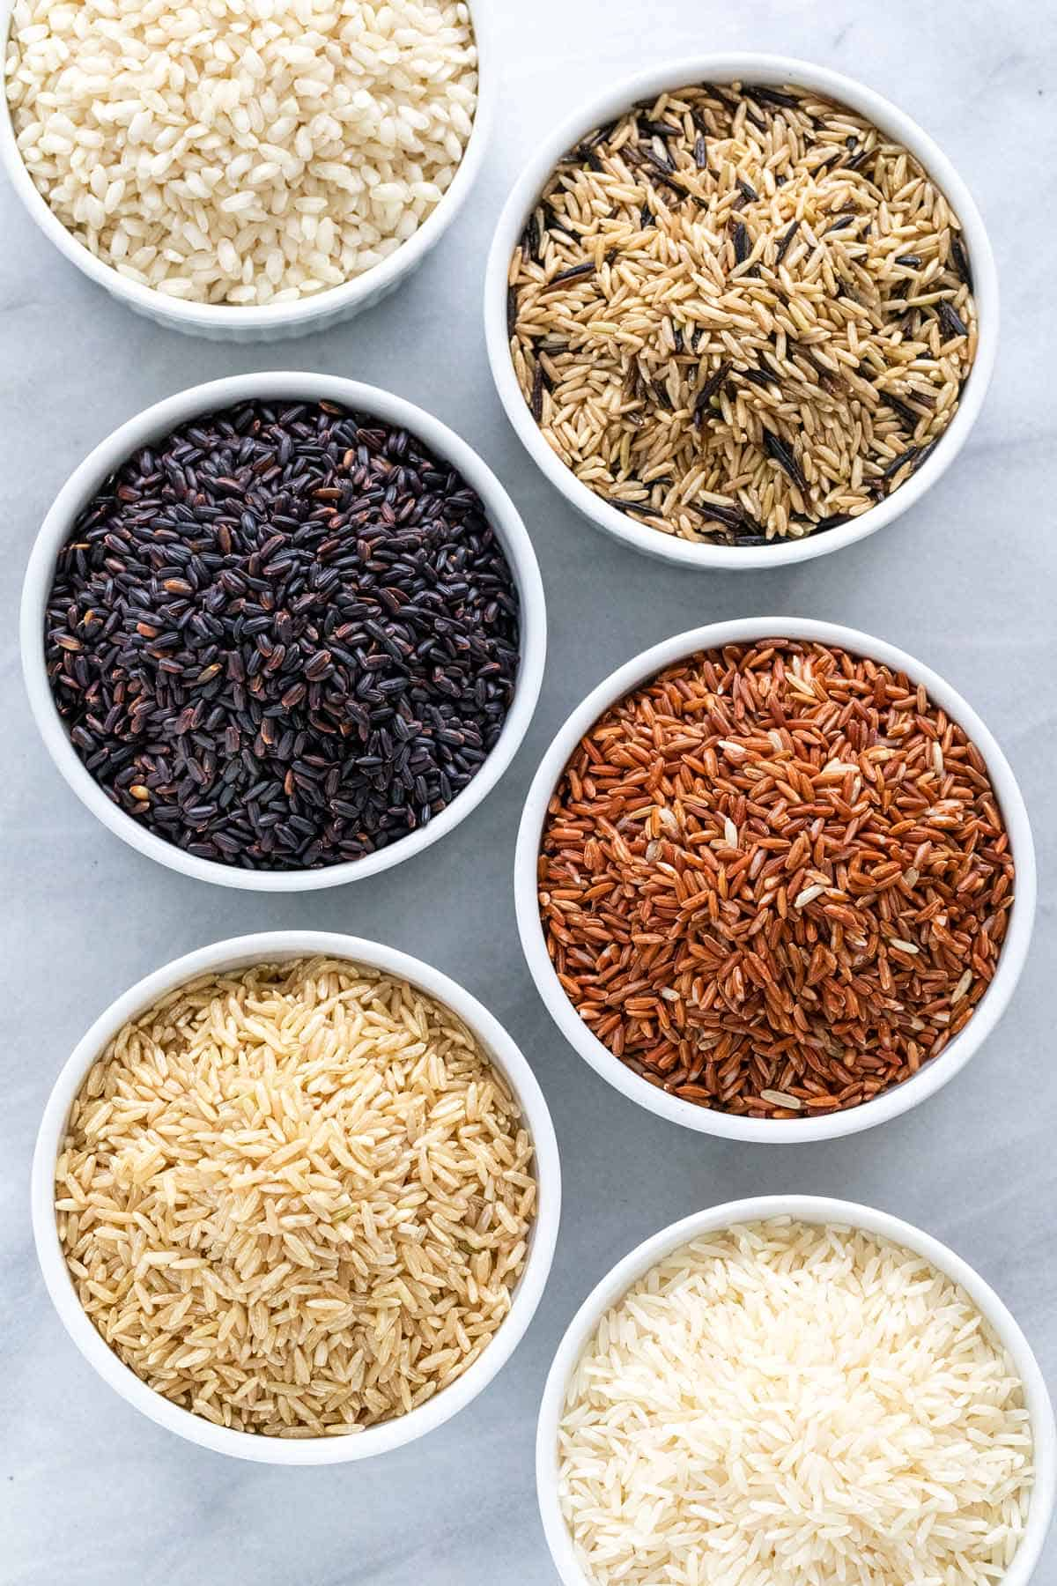

<https://www.ecfr.gov/current/title-7/subtitle-B/chapter-VIII/subchapter-A/part-868/subpart-D>

<https://www.seriouseats.com/carolina-gold-heirloom-rice-anson-mills>

# But this information doesn’t just affect consumers

## In the US there are many people involved in the production and consumption of rice

## Therefore, there are many people interested in information about rice: farmers, millers, trading companies, government agencies, international traders, chefs, etc.

<https://www.ers.usda.gov/topics/crops/rice/rice-sector-at-a-glance/>

### [Maybe photos of chefs, farmers, etc]

# We define a “persona” as the social role of a person.

## Examples of personas in this context would be seed breeders, farmers, grain handlers, millers, distributors, chefs, administration, consumers, etc.

## Each persona has a profile of their interests and information that is relevant to them when talking about the different types of rice

### [Maybe here it can be more cartoonish pictures of the same people, or some program screenshots if they look relevant?]

# We can use databases such as wikidata to obtain all the information we might need about all types of rice

<https://www.wikidata.org/wiki/Q5090>

# But this information can sometimes be dense and difficult to read.

## [Snapshot of the data, that shows how complicated it might get]

### Instead, only the relevant information could be given to the different groups of people, depending on their interest, as defined by their “persona”.

# Based on which persona is our target, we can give different information

## The grower might be interested on the type of grain, how much water it needs

## The nutritionist would want to know the caloric and micronutrient content of the food

## The chef would want to know about the cooking time, flavor and stickiness of the rice

# Ontomatica provides products that facilitate navigating this information depending on the “persona” looking for it.

## It does the research for you

## It connects the dots for you

### [Add some image of your product here]

# For example, if a chef uses this resource, potential pairings and recipes could be given

## It would let the chef know if it is a good rice to make risotto

## Or what meat, fish or wine pairs well with which rice.

### [Picture of a chef]

# The same principle can be applied to each persona

## Using computer programming, a smart program can provide only relevant, useful information to each different user

## It can also be extended to other foods, medicines or products

### [Add a link to your program/website/product]

# It is a powerful tool to help people be healthier and enjoy their food more.

_____________________________________

Objective

reuse industry information about rice to feature Knowledge Graph related content

Tell Story of Rice using Personas

draft link: Story of Rice

currently has more about rice as a primary commodity; has less about risotto (an "application" of rice)

TODO

add placeholder opening page and closing page from original