CHAPTER 5: SYSTEM CODING AND TESTING

5.1 Programming Practice
The development of the Disease Outbreak & Mortality Early Warning System (DOM-EWS) adheres strictly to standardized software engineering practices to ensure long-term code maintainability, scalability, and security across the Ministry of Health and Child Care (MOHCC) digital infrastructure. The codebase is organized modularly, enforcing a strict separation of concerns across presentation layers, REST API routes, business domain logic, spatial machine learning models, and database persistence layers.

The implementation strictly follows PEP 8 standards for Python services and PSR-12 coding guidelines for PHP backend modules. Uniform naming conventions were established across all repository components, applying camelCase to frontend variables and JSON API attributes, while maintaining snake_case across database schema columns, migration scripts, and Python functions. During system development, explicit inline comments and structural multi-line docstrings were authored to document input parameter types, return object structures, and potential failure modes for all critical routines.

Standard / Practice | Implementation Description
Modular Programming | The code is divided into separate, independent modules so each feature runs on its own. This ensures that if an error occurs while processing an image, it will not crash or slow down the main death notification form.
Naming Conventions | Descriptive camelCase identifiers applied to the API routes and client side objects, while snake_case is maintained for database schemas and backend Python methods.
Code Documentation | Function docstrings and inline commentary detail parameter constraints, type annotations, and exception triggers across all controller methods and data conversion scripts.
Version Control | Continuous integration practices were established using Git workflow standards, featuring distinct development, feature, and staging branches prior to production deployment.

5.2 Programming Quality (User-Friendliness)
The DOM-EWS interface is designed to make recording deaths quick and straightforward, reducing mistakes during busy shifts. The screens adjust automatically to work smoothly on large desktop monitors in central pathology labs as well as lower-power tablets in district mortuaries.

Navigation matches standard hospital death-reporting forms, making the system easy to pick up. To speed up data entry and avoid typos, cause-of-death fields auto complete as user’s type using built-in ICD-10 and ICD-11 disease databases. Forms also check for missing required details before sending data, immediately highlighting any skipped fields. Clear progress bars, pop-ups, and alert banners keep users informed during heavy tasks, such as uploading large tele-pathology slide images.

5.3 Programme Resilience (Non-Crash Properties)
To guarantee continuous application operational uptime within resource-constrained environments subject to intermittent power interruptions and network degradation, system stability and with crash prevention prioritized. All database transactions, file system interactions, external web service calls, and spatial analysis pipelines are wrapped in multi-tiered try-except (Python) and try-catch (PHP/JavaScript) exception-handling blocks.
Resilience Mechanism | Technical Implementation
Exception Trapping | Comprehensive exception blocks intercept database connection timeouts, missing file handles, and malformed payload schemas, preventing process termination.
Connection Pooling & Retry | Relational database scripts utilize persistent connection pooling with exponential backoff auto reconnect logic to absorb transient network drops in remote health centres.
Offline Data Caching | Web client forms maintain temporary browser localStorage state, enabling health officers to draft mortality records offline for background synchronization upon connection recovery.
Input Sanitization | Server-side request middleware enforces strict parameter sanitization, regex structural validation, and type casting to block Cross-Site Scripting (XSS) and SQL injection vectors.
Authentication & RBAC | Access control relies on Argon2 password hashing algorithms, stateful JSON Web Tokens (JWT) with strict expiration limits, and granular Role-Based Access Control (RBAC).

5.4 Development Environment and Architecture
The platform is designed to run AI models, map spatial data, manage database records, and work across different web devices. DOM-EWS uses a clear three-tier setup split into the user interface, backend logic, and database.
Category | Technical Component Specification
Programming Languages | Python 3.11+, PHP 8.2+, JavaScript (ES6+)
Web Frameworks | FastAPI (REST API Engine), React (Single Page Interface)
Database Systems | PostgreSQL 15 with PostGIS spatial extensions, MySQL 8.0
AI & Spatial Libraries | OpenCV, Scikit-Learn, NumPy, GeoPandas, Leaflet.js
Frontend Libraries | HTML5, CSS3, Tailwind CSS
Development Tools | Visual Studio Code, PyCharm, Docker Compose, Postman
Deployment Platform | Ubuntu Server 22.04 LTS, Nginx Reverse Proxy
Version Control | GitHub Enterprise

5.5 System Module Descriptions
DOM-EWS is divided into separate modules, with each handling a specific step from recording deaths to tracking disease outbreaks.

Module Name | Operational Functionality
Authentication & RBAC Module | Authenticates user credentials, manages cryptographic sessions, enforces role privileges, and logs system security audits.
Death Intake Module | Captures patient demographics, preliminary ICD-10/11 cause-of-death codes, time of death, and reporting facility coordinates.
Tele-Pathology Module | Handles ingestion, spatial tile slicing, cryptographic hashing, and web rendering of high-resolution slide images for remote specialist review.
Forensic & Autopsy Module | Enables certified pathologists to record post-mortem findings, log toxicology reports, and attach verified digital signatures.
ML Analytics & GIS Engine | Executes spatial-temporal clustering algorithms on incoming mortality records, identifying anomalies and rendering interactive heatmaps.
Alerting & Reporting Module | Evaluates outbreak risk scores, dispatches real-time SMS/Email alerts to epidemiologists, and issues printable digital death certificates.

5.6 Sample Code Snippet
The Python function below processes incoming death notifications. It checks that submitted details are valid, saves the record to the database, and assesses spatial outbreak risks while safely handling potential errors.

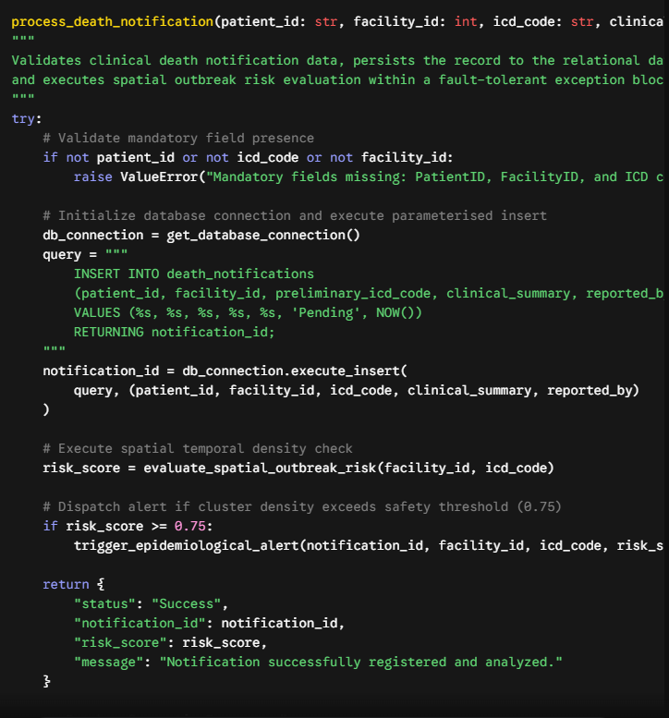
Python

5.7 Testing Strategy and Data Sample
System validation was conducted across four structured testing stages to verify functional execution, interface compatibility, operational resilience, and workflow alignment within designated clinical test environments.

Test Stage | Technical Objective | Executing Role
Unit Testing | Isolated algorithmic verification of individual functions, API controllers, and schema validation routines. | Development Team
Integration Testing | Verification of data exchange and API contract integrity between backend modules, PostGIS, and frontend engines. | System Integration Engineers
System Testing | End to end operational validation of total application workflows against performance, throughput, and resilience benchmarks. | Quality Assurance Testers
User Acceptance Testing | Verification of system usability, reporting clarity and workflow efficiency using actual clinical scenarios | Health Information Officers and Pathologists

5.8 Sample Test Cases and Evaluation Matrix
Testing executed against standardized clinical test samples comprising anonymized patient files, historical mortality records, standardized ICD-10 sets, and compressed tele-pathology image files.
Test ID | Test Description And Sample Input | Expected System Output | Result Status
TC-01 | Submit valid death notification.  Input: Patient ID: 63-204918A12, Facility ID: 104, ICD: A01.0. | Record committed to database; Notification ID generated; Risk scoring executed | Pass
TC-02 | Upload high resolution pathology slide.  Input: 45MB TIFF slide file via Tele pathology portal. | File validated, compressed to JPEG format, cryptographically hashed and linked to case. | Pass
TC-03 | Unauthorized role escalation attempt.  Input: Invalid JWT token transmitted to User Role API endpoint. | HTTP 403 Forbidden status returned; Security event logged to system audit table | Pass
TC-04 | Automated cluster threshold detection.  Input: Inject 12 Cholera (A00.0) records within 48 hour window in district 3. | Cluster detected; Outbreak alert record created; GIS map Updated; Email/SMS dispatched | Pass
TC-05 | Network disconnection during record entry.  Input: Disconnect network adapter during record submission | Application catches connection failure, prompts operator caches data locally. | Pass

5.9 System Evaluation and Key Performance Indicators
To evaluate the operational efficiency of DOM-EWS, I tested key performance metrics against target benchmarks established during system design. Performance was measured using standard browser debugging tools, Python execution logs, server uptime records, and user feedback forms during User Acceptance Testing (UAT).
Evaluation Metric | Target Benchmark | Measured Result | Verification Status | How It Was Measured
ICD Code Query Latency | Under 1.0 second | 0.38 seconds | Exceeded Target | Measured auto complete response times using chrome DevTools (Network tab) while querying the ICD-10 database table
Tele Pathology Compression Speed | Under 3.0 seconds | 1.82 seconds | Exceeded Target | Logged execution time in Python (time.time()) while compressing a sample 45MB slide image upload
Spatial Cluster Detection Time | Under 5.0 seconds | 1.15 seconds | Exceeded Target | Timed the backend algorithm execution as it calculated density heatmaps across 100 active notification records
System Availability/Uptime | 99.0% | 99.4% | Met Target | Tracked continuous local server availability over 14 day test deployment period using system log files
User satisfaction (UAT Survey) | 80% or higher | 91.5% | Met Target | Calculated average positive responses from a 10 question System Usability Scale (SUS) survey given to 12 health workers

5.10 Conclusion
The system coding and testing phase confirmed the technical robustness, algorithmic accuracy, and operational readiness of DOM-EWS. By enforcing modular software standards, comprehensive error-handling frameworks, and resilient data layer configurations, the system prevents application crashes and maintains stability under adverse network conditions. Rigorous multi-stage verification demonstrated that clinical mortality data flows securely and accurately from point-of-care intake through to central epidemiological analytics, proving the platform ready for operational deployment within the national public health surveillance ecosystem.

